Part02
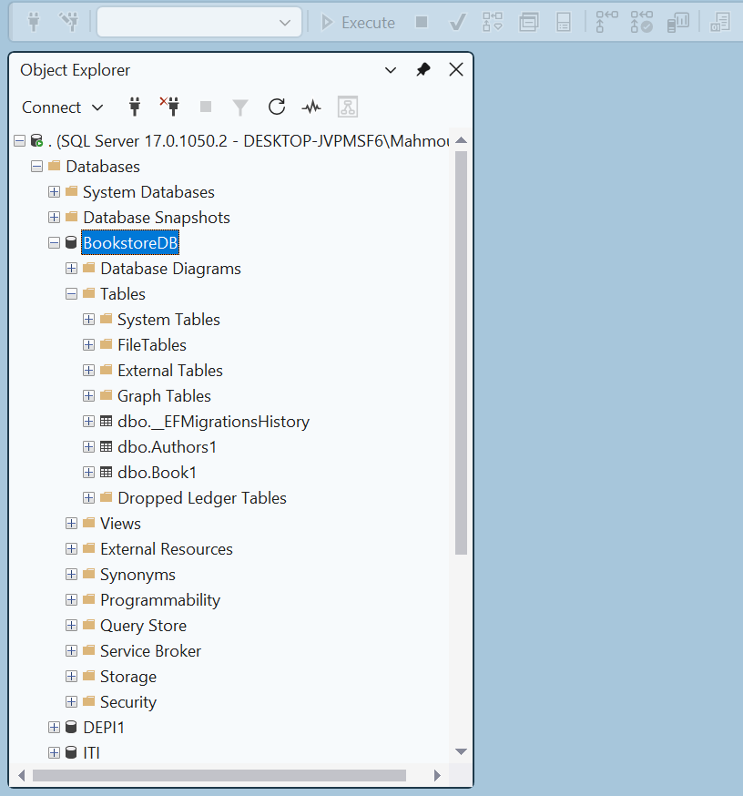
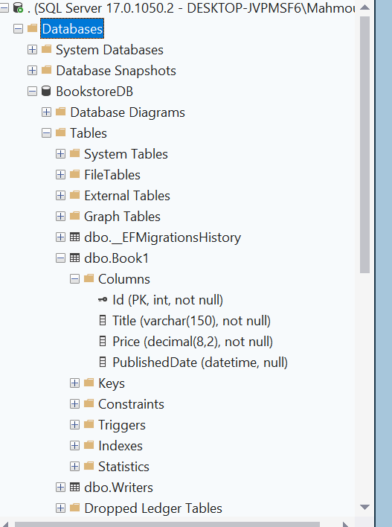

Code First vs DB First:
- Code First gives you control and flexibility
- DB First ties you to an existing database structure
- Code First is better for new projects following DDD principles
- Code First supports modern development practices like TDD
Fluent API vs Data Annotations:
- Fluent API is more powerful and flexible
- Data Annotations are simpler but limited
- Fluent API leads to cleaner, more maintainable code
- Fluent API is the professional choice for enterprise applications

