Part02
- LinkedIn article about Delegates in implementing functional paradigm
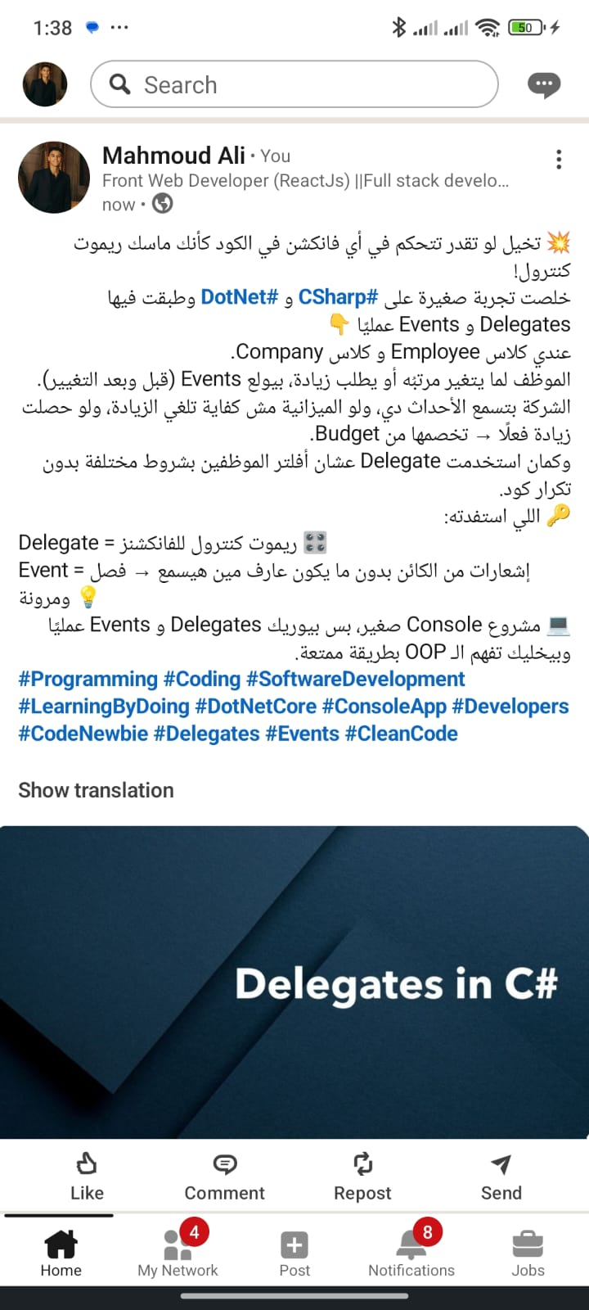

- Search about these topics (Parallel Programming and Concurrency - Unit Testing and Test-Driven Development (TDD) - Asynchronous Programming with async and await)

Parallel Programming and Concurrency :
Parallel programming allows multiple tasks to run simultaneously using multiple CPU cores to improve performance.
Concurrency enables handling multiple tasks efficiently by managing their execution, even if they are not executed at the exact same time.
Unit Testing and Test-Driven Development (TDD) :
Unit Testing is the process of testing individual units of code to ensure they work correctly.
Test-Driven Development (TDD) is a development approach where tests are written before the actual implementation.
TDD follows the cycle: Red → Green → Refactor, and helps improve code quality, maintainability, and reliability.

Asynchronous Programming with async and await:
Asynchronous programming using async and await allows long-running operations to execute without blocking the main thread.
The async keyword enables asynchronous methods, and await pauses execution until a Task completes without freezing the application.

