**ExaminationSystemDB**

**Table of Contents**

Table of Contents 2

 (local)\SQLEXPRESS 5

 User databases 6

 ExaminationSystemDB Database 7

 Tables 8

 [dbo].[Answers] 9

 [dbo].[Choices] 11

 [dbo].[Courses] 13

 [dbo].[Courses_Instructor] 15

 [dbo].[Departments] 17

 [dbo].[Exam_Questions] 18

 [dbo].[Exams] 20

 [dbo].[Instructors] 22

 [dbo].[Questions] 24

 [dbo].[Student_Answer_In_Exam] 26

 [dbo].[Student_Courses] 28

 [dbo].[Students] 30

 [dbo].[Topic] 32

 Stored Procedures 34

 [dbo].[delete_Course] 36

 [dbo].[delete_CourseInstructor] 37

 [dbo].[delete_CourseInstructor2] 38

 [dbo].[delete_Instructor] 39

 [dbo].[delete_Topic] 40

 [dbo].[DeleteAllChoicesForQuestion] 41

 [dbo].[DeleteAnswersForQuestion] 42

 [dbo].[DeleteChoiceForQuestion] 43

 [dbo].[DeleteDepartment] 44

 [dbo].[DeleteExam] 45

 [dbo].[DeleteQuestion] 46

 [dbo].[DeleteQuestionFromExam] 47

 [dbo].[DeleteStudent] 48

 [dbo].[DeleteStudentAnswerOfQuestionInExam] 49

 [dbo].[DeleteStudentCourse] 50

 [dbo].[Exam_Answers] 51

 [dbo].[Exam_Correct] 53

 [dbo].[Exam_Generation] 56

 [dbo].[ExamQuestions_StudentAnswers_ModelAnswers] 58

 [dbo].[GetCoursesTeachedByInstructor] 60

 [dbo].[getExamFromCrsID] 61

 [dbo].[GetStudentAnswerAndModelAnswer] 62

 [dbo].[GetStudentGradeInAllCourses] 63

 [dbo].[GetStudentsInDepartment] 64

 [dbo].[GetTopicsOfCourse] 65

 [dbo].[insert_Course] 66

 [dbo].[insert_CourseInstructor] 67

 [dbo].[insert_Instructor] 68

 [dbo].[insert_Topic] 69

 [dbo].[InsertAnswerForQuestion] 70

 [dbo].[InsertChoiceForQuestion] 71

 [dbo].[InsertDepartment] 72

 [dbo].[InsertExam] 73

 [dbo].[InsertQuestion] 74

 [dbo].[InsertQuestionInExam] 75

 [dbo].[InsertStudent] 76

 [dbo].[InsertStudentAnswerOfQuestionInExam] 77

 [dbo].[InsertStudentCourse] 78

 [dbo].[questionsAndChoicesFromExamID] 79

 [dbo].[Report6_ExamQuestions_StudnetAnswers] 80

 [dbo].[select_Course] 82

 [dbo].[select_CourseInstructor] 83

 [dbo].[select_CourseInstructor2] 84

 [dbo].[select_Instructor] 85

 [dbo].[select_Topic] 86

 [dbo].[SelectAnswerForQuestion] 87

 [dbo].[SelectChoices] 88

 [dbo].[SelectDepartment] 89

 [dbo].[SelectExam] 90

 [dbo].[SelectExamQuestion] 91

 [dbo].[SelectQuestion] 92

 [dbo].[SelectStudent] 93

 [dbo].[SelectStudentAnswerOfQuestionInExam] 94

 [dbo].[SelectStudentCourse] 95

 [dbo].[update_Course] 96

 [dbo].[update_CourseInstructor] 97

 [dbo].[update_CourseInstructor2] 98

 [dbo].[update_Instructor] 99

 [dbo].[update_Topic] 100

 [dbo].[UpdateAnswerForQuestion] 101

 [dbo].[UpdateChoiceForQuestion] 102

 [dbo].[UpdateDepartment] 103

 [dbo].[UpdateExam] 104

 [dbo].[UpdateQuestion] 105

 [dbo].[UpdateQuestionInExam] 106

 [dbo].[UpdateStudent] 107

 [dbo].[UpdateStudentAnswerOfQuestionInExam] 108

 [dbo].[UpdateStudentCourse] 109

 Users 110

 dbo 111

 guest 112

 Database Roles 113

 db_accessadmin 113

 db_backupoperator 113

 db_datareader 114

 db_datawriter 114

 db_ddladmin 114

 db_denydatareader 114

 db_denydatawriter 115

 db_owner 115

 db_securityadmin 115

 public 115

Project > (local)\SQLEXPRESS



 ***(local)\SQLEXPRESS***

**Databases (1)**

*  ExaminationSystemDB

**Server Settings**

|  |  |
| --- | --- |
| **Property** | **Value** |
|  |  |
| Default data file path | C:\Program Files\Microsoft SQL Server\MSSQL16.SQLEXPRESS\MSSQL\DATA\ |
|  |  |
| Default backup file path | C:\Program Files\Microsoft SQL Server\MSSQL16.SQLEXPRESS\MSSQL\Backup |
|  |  |
| Default log file path | C:\Program Files\Microsoft SQL Server\MSSQL16.SQLEXPRESS\MSSQL\DATA\ |
|  |  |
| Recovery Interval (minutes) | 0 |
|  |  |
| Default index fill factor | 0 |
|  |  |
| Default backup media retention | 0 |
|  |  |



**Advanced Server Settings**

|  |  |
| --- | --- |
| **Property** | **Value** |
|  |  |
| Locks | 0 |
|  |  |
| Nested triggers enabled | True |
|  |  |
| Allow triggers to fire others | True |
|  |  |
| Default language | English |
|  |  |
| Network packet size | 4096 |
|  |  |
| Default fulltext language LCID | 1033 |
|  |  |
| Two-digit year cutoff | 2049 |
|  |  |
| Remote login timeout | 10 |
|  |  |
| Cursor threshold | -1 |
|  |  |
| Max text replication size | 65536 |
|  |  |
| Parallelism cost threshold | 5 |
|  |  |
| Max degree of parallelism | 0 |
|  |  |
| Min server memory | 16 |
|  |  |
| Max server memory | 2147483647 |
|  |  |
| Scan for startup procs | False |
|  |  |
| Transform noise words | False |
|  |  |
| CLR enabled | False |
|  |  |
| Blocked process threshold | 0 |
|  |  |
| Filestream access level | False |
|  |  |
| Optimize for ad hoc workloads | False |
|  |  |
| CLR strict security | True |
|  |  |



Author: Mahmoud Copyright 2024 - All Rights Reserved Page 5 of 116

Project > (local)\SQLEXPRESS > User databases



 **User databases**

**Databases (1)**

*  ExaminationSystemDB

Author: Mahmoud Copyright 2024 - All Rights Reserved Page 6 of 116

Project > (local)\SQLEXPRESS > User databases > Examination-SystemDB



 **ExaminationSystemDB Database**

**Files**

|  |  |  |  |  |  |
| --- | --- | --- | --- | --- | --- |
| **Name** | **Type** | **Size** | **Maxsize** | **Autogrowth** | **File Name** |
|  |  |  |  |  |  |
| Examination- | Data | 72.00 | unlimited | 64.00 MB | C:\Program Files\Microsoft SQL |
| SystemDB |  | MB |  |  | Server\MSSQL16.SQLEXPRESS\MSSQL\DATA\Examination- |
|  |  |  |  |  | SystemDB.mdf |
|  |  |  |  |  |  |
| Examination- | Log | 72.00 | 2048.00 | 64.00 MB | C:\Program Files\Microsoft SQL |
| SystemDB_log |  | MB | GB |  | Server\MSSQL16.SQLEXPRESS\MSSQL\DATA\Examination- |
|  |  |  |  |  | SystemDB_log.ldf |
|  |  |  |  |  |  |



Author: Mahmoud Copyright 2024 - All Rights Reserved Page 7 of 116

Project > (local)\SQLEXPRESS > User databases > Examination-SystemDB > Tables



 ***Tables***

**Objects**



**Name**

dbo.Answers



dbo.Choices

dbo.Courses



dbo.Courses_Instructor

dbo.Departments



dbo.Exam_Questions

dbo.Exams



dbo.Instructors

dbo.Questions



dbo.Student_Answer_In_Exam

dbo.Student_Courses



dbo.Students

dbo.Topic

Author: Mahmoud Copyright 2024 - All Rights Reserved Page 8 of 116

Project > (local)\SQLEXPRESS > User databases > Examination-SystemDB > Tables > dbo.Answers



 **[dbo].[Answers]**

**Properties**

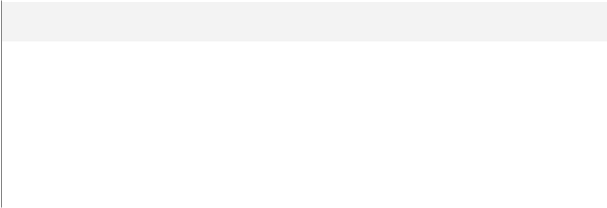

**Property**

Collation



Row Count (~)

Created



Last Modified

**Value**

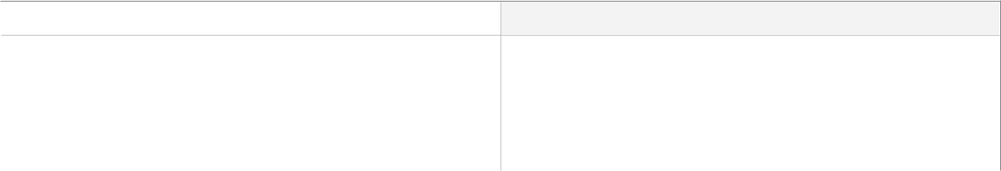

SQL_Latin1_General_CP1_CI_AS



60

2:36:11 PM Thursday, January 25, 2024



11:09:00 PM Sunday, February 11, 2024

**Columns**

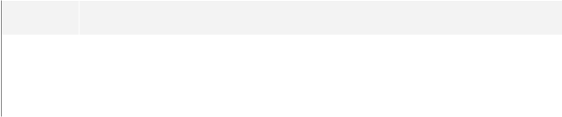

|  |  |
| --- | --- |
| **Key** | **Name** |
|  | Question_Id |
|  | Value |
|  |  |



|  |  |  |
| --- | --- | --- |
| **Data Type** | **Max Length (Bytes)** | **Nullability** |
| int | 4 | NOT NULL |
| varchar(50) | 50 | NOT NULL |
|  |  |  |

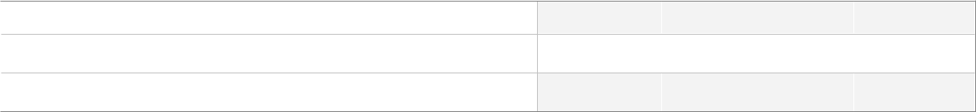

**Indexes**

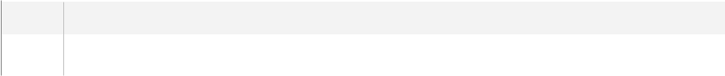

**Key** **Name**

PK_Answers



|  |  |
| --- | --- |
| **Key Columns** | **Unique** |
| Question_Id, Value | True |
|  |  |



**Foreign Keys**

|  |  |  |  |
| --- | --- | --- | --- |
| **Name** | **Update** | **Delete** | **Columns** |
|  |  |  |  |
| FK_Answers_Questions | Cascade | Cascade | Question_Id->[dbo].[Questions].[Question_Id] |
|  |  |  |  |



**SQL Script**



CREATE TABLE [dbo].[Answers]

(

[Question_Id] [int] NOT NULL,

[Value] [varchar] (50) COLLATE SQL_Latin1_General_CP1_CI_AS NOT NULL

) ON [PRIMARY]

GO

ALTER TABLE [dbo].[Answers] ADD CONSTRAINT [PK_Answers] PRIMARY KEY CLUSTERED ([Question_Id], [Value]) ON [PRIMARY]

GO

ALTER TABLE [dbo].[Answers] ADD CONSTRAINT [FK_Answers_Questions] FOREIGN KEY ([Question_Id]) REFERENCES [dbo].[Questions] ([Question_Id]) ON DELETE CASCADE ON UPDATE CASCADE

GO

**Uses**

[dbo].[Questions]

Author: Mahmoud Copyright 2024 - All Rights Reserved Page 9 of 116

Project > (local)\SQLEXPRESS > User databases > Examination-SystemDB > Tables > dbo.Answers

**Used By**

[dbo].[DeleteAnswersForQuestion]

[dbo].[Exam_Correct]

[dbo].[ExamQuestions_StudentAnswers_ModelAnswers]

[dbo].[GetStudentAnswerAndModelAnswer]

[dbo].[InsertAnswerForQuestion]

[dbo].[SelectAnswerForQuestion]

[dbo].[UpdateAnswerForQuestion]

Author: Mahmoud Copyright 2024 - All Rights Reserved Page 10 of 116

Project > (local)\SQLEXPRESS > User databases > Examination-SystemDB > Tables > dbo.Choices



 **[dbo].[Choices]**

**Properties**



**Property**

Collation



Row Count (~)

Created



Last Modified

**Value**



SQL_Latin1_General_CP1_CI_AS



180

11:07:52 PM Sunday, February 11, 2024



11:09:00 PM Sunday, February 11, 2024

**Columns**

|  |  |  |  |  |
| --- | --- | --- | --- | --- |
| **Key** | **Name** | **Data Type** | **Max Length (Bytes)** | **Nullability** |
|  |  |  |  |  |
|  | Question_Id | int | 4 | NOT NULL |
|  |  |  |  |  |
|  | Choice_Number | varchar(50) | 50 | NOT NULL |
|  |  |  |  |  |
|  | Content | varchar(500) | 500 | NOT NULL |
|  |  |  |  |  |



**Indexes**

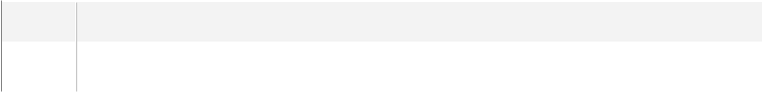

**Key** **Name**

PK_Choices



|  |  |
| --- | --- |
| **Key Columns** | **Unique** |
| Question_Id, Choice_Number | True |
|  |  |



**Foreign Keys**

|  |  |  |  |
| --- | --- | --- | --- |
| **Name** | **Update** | **Delete** | **Columns** |
|  |  |  |  |
| FK_Choices_Questions | Cascade | Cascade | Question_Id->[dbo].[Questions].[Question_Id] |
|  |  |  |  |



**SQL Script**



CREATE TABLE [dbo].[Choices]

(

[Question_Id] [int] NOT NULL,

[Choice_Number] [varchar] (50) COLLATE SQL_Latin1_General_CP1_CI_AS NOT NULL, [Content] [varchar] (500) COLLATE SQL_Latin1_General_CP1_CI_AS NOT NULL ) ON [PRIMARY]

GO

ALTER TABLE [dbo].[Choices] ADD CONSTRAINT [PK_Choices] PRIMARY KEY CLUSTERED ([Question_Id], [Choice_Number]) ON [PRIMARY]

GO

ALTER TABLE [dbo].[Choices] ADD CONSTRAINT [FK_Choices_Questions] FOREIGN KEY ([Question_Id]) REFERENCES [dbo].[Questions] ([Question_Id]) ON DELETE CASCADE ON UPDATE CASCADE

GO

Author: Mahmoud Copyright 2024 - All Rights Reserved Page 11 of 116

Project > (local)\SQLEXPRESS > User databases > Examination-SystemDB > Tables > dbo.Choices

**Uses**

[dbo].[Questions]

**Used By**

[dbo].[DeleteAllChoicesForQuestion]

[dbo].[DeleteChoiceForQuestion]

[dbo].[ExamQuestions_StudentAnswers_ModelAnswers]

[dbo].[GetStudentAnswerAndModelAnswer]

[dbo].[InsertChoiceForQuestion]

[dbo].[questionsAndChoicesFromExamID]

[dbo].[Report6_ExamQuestions_StudnetAnswers]

[dbo].[SelectChoices]

[dbo].[UpdateChoiceForQuestion]

Author: Mahmoud Copyright 2024 - All Rights Reserved Page 12 of 116

Project > (local)\SQLEXPRESS > User databases > Examination-SystemDB > Tables > dbo.Courses



 **[dbo].[Courses]**

**Properties**



**Property**

Collation



Row Count (~)

Created



Last Modified

**Value**



SQL_Latin1_General_CP1_CI_AS



4

9:52:37 PM Saturday, February 3, 2024



11:09:00 PM Sunday, February 11, 2024

**Columns**

|  |  |  |  |  |  |
| --- | --- | --- | --- | --- | --- |
| **Key** | **Name** | **Data Type** | **Max Length (Bytes)** | **Nullability** | **Identity** |
|  |  |  |  |  |  |
|  | Course_Id | int | 4 | NOT NULL | 1 - 1 |
|  |  |  |  |  |  |
|  | Course_Name | varchar(50) | 50 | NULL allowed |  |
|  |  |  |  |  |  |



**Indexes**

**Key** **Name**

PK_Courses

|  |  |
| --- | --- |
| **Key Columns** | **Unique** |
| Course_Id | True |
|  |  |



**SQL Script**



CREATE TABLE [dbo].[Courses]

(

[Course_Id] [int] NOT NULL IDENTITY(1, 1),

[Course_Name] [varchar] (50) COLLATE SQL_Latin1_General_CP1_CI_AS NULL

) ON [PRIMARY]

GO

ALTER TABLE [dbo].[Courses] ADD CONSTRAINT [PK_Courses] PRIMARY KEY CLUSTERED ([Course_Id]) ON [PRIMARY]

GO

**Used By**

[dbo].[Courses_Instructor]

[dbo].[Exams]

[dbo].[Questions]

[dbo].[Student_Courses]

[dbo].[Topic]

[dbo].[delete_Course]

[dbo].[Exam_Generation]

[dbo].[GetCoursesTeachedByInstructor]

[dbo].[GetStudentGradeInAllCourses]

[dbo].[GetTopicsOfCourse]

Author: Mahmoud Copyright 2024 - All Rights Reserved Page 13 of 116

Project > (local)\SQLEXPRESS > User databases > Examination-SystemDB > Tables > dbo.Courses

[dbo].[insert_Course]

[dbo].[select_Course]

[dbo].[update_Course]

Author: Mahmoud Copyright 2024 - All Rights Reserved Page 14 of 116

Project > (local)\SQLEXPRESS > User databases > Examination-SystemDB > Tables > dbo.Courses_Instructor



 **[dbo].[Courses_Instructor]**

**Properties**

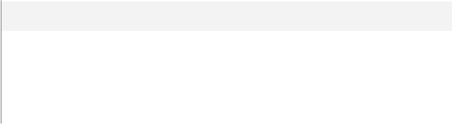

**Property**

Row Count (~)



Created

Last Modified

**Columns**

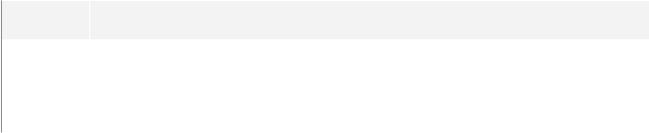

|  |  |
| --- | --- |
| **Key** | **Name** |
|  | Course_Id |
|  | Ins_Id |
|  |  |



**Value**

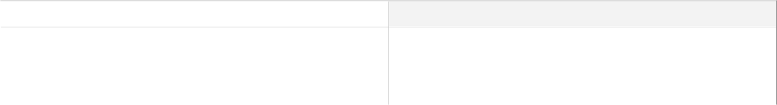

5



2:29:36 PM Thursday, January 25, 2024

9:52:37 PM Saturday, February 3, 2024

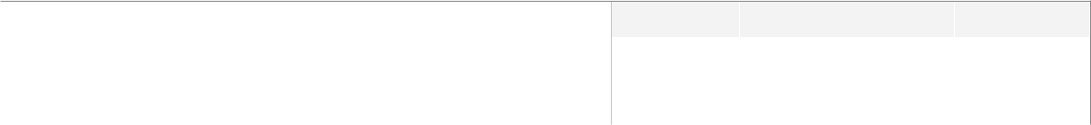

|  |  |  |
| --- | --- | --- |
| **Data Type** | **Max Length (Bytes)** | **Nullability** |
| int | 4 | NOT NULL |
| int | 4 | NOT NULL |
|  |  |  |



**Indexes**

|  |  |  |  |
| --- | --- | --- | --- |
| **Key** | **Name** | **Key Columns** | **Unique** |
|  |  |  |  |
|  | PK_Courses_Instructor | Course_Id, Ins_Id | True |
|  |  |  |  |



**Foreign Keys**

|  |  |
| --- | --- |
| **Name** | **Columns** |
|  |  |
| FK_Courses_Instructor_Courses | Course_Id->[dbo].[Courses].[Course_Id] |
|  |  |
| FK_Courses_Instructor_Instructors | Ins_Id->[dbo].[Instructors].[Instructor_Id] |
|  |  |



**SQL Script**

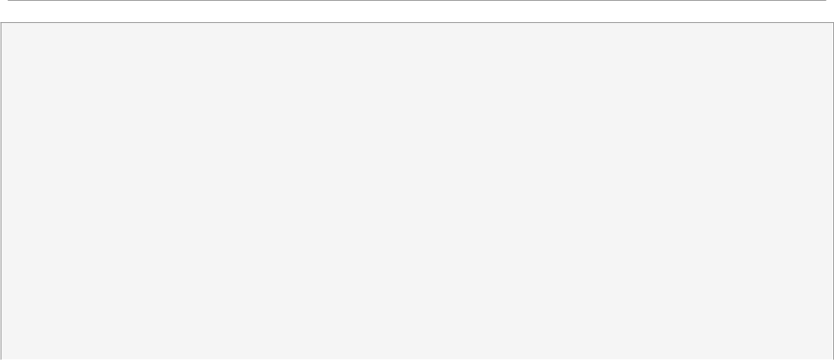

CREATE TABLE [dbo].[Courses_Instructor]

(

[Course_Id] [int] NOT NULL,

[Ins_Id] [int] NOT NULL

) ON [PRIMARY]

GO

ALTER TABLE [dbo].[Courses_Instructor] ADD CONSTRAINT [PK_Courses_Instructor] PRIMARY KEY CLUSTERED ([Course_Id], [Ins_Id]) ON [PRIMARY]

GO

ALTER TABLE [dbo].[Courses_Instructor] ADD CONSTRAINT [FK_Courses_Instructor_Courses] FOREIGN KEY ([Course_Id]) REFERENCES [dbo].[Courses] ([Course_Id])

GO

ALTER TABLE [dbo].[Courses_Instructor] ADD CONSTRAINT [FK_Courses_Instructor_Instructors] FOREIGN KEY ([Ins_Id]) REFERENCES [dbo].[Instructors] ([Instructor_Id])

GO

Author: Mahmoud Copyright 2024 - All Rights Reserved Page 15 of 116

Project > (local)\SQLEXPRESS > User databases > Examination-SystemDB > Tables > dbo.Courses_Instructor

**Uses**

[dbo].[Courses]

[dbo].[Instructors]

**Used By**

[dbo].[delete_CourseInstructor]

[dbo].[delete_CourseInstructor2]

[dbo].[GetCoursesTeachedByInstructor]

[dbo].[insert_CourseInstructor]

[dbo].[select_CourseInstructor]

[dbo].[select_CourseInstructor2]

[dbo].[update_CourseInstructor]

[dbo].[update_CourseInstructor2]

Author: Mahmoud Copyright 2024 - All Rights Reserved Page 16 of 116

Project > (local)\SQLEXPRESS > User databases > Examination-SystemDB > Tables > dbo.Departments



 **[dbo].[Departments]**

**Properties**



**Property**

Collation



Row Count (~)

Created



Last Modified

**Value**



SQL_Latin1_General_CP1_CI_AS



2

7:55:22 PM Tuesday, January 30, 2024



7:55:22 PM Tuesday, January 30, 2024

**Columns**

|  |  |  |  |  |  |
| --- | --- | --- | --- | --- | --- |
| **Key** | **Name** | **Data Type** | **Max Length (Bytes)** | **Nullability** | **Identity** |
|  |  |  |  |  |  |
|  | Department_ID | int | 4 | NOT NULL | 1 - 1 |
|  |  |  |  |  |  |
|  | Department_Name | varchar(50) | 50 | NULL allowed |  |
|  |  |  |  |  |  |
|  | Dept_Description | varchar(200) | 200 | NULL allowed |  |
|  |  |  |  |  |  |



**Indexes**

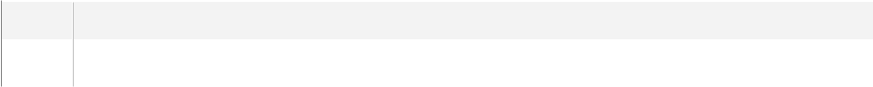

**Key** **Name**

PK_Departments



|  |  |
| --- | --- |
| **Key Columns** | **Unique** |
| Department_ID | True |
|  |  |



**SQL Script**



CREATE TABLE [dbo].[Departments]

(

[Department_ID] [int] NOT NULL IDENTITY(1, 1),

[Department_Name] [varchar] (50) COLLATE SQL_Latin1_General_CP1_CI_AS NULL,

[Dept_Description] [varchar] (200) COLLATE SQL_Latin1_General_CP1_CI_AS NULL

) ON [PRIMARY]

GO

ALTER TABLE [dbo].[Departments] ADD CONSTRAINT [PK_Departments] PRIMARY KEY CLUSTERED ([Department_ID]) ON [PRIMARY]

GO

**Used By**

[dbo].[Instructors]

[dbo].[Students]

[dbo].[DeleteDepartment]

[dbo].[GetStudentsInDepartment]

[dbo].[InsertDepartment]

[dbo].[SelectDepartment]

[dbo].[UpdateDepartment]

Author: Mahmoud Copyright 2024 - All Rights Reserved Page 17 of 116

Project > (local)\SQLEXPRESS > User databases > Examination-SystemDB > Tables > dbo.Exam_Questions



 **[dbo].[Exam_Questions]**

**Properties**



**Property**

Row Count (~)



Created

Last Modified

**Value**



250



9:54:49 PM Saturday, January 27, 2024

11:09:00 PM Sunday, February 11, 2024

**Columns**



|  |  |
| --- | --- |
| **Key** | **Name** |
|  | Question_Id |
|  | Exam_ID |
|  |  |



|  |  |  |
| --- | --- | --- |
| **Data Type** | **Max Length (Bytes)** | **Nullability** |
| int | 4 | NOT NULL |
| int | 4 | NOT NULL |
|  |  |  |

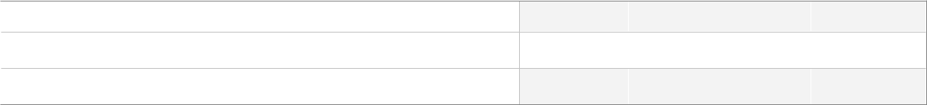

**Indexes**

|  |  |  |  |
| --- | --- | --- | --- |
| **Key** | **Name** | **Key Columns** | **Unique** |
|  |  |  |  |
|  | PK_Exam_Questions | Question_Id, Exam_ID | True |
|  |  |  |  |



**Foreign Keys**

|  |  |  |
| --- | --- | --- |
| **Name** | **Delete** | **Columns** |
|  |  |  |
| FK_Exam_Questions_Exams | Cascade | Exam_ID->[dbo].[Exams].[Exam_Id] |
|  |  |  |
| FK_Exam_Questions_Questions | Cascade | Question_Id->[dbo].[Questions].[Question_Id] |
|  |  |  |



**SQL Script**



CREATE TABLE [dbo].[Exam_Questions]

(

[Question_Id] [int] NOT NULL,

[Exam_ID] [int] NOT NULL

) ON [PRIMARY]

GO

ALTER TABLE [dbo].[Exam_Questions] ADD CONSTRAINT [PK_Exam_Questions] PRIMARY KEY CLUSTERED ([Question_Id], [Exam_ID]) ON [PRIMARY]

GO

ALTER TABLE [dbo].[Exam_Questions] ADD CONSTRAINT [FK_Exam_Questions_Exams] FOREIGN KEY ([Exam_ID]) REFERENCES [dbo].[Exams] ([Exam_Id]) ON DELETE CASCADE

GO

ALTER TABLE [dbo].[Exam_Questions] ADD CONSTRAINT [FK_Exam_Questions_Questions] FOREIGN KEY ([Question_Id]) REFERENCES [dbo].[Questions] ([Question_Id]) ON DELETE CASCADE

GO

Author: Mahmoud Copyright 2024 - All Rights Reserved Page 18 of 116

Project > (local)\SQLEXPRESS > User databases > Examination-SystemDB > Tables > dbo.Exam_Questions

**Uses**

[dbo].[Exams]

[dbo].[Questions]

**Used By**

[dbo].[DeleteQuestionFromExam]

[dbo].[Exam_Answers]

[dbo].[Exam_Generation]

[dbo].[InsertQuestionInExam]

[dbo].[questionsAndChoicesFromExamID]

[dbo].[SelectExamQuestion]

[dbo].[UpdateQuestionInExam]

Author: Mahmoud Copyright 2024 - All Rights Reserved Page 19 of 116

Project > (local)\SQLEXPRESS > User databases > Examination-SystemDB > Tables > dbo.Exams



 **[dbo].[Exams]**

**Properties**



**Property**

Collation



Row Count (~)

Created



Last Modified

**Value**



SQL_Latin1_General_CP1_CI_AS



32

10:58:34 PM Sunday, February 11, 2024



11:09:25 PM Sunday, February 11, 2024

**Columns**

|  |  |  |  |  |  |
| --- | --- | --- | --- | --- | --- |
| **Key** | **Name** | **Data Type** | **Max Length (Bytes)** | **Nullability** | **Identity** |
|  |  |  |  |  |  |
|  | Exam_Id | int | 4 | NOT NULL | 1 - 1 |
|  |  |  |  |  |  |
|  | Exam_Name | varchar(50) | 50 | NULL allowed |  |
|  |  |  |  |  |  |
|  | Exam_Duration | varchar(50) | 50 | NOT NULL |  |
|  |  |  |  |  |  |
|  | Course_Id | int | 4 | NOT NULL |  |
|  |  |  |  |  |  |



**Indexes**

**Key** **Name**

PK_Exams

|  |  |
| --- | --- |
| **Key Columns** | **Unique** |
| Exam_Id | True |
|  |  |



**Foreign Keys**



**Name**

FK_Exams_Courses

**Columns**

Course_Id->[dbo].[Courses].[Course_Id]

**SQL Script**

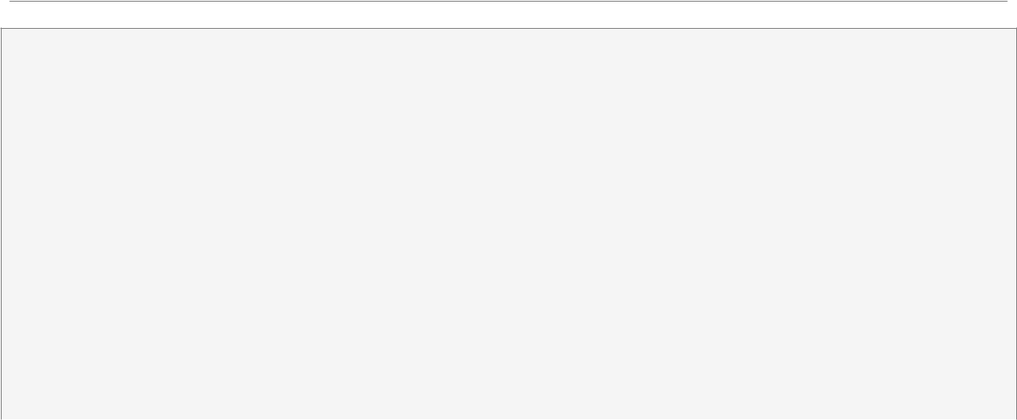

CREATE TABLE [dbo].[Exams]

(

[Exam_Id] [int] NOT NULL IDENTITY(1, 1),

[Exam_Name] [varchar] (50) COLLATE SQL_Latin1_General_CP1_CI_AS NULL,

[Exam_Duration] [varchar] (50) COLLATE SQL_Latin1_General_CP1_CI_AS NOT NULL,

[Course_Id] [int] NOT NULL

) ON [PRIMARY]

GO

ALTER TABLE [dbo].[Exams] ADD CONSTRAINT [PK_Exams] PRIMARY KEY CLUSTERED ([Exam_Id]) ON [PRIMARY]

GO

ALTER TABLE [dbo].[Exams] ADD CONSTRAINT [FK_Exams_Courses] FOREIGN KEY ([Course_Id])

REFERENCES [dbo].[Courses] ([Course_Id])

GO

Author: Mahmoud Copyright 2024 - All Rights Reserved Page 20 of 116

Project > (local)\SQLEXPRESS > User databases > Examination-SystemDB > Tables > dbo.Exams

**Uses**

[dbo].[Courses]

**Used By**

[dbo].[Exam_Questions]

[dbo].[Student_Answer_In_Exam]

[dbo].[DeleteExam]

[dbo].[DeleteQuestionFromExam]

[dbo].[Exam_Answers]

[dbo].[Exam_Correct]

[dbo].[Exam_Generation]

[dbo].[ExamQuestions_StudentAnswers_ModelAnswers]

[dbo].[getExamFromCrsID]

[dbo].[GetStudentAnswerAndModelAnswer]

[dbo].[InsertExam]

[dbo].[InsertQuestionInExam]

[dbo].[questionsAndChoicesFromExamID]

[dbo].[Report6_ExamQuestions_StudnetAnswers]

[dbo].[SelectExam]

[dbo].[SelectExamQuestion]

[dbo].[UpdateExam]

Author: Mahmoud Copyright 2024 - All Rights Reserved Page 21 of 116

Project > (local)\SQLEXPRESS > User databases > Examination-SystemDB > Tables > dbo.Instructors



 **[dbo].[Instructors]**

**Properties**



**Property**

Collation



Row Count (~)

Created



Last Modified

**Value**



SQL_Latin1_General_CP1_CI_AS



5

7:55:02 PM Tuesday, January 30, 2024



7:55:22 PM Tuesday, January 30, 2024

**Columns**

|  |  |  |  |  |  |
| --- | --- | --- | --- | --- | --- |
| **Key** | **Name** | **Data Type** | **Max Length (Bytes)** | **Nullability** | **Identity** |
|  |  |  |  |  |  |
|  | Instructor_Id | int | 4 | NOT NULL | 1 - 1 |
|  |  |  |  |  |  |
|  | Instructor_Name | varchar(50) | 50 | NULL allowed |  |
|  |  |  |  |  |  |
|  | Dept_Id | int | 4 | NULL allowed |  |
|  |  |  |  |  |  |



**Indexes**

**Key** **Name**

PK_Instructors

|  |  |
| --- | --- |
| **Key Columns** | **Unique** |
| Instructor_Id | True |
|  |  |



**Foreign Keys**

|  |  |
| --- | --- |
| **Name** | **Columns** |
|  |  |
| FK_Instructors_Departments | Dept_Id->[dbo].[Departments].[Department_ID] |
|  |  |



**SQL Script**



CREATE TABLE [dbo].[Instructors]

(

[Instructor_Id] [int] NOT NULL IDENTITY(1, 1),

[Instructor_Name] [varchar] (50) COLLATE SQL_Latin1_General_CP1_CI_AS NULL,

[Dept_Id] [int] NULL

) ON [PRIMARY]

GO

ALTER TABLE [dbo].[Instructors] ADD CONSTRAINT [PK_Instructors] PRIMARY KEY CLUSTERED ([Instructor_Id]) ON [PRIMARY]

GO

ALTER TABLE [dbo].[Instructors] ADD CONSTRAINT [FK_Instructors_Departments] FOREIGN KEY ([Dept_Id]) REFERENCES [dbo].[Departments] ([Department_ID])

GO

Author: Mahmoud Copyright 2024 - All Rights Reserved Page 22 of 116

Project > (local)\SQLEXPRESS > User databases > Examination-SystemDB > Tables > dbo.Instructors

**Uses**

[dbo].[Departments]

**Used By**

[dbo].[Courses_Instructor]

[dbo].[delete_Instructor]

[dbo].[GetCoursesTeachedByInstructor]

[dbo].[insert_Instructor]

[dbo].[select_Instructor]

[dbo].[update_Instructor]

Author: Mahmoud Copyright 2024 - All Rights Reserved Page 23 of 116

Project > (local)\SQLEXPRESS > User databases > Examination-SystemDB > Tables > dbo.Questions



 **[dbo].[Questions]**

**Properties**



**Property**

Collation



Row Count (~)

Created



Last Modified

**Value**



SQL_Latin1_General_CP1_CI_AS



71

11:08:59 PM Sunday, February 11, 2024



9:09:15 PM Wednesday, February 28, 2024

**Columns**

|  |  |  |  |  |  |
| --- | --- | --- | --- | --- | --- |
| **Key** | **Name** | **Data Type** | **Max Length (Bytes)** | **Nullability** | **Identity** |
|  |  |  |  |  |  |
|  | Question_Id | int | 4 | NOT NULL | 1 - 1 |
|  |  |  |  |  |  |
|  | Grade | int | 4 | NOT NULL |  |
|  |  |  |  |  |  |
|  | Content | varchar(400) | 400 | NOT NULL |  |
|  |  |  |  |  |  |
|  | Question_Type | varchar(100) | 100 | NOT NULL |  |
|  |  |  |  |  |  |
|  | Course_Id | int | 4 | NOT NULL |  |
|  |  |  |  |  |  |



**Indexes**

**Key** **Name**

PK_Questions

|  |  |
| --- | --- |
| **Key Columns** | **Unique** |
| Question_Id | True |
|  |  |



**Foreign Keys**

|  |  |  |
| --- | --- | --- |
| **Name** | **No Check** | **Columns** |
|  |  |  |
| FK_Questions_Courses | True | Course_Id->[dbo].[Courses].[Course_Id] |
|  |  |  |



**SQL Script**



CREATE TABLE [dbo].[Questions]

(

[Question_Id] [int] NOT NULL IDENTITY(1, 1),

[Grade] [int] NOT NULL,

[Content] [varchar] (400) COLLATE SQL_Latin1_General_CP1_CI_AS NOT NULL,

[Question_Type] [varchar] (100) COLLATE SQL_Latin1_General_CP1_CI_AS NOT NULL,

[Course_Id] [int] NOT NULL

) ON [PRIMARY]

GO

ALTER TABLE [dbo].[Questions] ADD CONSTRAINT [PK_Questions] PRIMARY KEY CLUSTERED ([Question_-Id]) ON [PRIMARY]

GO

ALTER TABLE [dbo].[Questions] WITH NOCHECK ADD CONSTRAINT [FK_Questions_Courses] FOREIGN KEY

Author: Mahmoud Copyright 2024 - All Rights Reserved Page 24 of 116

Project > (local)\SQLEXPRESS > User databases > Examination-SystemDB > Tables > dbo.Questions

([Course_Id]) REFERENCES [dbo].[Courses] ([Course_Id])



GO

**Uses**

[dbo].[Courses]

**Used By**

[dbo].[Answers]

[dbo].[Choices]

[dbo].[Exam_Questions]

[dbo].[Student_Answer_In_Exam]

[dbo].[DeleteQuestion]

[dbo].[Exam_Correct]

[dbo].[Exam_Generation]

[dbo].[ExamQuestions_StudentAnswers_ModelAnswers]

[dbo].[GetStudentAnswerAndModelAnswer]

[dbo].[InsertQuestion]

[dbo].[questionsAndChoicesFromExamID]

[dbo].[Report6_ExamQuestions_StudnetAnswers]

[dbo].[SelectChoices]

[dbo].[SelectExamQuestion]

[dbo].[SelectQuestion]

[dbo].[UpdateQuestion]

Author: Mahmoud Copyright 2024 - All Rights Reserved Page 25 of 116

Project > (local)\SQLEXPRESS > User databases > Examination-SystemDB > Tables > dbo.Student_Answer_In_Exam



 **[dbo].[Student_Answer_In_Exam]**

**Properties**



**Property**

Collation



Row Count (~)

Created



Last Modified

**Value**



SQL_Latin1_General_CP1_CI_AS



95

11:09:25 PM Sunday, February 11, 2024



11:09:25 PM Sunday, February 11, 2024

**Columns**

|  |  |  |  |  |
| --- | --- | --- | --- | --- |
| **Key** | **Name** | **Data Type** | **Max Length (Bytes)** | **Nullability** |
|  |  |  |  |  |
|  | Student_Id | int | 4 | NOT NULL |
|  |  |  |  |  |
|  | Exam_Id | int | 4 | NOT NULL |
|  |  |  |  |  |
|  | Question_Id | int | 4 | NOT NULL |
|  |  |  |  |  |
|  | Student_Answer | varchar(200) | 200 | NOT NULL |
|  |  |  |  |  |



**Indexes**

|  |  |  |  |
| --- | --- | --- | --- |
| **Key** | **Name** | **Key Columns** | **Unique** |
|  |  |  |  |
|  | PK_Student_Answer_In_Exam | Student_Id, Question_Id | True |
|  |  |  |  |



**Foreign Keys**

|  |  |  |
| --- | --- | --- |
| **Name** | **Delete** | **Columns** |
|  |  |  |
| FK_Student_Answer_In_Exam_Exams | Cascade | Exam_Id->[dbo].[Exams].[Exam_Id] |
|  |  |  |
| FK_Student_Answer_In_Exam_Questions |  | Question_Id->[dbo].[Questions].[Question_Id] |
|  |  |  |
| FK_Student_Answer_In_Exam_Students |  | Student_Id->[dbo].[Students].[Student_Id] |
|  |  |  |



**SQL Script**



CREATE TABLE [dbo].[Student_Answer_In_Exam]

(

[Student_Id] [int] NOT NULL,

[Exam_Id] [int] NOT NULL,

[Question_Id] [int] NOT NULL,

[Student_Answer] [varchar] (200) COLLATE SQL_Latin1_General_CP1_CI_AS NOT NULL

) ON [PRIMARY]

GO

ALTER TABLE [dbo].[Student_Answer_In_Exam] ADD CONSTRAINT [PK_Student_Answer_In_Exam] PRIMARY KEY CLUSTERED ([Student_Id], [Question_Id]) ON [PRIMARY]

GO

ALTER TABLE [dbo].[Student_Answer_In_Exam] ADD CONSTRAINT [FK_Student_Answer_In_Exam_Exams]

Author: Mahmoud Copyright 2024 - All Rights Reserved Page 26 of 116

Project > (local)\SQLEXPRESS > User databases > Examination-SystemDB > Tables > dbo.Student_Answer_In_Exam

FOREIGN KEY ([Exam_Id]) REFERENCES [dbo].[Exams] ([Exam_Id]) ON DELETE CASCADE GO



ALTER TABLE [dbo].[Student_Answer_In_Exam] ADD CONSTRAINT [FK_Student_Answer_In_Exam_-Questions] FOREIGN KEY ([Question_Id]) REFERENCES [dbo].[Questions] ([Question_Id])

GO

ALTER TABLE [dbo].[Student_Answer_In_Exam] ADD CONSTRAINT [FK_Student_Answer_In_Exam_Students] FOREIGN KEY ([Student_Id]) REFERENCES [dbo].[Students] ([Student_Id])

GO

**Uses**

[dbo].[Exams]

[dbo].[Questions]

[dbo].[Students]

**Used By**

[dbo].[DeleteStudentAnswerOfQuestionInExam]

[dbo].[Exam_Correct]

[dbo].[ExamQuestions_StudentAnswers_ModelAnswers]

[dbo].[getExamFromCrsID]

[dbo].[GetStudentAnswerAndModelAnswer]

[dbo].[InsertStudentAnswerOfQuestionInExam]

[dbo].[Report6_ExamQuestions_StudnetAnswers]

[dbo].[SelectStudentAnswerOfQuestionInExam]

[dbo].[UpdateStudentAnswerOfQuestionInExam]

Author: Mahmoud Copyright 2024 - All Rights Reserved Page 27 of 116

Project > (local)\SQLEXPRESS > User databases > Examination-SystemDB > Tables > dbo.Student_Courses



 **[dbo].[Student_Courses]**

**Properties**



**Property**

Row Count (~)



Created

Last Modified

**Value**



16



2:20:56 PM Thursday, January 25, 2024

10:30:47 PM Monday, February 12, 2024

**Columns**

|  |  |  |  |  |
| --- | --- | --- | --- | --- |
| **Key** | **Name** | **Data Type** | **Max Length (Bytes)** | **Nullability** |
|  |  |  |  |  |
|  | Student_Id | int | 4 | NOT NULL |
|  |  |  |  |  |
|  | Course_Id | int | 4 | NOT NULL |
|  |  |  |  |  |
|  | StudentGrade | decimal(18,2) | 9 | NULL allowed |
|  |  |  |  |  |



**Indexes**

|  |  |  |  |
| --- | --- | --- | --- |
| **Key** | **Name** | **Key Columns** | **Unique** |
|  |  |  |  |
|  | PK_Student_Courses | Student_Id, Course_Id | True |
|  |  |  |  |



**Foreign Keys**

|  |  |
| --- | --- |
| **Name** | **Columns** |
|  |  |
| FK_Student_Courses_Courses | Course_Id->[dbo].[Courses].[Course_Id] |
|  |  |
| FK_Student_Courses_Students | Student_Id->[dbo].[Students].[Student_Id] |
|  |  |



**SQL Script**



CREATE TABLE [dbo].[Student_Courses]

(

[Student_Id] [int] NOT NULL,

[Course_Id] [int] NOT NULL,

[StudentGrade] [decimal] (18, 2) NULL

) ON [PRIMARY]

GO

ALTER TABLE [dbo].[Student_Courses] ADD CONSTRAINT [PK_Student_Courses] PRIMARY KEY CLUSTERED ([Student_Id], [Course_Id]) ON [PRIMARY]

GO

ALTER TABLE [dbo].[Student_Courses] ADD CONSTRAINT [FK_Student_Courses_Courses] FOREIGN KEY ([Course_Id]) REFERENCES [dbo].[Courses] ([Course_Id])

GO

ALTER TABLE [dbo].[Student_Courses] ADD CONSTRAINT [FK_Student_Courses_Students] FOREIGN KEY ([Student_Id]) REFERENCES [dbo].[Students] ([Student_Id])

GO

Author: Mahmoud Copyright 2024 - All Rights Reserved Page 28 of 116

Project > (local)\SQLEXPRESS > User databases > Examination-SystemDB > Tables > dbo.Student_Courses



**Uses**

[dbo].[Courses]

[dbo].[Students]

**Used By**

[dbo].[DeleteStudentCourse]

[dbo].[Exam_Answers]

[dbo].[Exam_Correct]

[dbo].[GetCoursesTeachedByInstructor]

[dbo].[getExamFromCrsID]

[dbo].[GetStudentAnswerAndModelAnswer]

[dbo].[GetStudentGradeInAllCourses]

[dbo].[InsertStudentCourse]

[dbo].[SelectStudentCourse]

[dbo].[UpdateStudentCourse]

Author: Mahmoud Copyright 2024 - All Rights Reserved Page 29 of 116

Project > (local)\SQLEXPRESS > User databases > Examination-SystemDB > Tables > dbo.Students



 **[dbo].[Students]**

**Properties**



**Property**

Collation



Row Count (~)

Created



Last Modified

**Value**



SQL_Latin1_General_CP1_CI_AS



8

7:53:48 PM Tuesday, January 30, 2024



11:09:25 PM Sunday, February 11, 2024

**Columns**

|  |  |  |  |  |  |
| --- | --- | --- | --- | --- | --- |
| **Key** | **Name** | **Data Type** | **Max Length (Bytes)** | **Nullability** | **Identity** |
|  |  |  |  |  |  |
|  | Student_Id | int | 4 | NOT NULL | 1 - 1 |
|  |  |  |  |  |  |
|  | Fname | varchar(10) | 10 | NULL allowed |  |
|  |  |  |  |  |  |
|  | LName | varchar(10) | 10 | NULL allowed |  |
|  |  |  |  |  |  |
|  | Age | int | 4 | NULL allowed |  |
|  |  |  |  |  |  |
|  | Email | varchar(50) | 50 | NULL allowed |  |
|  |  |  |  |  |  |
|  | Dept_Id | int | 4 | NULL allowed |  |
|  |  |  |  |  |  |



**Indexes**

**Key** **Name**

PK_Students

|  |  |
| --- | --- |
| **Key Columns** | **Unique** |
| Student_Id | True |
|  |  |



**Foreign Keys**

|  |  |
| --- | --- |
| **Name** | **Columns** |
|  |  |
| FK_Students_Departments | Dept_Id->[dbo].[Departments].[Department_ID] |
|  |  |



**SQL Script**



CREATE TABLE [dbo].[Students]

(

[Student_Id] [int] NOT NULL IDENTITY(1, 1),

[Fname] [varchar] (10) COLLATE SQL_Latin1_General_CP1_CI_AS NULL,

[LName] [varchar] (10) COLLATE SQL_Latin1_General_CP1_CI_AS NULL,

[Age] [int] NULL,

[Email] [varchar] (50) COLLATE SQL_Latin1_General_CP1_CI_AS NULL,

[Dept_Id] [int] NULL

) ON [PRIMARY]

GO

ALTER TABLE [dbo].[Students] ADD CONSTRAINT [PK_Students] PRIMARY KEY CLUSTERED ([Student_Id]) ON [PRIMARY]

Author: Mahmoud Copyright 2024 - All Rights Reserved Page 30 of 116

Project > (local)\SQLEXPRESS > User databases > Examination-SystemDB > Tables > dbo.Students

GO

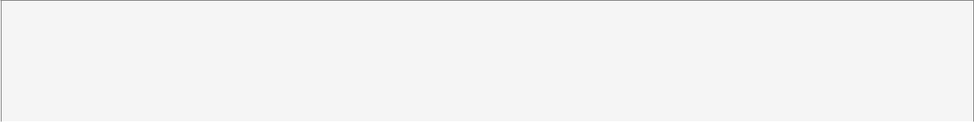

ALTER TABLE [dbo].[Students] ADD CONSTRAINT [FK_Students_Departments] FOREIGN KEY ([Dept_Id])

REFERENCES [dbo].[Departments] ([Department_ID])

GO

**Uses**

[dbo].[Departments]

**Used By**

[dbo].[Student_Answer_In_Exam]

[dbo].[Student_Courses]

[dbo].[DeleteStudent]

[dbo].[Exam_Answers]

[dbo].[Exam_Correct]

[dbo].[ExamQuestions_StudentAnswers_ModelAnswers]

[dbo].[GetStudentsInDepartment]

[dbo].[InsertStudent]

[dbo].[Report6_ExamQuestions_StudnetAnswers]

[dbo].[SelectStudent]

[dbo].[UpdateStudent]

Author: Mahmoud Copyright 2024 - All Rights Reserved Page 31 of 116

Project > (local)\SQLEXPRESS > User databases > Examination-SystemDB > Tables > dbo.Topic



 **[dbo].[Topic]**

**Properties**



**Property**

Collation



Row Count (~)

Created



Last Modified

**Value**



SQL_Latin1_General_CP1_CI_AS



6

7:54:18 PM Tuesday, January 30, 2024



9:52:37 PM Saturday, February 3, 2024

**Columns**

|  |  |  |  |  |  |
| --- | --- | --- | --- | --- | --- |
| **Key** | **Name** | **Data Type** | **Max Length (Bytes)** | **Nullability** | **Identity** |
|  |  |  |  |  |  |
|  | Topic_Id | int | 4 | NOT NULL | 1 - 1 |
|  |  |  |  |  |  |
|  | Course_Id | int | 4 | NOT NULL |  |
|  |  |  |  |  |  |
|  | Topic_Name | varchar(50) | 50 | NULL allowed |  |
|  |  |  |  |  |  |



**Indexes**

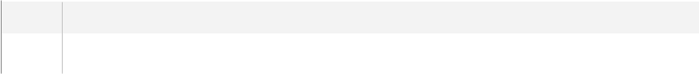

**Key** **Name**

PK_Topic



|  |  |
| --- | --- |
| **Key Columns** | **Unique** |
| Topic_Id, Course_Id | True |
|  |  |



**Foreign Keys**

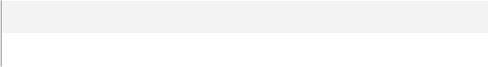

**Name**

FK_Topic_Courses

**Columns**



Course_Id->[dbo].[Courses].[Course_Id]

**SQL Script**



CREATE TABLE [dbo].[Topic]

(

[Topic_Id] [int] NOT NULL IDENTITY(1, 1),

[Course_Id] [int] NOT NULL,

[Topic_Name] [varchar] (50) COLLATE SQL_Latin1_General_CP1_CI_AS NULL

) ON [PRIMARY]

GO

ALTER TABLE [dbo].[Topic] ADD CONSTRAINT [PK_Topic] PRIMARY KEY CLUSTERED ([Topic_Id], [Course_Id]) ON [PRIMARY]

GO

ALTER TABLE [dbo].[Topic] ADD CONSTRAINT [FK_Topic_Courses] FOREIGN KEY ([Course_Id])

REFERENCES [dbo].[Courses] ([Course_Id])

GO

Author: Mahmoud Copyright 2024 - All Rights Reserved Page 32 of 116

Project > (local)\SQLEXPRESS > User databases > Examination-SystemDB > Tables > dbo.Topic

**Uses**

[dbo].[Courses]

**Used By**

[dbo].[delete_Topic]

[dbo].[GetTopicsOfCourse]

[dbo].[insert_Topic]

[dbo].[select_Topic]

[dbo].[update_Topic]

Author: Mahmoud Copyright 2024 - All Rights Reserved Page 33 of 116

Project > (local)\SQLEXPRESS > User databases > Examination-SystemDB > Programmability > Stored Procedures



 ***Stored Procedures***

**Objects**



**Name**

dbo.delete_Course



dbo.delete_CourseInstructor

dbo.delete_CourseInstructor2



dbo.delete_Instructor

dbo.delete_Topic



dbo.DeleteAllChoicesForQuestion

dbo.DeleteAnswersForQuestion



dbo.DeleteChoiceForQuestion

dbo.DeleteDepartment



dbo.DeleteExam

dbo.DeleteQuestion



dbo.DeleteQuestionFromExam

dbo.DeleteStudent



dbo.DeleteStudentAnswerOfQuestionInExam

dbo.DeleteStudentCourse



dbo.Exam_Answers

dbo.Exam_Correct



dbo.Exam_Generation

dbo.ExamQuestions_StudentAnswers_ModelAnswers



dbo.GetCoursesTeachedByInstructor

dbo.getExamFromCrsID



dbo.GetStudentAnswerAndModelAnswer

dbo.GetStudentGradeInAllCourses



dbo.GetStudentsInDepartment

dbo.GetTopicsOfCourse



dbo.insert_Course

dbo.insert_CourseInstructor



dbo.insert_Instructor

dbo.insert_Topic



dbo.InsertAnswerForQuestion

dbo.InsertChoiceForQuestion



dbo.InsertDepartment

dbo.InsertExam



dbo.InsertQuestion

dbo.InsertQuestionInExam



dbo.InsertStudent

dbo.InsertStudentAnswerOfQuestionInExam

Author: Mahmoud Copyright 2024 - All Rights Reserved Page 34 of 116

Project > (local)\SQLEXPRESS > User databases > Examination-SystemDB > Programmability > Stored Procedures



dbo.InsertStudentCourse

dbo.questionsAndChoicesFromExamID



dbo.Report6_ExamQuestions_StudnetAnswers

dbo.select_Course



dbo.select_CourseInstructor

dbo.select_CourseInstructor2



dbo.select_Instructor

dbo.select_Topic



dbo.SelectAnswerForQuestion

dbo.SelectChoices



dbo.SelectDepartment

dbo.SelectExam



dbo.SelectExamQuestion

dbo.SelectQuestion



dbo.SelectStudent

dbo.SelectStudentAnswerOfQuestionInExam



dbo.SelectStudentCourse

dbo.update_Course



dbo.update_CourseInstructor

dbo.update_CourseInstructor2



dbo.update_Instructor

dbo.update_Topic



dbo.UpdateAnswerForQuestion

dbo.UpdateChoiceForQuestion



dbo.UpdateDepartment

dbo.UpdateExam



dbo.UpdateQuestion

dbo.UpdateQuestionInExam



dbo.UpdateStudent

dbo.UpdateStudentAnswerOfQuestionInExam



dbo.UpdateStudentCourse

Author: Mahmoud Copyright 2024 - All Rights Reserved Page 35 of 116

Project > (local)\SQLEXPRESS > User databases > Examination-SystemDB > Programmability > Stored Procedures > dbo.delete_-Course



 **[dbo].[delete_Course]**

**Properties**

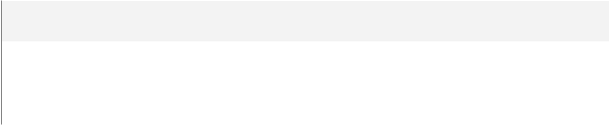

**Property**

ANSI Nulls On



Quoted Identifier On

**Value**

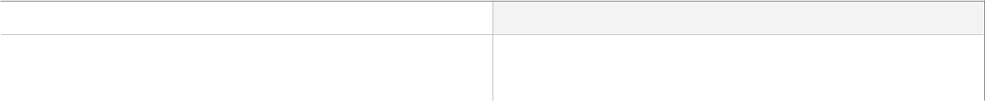

True



True

**Parameters**

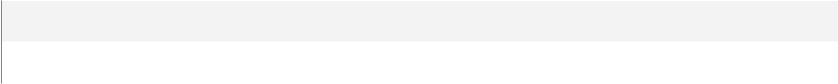

**Name**

@Course_ID

|  |  |
| --- | --- |
| **Data Type** | **Max Length (Bytes)** |
| int | 4 |
|  |  |



**SQL Script**



create proc [dbo].[delete_Course] @Course_ID int as

delete from Courses

where Course_Id = @Course_ID

GO

**Uses**

[dbo].[Courses]

Author: Mahmoud Copyright 2024 - All Rights Reserved Page 36 of 116

Project > (local)\SQLEXPRESS > User databases > Examination-SystemDB > Programmability > Stored Procedures > dbo.delete_-CourseInstructor



 **[dbo].[delete_CourseInstructor]**

**Properties**



**Property**

ANSI Nulls On



Quoted Identifier On

**Value**



True



True

**Parameters**



**Name**

@Course_ID

|  |  |
| --- | --- |
| **Data Type** | **Max Length (Bytes)** |
| int | 4 |
|  |  |



**SQL Script**



create proc [dbo].[delete_CourseInstructor] @Course_ID int as

delete from Courses_Instructor

where Course_Id = @Course_ID

GO

**Uses**

[dbo].[Courses_Instructor]

Author: Mahmoud Copyright 2024 - All Rights Reserved Page 37 of 116

Project > (local)\SQLEXPRESS > User databases > Examination-SystemDB > Programmability > Stored Procedures > dbo.delete_-CourseInstructor2



 **[dbo].[delete_CourseInstructor2]**

**Properties**



**Property**

ANSI Nulls On



Quoted Identifier On

**Value**



True



True

**Parameters**



**Name**

@Instructor_ID

|  |  |
| --- | --- |
| **Data Type** | **Max Length (Bytes)** |
| int | 4 |
|  |  |



**SQL Script**



create proc [dbo].[delete_CourseInstructor2] @Instructor_ID int as

delete from Courses_Instructor

where Ins_Id = @Instructor_ID

GO

**Uses**

[dbo].[Courses_Instructor]

Author: Mahmoud Copyright 2024 - All Rights Reserved Page 38 of 116

Project > (local)\SQLEXPRESS > User databases > Examination-SystemDB > Programmability > Stored Procedures > dbo.delete_-Instructor



 **[dbo].[delete_Instructor]**

**Properties**



**Property**

ANSI Nulls On



Quoted Identifier On

**Value**



True



True

**Parameters**



**Name**

@InstructorID

|  |  |
| --- | --- |
| **Data Type** | **Max Length (Bytes)** |
| int | 4 |
|  |  |



**SQL Script**



--4 delete by instructor_ID

create proc [dbo].[delete_Instructor] @InstructorID int as

delete from Instructors

where Instructor_Id = @InstructorID

GO

**Uses**

[dbo].[Instructors]

Author: Mahmoud Copyright 2024 - All Rights Reserved Page 39 of 116

Project > (local)\SQLEXPRESS > User databases > Examination-SystemDB > Programmability > Stored Procedures > dbo.delete_-Topic



 **[dbo].[delete_Topic]**

**Properties**



**Property**

ANSI Nulls On



Quoted Identifier On

**Value**



True



True

**Parameters**



**Name**

@TopicID

|  |  |
| --- | --- |
| **Data Type** | **Max Length (Bytes)** |
| int | 4 |
|  |  |



**SQL Script**



create proc [dbo].[delete_Topic] @TopicID int

as

delete from Topic

where Topic_Id = @TopicID

GO

**Uses**

[dbo].[Topic]

Author: Mahmoud Copyright 2024 - All Rights Reserved Page 40 of 116

Project > (local)\SQLEXPRESS > User databases > Examination-SystemDB > Programmability > Stored Procedures > dbo.DeleteAll-ChoicesForQuestion



 **[dbo].[DeleteAllChoicesForQuestion]**

**Properties**



**Property**

ANSI Nulls On



Quoted Identifier On

**Value**



True



True

**Parameters**



**Name**

@Quest_id

|  |  |
| --- | --- |
| **Data Type** | **Max Length (Bytes)** |
| int | 4 |
|  |  |



**SQL Script**



create proc [dbo].[DeleteAllChoicesForQuestion] @Quest_id int as

delete from Choices

where Question_Id = @Quest_id

GO

**Uses**

[dbo].[Choices]

Author: Mahmoud Copyright 2024 - All Rights Reserved Page 41 of 116

Project > (local)\SQLEXPRESS > User databases > Examination-SystemDB > Programmability > Stored Procedures > dbo.Delete-AnswersForQuestion



 **[dbo].[DeleteAnswersForQuestion]**

**Properties**



**Property**

ANSI Nulls On



Quoted Identifier On

**Value**



True



True

**Parameters**



**Name**

@Quest_id

|  |  |
| --- | --- |
| **Data Type** | **Max Length (Bytes)** |
| int | 4 |
|  |  |



**SQL Script**



create proc [dbo].[DeleteAnswersForQuestion] @Quest_id int as

delete from Answers

where Question_Id = @Quest_id

GO

**Uses**

[dbo].[Answers]

Author: Mahmoud Copyright 2024 - All Rights Reserved Page 42 of 116

Project > (local)\SQLEXPRESS > User databases > Examination-SystemDB > Programmability > Stored Procedures > dbo.Delete-ChoiceForQuestion



 **[dbo].[DeleteChoiceForQuestion]**

**Properties**



**Property**

ANSI Nulls On



Quoted Identifier On

**Value**



True



True

**Parameters**

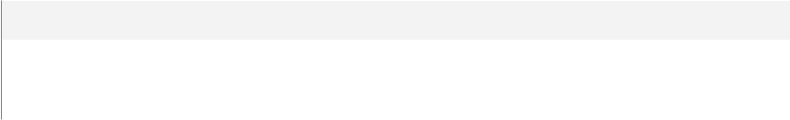

**Name**

@Quest_id



@choice_id

|  |  |
| --- | --- |
| **Data Type** | **Max Length (Bytes)** |
| int | 4 |
| varchar(50) | 50 |
|  |  |

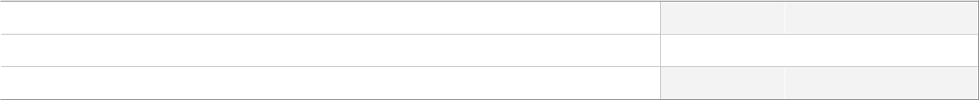

**SQL Script**



CREATE proc [dbo].[DeleteChoiceForQuestion] @Quest_id int , @choice_id varchar(50) as

delete from Choices

where Question_Id = @Quest_id and Choice_Number = @choice_id

GO

**Uses**

[dbo].[Choices]

Author: Mahmoud Copyright 2024 - All Rights Reserved Page 43 of 116

Project > (local)\SQLEXPRESS > User databases > Examination-SystemDB > Programmability > Stored Procedures > dbo.Delete-Department



 **[dbo].[DeleteDepartment]**

**Properties**



**Property**

ANSI Nulls On



Quoted Identifier On

**Value**



True



True

**Parameters**



**Name**

@DepartmentID

|  |  |
| --- | --- |
| **Data Type** | **Max Length (Bytes)** |
| int | 4 |
|  |  |



**SQL Script**



CREATE PROC [dbo].[DeleteDepartment]

@DepartmentID INT

AS

BEGIN

DELETE FROM Departments WHERE Department_ID = @DepartmentID;

END;

GO

**Uses**

[dbo].[Departments]

Author: Mahmoud Copyright 2024 - All Rights Reserved Page 44 of 116

Project > (local)\SQLEXPRESS > User databases > Examination-SystemDB > Programmability > Stored Procedures > dbo.Delete-Exam



 **[dbo].[DeleteExam]**

**Properties**



**Property**

ANSI Nulls On



Quoted Identifier On

**Value**



True



True

**Parameters**



**Name**

@Exam_id

|  |  |
| --- | --- |
| **Data Type** | **Max Length (Bytes)** |
| int | 4 |
|  |  |



**SQL Script**



create proc [dbo].[DeleteExam] @Exam_id int

as

delete from Exams

where Exam_Id = @Exam_id

GO

**Uses**

[dbo].[Exams]

Author: Mahmoud Copyright 2024 - All Rights Reserved Page 45 of 116

Project > (local)\SQLEXPRESS > User databases > Examination-SystemDB > Programmability > Stored Procedures > dbo.Delete-Question



 **[dbo].[DeleteQuestion]**

**Properties**



**Property**

ANSI Nulls On



Quoted Identifier On

**Value**



True



True

**Parameters**



**Name**

@id

|  |  |
| --- | --- |
| **Data Type** | **Max Length (Bytes)** |
| int | 4 |
|  |  |



**SQL Script**



create proc [dbo].[DeleteQuestion] @id int

as

delete from Questions

where Question_Id = @id

GO

**Uses**

[dbo].[Questions]

Author: Mahmoud Copyright 2024 - All Rights Reserved Page 46 of 116

Project > (local)\SQLEXPRESS > User databases > Examination-SystemDB > Programmability > Stored Procedures > dbo.Delete-QuestionFromExam



 **[dbo].[DeleteQuestionFromExam]**

**Properties**



**Property**

ANSI Nulls On



Quoted Identifier On

**Value**



True



True

**Parameters**



**Name**

@Quest_id



@Exam_name

|  |  |
| --- | --- |
| **Data Type** | **Max Length (Bytes)** |
| int | 4 |
| varchar(50) | 50 |
|  |  |



**SQL Script**



CREATE proc [dbo].[DeleteQuestionFromExam] @Quest_id int ,@Exam_name varchar(50) as

delete eq

from Exams e , Exam_Questions eq

where e.Exam_Id=eq.Exam_ID and e.Exam_Name = @Exam_name

GO

**Uses**

[dbo].[Exam_Questions]

[dbo].[Exams]

Author: Mahmoud Copyright 2024 - All Rights Reserved Page 47 of 116

Project > (local)\SQLEXPRESS > User databases > Examination-SystemDB > Programmability > Stored Procedures > dbo.Delete-Student



 **[dbo].[DeleteStudent]**

**Properties**



**Property**

ANSI Nulls On



Quoted Identifier On

**Value**



True



True

**Parameters**



**Name**

@StudentID

|  |  |
| --- | --- |
| **Data Type** | **Max Length (Bytes)** |
| int | 4 |
|  |  |



**SQL Script**



CREATE PROC [dbo].[DeleteStudent]

@StudentID INT

AS

BEGIN

DELETE FROM Students WHERE Student_Id = @StudentID;

END;

GO

**Uses**

[dbo].[Students]

Author: Mahmoud Copyright 2024 - All Rights Reserved Page 48 of 116

Project > (local)\SQLEXPRESS > User databases > Examination-SystemDB > Programmability > Stored Procedures > dbo.Delete-StudentAnswerOfQuestionInExam



 **[dbo].[DeleteStudentAnswerOfQuestionInExam]**

**Properties**



**Property**

ANSI Nulls On



Quoted Identifier On

**Value**



True



True

**Parameters**

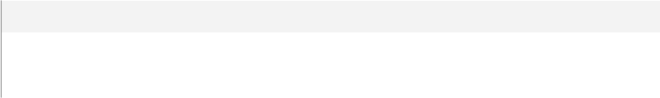

**Name**

@stud_Id



@Quest_Id

|  |  |
| --- | --- |
| **Data Type** | **Max Length (Bytes)** |
| int | 4 |
| int | 4 |
|  |  |

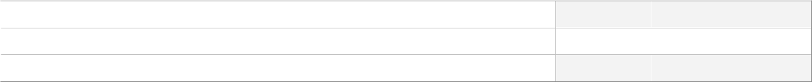

**SQL Script**



create proc [dbo].[DeleteStudentAnswerOfQuestionInExam] @stud_Id int , @Quest_Id int as

delete from Student_Answer_In_Exam

where Student_Id = @stud_Id and Question_Id = @Quest_Id

GO

**Uses**

[dbo].[Student_Answer_In_Exam]

Author: Mahmoud Copyright 2024 - All Rights Reserved Page 49 of 116

Project > (local)\SQLEXPRESS > User databases > Examination-SystemDB > Programmability > Stored Procedures > dbo.Delete-StudentCourse



 **[dbo].[DeleteStudentCourse]**

**Properties**



**Property**

ANSI Nulls On



Quoted Identifier On

**Value**



True



True

**Parameters**



**Name**

@StudentID



@CourseID

|  |  |
| --- | --- |
| **Data Type** | **Max Length (Bytes)** |
| int | 4 |
| int | 4 |
|  |  |



**SQL Script**



CREATE PROC [dbo].[DeleteStudentCourse]

@StudentID INT,

@CourseID INT

AS

BEGIN

DELETE FROM Student_Courses

WHERE Student_Id = @StudentID AND Course_Id = @CourseID;

END;

GO

**Uses**

[dbo].[Student_Courses]

Author: Mahmoud Copyright 2024 - All Rights Reserved Page 50 of 116

Project > (local)\SQLEXPRESS > User databases > Examination-SystemDB > Programmability > Stored Procedures > dbo.Exam_-Answers



 **[dbo].[Exam_Answers]**

**Properties**



**Property**

ANSI Nulls On



Quoted Identifier On

**Value**



True



True

**Parameters**

**Name**

@exam_id

@std_Id

@Ans_1

@Ans_2

@Ans_3

@Ans_4

@Ans_5

@Ans_6

@Ans_7

@Ans_8

@Ans_9

@Ans_10

|  |  |
| --- | --- |
| **Data Type** | **Max Length (Bytes)** |
| int | 4 |
| int | 4 |
| varchar(50) | 50 |
| varchar(50) | 50 |
| varchar(50) | 50 |
| varchar(50) | 50 |
| varchar(50) | 50 |
| varchar(50) | 50 |
| varchar(50) | 50 |
| varchar(50) | 50 |
| varchar(50) | 50 |
| varchar(50) | 50 |
|  |  |

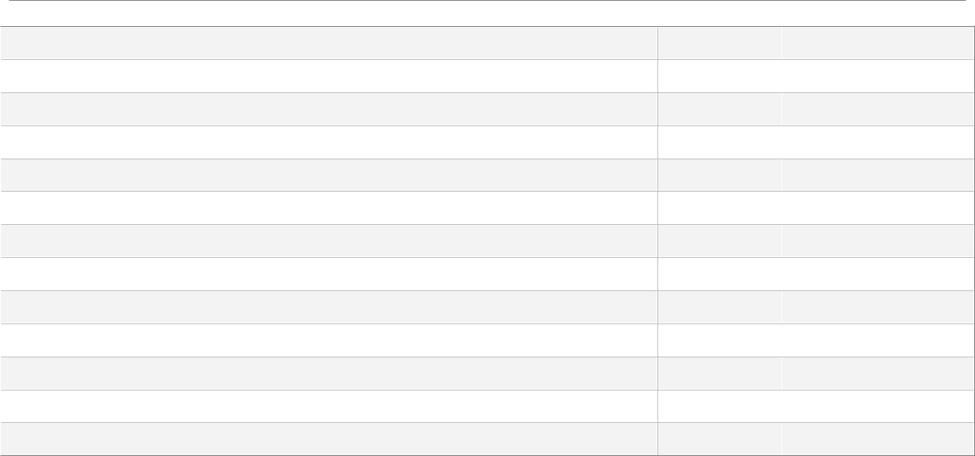

**SQL Script**



CREATE proc [dbo].[Exam_Answers] @exam_id int /* 2 */ , @std_Id int /*1 */ , @Ans_1 varchar(50),@Ans_2 varchar(50)

,@Ans_3 varchar(50),@Ans_4 varchar(50),@Ans_5 varchar(50),@Ans_6

varchar(50),

@Ans_7 varchar(50),@Ans_8 varchar(50),@Ans_9 varchar(50),@Ans_10

varchar(50)

as

if not exists(select Exams.Exam_Id From Exams where Exams.Exam_Id = @exam_id) begin

RAISERROR('Invalid Exam ID', 16, 1);

return;

end

if not exists(select Students.Student_Id From Students where Students.Student_Id = @std_Id)

begin

RAISERROR('Invalid Student ID', 16, 1);

return;

end

Author: Mahmoud Copyright 2024 - All Rights Reserved Page 51 of 116

Project > (local)\SQLEXPRESS > User databases > Examination-

SystemDB > Programmability > Stored Procedures > dbo.Exam_-

Answers

Declare @CourseID int;



Select @CourseID = Exams.Course_Id From Exams where Exams.Exam_Id = @exam_id

if exists (

Select Student_Courses.Student_Id

From Student_Courses

Where Student_Id= @std_Id and Course_Id = @CourseID and StudentGrade IS NOT NULL)

begin

RAISERROR('Student Has already took this exam!', 16, 1); return;

end

declare @indx int =0 , @Quest_id int

while @indx <10

begin

set @indx +=1

select @Quest_id=Question_Id from(

select * , ROW_NUMBER() over (partition by Exam_ID order by Question_Id) as RN

from Exam_Questions

where Exam_ID = @exam_id

) as Newtable Where RN =@indx

declare @Answer varchar(50) = CASE @indx

WHEN 1 THEN @Ans_1

WHEN 2 THEN @Ans_2

WHEN 3 THEN @Ans_3

WHEN 4 THEN @Ans_4

WHEN 5 THEN @Ans_5

WHEN 6 THEN @Ans_6

WHEN 7 THEN @Ans_7

WHEN 8 THEN @Ans_8

WHEN 9 THEN @Ans_9

WHEN 10 THEN @Ans_10

END

exec InsertStudentAnswerOfQuestionInExam @std_Id,@Quest_id,@exam_id,@Answer

end

GO

**Uses**

[dbo].[Exam_Questions]

[dbo].[Exams]

[dbo].[Student_Courses]

[dbo].[Students]

[dbo].[InsertStudentAnswerOfQuestionInExam]

Author: Mahmoud Copyright 2024 - All Rights Reserved Page 52 of 116

Project > (local)\SQLEXPRESS > User databases > Examination-SystemDB > Programmability > Stored Procedures > dbo.Exam_-Correct



 **[dbo].[Exam_Correct]**

**Properties**



**Property**

ANSI Nulls On



Quoted Identifier On

**Value**



True



True

**Parameters**



**Name**

@ExamID



@StudentID

|  |  |
| --- | --- |
| **Data Type** | **Max Length (Bytes)** |
| int | 4 |
| int | 4 |
|  |  |



**SQL Script**



CREATE PROC [dbo].[Exam_Correct] @ExamID int, @StudentID int AS

if not exists(select Exams.Exam_Id From Exams where Exams.Exam_Id = @ExamID) begin

RAISERROR('Invalid Exam ID', 16, 1);

return;

end

if not exists(select Students.Student_Id From Students where Students.Student_Id = @StudentID)

begin

RAISERROR('Invalid Student ID', 16, 1);

return;

end

Declare @StudentGrade decimal(18,2) = 0;

Declare @totalGrade int = 0;

DECLARE @SavedResult TABLE (

Question_Id INT,

Student_Answer VARCHAR(255),

Answer_Value VARCHAR(255),

Grade INT

);

INSERT INTO @SavedResult (Question_Id, Student_Answer, Answer_Value, Grade) SELECT Student_Answer_In_Exam.Question_Id, Student_Answer_In_Exam.Student_Answer,

Answers.Value, Questions.Grade

FROM Student_Answer_In_Exam, Questions, Answers

Author: Mahmoud Copyright 2024 - All Rights Reserved Page 53 of 116

Project > (local)\SQLEXPRESS > User databases > Examination-

SystemDB > Programmability > Stored Procedures > dbo.Exam_-

Correct

WHERE Student_Answer_In_Exam.Question_Id = Questions.Question_Id



AND Answers.Question_Id = Questions.Question_Id

AND Student_Id = @StudentID

AND Exam_Id = @ExamID;

Declare @tableRows int;

Select @tableRows = count(*) From @SavedResult;

if ( @tableRows = 0 )

begin

RAISERROR('This student did not take this exam!', 16, 1); return;

end

DECLARE @Student_Answer VARCHAR(255);

DECLARE @Answer_Value VARCHAR(255);

DECLARE @Grade INT;

DECLARE cursor_saved_result CURSOR FOR

SELECT Student_Answer, Answer_Value, Grade

FROM @SavedResult;

OPEN cursor_saved_result;

FETCH NEXT FROM cursor_saved_result INTO @Student_Answer, @Answer_Value, @Grade;

WHILE @@FETCH_STATUS = 0

BEGIN

set @totalGrade += @Grade;

if (@Student_Answer = @Answer_Value)

Set @StudentGrade += @Grade;

FETCH cursor_saved_result INTO @Student_Answer, @Answer_Value, @Grade;

END

CLOSE cursor_saved_result;

DEALLOCATE cursor_saved_result;

set @StudentGrade = (@StudentGrade / @totalGrade) * 100;

Declare @CourseID int;

Select @CourseID = Exams.Course_Id

From Exams

Where Exams.Exam_Id = @ExamID

declare @old_grade decimal(18,2)

select @old_grade = StudentGrade

From Student_Courses

Where Student_Id = @StudentID and @CourseID = Course_Id

if (@old_grade is NULL)

exec UpdateStudentCourse @StudentID, @CourseID, @StudentGrade

else

exec InsertStudentCourse @StudentID, @CourseID, @StudentGrade

GO

Author: Mahmoud Copyright 2024 - All Rights Reserved Page 54 of 116

Project > (local)\SQLEXPRESS > User databases > Examination-SystemDB > Programmability > Stored Procedures > dbo.Exam_-Correct

**Uses**

[dbo].[Answers]

[dbo].[Exams]

[dbo].[Questions]

[dbo].[Student_Answer_In_Exam]

[dbo].[Student_Courses]

[dbo].[Students]

[dbo].[InsertStudentCourse]

[dbo].[UpdateStudentCourse]

Author: Mahmoud Copyright 2024 - All Rights Reserved Page 55 of 116

Project > (local)\SQLEXPRESS > User databases > Examination-SystemDB > Programmability > Stored Procedures > dbo.Exam_-Generation



 **[dbo].[Exam_Generation]**

**Properties**



**Property**

ANSI Nulls On



Quoted Identifier On

**Value**



True



True

**Parameters**

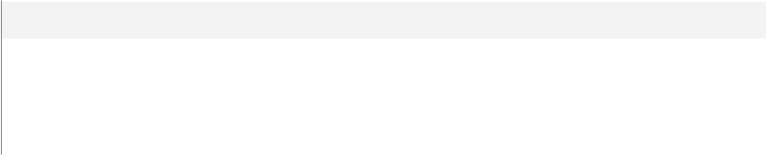

**Name**

@Crs_Name



@num_MCQ

@num_ToF

|  |  |
| --- | --- |
| **Data Type** | **Max Length (Bytes)** |
| varchar(10) | 10 |
| int | 4 |
| int | 4 |
|  |  |

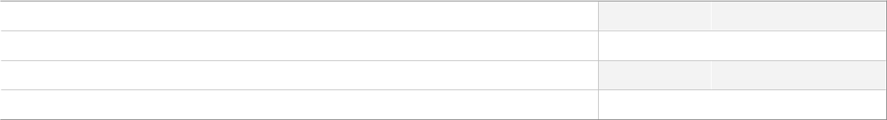

**SQL Script**



CREATE proc [dbo].[Exam_Generation] @Crs_Name varchar(10), @num_MCQ int ,@num_ToF int as

if not exists(select c.Course_Name from Courses c where c.Course_Name = @Crs_Name) begin

RAISERROR('Invalid Course Name', 16, 1);

return;

end

if @num_MCQ + @num_ToF = 10

BEGIN

DECLARE @crsID int

Select @crsID = Courses.Course_Id From Courses where Courses.Course_Name = @Crs_Name

DECLARE @LastExam int

Select @LastExam =

Count(Exams.Exam_Id)

From Exams

Group By Course_ID

Having Course_Id = @crsID

declare @ExamName varchar(50) =concat(@Crs_Name + ' ',(ISNULL (@LastExam,0) + 1)) exec InsertExam @ExamName,'1',@crsID;

DECLARE @ExmId INT

SET @ExmId = ISNULL((select top(1) Exam_Id from Exams order by Exam_Id DESC),1)

insert into Exam_Questions

select top(@num_MCQ) q.Question_Id , @ExmId from Questions q ,Courses c

where q.Question_Type = 'MCQ' and c.Course_Id = q.Course_Id and c.Course_Name = @Crs_-

Name

Author: Mahmoud Copyright 2024 - All Rights Reserved Page 56 of 116

Project > (local)\SQLEXPRESS > User databases > Examination-

SystemDB > Programmability > Stored Procedures > dbo.Exam_-

Generation

order by NEWID()



insert into Exam_Questions

select top(@num_ToF) q.Question_Id , @ExmId from Questions q ,Courses c

where q.Question_Type = 'T/F' and c.Course_Id = q.Course_Id and c.Course_Name = @Crs_-

Name

order by NEWID()

End

else

RAISERROR('Invalid Parameter', 16, 1);

GO

**Uses**

[dbo].[Courses]

[dbo].[Exam_Questions]

[dbo].[Exams]

[dbo].[Questions]

[dbo].[InsertExam]

Author: Mahmoud Copyright 2024 - All Rights Reserved Page 57 of 116

Project > (local)\SQLEXPRESS > User databases > Examination-SystemDB > Programmability > Stored Procedures > dbo.Exam-Questions_StudentAnswers_ModelAnswers



 **[dbo].[ExamQuestions_StudentAnswers_ModelAnswers]**

**Properties**



**Property**

ANSI Nulls On



Quoted Identifier On

**Value**



True



True

**Parameters**



**Name**

@examID



@studentID

|  |  |
| --- | --- |
| **Data Type** | **Max Length (Bytes)** |
| int | 4 |
| int | 4 |
|  |  |



**SQL Script**



CREATE PROCEDURE [dbo].[ExamQuestions_StudentAnswers_ModelAnswers]

(

@examID INT,

@studentID INT

)

AS

BEGIN

IF NOT EXISTS (SELECT 1 FROM Exams WHERE Exam_Id = @examID)

BEGIN

RAISERROR('Invalid Exam ID', 16, 1);

RETURN;

END

IF NOT EXISTS (SELECT 1 FROM Students WHERE Student_Id = @studentID)

BEGIN

RAISERROR('Invalid Student ID', 16, 1);

RETURN;

END

SELECT q.Content AS Question,

CONCAT(a.Value,') ', mc.Content) AS ModelAnswer, s.Student_Answer AS StudentAnswer

FROM Questions q

JOIN Student _Answer_In_Exam s ON s.Question_ID = q.Question_Id JOIN Answers a ON a.Question_ID = q.Question_Id

JOIN Choices mc ON a.Value = mc.Choice_Number AND q.Question_Id = mc.Question_Id WHERE s.Exam_Id = @examID AND s.Student_Id = @studentID;

END

GO

Author: Mahmoud Copyright 2024 - All Rights Reserved Page 58 of 116

Project > (local)\SQLEXPRESS > User databases > Examination-SystemDB > Programmability > Stored Procedures > dbo.Exam-Questions_StudentAnswers_ModelAnswers

**Uses**

[dbo].[Answers]

[dbo].[Choices]

[dbo].[Exams]

[dbo].[Questions]

[dbo].[Student_Answer_In_Exam]

[dbo].[Students]

Author: Mahmoud Copyright 2024 - All Rights Reserved Page 59 of 116

Project > (local)\SQLEXPRESS > User databases > Examination-SystemDB > Programmability > Stored Procedures > dbo.Get-CoursesTeachedByInstructor



 **[dbo].[GetCoursesTeachedByInstructor]**

**Properties**



**Property**

ANSI Nulls On



Quoted Identifier On

**Value**



True



True

**Parameters**



**Name**

@insID

|  |  |
| --- | --- |
| **Data Type** | **Max Length (Bytes)** |
| int | 4 |
|  |  |



**SQL Script**



CREATE proc [dbo].[GetCoursesTeachedByInstructor] @insID int as

if(@insID not in (select Instructor_Id from Instructors))

begin

RAISERROR('Invalid Instructor ID', 16, 1);

return;

end

select i.Instructor_Name,c.Course_Name , COUNT(sc.Student_Id) as [Number Of Students] from Instructors i , Courses_Instructor ci , Courses c,Student_Courses sc where i.Instructor_Id = ci.Ins_Id and

c.Course_Id = ci.Course_Id and

sc.Course_Id = c.Course_Id and

i.Instructor_Id = @insID

group by sc.Course_Id,i.Instructor_Name,c.Course_Name , c.Course_Id

GO

**Uses**

[dbo].[Courses]

[dbo].[Courses_Instructor]

[dbo].[Instructors]

[dbo].[Student_Courses]

Author: Mahmoud Copyright 2024 - All Rights Reserved Page 60 of 116

Project > (local)\SQLEXPRESS > User databases > Examination-SystemDB > Programmability > Stored Procedures > dbo.getExam-FromCrsID



 **[dbo].[getExamFromCrsID]**

**Properties**



**Property**

ANSI Nulls On



Quoted Identifier On

**Value**



True



True

**Parameters**



**Name**

@crs_id



@studID

|  |  |
| --- | --- |
| **Data Type** | **Max Length (Bytes)** |
| int | 4 |
| int | 4 |
|  |  |



**SQL Script**



CREATE proc [dbo].[getExamFromCrsID] @crs_id int , @studID int as

select distinct e.Exam_Id from Exams e ,Student_Courses sc , Student_Answer_In_Exam sa where @crs_id = e.Course_Id and

sc.Student_Id = @studID and

sc.Course_Id = @crs_id and

sa.Student_Id = @studID and

sa.Exam_Id = e.Exam_Id

GO

**Uses**

[dbo].[Exams]

[dbo].[Student_Answer_In_Exam]

[dbo].[Student_Courses]

Author: Mahmoud Copyright 2024 - All Rights Reserved Page 61 of 116

Project > (local)\SQLEXPRESS > User databases > Examination-SystemDB > Programmability > Stored Procedures > dbo.Get-StudentAnswerAndModelAnswer



 **[dbo].[GetStudentAnswerAndModelAnswer]**

**Properties**



**Property**

ANSI Nulls On



Quoted Identifier On

**Value**



True



True

**Parameters**



**Name**

@courseID



@studentID

|  |  |
| --- | --- |
| **Data Type** | **Max Length (Bytes)** |
| int | 4 |
| int | 4 |
|  |  |



**SQL Script**



CREATE PROC [dbo].[GetStudentAnswerAndModelAnswer] @courseID int, @studentID int

AS

select q.Content as Question,

CONCAT(sa.Student_Answer,') ', c.Content) AS StudentAnswer, CONCAT(a.Value,') ', mc.Content) AS ModelAnswer

from Student_Courses sc , Exams e, Student_Answer_In_Exam sa, Questions q, Answers a,Choices c, Choices mc

|  |  |  |
| --- | --- | --- |
| where | sc.Course_Id = @courseID and |  |
|  | e.Course_Id = @courseID and |  |
|  | sa.Exam_Id = e.Exam_Id and |  |
|  | sc.Student_Id = @studentID and |  |
|  | sa.Student_Id = @studentID and |  |
|  | q.Question_Id = a.Question_Id and |  |
|  | q.Question_Id = sa.Question_Id and |  |
|  | sa.Student_Answer = c.Choice_Number AND |  |
|  | q.Question_Id = c.Question_Id and |  |
|  | a.Value = mc.Choice_Number and |  |
| GO | q.Question_Id = mc.Question_Id |  |
|  |  |

**Uses**

[dbo].[Answers]

[dbo].[Choices]

[dbo].[Exams]

[dbo].[Questions]

[dbo].[Student_Answer_In_Exam]

[dbo].[Student_Courses]

Author: Mahmoud Copyright 2024 - All Rights Reserved Page 62 of 116

Project > (local)\SQLEXPRESS > User databases > Examination-SystemDB > Programmability > Stored Procedures > dbo.Get-StudentGradeInAllCourses



 **[dbo].[GetStudentGradeInAllCourses]**

**Properties**



**Property**

ANSI Nulls On



Quoted Identifier On

**Value**



True



True

**Parameters**



**Name**

@Student_id

|  |  |
| --- | --- |
| **Data Type** | **Max Length (Bytes)** |
| int | 4 |
|  |  |



**SQL Script**



CREATE proc [dbo].[GetStudentGradeInAllCourses] @Student_id int as

if(@Student_id not in (select Student_Id from Student_Courses))

begin

RAISERROR('Invalid Student ID', 16, 1);

return;

end

select sc.Student_Id, c.Course_Name, sc.StudentGrade from Student_Courses sc, Courses c where sc.Course_Id = c.Course_Id and sc.Student_Id = @Student_id and sc.StudentGrade is not Null

GO

**Uses**

[dbo].[Courses]

[dbo].[Student_Courses]

Author: Mahmoud Copyright 2024 - All Rights Reserved Page 63 of 116

Project > (local)\SQLEXPRESS > User databases > Examination-SystemDB > Programmability > Stored Procedures > dbo.Get-StudentsInDepartment



 **[dbo].[GetStudentsInDepartment]**

**Properties**



**Property**

ANSI Nulls On



Quoted Identifier On

**Value**



True



True

**Parameters**



**Name**

@dept_Id

|  |  |
| --- | --- |
| **Data Type** | **Max Length (Bytes)** |
| int | 4 |
|  |  |



**SQL Script**



CREATE proc [dbo].[GetStudentsInDepartment] @dept_Id int as

if(@dept_Id not in (select Department_ID from Departments))

begin

RAISERROR('Invalid Departemnt ID', 16, 1);

return;

end

select d.Department_Name, CONCAT (s.Fname ,' ',s.LName) as [Student Name] , s.Email,s.Age from Students s , Departments d

where s.Dept_Id =@dept_Id and d.Department_ID =s.Dept_Id

GO

**Uses**

[dbo].[Departments]

[dbo].[Students]

Author: Mahmoud Copyright 2024 - All Rights Reserved Page 64 of 116

Project > (local)\SQLEXPRESS > User databases > Examination-SystemDB > Programmability > Stored Procedures > dbo.Get-TopicsOfCourse



 **[dbo].[GetTopicsOfCourse]**

**Properties**



**Property**

ANSI Nulls On



Quoted Identifier On

**Value**



True



True

**Parameters**



**Name**

@CrsID

|  |  |
| --- | --- |
| **Data Type** | **Max Length (Bytes)** |
| int | 4 |
|  |  |



**SQL Script**



CREATE proc [dbo].[GetTopicsOfCourse] @CrsID int as

select t.Topic_Name from Topic t , Courses c

where c.Course_Id = t.Course_Id and c.Course_Id = @CrsID

GO

**Uses**

[dbo].[Courses]

[dbo].[Topic]

Author: Mahmoud Copyright 2024 - All Rights Reserved Page 65 of 116

Project > (local)\SQLEXPRESS > User databases > Examination-SystemDB > Programmability > Stored Procedures > dbo.insert_-Course



 **[dbo].[insert_Course]**

**Properties**



**Property**

ANSI Nulls On



Quoted Identifier On

**Value**



True



True

**Parameters**



**Name**

@Course_Name

|  |  |
| --- | --- |
| **Data Type** | **Max Length (Bytes)** |
| nchar(10) | 20 |
|  |  |



**SQL Script**



create proc [dbo].[insert_Course] @Course_Name nchar(10)

as

insert into Courses (Course_Name)

values(@Course_Name)

GO

**Uses**

[dbo].[Courses]

Author: Mahmoud Copyright 2024 - All Rights Reserved Page 66 of 116

Project > (local)\SQLEXPRESS > User databases > Examination-SystemDB > Programmability > Stored Procedures > dbo.insert_-CourseInstructor



 **[dbo].[insert_CourseInstructor]**

**Properties**



**Property**

ANSI Nulls On



Quoted Identifier On

**Value**



True



True

**Parameters**



**Name**

@Course_ID



@Instructor_ID

|  |  |
| --- | --- |
| **Data Type** | **Max Length (Bytes)** |
| int | 4 |
| int | 4 |
|  |  |



**SQL Script**



create proc [dbo].[insert_CourseInstructor] @Course_ID int,@Instructor_ID int as

insert into Courses_Instructor

values(@Course_ID,@Instructor_ID)

GO

**Uses**

[dbo].[Courses_Instructor]

Author: Mahmoud Copyright 2024 - All Rights Reserved Page 67 of 116

Project > (local)\SQLEXPRESS > User databases > Examination-SystemDB > Programmability > Stored Procedures > dbo.insert_-Instructor



 **[dbo].[insert_Instructor]**

**Properties**



**Property**

ANSI Nulls On



Quoted Identifier On

**Value**



True



True

**Parameters**



**Name**

@Instructor_Name



@Dept_no

|  |  |
| --- | --- |
| **Data Type** | **Max Length (Bytes)** |
| varchar(50) | 50 |
| int | 4 |
|  |  |



**SQL Script**



create proc [dbo].[insert_Instructor] @Instructor_Name varchar(50),@Dept_no int as

insert into Instructors (Instructor_Id,Dept_Id)

values(@Instructor_Name,@Dept_no)

GO

**Uses**

[dbo].[Instructors]

Author: Mahmoud Copyright 2024 - All Rights Reserved Page 68 of 116

Project > (local)\SQLEXPRESS > User databases > Examination-SystemDB > Programmability > Stored Procedures > dbo.insert_-Topic



 **[dbo].[insert_Topic]**

**Properties**



**Property**

ANSI Nulls On



Quoted Identifier On

**Value**



True



True

**Parameters**



**Name**

@Course_ID



@Topic_Name

|  |  |
| --- | --- |
| **Data Type** | **Max Length (Bytes)** |
| int | 4 |
| varchar(50) | 50 |
|  |  |



**SQL Script**



create proc [dbo].[insert_Topic] @Course_ID int,@Topic_Name varchar(50)

as

insert into Topic (Course_Id,Topic_Name)

values(@Course_ID,@Topic_Name)

GO

**Uses**

[dbo].[Topic]

Author: Mahmoud Copyright 2024 - All Rights Reserved Page 69 of 116

Project > (local)\SQLEXPRESS > User databases > Examination-SystemDB > Programmability > Stored Procedures > dbo.Insert-AnswerForQuestion



 **[dbo].[InsertAnswerForQuestion]**

**Properties**



**Property**

ANSI Nulls On



Quoted Identifier On

**Value**



True



True

**Parameters**



**Name**

@Ques_id



@correct_Answer

|  |  |
| --- | --- |
| **Data Type** | **Max Length (Bytes)** |
| int | 4 |
| varchar(50) | 50 |
|  |  |



**SQL Script**



CREATE proc [dbo].[InsertAnswerForQuestion] @Ques_id int , @correct_Answer varchar(50) as

insert into Answers(Question_Id , Value)

values(@Ques_id,@correct_Answer)

GO

**Uses**

[dbo].[Answers]

Author: Mahmoud Copyright 2024 - All Rights Reserved Page 70 of 116

Project > (local)\SQLEXPRESS > User databases > Examination-SystemDB > Programmability > Stored Procedures > dbo.Insert-ChoiceForQuestion



 **[dbo].[InsertChoiceForQuestion]**

**Properties**



**Property**

ANSI Nulls On



Quoted Identifier On

**Value**



True



True

**Parameters**

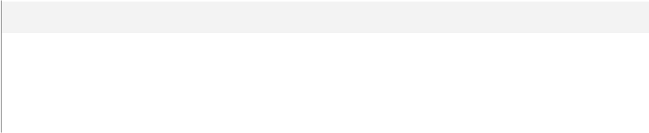

**Name**

@Ques_id



@choiceNumber

@content

|  |  |
| --- | --- |
| **Data Type** | **Max Length (Bytes)** |
| int | 4 |
| int | 4 |
| varchar(250) | 250 |
|  |  |

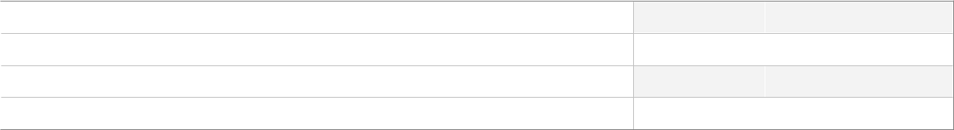

**SQL Script**



CREATE proc [dbo].[InsertChoiceForQuestion] @Ques_id int , @choiceNumber int, @content varchar(250)

as

insert into Choices(Question_Id , Choice_Number, Content)

values(@Ques_id,@choiceNumber,@content)

GO

**Uses**

[dbo].[Choices]

Author: Mahmoud Copyright 2024 - All Rights Reserved Page 71 of 116

Project > (local)\SQLEXPRESS > User databases > Examination-SystemDB > Programmability > Stored Procedures > dbo.Insert-Department



 **[dbo].[InsertDepartment]**

**Properties**



**Property**

ANSI Nulls On



Quoted Identifier On

**Value**



True



True

**Parameters**

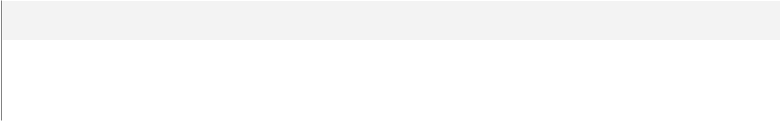

**Name**

@Department_Name



@Dept_Description

|  |  |
| --- | --- |
| **Data Type** | **Max Length (Bytes)** |
| varchar(50) | 50 |
| varchar(200) | 200 |
|  |  |

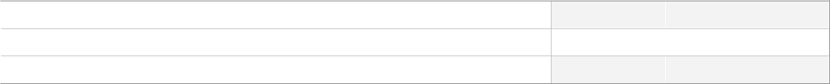

**SQL Script**



CREATE PROCEDURE [dbo].[InsertDepartment]

@Department_Name VARCHAR(50),

@Dept_Description VARCHAR(200)

AS

BEGIN

INSERT INTO Departments (Department_Name, Dept_Description)

VALUES (@Department_Name, @Dept_Description);

END;

GO

**Uses**

[dbo].[Departments]

Author: Mahmoud Copyright 2024 - All Rights Reserved Page 72 of 116

Project > (local)\SQLEXPRESS > User databases > Examination-SystemDB > Programmability > Stored Procedures > dbo.Insert-Exam



 **[dbo].[InsertExam]**

**Properties**



**Property**

ANSI Nulls On



Quoted Identifier On

**Value**



True



True

**Parameters**



**Name**

@ExamName



@duration

@Crs_id

|  |  |
| --- | --- |
| **Data Type** | **Max Length (Bytes)** |
| varchar(50) | 50 |
| varchar(50) | 50 |
| int | 4 |
|  |  |



**SQL Script**



CREATE proc [dbo].[InsertExam] @ExamName varchar(50) , @duration varchar(50) , @Crs_id int as

insert into Exams(Exam_Name , Exam_Duration , Course_Id)

values(@ExamName , @duration , @Crs_id)

GO

**Uses**

[dbo].[Exams]

**Used By**

[dbo].[Exam_Generation]

Author: Mahmoud Copyright 2024 - All Rights Reserved Page 73 of 116

Project > (local)\SQLEXPRESS > User databases > Examination-SystemDB > Programmability > Stored Procedures > dbo.Insert-Question



 **[dbo].[InsertQuestion]**

**Properties**



**Property**

ANSI Nulls On



Quoted Identifier On

**Value**



True



True

**Parameters**

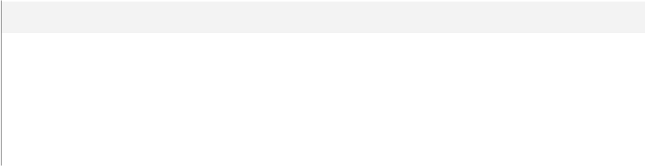

**Name**

@grade



@content

@Qust_type



@crs_id

|  |  |
| --- | --- |
| **Data Type** | **Max Length (Bytes)** |
| int | 4 |
| varchar(400) | 400 |
| varchar(100) | 100 |
| int | 4 |
|  |  |

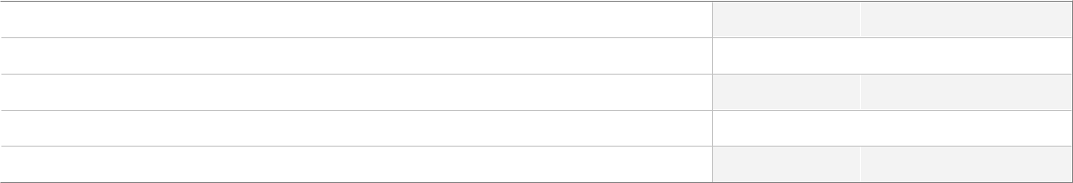

**SQL Script**



create proc [dbo].[InsertQuestion] @grade int , @content varchar(400),@Qust_type varchar(100),@crs_id int

as

insert into Questions(Grade , Content , Question_Type,Course_Id)

values(@grade,@content,@Qust_type,@crs_id)

GO

**Uses**

[dbo].[Questions]

Author: Mahmoud Copyright 2024 - All Rights Reserved Page 74 of 116

Project > (local)\SQLEXPRESS > User databases > Examination-SystemDB > Programmability > Stored Procedures > dbo.Insert-QuestionInExam



 **[dbo].[InsertQuestionInExam]**

**Properties**



**Property**

ANSI Nulls On



Quoted Identifier On

**Value**



True



True

**Parameters**



**Name**

@QuestID



@ExamName

|  |  |
| --- | --- |
| **Data Type** | **Max Length (Bytes)** |
| int | 4 |
| varchar(50) | 50 |
|  |  |



**SQL Script**



CREATE proc [dbo].[InsertQuestionInExam] @QuestID int,@ExamName varchar(50) as

insert into Exam_Questions

select @QuestID, Exam_Id as eID from Exams

where Exam_Name = @ExamName

GO

**Uses**

[dbo].[Exam_Questions]

[dbo].[Exams]

Author: Mahmoud Copyright 2024 - All Rights Reserved Page 75 of 116

Project > (local)\SQLEXPRESS > User databases > Examination-SystemDB > Programmability > Stored Procedures > dbo.Insert-Student



 **[dbo].[InsertStudent]**

**Properties**



**Property**

ANSI Nulls On



Quoted Identifier On

**Value**



True



True

**Parameters**

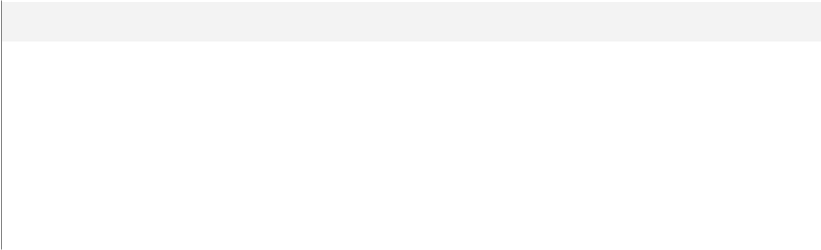

**Name**

@FName



@LName

@Age



@Email

@Dept_Id

|  |  |
| --- | --- |
| **Data Type** | **Max Length (Bytes)** |
| varchar(10) | 10 |
| varchar(10) | 10 |
| int | 4 |
| varchar(50) | 50 |
| int | 4 |
|  |  |

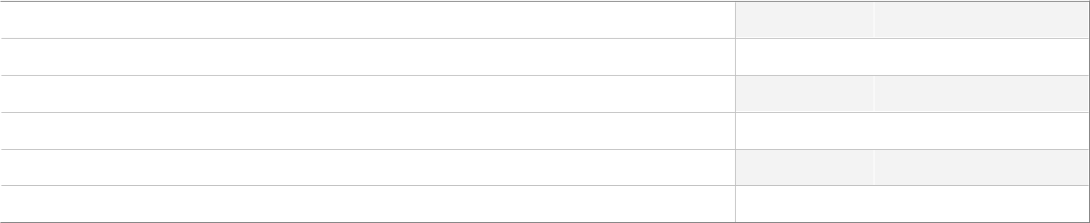

**SQL Script**



create proc [dbo].[InsertStudent] @FName VARCHAR(10),@LName VARCHAR(10),@Age INT, @Email VARCHAR(50),@Dept_Id INT

AS

BEGIN

INSERT INTO Students (FName, LName, Age, Email, Dept_Id)

VALUES (@FName, @LName, @Age, @Email, @Dept_Id);

END;

GO

**Uses**

[dbo].[Students]

Author: Mahmoud Copyright 2024 - All Rights Reserved Page 76 of 116

Project > (local)\SQLEXPRESS > User databases > Examination-SystemDB > Programmability > Stored Procedures > dbo.Insert-StudentAnswerOfQuestionInExam



 **[dbo].[InsertStudentAnswerOfQuestionInExam]**

**Properties**



**Property**

ANSI Nulls On



Quoted Identifier On

**Parameters**



**Name**

@stud_Id



@Quest_Id

@Exam_Id



@stud_Answer

**Value**



True



True



|  |  |
| --- | --- |
| **Data Type** | **Max Length (Bytes)** |
| int | 4 |
| int | 4 |
| int | 4 |
| varchar(200) | 200 |
|  |  |

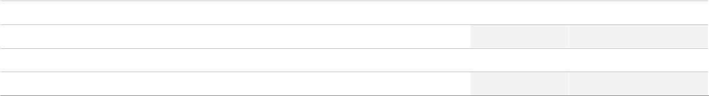

**SQL Script**



create proc [dbo].[InsertStudentAnswerOfQuestionInExam] @stud_Id int , @Quest_Id int,@Exam_Id int , @stud_Answer varchar(200)

as

insert into Student_Answer_In_Exam

values(@stud_Id,@Exam_Id,@Quest_Id,@stud_Answer)

GO

**Uses**

[dbo].[Student_Answer_In_Exam]

**Used By**

[dbo].[Exam_Answers]

Author: Mahmoud Copyright 2024 - All Rights Reserved Page 77 of 116

Project > (local)\SQLEXPRESS > User databases > Examination-SystemDB > Programmability > Stored Procedures > dbo.Insert-StudentCourse



 **[dbo].[InsertStudentCourse]**

**Properties**



**Property**

ANSI Nulls On



Quoted Identifier On

**Value**



True



True

**Parameters**

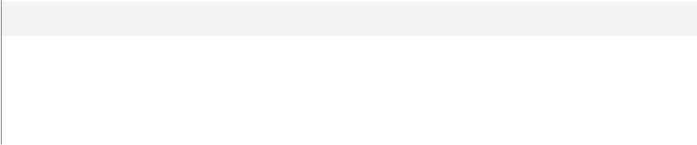

**Name**

@StudentID



@CourseID

@StudentGrade

|  |  |
| --- | --- |
| **Data Type** | **Max Length (Bytes)** |
| int | 4 |
| int | 4 |
| decimal(18,2) | 9 |
|  |  |

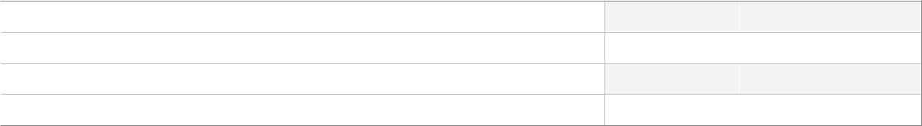

**SQL Script**



CREATE PROC [dbo].[InsertStudentCourse]

@StudentID INT,

@CourseID INT,

@StudentGrade decimal (18,2)

AS

BEGIN

INSERT INTO Student_Courses (Student_Id, Course_Id,StudentGrade)

VALUES (@StudentID, @CourseID,@StudentGrade);

END;

GO

**Uses**

[dbo].[Student_Courses]

**Used By**

[dbo].[Exam_Correct]

Author: Mahmoud Copyright 2024 - All Rights Reserved Page 78 of 116

Project > (local)\SQLEXPRESS > User databases > Examination-SystemDB > Programmability > Stored Procedures > dbo.questionsAndChoicesFromExamID



 **[dbo].[questionsAndChoicesFromExamID]**

**Properties**



**Property**

ANSI Nulls On



Quoted Identifier On

**Value**



True



True

**Parameters**



**Name**

@ExamID

|  |  |
| --- | --- |
| **Data Type** | **Max Length (Bytes)** |
| int | 4 |
|  |  |



**SQL Script**



CREATE PROC [dbo].[questionsAndChoicesFromExamID] @ExamID int AS

if(@ExamID not in (select Exam_Id from Exams))

begin

RAISERROR('Invalid Exam ID', 16, 1);

return;

end

Select Questions.Content as [QuestionContent], Choices.Choice_Number, Choices.Content,Questions.Question_Type

From Exams e, Exam_Questions, Questions, Choices

Where e.Exam_Id = Exam_Questions.Exam_ID AND

Exam_Questions.Question_Id = Questions.Question_Id AND

Questions.Question_Id = Choices.Question_Id and

e.Exam_Id = @ExamID

GO

**Uses**

[dbo].[Choices]

[dbo].[Exam_Questions]

[dbo].[Exams]

[dbo].[Questions]

Author: Mahmoud Copyright 2024 - All Rights Reserved Page 79 of 116

Project > (local)\SQLEXPRESS > User databases > Examination-SystemDB > Programmability > Stored Procedures > dbo.Report6_-ExamQuestions_StudnetAnswers



 **[dbo].[Report6_ExamQuestions_StudnetAnswers]**

**Properties**



**Property**

ANSI Nulls On



Quoted Identifier On

**Value**



True



True

**Parameters**



**Name**

@examID



@studentID

|  |  |
| --- | --- |
| **Data Type** | **Max Length (Bytes)** |
| int | 4 |
| int | 4 |
|  |  |



**SQL Script**



CREATE proc [dbo].[Report6_ExamQuestions_StudnetAnswers]

(

@examID int,

@studentID int

)

AS

BEGIN

if not exists(select Exams.Exam_Id From Exams where Exams.Exam_Id = @examID) begin

RAISERROR('Invalid Exam ID', 16, 1);

return;

end

if not exists(select Students.Student_Id From Students where Students.Student_Id = @studentID)

begin

RAISERROR('Invalid Student ID', 16, 1);

return;

end

SELECT q.Content as Question,s.Student_Answer,c.Content FROM Questions q

JOIN Student_Answer_In_Exam s ON s.Question_ID = q.Question_Id

join Choices c on s.Student_Answer = c.Choice_Number AND q.Question_Id = c.Question_Id WHERE s.Exam_Id = @examID AND s.Student_Id = @studentID;

END;

GO

Author: Mahmoud Copyright 2024 - All Rights Reserved Page 80 of 116

Project > (local)\SQLEXPRESS > User databases > Examination-SystemDB > Programmability > Stored Procedures > dbo.Report6_-ExamQuestions_StudnetAnswers

**Uses**

[dbo].[Choices]

[dbo].[Exams]

[dbo].[Questions]

[dbo].[Student_Answer_In_Exam]

[dbo].[Students]

Author: Mahmoud Copyright 2024 - All Rights Reserved Page 81 of 116

Project > (local)\SQLEXPRESS > User databases > Examination-SystemDB > Programmability > Stored Procedures > dbo.select_-Course



 **[dbo].[select_Course]**

**Properties**



**Property**

ANSI Nulls On



Quoted Identifier On

**Value**



True



True

**Parameters**



**Name**

@courseID

|  |  |
| --- | --- |
| **Data Type** | **Max Length (Bytes)** |
| int | 4 |
|  |  |



**SQL Script**



create proc [dbo].[select_Course] @courseID int

as

select Course_Id, Course_Name

from Courses

where Course_Id = @courseID

GO

**Uses**

[dbo].[Courses]

Author: Mahmoud Copyright 2024 - All Rights Reserved Page 82 of 116

Project > (local)\SQLEXPRESS > User databases > Examination-SystemDB > Programmability > Stored Procedures > dbo.select_-CourseInstructor



 **[dbo].[select_CourseInstructor]**

**Properties**



**Property**

ANSI Nulls On



Quoted Identifier On

**Value**



True



True

**Parameters**



**Name**

@CourseID

|  |  |
| --- | --- |
| **Data Type** | **Max Length (Bytes)** |
| int | 4 |
|  |  |



**SQL Script**



create proc [dbo].[select_CourseInstructor] @CourseID int as

select Course_Id, Ins_Id

from Courses_Instructor

where Course_Id = @CourseID

GO

**Uses**

[dbo].[Courses_Instructor]

Author: Mahmoud Copyright 2024 - All Rights Reserved Page 83 of 116

Project > (local)\SQLEXPRESS > User databases > Examination-SystemDB > Programmability > Stored Procedures > dbo.select_-CourseInstructor2



 **[dbo].[select_CourseInstructor2]**

**Properties**



**Property**

ANSI Nulls On



Quoted Identifier On

**Value**



True



True

**Parameters**



**Name**

@InstructorID

|  |  |
| --- | --- |
| **Data Type** | **Max Length (Bytes)** |
| int | 4 |
|  |  |



**SQL Script**



create proc [dbo].[select_CourseInstructor2] @InstructorID int as

select Course_Id, Ins_Id

from Courses_Instructor

where Ins_Id = @InstructorID

GO

**Uses**

[dbo].[Courses_Instructor]

Author: Mahmoud Copyright 2024 - All Rights Reserved Page 84 of 116

Project > (local)\SQLEXPRESS > User databases > Examination-SystemDB > Programmability > Stored Procedures > dbo.select_-Instructor



 **[dbo].[select_Instructor]**

**Properties**



**Property**

ANSI Nulls On



Quoted Identifier On

**Value**



True



True

**Parameters**



**Name**

@InstructorID

|  |  |
| --- | --- |
| **Data Type** | **Max Length (Bytes)** |
| int | 4 |
|  |  |



**SQL Script**



create proc [dbo].[select_Instructor] @InstructorID int as

select Instructor_Id, Instructor_Name, Dept_Id

from Instructors

where Instructor_Id = @InstructorID

GO

**Uses**

[dbo].[Instructors]

Author: Mahmoud Copyright 2024 - All Rights Reserved Page 85 of 116

Project > (local)\SQLEXPRESS > User databases > Examination-SystemDB > Programmability > Stored Procedures > dbo.select_-Topic



 **[dbo].[select_Topic]**

**Properties**



**Property**

ANSI Nulls On



Quoted Identifier On

**Value**



True



True

**Parameters**



**Name**

@topicID

|  |  |
| --- | --- |
| **Data Type** | **Max Length (Bytes)** |
| int | 4 |
|  |  |



**SQL Script**



create proc [dbo].[select_Topic] @topicID int

as

select Topic_id,Course_Id, Topic_Name

from Topic

where Topic_Id = @topicID

GO

**Uses**

[dbo].[Topic]

Author: Mahmoud Copyright 2024 - All Rights Reserved Page 86 of 116

Project > (local)\SQLEXPRESS > User databases > Examination-SystemDB > Programmability > Stored Procedures > dbo.Select-AnswerForQuestion



 **[dbo].[SelectAnswerForQuestion]**

**Properties**



**Property**

ANSI Nulls On



Quoted Identifier On

**Value**



True



True

**Parameters**



**Name**

@id_Question

|  |  |
| --- | --- |
| **Data Type** | **Max Length (Bytes)** |
| int | 4 |
|  |  |



**SQL Script**

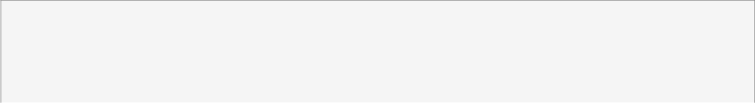

CREATE proc [dbo].[SelectAnswerForQuestion] @id_Question int as

select Question_Id , Value as [Correct Answer] from Answers

GO

**Uses**

[dbo].[Answers]

Author: Mahmoud Copyright 2024 - All Rights Reserved Page 87 of 116

Project > (local)\SQLEXPRESS > User databases > Examination-SystemDB > Programmability > Stored Procedures > dbo.Select-Choices



 **[dbo].[SelectChoices]**

**Properties**



**Property**

ANSI Nulls On



Quoted Identifier On

**Value**



True



True

**Parameters**



**Name**

@id_Question

|  |  |
| --- | --- |
| **Data Type** | **Max Length (Bytes)** |
| int | 4 |
|  |  |



**SQL Script**



CREATE proc [dbo].[SelectChoices] @id_Question int as

select c.Question_Id , c.Content from Choices c inner join Questions q on c.Question_Id = q.Question_Id and c.Question_Id = @id_Question GO

**Uses**

[dbo].[Choices]

[dbo].[Questions]

Author: Mahmoud Copyright 2024 - All Rights Reserved Page 88 of 116

Project > (local)\SQLEXPRESS > User databases > Examination-SystemDB > Programmability > Stored Procedures > dbo.Select-Department



 **[dbo].[SelectDepartment]**

**Properties**



**Property**

ANSI Nulls On



Quoted Identifier On

**Value**



True



True

**Parameters**



**Name**

@DepartmentID

|  |  |
| --- | --- |
| **Data Type** | **Max Length (Bytes)** |
| int | 4 |
|  |  |



**SQL Script**



CREATE PROC [dbo].[SelectDepartment]

@DepartmentID INT

AS

BEGIN

SELECT * FROM Departments WHERE Department_ID = @DepartmentID;

END;

GO

**Uses**

[dbo].[Departments]

Author: Mahmoud Copyright 2024 - All Rights Reserved Page 89 of 116

Project > (local)\SQLEXPRESS > User databases > Examination-SystemDB > Programmability > Stored Procedures > dbo.Select-Exam



 **[dbo].[SelectExam]**

**Properties**



**Property**

ANSI Nulls On



Quoted Identifier On

**Value**



True



True

**Parameters**



**Name**

@id

|  |  |
| --- | --- |
| **Data Type** | **Max Length (Bytes)** |
| int | 4 |
|  |  |



**SQL Script**



create proc [dbo].[SelectExam] @id int

as

select * from Exams

where Exam_Id = @id

GO

**Uses**

[dbo].[Exams]

Author: Mahmoud Copyright 2024 - All Rights Reserved Page 90 of 116

Project > (local)\SQLEXPRESS > User databases > Examination-SystemDB > Programmability > Stored Procedures > dbo.Select-ExamQuestion



 **[dbo].[SelectExamQuestion]**

**Properties**



**Property**

ANSI Nulls On



Quoted Identifier On

**Value**



True



True

**Parameters**



**Name**

@ExamId

|  |  |
| --- | --- |
| **Data Type** | **Max Length (Bytes)** |
| int | 4 |
|  |  |



**SQL Script**



CREATE proc [dbo].[SelectExamQuestion] @ExamId int as

select q.* from Exams e , Questions q , Exam_Questions eq

where eq.Exam_ID = e.Exam_Id and eq.Question_Id = q.Question_Id and eq.Exam_ID = @ExamId

GO

**Uses**

[dbo].[Exam_Questions]

[dbo].[Exams]

[dbo].[Questions]

Author: Mahmoud Copyright 2024 - All Rights Reserved Page 91 of 116

Project > (local)\SQLEXPRESS > User databases > Examination-SystemDB > Programmability > Stored Procedures > dbo.Select-Question



 **[dbo].[SelectQuestion]**

**Properties**



**Property**

ANSI Nulls On



Quoted Identifier On

**Value**



True



True

**Parameters**



**Name**

@id

|  |  |
| --- | --- |
| **Data Type** | **Max Length (Bytes)** |
| int | 4 |
|  |  |



**SQL Script**



create proc [dbo].[SelectQuestion] @id int

as

select * from Questions

where Question_Id = @id

GO

**Uses**

[dbo].[Questions]

Author: Mahmoud Copyright 2024 - All Rights Reserved Page 92 of 116

Project > (local)\SQLEXPRESS > User databases > Examination-SystemDB > Programmability > Stored Procedures > dbo.Select-Student



 **[dbo].[SelectStudent]**

**Properties**



**Property**

ANSI Nulls On



Quoted Identifier On

**Value**



True



True

**Parameters**



**Name**

@Student_ID

|  |  |
| --- | --- |
| **Data Type** | **Max Length (Bytes)** |
| int | 4 |
|  |  |



**SQL Script**



-- 1- Select --

create proc [dbo].[SelectStudent] @Student_ID int as

select *

from Students

where Student_Id = @Student_ID

--Calling

execute select_Student 1

GO

**Uses**

[dbo].[Students]

Author: Mahmoud Copyright 2024 - All Rights Reserved Page 93 of 116

Project > (local)\SQLEXPRESS > User databases > Examination-SystemDB > Programmability > Stored Procedures > dbo.Select-StudentAnswerOfQuestionInExam



 **[dbo].[SelectStudentAnswerOfQuestionInExam]**

**Properties**



**Property**

ANSI Nulls On



Quoted Identifier On

**Value**



True



True

**Parameters**



**Name**

@stud_Id



@Quest_Id

|  |  |
| --- | --- |
| **Data Type** | **Max Length (Bytes)** |
| int | 4 |
| int | 4 |
|  |  |



**SQL Script**



create proc [dbo].[SelectStudentAnswerOfQuestionInExam] @stud_Id int , @Quest_Id int as

select * from Student_Answer_In_Exam

where Student_Id = @stud_Id and Question_Id = @Quest_Id

GO

**Uses**

[dbo].[Student_Answer_In_Exam]

Author: Mahmoud Copyright 2024 - All Rights Reserved Page 94 of 116

Project > (local)\SQLEXPRESS > User databases > Examination-SystemDB > Programmability > Stored Procedures > dbo.Select-StudentCourse



 **[dbo].[SelectStudentCourse]**

**Properties**



**Property**

ANSI Nulls On



Quoted Identifier On

**Value**



True



True

**Parameters**



**Name**

@StudentID



@CourseID

|  |  |
| --- | --- |
| **Data Type** | **Max Length (Bytes)** |
| int | 4 |
| int | 4 |
|  |  |



**SQL Script**



CREATE PROC [dbo].[SelectStudentCourse]

@StudentID INT,

@CourseID INT

AS

BEGIN

SELECT * FROM Student_Courses WHERE Student_Id = @StudentID AND Course_Id = @CourseID;

END;

GO

**Uses**

[dbo].[Student_Courses]

Author: Mahmoud Copyright 2024 - All Rights Reserved Page 95 of 116

Project > (local)\SQLEXPRESS > User databases > Examination-SystemDB > Programmability > Stored Procedures > dbo.update_-Course



 **[dbo].[update_Course]**

**Properties**



**Property**

ANSI Nulls On



Quoted Identifier On

**Value**



True



True

**Parameters**



**Name**

@Course_ID



@Course_Name

|  |  |
| --- | --- |
| **Data Type** | **Max Length (Bytes)** |
| int | 4 |
| nchar(10) | 20 |
|  |  |



**SQL Script**



create proc [dbo].[update_Course] @Course_ID int,@Course_Name nchar(10) = NULL as

update Courses

set Course_Name = ISNULL(@Course_Name,Course_Name)

where Course_Id = @Course_ID

GO

**Uses**

[dbo].[Courses]

Author: Mahmoud Copyright 2024 - All Rights Reserved Page 96 of 116

Project > (local)\SQLEXPRESS > User databases > Examination-SystemDB > Programmability > Stored Procedures > dbo.update_-CourseInstructor



 **[dbo].[update_CourseInstructor]**

**Properties**



**Property**

ANSI Nulls On



Quoted Identifier On

**Value**



True



True

**Parameters**



**Name**

@Course_ID



@InstructorID

|  |  |
| --- | --- |
| **Data Type** | **Max Length (Bytes)** |
| int | 4 |
| int | 4 |
|  |  |



**SQL Script**



create proc [dbo].[update_CourseInstructor] @Course_ID int,@InstructorID int as

update Courses_Instructor

set Course_Id = @Course_ID

where Ins_Id = @InstructorID

GO

**Uses**

[dbo].[Courses_Instructor]

Author: Mahmoud Copyright 2024 - All Rights Reserved Page 97 of 116

Project > (local)\SQLEXPRESS > User databases > Examination-SystemDB > Programmability > Stored Procedures > dbo.update_-CourseInstructor2



 **[dbo].[update_CourseInstructor2]**

**Properties**



**Property**

ANSI Nulls On



Quoted Identifier On

**Value**



True



True

**Parameters**



**Name**

@InstructorID



@Course_ID

|  |  |
| --- | --- |
| **Data Type** | **Max Length (Bytes)** |
| int | 4 |
| int | 4 |
|  |  |



**SQL Script**



create proc [dbo].[update_CourseInstructor2] @InstructorID int,@Course_ID int as

update Courses_Instructor

set Ins_Id = @InstructorID

where Course_Id = @Course_ID

GO

**Uses**

[dbo].[Courses_Instructor]

Author: Mahmoud Copyright 2024 - All Rights Reserved Page 98 of 116

Project > (local)\SQLEXPRESS > User databases > Examination-SystemDB > Programmability > Stored Procedures > dbo.update_-Instructor



 **[dbo].[update_Instructor]**

**Properties**



**Property**

ANSI Nulls On



Quoted Identifier On

**Value**



True



True

**Parameters**



**Name**

@InstructorID



@Instructor_Name

@Dept_no

|  |  |
| --- | --- |
| **Data Type** | **Max Length (Bytes)** |
| int | 4 |
| varchar(50) | 50 |
| int | 4 |
|  |  |



**SQL Script**



create proc [dbo].[update_Instructor] @InstructorID int,@Instructor_Name varchar(50) = NULL,@Dept_no int = NULL

as

update Instructors

set Instructor_Name = ISNULL(@Instructor_Name, Instructor_Name), Dept_Id = ISNULL(@Dept_no, Dept_Id)

where Instructor_Id = @InstructorID

GO

**Uses**

[dbo].[Instructors]

Author: Mahmoud Copyright 2024 - All Rights Reserved Page 99 of 116

Project > (local)\SQLEXPRESS > User databases > Examination-SystemDB > Programmability > Stored Procedures > dbo.update_-Topic



 **[dbo].[update_Topic]**

**Properties**



**Property**

ANSI Nulls On



Quoted Identifier On

**Value**



True



True

**Parameters**



**Name**

@TopicID



@Course_ID

@Topic_Name

|  |  |
| --- | --- |
| **Data Type** | **Max Length (Bytes)** |
| int | 4 |
| int | 4 |
| varchar(50) | 50 |
|  |  |



**SQL Script**



create proc [dbo].[update_Topic] @TopicID int,@Course_ID int,@Topic_Name varchar(50) as

update Topic

set Topic_Name = @Topic_Name ,Course_Id = @Course_ID where Topic_Id = @TopicID

GO

**Uses**

[dbo].[Topic]

Author: Mahmoud Copyright 2024 - All Rights Reserved Page 100 of 116

Project > (local)\SQLEXPRESS > User databases > Examination-SystemDB > Programmability > Stored Procedures > dbo.Update-AnswerForQuestion



 **[dbo].[UpdateAnswerForQuestion]**

**Properties**



**Property**

ANSI Nulls On



Quoted Identifier On

**Value**



True



True

**Parameters**



**Name**

@Question_id



@old_answer

@correct_answer

|  |  |
| --- | --- |
| **Data Type** | **Max Length (Bytes)** |
| int | 4 |
| varchar(50) | 50 |
| varchar(50) | 50 |
|  |  |



**SQL Script**



CREATE proc [dbo].[UpdateAnswerForQuestion] @Question_id int ,@old_answer varchar(50)

,@correct_answer varchar(50)

as

update Answers

set Value = @correct_answer

where Question_Id = @Question_id and Value = @old_answer

GO

**Uses**

[dbo].[Answers]

Author: Mahmoud Copyright 2024 - All Rights Reserved Page 101 of 116

Project > (local)\SQLEXPRESS > User databases > Examination-SystemDB > Programmability > Stored Procedures > dbo.Update-ChoiceForQuestion



 **[dbo].[UpdateChoiceForQuestion]**

**Properties**



**Property**

ANSI Nulls On



Quoted Identifier On

**Value**



True



True

**Parameters**



**Name**

@Question_id



@choice_num

@content

|  |  |
| --- | --- |
| **Data Type** | **Max Length (Bytes)** |
| int | 4 |
| varchar(50) | 50 |
| varchar(250) | 250 |
|  |  |



**SQL Script**



CREATE proc [dbo].[UpdateChoiceForQuestion] @Question_id int , @choice_num varchar(50) , @content varchar(250)

as

update Choices

set Content = @content

where Question_Id = @Question_id and Choice_Number = @choice_num

GO

**Uses**

[dbo].[Choices]

Author: Mahmoud Copyright 2024 - All Rights Reserved Page 102 of 116

Project > (local)\SQLEXPRESS > User databases > Examination-SystemDB > Programmability > Stored Procedures > dbo.Update-Department



 **[dbo].[UpdateDepartment]**

**Properties**



**Property**

ANSI Nulls On



Quoted Identifier On

**Value**



True



True

**Parameters**



**Name**

@DepartmentID



@Department_Name

@Dept_Description

|  |  |
| --- | --- |
| **Data Type** | **Max Length (Bytes)** |
| int | 4 |
| varchar(50) | 50 |
| varchar(200) | 200 |
|  |  |



**SQL Script**



CREATE PROC [dbo].[UpdateDepartment]

@DepartmentID INT,

@Department_Name VARCHAR(50) = NULL,

@Dept_Description VARCHAR(200) = NULL

AS

BEGIN

UPDATE Departments

SET Department_Name = ISNULL(@Department_Name, Department_Name), Dept_Description = ISNULL(@Dept_Description, Dept_Description)

WHERE Department_ID = @DepartmentID;

END;

GO

**Uses**

[dbo].[Departments]

Author: Mahmoud Copyright 2024 - All Rights Reserved Page 103 of 116

Project > (local)\SQLEXPRESS > User databases > Examination-SystemDB > Programmability > Stored Procedures > dbo.Update-Exam



 **[dbo].[UpdateExam]**

**Properties**



**Property**

ANSI Nulls On



Quoted Identifier On

**Value**



True



True

**Parameters**

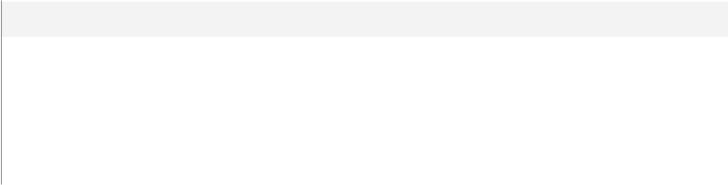

**Name**

@Exam_id



@Exam_Name

@duration



@Crs_id

|  |  |
| --- | --- |
| **Data Type** | **Max Length (Bytes)** |
| int | 4 |
| varchar(50) | 50 |
| varchar(50) | 50 |
| int | 4 |
|  |  |

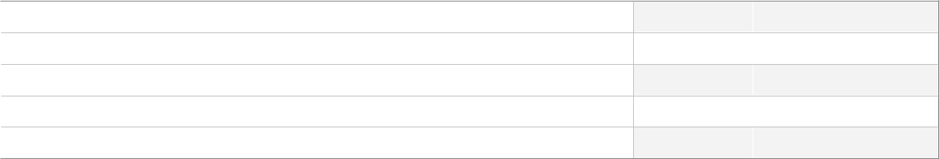

**SQL Script**



CREATE proc [dbo].[UpdateExam] @Exam_id int,@Exam_Name varchar(50) , @duration varchar(50), @Crs_id int

as

update Exams

set Exam_Name =ISNULL(@Exam_Name,Exam_Name)

,Exam_Duration = isnull(@duration,Exam_Duration) ,

Course_Id = isnull (@Crs_id,Course_Id)

where Exam_Id = @Exam_id

GO

**Uses**

[dbo].[Exams]

Author: Mahmoud Copyright 2024 - All Rights Reserved Page 104 of 116

Project > (local)\SQLEXPRESS > User databases > Examination-SystemDB > Programmability > Stored Procedures > dbo.Update-Question



 **[dbo].[UpdateQuestion]**

**Properties**



**Property**

ANSI Nulls On



Quoted Identifier On

**Value**



True



True

**Parameters**

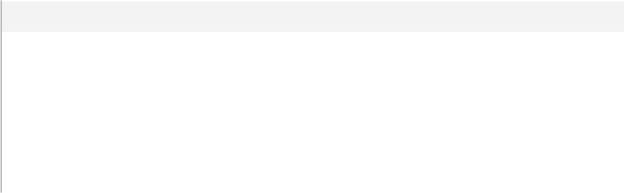

**Name**

@id



@grade

@content



@qust_type

@crsId

|  |  |
| --- | --- |
| **Data Type** | **Max Length (Bytes)** |
| int | 4 |
| int | 4 |
| varchar(400) | 400 |
| varchar(100) | 100 |
| int | 4 |
|  |  |

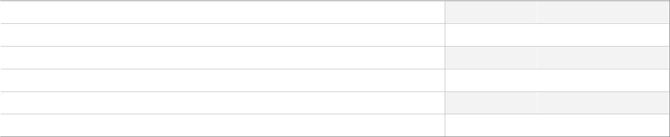

**SQL Script**



CREATE proc [dbo].[UpdateQuestion]

@id int ,

@grade int =NULL,

@content varchar(400)=NULL,

@qust_type varchar(100)=NULL ,

@crsId int=NULL

as

update Questions

set Content =ISNULL(@content,Content),

Grade = ISNULL(@grade,Grade),

Question_Type = ISNULL(@qust_type,Question_Type), Course_Id =ISNULL (@crsId , Course_Id)

where Question_Id = @id

GO

**Uses**

[dbo].[Questions]

Author: Mahmoud Copyright 2024 - All Rights Reserved Page 105 of 116

Project > (local)\SQLEXPRESS > User databases > Examination-SystemDB > Programmability > Stored Procedures > dbo.Update-QuestionInExam



 **[dbo].[UpdateQuestionInExam]**

**Properties**



**Property**

ANSI Nulls On



Quoted Identifier On

**Value**



True



True

**Parameters**

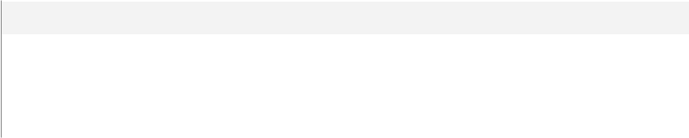

**Name**

@Exam_id



@old_quest

@newQuest

|  |  |
| --- | --- |
| **Data Type** | **Max Length (Bytes)** |
| int | 4 |
| int | 4 |
| int | 4 |
|  |  |

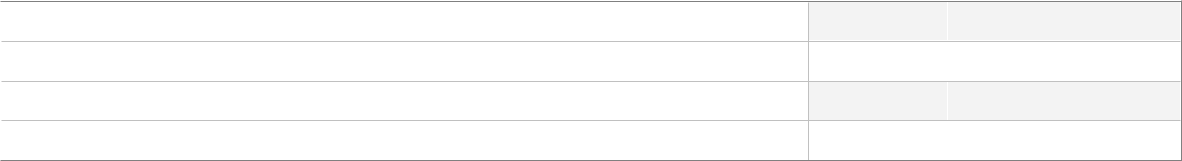

**SQL Script**



create proc [dbo].[UpdateQuestionInExam] @Exam_id int,@old_quest int , @newQuest int as

update Exam_Questions

set Question_Id = @newQuest

where Exam_ID = @Exam_id and Question_Id = @old_quest

GO

**Uses**

[dbo].[Exam_Questions]

Author: Mahmoud Copyright 2024 - All Rights Reserved Page 106 of 116

Project > (local)\SQLEXPRESS > User databases > Examination-SystemDB > Programmability > Stored Procedures > dbo.Update-Student



 **[dbo].[UpdateStudent]**

**Properties**



**Property**

ANSI Nulls On



Quoted Identifier On

**Value**



True



True

**Parameters**



**Name**

@StudentID



@FName

@LName



@Age

@Email



@Dept_Id

|  |  |
| --- | --- |
| **Data Type** | **Max Length (Bytes)** |
| int | 4 |
| varchar(10) | 10 |
| varchar(10) | 10 |
| int | 4 |
| varchar(50) | 50 |
| int | 4 |
|  |  |



**SQL Script**



CREATE PROC [dbo].[UpdateStudent]

@StudentID INT,

@FName VARCHAR(10) = NULL,

@LName VARCHAR(10) = NULL,

@Age INT = NULL,

@Email VARCHAR(50) = NULL,

@Dept_Id INT = NULL

AS

BEGIN

UPDATE Students

SET FName = ISNULL(@FName, FName),

LName = ISNULL(@LName, LName),

Age = ISNULL(@Age, Age),

Email = ISNULL(@Email, Email),

Dept_Id = ISNULL(@Dept_Id, Dept_Id)

WHERE Student_Id = @StudentID;

END;

GO

**Uses**

[dbo].[Students]

Author: Mahmoud Copyright 2024 - All Rights Reserved Page 107 of 116

Project > (local)\SQLEXPRESS > User databases > Examination-SystemDB > Programmability > Stored Procedures > dbo.Update-StudentAnswerOfQuestionInExam



 **[dbo].[UpdateStudentAnswerOfQuestionInExam]**

**Properties**



**Property**

ANSI Nulls On



Quoted Identifier On

**Parameters**



**Name**

@stud_Id



@Quest_Id

@newAnswer

**Value**



True



True

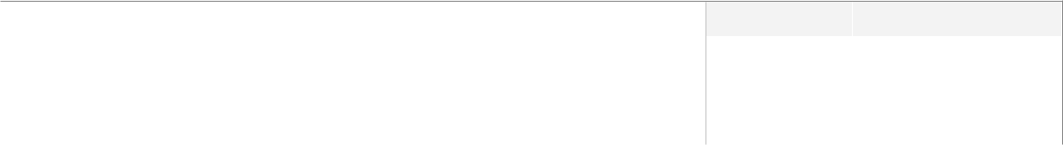

|  |  |
| --- | --- |
| **Data Type** | **Max Length (Bytes)** |
| int | 4 |
| int | 4 |
| varchar(200) | 200 |
|  |  |



**SQL Script**



--update

create proc [dbo].[UpdateStudentAnswerOfQuestionInExam] @stud_Id int , @Quest_Id int , @new-Answer varchar(200)

as

update Student_Answer_In_Exam

set Student_Answer = @newAnswer

where Student_Id = @stud_Id and Question_Id = @Quest_Id

GO

**Uses**

[dbo].[Student_Answer_In_Exam]

Author: Mahmoud Copyright 2024 - All Rights Reserved Page 108 of 116

Project > (local)\SQLEXPRESS > User databases > Examination-SystemDB > Programmability > Stored Procedures > dbo.Update-StudentCourse



 **[dbo].[UpdateStudentCourse]**

**Properties**



**Property**

ANSI Nulls On



Quoted Identifier On

**Value**



True



True

**Parameters**



**Name**

@StudentID



@CourseID

@StudentGrade

|  |  |
| --- | --- |
| **Data Type** | **Max Length (Bytes)** |
| int | 4 |
| int | 4 |
| decimal(18,2) | 9 |
|  |  |



**SQL Script**



CREATE PROC [dbo].[UpdateStudentCourse]

@StudentID INT,

@CourseID INT,

@StudentGrade decimal (18,2)

AS

BEGIN

UPDATE Student_Courses

SET StudentGrade = @StudentGrade

WHERE Student_Id = @StudentID and Course_Id = @CourseID;

END;

GO

**Uses**

[dbo].[Student_Courses]

**Used By**

[dbo].[Exam_Correct]

Author: Mahmoud Copyright 2024 - All Rights Reserved Page 109 of 116

Project > (local)\SQLEXPRESS > User databases > Examination-SystemDB > Security > Users



 ***Users***

**Objects**

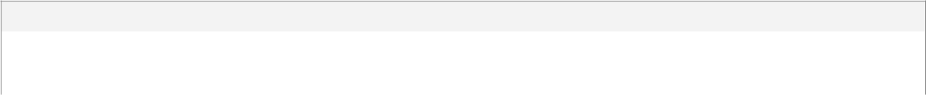

**Name**

dbo



guest

Author: Mahmoud Copyright 2024 - All Rights Reserved Page 110 of 116

Project > (local)\SQLEXPRESS > User databases > Examination-SystemDB > Security > Users > dbo



 **dbo**

**Properties**



**Property**

Type



Login Name

Default Schema

**Value**



SqlUser



sa

dbo

**Database Level Permissions**



**Type**

CONNECT

**Action**

Grant

**SQL Script**



GO

Author: Mahmoud Copyright 2024 - All Rights Reserved Page 111 of 116

Project > (local)\SQLEXPRESS > User databases > Examination-SystemDB > Security > Users > guest



 **guest**

**Properties**



**Property**

Type



Default Schema

**SQL Script**

GO

**Value**



SqlUser



guest



Author: Mahmoud Copyright 2024 - All Rights Reserved Page 112 of 116

Project > (local)\SQLEXPRESS > User databases > Examination-SystemDB > Security > Roles > Database Roles



 ***Database Roles***

**Objects**



**Name**

db_accessadmin



db_backupoperator

db_datareader



db_datawriter

db_ddladmin



db_denydatareader

db_denydatawriter



db_owner

db_securityadmin



public



 **db_accessadmin**

**Properties**



**Property**

Owner

**Value**



dbo



 **db_backupoperator**

**Properties**



**Property**

Owner

**Value**



dbo

Author: Mahmoud Copyright 2024 - All Rights Reserved Page 113 of 116

Project > (local)\SQLEXPRESS > User databases > Examination-SystemDB > Security > Roles > Database Roles > db_datareader



 **db_datareader**

**Properties**



**Property**

Owner

**Value**



dbo



 **db_datawriter**

**Properties**



**Property**

Owner

**Value**



dbo



 **db_ddladmin**

**Properties**



**Property**

Owner

**Value**



dbo



 **db_denydatareader**

**Properties**



**Property**

Owner

**Value**



dbo

Author: Mahmoud Copyright 2024 - All Rights Reserved Page 114 of 116

Project > (local)\SQLEXPRESS > User databases > Examination-SystemDB > Security > Roles > Database Roles > db_denydatareader



 **db_denydatawriter**

**Properties**



**Property**

Owner

**Value**



dbo



 **db_owner**

**Properties**



**Property**

Owner

**Value**



dbo



 **db_securityadmin**

**Properties**



**Property**

Owner

**Value**



dbo



 **public**

Author: Mahmoud Copyright 2024 - All Rights Reserved Page 115 of 116

Project > (local)\SQLEXPRESS > User databases > Examination-SystemDB > Security > Roles > Database Roles > public

**Properties**



**Property**

Owner

**Value**



dbo

Author: Mahmoud Copyright 2024 - All Rights Reserved Page 116 of 116