Kotlin – 2850
Passphrase: Ma@Kotlin#2106
- First Steps
- Script names must start with ./
- When ‘permission is denied’ when attempting to run a script, use chmod e.g.
  - chmod u+x kotlin
- Should create a file named Main.kt that should be inside the src file
- Starter code, “Hello World”:
fun main() {
println("Hello World!")
}
println: prints the string on a new line
fun: defines a new function
{ }: indicate the beginning and ending of function body
- Compiling & Running:
  - kotlin build – compiles the program and creates a build subdirectory with the JAR file which contains all the Java bytecode generated by the compiler.
  - kotlin run – loads the code from the JAR file and executes in JVM
- .gitignore file should have the build directory, as compiler output should never be put under version control (since it can be regenerated easily from source code)
- Cleaning up
  - kotlin clean – removes all compiler output
  - Should always use when finished working in a Kotlin Toolchain project
- Kotlin toolchain combines compiler with other tools, providing a sophisticated build system for managing kotlin software.
- Build Management Systems – common in software dev and offer many benefits, they can (last year we used Make in C):
  - Download dependencies (libraries of code used by an application)
  - Work efficiently - compiling on changed files
  - Run tests and report on output
  - Perform checks on code style or code quality
  - Generate API docs from doc comments
  - Package a library or application for deployment and distribution
- Dependencies – external libraries an application depends on
  - KT allows specification of what external libraries an application needs, download them and cache them for use by the application
- libs.versions.toml is the top-level library catalog for any project
  - standard way of capturing details of the external libraries used by a Kotlin or Java application
  - it has 2 sections to simplify maintenance as library versions are more frequent to change than set of libraries
    - libraries section with each library referred to by a key that can be customised by preference
      - each key is associated with a module identifier (specifies the external library wished to use by its Maven Coordinates (A standard way of uniquely identifying a software library in in the JVM ecosystem) and version reference
    - versions sections links the version references from the libraries section with specific library version numbers.
- $libs. Tells the KT that it needs to look in the library catalogue for further details
- Mordant a kotlin text styling library
- Import is used to mention a library or look for tools in it to use
- On any given system, dependencies need to be resolved, so subsequent uses of build and run commands will be faster
- Configuring Kotlin & JDK Versions:
  - Must add a settings section to module.yaml
Settings:
Kotlin:
Version: 2.4.20
- If you wish to configure a specific version of the JDK, use this:
Settings:
Jvm:
Jdk:
Version:
26
Indicating that JDK version 26 should be used instead of 25
- Main Class Configuration:
  - When JVM is the target, files of kotlin source code are transformed into class files containing java bytecode.
    - When the application is run by the KT, it assumes by defaylt that one of these class files is named MainKt.class, which contains the bytecode for the main(), in the src directory
(free to put main() in a source file with a diff name however will have to instruct KT where to find main() in all of the bytecode generated by the computer)
e.g. if “Hello World” program’s main() is put in a file called Hello.kt, the compiler will then put the bytecode of main() in a file named HelloKt.class and will need to add the following to module.yaml:
settings:
jvm:
mainClass: HelloKt
the name of the class file is specified here without the .class extension, not the name of the Kotlin source file
    - Will also need to configure main class explicitly if the source file containing main() has been made part of a package, so the “Hello World” program will be in file Main.kt that would look like:
package comp2850.hello
fun main() {
println(“Hello World!”)
}
main() is declared to be part of the package comp2850.hello, thus will need to configure module.yaml with the following:
settings:
jvm:
mainclass: comp2850.hello.MainKt
- Deployment:
  - To deploy an application on systems that do not have KT installed, you will need to include the application’s dependencies, using the KT’s package command
  - When kotlin package is run in task1_3_1 for example:
    - Two subdirectories are created of build/tasks named:
      - _task1_3_1_jarJvm
      - _task1_3_1_executableJarJvm
    - Each containing a JAR file (Java Archive containing compiled Java/Kotlin program – consider it a ZIP folder for a Java/Kotlin program)
    - The 2 JAR files are different as they are:
      - Normal JAR – contains the program, so it might have program.class, other classes from the program and metadata
(Does not necessarily have all the code from the libraries you depend on)
So when run, the computer needs access to program, Kotlin Standard library, kotlinx-datetime and mordant
      - Executable JAR – designed to be much more self-contained, as it bundles the following:
Program, Kotlin standard library, kotlinx-datetime and mordant in one big JAR
This can be used when sending the file to another computer as it won’t have access to the dependencies in the normal JAR, but the executable would have all the dependencies
(The executable file is larger as it packages the program together with the libraries it needs, making it easier to run on another machine.)
- Project Initialisation:
  - KT can initialise a kotlin program using the init command, when done on a file with a README file and nothing else, and then the “JVM Console Application” option is chosen from the menu, it will create the following:
    - A shell script named kotlin
    - A Windows batch file named kotlin.bat
    - A module.yaml file, declaring this to be a JVM-based application
    - A src subdirectory, containing some source code files
    - A test subdirectory, containing some unit tests
  - The script and batch file can be used to invoke KT, for instance you can do:
    - ./kotlin run
Including the script and batch files make the project easier to share with other people (will not need to install KT or even JDK themselves to build and run the application as the script and batch file performs that)
- Using Gradle:
  - Project Organisation:
    - using the build.gradle.kts in the editor to examine project organisation
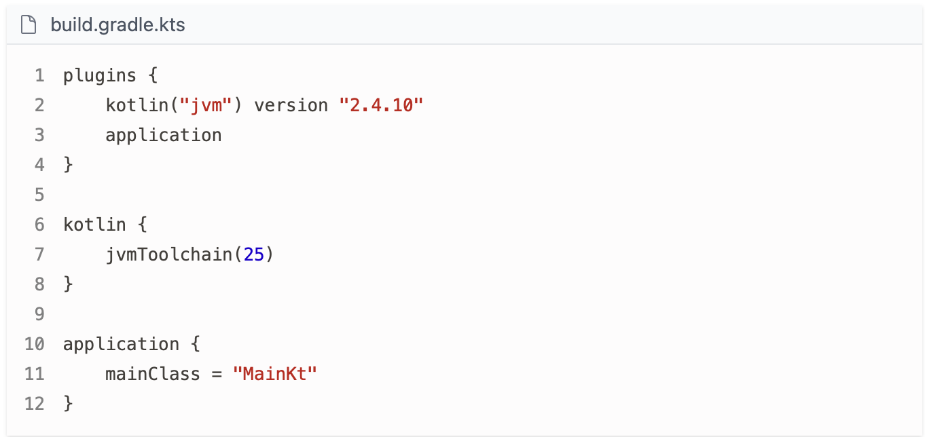
Top part of the file
  - Kotlin Version: Uses Kotlin version 2.4.10.
  - Java Version: Targets Java 25 for both compiler and runtime.
  - Application Entry Point: Specifies the main class containing the `main()` function.
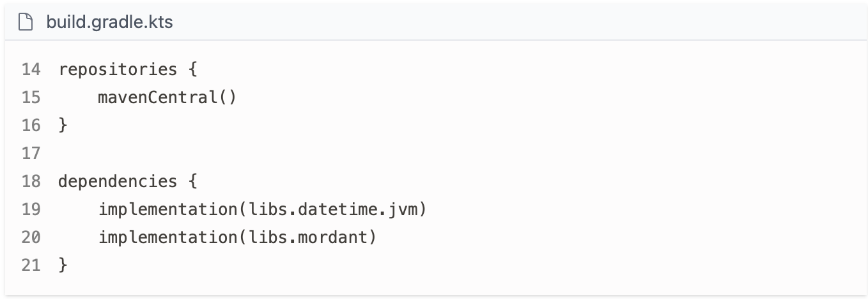
Bottom part of the file
- Dependency Management: The code manages application dependencies using Maven Central.
- Dependency Sources: Dependencies are downloaded from Maven Central if not already present and cached locally.
- Specific Dependencies: The code specifies dependencies on `libs.datetime.jvm` and `libs.mordant` libraries.
- Build Tasks:
  - To see the tasks that can be performed by the build script, can run:
    - ./gradlew tasks
This command runs the Gradle wrapper.
- To run the application:
  - ./gradlew run
The run task runs an application without command line arguments (by default)
Can supply arguments by expressing them as quoted strings and using - -args option e.g.
      - ./gradlew run –args=’arg1 arg2’
  - To package the application for distribution, use:
    - ./gradlew distZip
This will create a file e.g. task1_4.zip in the build/distributions subdirectory of task1_4. It will contain:
        - JAR files for the application and its dependencies
        - Shell script and batch file

- Types & Variables
- Integer Types:
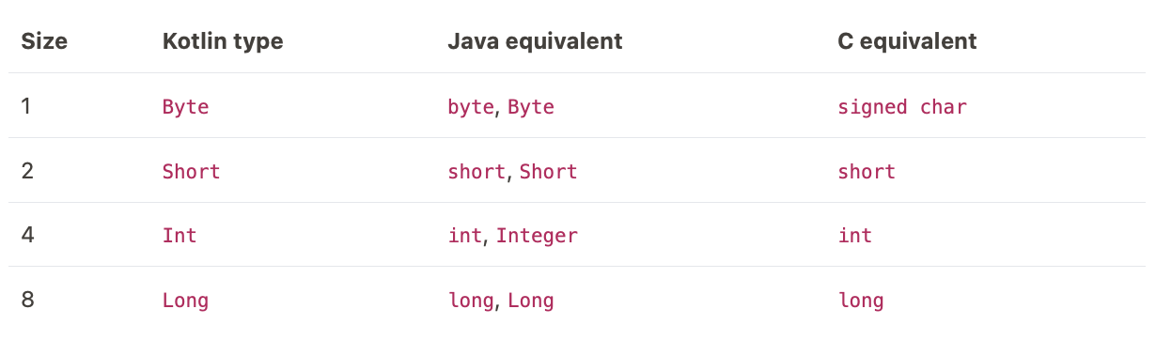
  - There are four most common integer types supported by Kotlin, shown in the table below (names of Kotlin’s built-in types all start with a capital letter):

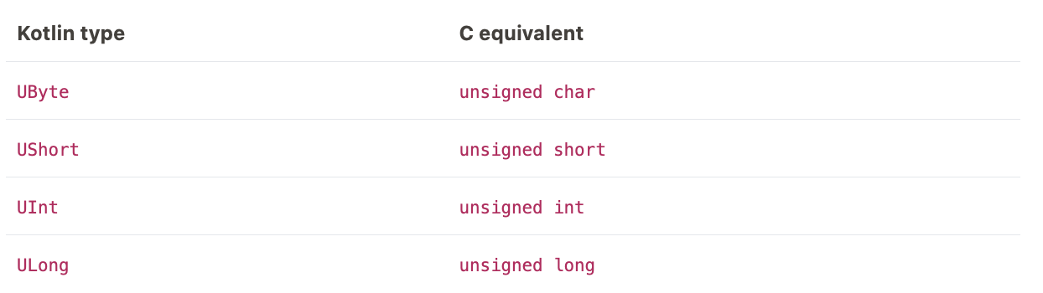
- Kotlin also has a way to represent unsigned integers (like C does):
- An unsigned integer uses the same storage space as its signed counterpart but shifts the range of representable values – only positive values are represented.
- A Byte can be a value in the range -128 to 127, whereas a UByte can be in the range 0-255
- Integer Literals:
  - A sequence of digits (optionally preceded by a + or - ) taken to represent an Int value.
    - Can also include the _ in between digits and is ignored by the compiler but can be used to separate group of digits.
  - To treat a literal as an unsigned value, can add the u or U suffix
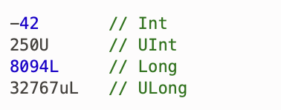
  - To treat a literal as a long integer, can add the l or the L suffix

- Floating-Point Types:
  - Kotlin has two ways to represent floating point values:
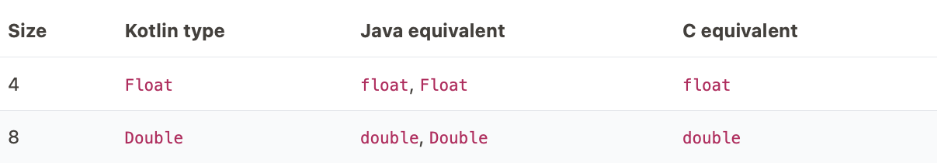
- The Double is also used in Kotlin to represent a wider range of values
- Floating-Point Literals
  - They are distinguished from integral literals either by inclusion of a decimal point or use of scientific notation
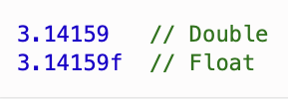
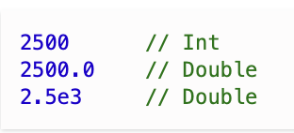

If literal is to be treated as a Float value rather than a Double value, can add the f or F suffix to it.

- Type Duplication in Java:
  - Java provides two types for each of Kotlin’s primitive types (like int or float) and wrapper classes (like Integer or Float)
  - Primitive types are more efficient and used for most things, but wrapper classes are required in certain cases like creating a list of integer values.
- Comparison with Python:
  - In Python all integers are represented as int type and all floating-point values are represented using float type
  - Python’s float is equivalent to Kotlin’s Double, but Python’s int has no direct equivalent in Kotlin – it is not restricted to occupying a maximum of 8 bytes.
- Individual Characters:
  - Kotlin provides the Char type to represent an individual Unicode character
    - Equivalent in Java is char for primitive type and Character for wrapper class.
  - Characters in Java and Kotlin require more storage spaces than a single byte (like C), but can represent letters from multiple alphabets, and a wider range of symbols.
- Character Literals:
  - The single quote (‘ ’) is the delimiter for literal Char values
    - Compiler error to put more than one character inside single quotes, or have an empty pair of single quotes
  - Can represent special non-printable characters via escape sequences that begin with a backlash e.g. ‘\n’
  - Can represent Unicode characters using escape sequences consisting of \u followed by the Unicode code point of the character (expressed with four hexadecimal digits) e.g. '€' or as '\u20ac'
- Strings:
  - Kotlin provides the String type to represent a sequence of Unicode characters
    - C strings are very primitive, being nothing more than a sequence of bytes in memory ending in a terminating null byte (Kotlin is like Python in strings)
  - Kotlin string is an object, with a length property and a variety of operations like:
    - .lowercase()
    - .isBlank()
- String literals:
  - As like C, the double quote (“ ”) is the usual delimiter for literal string values e.g. “Hello”
    - An empty pair of double quotes = a string of length 0
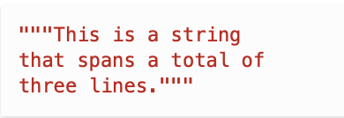
  - Can also use triple quotes for easy multiline texts

- Defining Variables in Kotlin:
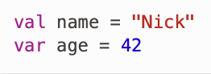
  - To introduce a variable into Kotlin code use either the val or var followed by the name of the variable and an assignment operation providing the value e.g.

- Type Interface:
  - Kotlin requires that the type of a variable is known at compile time (like C)
  - Kotlin can often infer what the type should be, freeing the idea of having to explicitly specify it, previous example can be written as:
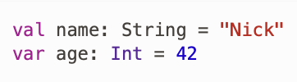

However, it does not require this level of explication, as Kotlin can infer it is a String due to the double quotes
Integer literals consisting of only digits are always regarded as Int values, same with Floating-point literals as a value like 3.5 would be treated as a Double. So, both are not ambiguous.
- Kotlin doesn’t provide special syntax to indicate that an integer literal should be represented as a Short or Byte value – must be indicated explicitly
- Difference between val and var:
  - When you define a variable with val, you are allowed to assign a value to it once and once only.
  - When you define a variable with var, you can assign a value to it as many times as you like e.g.

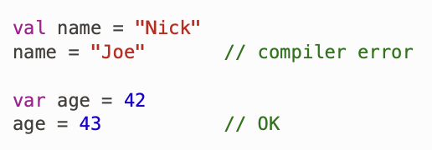
- Why use Val?
  - Kotlin uses val and var to separate values that remain unchanged from those that require updates.
  - Using val allows the compiler to detect accidental reassignment, such as updating amount instead of newAmount
  - Explicit syntax avoids hidden errors that could occur if all variables were defined as var, making issues harder to locate
  - In Kotlin it is best to define variables using val whenever possible and use var only in places where a variable will need to be reassigned a value.
- Constants:
  - When val is used, a fixed association between a name and an object is created – not allowed to associate the chosen name with a different object.
    - Doesn’t mean the object remains in the same state, so val variables are not true constants.
  - Kotlin allows for the creation of true compile-time constants for certain types, by applying the const modifier to a val:
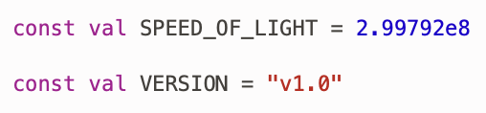

The compiler will inline any usage of that constant that it finds – meaning it will replace all occurrences of the constant with its literal value
- Restrictions to constants:
    - A constant can only be an instance of String, Char or a numeric type
    - A constant must be defined either at the top level of a file (i.e. not in a function), or inside the companion object of a class.
(By default, will be visible to code in other files that are part of the same package – doesn’t mean you cannot limit the constant’s visibility to just the file it is defined in by adding a private as a prefix)
- Naming Styles:
  - Lower Camel Case:
    - join words together to create the name, using all lowercase for the first word and then starting each subsequent word with an uppercase letter e.g. writeToFile
  - Upper Camel Case:
    - Like lower camel case, except all words start with an uppercase letter e.g. ConfigurationFile

  - Snake Case:
    - Render all words in uppercase and join them with underscores e.g. FILE_PATH
- When to use which naming style:
  - Lower Camel Case for names of variables, functions and methods
  - Upper Camel Case for class names
  - Screaming Snake Case for names of constants

- Introduction to I/O
- Command Line Input:
  - For Kotlin programs to use command line arguments, must modify definition of main() so that it has an array of strings as its sole parameter
    - Must be declared as Array<String>, the name has no significance but args or agrv are common/sensible choices.
  - Individual arguments are accessed by array indexing, which uses square brackets and a zero-based integer index
  - Arrays in Kotlin have a size property to check the correct number of arguments have been supplied to the program.
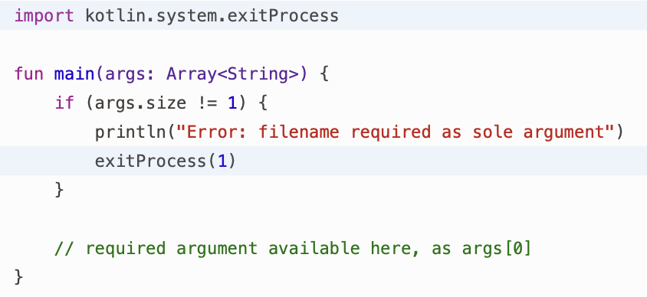
    - If the required number was not provided, it will be necessary to terminate the program prematurely with an error message e.g.

- Program name/File path is not stored in the array in Kotlin (unlike C & Python) thus, args[0] is the first argument supplied to the program not args[1],
  - terminating the program if the size of args is NOT equal to 1
- Kotlin source files have to begin with multiple import statements so that it can refer to functions, classes, etc.
- Calling the function exitProcess() halts a program’s execution by setting the program’s exit status to the value supplied as an argument
(By convention, an operating system will assume that a program has terminated normally if it has an exit status of zero)f

