Ktor – 2850
- HTML:
- HTML: HyperText Markup Language, foundational tech of web development.
  - Defines structure of resources (primarily text-based)
  - Can Include other types of media such as images/video
  - Can make resources interactive i.e. via forms
- Document Structure:
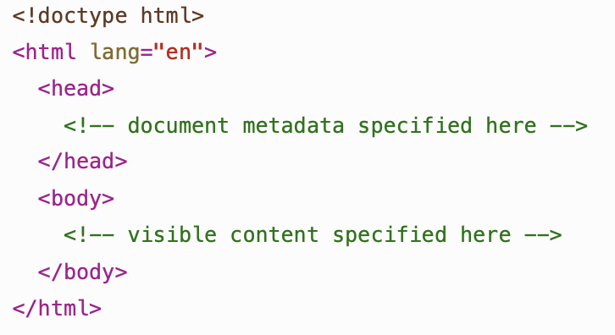
  - This is what a modern HTML document structure looks like:
Begins with a doctype declaration to indicate this is a HTML document
Without this the browser renders in ‘quirks mode’
After comes a single html element, known as the ‘root element’ of the document
- All elements in HTML documents are specified using tags, some may use:
  - A single tag like the document type declaration
  - An opening and a closing tag < > & </ >
- Opening tag of html element is <html> and the closing tag is </html>
- Document Head:
  - This is typically how a head element is typically defined
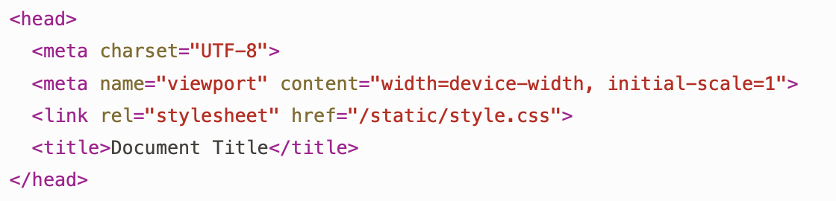

- Meta:
  - HTML documents should specify the character encoding using a meta element (UTF-8 is the most common encoding)
  - Used for viewport sizing (to render sites appropriately on different devices like mobile phones)
  - name and content attributes are used to specify arbitrary document metadata
  - specified using a single tag, doesn’t have a separate opening and closing tag
- title:
  - HTML documents should have a title element, which will be shown by the browser tab in which the document is displayed.
  - Contents of title are not displayed within the document itself, for that you will need to use the h1 element
- link:
  - used to link external resources for rendering
  - typically used to reference an external stylesheet containing CSS rules that apply to the code
  - Body Elements:
    - Text:
      - the p element organises text into paragraphs (can put emphasis on text using em, or stronger emphasis using strong)
e.g.

      - browsers typically default to italics for emphasis and bold for strong emphasis (can ve overridden using CSS)
      - there are also the i (italic) and b (bold) elements
    - Lists:
      - Can be an unordered (ul) or an ordered (ol) list
      - Represented using the li element which must be listed within the parent list element
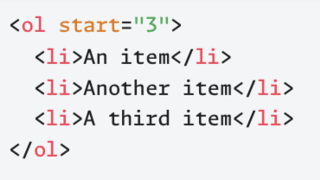
      - Browsers use bullets as default for items in an unordered list and an ascending sequence number for an ordered list
      - Ordered lists support a numeric attribute ‘start’, can be used to set the number of the first item in the list
    - Hyperlinks:
      - Created using the a (anchor) element, which can link to another part of the same document, or to an external document, or to another kind of resource
      - Target is specified using href attribute, which is usually a URL
      - Browsers typically render the anchor text in blue and underline it, style of it can be customised using CSS
    - Images:
      - Introduced to a document using the img element, which has the required attribute src providing a path to the image file
      - Path can be a local path or a full URL connecting to an external resource
      - Browsers can handle various image formats, but PNG and JPEG are the most used ones
      - Accessible documents require alt attribute as well, to provide a descriptive text for an image (can be read by screen readers) or can have the screen reader ignore it by using alt=“ ”

      - Can specify image dimensions (in pixels) using width and height attributes
    - Headings:
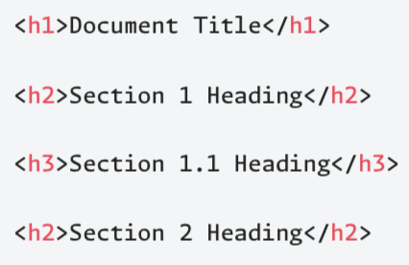
      - HTML supports six different levels of section heading using h1, h2, …, h6
      - The size of the headings decreases with h1 being the largest and h6 the smallest (can be customised by CSS)
      - Headings must have proper nesting with no skipping of levels
    - Other Structure:
      - Can enclose the main content inside a main element and represent a sidebar containing navigation links using nav element
      - Can use the article element which can be used to represent mini-reviews for example, can have header and footer elements within
      - Can use section element which is used in plcases where main, nav and article are not appropriate
    - div and span:
      - have no inherent meaning and used to mark specific parts of a document for targeting by CSS or JavaScript
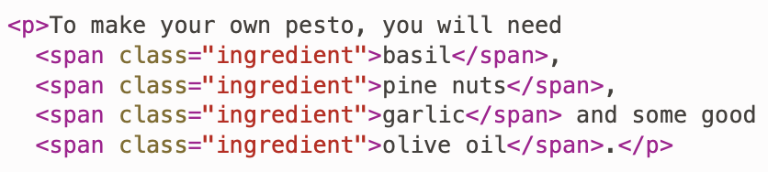
      - span can be used with a class to label inline items (like recipe ingredients) so they can be styled consistently with CSS

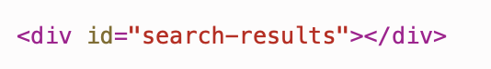
      - div can be used with an id to create a container (like search results area) that can be dynamically populated with content using JavaScript or htmx
  - Forms:
    - A form is introduced using the form element, which has several attributes, action and method being the most significant.
    - action attribute provides a URL pointing to the server-side code that will process the form data
    - method attribute specifies which HTTP method will be used to the submit the data to the given URL
      - default is GET but can use POST instead
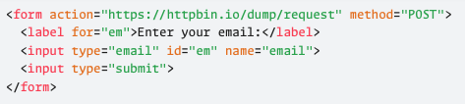
e.g.
single form field implemented using the input element, the name attribute is used to provide a name for the data the user types into the field
A field is described using a label element and for is used to associate the label with the form field that it describes
Value of the label’s for attribute must match the value of the associated form field’s id attribute
    - An alternative to <input type=”submit”> is:
  - Form Fields:
    - Single-line text inputs are created using the input element with various type attributes e.g. email, tel, url, number
    - Browsers provide Client-side built-in validation based on the type attribute (like an @ in an email) but it is for usability not security
      - Can be easily bypassed using tools like httpx to send arbitrary data directly to the server
    - Use textarea for larger amounts of text and select with option elements for dropdown lists
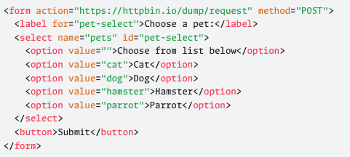
e.g.

- CSS:
- CSS: cascading style sheets, is a tech that compliments HTML. It focuses on specifying the appearance of different HTML document elements.
- Key Concepts:
  - Stylesheets consist of a set of style rules with the following format:
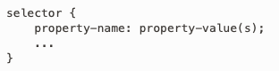
selector is an expression that matches one or more elements in a document
inside the { } are one or more property settings that will be applied to all matching elements
e.g. Targeting all level 1 headings
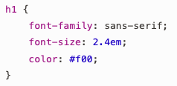
sans-serif is a standard way of referring to a browser’s default sans serif font but can explicitly name desired font family explicitly by providing name in quotes e.g. “Fira Sans”
Can also use a comma-separated list of font options and the first one found will be used.
2.4em refers to the size of the font where em is a relative size measure indicating n * larger than the base font size
- Selectors:
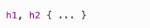
  - Can apply a rule to a set of different elements using a comma-separated list of the elements e.g.
  - An element can be given a unique ID in an HTML document using the id attribute e.g.
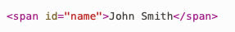
The selector for such an element uses the value of the id attribute, prefixed by a hash e.g. #name { … }
    - The rule applies to that one element only as the ID is unique
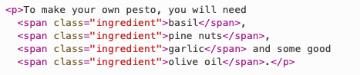
  - To apply the same rule, use the class attribute e.g.

    - To target this class .ingredient { … }
    - Can also combine type and class selectors to have span.ingredient { … }
(Which would target span elements in the ingredient class but not other elements of the same class)
  - CSS pseudo-classes: classes that automatically apply to elements that are in particular states e.g. :hover will apply to an element when the cursor is hovering over it.
  - CSS can also target pseudo-elements (not real HTML elements) which allow styling of particular parts of real elements e.g. : : first-letter and : : first-line
- Contextual Selectors:
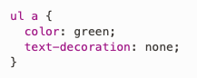
  - Descendant selector, consists of a type selector for a parent element then a space then a type selector for a descendant element.
This would target all hyperlinks a that are within unordered lists
  - Child selector, similar to a descendant selector but is more restrictive as it targets only direct descendants, using the ‘has child’ combinator > e.g.
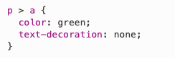
Will match only the hyperlink a that is within the p element, as it is directly within it.
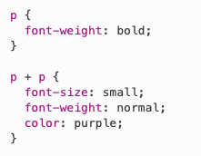
  - Adjacent Sibling, the + combinator is used to create selectors that target adjacent siblings in the element hierarchy of an html document e.g.
The p + p selector will select any paragraph that is immediately preceeded by a paragraph.
- CSS Frameworks:
  - Provide useful shortcuts to achieving an acceptable design, Bootstrap and Tailwind being common choices.
  - Will use a simpler framework Pico CSS
  - Pico CSS: a distributed bundle of CSS files that can be served from own web server, but a more convenient alternative is to load the stylesheet from a Content Delivery Network (CDN).
    - Can reduce bandwidth costs and will allow users of the site to benefit from upstream caching
    - To include via a CDN, include this in head (different versions are available):

    - Should also include this in head:
    - and finally include this:
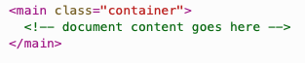

- HTTP:
  - HTTP: hyper-text transfer protocol which handles client-side requests and issues responses.
- Web Clients:
  - Typical web client is a standard web browser such as Chrome, and common to also have mobile apps.
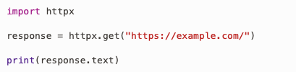
  - Any piece of software can act as a web client, provided that it has the ability to establish a secure connection to a web server, issue an HTTP request over the connection and handle resulting HTTP response e.g.
- Simple Web Server:
  - Listens on a particular TCP (Transmission Communication Protocol) port for incoming HTTP requests
  - Handles each request in an appropriate manner depending on associated URL
  - Delivers an HTTP response back to the client
  - Static Response: returns a fixed HTTP response immediately without invoking any downstream handlers.
  - Dynamic Response: server generates the content of its reply in real time when it receives a request, rather than sending a pre-existing, unchanged file.
  - To run a web server provided in the Python standard library python -m http.server
- Real Web Applications:
  - Standard web servers (like Apache or Nginx) handle static resources while separate application servers provided dynamic responses.
  - Heavily used applications may use a server farm with replica web servers to handle high traffic
  - Load Balancers: distribute requests among replicas to prevent overloading.
  - Many applications are database driven and may use a caching server (like Memcached or Redis) to store the results of expensive queries.
- HTPP Requests:
  - Consists of multiple lines each terminated with a carriage return character (CR) followed by a line feed character (LF).
  - Begins with a request line, starting with a request method, specifying the action to be performed on a resource.
    - Followed by a Uniform Resource Identifier (URI), a string that identifies the resource on which the method will operate
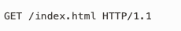
e.g. invokes the GET method requesting resource index.html
- Following the request line comes the header, consisting of one or more lines that specify header fields.
(Each field contains a case-insensitive field name, followed by a colon, followed by the value) e.g.

provides the domain name of the web server to which the request has been directed.
- Third element required is an empty line i.e. consists only of the CR and LF characters.
- Fourth element is a message body (optional) where data is usually placed within a request.
- GET & POST methods:
  - GET method: designed to fetch a resource from the server without changing anything on the server.
    - Should not contain a body, but can carry limited amounts of data from client to server by encoding that data into the URL.
  - POST method: can be used to send data, encoded in message body, to the server. Type of data being sent is specified using the Content-Type header field.
- GET & POST requests:
  - GET Requests: request line received after a GET request is usually something of the following

    - The form data submitted is encoded into the URL after the ? character
    - %40 is the URL encoding of the @ character as there are restrictions on characters allowed
    - Only HTTP headers are displayed, no body supplied in a GET request.
    - When refreshing, it resubmits the request made by the form and a Cache-Control header appears.
  - POST Requests: unlike GET requests, POST requests do not include form data in the request line but in the message body.
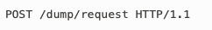
    - Browsers will warn before resubmitting a POST request as they are intended to modify data on the server (accidental resubmission could cause unintended consequences)
- Other Methods:
  - HEAD: behaves like GET, except it retrieves only the response header and not the content of the requested source.
    - Allows a web client to access metadata of that resource without having to download a potentially large amount of data.
e.g. could use to find out how big a video file is and check for sufficient space before attempting to download it using GET
- PUT: creates a new resource on the server using the content provided in the request body, or it replaces the specified resource with the content provided in the request body.
  - Browsers do not make PUT requests; they use POST to send data back to a server
  - Requests are idempotent, effect of making the same PUT request multiple times is no different than the effect of making it once.
  - A PUT request will trigger one of three possible responses if successful:
    - A 201 Created – a new resource created with a new header Content-Location
    - A 204 No Content or 200 OK – response already exists and was modified using the data provided in the request.
- DELETE: requests the server to delete the specified resource, not used by browsers but intended for use by other kinds of web client.
  - A DELETE request will trigger one of three possible responses if successful:
    - A 200 OK – deletion succeeded, with further info provided via response body
    - A 202 Accepted – deletion is pending and will probably succeed, with further info provided via response body
    - A 204 No Content – deletion succeeded but no further info has been provided via response body
- HTTP Responses:
  - Consists of multiple lines terminated by a carriage return and line feed
  - Status Line: First line includes the HTTP version, a three-digit status code (e.g. 200 for Success, 4xx for client errors, 5xx for server errors) and an optional explanatory phrase.
  - Headers: zero or more header lines follow the status line each containing a case-insensitive name, colon and a value
  - Empty Line: a blank line separates the headers from the message body
  - Message Body: final part containing the content, which can be text (like HTML) or binary data (like an image) and may be empty for certain requests (like HEAD).
- Investigating Response Headers:
  - Content-Type: indicates the document type e.g. text/html
  - Content-Encoding: shows if the content has been compressed e.g. gzip
  - Content-Length: Displays the size of the content in bytes (set to 363 Bytes)
  - Connection: when set to keep-alive, the server maintains TCP connection for future requests to speed up browsing.
  - Verbose Output (-v): adding this option reveals additional details, including TLS (Transport Layer Security), which begin with a *, information and the raw request header.
- Content Types:
  - Important part of the HTTP request-response cycle is the negotiation of content types.
  - Web client signals the content types it can handle by including the Accept header in a request.
  - Types are specified in a standard way, with a type/subtype format e.g.
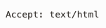
client accepts HTML documents

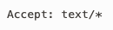
client accepts any kind of text document
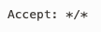
client accepts any type of content
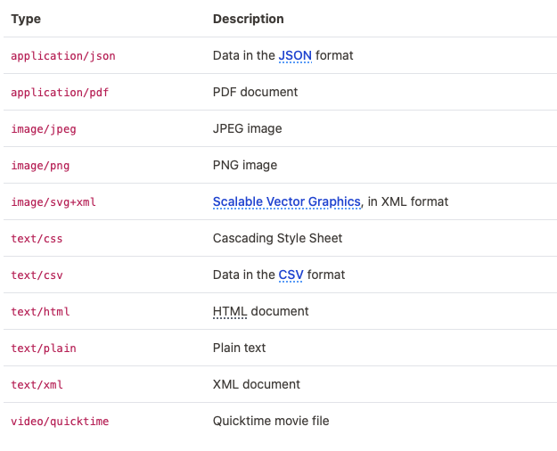
- Some examples of common content type specifications:

