1- List the user commands and redirect the output to /tmp/commands.list

2- Count the number of user commands

3- Get all the users names whose first character in their login is ‘g’.

4- Get the logins name and full names (comment) of logins starts with “g”

5- Save the output of the last command sorted by their full names in a file.

6- 1- to search for all files on the system that named .bash_profile



6-2- sorts the output of ls command on / recursively, Saving their output and error in 2 different files and sending them to the background.

* t option will sort files and directories by their last modification time, displaying the most recently modified ones first.

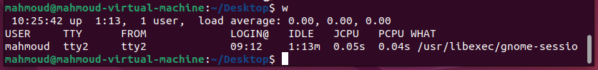7- Display the number of users who is logged now to the system.

8- Display lines 7 to line 10 of /etc/passwd file

9-1- usually the pipe line send the output of command 1 as input for command 2 but in this case it’s reading files so the output of filename1 won’t go as input for filename2 and it will show the output of filename2

9-2- it gave an error because the rm was expecting an argument of the name of the files to remove and ls doesn’t provide any arguments for rm

9-3- the `wc` word count command is counting the words but with `-l` option it counts the lines and the output of `ls /etc/passwd` shows one line the `wc` will give us 1

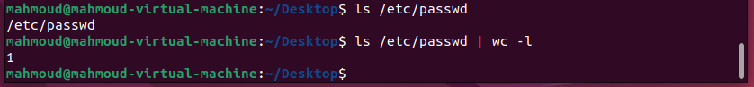

10- the `sleep 100` will make my current terminal sleep for 100 seconds and I will can’t do any more commands until it end.



11- I can use `CTRL + z` to stop the last command and here it gives me the status of every job and the job id

12- Resume the last command in the background

* A computer screen shot of text

  Description automatically generatedWhen I use `kill -CONT %1` it runs the job with id 1 again on the bg

13- Issue the jobs command and see its output.

* It displays the status of the jobs in the current shell and the job is a process associated with a terminal and I can run the job in background or foreground.

14- Send the sleep command to the foreground and send it again to the background.

15- Kill the sleep command.

* A screenshot of a computer

  Description automatically generatedI used another terminal to be able to write commands an then used `ps -e` command to get all process with their id and I used `kill -9 3872` to kill the sleep command with the process id and signal 9 ‘sigkill’

16- Display your processes only

17- Display all processes except yours

18- Use the pgrep command to list your processes only

* A screenshot of a computer

  Description automatically generated`-l` option shows the name of the process and `-u` option to specify the user and it will get only the process id

19- I used `killall -u user` and it killed all the process and logged me out

