Name :Mahmoud ashraf Mahmoud helmy

SEC: 3

-----------------------------

I = imread('cameraman.tif');

figure;imshow(I); %show original image

first = edge(I, 'prewitt');

figure;imshow(first); % show edges with first derivative

second = edge(I, 'log');

figure;imshow(second); % show edges with second derivative

canny = edge(I, 'canny');

figure;imshow(canny); % show edges with canny algorithm

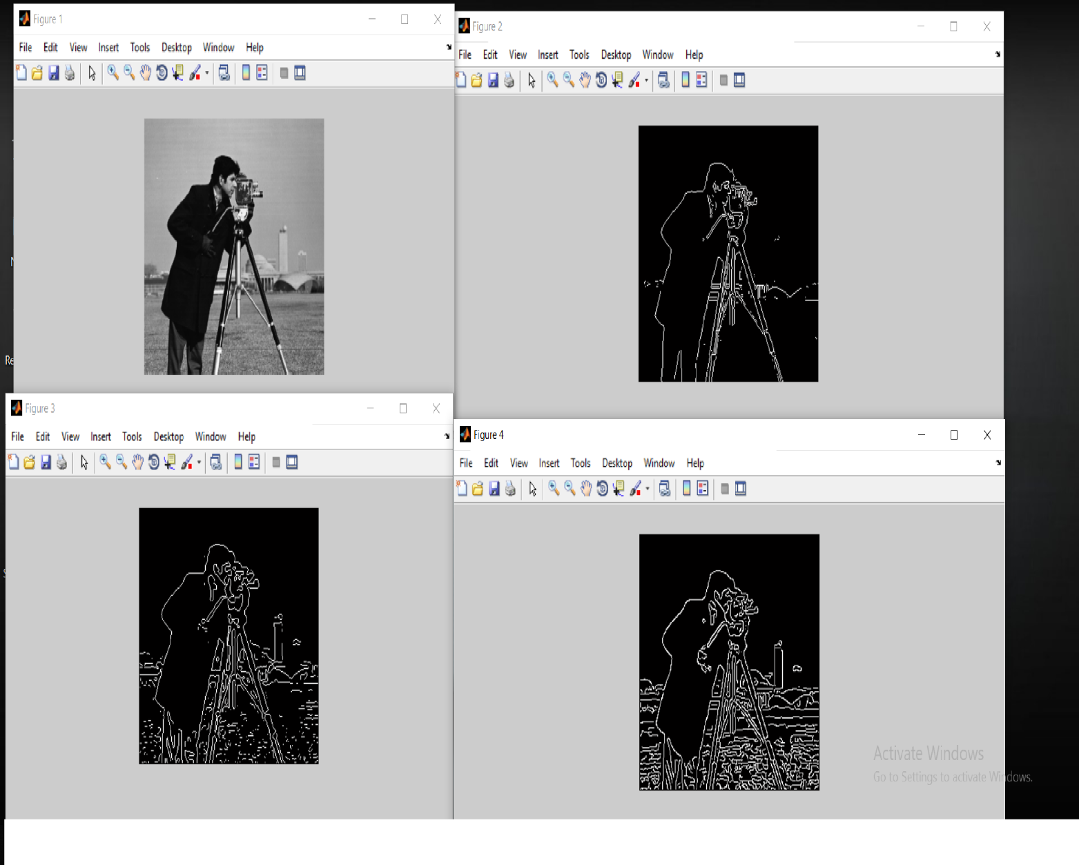

Figure 4 has best edge detection using canny algorithm