A Deep Learning-based Approach for Unsafe Area Prediction in Building Fire Evacuation
Hongqiang Fang^{1,}*, Botao Zhang¹, Wai Cheong Tam², Chendi Yang¹, S.M. Lo¹
- Department of Architecture and Civil Engineering, City University of Hong Kong, Hong Kong, People’s Republic of China
- Fire Research Division, National Institute of Standards and Technology, Maryland, USA
*Corresponding author
E-mail: hqfang3-c@my.cityu.edu.hk (H. Fang); zhang.botao@my.cityu.edu.hk (B. Zhang); waicheong.tam@nist.gov (W.C. Tam); chendyang2-c@my.cityu.edu.hk (C. Yang); sm.lo@cityu.edu.hk (S.M. Lo)

Abstract:
Dynamic directional exit signs (DDES), also known as smart exit signs, are specifically developed to provide real-time guidance to evacuees during building fire emergencies. However, the existing research lacks adequate focus on effectively predicting unsafe areas in such situations. This insufficiency hampers the ability of DDES systems to incorporate dynamic fire condition awareness seamlessly into route planning algorithms, thereby restricting their applicability in fire emergencies. To address this gap, this paper introduces a novel approach that utilizes deep learning (DL) methods for dynamically predicting unsafe areas during building fire emergencies. By leveraging DL methods--Bidirectional-GRU-based encoder-decoder (BiGRU-ED), the proposed approach establishes a mapping between sequential data of on-site temperature observations and future states of fire characteristics. This enables the identification of potential hazards in building floor areas that may become unsafe zones in advance, which allows for adequate time to plan safer evacuation routes and control DDES systems accordingly. The results of a case study demonstrate the feasibility and effectiveness of the proposed approach, highlighting its potential for improving smart control of DDES systems in building fire emergencies.
Key words: fire safety, dynamic evacuation, deep learning, GRU, fire exit signs.

Introduction
Building fire evacuation is the major concern of design professionals, building engineers, and emergency responders. Currently, building fire evacuation follows a prescriptive evacuation plan to evacuate occupants in a fire event. The evacuees are directed to the nearest exit with a stipulated evacuation route, regardless of any changes in fire situations. Nevertheless, it is worth discovering that the prescriptive evacuation route may not always be safe in actual fire events. Due to rapid fire spread and smoke propagation, there is a great chance for dense smoke and extreme heat to spread to the evacuation route and significantly endanger evacuees’ lives when the fire intensifies. Therefore, challenges and insufficiencies may exist in current prescriptive escape route plans, and dynamic evacuation path planning may be more adapted.
Recently, the use of intelligent control for facility management has become a promising solution in built environment studies (Fang, Lo, & Lo, 2021; Jia, Komeily, Wang, & Srinivasan, 2019; Kelly, Suryadevara, & Mukhopadhyay, 2013; Pan, et al., 2015; Yu, et al., 2021). By facilitating the collection and exchange of data among virtually everyone and everything in buildings, the cyber and physical environments in buildings have become unprecedentedly entangled. Regarding the intelligent control of fire evacuation in buildings, dynamic directional exit signs (DDES), also known as smart exit signs, become one of the most conspicuous applications in this context (Wong, Zhang, & Huang, 2022). The DDES is a dynamic signage system that can dynamically change its directions to inform evacuees of the directions for escape, as shown in Figure 1. During the fire evacuation process, it can be used to keep evacuees safe by guiding evacuees to detour ahead before reaching an unsafe area on evacuation routes. It is noted that the DDES, unlike conventional exit signs, is specifically designed as an intelligent control system capable of dynamically adjusting evacuation routes in response to changing fire scenes. Thus, certain models and algorithms should be equipped to analyze the on-site fire situations and subsequently control the exit signs’ directions.
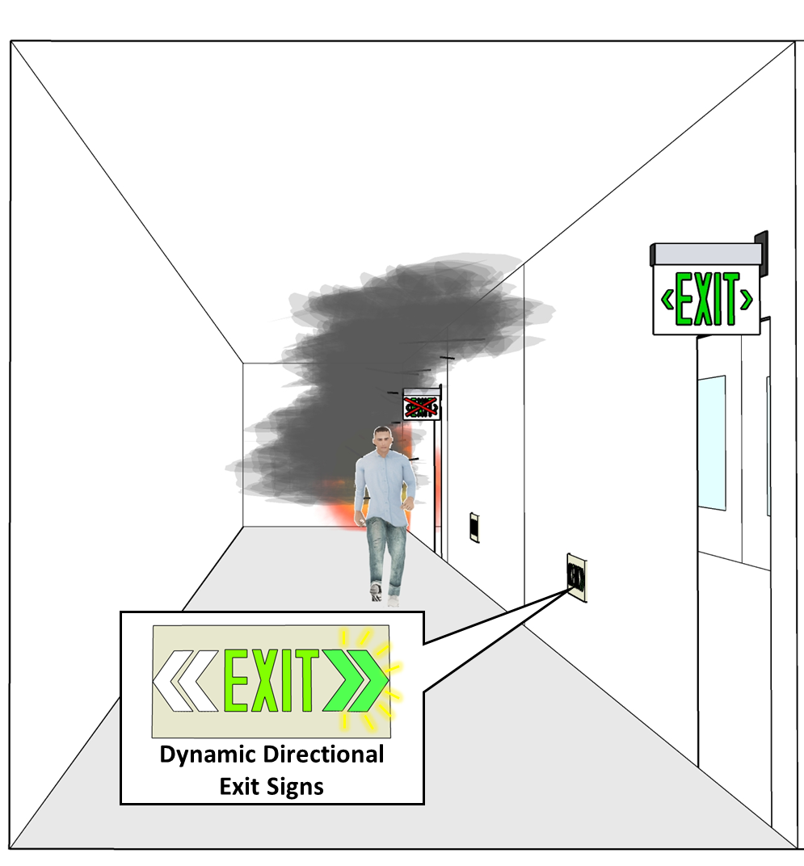
Figure 1. The application of DDES involves preventing evacuees from entering unsafe areas and guiding them toward safer evacuation routes.
Currently, many researchers have designed intelligent control algorithms for DDES. An automated direction setting algorithm (ADSA) for smart exit signs was proposed by Cho et al. (J. Cho, Lee, & Lee, 2015). The algorithm translated spaces and elements in real buildings into nodes and lines. Then, certain nodes representing unsafe areas were eliminated from the navigation graph network according to a given fire situation. Finally, the shortest path for the escape was determined via Dijkstra’s algorithms. Moreover, a building information modeling (BIM)-based exit sign direction control algorithm was proposed by Fu et al. (Fu & Liu, 2020). This study also employed Dijkstra’s algorithm to calculate the shortest path in a navigation graph network where the nodes representing the unsafe area were excluded. Apart from these intelligent algorithms directly for DDES control, many researchers investigated pathfinding in fire emergencies. These studies also provided basic knowledge for DDES control. In the work of Jiang (Jiang, 2019), an intelligent route planning algorithm considering the intensity of the fire was proposed. The ant colony algorithm was utilized to search the shortest path toward building exits, and the interference of fire hazards was considered by setting a dynamic obstacle in the established two-dimensional grid building environment. An optimal path-planning algorithm for dynamic building fire rescue operations was proposed by Chou et al. (Chou, Cheng, Hsieh, Yang, & Hsu, 2019). The algorithm employed Dijkstra’s algorithm to plan the rescue path by taking the ignition point and the locations of trapped occupants as starting points.
From the current literature, although many studies have already considered the impact of fire hazards in their path planning algorithms, there is still a lack of research efforts to clarify how unsafe areas are determined and considered in dynamic fire evacuation problems. The most common practice is to assume a fixed range of unsafe areas based on the activated detector locations (Chou, et al., 2019; Fu & Liu, 2020; S. Park, et al., 2018). Then, safer evacuation routes are planned by considering such a risky area in the route planning algorithm. Finally, DDES is controlled to guide occupant evacuation by directing the safe evacuation route. Notably, there may be a shortcoming in such a real-time unsafe area identification and route planning process. Time spent on real-time data collection and processing, evacuation route re-routing, and change of exit sign directions can cause significant delays. As a result, the updated evacuation guidance information can only be delivered to evacuees in near real-time or even on a delayed basis. In a real built environment, fire spreads rapidly in enclosure spaces. Evacuees are likely to have entered an unsafe area before seeing such an exit sign changing signal. Furthermore, fire detectors are usually mounted on the ceiling height of a room or corridor. Consequently, the fire detector observation may only represent the environmental condition of the upper layer in a fire. A large difference may exist between the fire condition at the upper layer and human height. Therefore, the application of DDES is still at a very early stage, and these major insufficiencies in fire situational awareness hinder the DDES control algorithms from being more effective.
A sequence-to-sequence mapping between the current fire development and its future state may be considered to tackle these issues. Based on the monitoring of the current fire conditions, forecasts of the future state of fire conditions and identification of the unsafe areas can be advised. This predicted information can then be used to control and update DDES, guiding occupants to follow the safest evacuation route toward the exits fairly before the hazard reaches. Such a sequence-to-sequence mapping problem is commonly encountered in engineering fields demanding a period of forecasting (K. Cho, et al., 2014; Park, Kim, Kang, Chung, & Choi, 2018; Shah, Chadha, Schwung, & Ding, 2021). One of the most common approaches to solving the problem is to develop sequence-to-sequence prediction models using deep learning (DL). For instance, a DL-based prediction model for estimating the state of charge of lithium-ion batteries at different temperature conditions was proposed by Bian et al. (Bian, He, Yang, & Huang, 2020). Short-term predictions of gas concentration in coal mines were achieved via a sequence-to-sequence DL model by Lyu et al. (Lyu, Chen, Mao, & Li, 2020). Moreover, Li and Tong (Y. Li & Tong, 2021) developed a sequence-to-sequence model to enable predictions of thermal environments and smart control in buildings.
Recently, DL has rapidly emerged to solve various fire-related problems. Fang et al. (Fang, Lo, Zhang, & Shen, 2021; Fang, Xu, Zhang, & Lo, 2023) employed DL-based approaches to identify the stages of fire development and localize the origin of fire sources on building floors. In the work of Wu et al. (Wu, et al., 2021; Wu, et al., 2022), Long short-term memory (LSTM) networks were employed to enable the inverse of fire source and fire size in a tunnel fire. Regarding identifying flashovers in multi-compartment building structures, Tam et al. (Tam, et al., 2022; Tam, et al., 2023) successfully employed attention-based recurrent neural networks to identify flashovers in multi-compartment building structures. Besides, a DL-based model was developed by Li et al. (J. Li, et al., 2023) to classify the state of firefighters’ heart health during a mission in a real-time manner. Therefore, DL methods can be employed to achieve short-term prediction of unsafe areas in building fires. For that, the sequence-to-sequence DL model is expected to be developed to forecast the future state of fire development and subsequently identify the corresponding unsafe areas on evacuation routes. By considering such unsafe areas during the evacuation response, active evacuation route planning and DDES control can be efficiently obtained.
To demonstrate the feasibility and effectiveness of the development of the sequence-to-sequence DL model for unsafe area prediction, we propose a methodology for dynamic unsafe area prediction and present a case study in this paper. The remaining sections of the paper are organized as follows. The theoretical background of the DL methods used in this paper is described in Section 2. Section 3 introduces the methodology for dynamic unsafe area prediction. In Section 4, we present a case study on the development of the sequence-to-sequence DL model for unsafe area prediction and provide an example of its application in active evacuation route planning. The discussion of the study is given in Section 5, followed by the conclusions in Section 6.

Theoretical background
In order to carry out short-term prediction of unsafe areas in a building fire, we consider using sequence models—Recurrent Neural Networks (RNNs) (Fang, et al., 2023; Y. Li & Tong, 2021; Tam, et al., 2023), as the backbone network structure for processing the sequential data from temperature sensor measurements. Particularly, bidirectional RNNs are applied to improve the accuracy over traditional sequence modeling. In addition, encoder-decoder (ED) architecture is employed to enable mapping between input and output sequence data and facilitate sequence-to-sequence predictions. The theoretical background of these DL methods is introduced below.

Gated Recurrent Unit (GRU)
RNNs are a type of artificial neural network that is designed to process sequential data or temporal data (Tealab, 2018). It is fundamental to various applications, including natural language processing, speech recognition, and time series analysis. However, the traditional RNN suffers from several shortcomings, including vanishing gradient problems, exploding gradient problems, and difficulty in capturing long-term dependencies (Bengio, Simard, & Frasconi, 1994). Therefore, Long Short-Term Memory (LSTM), which acts as an improved RNN (Hochreiter & Schmidhuber, 1997), and Gated Recurrent Units (GRU), a further variation of LSTM (K. Cho, et al., 2014), was utilized. By incorporating memory cells and gating mechanisms to selectively retain and forget information over time, LSTMs overcome the limitations of traditional RNNs and capture long-term dependencies in sequential data. Similar to LSTMs, in addition to effectively solving the problem of gradient explosion and gradient disappearance in the RNN, GRUs provide a simpler architecture than LSTMs, making GRUs more computationally efficient and especially effective in handling short-term dependencies.
Figure 2 illustrates the difference between a typical LSTM and GRU cell structure. In the single cell of LSTMs, a special unit called memory blocks is set up to process long-term past data. Each memory block contains an input gate, an output gate, and a forget gate to regulate the flow of input information to prevent gradients from disappearing too quickly (Sak, Senior, & Beaufays, 2014). The computation of a LSTM network is governed by the following equations (Kim, Park, Kim, & Shin, 2019):
$$f_{t}=σ\left(W_{f}[h_{t-1},x_{t}]+b_{f}\right)$$ | (1)
$$i_{t}=σ\left(W_{i}[h_{t-1},x_{t}]+b_{i}\right)$$ | (2)
$${\overset{˜}{C}}_{t}=tanh⁡\left(W_{c}[h_{t-1},x_{t}]+b_{c}\right)$$ | (3)
$$o_{t}=σ\left(W_{o}[h_{t-1},x_{t}]+b_{o}\right)$$ | (4)
$$C_{t}=f_{t}⊙C_{t-1}+i_{t}⊙{\tilde{C}}_{t}$$ | (5)
$$h_{t}=o_{t}⊙tanh⁡\left(C_{t}\right)$$ | (6)
where $C_{t-1}$ and $h_{t-1}$ are two states of LSTM cell at the previous time point. $f$, $i$, and $o$ are the forget gate, input gate and output gate, respectively. Their corresponding weight matrix are $W_{c}$, $W_{f}$, $W_{i}$, and $W_{o}$, and $b$ is the bias term. $σ$ represents the logistic sigmoid function. Controlled by the forget gate, input gate, and output gate, both the cell state $C$ and hidden state $h$ of LSTM cells are updated to form a new cell state $C_{t}$ and a new hidden layer state $h_{t}$ after feeding a new input data $x_{t}$.
Alternatively, in the cell of GRUs, the forget gate and input gate are merged to form a new gate called the update gate. Moreover, GRUs use a reset gate to determine whether the past hidden state is ignored. Since the GRU has one fewer gate and a smaller matrix multiplication, less computational time is needed when a large volume of sequence data is being processed. The following equations govern the computation of a GRU network (Dey & Salem, 2017):
$$z_{t}=σ\left(W_{z}[h_{t-1},x_{t}]+b_{z}\right)$$ | (7)
$$r_{t}=σ\left(W_{r}[h_{t-1},x_{t}]+b_{r}\right)$$ | (8)
$${\overset{˜}{h}}_{t}=tanh⁡\left(W_{h}[{r_{t}⊙h}_{t-1},x_{t}]+b_{h}\right)$$ | (9)
$$h_{t}={(1-z}_{t})⊙h_{t-1}+z_{t}⊙{\tilde{h}}_{t}$$ | (10)
where $h_{t-1}$ is the hidden state of a GRU cell at the previous time point. $z$ and $r$ are the update gate and reset gate, respectively. Their corresponding weight matrix are $W_{z}$, $W_{r}$, and $W_{h}$, and $b_{z}, b_{r}, b_{h}$ are the bias terms. $σ$ represents a sigmoid activation function to squash the result between 0 and 1, and $tanh$ denotes an activation function to scale the values into the range of -1 to 1. Governed by the update gate, reset gate, and input transformation, the hidden state $h$ of GRU cells is updated to create a new hidden state $h_{t}$ as a result of inputting a new input data $x_{t}$, while the memory content remains relatively unchanged.
Due to such a simplified structure in GRUs, faster training and inference time are observed in GRUs and make them more computationally efficient. Therefore, we decide to employ GRUs as the basic RNN cell in this study.
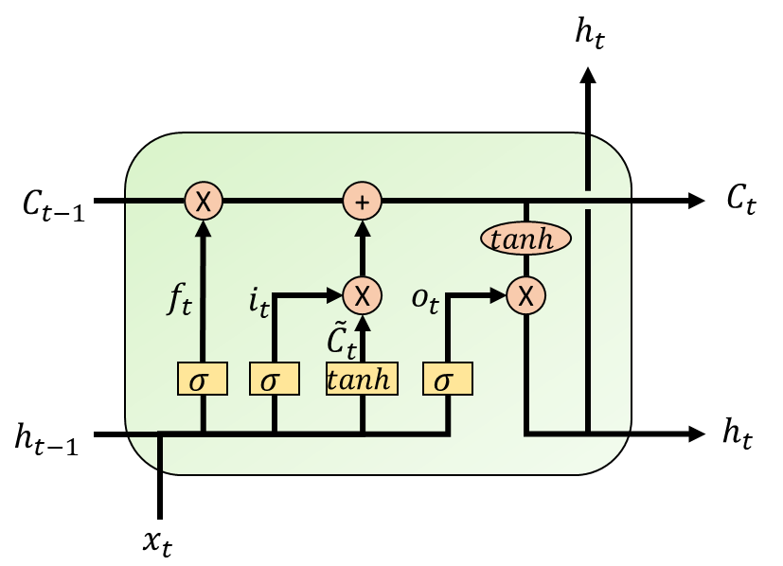 | 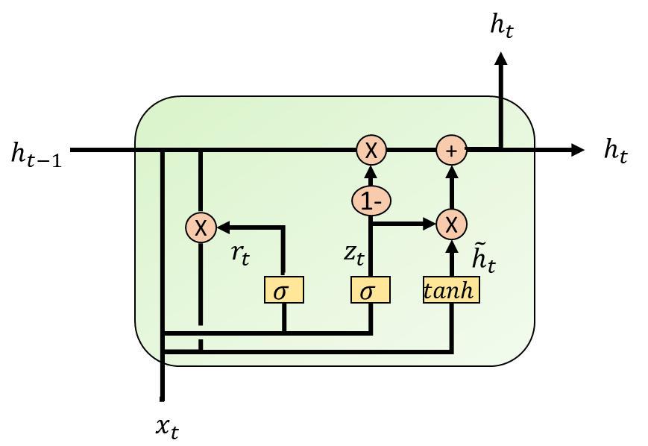
LSTM | GRU
Figure 2. Diagram of a single LSTM and GRU cell structure.

Bidirectional RNNs
In basic RNN, LSTM, and GRU networks, unidirectional architecture is usually considered, making them only able to access the previous input for each specific time step (Krizhevsky, Sutskever, & Hinton, 2017). Such a unidirectional information collection mechanism may limit the model’s ability to capture dependencies and context from both past and future time steps in sequential data. Therefore, a bidirectional recurrent architecture was proposed to integrate two separate recurrent structures and enable data processing from forward (past to future) and backward (future to past) directions (Schuster & Paliwal, 1997). Figure 3 illustrates the general bidirectional RNN structure. The internal cell of the network can be replaced by more sophisticated units, such as LSTMs and GRUs. Consequently, bidirectional GRU (BiGRU) networks are employed in this study. The network system is constructed with two separate GRU networks, where one processes the input sequence in the forward direction and the other in the backward direction. By processing information and context from past and future time steps, BiGRU is able to capture a broader range of dependencies and provide a more comprehensive understanding of the sequential data. At any timestep t, the output of BiGRU from each of the forward and backward cells is represented as:
$${\hat{y}}_{t}=\vec{W_{hy}}∙\vec{h_{t}}+\overset{⃖}{W_{hy}}∙\overset{⃖}{h_{t}}+b_{y}$$ | (11)
where ${\hat{y}}_{t}$ is the complete output. $\vec{W_{hy}}$ and $\overset{⃖}{W_{hy}}$ denote the forward and backward hidden to output weights. $b_{y}$ denotes the output bias. A single output is equal to the concatenated vector of the forward and backward process outputs. In this way, a summary of the past and future information can be obtained.
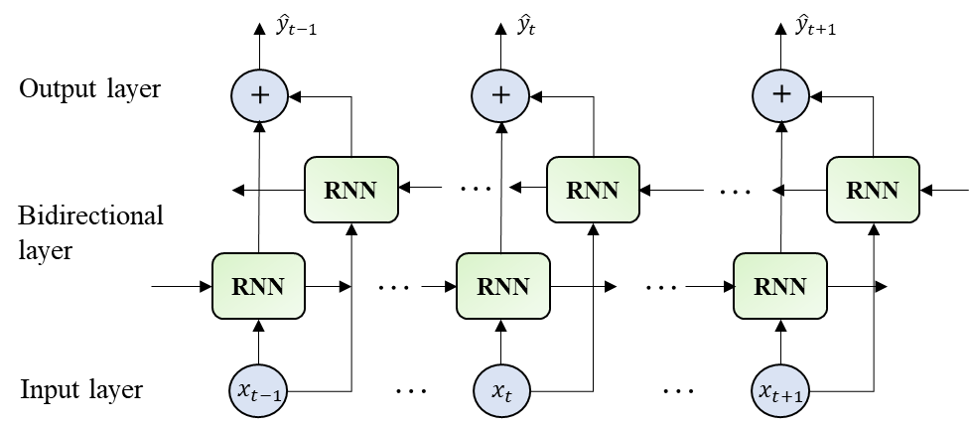
Figure 3. Structure of the bidirectional RNN.

Encoder-decoder (ED) architecture
The problem of mapping an input sequence to an output sequence in a DL context is called a sequence-to-sequence problem (Sutskever, Vinyals, & Le, 2014). The ED architecture is a way to solve this sort of problem by enabling reading and generating a sequence of arbitrary lengths of data (S. H. Park, et al., 2018). In the architecture of an ED, encoder and decoder layers based on RNNs are constructed, as shown in Figure 4. In the data processing process, the encoder layer processes a variable-length sequence data, $x=\{x_{1},..,x_{n}\}$, and encodes the sequence into a fixed-length state vector. By feeding such a state vector to the decoder layer, the decoder decodes the state vector, and the corresponding output sequence data, $y=\{y_{1},..,y_{m}\}$ is generated. The state vector can be seen as a bridge to connect the encoder and decoder layers, enabling the ED to capture and utilize the relevant information from the input data sequence. It is noted that the recurrent block of the ED can also be replaced to improve overall performance. Thus, in this study, the encoder and decoder are each replaced by bidirectional GRU units to develop a bidirectional-GRU-based encoder-decoder (BiGRU-ED). The formulated BiGRU-ED networks are applied to support the dynamic prediction of unsafe areas in a building fire and subsequently provide information to plan the safe evacuation route and control DDES, guiding occupants toward the safest paths for escape.
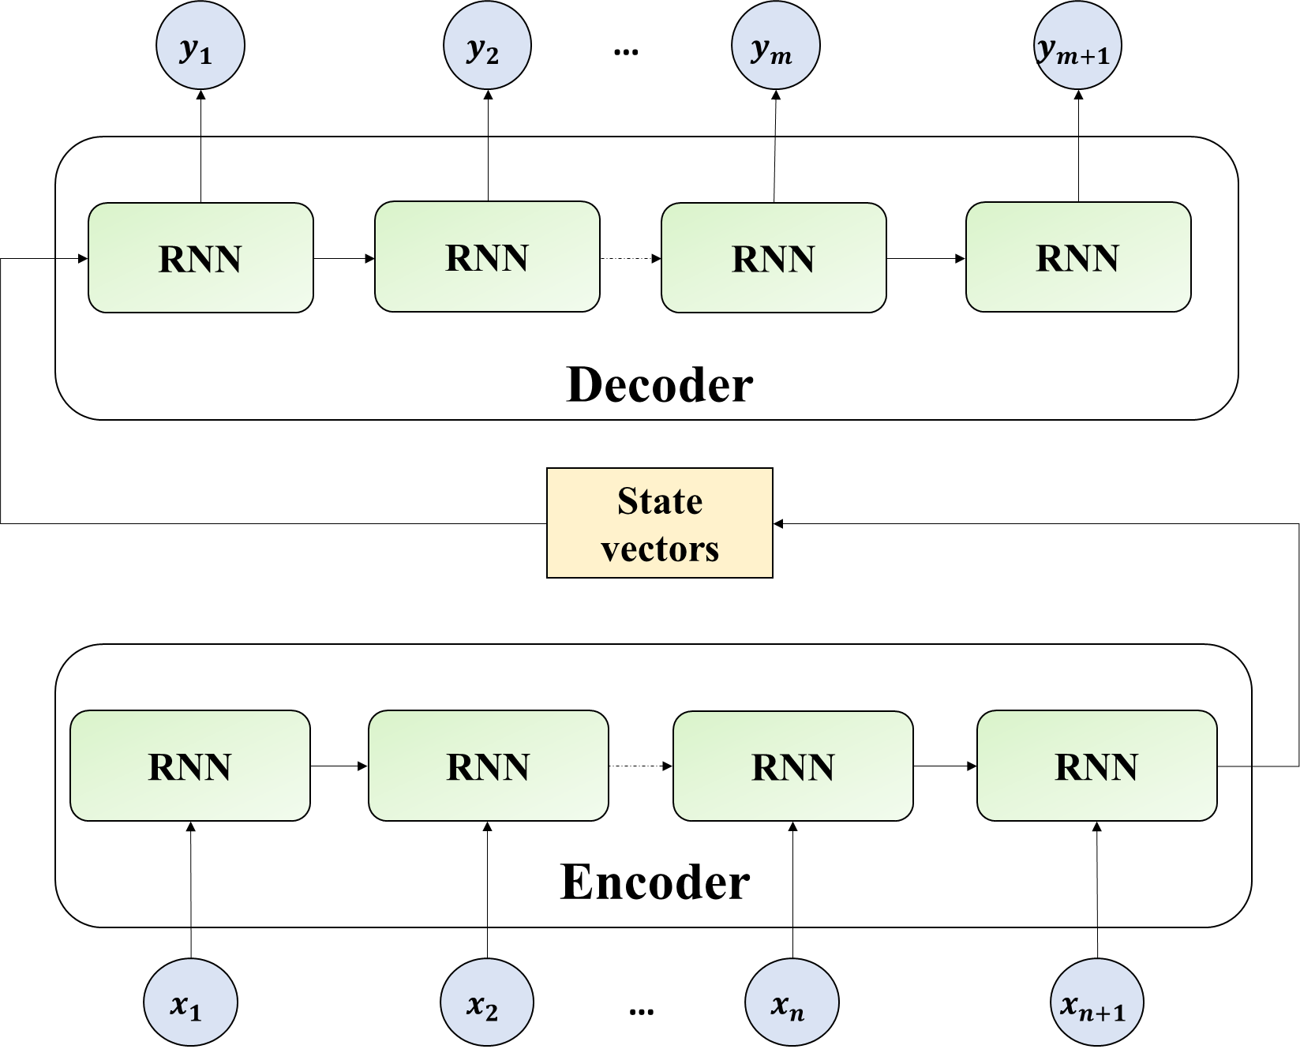
Figure 4. Overall encoder-decoder architecture.

Methodology for dynamic unsafe area prediction
The methodology for the dynamic unsafe area prediction is introduced in this section. The methodology enables an overall process of data collection, DL modeling, and model application. An overview of the framework architecture, BiGRU-ED workflow, and the criteria for unsafe area determination are respectively introduced.

Overview of the framework architecture
The overall framework contains 4 major steps, as shown in Figure 5:
Step 1: Numerical simulation data generation (Task 1, 2, and 3)
The first step is to generate numerical simulation data required for the BiGRU-ED model training, validation, and testing. Since fire incidents and accidents are relatively rare in the real world, a common approach for creating enormous data for DL model training in the fire safety domain is to use numerical data (Buffington, Cabrera, Kurzawski, & Ezekoye, 2021; Fang, Lo, Zhang, et al., 2021; Kou, Wang, Guo, Zhu, & Zhang, 2021; Wu, et al., 2021). Fire Dynamics Simulator (FDS) (McGrattan, et al., 2013), a computational fluid dynamics (CFD)-based fire-driven model, is one of the most common models for simulating the smoke propagation of a fire event. Thus, FDS is used in this framework to generate the necessary data for the DL model training, validation, and testing.
Task 1 - Fire scenario design
In order to generate a substantial quantity of numerical simulation data for DL modeling, it is essential to carefully design a series of fire scenarios that accurately represent the potential fire events within the chosen physical domain. Given the inherent randomness of fire events, creating a comprehensive list of fire scenes involves combining various fire parameters, including fire location, fire size, fire growth rate, and more. By employing sampling methods to effectively extract fire parameter values from a reasonable range, a diverse set of fire scenarios can be obtained. These scenarios encompass a wide range of possible combinations, enabling the generation of rich and representative numerical simulation data for DL modeling purposes.
Task 2 - Raw numerical database
A sufficiently large amount of fire simulation data is obtained after executing the designed fire scenarios using the numerical simulation model—FDS. A database containing various fire characteristics, including temperatures, CO level, and visibility, can be constructed. Notably, the database is described in a four-dimension array, including time series, scenario cases, specific fire characteristics, and measurement points. Additionally, in terms of fire characteristics, X represents the specific temperature sensor measurements at a ceiling height, and Y1, Y2, and Y3 denote the fire condition of temperatures, CO level, and visibility at a human height, respectively.
Task 3 - Split the database
Afterward, normalization needs to be conducted to scale the data within a specific range so that the model learning process and the computational complexity can be reduced. Additionally, the normalized dataset is divided into training, validation, and testing sets. The training dataset is used to train the model, while the validation dataset is utilized to evaluate the fitted model during the training process. The testing dataset is employed to estimate the quality of the final model. In this study, 60% of the data in the dataset is allocated for model training, 30% for model validation, and 10% for model testing.
Step 2: Preprocessing the data (Task 4 and 5)
The second step is to preprocess the raw data and organize the input and output data. As a result, the raw data can be transformed into a format that is suitable for further analysis and modeling. The major task includes reshaping the data structure and labeling input data with their corresponding outputs.
Task 4 - Reshape data structure
Different types of neural networks require specified data formats. Thus, a time series data array needs to be constructed for BiGRU-ED modeling. In the four-dimension raw database array, data features from each time slice are included. Specifically, for each time slice, temperature collections from a series of measurement points are included. Therefore, we generated sequential data arrays for model input and output by sliding down a window in a fixed length overlappingly in the database. It is noted that the input and output window lengths can be different. The window length determines the number of past or future time steps considered for each input or output.
Task 5 - Label input data with their corresponding outputs
After formatting the input and output data arrays, the input data array with its corresponding output data array needs to be labeled accordingly. For dynamic unsafe area prediction, we require fire characteristics, including temperature, CO level, and visibility, at a human height to be predicted using temperature information from sensors at a ceiling height. In addition, outputs in a period of future time are required to be predicted from a window of input data up to the current time step. Thus, three pairs of input and output are arranged. As shown in Task 5 in Figure 5, the sequential input data of X (temperatures at ceiling height in a period of previous timesteps) is labeled with output data of Y1 (temperature), Y2 (CO), and Y3 (visibility) at a human height in a period of future timesteps, respectively. The timesteps for the input and output data are determined by the window lengths defined in the previous task.
Step 3: Formulating the neural network model (Task 6)
Task 6 - BiGRU-ED modeling
Hereafter, the dynamic unsafe area prediction model is formulated by constructing the sequence-to-sequence DL model--BiGRU-ED. The proposed BiGRU-ED is a combination of GRU, bidirectional RNNs, and ED architecture. The encode-decode mechanism of the model ensures the dynamic unsafe area prediction through processing the sequential data. The proposed model is trained and tested by feeding the BiGRU-ED with the structured input and output data in the training, validation, and testing datasets. Based on an evaluation of the model’s performance, modifications to the model structure and hyperparameters can be applied to improve the model’s predictive power and eventually obtain the optimal model for unsafe area prediction. The detailed workflow of the BiGRU-ED modeling is introduced in Section 3.2.
Step 4: Predicting the unsafe areas (Task 7)
Task 7 - Unsafe area identification
With the establishment of the DL model of BiGRU-ED, prediction of future temperature, CO level, and visibility at a human height is achieved. In terms of fire emergencies in building floors, a time-series prediction of fire characteristics at human heights can be obtained by feeding the measurements of the ceiling-mounted temperature sensors as model inputs. Then, these predictions need to be converted into identifying the unsafe areas for egress. Here, tenability limits of human beings in a fire are employed. In general, fire tenability involves assessing the environmental factors, such as heat, smoke, and toxic gases (AiRAH, 2011). Thus, an unsafe area can be identified as the predictions generated by the model exceed the established fire tenability criteria. The specified fire tenability criteria for the study are introduced in Section 3.3.
In addition to identifying unsafe areas, the knowledge of these areas allows for the active dynamic planning of evacuation routes, facilitating a safe and efficient fire evacuation process. In this context, DDES can be intelligently controlled to provide occupants with valuable and timely guidance toward the safest evacuation paths during a fire emergency. The detailed methods of enabling such safe evacuation route planning based on the prediction of unsafe areas are introduced within the application example in Section 4.
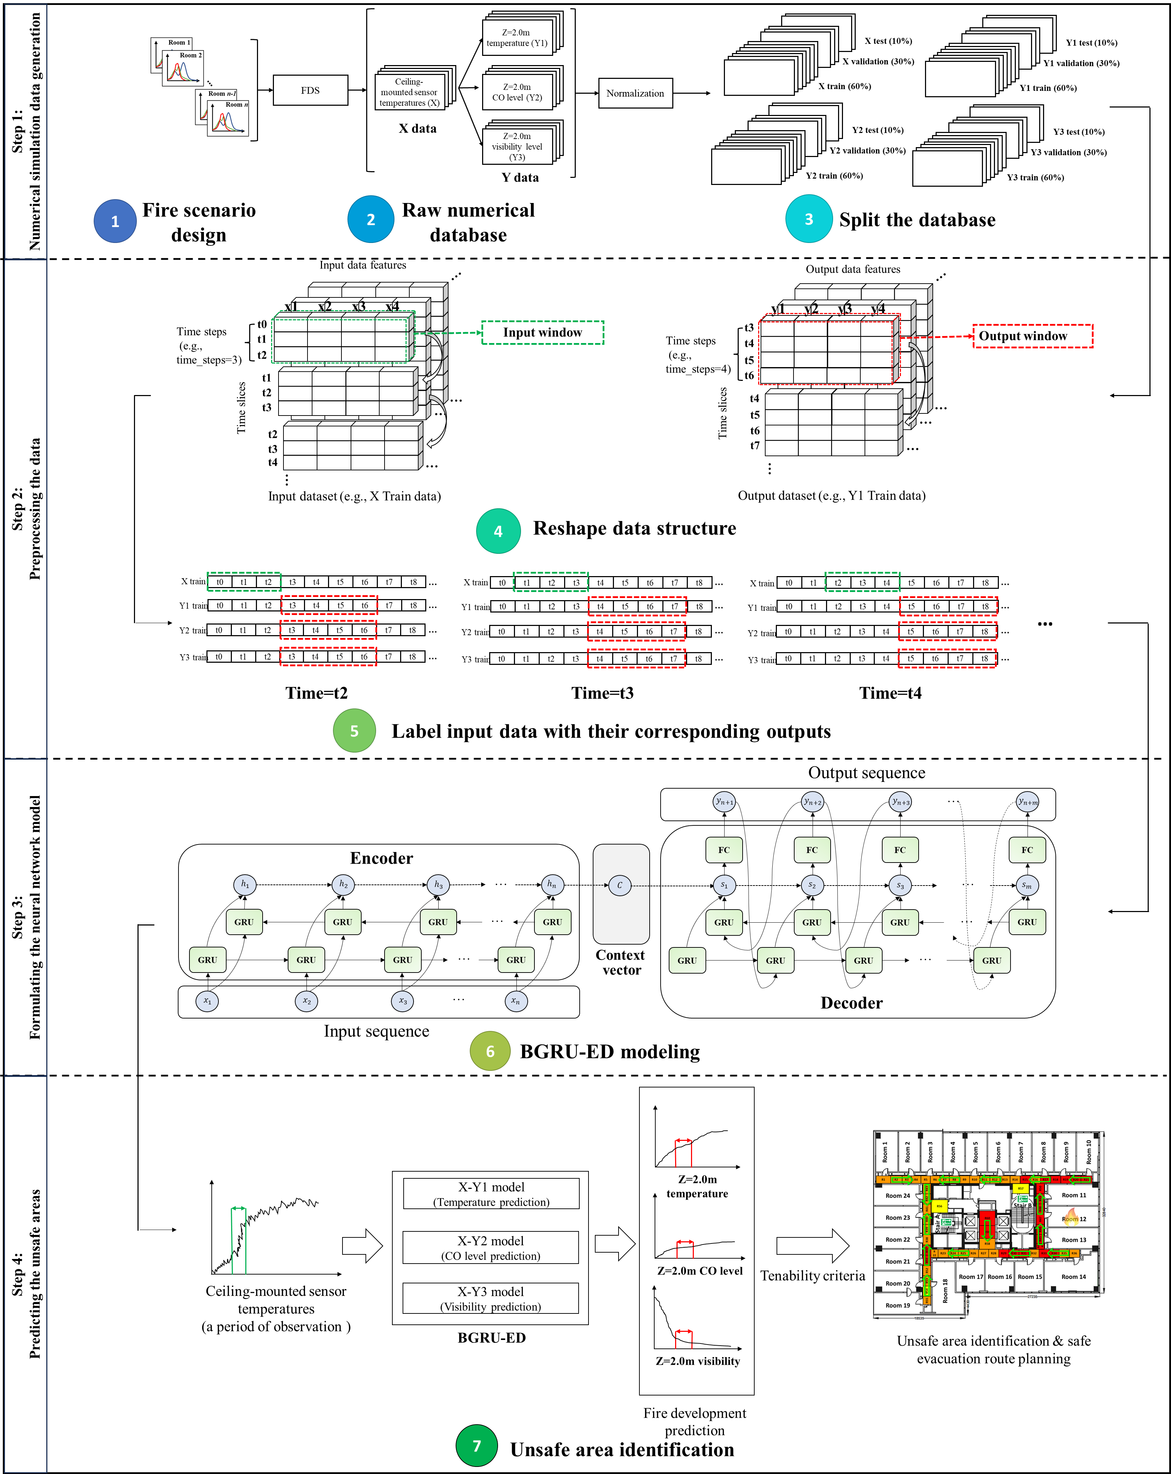
Figure 5. Flowchart of the methodology for dynamic unsafe area prediction.

Bidirectional-GRU-based encoder-decoder
The core of the dynamic unsafe area prediction is to develop the DL model—BiGRU-ED. Figure 6 illustrates the overall workflow of the model. In this study, three fire characteristics (temperature, CO level, and visibility) are required to be predicted from the sequenced temperature sensor measurements. For each of the simulated fire scenes, assuming the total time span of the simulation contains $N$ time slices, then the structured dataset can be represented as $DS=\{(O_{i},P_{i})|i=1,…,N\}$, where $O_{i}$ represents the sensor measurements and $P_{i}$ represents the corresponding predicted fire characteristics. In a timestamp of i, a series of consecutive temperature sensor measurements for model inputs is represented as $O_{i}=\{X^{\left(i-l+1\right)}|l=1,…,L\}$, where $X^{(∙)}$ denotes the data array containing all sensor node measurements in a single timestep, and $l$ is the input timestep defined by the input window length $L$. Correspondingly, $P_{i}=\{Y^{\left(i+m\right)}|m=1,…,M\}$, represents the consecutive time series model outputs, where $Y^{(∙)}$ denotes the time series predictions in a variety of fire characteristics at human heights, containing Y1 (temperature), Y2 (CO), and Y3 (visibility), and $m$ denotes the output timestep defined by the output window length $M$. In this way, input data with $L$ timesteps is labeled with output data in $M$ timesteps to enable the sequence-to-sequence prediction.
On the basis of such a labeled dataset, the BiGRU-ED model can be trained, validated, and tested. The workflow of the BiGRU-ED modeling is shown in Figure 6, where the model uses a fixed-length vector representation from the input layer tensor. After, the decoder generates the target sequence using the current hidden state from the encode and the target value in the previous timestep. By using shape transformation through the repeat vector layer, the encoder and decoder are connected. The initial state of the decoder uses the encoder’s hidden state of each timestep passing on to it. Finally, an output layer is used to estimate the prediction values in every timestep.
Regarding the other components in the model, rectified linear unit (ReLU) (Nair & Hinton, 2010) is used as the activation function in each layer to improve the performance of the network and relieve gradient vanishing problems. Mean squared error (MSE) is used as the loss function, and Adam optimizer is used as the optimizer for the model (Kingma & Ba, 2014). The weights and biases of the model can be updated through backpropagation processes by computing the gradients of the loss function and guided by the optimization algorithm. In addition, to prevent overfitting during the model training, dropout techniques (Srivastava, Hinton, Krizhevsky, Sutskever, & Salakhutdinov, 2014) can be applied by the model. The dropout layer is added between the bidirectional GRU and dense layers, and a masking probability of the dropout layer is set to block certain portions of hidden neurons.
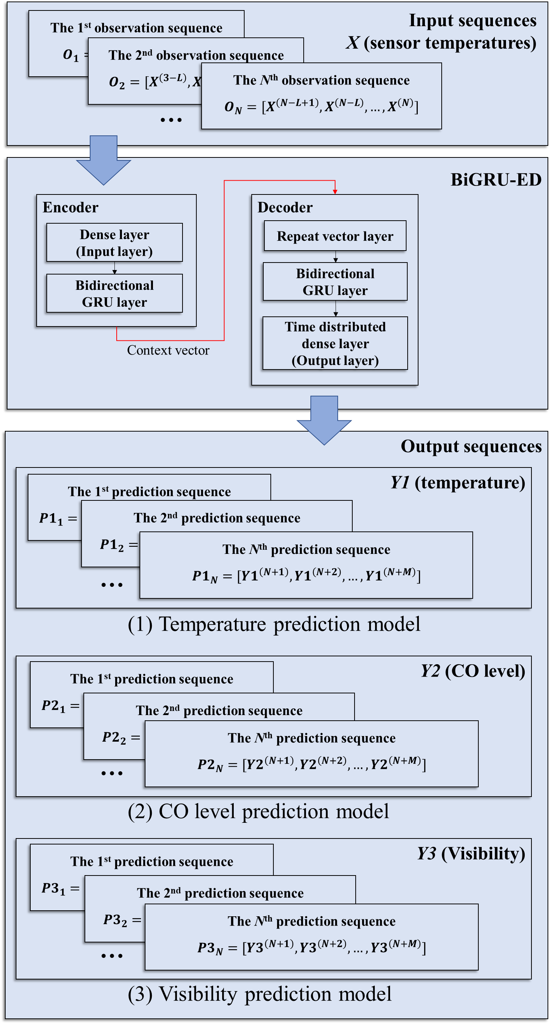
Figure 6. Overall workflow for the model development of BiGRU-ED.

Criteria for unsafe area determination
As introduced in Section 3.1, the forecasted states of fire characteristics need to be eventually converted into the recognition of the unsafe areas where occupants may be at risk. Therefore, the fire tenability criteria are applied. Regarding the occupant life safety criteria in building fires, a series of codes and regulations has been proposed based on the studies of hazards to occupants from smoke, toxic gases, and heat (Buchanan, 2001; Hadjisophocleous & Benichou, 1999; Hurley, et al., 2015). The tenability limits used for unsafe area determination in this study are summarized in Table 1. It is stipulated that once one of the states of fire characteristics forecasted by the model exceeds the certain tenability limits, the corresponding areas will be considered unsafe areas, forcing the evacuation path planning to avoid entering these areas.
Table 1. Assessment criteria for unsafe area determination.
Tenability type | Tenability limit
Convective heat | Temperature of the gas layer ≤ 65℃
Smoke obscuration | Visibility in the relevant layer does not fall below 2 m
Toxicity | Level of CO concentration ≤ 1400 ppm

A case study
Based on the methodology introduced in Section 3, a case study was performed to demonstrate the feasibility and effectiveness of using the DL method to enable dynamic unsafe area prediction and, subsequently, active evacuation route planning. Therefore, in addition to developing the BiGRU-ED model for unsafe area prediction for the case, an application example was implemented to actively plan the evacuation route and combine it with DDES to demonstrate safer evacuation operations. The DL model and algorithm for evacuation route planning were both developed and tested on a PC with Intel(R) Core(TM) i7-10510U CPU @ 1.80GHz and 16 GB RAM. The model algorithms were compiled in Python 3.8 (Van Rossum & Drake Jr, 1995) with the aid of a third-party library—Keras (Gulli & Pal, 2017) for DL modeling and NetworkX (Hagberg, Swart, & S Chult, 2008) for route planning.

Case building layout
This case study selected a commercial-used housing estate as an example and assumed that the fire spread on a single floor of the building. The floor plan of the selected building is depicted in Figure 7. The building floor contains a total of 24 rooms for accommodation, and two stair exits for escape, located on the east and west cores of the building. Additionally, in order to clearly present the heterogeneous fire characteristics in different areas of the corridor, the building corridor was divided into 60 zones, named R1 to R60, as shown in Figure 7. In this way, the unsafe areas can be distinguished and presented more easily.
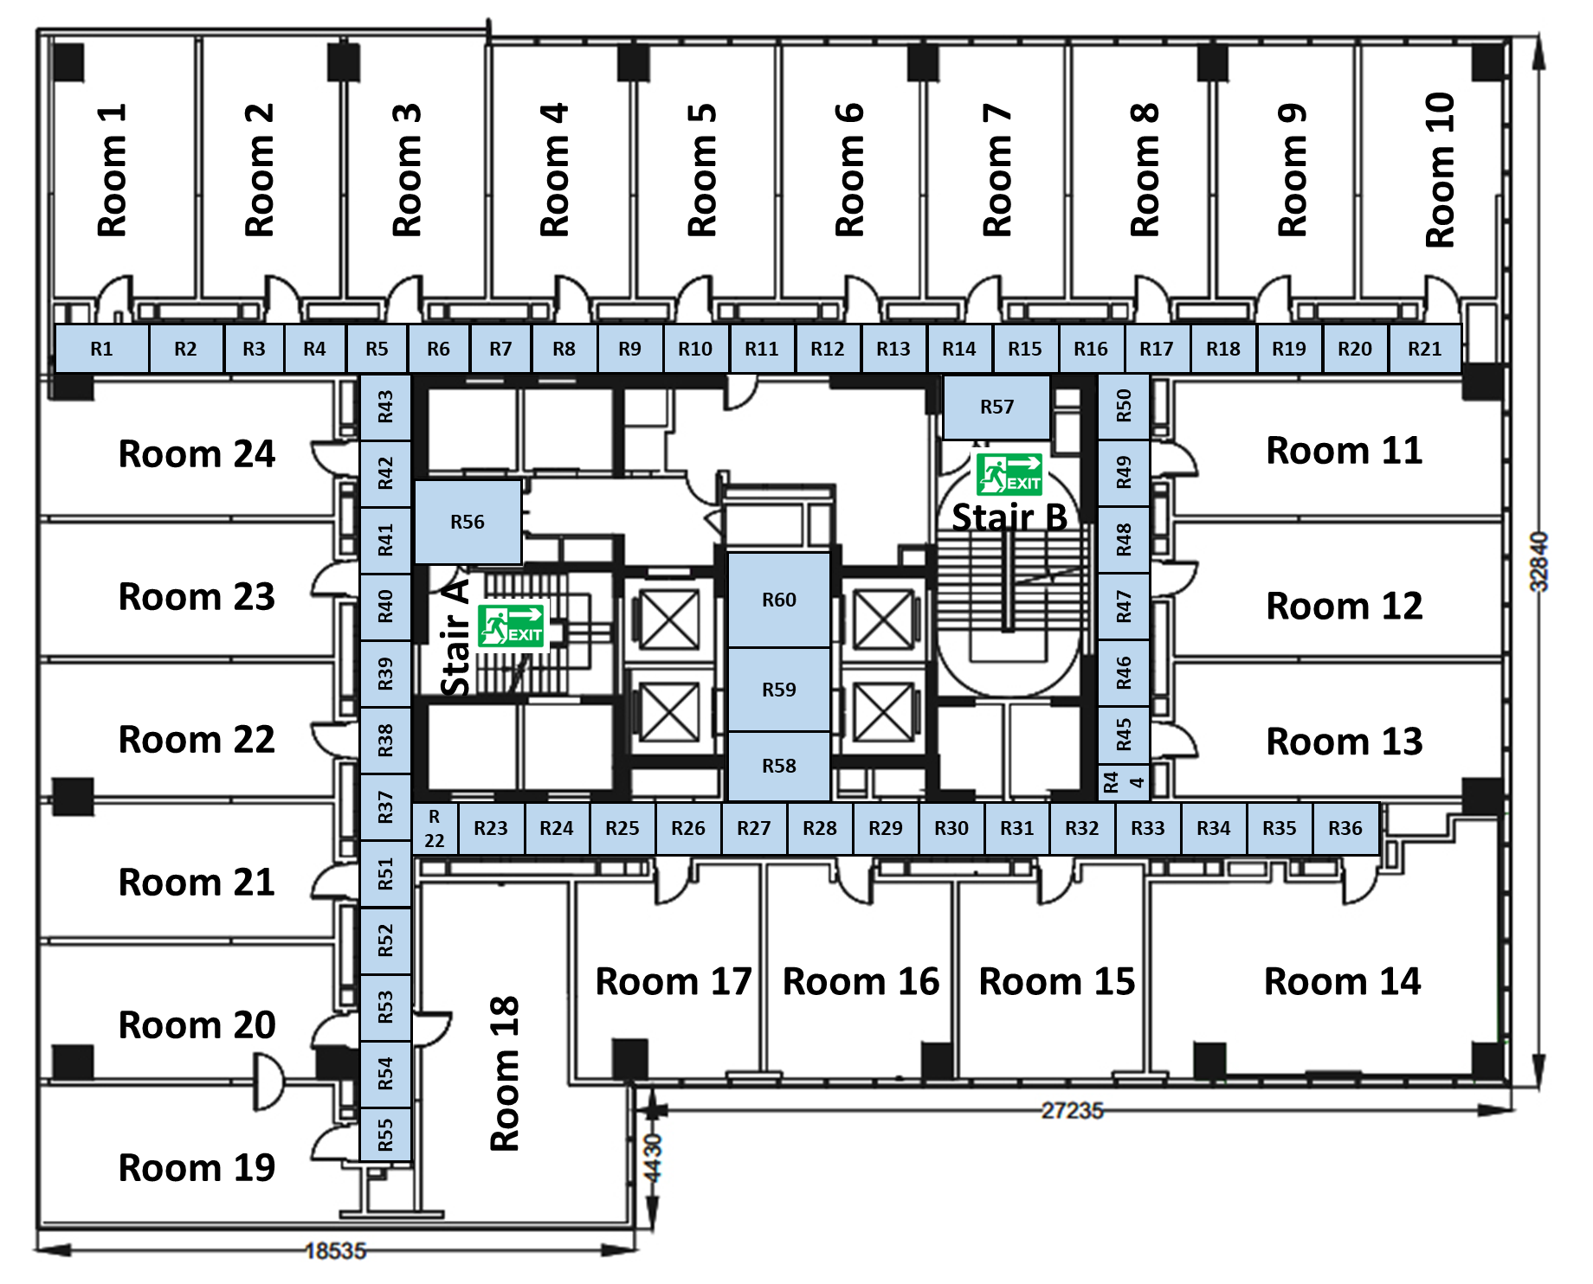
Figure 7. Floor plan of the selected building.

Numerical data generation

Fire scenario design
Based on the given building floor plan, we first generated a large number of fire scenarios to cover a wide range of fire scenes on the building floor. In this study, we assumed that the fire was confined to a single room on the floor. Hence, scenarios involving multiple fire sources or fire spreads to additional rooms were not considered. For the case’s fire scenario design, various fire parameters were considered, including the fire source room, fire location, heat release rate per unit area, the estimated maximum area of the fire, fire growth rate, and door open time of the room. The general probability distributions of these varying parameters are summarized in Table 2.
To select finite samples for the model development and ensure representative and efficient sampling of the input space, we applied the probabilistically based sampling method—Latin Hypercube Sampling (LHS) (Helton & Davis, 2003). By using a stratified Monte Carlo sampling method in LHS, the number of selected scenes can be drastically reduced. A large number of fire scenarios were generated by using LHS to extract parameters from a certain range of values from a variety of parameters and follow the designated type of probability distribution functions. After, the sampled parameters were recombined together and constituted the fire scenarios. To ensure that every room contains an equal amount of fire cases and considering overall computation efficiency, we sampled a total of 480 fire cases. For each room of fire origin, we gave 20 different fire cases to account for possible fire events.
Table 2. Probability distributions of the parameters considered in the fire scenario design.
Uncertain parameters | symbol | Unit | Probability Distributions | Min | Max
Room of fire origin | Loc | - | uniform | 1 | 24
Fire location | X_{loc}, Y_{loc} | m | uniform | Depends on the room coordinates
Heat Release Rate Per Unit Area (HRRPUA) | 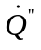 | kW/m² | constant | - | 250 (Residential room (Staffansson, 2010))
Estimated maximum area of the fire | A | m² | uniform | 2 | 32
Fire growth rate (FGR) |  | kW/s² | uniform | 0.01172 (Medium) | 0.1876 (Ultrafast)
Door opened time | t_{open} | s | uniform | 30 | 60

Simulation setup
Simulation cases in FDS were set up on the basis of the designed fire scenarios. The burner was placed based on the sampled fire locations in the fire scenario design. The heat release rate (HRR) ramp of the burner was determined by the sampled parameters of HRRPUA, the estimated maximum area of the fire, and the fire growth rate (FGR) to follow a T-square fire curve. T-square fire curves are commonly used for designing an actual growth of fire (Hurley, et al., 2015). It is defined to follow a quadratic increase with time until either the fuel is totally consumed or the HRR is assumed to have reached a peak value. As a result, the HRR of the burner was approximated by:
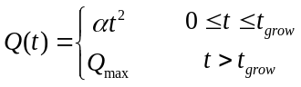 | (12)
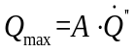 | (13)
where 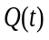 represents the HRR (kW) at time t (s). denotes the FGR (kW/s²), and 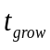 denotes the time when HRR reaches its peak value. Besides, 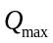 represents the maximum HRR (kW) of the fire, which equals the product of the estimated maximum area of the fire A and the HRRPUA .
Following such a T-square fire ramp method, we generated HRR ramps for all the sampled fire cases, as shown in Figure 8. The diversity of the HHR curves indicates a wide range of fire sizes and fire growth rates contained in the simulations. Therefore, a wide range of possible fire events in terms of the selected case building can be represented. Additionally, as shown in Table 2, the simulation took into account the door open time of the fire source room because it was assumed that the fire started in an enclosed space, and then after a period of time, the occupants found out and left the room with the door opened, therefore the smoke spread out. The sampling of the door open time was governed by a uniform probability distribution between 30 s and 60 s.
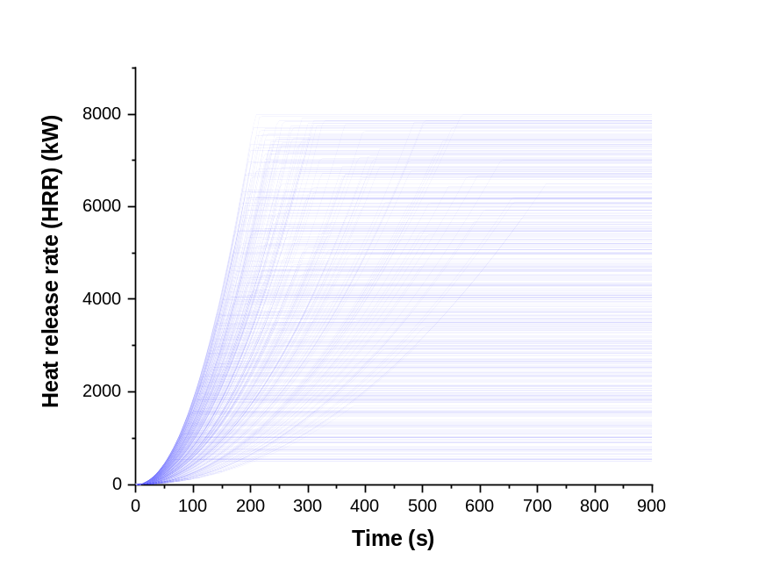
Figure 8. HRR ramps of the sampled fire scenes for the case building floor. A total of 480 fire cases.
Additionally, the mesh grid was set up to enable the calculation of the simulation. The grid cell size was determined based on the nondimensional quantity $D^{*}/δ_{x}$ to consider the balance between the computational cost and the accuracy of physical simulation, where $D^{*}$ represents a characteristic fire diameter and $δ_{x}$ denotes the nominal size of a spatial grid cell. The characteristic fire diameter is defined as (McGrattan, et al., 2013; Merci & Van Maele, 2008):
$$D^{*}={(\frac{\dot{Q}}{ρ_{∞}c_{p}T_{∞}\sqrt{g}})}^{2/5}$$ | (14)
where $\dot{Q}$ represents the maximum HRR; $ρ_{∞}$is the ambient density of air (1.2 [kg/m³]), $c_{p}$ is the specific heat of air (1.012 [kJ/kg/K]), $T_{∞}$ is the ambient air temperature (293 [K]), and $g$ is the acceleration of gravity (9.81 [m/s²]).
The calculation of $D^{*}/δ_{x}$ indicates how many numerical grid cells span the characteristic diameter of the fire. Previous studies suggest that the adequate range of $D^{*}/δ_{x}$ is between 4 and 16 to accurately resolve fires in various scenarios (Hamins & McGrattan, 2007). Thus, in this case study, we set a grid size of 0.2 m to balance the computational cost and accuracy of the simulation. Moreover, the computation area was reduced as much as possible. For instance, when the fire source was located in Room 24, we set only corridor areas and Room 24 itself as the computation domain since we assumed no fire spread to additional rooms. With that, the computational cost for generating the numerical dataset of the cases was greatly reduced. The total number of cubic meshes for a single fire case is about 150,000.
Regarding the data outputs in the simulation, fire characteristics at different locations and building heights were monitored. As indicated in Figure 7, the entire building corridor area was divided into 60 zones. For each zone, we applied virtual devices to collect temperatures, CO level, and visibility from the central point of the zone at 0.2 m below the ceiling and a human height 2.0 m relative to the floor surface, respectively. The temperature data obtained from ceiling heights was used as the model inputs, and the temperature, CO level, and visibility at the human height were used as the model outputs. The entire simulation time was limited to 900 s, giving enough time to monitor the fire development during the fire emergency evacuation operation.
Finally, the generated fire simulation cases were executed using FDS, and the corresponding data were obtained to develop the sequence-to-sequence DL model for unsafe area prediction. The result of one simulation case is exemplified in Figure 9. The temperature profiles in the building corridor were observed, and then the fire characteristic data at different areas within the corridors could be extracted from these specific measurement points.
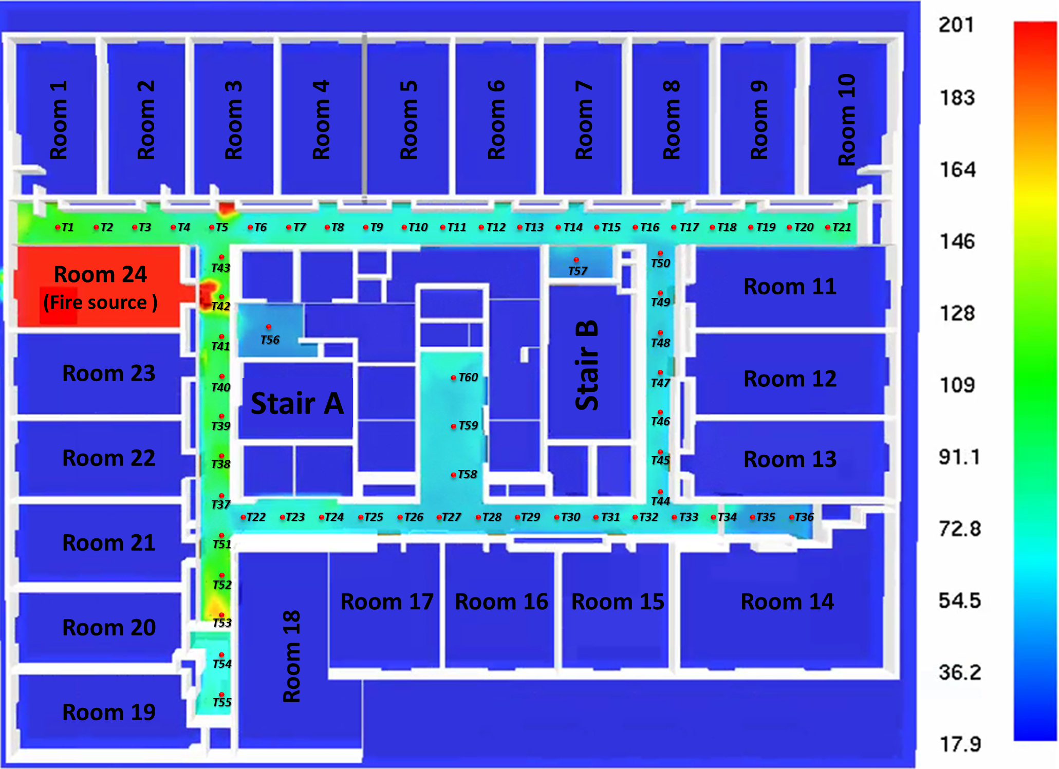
Figure 9. An example of the simulation result from one fire scenario case-a fire in room 24. Temperature contours at z=2.0m.

BiGRU-ED model development

Dataset preparation
After extracting the fire characteristic variables from the simulation outputs, we established a raw database with a size of 900×60×4×480. The database comprises 900-time slices, 60 features (measurement points), and four fire characteristics variables (X, Y1, Y2, and Y3) across 480 simulated cases. The total number of data points in the database is 100,224,000. Based on such a database, we performed data preprocessing to convert the data into a suitable format for developing the BiGRU-ED model. Given the time series features of GRUs, a 30-second time window was set for the model input. With a refresh rate of 5 seconds, the input window included 6 timesteps. For the output window of the model, we established three different prediction window lengths: 30 seconds, 60 seconds, and 120 seconds, corresponding to 6, 12, and 24 timesteps, respectively. To maintain the temporal relationships between the data, we constructed the input and output datasets in partitions by sliding the window with overlapping segments. Since different prediction window lengths were used for the outputs, the output dataset was constructed individually. The sizes of the output datasets for the three different prediction window lengths were 81120×6×60, 78240×12×60, and 72480×24×60, respectively. Additionally, we divided the data in the input and output datasets into training, validation, and testing sets, allocating 60%, 30%, and 10% of the data, respectively, to each set. This division allowed us to train, validate, and test the model with data that are unseen to each other.

Model development
Afterward, BiGRU-ED models were developed for dynamic unsafe area prediction. Due to the utilization of three different prediction window lengths and three fire characteristic variables (temperature, CO level, and visibility), three sets of models were created: Models 1, 2, and 3. Each set consists of three models: 1-1, 1-2, and 1-3 for temperature (Y1) forecasting, 2-1, 2-2, and 2-3 for CO levels (Y2) forecasting, and 3-1, 3-2, and 3-3 for visibility (Y3) forecasting. Each model within the set forecasts the respective variable (temperature, CO level, or visibility) at different time intervals: 30 seconds, 60 seconds, and 120 seconds. Consequently, a total of nine BiGRU-ED models were formulated. Detailed parameter settings for these models can be found in Table 3. The bidirectional GRU encoder and decoder each utilized 200 neural units, resulting in a total of 289,260 parameters for the proposed models. Additionally, different learning and dropout rates were applied to each model to achieve acceptable prediction performance.
Table 3. Hyperparameters of the BiGRU-ED models. Models 1-1, 1-2, and 1-3 forecasts the future temperatures (Y1), models 2-1, 2-2, and 2-3 forecasts the future CO levels (Y2), and models 3-1, 3-2, and 3-3 forecasts the future visibility (Y3).
Model | Input | Input length (s) (timesteps) | Output | Prediction length (s) (timesteps) | Encode neuro units | Decode neuro units | Total parameters | Learning rate | Dropout rate
1-1 | X | 30 (6) | Y1 | 30 (6) | 200 | 200 | 289,260 | 0.0005 | 0.1
1-2 | X | 30 (6) | Y1 | 60 (12)
1-3 | X | 30 (6) | Y1 | 120 (24)
2-1 | X | 30 (6) | Y2 | 30 (6) | 200 | 200 | 289,260 | 0.0002 | 0.1
2-2 | X | 30 (6) | Y2 | 60 (12)
2-3 | X | 30 (6) | Y2 | 120 (24)
3-1 | X | 30 (6) | Y3 | 30 (6) | 200 | 200 | 289,260 | 0.0008 | 0.2
3-2 | X | 30 (6) | Y3 | 60 (12)
3-3 | X | 30 (6) | Y3 | 120 (24)

Results

Model training results
By feeding the inputs and outputs into the designed model structure, we formulated the BiGRU-ED models for forecasting the future fire characteristics within the case building floor. The overall MSE loss curves of these models during the model training process are presented in Figure 10. From the validation loss curves, it is observed that all models reach a relatively low training and validation loss after a certain number of iterations. Models 1-1, 1-2, and 1-3 for temperature forecasting indicate the lowest loss value compared to models 2-1, 2-2, and 2-3 for CO level forecasting and models 3-1, 3-2, and 3-3 for visibility forecasting. Usually, the model accuracy is warranted as long as the validation loss converges to a reasonable value.
Taking one fire test case in the testing dataset as an example, we fed the time series input data into the BiGRU-ED models and exhibited the results. Area 17 (R17) from the case with a fire initiated in Room 12 was selected as the example. Figure 11 presents a comparison of the fire characteristics between the actual simulated and model-predicted results in a total length of simulation time for the case. Take Figure 11 (a) as an example. The figure’s red line represents the actual simulated temperatures from the selected case, which denotes the ground truths. The blue lines in segments represent the BiGRU-ED model’s predicted temperatures in the next 30 seconds from every observation time point. It is indicated from the figure that the predictions generally follow the trend of the ground truths of the selected case. The predictions successfully reflect the future state of temperatures. In a similar way, Figure 11 (b) and (c) represent the comparison of the actual simulated temperatures and the BiGRU-ED model’s predicted temperatures in the next 60 and 120 seconds, respectively. The comparison results are the same as shown in Figure 11 (a), indicating a good model prediction performance in temperatures. Furthermore, Figure 11 (d) (e) and (f) exhibit the comparison of the ground truth and model-predicted CO levels. Figure 11 (g) (h) and (i) exhibit the comparison of the ground truth and model-predicted visibility. It is observed that the model-predicted values in the variables of CO level and visibility are relatively close to the actual simulated values. Therefore, it is likely that the formulated BiGRU-ED models can accurately forecast the future states of fire characteristics and be utilized for unsafe area prediction.
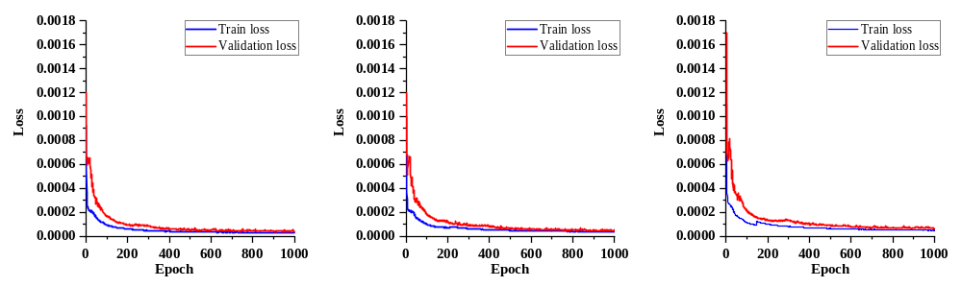
- Model 1-1 (Output=Y1, Prediction length=30s) | - Model 1-2 (Output=Y1, Prediction length=60s) | - Model 1-3 (Output=Y1, Prediction length=120s)
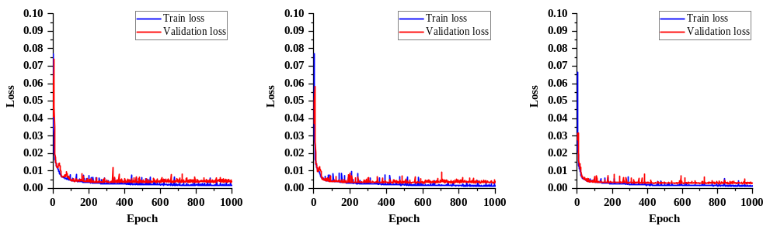
- Model 2-1 (Output=Y2, Prediction length=30s) | - Model 2-2 (Output=Y2, Prediction length=60s) | - Model 2-3 (Output=Y2, Prediction length=120s)
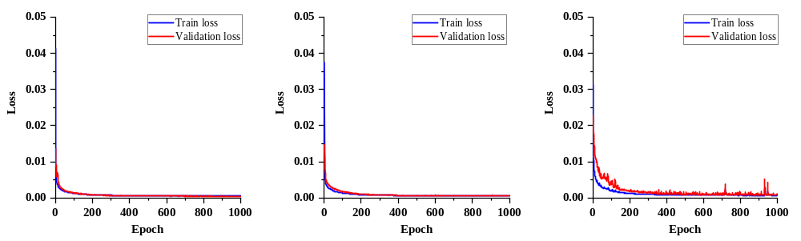
- Model 3-1 (Output=Y3, Prediction length=30s) | - Model 3-2 (Output=Y3, Prediction length=60s) | - Model 3-3 (Output=Y3, Prediction length=120s)
Figure 10. The overall MSE loss curves during the model training process.

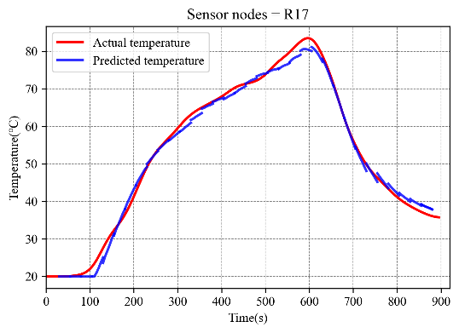 | 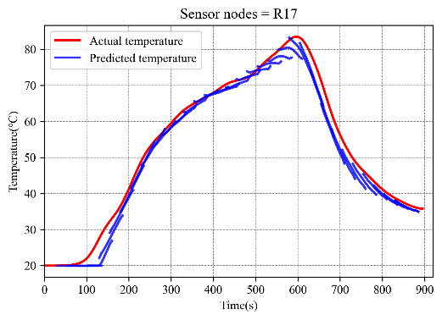 | 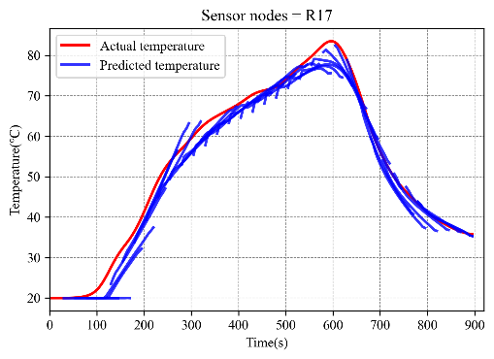
- Model 1-1 (Output=Y1, Prediction length=30s) | - Model 1-2 (Output=Y1, Prediction length=60s) | - Model 1-3 (Output=Y1, Prediction length=120s)
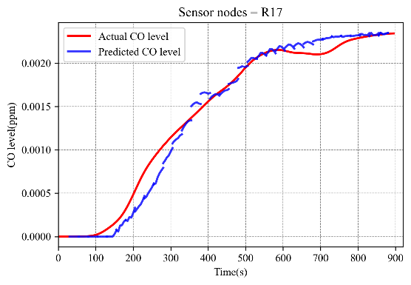 | 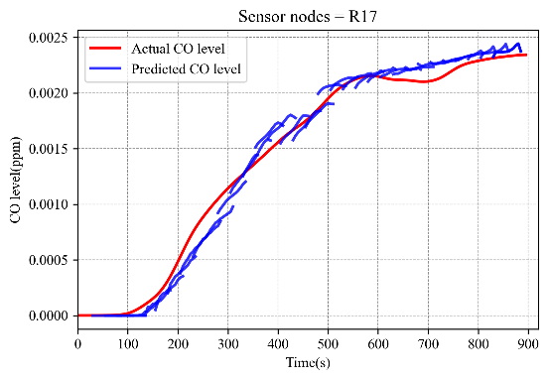 | 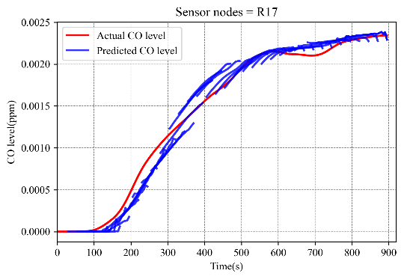
- Model 2-1 (Output=Y2, Prediction length=30s) | - Model 2-2 (Output=Y2, Prediction length=60s) | - Model 2-3 (Output=Y2, Prediction length=120s)
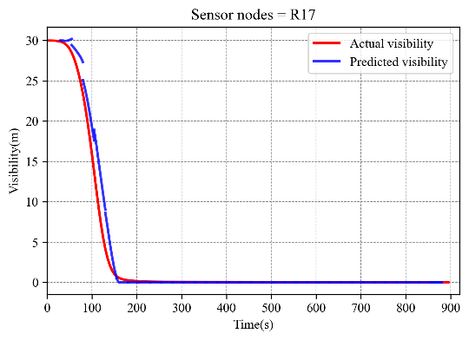 | 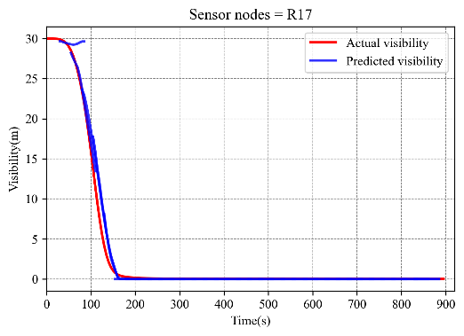 | 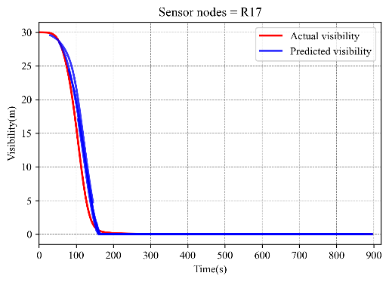
- Model 3-1 (Output=Y3, Prediction length=30s) | - Model 3-2 (Output=Y3, Prediction length=60s) | - Model 3-3 (Output=Y3, Prediction length=120s)
Figure 11. A comparison of the fire characteristics between the actual simulated and model-predicted results in a total length of simulation time. Area 17 (R17) from the test case with a fire initiated in Room 12 was selected as the example.

Model test and evaluation
To ensure the generalization and robustness of the model, we tested the formulated BiGRU-ED models with all fire cases in the testing dataset. The mean absolute percentage error (MAPE) for model predictions and the average lead time for unsafe area prediction were calculated.
First, MAPE was utilized to evaluate the differences between the fire characteristics in the actual simulated and model-predicted results from all test cases. MAPE is a measure of prediction accuracies of a forecasting method in statistics (Makridakis, 1993). MAPE value measures the precision of the forecasts by showing the average percent difference between forecasts and actual activities regardless of whether the individual forecasts were too high or too low (Blasco, Moreno, Pol, & Abad, 2013). The general expression for MAPE is:
$$MAPE=\frac{1}{n}×\sum{\left|\frac{actual-forecast}{actual}\right|}$$ | (15)
where $forecst$ denotes the forecast values of a variable, and $actual$ denotes the corresponding actual values. n represents the number of observations or data points being evaluated. In this study, $forecst$ is the fire characteristics obtained from the model’s predictions, $actual$ is the fire characteristics in the actual simulated results, and n stands for the total predicted data points within the given output timesteps in each time slice.
A clear and intuitive understanding of the model’s prediction performance was derived by examining the statistics of mean absolute percentage error (MAPE) across all the test cases. The statistics of the MAPE calculations in nine BiGRU-ED models are given in Table 4. Four categories of accuracy levels were defined, and the percentage of MAPE calculations belonging to each category was counted. For the entire testing set, it is found that the BiGRU-ED models for temperature forecasting (Models 1-1, 1-2, and 1-3) have relatively higher accuracies. Over 85% of the predictions have a MAPE value less than 10%. A relatively poor accuracy is observed in the models for CO level forecasting (Models 2-1, 2-2, and 2-3) and visibility forecasting (Moldes 3-1, 3-2, and 3-3). The main reason for this discrepancy is likely due to the difference in the trends of changes in temperatures, CO levels, and visibility within the environment. Unlike temperature, which is very sensitive to the changes in fire development, smoke continues to accumulate as the fire develops. Thus, forecasting CO level and visibility may depend on much longer time dependencies in data sequences. A higher model accuracy may require more available training data, increase the complexity of the model structure, or use more advanced time-series model methods.
Even though the accuracies of the BiGRU-ED models for CO level and visibility forecasting seem not satisfied, it can be seen that the trend of the prediction is good. The model may have already captured the specific features for CO level and visibility forecasting, but the predictions are only a bit shifting. Since the study is concerned about whether the model can realize an early prediction of unsafe areas, a small discrepancy in CO level and visibility predictions may not influence much. Therefore, a lead time for unsafe area prediction was calculated based on the criteria for unsafe area determination.
Table 4. The statistics of the MAPE calculations in nine BiGRU-ED models.
Model (Output, Prediction length) | MAPE value
Model (Output, Prediction length) | >50%  (inaccurate) | 20%-50%  (reasonable) | 10%-20%  (good) | <10%  (excellent)
1-1 (Y1, 30s) | 0.00% | 0.62% | 7.07% | 92.31%
1-2 (Y1, 60s) | 0.00% | 0.99% | 10.73% | 88.28%
1-3 (Y1, 120s) | 0.03% | 2.09% | 12.56% | 85.31%
2-1 (Y2, 30s) | 23.36% | 19.79% | 13.25% | 43.60%
2-2 (Y2, 60s) | 22.61% | 21.37% | 13.48% | 42.54%
2-3 (Y2, 120s) | 24.34% | 22.66% | 13.63% | 39.37%
3-1 (Y3, 30s) | 10.83% | 12.14% | 7.44% | 69.59%
3-2 (Y3, 60s) | 19.33% | 13.72% | 8.16% | 58.79%
3-3 (Y3, 120s) | 37.14% | 21.23% | 9.51% | 32.12%
To transform the predicted fire characteristics into the determination of unsafe areas within the case building, the criteria in Section 3.3 were applied. We stipulated that once one of the state of fire characteristics forecasted by the model exceeds the certain tenability limits, the corresponding areas would be considered unsafe areas. Thus, for each fire case, the earliest time slice for the model to recognize a transition to an unsafe area is expressed as follows:
30 second prediction length model set (Models 1-1, 2-1, and 3-1):  $$t_{predicted}^{(30s)}=min⁡\left\{i | \begin{matrix}{∀ Y1 ϵ F}_{1-1}\left(i\right): Y1≥65℃, or \\ {∀ Y2 ϵ F}_{2-1}\left(i\right): Y2≥1400ppm, or \\ {∀ Y3 ϵ F}_{3-1}\left(i\right): Y3≤2 m\end{matrix}\right\}$$ | (16)
60 second prediction length model set (Models 1-2, 2-2, and 3-2):  $$t_{predicted}^{(60s)}=min⁡\left\{i | \begin{matrix}{∀ Y1 ϵ F}_{1-2}\left(i\right): Y1≥65℃, or \\ {∀ Y2 ϵ F}_{2-2}\left(i\right): Y2≥1400ppm, or \\ {∀ Y3 ϵ F}_{3-2}\left(i\right): Y3≤2 m\end{matrix}\right\}$$ | (17)
120 second prediction length model set (Models 1-3, 2-3, and 3-3):  $$t_{predicted}^{(120s)}=min⁡\left\{i | \begin{matrix}{∀ Y1 ϵ F}_{1-3}\left(i\right): Y1≥65℃, or \\ {∀ Y2 ϵ F}_{2-3}\left(i\right): Y2≥1400ppm, or \\ {∀ Y3 ϵ F}_{3-3}\left(i\right): Y3≤2 m\end{matrix}\right\}$$ | (18)
where $t_{predicted}^{(30s)}$ refers to the earliest time slice of unsafe area prediction based on the 30 second prediction length model set—$F_{1-1}$, $F_{2-1}$, and $F_{3-1}$, $t_{predicted}^{\left(60s\right)}$ refers to the earliest time slice of unsafe area prediction based on the 60 second prediction length model set—$F_{1-2}$, $F_{2-2}$, and $F_{3-2}$, and $t_{predicted}^{(120s)}$ refers to the earliest time slice of unsafe area prediction based on the 120 second prediction length model set—$F_{1-3}$, $F_{2-3}$, and $F_{3-3}$. $i$ denotes the observed timestamp that observation made, and $F(i)$ represents the model predictions made by inputting the temperature observations into the BiGRU-ED models.
By applying the BiGRU-ED models to forecast fire characteristics and transform them into the recognition of unsafe areas, we counted the earliest time slice that recognizes the transition to unsafe areas across all test cases. Since it has been observed that a discrepancy or shift exists between the predictions made by the models and the ground truths from the simulation, the counted time slice from the model predictions may likely exceed the actual time point at which the area becomes unsafe in the simulation. If that is the case, the model would fail to predict unsafe areas timely, resulting in a lack of warning for the occupants. Therefore, we computed the differences between the counted time slice from the model predictions and the actual time point when the area becomes unsafe in the simulation. In this way, a lead time for predicting unsafe areas was able to be obtained. Figure 12 displays the calculated lead time in all corridor areas across all test cases. Figure 12 (a), (b), and (c) show the results based on the predictions from the 30, 60, and 120-second prediction length model set, respectively. It is found that whether the predictions are from the 30, 60, or 120-second prediction length model set, there is a lead time before the actual occurrence of the corridor area becoming unsafe. The model successfully predicts the transition to unsafe areas and can be notified with a long lead time. Additionally, the average lead time for unsafe area prediction was calculated. The average lead time in the 30, 60, or 120-second prediction length model set is 24.3 s, 55.2 s, and 111.7 s, respectively. The gap between the lead time of exact prediction (equal to the corresponding prediction length) is 5.7 s, 4.8 s, and 8.3 s. It is observed that although the gap is extended as the prediction length lengthens, the unsafe area prediction still leads to a large amount of time. Therefore, it is viable to use BiGRU-ED models for dynamic unsafe area prediction.
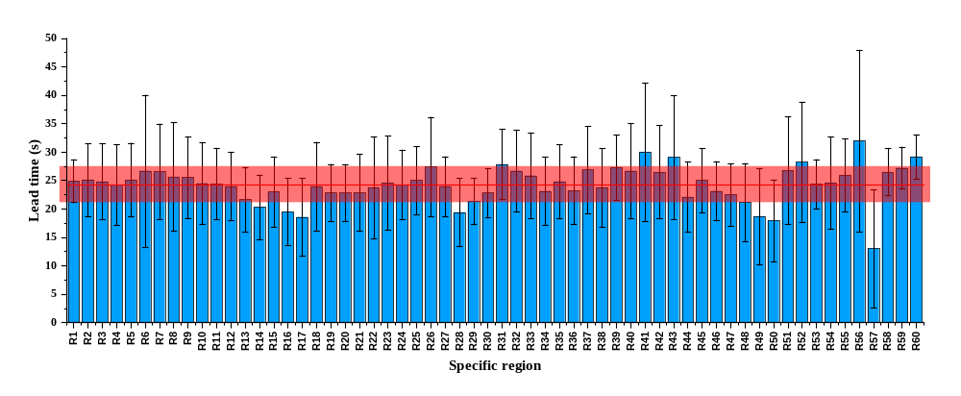
(a) 30 second prediction length model set (Models 1-1, 2-1, and 3-1)
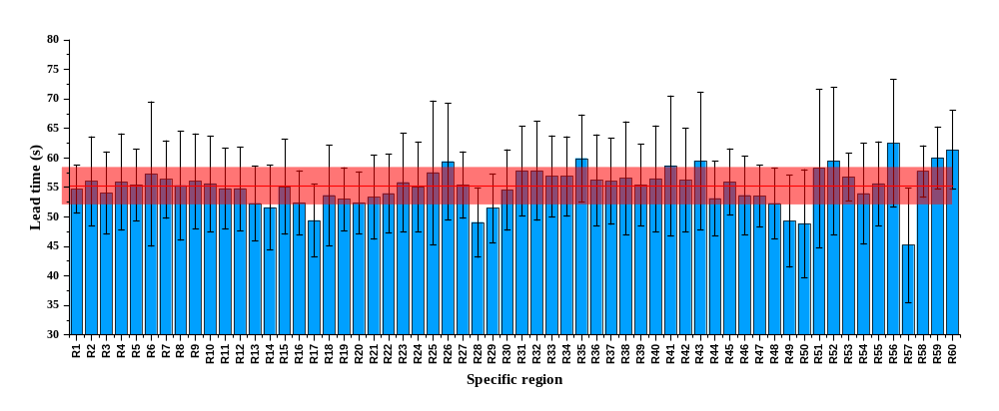
(b) 60 second prediction length model set (Models 1-2, 2-2, and 3-2)
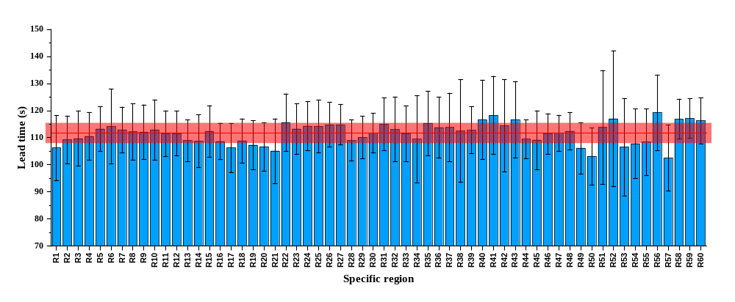
(c) 120 second prediction length model set (Models 1-3, 2-3, and 3-3)
Figure 12. Lead time for unsafe area prediction. The lead time refers to the duration or time interval between the prediction of an unsafe area by the model and the actual occurrence of the area becoming unsafe in the simulation. It is the amount of time available between the prediction and the event itself.

Application example
Finally, an application example was conducted to demonstrate the effectiveness of dynamic unsafe area prediction and the feasibility of combining evacuation route planning. By applying the BiGRU-ED models to a specific fire case, we forecasted the future states of fire characteristics and predicted the unsafe area in advance. Then, the unsafe area prediction information was combined with Dijkstra’s algorithms to keep updating safer evacuation routes, ensuring occupant safety in emergency evacuation operations.
The application took a fire initiated in Room 12 as an example. Details of the fire parameters in the example are shown in Table 5. By simulating the fire and smoke propagation via FDS, we extracted the temperature sensor measurement data and fed it into the BiGRU-ED models for inference. Figure 13 indicates the timeline histories of the unsafe area prediction during the fire development. Due to the development of the BiGRU-ED model sets in three different prediction lengths—30, 60, and 120 seconds, we established three levels of risk notification—critical, urgent, and minor. A minor risk indicates that the analyzed area will become unsafe within 120 seconds, an urgent risk within 60 seconds, and a critical risk within 30 seconds. The risk levels are determined by which model sets’ predictions identify the unsafe area. For instance, a minor risk is determined once the 120-second prediction length model sets’ predictions exceed the tenability limits. In this way, dynamic changes in fire risks can be identified and presented.
By mapping the different levels of fire risk across all building corridor areas, four lines of time points that the building areas are recognized as unsafe areas are shown in Figure 13. The black line represents the ground truth of the example, which is the actual time points when the areas become unsafe in the simulation. The lines in yellow, orange, and red represent the time points of each area recognizing a minor, urgent, and critical risk from the model predictions, respectively. The result shows that the time points of all levels of risk notification are below the time points of ground truths where the tenability limits are exceeded. Hence, successful predictions of unsafe areas before they actually turn into them are realized.
Table 5. Details of the fire parameters in the application example.
Fire parameter | Value
Fire source room | Room 12
Fire size | 4.02 MW
Fire growth rate | 0.082 kw/s²
Door opened time | 39.4s
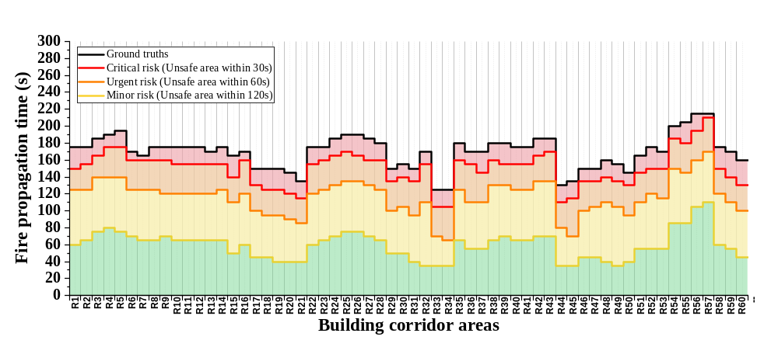Figure 13. Timeline histories of the unsafe area prediction during the fire development. A comparison between the time points of all levels of risk recognition and the time points of ground truths where the tenability limits are exceeded.
In addition, we implemented an example of active evacuation route planning based on the dynamic changes in risks for unsafe areas in the aforementioned fire scenario. Specifically, we utilized Dijkstra’s algorithm to determine the shortest path to exits within the dynamic and changing fire environment. By excluding the specific nodes representing unsafe areas from the algorithm, the predicted unsafe areas were incorporated into the evacuation route planning process. As a result, the algorithm calculated alternative evacuation routes that bypassed unsafe areas, ensuring the safety of occupants. It is noted that we established three levels of risk to classify the severity of the emergency. Therefore, distinct evacuation guidance and DDES controls were considered based on the recognized level of risk. For instance, areas classified as “minor risk” indicated that occupants had approximately 120 seconds of safety remaining, and as such, these areas were considered passable. Consequently, no nodes were eliminated from the Dijkstra's algorithm for these areas. In contrast, areas identified as “urgent risk” indicated that occupants had less than 60 seconds to maintain safety, necessitating detours to safer evacuation routes. Nodes corresponding to these areas were removed from the algorithm, and the shortest path for escape was recalculated. In cases where no alternative routes were available, the original shortest path could still be followed, but exit signs were presented urgently, such as through quick flashes. For areas identified as “critical risk,” where occupants had less than 30 seconds to maintain safety, occupants were advised to await rescue. These corresponding areas were marked with a stop sign via the DDES.
Figure 14 illustrates the active evacuation route planning for the example case using the provided mechanism for evacuation guidance and DDES controls. Three specific timestamps, namely 60 seconds, 90 seconds, and 120 seconds after the fire occurrence, were selected to demonstrate the evolving risk levels and active evacuation route plans in both time and space. Results from these timestamps indicate that three different risk levels were successfully recognized and demonstrated as the hot smoke spread. In addition, by using Dijkstra’s algorithm, the undirected graph representing available paths was continuously updated to accommodate the changing risk levels and calculate the shortest path for escape.
Examining the details in Figure 14 (a), it is observed that 60 seconds after the fire occurrence, smoke was just spread from the room to the corridor area, with only a small portion of the area classified as “minor risk.” At this stage, the DDES guided the evacuation route by following the shortest path to the exits. As the fire grew to 90 seconds, as shown in Figure 14 (b), smoke spread extensively, and most of the corridor areas were deemed “minor risk.” Additionally, areas such as R34, R33, R44, and R45 were recognized as “urgent risk.” Consequently, Exit sign 10 (ES10) adjusted its direction to avoid leading occupants into the “urgent risk” areas and directed them toward Exit 1 (Stair A) for escape. By the time 120 seconds, as shown in Figure 14 (c), smoke covered a significant portion of the building’s corridors, and numerous areas were classified as “urgent risk.” Notably, the areas of R14 and R15, directly connected to Exit 2 (Stair B), were identified as “urgent risk” at this point. As a result, the DDES switched the direction of Exit sign 3 (ES3) to guide occupants toward Exit 1 (Stair A), which was farther away from the fire source. Furthermore, due to the critical risk level in areas R34, R33, R44, and R45, the only escape route for Room 14 was blocked. Therefore, Exit sign 11 (ES11) displayed a stop sign, indicating that occupants in these areas should await rescue.
Through such a display of active evacuation route planning in building fires, we have effectively demonstrated the potential of controlling the DDES based on dynamic predictions of unsafe areas. This approach enables us to proactively address the risks associated with evacuation routes, leading to safer and more efficient fire evacuations. Moreover, the implementation of smart control through the DDES serves a crucial role in organizing and guiding occupants effectively during evacuation operations. As a result, this approach holds great potential for enhancing overall fire evacuation procedures.
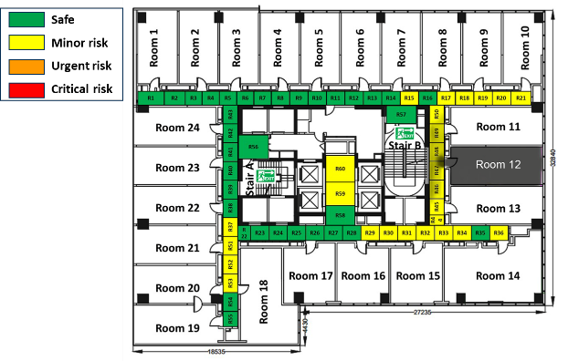 | 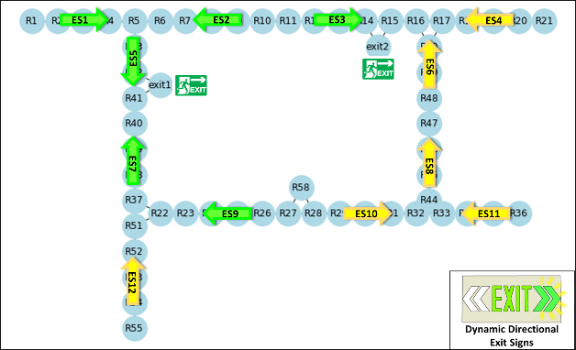
- 60 s after the fire occurrence
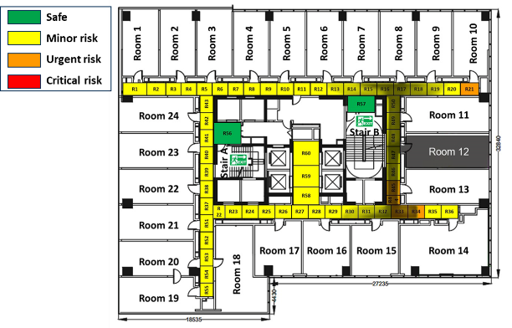 | 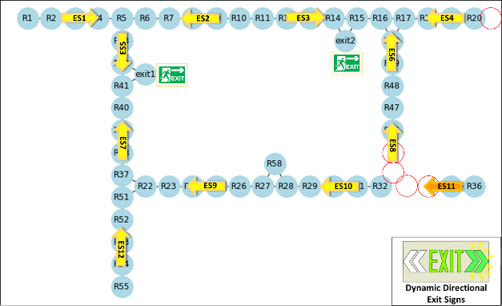
- 90 s after the fire occurrence
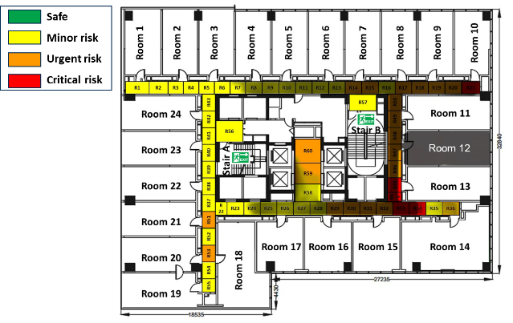 | 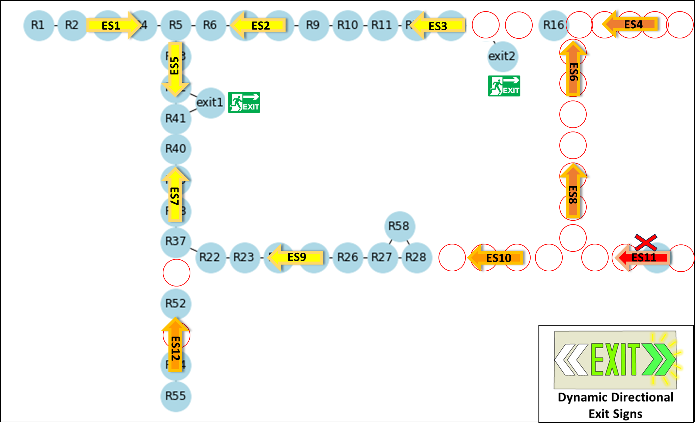
- 120 s after the fire occurrence
Figure 14. An example of dynamic unsafe area prediction and active evacuation route planning.

Discussion
In our current approach, DL models were developed to predict future states of fire characteristics, such as temperature, CO level, and visibility. These predictions are then used to identify unsafe areas by applying a threshold. It is observed that we have chosen to convert the problem into a regression problem instead of directly outputting a spatial classification matrix of unsafe areas. This decision is driven by the need to avoid a large number of classes that would be required to describe all possible spatial patterns of unsafe areas. By treating the problem as a regression task, we can leverage the advantages of regression models to handle imbalanced data. Since regression models aim to predict continuous values rather than assigning discrete class labels, they are less affected by class imbalance. This means they can learn from both majority and minority samples without being biased towards the majority class. This approach shares similarities with logistic regression, which also fits a logistic function (sigmoid function) to estimate the probability of an instance belonging to a particular class. By applying a threshold, the class membership can be manually adjusted. The effectiveness of logistic regression in dealing with imbalanced data classification has been widely verified (Maalouf, Homouz, & Trafalis, 2018; Maalouf & Siddiqi, 2014; Ohsaki, et al., 2017). Therefore, for the purpose of unsafe area prediction in our study, we directly built the fire characteristics forecasting model and identified the unsafe areas afterward. This approach allows us to leverage regression techniques and benefit from their ability to handle imbalanced data effectively.
Regarding the potential biases and limitations in this study, it is noted that the current proposed approach utilized temperature sensors in a full range of measurements to capture information about the fire situation and make inferences. However, it is important to consider that existing heat detectors or typical temperature sensors often have a limited measurement range, typically ranging from approximately 29 ℃ – 302 ℃ (Fan, Tam, Tong, Fu, & Liang, 2023). Therefore, future research should explore the development of a DL model that can effectively utilize sensor measurements within this limited range for dynamic unsafe area prediction. Furthermore, in terms of the DL model itself, it is acknowledged that the proposed model may only be appropriate to specific floor layouts, as the entire training dataset was compiled under the same building elements. Due to the diversity of building floors within an entire structure, it may be necessary to construct a large number of individual models to accommodate the different situations. However, implementing such a system could be cumbersome and require substantial computational resources. Hence, it would be beneficial to explore more advanced approaches, such as developing a genetic model trained on a variety of building floorplans (Tam, et al., 2022), to enhance the model’s applicability across different layout settings.

Conclusions
To overcome the limitations of the existing prescriptive evacuation route plan and address the gaps in recent advancements related to DDES, this paper introduced a novel approach for dynamic unsafe area prediction. This approach involves the development of a sequence-to-sequence DL model capable of predicting future states of fire characteristics, including temperature, CO level, and visibility. By leveraging these predictions, it is possible to identify unsafe areas in advance, enabling proactive measures to be taken. By utilizing this dynamic unsafe area prediction information, active evacuation route planning can be implemented, resulting in the smart control of the DDES. The integration of such dynamic unsafe area prediction and smart control of DDES facilitates safer and more efficient evacuation operations.
To establish such a DL model for dynamic unsafe area prediction, synthetic numerical data was generated using FDS. This data served as the foundation for training, validating, and testing the model. Then, BiGRU-ED models were established to predict fire characteristics, including temperature, CO level, and visibility. Finally, fire tenability limits were applied to the predictions to identify the unsafe areas. Taking fire scenarios in a complex building floor as a case study, we employed the proposed approach to establish the BiGRU-ED models for dynamic unsafe area prediction. Tested by the testing dataset, it was found that regardless of the prediction length (30, 60, or 120 seconds), the model provided a lead time before the corridor area became unsafe. The model successfully predicted the transition to unsafe areas, providing early notifications. Furthermore, an application example was performed to demonstrate the feasibility of active evacuation route planning and smart control of DDES. Based on the dynamic unsafe area predictions, three risk levels were recognized and demonstrated on building floors as the hot smoke spread. In addition, by utilizing Dijkstra’s algorithm to accommodate the changing risk levels and calculate the shortest path for escape, evacuation guidance combined with smart control of DDES was successfully performed.
The research outcome presented offers available technical resources for integrating fire protection systems, machine learning, and fire situation awareness in building fire safety. By leveraging machine learning technologies, there is a significant opportunity to enhance the role of fire protection systems in building fire emergency response, specifically in areas such as early fire detection, fire source localization, and smoke exhaust control. These advancements have the potential to greatly improve public safety, reduce property damage, and save lives during fire incidents.

Acknowledgments
This paper was supported by the General Research Fund (No. CityU 11216920) of Research Grant Council, Hong Kong Special Administrative Region, China.

References
AiRAH, W. P. M. (2011). Tenability criteria for design of smoke hazard management systems. Ecolibrium Journal, 32-37.
Bengio, Y., Simard, P., & Frasconi, P. (1994). Learning long-term dependencies with gradient descent is difficult. IEEE transactions on neural networks, 5, 157-166.
Bian, C., He, H., Yang, S., & Huang, T. (2020). State-of-charge sequence estimation of lithium-ion battery based on bidirectional long short-term memory encoder-decoder architecture. Journal of Power Sources, 449, 227558.
Blasco, B. C., Moreno, J. J. M., Pol, A. P., & Abad, A. S. (2013). Using the R-MAPE index as a resistant measure of forecast accuracy. Psicothema, 25, 500-506.
Buchanan, A. H. (2001). Fire engineering design guide: Centre for Advanced Engineering, University of Canterbury.
Buffington, T., Cabrera, J.-M., Kurzawski, A., & Ezekoye, O. A. (2021). Deep-Learning Emulators of Transient Compartment Fire Simulations for Inverse Problems and Room-Scale Calorimetry. Fire Technology, 57, 2859-2885.
Cho, J., Lee, G., & Lee, S. (2015). An automated direction setting algorithm for a smart exit sign. Automation in Construction, 59, 139-148.
Cho, K., Van Merriënboer, B., Gulcehre, C., Bahdanau, D., Bougares, F., Schwenk, H., & Bengio, Y. (2014). Learning phrase representations using RNN encoder-decoder for statistical machine translation. arXiv preprint arXiv:1406.1078.
Chou, J.-S., Cheng, M.-Y., Hsieh, Y.-M., Yang, I. T., & Hsu, H.-T. (2019). Optimal path planning in real time for dynamic building fire rescue operations using wireless sensors and visual guidance. Automation in Construction, 99, 1-17.
Dey, R., & Salem, F. M. (2017). Gate-variants of gated recurrent unit (GRU) neural networks. In 2017 IEEE 60th international midwest symposium on circuits and systems (MWSCAS) (pp. 1597-1600): IEEE.
Fan, L., Tam, W. C., Tong, Q., Fu, E. Y., & Liang, T. (2023). An explainable machine learning based flashover prediction model using dimension-wise class activation map. Fire Safety Journal, 140, 103849.
Fang, H., Lo, S., & Lo, J. T. Y. (2021). Building Fire Evacuation: An IoT-Aided Perspective in the 5G Era. Buildings, 11, 643.
Fang, H., Lo, S. M., Zhang, Y., & Shen, Y. (2021). Development of a Machine‐Learning Approach for Identifying the Stages of Fire Development in Residential Room Fires. Fire Safety Journal.
Fang, H., Xu, M., Zhang, B., & Lo, S. M. (2023). Enabling fire source localization in building fire emergencies with a machine learning-based inverse modeling approach. Journal of Building Engineering, 78, 107605.
Fu, M., & Liu, R. (2020). BIM-based automated determination of exit sign direction for intelligent building sign systems. Automation in Construction, 120, 103353.
Gulli, A., & Pal, S. (2017). Deep learning with Keras: Packt Publishing Ltd.
Hadjisophocleous, G. V., & Benichou, N. (1999). Performance criteria used in fire safety design. Automation in Construction, 8, 489-501.
Hagberg, A., Swart, P., & S Chult, D. (2008). Exploring network structure, dynamics, and function using NetworkX. In: Los Alamos National Lab.(LANL), Los Alamos, NM (United States).
Hamins, A. P., & McGrattan, K. B. (2007). Verification and Validation of Selected Fire Models for Nuclear Power Plant Applications. Volume 2. Experimental Uncertainty (NUREG 1824).
Helton, J. C., & Davis, F. J. (2003). Latin hypercube sampling and the propagation of uncertainty in analyses of complex systems. Reliability Engineering & System Safety, 81, 23-69.
Hochreiter, S., & Schmidhuber, J. (1997). Long short-term memory. Neural Computation, 9, 1735-1780.
Hurley, M. J., Gottuk, D. T., Hall Jr, J. R., Harada, K., Kuligowski, E. D., Puchovsky, M., Watts Jr, J. M., & WIECZOREK, C. J. (2015). SFPE handbook of fire protection engineering: Springer.
Jia, M., Komeily, A., Wang, Y., & Srinivasan, R. S. (2019). Adopting Internet of Things for the development of smart buildings: A review of enabling technologies and applications. Automation in Construction, 101, 111-126.
Jiang, H. (2019). Mobile Fire Evacuation System for Large Public Buildings Based on Artificial Intelligence and IoT. IEEE Access, 7, 64101-64109.
Kelly, S. D. T., Suryadevara, N. K., & Mukhopadhyay, S. C. (2013). Towards the Implementation of IoT for Environmental Condition Monitoring in Homes. IEEE Sensors Journal, 13, 3846-3853.
Kim, H., Park, M., Kim, C. W., & Shin, D. (2019). Source localization for hazardous material release in an outdoor chemical plant via a combination of LSTM-RNN and CFD simulation. Computers & Chemical Engineering, 125, 476-489.
Kingma, D. P., & Ba, J. (2014). Adam: A method for stochastic optimization. arXiv preprint arXiv:1412.6980.
Kou, L., Wang, X., Guo, X., Zhu, J., & Zhang, H. (2021). Deep learning based inverse model for building fire source location and intensity estimation. Fire Safety Journal, 121, 103310.
Krizhevsky, A., Sutskever, I., & Hinton, G. E. (2017). Imagenet classification with deep convolutional neural networks. Communications of the ACM, 60, 84-90.
Li, J., Brown, C., Dzikowicz, D. J., Carey, M. G., Tam, W. C., & Huang, M. X. (2023). Towards real-time heart health monitoring in firefighting using convolutional neural networks. Fire Safety Journal, 140.
Li, Y., & Tong, Z. (2021). Model predictive control strategy using encoder-decoder recurrent neural networks for smart control of thermal environment. Journal of Building Engineering, 42, 103017.
Lyu, P., Chen, N., Mao, S., & Li, M. (2020). LSTM based encoder-decoder for short-term predictions of gas concentration using multi-sensor fusion. Process Safety and Environmental Protection, 137, 93-105.
Maalouf, M., Homouz, D., & Trafalis, T. B. (2018). Logistic regression in large rare events and imbalanced data: A performance comparison of prior correction and weighting methods. Computational Intelligence, 34, 161-174.
Maalouf, M., & Siddiqi, M. (2014). Weighted logistic regression for large-scale imbalanced and rare events data. Knowledge-Based Systems, 59, 142-148.
Makridakis, S. (1993). Accuracy measures: theoretical and practical concerns. International journal of forecasting, 9, 527-529.
McGrattan, K., Hostikka, S., McDermott, R., Floyd, J., Weinschenk, C., & Overholt, K. (2013). Fire dynamics simulator user’s guide. NIST special publication, 1019.
Merci, B., & Van Maele, K. (2008). Numerical simulations of full-scale enclosure fires in a small compartment with natural roof ventilation. Fire Safety Journal, 43, 495-511.
Nair, V., & Hinton, G. E. (2010). Rectified linear units improve restricted boltzmann machines. In Proceedings of the 27th international conference on machine learning (ICML-10) (pp. 807-814).
Ohsaki, M., Wang, P., Matsuda, K., Katagiri, S., Watanabe, H., & Ralescu, A. (2017). Confusion-matrix-based kernel logistic regression for imbalanced data classification. IEEE Transactions on Knowledge and Data Engineering, 29, 1806-1819.
Pan, J., Jain, R., Paul, S., Vu, T., Saifullah, A., & Mo, S. (2015). A Internet of Things Framework for Smart Energy in Buildings: Designs, Prototype, and Experiments. IEEE Internet of Things Journal, 2, 527-537.
Park, S., Park, S., Park, L., Park, S., Lee, S., Lee, T., Lee, S., Jang, H., Kim, S., Chang, H., & Park, S. (2018). Design and Implementation of a Smart IoT Based Building and Town Disaster Management System in Smart City Infrastructure. Applied Sciences, 8, 2239.
Park, S. H., Kim, B., Kang, C. M., Chung, C. C., & Choi, J. W. (2018). Sequence-to-sequence prediction of vehicle trajectory via LSTM encoder-decoder architecture. In 2018 IEEE intelligent vehicles symposium (IV) (pp. 1672-1678): IEEE.
Sak, H., Senior, A., & Beaufays, F. (2014). Long short-term memory based recurrent neural network architectures for large vocabulary speech recognition. arXiv preprint arXiv:1402.1128.
Schuster, M., & Paliwal, K. K. (1997). Bidirectional recurrent neural networks. IEEE transactions on Signal Processing, 45, 2673-2681.
Shah, S. R. B., Chadha, G. S., Schwung, A., & Ding, S. X. (2021). A Sequence-to-Sequence Approach for Remaining Useful Lifetime Estimation Using Attention-augmented Bidirectional LSTM. Intelligent Systems with Applications, 10-11, 200049.
Srivastava, N., Hinton, G., Krizhevsky, A., Sutskever, I., & Salakhutdinov, R. (2014). Dropout: a simple way to prevent neural networks from overfitting. The journal of machine learning research, 15, 1929-1958.
Staffansson, L. (2010). Selecting design fires: Brandteknik och Riskhantering, Lunds tekniska högskola Lund.
Sutskever, I., Vinyals, O., & Le, Q. V. (2014). Sequence to sequence learning with neural networks. Advances in neural information processing systems, 27.
Tam, W. C., Fu, E. Y., Li, J., Huang, X., Chen, J., & Huang, M. X. (2022). A spatial temporal graph neural network model for predicting flashover in arbitrary building floorplans. Engineering Applications of Artificial Intelligence, 115, 105258.
Tam, W. C., Fu, E. Y., Li, J., Peacock, R., Reneke, P., Ngai, G., Leong, H. V., Cleary, T., & Huang, M. X. (2023). Real-time flashover prediction model for multi-compartment building structures using attention based recurrent neural networks. Expert Systems with Applications, 223, 119899.
Tealab, A. (2018). Time series forecasting using artificial neural networks methodologies: A systematic review. Future Computing and Informatics Journal, 3, 334-340.
Van Rossum, G., & Drake Jr, F. L. (1995). Python tutorial: Centrum voor Wiskunde en Informatica Amsterdam, The Netherlands.
Wong, H. Y., Zhang, Y., & Huang, X. (2022). A Review of Dynamic Directional Exit Signage: Challenges and Perspectives. In: The Hong Kong Polytechnic University.
Wu, X., Park, Y., Li, A., Huang, X., Xiao, F., & Usmani, A. (2021). Smart Detection of Fire Source in Tunnel Based on the Numerical Database and Artificial Intelligence. Fire Technology, 57, 657-682.
Wu, X., Zhang, X., Jiang, Y., Huang, X., Huang, G. G. Q., & Usmani, A. (2022). An intelligent tunnel firefighting system and small-scale demonstration. Tunnelling and Underground Space Technology, 120, 104301.
Yu, L., Qin, S., Zhang, M., Shen, C., Jiang, T., & Guan, X. (2021). A review of deep reinforcement learning for smart building energy management. IEEE Internet of Things Journal, 8, 12046-12063.

Disclaimer: any mention of commercial products by NIST authors is for information only; it does not imply recommendation or endorsement by NIST.

