* **ER Diagram :**

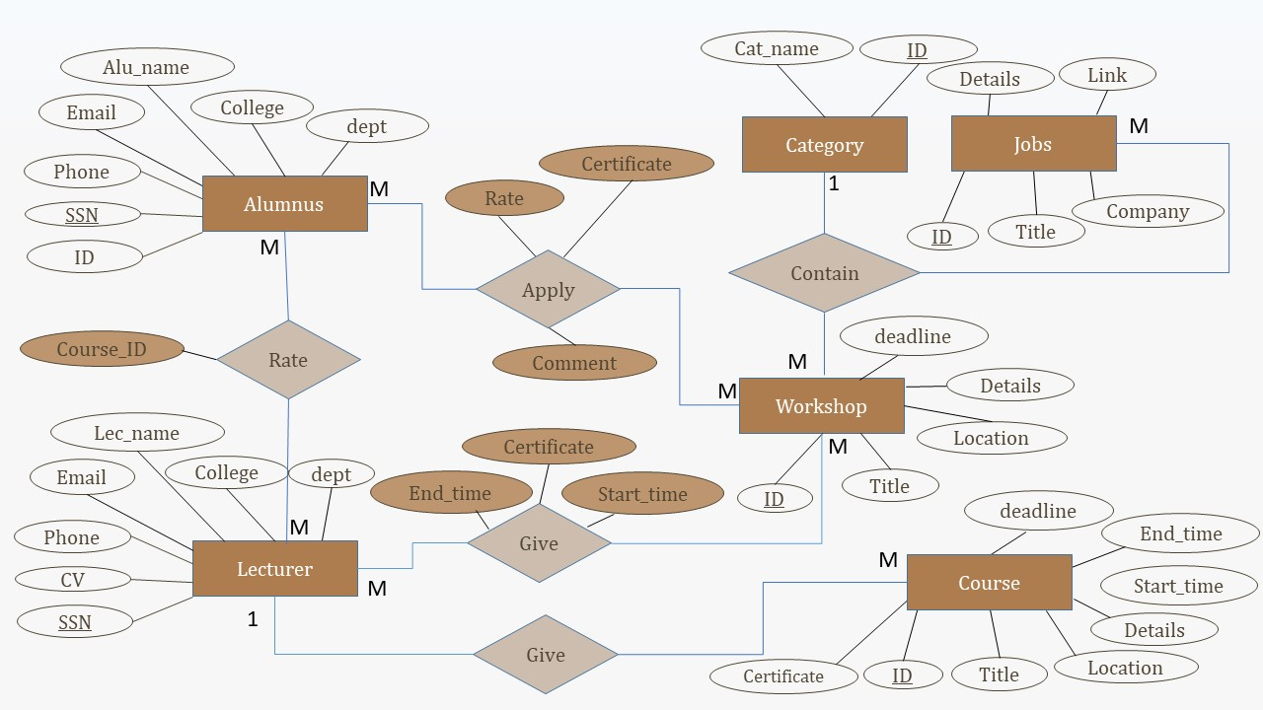

|  |  |  |
| --- | --- | --- |
| **Entity : Category** | | |
| **Field Name** | **Data Type** | **Constraint** |
| Cat_ID | Number | Primary Key |
| Cat_Name | Text |  |

* **Data Dictionary :**

|  |  |  |
| --- | --- | --- |
| **Entity : Lecturer** | | |
| **Field Name** | **Data Type** | **Constraint** |
| SSN | Number | Primary Key |
| Lec_name | Text |  |
| college | Text |  |
| department | Text |  |
| CV | Text |  |
| Email | Text |  |
| Phone | Text |  |
| rate | number |  |

|  |  |  |
| --- | --- | --- |
| **Entity : Courses** | | |
| **Field Name** | **Data Type** | **Constraint** |
| Course_ID | Number | Primary Key |
| Title | Text |  |
| Location | Text |  |
| deadline date | Date |  |
| Start Time | Date |  |
| End Time | Date |  |
| Cat_ID | Number | Foreign key |
| Lecturer_ID | Number | Foreign key |
| Lecturer_certificate | Text |  |

|  |  |  |
| --- | --- | --- |
| **Entity : Workshop** | | |
| **Field Name** | **Data Type** | **Constraint** |
| Workshop_ID | Number | Primary Key |
| Title | Text |  |
| Location | Text |  |
| deadline date | Date |  |
| Cat_ID | Number | Foreign key |

|  |  |  |
| --- | --- | --- |
| **Entity : WorkShop_Lecturers** | | |
| **Field Name** | **Data Type** | **Constraint** |
| Workshop_ID | Number | Foreign key |
| Lecturer_ID | Number | Foreign key |
| Lecturer_certificate | Text |  |
| Start Time | Date |  |
| End Time | Date |  |

|  |  |  |
| --- | --- | --- |
| **Entity : Alumnus** | | |
| **Field Name** | **Data Type** | **Constraint** |
| SSN | Number | Primary Key |
| Alu_name | Text |  |
| college | Text |  |
| department | Text |  |
| ID | Text |  |
| Email | Text |  |
| Phone | Text |  |

|  |  |  |
| --- | --- | --- |
| **Entity : alumnus courses rate** | | |
| **Field Name** | **Data Type** | **Constraint** |
| SSN | Number | Foreign Key |
| Course_ID | Text | Foreign Key |
| rate | number |  |

|  |  |  |
| --- | --- | --- |
| **Entity : alumnus courses Comments** | | |
| **Field Name** | **Data Type** | **Constraint** |
| SSN | Number | Foreign Key |
| Course_ID | Text | Foreign Key |
| Comment | Text |  |

|  |  |  |
| --- | --- | --- |
| **Entity : alumnus course certificates** | | |
| **Field Name** | **Data Type** | **Constraint** |
| SSN | Number | Foreign Key |
| Course_ID | Text | Foreign Key |
| certificate | Text |  |

|  |  |  |
| --- | --- | --- |
| **Entity : Lecturer course rate** | | |
| **Field Name** | **Data Type** | **Constraint** |
| SSN | Number | Foreign Key |
| Lecturer_ID | Number | Foreign Key |
| Course_ID | Number | Foreign Key |
| rate | number |  |