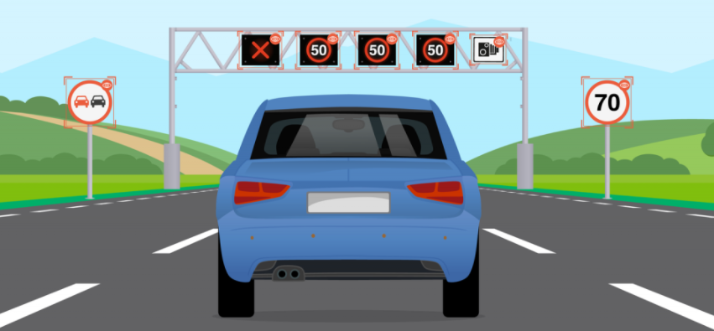

**Traffic Sign Recognition**

Faculty of Computers & Artificial Intelligence

Selected 1

Repository Link: <https://github.com/mahmoudhaney/TrafficSignRecognition>

**Team 15**

|  |  |  |  |  |
| --- | --- | --- | --- | --- |
|  | ID | NAME | LEVEL | Department |
| 1 | 202000186 | آية عماد طلعت حرب | **3** | **CS** |
| 2 | 202000376 | **ساره وليد سيد** | **3** | **CS** |
| 3 | 202000649 | **فيروز جمعه منصور محمد** | **3** | **CS** |
| 4 | 202000677 | كريمه ابو حسيبه محارب | **3** | **CS** |
| 5 | 202000861 | محمود هاني سعيد | **3** | **CS** |
| 6 | **202000895** | مصطفى جمال عبد الحكيم | **3** | **CS** |
| 7 | **202001010** | نورهان طارق عبدالهادي | **3** | **CS** |

**Dataset Information**

Name

**Traffic Sign Recognition**

**Total Dataset 39209**

**Training Data 31367**

**Validation Data 7842**

**ANN Model**

Confusion Matrix

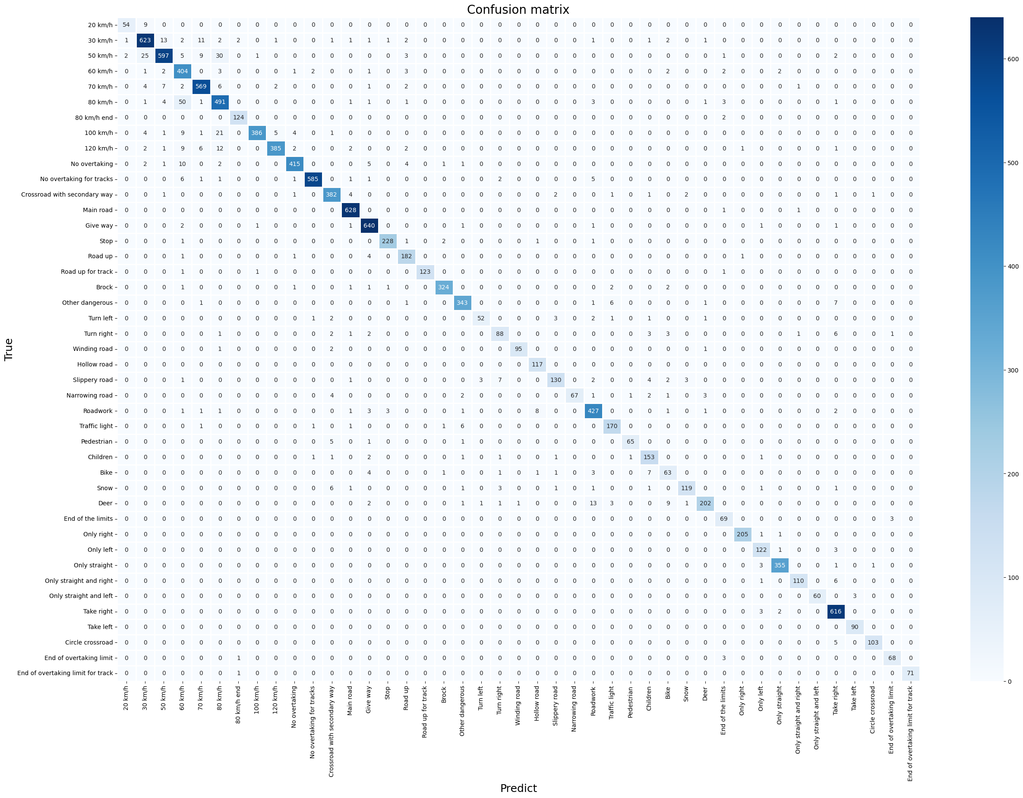

Accuracy Curve

Loss Curve

**SVM Model**

ROC Curve

Score Curve

**Another NN Model**

Accuracy Curve

Loss Curve

Confusion Matrix

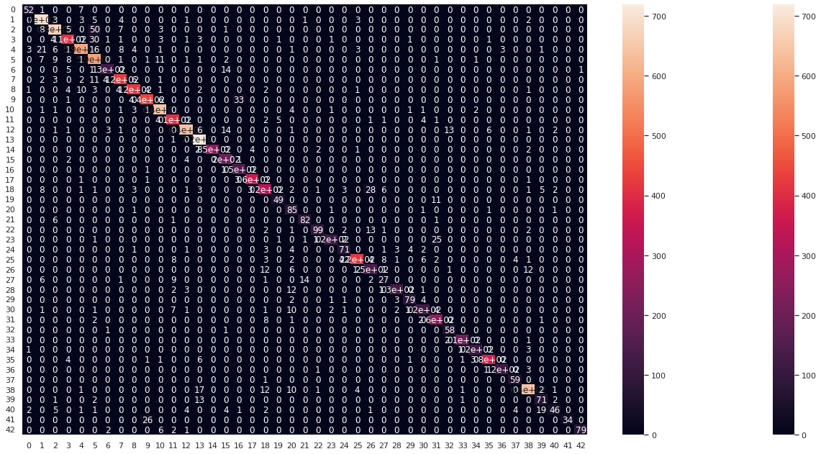

ROC Curve

**Hyperparameters**

**For ANN Model**

Resize Image: 32 * 32

Num of Epochs: 30 epochs

Learning Rate: 0.25 - 0.5

Activation Fun: Relu & Sigmoid

Optimizer: Adam

**For SVM Model**

Resize Image: 32 * 32

SVC Kernel: Linear