Online Voting System

Mahmoud Haney Saeed



Table Of Content

# Description

# System Requirements

# Functional Requirements

# Non-Functional Requirements

# System Design

# System Use Case Diagram

# UML Classes

# Databases

# ERD

# Entities

# 



**Description**

A voting System is an application where the user (a voter) is allowed to vote in a specific election. A voter can vote for the candidate only once, the system will not allow the user to vote a second time. The system will allow the admins to add elections and add the candidates’ names and photos (those who are nominated for an election). Admins only have the right to add candidates’ names, photos, and other personal info.

Admins will register the voter’s name by verifying the voter/user through his/her identity proof (and then the admin will register the voter). The candidates added to the system by the admins will be automatically deleted after the completion of an election. Admins must add the date on which an election is going to end. Once a user has received the user ID and password from the admin, the user can log in and vote for a candidate from those who are nominated.

The system will allow the user to vote for only one candidate. The system will allow the user to vote once in a particular election. Admins can add any number of candidates when a new election is announced. Admins can also view an election’s result by using the election ID. A user can also view an election’s result.



**System Requirements**



Functional Requirements

1- Manage Admins

|  |  |
| --- | --- |
| Function | Its Requirements |
| 1. Admin Register | System must allow admins to register in the system using their information:   * Name * Email * ID * Password |
| 2. Admin Log-in | System should admins to “**login**” to the system using their **Email & Password** |
| 3. Accept Candidate | System must allow admins to “**add a candidate**” to the system.   * The candidate is added by **only admins**. * **Any number** of candidates can be added. * Admin will take only the Candidate **full name, photo,** and other personal info. * The admin will take from candidate the **election id** in which he will nominate**.** |
| 4. Accept Voters | The system will allow the user to register by the admins.   * The user will send his **identity proof** to the admins. * Admins will **register the user’s name** based on verifying his identity proof and   system will create an **id & password** for user to login using them. |
| 5. New Election | The system must allow admins to create a new election.   * Admins will create a new election with:   + Election’s Name.   + Election’s Start Date.   + Election’s End Date. |
| 6. Announce Election for Candidates | The system must allow admins to announce an existing election for candidates to nominate.   * Admins will announce an election that has been created before to allow candidates to nominate in this election. * It’s important to know that this period is limited for only 10 days and after that nomination process must be ended. |
| 7. Announce Election for Voters | The system must allow admins to announce an existing election for voters to vote.   * Admins will announce an election that has been created before to allow users (voters) to vote in this created election. * It’s important to know that this period is limited for only 5 days and after that voting process must be ended. |
| 8. Announce Result | The system must allow admins to announce the result of an election after its completion **using its id**.   * Admins can announce the result of an election after its completion with these details:   + All candidates who are nominated in this election.   + Total number of votes that have been submitted.   + Total number of right and correct votes that have been submitted.   + The candidate who has won in this specific election with the total numbers of   votes that belong to this candidate. |
| 9. Log Out | System must allow the admins to log out from the system and end up their session. |

Functional Requirements of Manage Admins

2- Manage Voters

|  |  |
| --- | --- |
| Function | Its Requirements |
| 1. Register | The system will allow the user to register to vote.   * The user will send his **identity proof** to the admins. * Admins will **register the user’s name** based on verifying his identity proof. * User will receive a message with **id & password** to use them for logging in. |
| 2. User Login | System must allow the user to “**Login**” to vote.  - User will login to the system using the **id & password** which he has received in a message. |

|  |  |
| --- | --- |
| 3. Show Candidates | The system should allow the users to see the candidates to choose one of them.  - Users will see **only the candidates of the election that they want to vote in.** |
| 4. User Vote | System must allow the user to “**vote**” to one candidate.   * Users will vote for only **one candidate**, for only **one time**, in only **one election.** * The system will not allow the user to **vote a second time.** * Users can’t change their voting. |
| 4. User Log Out | System must allow the users to log out from the system and end up their session. |

Functional Requirements of Manage Voters

3- Manage Candidates

|  |  |
| --- | --- |
| Function | Its Requirements |
| 1. Nominate | System must allow candidates to “**nominate**” to a specific election.   * The candidate will be nominated to a specific election. * The candidate will nominate by sending his **name & photo** to the admin. * The candidate will be accepted by only the admins. * The admin will take from candidate the **election id** in which he will nominate**.** |

Functional Requirements of Manage Candidates

4- Manage Elections

|  |  |
| --- | --- |
| Function | Its Requirements |
| 1. New Election | System must allow admins to create a new election.   * Admins will create a new election with:   + Election’s Name.   + Election Nomination Start Date.   + Election Nomination End Date.   + Election Voting Start Date.   + Election Voting End Date. |
| 2. Copy to User | The system must send each voter who has successfully voted an email to prove they have voted.   * Email must mention this information:   + Election Id   + The candidate whom the user votes.   + Date of his voting and Time |
| 3. Elections History | The system must allow all users to see the completed and previous elections.   * All users can see previous elections including:   + All candidates who are nominated in this specific election.   + Total number of right and correct votes.   + The candidate who has won in this specific election with the total numbers of votes that belongs to this candidate.   + The date of this election. |

Functional Requirements of Manage Elections



Non-Functional Requirements

Performance

|  |  |
| --- | --- |
| **1.** | The system must respond the business operation in less than 3 seconds for user & admin. |
| **2.** | The system should response the operation messages to the users after solving the  complaint. |

Non-Functional Requirements of Performance

Security

|  |  |
| --- | --- |
| **1.** | The system must handle safe login and logout. |
| **2.** | The web application must be secure. |
| **3.** | It must be protected to avoid any data breach. |
| **4.** | The election’s result can’t be known before the election result date. |
| **5.** | System votes cannot be modified. |

Non-Functional Requirements of Safety and Security

Reliability

|  |  |
| --- | --- |
| **1.** | Every error in the system must be handled and prompt to the user. |
| **2.** | The system must be available at all events related to voting. |

Non-Functional Requirements of Reliability

Usability

|  |  |
| --- | --- |
| **1.** | The system must be available to all computers and browsers. |

Non-Functional Requirements of Usability



**System Design**



System Use Case Diagram

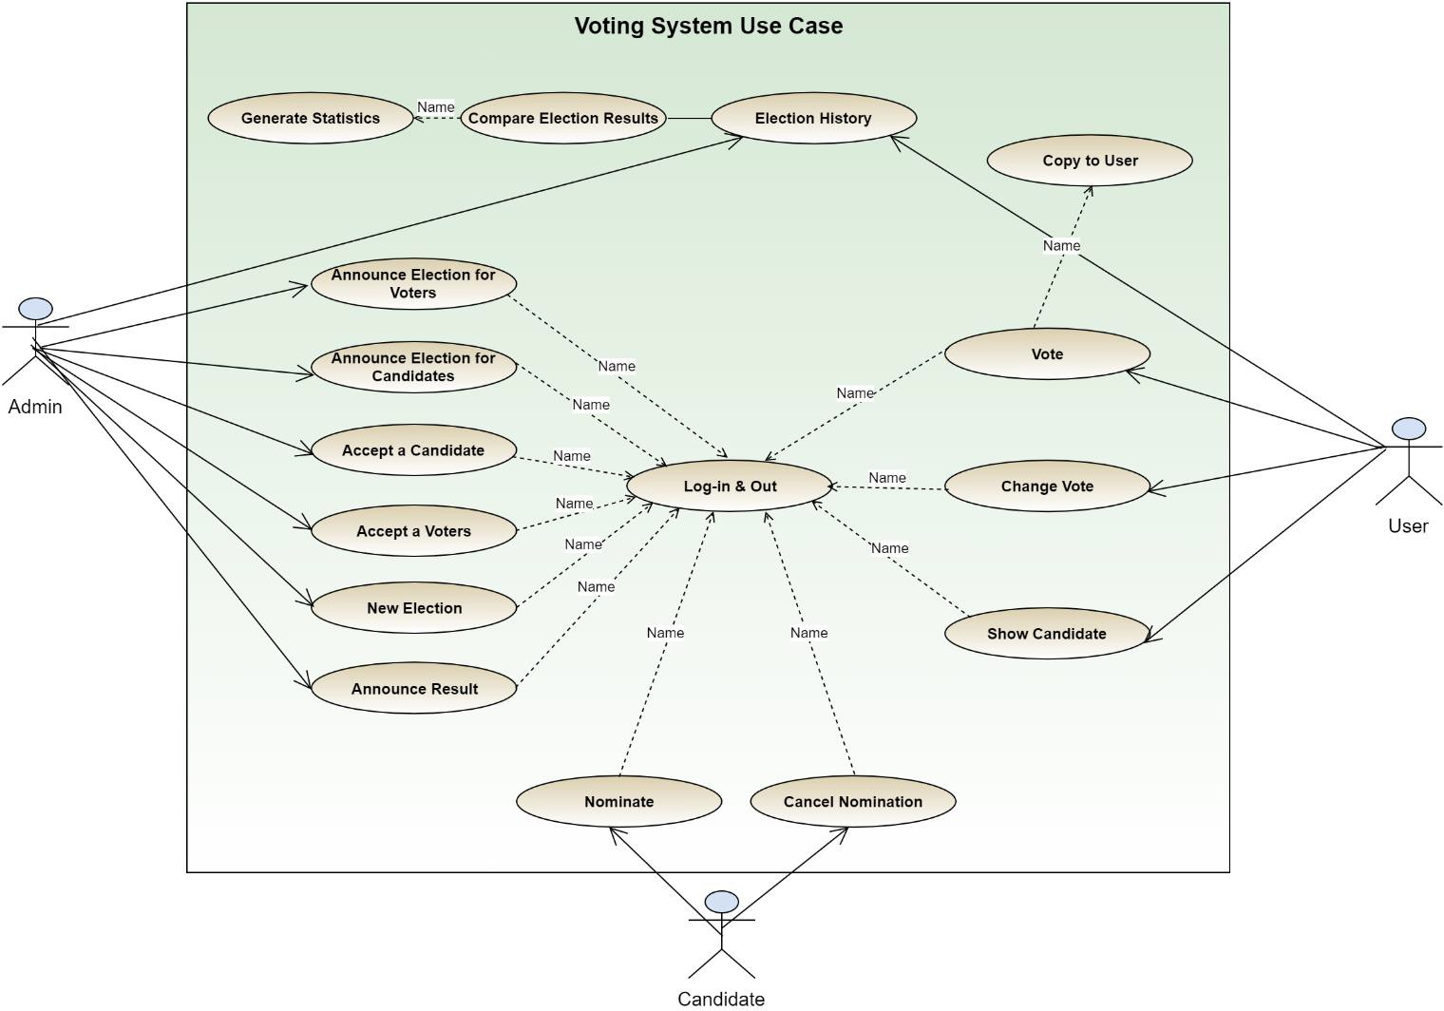

***Figure 1: System Use Case Diagram***



**UML Classes - Version 1**

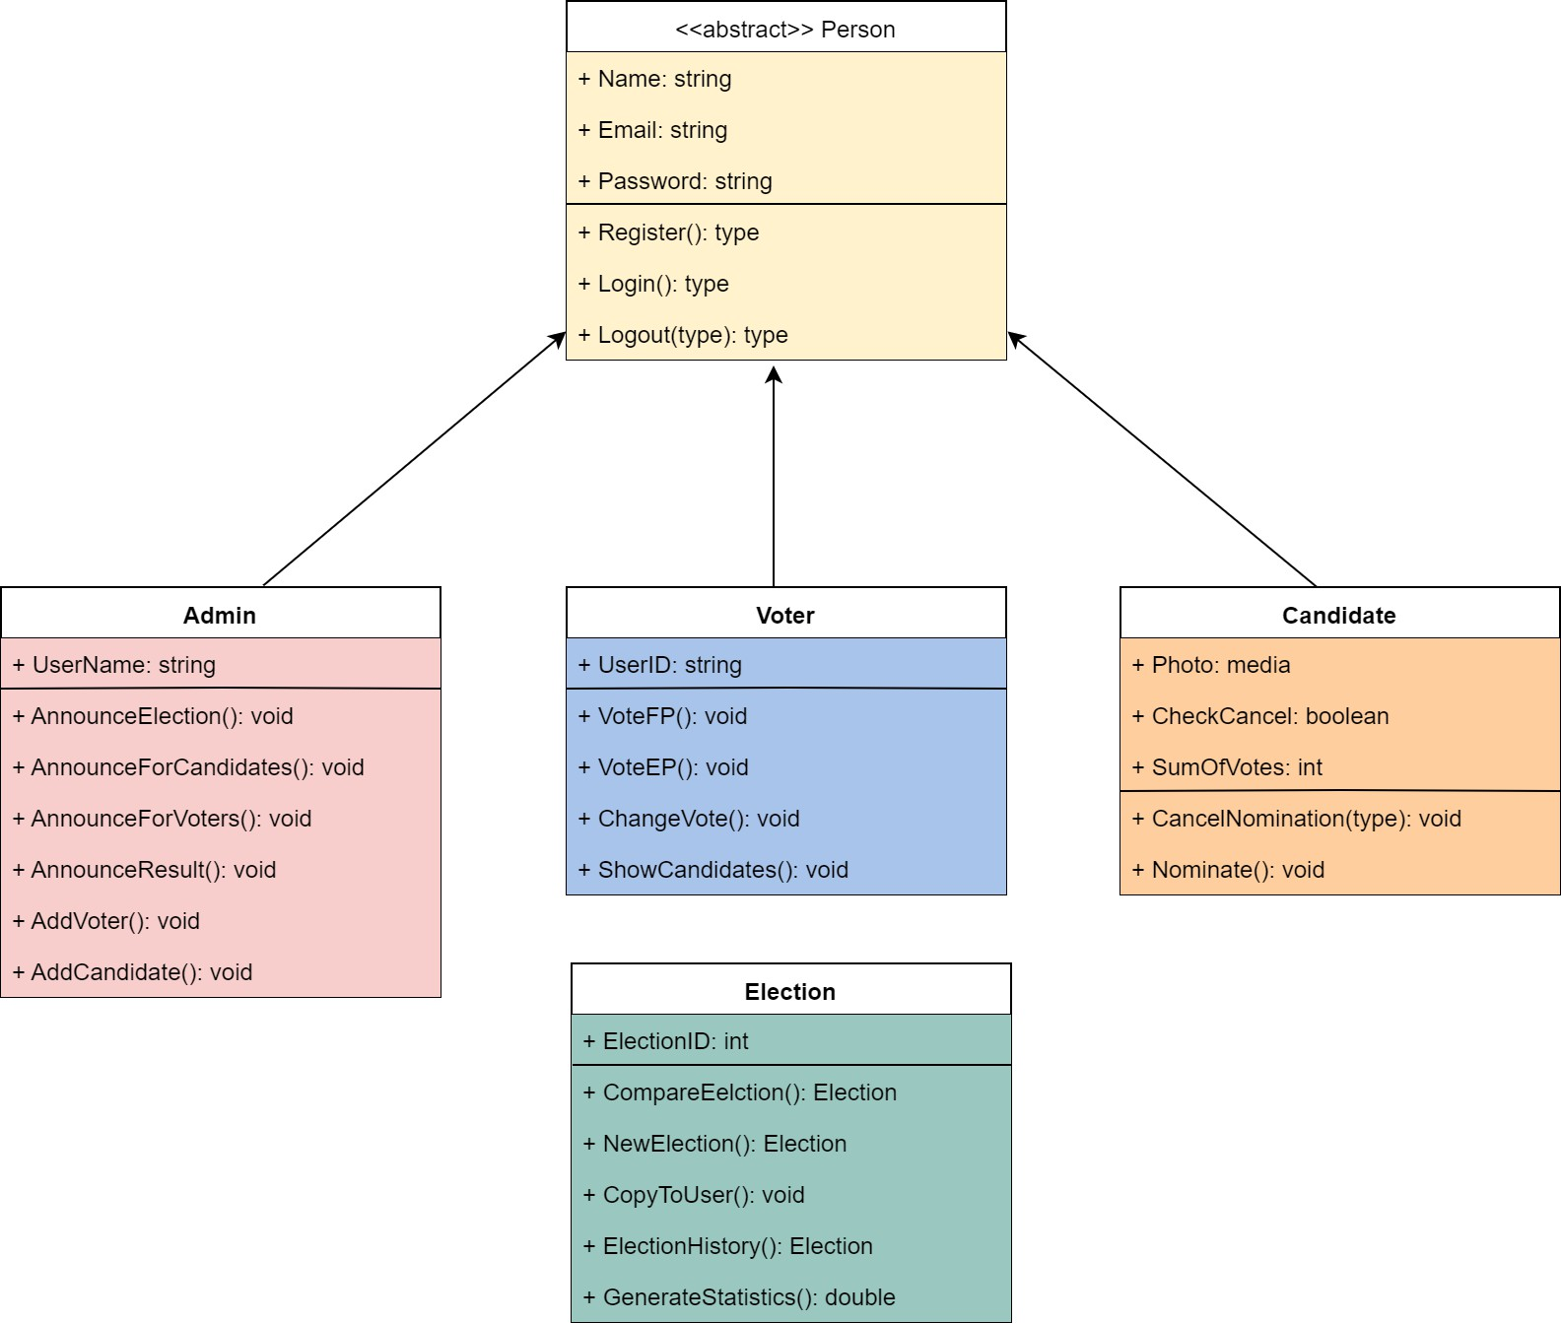

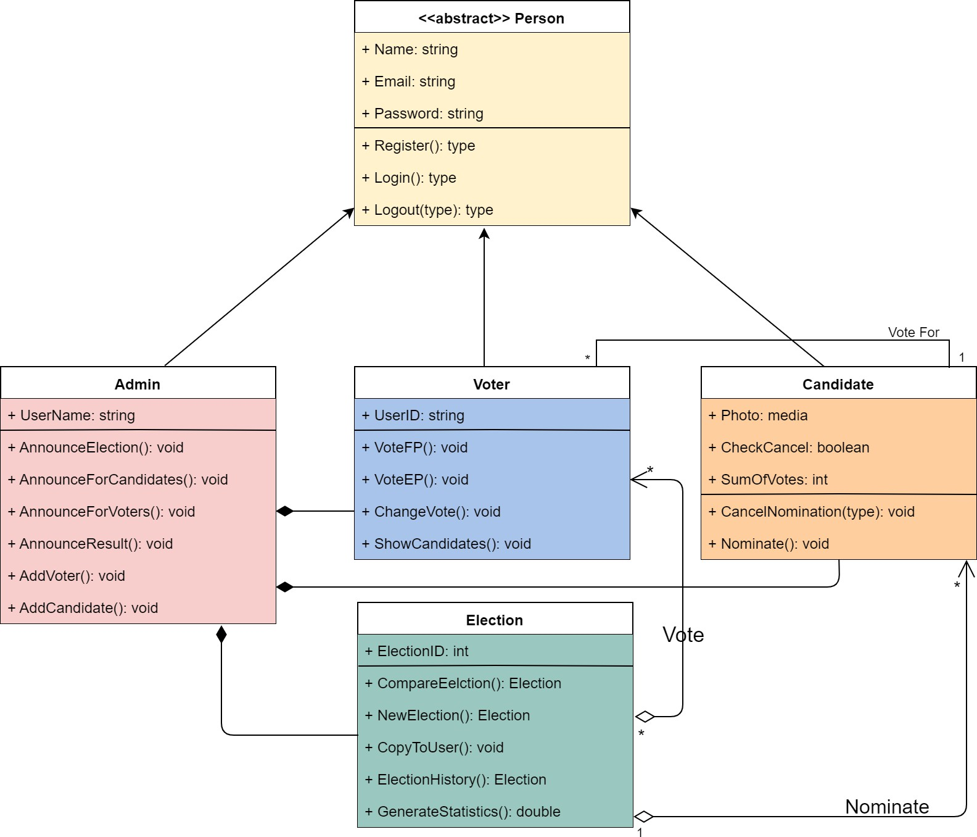



**UML Classes - Version 2**



**Databases**

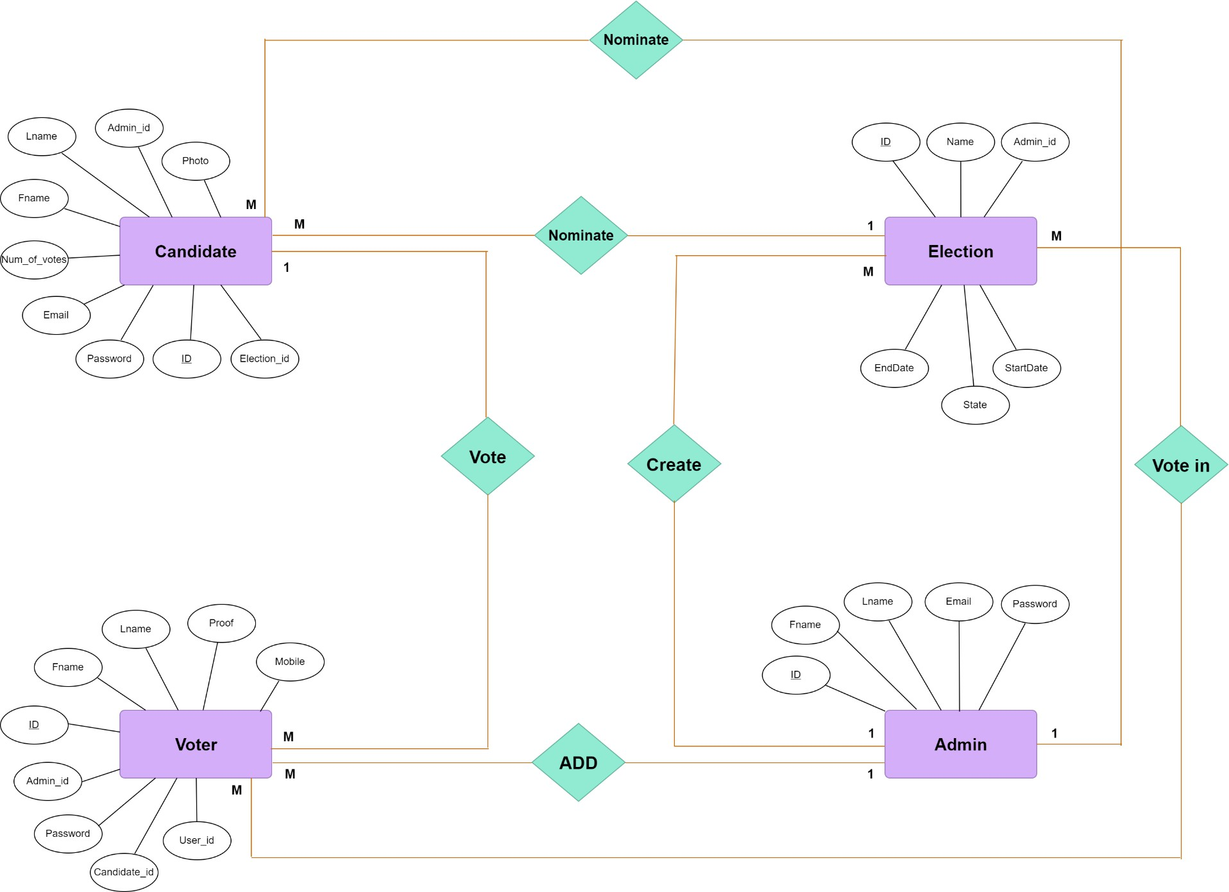

**ERD**



**ERD**



**Entities**

