## Using WinMIPS64 Simulator

# A Simple Tutorial

This exercise introduces WinMIPS64, a Windows based simulator of a pipelined implementation of the MIPS64 64-bit processor.

### 1. Starting and configuring WinMIPS64

Start WinMIPS64 from the task bar.

A window (denoted the main window) appears with seven child windows and a status line at the bottom. The seven windows are **Pipeline**, **Code**, **Data**, **Registers**, **Statistics**, **Cycles** and **Terminal**.

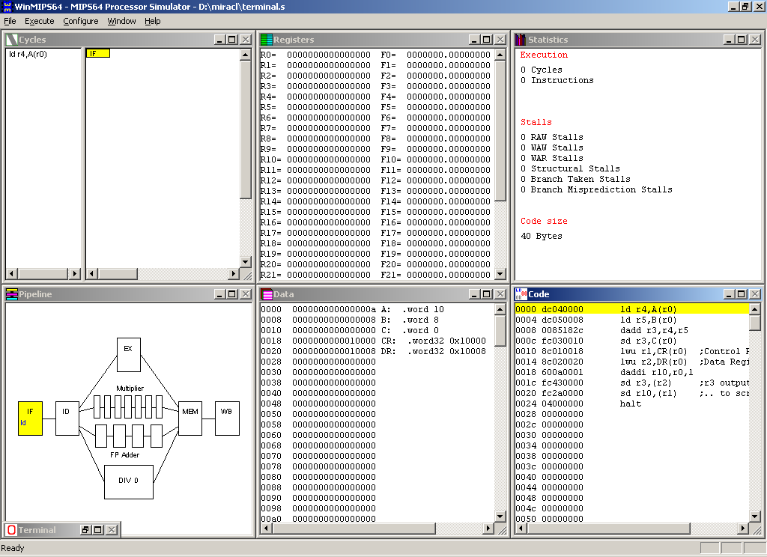

|  |  |
| --- | --- |
| Pipeline window | This window shows a schematic representation of the five pipeline stages of the MIPS64 processor and the units for floating point operations (addition / subtraction, multiplication and division). It shows which instruction is in each stage of the pipeline. |
| Code window | This window shows a three column representation of the code memory, showing from left to right 1) a byte address, 2) a hex number giving the 32-bit machine code representation of the instruction, and 3) the assembly language statement. Double-left-clicking on an instruction sets or clears break-points. |
| Data window | This window shows the contents of data memory, byte addressable, but displayed in 64-bit chunks, as appropriate for a 64-bit processor. To edit an integer value double-left-click. To display and edit as a floating-point number, double-right-click. |
| Register window | This window shows the values stored in the registers. If the register is displayed in grey, then it is in the process of being written to by an instruction. If displayed using a colour, the colour indicates the stage in the pipeline from which this value is available for *forwarding*. This window allows you to interactively change the contents of those 64-bit integer and floating-point registers that are not in the process of being written to, or being forwarded. To do this, double-left-click on the register you want to change and a pop-up window will ask you for new content. Press **OK** to confirm the change. |
| Clock Cycle diagram | This window gives a representation of the timing behaviour of the pipeline. It records the history of instructions as they enter and emerge from the pipeline. An instruction that causes a stall is highlighted in blue: instructions held up as a result of a stall are grayed. |
| Statistics | This window provides statistics on the number of simulation cycles, instructions, the average Cycles Per Instruction (CPI), the types of stalls, and numbers of conditional branches and Load/Store-instructions. |
| Terminal | This window mimics a dumb terminal I/O device with some limited graphics capability. |
| Status Line | The status line at the bottom normally displays "Ready", but will during program simulation provide useful information on the current status of the simulation. |

To make sure the simulation is reset, click on the ***File*** menu and click ***Reset MIPS64****.***OKOK**

WinMIPS64 can be configured in many ways. You can change the structure and time requirements of the floating-point pipeline, and the code/data memory size. To view or change standard settings click ***Configure***/***Architecture*** (read this as: click ***Configure*** to open the menu, then clicking on ***Architecture***)and you will see the following settings:

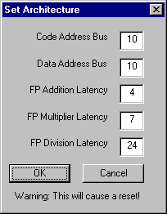

You can change the settings by clicking in the appropriate field and editing the given numbers. Any changes to the Floating-point latencies will be reflected in the Pipeline window. The *Code Address Bus* refers to the actual number of wires in the address bus. So a value of 10 means that 210 = 1024 bytes of code memory will be displayed in the Code window. When you are finished, click ***OK*** to return to the main window.

Three more options in the ***Configuration*** menu can be selected: ***Multi-Step***, ***Enable Forwarding***, ***Enable Branch Target Buffer*** and ***Enable Delay Slot.*** Of these ***Enable Forwarding*** should be enabled, that is, a small hook should be shown beside it. If this is not the case, click on the option.

You can change the size and/or position of child windows or bring up only one window using the maximise option for that window.

### 2. Loading a test program.

Use a standard text editor to create this file **sum.s**, which is a MIPS64 program that calculates the sum of two integers A and B from memory, and stores the result into the memory on location C.

.data

A: .word 10

B: .word 8

C: .word 0

.text

main:

ld r4,A(r0)

ld r5,B(r0)

dadd r3,r4,r5

sd r3,C(r0)

halt

A small command line utility asm.exe is provided to test a program for syntactical correctness. To check this program type

H:>asm sum.s

In order to be able to start the simulation, the program must be loaded into the main memory. To accomplish this, select ***File***/***Open***. A list of assembler programs in current directory appears in a window, including **sum.s**.

To load this file into WinMIPS64, do the following:

* Click on **sum.s**
* Click the ***Open*** button

The program is now loaded into the memory and the simulation is ready to begin.

You can view the content of code memory using the **Code** window, and observe the program data in the **Data** Window.

### 3. Simulation

#### 3.1 Cycle-by-cycle Simulation

At any stage you can press ***F10*** to restart the simulation from the beginning.

At the start you will note that the first line in the **Code** window with the address 0000 is coloured yellow. The IF stage in the **Pipeline** window is also coloured in yellow and contains the assembler mnemonic of the first instruction in the program. Now inspect the **Code** window and observe the first instruction **ld r4,A(r0)**. Look in the **Data** window to find the program variable **A**.

Clock 1:

Pressing ***Execute/Single Cycle*** (or simply pressing ***F7***) advances the simulation for one time step or one clock tick; in the **Code** Window, the colour of the first instruction is changed to blue and the second instruction is coloured in yellow. These colours indicate the pipeline stage the instruction is in (yellow for IF, blue for ID, red for EX, green for MEM, and purple for WB).

If you look in the IF stage in the **Pipeline** window, you can see that the second instruction **ld r5, B(r0)** is in the IF stage and the first instruction **ld r4,A(r0)** has advanced to the second stage, ID.

**Clock 2:**

Pressing ***F7*** again will re-arrange the colours in the **Code** window, introducing red for the third pipeline stage EX. Instruction **dadd r3,r4,r5** enters the pipeline. Note that the colour of an instruction indicates the stage in the pipeline that it will complete on the next clock tick.

**Clock 3:**

Pressing ***F7*** again will re-arrange the colours in the **Code** window, introducing green for the fourth pipeline stage MEM. Instruction **sd r3,C(r0)** enters the pipeline. Observe the Clock **Cycle** Diagram which shows a history of which instruction was in each stage before each clock tick.

**Clock 4:**

Press ***F7*** again. Each stage in the pipeline is now active with an instruction. The value that will end up in **r4** has been read from memory, but has not yet been written back to **r4**. However it is available for *forwarding* from the MEM stage. Hence observe that **r4** is displayed as green (the colour for MEM) in the **Registers**window. Can you explain the value of **r4**? Note that the last instruction **halt** has already entered the pipeline.

**Clock 5:**

Press ***F7*** again. Something interesting happens. The value destined for **r5** becomes available for forwarding. However the value for **r5** was not available in time for the **dadd r3,r4,r5** instruction to execute in EX. So it remains in EX, stalled. The status line reads "RAW stall in EX (R5)", indicating where the stall occurred, and which register's unavailability was responsible for it.

The picture in the Clock **Cycle** Diagram and the **Pipeline** window clearly shows that the **dadd** instruction is stalled in EX, and that the instructions behind it in the pipeline are also unable to progress. In the Clock **Cycle** Diagram, the **dadd** instruction is highlighted in blue, and the instructions behind are shown in gray.

**Clock 6:**

Press ***F7***. The **dadd r3,r4,r5** instruction executes and its output, destined for **r3**, becomes available for forwarding. This value is 12 hex, which is the sum of 10+8 = 18 in decimal. This is our answer.

Clock 7:

Press ***F7***. The halt instruction entering IF has had the effect of "freezing" the pipeline, so no new instructions are accepted into it.

**Clock 8:**

Press ***F7***. Examine **Data** memory, and observe that the variable C now has the value 12 hex. The **sd r3,C(r0)** instruction wrote it to memory in the MEM stage of the pipeline, using the forwarded value for **r3**.

**Clock 9:**

Press F7.

**Clock 10:**

Press F7. The program is finished

Look at the **Statistics** window and note that there has been one RAW stall. 10 clock cycles were needed to execute 5 instructions, so CPI=2. This is artificially high due to the one-off start-up cost in clock cycles needed to initially fill the pipeline.

The statistics window is extremely useful for comparing the effects of changes in the configuration. Let us examine the effect of forwarding in the example. Until now, we have used this feature; what would the execution time have been without forwarding?

To accomplish this, click on ***Configure***. To disable forwarding, click on ***Enable Forwarding*** (the hook must vanish).

Repeat the cycle-by-cycle program execution, re-examine the **Statistics** window and compare the results. Note that there are more stalls as instructions are held up in ID waiting for a register, and hence waiting for an earlier instruction to complete WB. The advantages of *forwarding* should be obvious.

#### 3.2 Other execution modes

Click on ***File/Reset MIPS64***. If you click on ***File/Full Reset***, you will delete the data memory, so you will have to repeat the procedure for program loading. Clicking on ***File/Reload*** or ***F10*** is a handy way to restart a simulation.

You can run simulation for a specified number of cycles. Use ***Execute/Multi cycle...*** for this. The number of cycles stepped through can be changed via ***Configure/Multi-step*.**

You can run the whole program by a single key-press - press ***F4***. Alternatively click on ***Execute/Run to***.

Also, you can set breakpoints. Press ***F10***. To set a break-point, double-left-click on the instruction, for example on **dadd r3,r4,r5**. Now press ***F4***. The program will halt when this instruction enters IF. To clear the break-point, double-left-click on the same instruction again.

#### 3.3 Terminal Output

#### The simulator supports a simple I/O device, which works like a simple dumb terminal screen, with some graphical capability. The output of a program can appear on this screen. To output the result of the previous program, modify it like this

#### .data

#### A: .word 10

#### B: .word 8

#### C: .word 0

#### CR: .word32 0x10000

#### DR: .word32 0x10008

#### .text

#### main:

#### ld r4,A(r0)

#### ld r5,B(r0)

#### dadd r3,r4,r5

#### sd r3,C(r0)

#### lwu r1,CR(r0) ;Control Register

#### lwu r2,DR(r0) ;Data Register

#### daddi r10,r0,1

#### sd r3,(r2) ;r3 output..

#### sd r10,(r1) ;.. to screen

#### halt

After this program is executed you can see the result of the addition printed in decimal on the **Terminal** window. For a more complete example of the I/O capabilities, see the *testio.s* and *hail.s* example programs.

# The Instruction set

The following assembler *directives* are supported

.data - start of data segment

.text - start of code segment

.code - start of code segment (same as .text)

.org <n> - start address

.space <n> - leave n empty bytes

.asciiz <s> - enters zero terminated ascii string

.ascii <s> - enter ascii string

.align <n> - align to n-byte boundary

.word <n1>,<n2>.. - enters word(s) of data (64-bits)

.byte <n1>,<n2>.. - enter bytes

.word32 <n1>,<n2>.. - enters 32 bit number(s)

.word16 <n1>,<n2>.. - enters 16 bit number(s)

.double <n1>,<n2>.. - enters floating-point number(s)

where <n> denotes a number like 24, <s> denotes a string like "fred", and <n1>,<n2>.. denotes numbers separated by commas. The integer registers can be referred to as r0-r31, or R0-R31, or $0-$31 or using standard MIPS pseudo-names, like $zero for r0, $t0 for r8 etc. Note that the size of an immediate is limited to 16-bits. The maximum size of an immediate register shift is 5 bits (so a shift by greater than 31 bits is illegal).

Floating point registers can be referred to as f0-f31, or F0-F31

The following *instructions* are supported. Note *reg* is an integer register, *freg* is a floating-point (FP) register, and *imm* is an immediate value.

lb reg,imm(reg) - load byte

lbu reg,imm(reg) - load byte unsigned

sb reg,imm(reg) - store byte

lh reg,imm(reg) - load 16-bit half-word

lhu reg,imm(reg) - load 16-bit half word unsigned

sh reg,imm(reg) - store 16-bit half-word

lw reg,imm(reg) - load 32-bit word

lwu reg,imm(reg) - load 32-bit word unsigned

sw reg,imm(reg) - store 32-bit word

ld reg,imm(reg) - load 64-bit double-word

sd reg,imm(reg) - store 64-bit double-word

l.d freg,imm(reg) - load 64-bit floating-point

s.d freg,imm(reg) - store 64-bit floating-point

halt - stops the program

daddi reg,reg,imm - add immediate

daddui reg,reg,imm - add immediate unsigned

andi reg,reg,imm - logical and immediate

ori reg,reg,imm - logical or immediate

xori reg,reg,imm - exclusive or immediate

lui reg,imm - load upper half of register immediate

slti reg,reg,imm - set if less than immediate

sltiu reg,reg,imm - set if less than immediate unsigned

beq reg,reg,imm - branch if pair of registers are equal

bne reg,reg,imm - branch if pair of registers are not equal

beqz reg,imm - branch if register is equal to zero

bnez reg,imm - branch if register is not equal to zero

j imm - jump to address

jr reg - jump to address in register

jal imm - jump and link to address (call subroutine)

jalr reg - jump and link to address in register

dsll reg,reg,imm - shift left logical

dsrl reg,reg,imm - shift right logical

dsra reg,reg,imm - shift right arithmetic

dsllv reg,reg,reg - shift left logical by variable amount

dsrlv reg,reg,reg - shift right logical by variable amount

dsrav reg,reg,reg - shift right arithmetic by variable amount

movz reg,reg,reg - move if register equals zero

movn reg,reg,reg - move if register not equal to zero

nop - no operation

and reg,reg,reg - logical and

or reg,reg,reg - logical or

xor reg,reg,reg - logical xor

slt reg,reg,reg - set if less than

sltu reg,reg,reg - set if less than unsigned

dadd reg,reg,reg - add integers

daddu reg,reg,reg - add integers unsigned

dsub reg,reg,reg - subtract integers

dsubu reg,reg,reg - subtract integers unsigned

dmul reg,reg,reg - signed integer multiplication

dmulu reg,reg,reg - unsigned integer multiplication

ddiv reg,reg,reg - signed integer division

ddivu reg,reg,reg - unsigned integer division

add.d freg,freg,freg - add floating-point

sub.d freg,freg,freg - subtract floating-point

mul.d freg,freg,freg - multiply floating-point

div.d freg,freg,freg - divide floating-point

mov.d freg,freg - move floating-point

cvt.d.l freg,freg - convert 64-bit integer to a double FP format

cvt.l.d freg,freg - convert double FP to a 64-bit integer format

c.lt.d freg,freg - set FP flag if less than

c.le.d freg,freg - set FP flag if less than or equal to

c.eq.d freg,freg - set FP flag if equal to

bc1f imm - branch to address if FP flag is FALSE

bc1t imm - branch to address if FP flag is TRUE

mtc1 reg,freg - move data from integer register to FP register

mfc1 reg,freg - move data from FP register to integer register

Memory Mapped I/O area

Addresses of CONTROL and DATA registers

CONTROL: .word32 0x10000

DATA: .word32 0x10008

Set CONTROL = 1, Set DATA to Unsigned Integer to be output

Set CONTROL = 2, Set DATA to Signed Integer to be output

Set CONTROL = 3, Set DATA to Floating Point to be output

Set CONTROL = 4, Set DATA to address of string to be output

Set CONTROL = 5, Set DATA+5 to x coordinate, DATA+4 to y coordinate, and DATA to RGB colour to be output

Set CONTROL = 6, Clears the terminal screen

Set CONTROL = 7, Clears the graphics screen

Set CONTROL = 8, read the DATA (either an integer or a floating-point) from the keyboard

Set CONTROL = 9, read one byte from DATA, no character echo.

# Notes on the Pipeline Simulation

The pipeline simulation attempts to mimic as far as possible that described in Appendix A of Computer Architecture: A Quantitative Approach.

However in a few places alternative strategies were suggested, and we had to choose one or the other.

Stalls are handled where they arise in the pipeline, not necessarily in ID.

We decided to allow floating-point instructions to issue out of ID into their own pipelines, if available. There they either proceed or stall, waiting for their operands to become available. This has the advantage of allowing out-of-order completion to be demonstrated, but it can cause WAR hazards to arise. However the student can thus learn the advantages of register renaming.

Consider this simple program fragment:-

.text

add.d f7,f7,f3

add.d f7,f7,f4

mul.d f4,f5,f6 ; WAR on f4

If the mul.d is allowed to issue, it could "overtake" the second add.d and write to f4 first. Therefore in this case the mul.d must be stalled in ID.

Structural hazards arise at the MEM stage bottleneck, as instructions attempt to exit more than one of the execute stage pipelines at the same time. Our simple rule is longest latency first.

# Installation

On your own computer, just install anywhere convenient, and create a short-cut to point at it. Note that winmips64 will write two initialisation files into this directory, one winmips64.ini which stores architectural details, one winmips64.las which remembers the last .s file accessed.

On a network drive, install winmips64.exe into a suitable system directory. Then use a standard text editor to create a file called winmips64.pth, and put this file in the same directory.

The read-only file winmips64.pth should contain a single line path to a read-write directory private to any logged-in user. This directory will then be used to store their .ini and .las files.

For example winmips64.pth might contain

H:

or

c:\temp

But remember only a single line - don't press return at the end of it!