SJF vs Priority Scheduling Simulator
CPU Scheduling Comparison Project Documentation

1. Project Overview
This project is a web-based CPU Scheduling Simulator designed to compare Shortest Job First (SJF) Scheduling and Priority Scheduling algorithms. The simulator helps students understand how different scheduling algorithms affect process execution order, waiting time, turnaround time, and response time.
The system allows users to enter processes with arrival time, burst time, and priority values, then displays the execution order using Gantt Charts and result tables for both algorithms.

2. Technologies Used
- HTML: Used to build the structure of the web page and input forms.
- CSS: Used to design the interface, colors, layout, and responsive styling.
- JavaScript: Used to implement the scheduling algorithms, validation, calculations, and dynamic interaction.

3. Main Features
- Add and remove processes dynamically.
- Validate user input values.
- Simulate SJF Non-Preemptive Scheduling.
- Simulate Priority Non-Preemptive Scheduling.
- Display Gantt Charts for both algorithms.
- Calculate Waiting Time (WT), Turnaround Time (TAT), and Response Time (RT).
- Compare the results between the two scheduling methods.

4. Scheduling Algorithms

4.1 Shortest Job First (SJF)
Shortest Job First (SJF) selects the process with the smallest burst time among the available processes. This algorithm is efficient for reducing average waiting time but may cause starvation for long processes.

4.2 Priority Scheduling
Priority Scheduling selects the process with the highest priority first. In this project, lower priority numbers represent higher importance (Priority 1 is the highest). If two processes have the same priority, the process with the earlier arrival time is selected first.

5. Scenario A Explanation
Scenario A represents a normal mixed workload with different arrival times, burst times, and priorities. The following processes were used in the test:
Process | Arrival Time | Burst Time | Priority
P1 | 0 | 5 | 2
P2 | 1 | 3 | 1
P3 | 2 | 8 | 4
P4 | 3 | 6 | 2
In this scenario, both SJF and Priority Scheduling produced the same execution order because the shortest available process also had the highest priority at the decision points.
Execution Order: P1 → P2 → P4 → P3
Average Waiting Time = 5.25
Average Turnaround Time = 10.75
Average Response Time = 5.25
This scenario demonstrates that under some workloads, different scheduling algorithms may generate identical results.

6. Scenario B Explanation — Conflict Between Burst Time and Priority
Scenario B is designed to highlight the conflict between burst time and priority. It includes a long-burst, high-priority process (P1) alongside several short-burst, lower-priority processes (P2, P3, P4) and one medium-burst process (P5). This setup reveals a meaningful difference between the two algorithms: SJF will skip the long high-priority job in favor of shorter ones, while Priority Scheduling executes the high-priority job first regardless of its length.
Process | Arrival Time | Burst Time | Priority
P1 | 0 | 10 | 5
P2 | 0 | 2 | 1 (highest)
P3 | 0 | 2 | 1 (highest)
P4 | 0 | 2 | 1 (highest)
P5 | 0 | 3 | 2
SJF Execution Order: P1 → P2 → P3 → P4 → P5 (0–10 → 10–12 → 12–14 → 14–16 → 16–19)
Priority Execution Order: P1 → P2 → P3 → P4 → P5 (0–10 → 10–12 → 12–14 → 14–16 → 16–19)
SJF Average: WT = 8.40 | TAT = 12.20 | RT = 8.40
Priority Average: WT = 8.40 | TAT = 12.20 | RT = 8.40
Key Insight: In this particular case the Gantt charts match because all short-burst processes (P2, P3, P4) share the same top priority and all arrived at time 0, so both algorithms agree on the tie-breaking order. The important teaching point is that SJF chose them because they are short, while Priority chose them because of their priority number — the motivation differs even when the outcome coincides. In general, a workload where arrival times differ will produce visibly different Gantt charts for these two algorithms.

7. Scenario C Explanation — Fairness and Starvation-Sensitive Case
Scenario C explores fairness and potential starvation. A long-burst, low-priority process (P1) arrives first, while several short-burst, high-priority processes (P2, P3, P4) arrive shortly after. Under Priority Scheduling, P1 is forced to wait until all higher-priority processes complete, causing a very long waiting time and demonstrating the starvation problem. Under SJF, P1 runs first because it is the only process available at time 0, after which the shorter jobs finish quickly.
Process | Arrival Time | Burst Time | Priority
P1 | 0 | 2 | 5
P2 | 1 | 10 | 1 (highest)
P3 | 1 | 4 | 3
P4 | 2 | 1 | 4
SJF Execution Order: P1 → P4 → P3 → P2 (0–2 → 2–3 → 3–7 → 7–17)
Priority Execution Order: P1 → P2 → P3 → P4 → P2 (see Gantt) → ... finishing at time 17
SJF Average: WT = 2.25 | TAT = 6.50 | RT = 2.25
Priority Average: WT = 9.00 | TAT = 13.25 | RT = 9.00
Key Insight: Under Priority Scheduling, process P1 (low priority = 5) is forced to wait until time 15 even though it arrived first and has one of the shortest burst times. This is a clear demonstration of starvation — a process that is ready and short can be indefinitely delayed by a stream of higher-priority arrivals. SJF, by contrast, naturally favors short jobs and produces a much lower average waiting time (2.25 vs 9.00), illustrating that the two algorithms optimize for fundamentally different goals.

8. Scenario D Explanation — Validation Case
Scenario D demonstrates the input validation behavior of the simulator. Rather than running a scheduling simulation, it verifies that the application correctly rejects invalid process data before any computation takes place. The following invalid inputs are tested:
Invalid Input | Error Message Shown
Arrival Time = -3 | Arrival Time cannot be negative.
Burst Time = 0 | Burst Time must be greater than zero.
Burst Time = -5 | Burst Time must be greater than zero.
Priority = “abc” | All numeric fields must be numbers.
Duplicate PID “P1” | Duplicate Process ID — each process must be unique.
Missing any field | All fields are required.
Priority = 0 | Priority must be a positive integer (1–99).
Key Insight: The validation layer ensures that only clean, meaningful data reaches the scheduling engine. Each rule prevents a specific category of logical error: negative times are physically impossible, a zero burst time would cause division-by-zero in metric calculations, non-numeric priorities would break comparisons, duplicate PIDs would corrupt the process table, and missing fields would leave the algorithm with incomplete information. The screenshot above shows the live error message displayed beneath the input form when an invalid value is entered — the process is not added to the table until all fields pass validation.

9. Project Screenshots
Project Interface
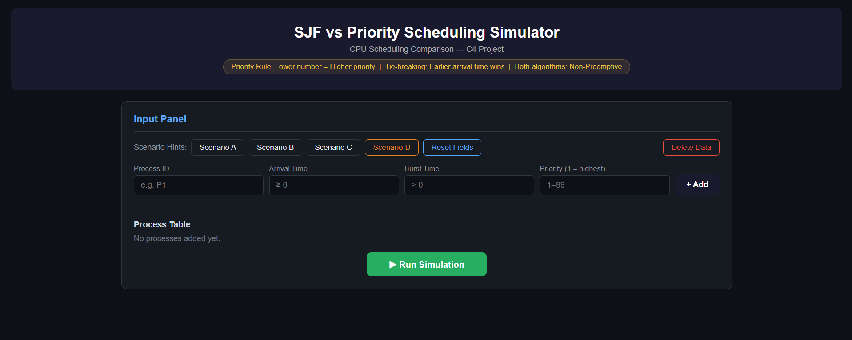
Scenario A Results
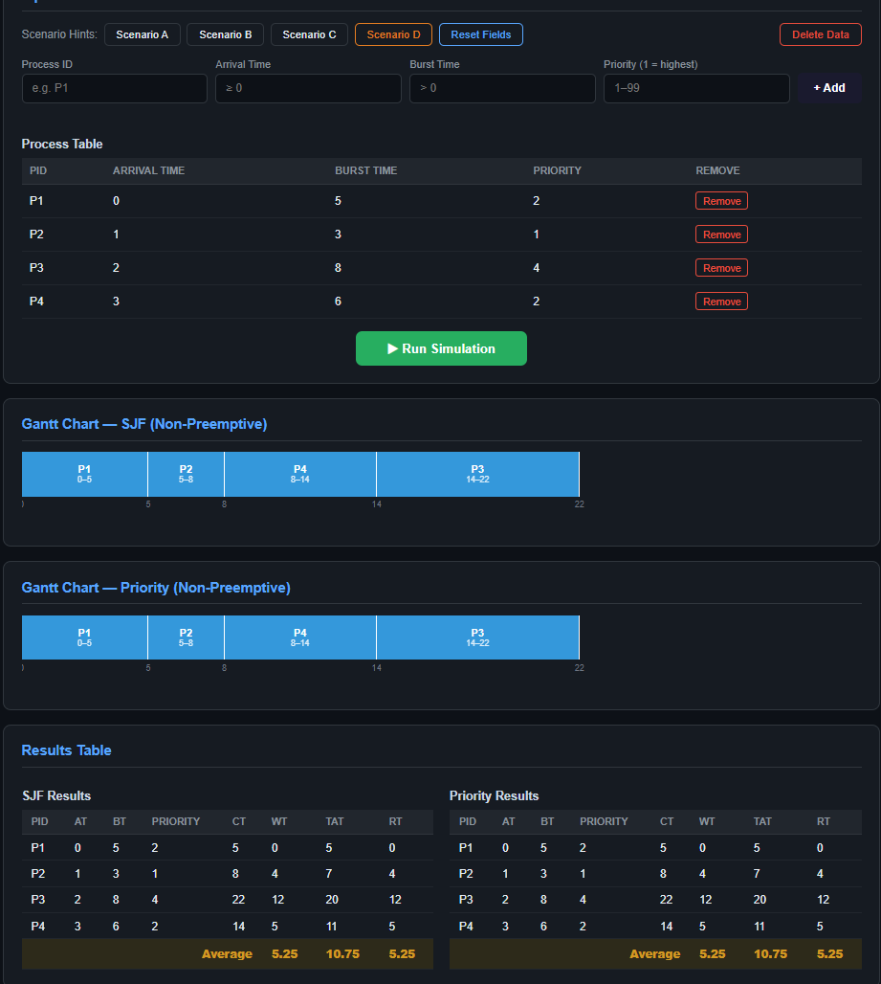
Scenario B Results
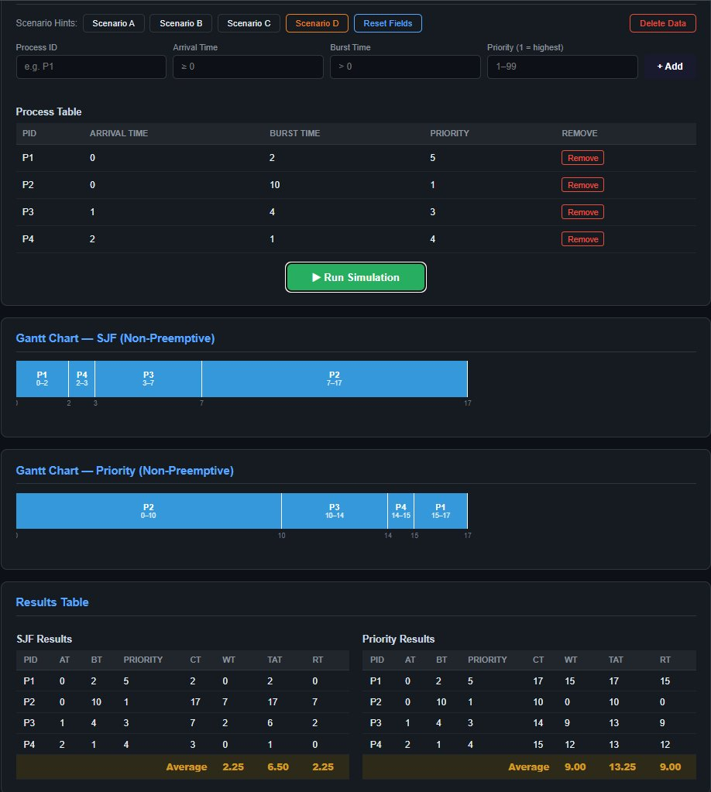
Scenario C Results
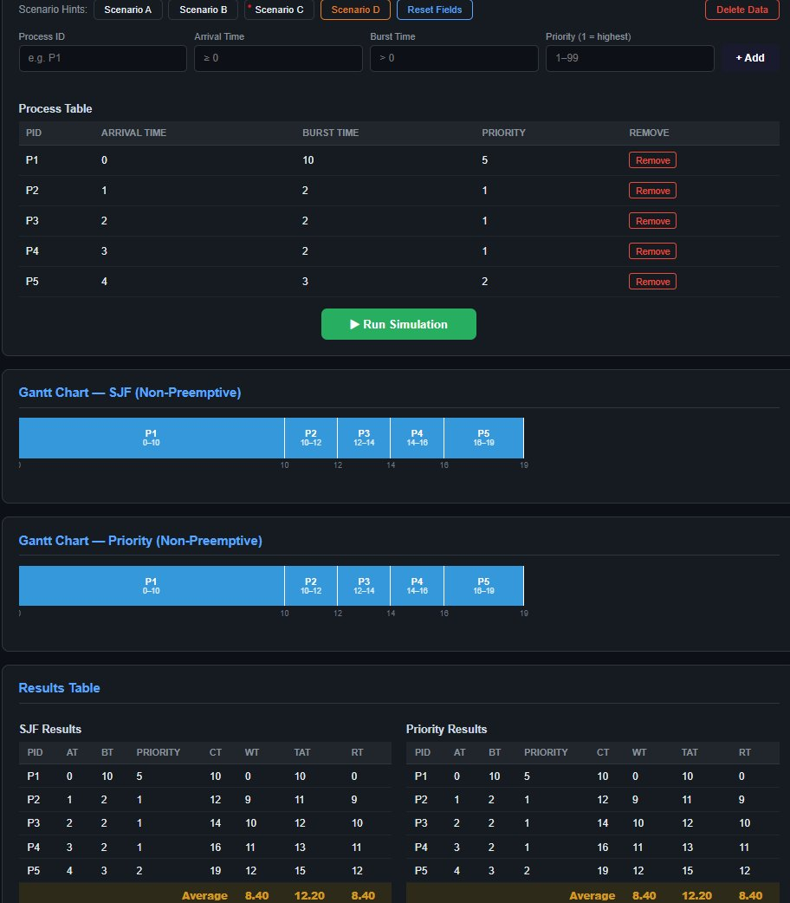
Scenario D Results
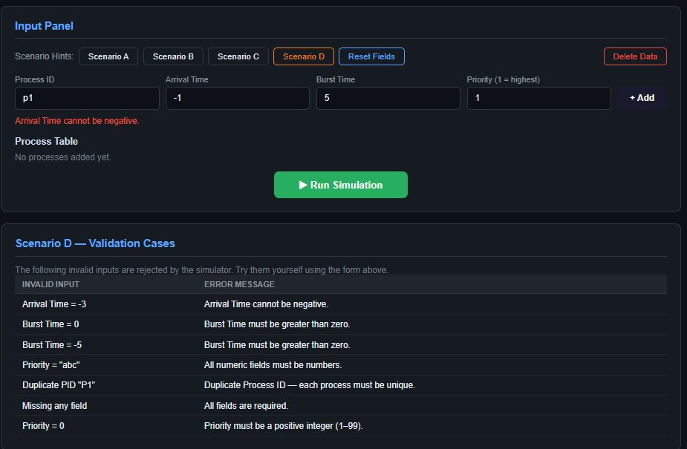

10. Conclusion
This project successfully demonstrates the differences between SJF Scheduling and Priority Scheduling using an interactive web application. The simulator helps users visualize process execution and compare scheduling performance through Gantt Charts and calculated metrics.
The project also improves understanding of CPU scheduling concepts and practical implementation using HTML, CSS, and JavaScript.

