

Software Engineering CSCI313

Instructor:

Dr. Ahmed F. Elnokrash

TA. Amira Tarek Mahmoud

Deliverable 3

Team Members

*Ezz El Dine Ayman – 19100852*

*Mahmoud Ayman Ebrahim – 19100969*

*Mahmoud Ibrahim – 19100242*

*Abdallah Emad Saad – 19106246*

*Hospital Management System*

**Functional:**

|  |  |
| --- | --- |
| **Title** | **Description** |
| Register | **System should allow users to be able to register so they can be able to login later.** |
| login | **System should allow registered users to login using a valid username and password.** |
| Add Patient | **System should allow admins to add Patients by filling all the Patients details.** |
| Delete Patient | **System should allow admins to delete Patients by removing all their information.** |
| View Patients | **System should allow admins to view Patients and see all his information.** |
| Edit Patients | **System should allow admins to edit the Patients information.** |
| Add doctor | **System should allow admins to add Doctors by filling all the doctor details.** |
| Delete doctor | **System should allow admins to remove Doctors assigned to the patients.** |
| View doctor | **System should allow admins to view Doctors and all their information.** |
| Edit Doctor | **System should allow admins to edit the Doctors information.** |
| Add Nurse | **System should allow admins to add Nurse by filling all the nurse details.** |
| Delete nurse | **System should allow admins to remove nurses.** |
| View nurse | **System should allow admins to view nurses and all their information.** |
| Edit Nurse | **System should allow admins to edit the Nurse information.** |
| Add room | **System should allow admins to add the patients to the rooms.** |
| View room | **System should allow admins to view the rooms.** |

**Non-Functional:**

|  |  |
| --- | --- |
| Title | details |
| Security | The user must enter a specific MySQL password manually and this may cause a leak in his password. |
| Reliability | The program must be connected to another program which is MySQL. |

**User-Case Diagram:**

Figure 1- Patient User-case

Figure 2- Doctor User-case

Figure 3- Nurse User-case

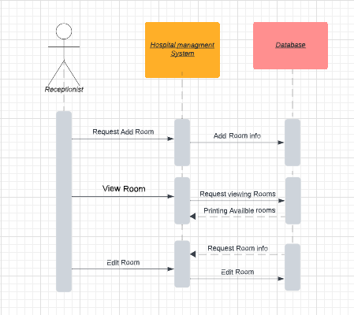

Figure 4- Room User-case