

Declaration
I hereby declare that this Senior Project entitled "AI-Powered Network Traffic Analyzer & Anomaly Detector" is my original work and has not been submitted, either wholly or partially, for any degree or diploma at any university or educational institution.
All information obtained from books, scientific journals, conference papers, official documentation, datasets, and technical resources has been properly acknowledged and cited according to APA 7 style. The report is prepared for the Bachelor of Science in Computer Science at the American University of Culture and Education (AUCE).
Student Name: Mahmoud Talal Kanaan
Student ID: 2240004
Supervisor: Dr. Hasan Nour Eldin
Signature: ______________________ Date: ______________________

Acknowledgment

First and foremost, I thank Almighty God for granting me the strength, patience, and determination to complete this Senior Project. I would also like to express my sincere gratitude to my project supervisor, Dr. Hasan Nour Eldin, for guidance, feedback, and encouragement throughout the preparation of this project.
I also thank the Faculty of Science and the Department of Computer Science at AUCE for providing the academic foundation needed to understand programming, databases, networking, cybersecurity, and artificial intelligence. Finally, I thank my family and friends for their support during my academic journey.

Abstract

Cyberattacks have become more sophisticated as organizations depend increasingly on cloud computing, IoT devices, web systems, and high-speed networks. Traditional signature-based Intrusion Detection Systems are useful for known attacks, but they are limited when attackers modify their behavior or when unknown zero-day attacks appear. This project proposes an AI-Powered Network Traffic Analyzer & Anomaly Detector, an academic Network Detection and Response platform designed to capture network traffic, extract meaningful features, detect anomalies, classify known attacks, generate alerts, and support automated response.
The proposed system integrates multiple Artificial Intelligence models, including Random Forest, XGBoost, Isolation Forest, Autoencoder, and LSTM. The design combines supervised detection, unsupervised anomaly detection, sequential attack prediction, Explainable AI, Threat Intelligence, geo-location, a real-time dashboard, database storage, email and Telegram notifications, and automatic IP blocking. The system is implemented using open-source technologies such as Python, FastAPI, PostgreSQL, Scikit-learn, TensorFlow/Keras, XGBoost, PyShark, Scapy, and web technologies.
This final condensed report is based on the full senior project document and keeps the essential academic content within a Bachelor-level 30-40 page structure. It includes the research problem, objectives, literature review, comparison of twenty cybersecurity platforms, proposed architecture, implementation plan, diagrams, evaluation metrics, expected results, limitations, future work, and verified APA 7 references.
Keywords: Artificial Intelligence, Network Intrusion Detection, Network Traffic Analysis, Anomaly Detection, Machine Learning, Deep Learning, NDR, XAI.

Declaration 3
Acknowledgment 4
Abstract 5
List of Figures 8
List of Tables 8
List of Acronyms 9
Chapter 1 - Introduction 10
1.1 Background 10
1.2 Problem Statement 10
1.3 Proposed Solution 10
1.4 Research Objectives 10
1.5 Research Questions 10
1.6 Scope 10
1.7 Methodology 11
1.8 Thesis Organization 11
Chapter 2 - Literature Review and State of the Art 12
2.1 Traditional Intrusion Detection Systems 12
2.2 AI-Based Intrusion Detection 12
2.3 Machine Learning and Deep Learning Techniques 12
2.4 Datasets Used in Network Intrusion Detection 12
2.5 State of the Art: 20 Applications 12
2.6 Literature Gap 13
2.7 Detailed State-of-the-Art Gap Analysis 13
Darktrace 13
Vectra AI 13
ExtraHop RevealX 14
Corelight Open NDR 14
Cisco Secure Network Analytics 14
Palo Alto Cortex XSIAM 14
Microsoft Sentinel 15
Splunk Enterprise Security 15
IBM QRadar 15
Elastic Security 15
CrowdStrike Falcon 16
Trend Micro Vision One 16
Google Security Operations 16
Rapid7 InsightIDR 16
Security Onion 2 16
Zeek 17
Suricata 17
Wazuh 17
Snort 3 17
Cisco XDR 18
Chapter 3 - Proposed System Architecture 19
3.1 Architecture Overview 19
3.2 AI Detection Pipeline 19
3.3 Main Modules 20
3.4 Data Flow Diagram 20
3.5 UML Diagrams 21
3.6 Threat Model 22
Chapter 4 - Implementation Methodology 24
4.1 Technology Stack 24
4.2 Feature Engineering 24
4.3 Model Development 24
4.4 Decision Fusion 24
4.5 Database Design 24
4.6 Dashboard Design 25
4.7 Implementation Workflow 25
4.8 Backend API Design 25
4.9 Algorithmic Workflow 26
4.10 Model Training Pseudocode 26
4.11 Project Folder Structure 26
Chapter 5 - Testing and Evaluation 27
5.1 Testing Objectives 27
5.2 Testing Environment 27
5.3 Attack Simulation Scenarios 27
5.4 Evaluation Metrics 27
5.5 Confusion Matrix and ROC Curve 28
5.6 Expected Performance Comparison 29
5.7 Success Criteria 29
5.8 Detailed Test Cases 29
5.9 Data Validation Checklist 30
5.10 Error Handling and Reliability 30
5.11 Academic Honesty in Results 30
Chapter 6 - Deployment, Limitations and Future Work 31
6.1 Deployment Architecture 31
6.2 Security Considerations 31
6.3 Limitations 31
6.4 Future Work 31
6.5 Ethical and Legal Considerations 31
Chapter 7 - Practical Implementation Notes 32
7.1 Dataset Preparation Notes 32
7.2 Handling Class Imbalance 32
7.3 Threshold Tuning 32
7.4 Explainability Strategy 32
7.5 Report Generation 32
7.6 Final Demonstration Scenario 32
Chapter 8 - User Manual and Operation Guide 33
8.1 Starting the System 33
8.2 Uploading Data or Capturing Live Traffic 33
8.3 Reading the Dashboard 33
8.4 Responding to Alerts 33
8.5 Maintenance Procedures 33
8.6 Minimal Functional Requirements 33
8.7 Non-Functional Requirements 33
Conclusion 34
Appendix A - Defense Preparation Notes 35
Appendix B - Presentation Outline 35
Appendix C - Additional Defense Questions 35
Appendix D - Implementation Timeline 35
Appendix E - Practical Code Skeleton 36
Appendix F - Final Submission Checklist 36
Appendix G - Glossary of Important Terms 36
References 37

List of Figures
No. | Figure Title
Figure 1 | Proposed System Architecture
Figure 2 | AI Detection Pipeline
Figure 3 | Data Flow Diagram
Figure 4 | Use Case Diagram
Figure 5 | Sequence Diagram
Figure 6 | Activity Diagram
Figure 7 | STRIDE Threat Model
Figure 8 | Dashboard Mockup
Figure 9 | Confusion Matrix Example
Figure 10 | ROC Curve Example
Figure 11 | Expected Model Performance Comparison

List of Tables
No. | Table Title
Table 1 | List of Acronyms
Table 2 | Research Questions and Objectives
Table 3 | Comparison of 20 Cybersecurity Platforms
Table 4 | Dataset Options
Table 5 | Extracted Network Features
Table 6 | AI Models and Roles
Table 7 | Database Tables
Table 8 | Performance Metrics
Table 9 | Expected Performance Comparison
Table 10 | Risk and Mitigation Plan

List of Acronyms
Acronym | Meaning
AI | Artificial Intelligence
ML | Machine Learning
DL | Deep Learning
IDS | Intrusion Detection System
IPS | Intrusion Prevention System
NIDS | Network Intrusion Detection System
NDR | Network Detection and Response
SIEM | Security Information and Event Management
SOAR | Security Orchestration, Automation and Response
XDR | Extended Detection and Response
XAI | Explainable Artificial Intelligence
LSTM | Long Short-Term Memory
RF | Random Forest
API | Application Programming Interface
REST | Representational State Transfer
SQL | Structured Query Language
DFD | Data Flow Diagram
UML | Unified Modeling Language
TCP | Transmission Control Protocol
UDP | User Datagram Protocol
DDoS | Distributed Denial of Service
ROC | Receiver Operating Characteristic
AUC | Area Under Curve

Chapter 1 - Introduction

1.1 Background
Modern computer networks generate huge volumes of packets every second. These packets carry normal business activity, web requests, cloud communication, authentication traffic, database connections, and sometimes malicious behavior. Because the number of packets is too large for manual inspection, organizations need automated monitoring systems that can discover suspicious behavior quickly and accurately.
Traditional IDS tools usually depend on predefined signatures. This approach is effective when the attack is already known, but it becomes weaker when the attack is new, modified, hidden inside normal-looking behavior, or performed slowly over time. Artificial Intelligence provides an alternative approach because it can learn patterns from network features and detect behavior that does not match normal traffic.

1.2 Problem Statement
The main problem addressed by this project is the difficulty of detecting known and unknown attacks in large-scale network traffic. Security analysts may receive many alerts, and traditional systems can miss unknown attacks or generate false positives. Therefore, the project proposes a hybrid AI-based platform that can analyze flows, classify attacks, detect anomalies, and present understandable alerts to the administrator.

1.3 Proposed Solution
- Capture network traffic from live interfaces, PCAP files, or benchmark datasets.
- Extract flow-based features such as duration, bytes, packets, protocol, ports, packet length statistics, and rate values.
- Preprocess the data by cleaning missing values, encoding categorical values, and scaling numerical features.
- Use multiple AI models for known attack detection, anomaly detection, and prediction.
- Provide Explainable AI outputs, Threat Intelligence enrichment, automatic response, and dashboard visualization.

1.4 Research Objectives
Objective | Description
O1 | Monitor network traffic and extract useful security features.
O2 | Detect known attacks using supervised ML models such as Random Forest and XGBoost.
O3 | Detect unknown anomalies using Isolation Forest and Autoencoder.
O4 | Use LSTM to analyze sequential behavior and support future attack prediction.
O5 | Improve transparency using Explainable AI and feature importance.
O6 | Support incident response using IP blocking, email alerts, Telegram alerts, and reports.

1.5 Research Questions
RQ | Question
RQ1 | How can Artificial Intelligence improve cyberattack detection compared with traditional signature-based IDS?
RQ2 | Can multiple ML and DL models improve accuracy while reducing false positives?
RQ3 | How effective is real-time network monitoring for detecting known and unknown threats?
RQ4 | Can Explainable AI improve the trust and transparency of AI-based cybersecurity systems?
RQ5 | How can automated response mechanisms reduce incident impact?

1.6 Scope
The project is designed as an academic Bachelor-level prototype. It focuses on packet/flow capture, feature extraction, AI-based detection, dashboard visualization, notifications, and response simulation. It does not claim to replace enterprise commercial systems, but it demonstrates a complete AI-assisted NDR workflow using open-source tools.

1.7 Methodology
The project follows a Design Science Research methodology. The process starts with literature review and gap analysis, then moves to architecture design, dataset preparation, model development, backend and dashboard implementation, testing, evaluation, and documentation. This methodology is suitable because the goal is to build and evaluate an artifact, not only discuss a theory.

1.8 Thesis Organization
Chapter 1 introduces the project. Chapter 2 reviews related work and compares twenty applications. Chapter 3 presents the proposed architecture. Chapter 4 explains implementation methodology. Chapter 5 presents testing and evaluation. Chapter 6 discusses deployment, limitations, and future work. The report ends with conclusion, references, and appendices.

Chapter 2 - Literature Review and State of the Art

2.1 Traditional Intrusion Detection Systems
An Intrusion Detection System monitors network or host activity to discover suspicious behavior. Signature-based detection compares traffic with known attack patterns and is efficient for known threats. However, it cannot reliably identify new attacks. Anomaly-based detection learns normal behavior and alerts when traffic deviates from that baseline. Hybrid IDS combines both methods to improve coverage.

2.2 AI-Based Intrusion Detection
AI-based IDS uses Machine Learning and Deep Learning to recognize patterns in network traffic. Supervised learning models use labeled datasets to classify traffic as normal or malicious. Unsupervised learning models detect outliers without requiring labels. Deep Learning models can learn complex relationships and sequential behavior, especially when network activity changes over time.

2.3 Machine Learning and Deep Learning Techniques
Model | Type | Reason for Use
Random Forest | Supervised classification | Strong baseline, handles nonlinear relations, gives feature importance.
XGBoost | Supervised gradient boosting | High performance on structured tabular data.
Isolation Forest | Unsupervised anomaly detection | Detects outliers by isolating abnormal samples.
Autoencoder | Unsupervised deep learning | Learns normal traffic reconstruction and flags high error as anomaly.
LSTM | Sequential deep learning | Captures temporal patterns and supports attack prediction.

2.4 Datasets Used in Network Intrusion Detection
Dataset | Use in Project
CICIDS2017 | Modern benign and attack traffic with PCAP and flow CSV files. Suitable for DoS, DDoS, PortScan, Brute Force, Web Attack, Botnet, and Infiltration.
CSE-CIC-IDS2018 | Large-scale IDS dataset with more attack scenarios and cloud-based traffic generation.
UNSW-NB15 | Modern normal and attack traffic including Fuzzers, Analysis, Backdoors, DoS, Exploits, Generic, Reconnaissance, Shellcode, and Worms.
NSL-KDD | Improved version of KDD99; useful for teaching but older than modern traffic.
TON-IoT | Useful for IoT and industrial IoT environments.

2.5 State of the Art: 20 Applications
The full senior project reviewed twenty cybersecurity systems and platforms. The condensed report keeps the comparison in a compact form so that the project remains within the required 40-50 pages while preserving the main research gap and how the proposed system addresses it.
# | Application | Main Focus | Strength | Weakness / Gap | How This Project Solves It
1 | Darktrace | AI-based NDR | Strong behavior learning | Proprietary AI, high cost, limited explainability | Open-source hybrid AI with XAI and model comparison
2 | Vectra AI | Behavior-based NDR | Strong threat prioritization | Proprietary models, limited academic access | Adds transparent models, LSTM prediction, and reports
3 | ExtraHop RevealX | Network detection and visibility | Deep traffic visibility | High cost, limited AI transparency | Adds open AI pipeline and XAI reasoning
4 | Corelight Open NDR | Network metadata/forensics | Open telemetry using Zeek/Suricata | Limited native AI and prediction | Adds integrated AI engine and automated response
5 | Cisco Secure Network Analytics | Flow-based NDR | Scalable NetFlow/IPFIX monitoring | Cisco dependency, limited model comparison | Adds local open-source model comparison
6 | Palo Alto Cortex XSIAM | AI SOC automation | SIEM, SOAR, XDR integration | Expensive and proprietary | Creates academic mini AI-SOC workflow
7 | Microsoft Sentinel | Cloud SIEM/SOAR | Cloud scalability and automation | Azure dependency and ingestion cost | Works locally with open-source stack
8 | Splunk Enterprise Security | SIEM/log analytics | Powerful search and correlation | High cost and log-centered | Adds packet/flow AI analysis
9 | IBM QRadar | SIEM and risk scoring | Strong correlation and enterprise features | Limited predictive AI visibility | Adds LSTM-based attack prediction
10 | Elastic Security | Open SIEM/XDR | Flexible and scalable | Needs configuration; limited native DL | Adds complete AI detection pipeline
11 | CrowdStrike Falcon | Endpoint/XDR | Strong endpoint protection | Endpoint-focused | Focuses on network traffic analysis
12 | Trend Micro Vision One | XDR | Strong email/cloud/endpoint coverage | Proprietary AI | Adds explainable open models
13 | Google Security Operations | Cloud SIEM | Massive cloud-scale analytics | Google Cloud dependency | Local academic open architecture
14 | Rapid7 InsightIDR | SIEM/XDR/UBA | Strong user behavior analytics | Limited LSTM prediction | Adds sequential attack prediction
15 | Security Onion 2 | Open-source NSM | Strong monitoring and forensics | No native AI engine | Adds Hybrid AI and XAI
16 | Zeek | Network metadata | Excellent protocol logs | No AI by default | Uses Zeek-like metadata with AI detection
17 | Suricata | IDS/IPS | Strong signature detection | Weak unknown attack detection | Adds anomaly detection
18 | Wazuh | HIDS/EDR/SIEM | Strong endpoint monitoring | Limited native AI | Adds AI layer and prediction
19 | Snort 3 | IDS/IPS | Mature signature-based IDS | Cannot detect unknown attacks well | Adds ML/DL anomaly detection
20 | Cisco XDR | Enterprise XDR | Unified Cisco security | Vendor dependency | Adds customizable open-source design

2.6 Literature Gap
The reviewed systems show that modern cybersecurity is moving toward AI-based detection, behavioral analytics, Threat Intelligence, real-time monitoring, SIEM/SOAR/XDR/NDR integration, and SOC-style dashboards. However, many existing solutions still suffer from high cost, proprietary models, limited Explainable AI, limited model comparison, vendor dependency, and reduced academic accessibility. The proposed project addresses these gaps by combining Hybrid AI, XAI, LSTM-based prediction, Threat Intelligence, geo-location, automated response, and a real-time dashboard in one academic platform.

2.7 Detailed State-of-the-Art Gap Analysis
The table above gives the compact comparison required in the final report. The following notes preserve the main analytical content from the full project by explaining why each application was studied and how the proposed system benefits from the analysis.

Darktrace
Darktrace was reviewed because it represents an important direction in modern cybersecurity: AI-based NDR. Its main strength is strong behavior learning. However, the identified gap is that it is affected by proprietary ai, high cost, limited explainability. The proposed AI-Powered Network Traffic Analyzer & Anomaly Detector does not attempt to replace this commercial or open-source system. Instead, it extracts the academic lesson from it and addresses the gap through the following improvement: open-source hybrid ai with xai and model comparison.
From a Bachelor project perspective, the value of comparing Darktrace is that it helps justify why the proposed project must include more than a simple classifier. The project should include visibility, detection, explanation, model comparison, alerts, and response workflow. This makes the final prototype closer to a small educational NDR platform rather than only a dataset experiment.

Vectra AI
Vectra AI was reviewed because it represents an important direction in modern cybersecurity: Behavior-based NDR. Its main strength is strong threat prioritization. However, the identified gap is that it is affected by proprietary models, limited academic access. The proposed AI-Powered Network Traffic Analyzer & Anomaly Detector does not attempt to replace this commercial or open-source system. Instead, it extracts the academic lesson from it and addresses the gap through the following improvement: adds transparent models, lstm prediction, and reports.
From a Bachelor project perspective, the value of comparing Vectra AI is that it helps justify why the proposed project must include more than a simple classifier. The project should include visibility, detection, explanation, model comparison, alerts, and response workflow. This makes the final prototype closer to a small educational NDR platform rather than only a dataset experiment.

ExtraHop RevealX
ExtraHop RevealX was reviewed because it represents an important direction in modern cybersecurity: Network detection and visibility. Its main strength is deep traffic visibility. However, the identified gap is that it is affected by high cost, limited ai transparency. The proposed AI-Powered Network Traffic Analyzer & Anomaly Detector does not attempt to replace this commercial or open-source system. Instead, it extracts the academic lesson from it and addresses the gap through the following improvement: adds open ai pipeline and xai reasoning.
From a Bachelor project perspective, the value of comparing ExtraHop RevealX is that it helps justify why the proposed project must include more than a simple classifier. The project should include visibility, detection, explanation, model comparison, alerts, and response workflow. This makes the final prototype closer to a small educational NDR platform rather than only a dataset experiment.

Corelight Open NDR
Corelight Open NDR was reviewed because it represents an important direction in modern cybersecurity: Network metadata/forensics. Its main strength is open telemetry using zeek/suricata. However, the identified gap is that it is affected by limited native ai and prediction. The proposed AI-Powered Network Traffic Analyzer & Anomaly Detector does not attempt to replace this commercial or open-source system. Instead, it extracts the academic lesson from it and addresses the gap through the following improvement: adds integrated ai engine and automated response.
From a Bachelor project perspective, the value of comparing Corelight Open NDR is that it helps justify why the proposed project must include more than a simple classifier. The project should include visibility, detection, explanation, model comparison, alerts, and response workflow. This makes the final prototype closer to a small educational NDR platform rather than only a dataset experiment.

Cisco Secure Network Analytics
Cisco Secure Network Analytics was reviewed because it represents an important direction in modern cybersecurity: Flow-based NDR. Its main strength is scalable netflow/ipfix monitoring. However, the identified gap is that it is affected by cisco dependency, limited model comparison. The proposed AI-Powered Network Traffic Analyzer & Anomaly Detector does not attempt to replace this commercial or open-source system. Instead, it extracts the academic lesson from it and addresses the gap through the following improvement: adds local open-source model comparison.
From a Bachelor project perspective, the value of comparing Cisco Secure Network Analytics is that it helps justify why the proposed project must include more than a simple classifier. The project should include visibility, detection, explanation, model comparison, alerts, and response workflow. This makes the final prototype closer to a small educational NDR platform rather than only a dataset experiment.

Palo Alto Cortex XSIAM
Palo Alto Cortex XSIAM was reviewed because it represents an important direction in modern cybersecurity: AI SOC automation. Its main strength is siem, soar, xdr integration. However, the identified gap is that it is affected by expensive and proprietary. The proposed AI-Powered Network Traffic Analyzer & Anomaly Detector does not attempt to replace this commercial or open-source system. Instead, it extracts the academic lesson from it and addresses the gap through the following improvement: creates academic mini ai-soc workflow.
From a Bachelor project perspective, the value of comparing Palo Alto Cortex XSIAM is that it helps justify why the proposed project must include more than a simple classifier. The project should include visibility, detection, explanation, model comparison, alerts, and response workflow. This makes the final prototype closer to a small educational NDR platform rather than only a dataset experiment.

Microsoft Sentinel
Microsoft Sentinel was reviewed because it represents an important direction in modern cybersecurity: Cloud SIEM/SOAR. Its main strength is cloud scalability and automation. However, the identified gap is that it is affected by azure dependency and ingestion cost. The proposed AI-Powered Network Traffic Analyzer & Anomaly Detector does not attempt to replace this commercial or open-source system. Instead, it extracts the academic lesson from it and addresses the gap through the following improvement: works locally with open-source stack.
From a Bachelor project perspective, the value of comparing Microsoft Sentinel is that it helps justify why the proposed project must include more than a simple classifier. The project should include visibility, detection, explanation, model comparison, alerts, and response workflow. This makes the final prototype closer to a small educational NDR platform rather than only a dataset experiment.

Splunk Enterprise Security
Splunk Enterprise Security was reviewed because it represents an important direction in modern cybersecurity: SIEM/log analytics. Its main strength is powerful search and correlation. However, the identified gap is that it is affected by high cost and log-centered. The proposed AI-Powered Network Traffic Analyzer & Anomaly Detector does not attempt to replace this commercial or open-source system. Instead, it extracts the academic lesson from it and addresses the gap through the following improvement: adds packet/flow ai analysis.
From a Bachelor project perspective, the value of comparing Splunk Enterprise Security is that it helps justify why the proposed project must include more than a simple classifier. The project should include visibility, detection, explanation, model comparison, alerts, and response workflow. This makes the final prototype closer to a small educational NDR platform rather than only a dataset experiment.

IBM QRadar
IBM QRadar was reviewed because it represents an important direction in modern cybersecurity: SIEM and risk scoring. Its main strength is strong correlation and enterprise features. However, the identified gap is that it is affected by limited predictive ai visibility. The proposed AI-Powered Network Traffic Analyzer & Anomaly Detector does not attempt to replace this commercial or open-source system. Instead, it extracts the academic lesson from it and addresses the gap through the following improvement: adds lstm-based attack prediction.
From a Bachelor project perspective, the value of comparing IBM QRadar is that it helps justify why the proposed project must include more than a simple classifier. The project should include visibility, detection, explanation, model comparison, alerts, and response workflow. This makes the final prototype closer to a small educational NDR platform rather than only a dataset experiment.

Elastic Security
Elastic Security was reviewed because it represents an important direction in modern cybersecurity: Open SIEM/XDR. Its main strength is flexible and scalable. However, the identified gap is that it is affected by needs configuration; limited native dl. The proposed AI-Powered Network Traffic Analyzer & Anomaly Detector does not attempt to replace this commercial or open-source system. Instead, it extracts the academic lesson from it and addresses the gap through the following improvement: adds complete ai detection pipeline.
From a Bachelor project perspective, the value of comparing Elastic Security is that it helps justify why the proposed project must include more than a simple classifier. The project should include visibility, detection, explanation, model comparison, alerts, and response workflow. This makes the final prototype closer to a small educational NDR platform rather than only a dataset experiment.

CrowdStrike Falcon
CrowdStrike Falcon was reviewed because it represents an important direction in modern cybersecurity: Endpoint/XDR. Its main strength is strong endpoint protection. However, the identified gap is that it is affected by endpoint-focused. The proposed AI-Powered Network Traffic Analyzer & Anomaly Detector does not attempt to replace this commercial or open-source system. Instead, it extracts the academic lesson from it and addresses the gap through the following improvement: focuses on network traffic analysis.
From a Bachelor project perspective, the value of comparing CrowdStrike Falcon is that it helps justify why the proposed project must include more than a simple classifier. The project should include visibility, detection, explanation, model comparison, alerts, and response workflow. This makes the final prototype closer to a small educational NDR platform rather than only a dataset experiment.

Trend Micro Vision One
Trend Micro Vision One was reviewed because it represents an important direction in modern cybersecurity: XDR. Its main strength is strong email/cloud/endpoint coverage. However, the identified gap is that it is affected by proprietary ai. The proposed AI-Powered Network Traffic Analyzer & Anomaly Detector does not attempt to replace this commercial or open-source system. Instead, it extracts the academic lesson from it and addresses the gap through the following improvement: adds explainable open models.
From a Bachelor project perspective, the value of comparing Trend Micro Vision One is that it helps justify why the proposed project must include more than a simple classifier. The project should include visibility, detection, explanation, model comparison, alerts, and response workflow. This makes the final prototype closer to a small educational NDR platform rather than only a dataset experiment.

Google Security Operations
Google Security Operations was reviewed because it represents an important direction in modern cybersecurity: Cloud SIEM. Its main strength is massive cloud-scale analytics. However, the identified gap is that it is affected by google cloud dependency. The proposed AI-Powered Network Traffic Analyzer & Anomaly Detector does not attempt to replace this commercial or open-source system. Instead, it extracts the academic lesson from it and addresses the gap through the following improvement: local academic open architecture.
From a Bachelor project perspective, the value of comparing Google Security Operations is that it helps justify why the proposed project must include more than a simple classifier. The project should include visibility, detection, explanation, model comparison, alerts, and response workflow. This makes the final prototype closer to a small educational NDR platform rather than only a dataset experiment.

Rapid7 InsightIDR
Rapid7 InsightIDR was reviewed because it represents an important direction in modern cybersecurity: SIEM/XDR/UBA. Its main strength is strong user behavior analytics. However, the identified gap is that it is affected by limited lstm prediction. The proposed AI-Powered Network Traffic Analyzer & Anomaly Detector does not attempt to replace this commercial or open-source system. Instead, it extracts the academic lesson from it and addresses the gap through the following improvement: adds sequential attack prediction.
From a Bachelor project perspective, the value of comparing Rapid7 InsightIDR is that it helps justify why the proposed project must include more than a simple classifier. The project should include visibility, detection, explanation, model comparison, alerts, and response workflow. This makes the final prototype closer to a small educational NDR platform rather than only a dataset experiment.

Security Onion 2
Security Onion 2 was reviewed because it represents an important direction in modern cybersecurity: Open-source NSM. Its main strength is strong monitoring and forensics. However, the identified gap is that it is affected by no native ai engine. The proposed AI-Powered Network Traffic Analyzer & Anomaly Detector does not attempt to replace this commercial or open-source system. Instead, it extracts the academic lesson from it and addresses the gap through the following improvement: adds hybrid ai and xai.
From a Bachelor project perspective, the value of comparing Security Onion 2 is that it helps justify why the proposed project must include more than a simple classifier. The project should include visibility, detection, explanation, model comparison, alerts, and response workflow. This makes the final prototype closer to a small educational NDR platform rather than only a dataset experiment.

Zeek
Zeek was reviewed because it represents an important direction in modern cybersecurity: Network metadata. Its main strength is excellent protocol logs. However, the identified gap is that it is affected by no ai by default. The proposed AI-Powered Network Traffic Analyzer & Anomaly Detector does not attempt to replace this commercial or open-source system. Instead, it extracts the academic lesson from it and addresses the gap through the following improvement: uses zeek-like metadata with ai detection.
From a Bachelor project perspective, the value of comparing Zeek is that it helps justify why the proposed project must include more than a simple classifier. The project should include visibility, detection, explanation, model comparison, alerts, and response workflow. This makes the final prototype closer to a small educational NDR platform rather than only a dataset experiment.

Suricata
Suricata was reviewed because it represents an important direction in modern cybersecurity: IDS/IPS. Its main strength is strong signature detection. However, the identified gap is that it is affected by weak unknown attack detection. The proposed AI-Powered Network Traffic Analyzer & Anomaly Detector does not attempt to replace this commercial or open-source system. Instead, it extracts the academic lesson from it and addresses the gap through the following improvement: adds anomaly detection.
From a Bachelor project perspective, the value of comparing Suricata is that it helps justify why the proposed project must include more than a simple classifier. The project should include visibility, detection, explanation, model comparison, alerts, and response workflow. This makes the final prototype closer to a small educational NDR platform rather than only a dataset experiment.

Wazuh
Wazuh was reviewed because it represents an important direction in modern cybersecurity: HIDS/EDR/SIEM. Its main strength is strong endpoint monitoring. However, the identified gap is that it is affected by limited native ai. The proposed AI-Powered Network Traffic Analyzer & Anomaly Detector does not attempt to replace this commercial or open-source system. Instead, it extracts the academic lesson from it and addresses the gap through the following improvement: adds ai layer and prediction.
From a Bachelor project perspective, the value of comparing Wazuh is that it helps justify why the proposed project must include more than a simple classifier. The project should include visibility, detection, explanation, model comparison, alerts, and response workflow. This makes the final prototype closer to a small educational NDR platform rather than only a dataset experiment.

Snort 3
Snort 3 was reviewed because it represents an important direction in modern cybersecurity: IDS/IPS. Its main strength is mature signature-based ids. However, the identified gap is that it is affected by cannot detect unknown attacks well. The proposed AI-Powered Network Traffic Analyzer & Anomaly Detector does not attempt to replace this commercial or open-source system. Instead, it extracts the academic lesson from it and addresses the gap through the following improvement: adds ml/dl anomaly detection.
From a Bachelor project perspective, the value of comparing Snort 3 is that it helps justify why the proposed project must include more than a simple classifier. The project should include visibility, detection, explanation, model comparison, alerts, and response workflow. This makes the final prototype closer to a small educational NDR platform rather than only a dataset experiment.

Cisco XDR
Cisco XDR was reviewed because it represents an important direction in modern cybersecurity: Enterprise XDR. Its main strength is unified cisco security. However, the identified gap is that it is affected by vendor dependency. The proposed AI-Powered Network Traffic Analyzer & Anomaly Detector does not attempt to replace this commercial or open-source system. Instead, it extracts the academic lesson from it and addresses the gap through the following improvement: adds customizable open-source design.
From a Bachelor project perspective, the value of comparing Cisco XDR is that it helps justify why the proposed project must include more than a simple classifier. The project should include visibility, detection, explanation, model comparison, alerts, and response workflow. This makes the final prototype closer to a small educational NDR platform rather than only a dataset experiment.

Chapter 3 - Proposed System Architecture

3.1 Architecture Overview
The proposed platform is designed as a modular AI-powered cybersecurity system. Each module performs a clear task and communicates with other modules through the backend. This design makes the system easier to understand, test, and expand.
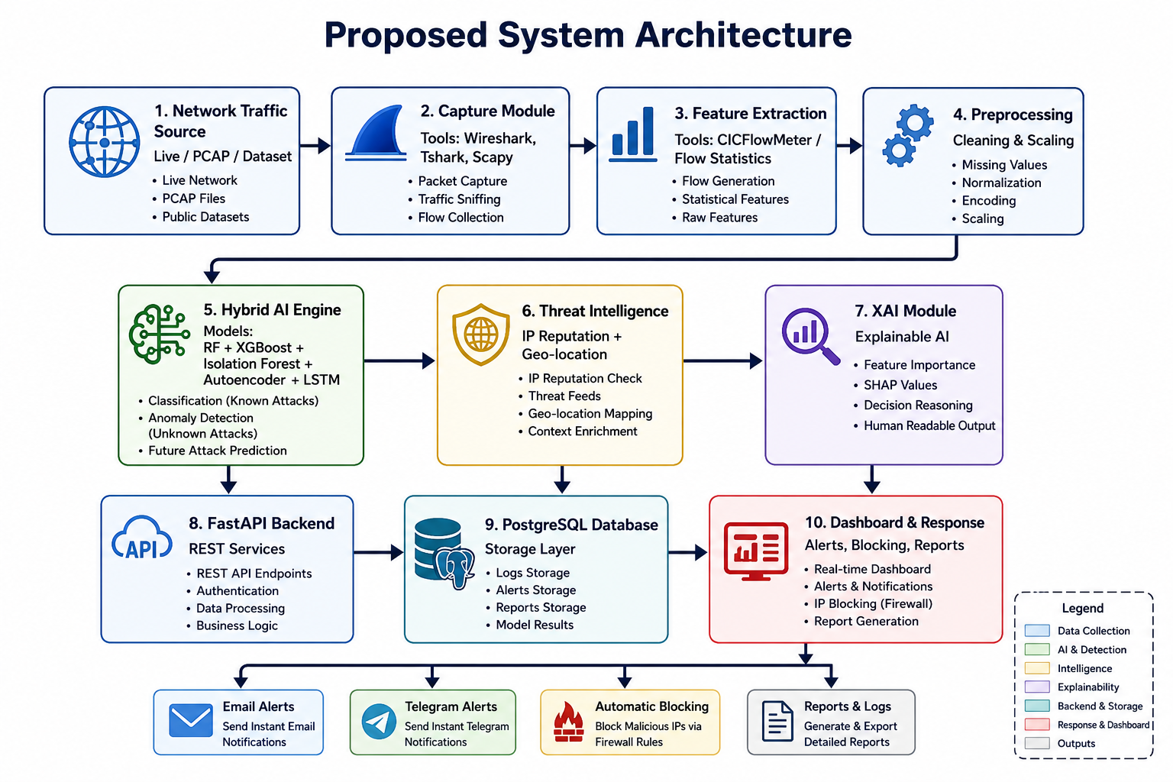
Figure 1. Proposed System Architecture.

3.2 AI Detection Pipeline
The detection pipeline starts with raw network traffic. The system extracts flow features, cleans and scales the data, sends the feature vector to the AI engine, combines model decisions, and finally generates a risk score, alert, and response action.
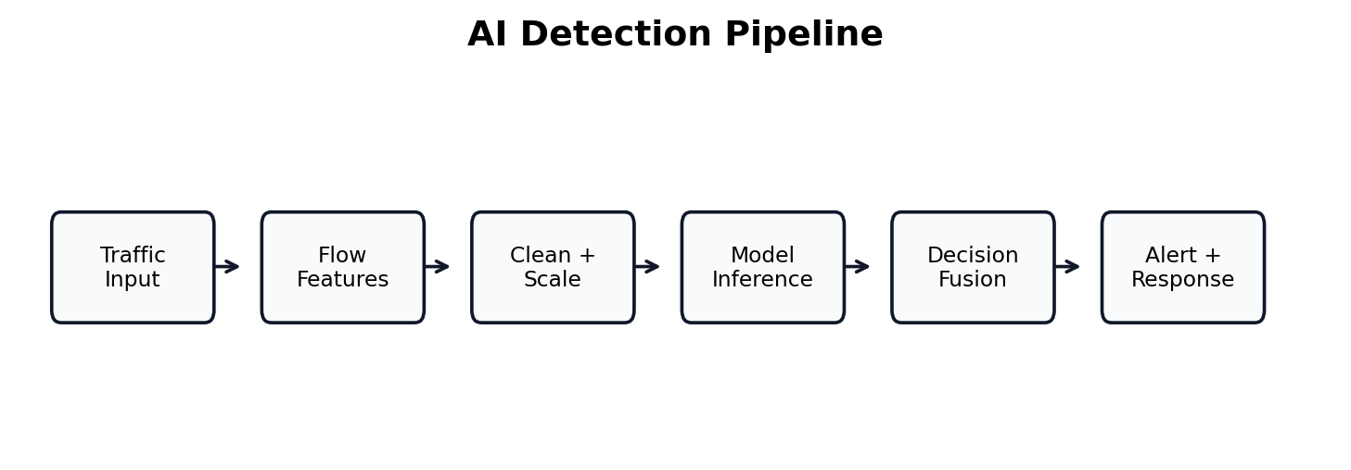
Figure 2. AI Detection Pipeline.

3.3 Main Modules
Module | Function
Traffic Capture Module | Collects live packets, PCAP files, or dataset records using Wireshark, Tshark, PyShark, or Scapy.
Feature Extraction Module | Converts raw packets into measurable flow features.
Preprocessing Module | Handles missing values, encoding, scaling, and train/test split.
Hybrid AI Engine | Uses supervised, unsupervised, and sequential models to improve detection.
Threat Intelligence Module | Checks IP reputation, country, ASN, and blacklist status.
Explainable AI Module | Explains why a traffic flow was classified as suspicious.
Response Engine | Blocks malicious IPs and sends alerts.
Dashboard | Displays traffic statistics, model output, alerts, trends, and reports.
Database | Stores users, traffic logs, predictions, alerts, reports, and blocked IPs.

3.4 Data Flow Diagram
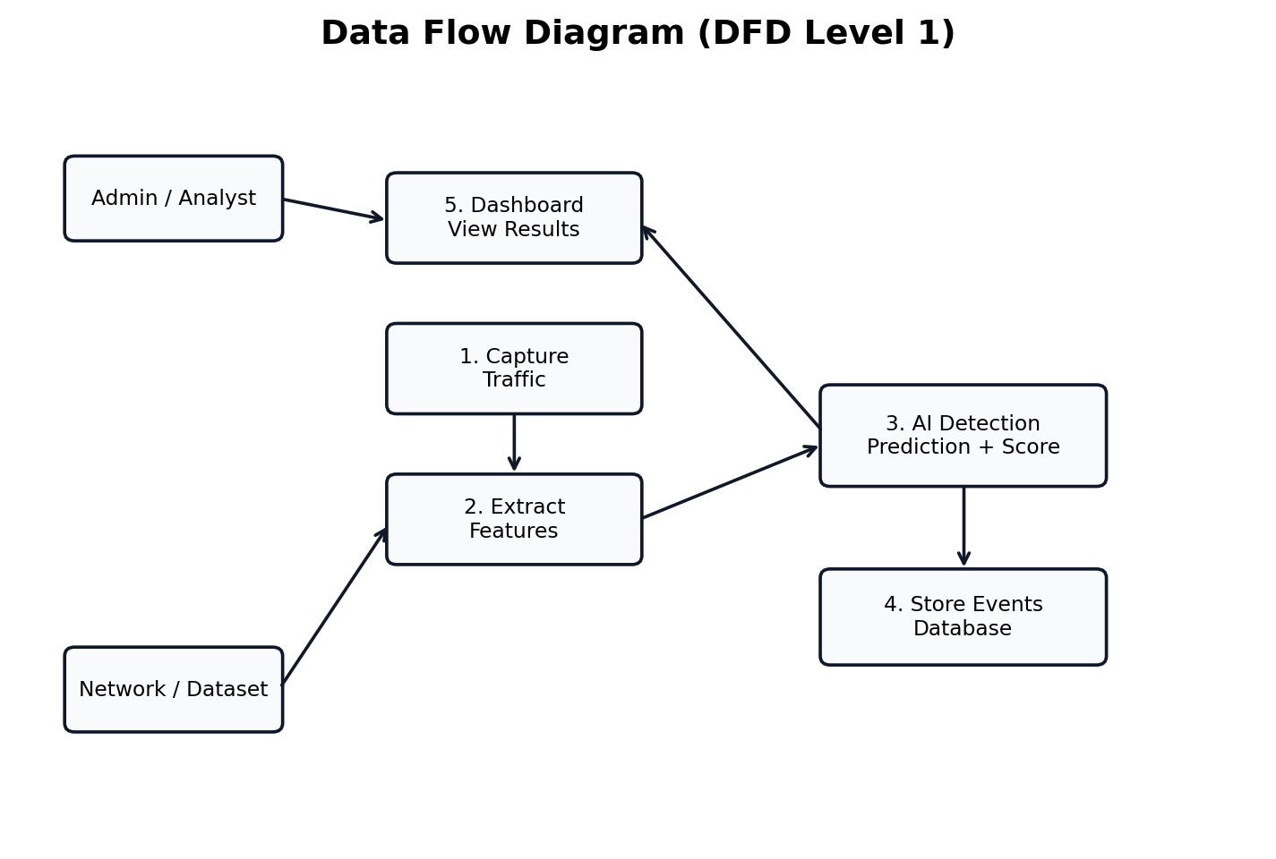
Figure 3. Data Flow Diagram (DFD Level 1).

3.5 UML Diagrams
The UML diagrams describe how the administrator interacts with the system and how system components communicate during real-time detection.
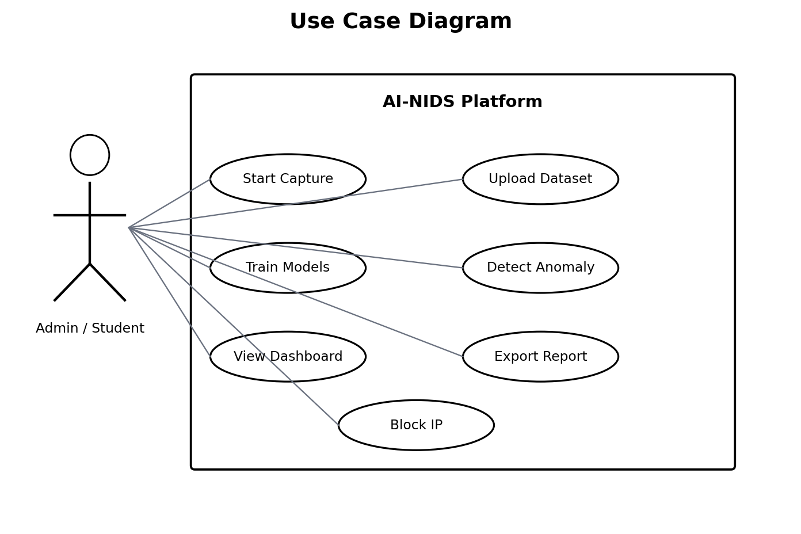
Figure 4. Use Case Diagram.
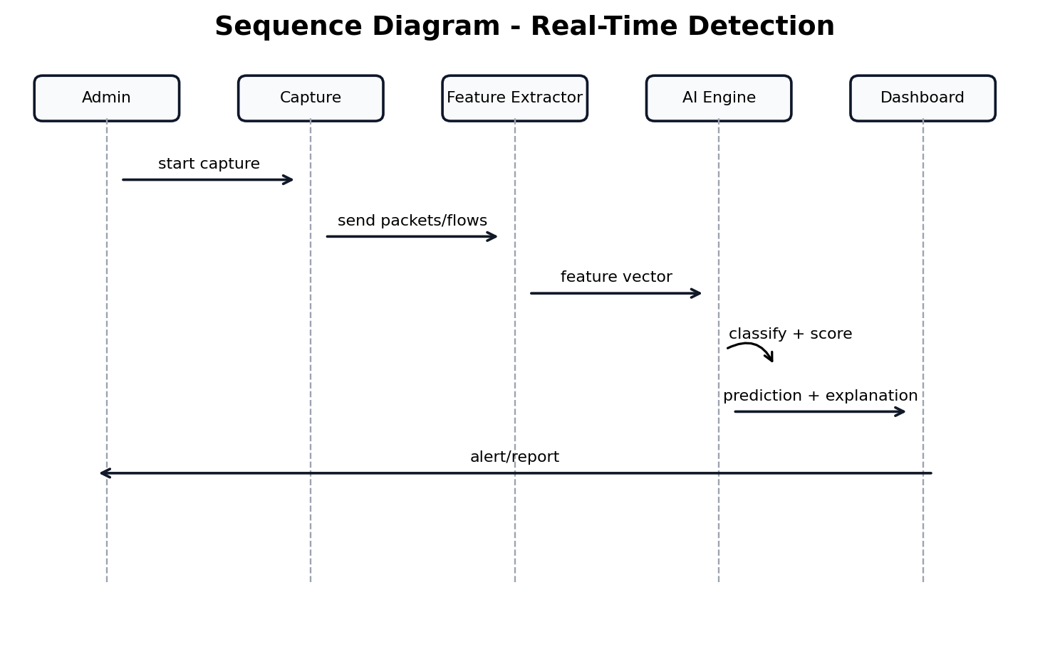
Figure 5. Sequence Diagram - Real-Time Detection.
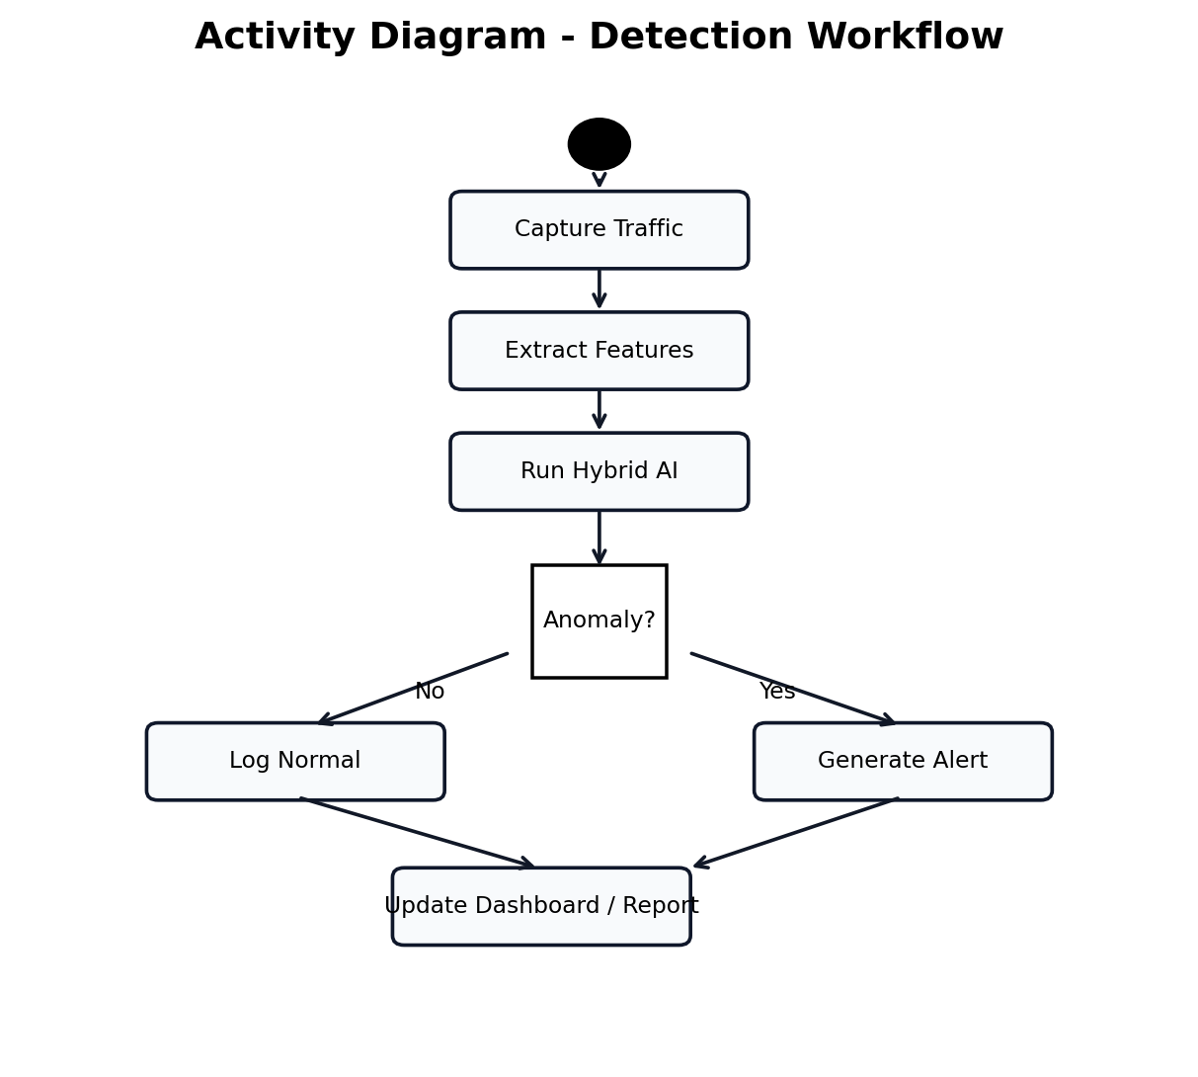
Figure 6. Activity Diagram - Detection Workflow.

3.6 Threat Model
The STRIDE model is used to identify major security risks affecting the proposed platform. The system must protect against spoofing, tampering, repudiation, information disclosure, denial of service, and elevation of privilege.
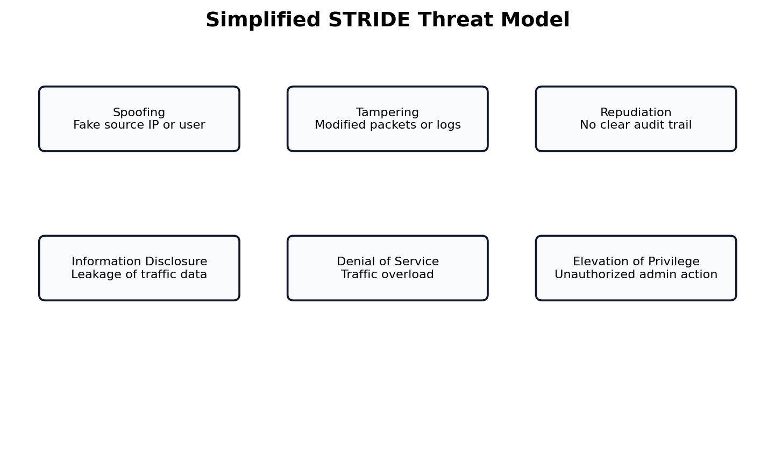
Figure 7. Simplified STRIDE Threat Model.

Chapter 4 - Implementation Methodology

4.1 Technology Stack
Component | Selected Technology
Programming Language | Python 3.12
Backend | FastAPI REST API
Database | PostgreSQL
AI Libraries | Scikit-learn, TensorFlow/Keras, XGBoost
Data Processing | Pandas, NumPy
Traffic Capture | Wireshark, Tshark, PyShark, Scapy
Feature Extraction | CICFlowMeter or custom flow extraction
Explainability | Feature importance and SHAP-style explanations
Dashboard | HTML5, CSS3, JavaScript, or Streamlit prototype
Notifications | SMTP Email and Telegram Bot API

4.2 Feature Engineering
Feature Group | Examples
Basic identifiers | Source IP, destination IP, source port, destination port, protocol
Flow timing | Flow duration, inter-arrival time, active time, idle time
Volume | Total forward packets, total backward packets, total bytes
Packet size | Minimum, maximum, mean, and standard deviation of packet length
Rates | Packets per second, bytes per second, flow rate
TCP flags | SYN, ACK, FIN, RST, PSH, URG counts
Behavioral indicators | Connection attempts, repeated destinations, unusual ports
Label | Normal or attack class used only for supervised training

4.3 Model Development
Model development begins with data loading, cleaning, feature selection, and splitting into training and testing sets. Random Forest and XGBoost are trained for labeled attack classification. Isolation Forest and Autoencoder are trained to detect unusual behavior. LSTM is prepared using traffic sequences so it can learn temporal patterns rather than isolated rows.

4.4 Decision Fusion
The proposed system does not depend on one model only. Instead, it combines model outputs into a final risk score. For example, if XGBoost classifies a flow as attack, Isolation Forest marks it as outlier, and Threat Intelligence reports the IP as suspicious, the system increases the severity level. This fusion approach is expected to reduce false negatives and improve analyst confidence.

4.5 Database Design
Table | Purpose
users | Stores administrator accounts and roles.
traffic_logs | Stores captured network flow features.
predictions | Stores AI model predictions, confidence, and risk score.
alerts | Stores generated alerts and severity levels.
blocked_ips | Stores IP addresses blocked by the response engine.
threat_intelligence | Stores IP reputation, country, ASN, and blacklist results.
reports | Stores generated incident and summary reports.

4.6 Dashboard Design
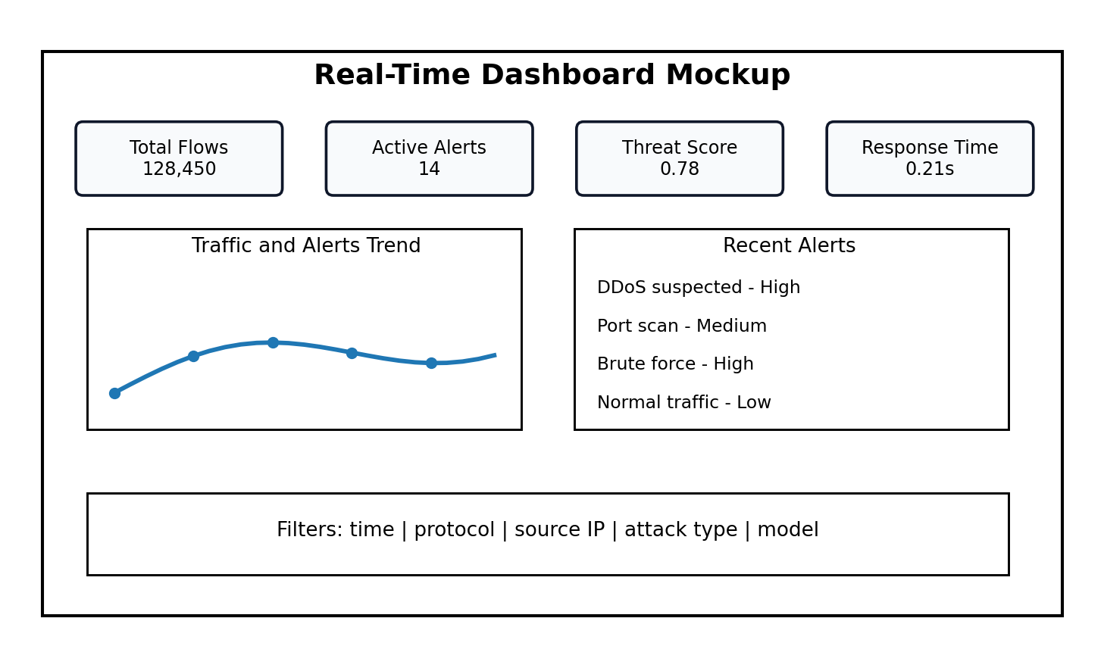
Figure 8. Real-Time Dashboard Mockup.
The dashboard should display total flows, active alerts, average threat score, detection time, recent alerts, protocol distribution, top attacking IPs, geo-location information, model comparison results, and downloadable reports. This makes the system useful for both technical evaluation and project defense.

4.7 Implementation Workflow
Step | Task
Step 1 | Prepare dataset or capture live traffic.
Step 2 | Extract and clean features.
Step 3 | Train baseline Random Forest and XGBoost models.
Step 4 | Train anomaly detection models.
Step 5 | Connect AI service to backend API.
Step 6 | Store predictions and alerts in the database.
Step 7 | Display results on dashboard.
Step 8 | Trigger notifications and simulated response actions.
Step 9 | Evaluate performance and replace placeholder values with final experimental results.

4.8 Backend API Design
The backend API connects the dashboard, the AI engine, the database, and the response engine. FastAPI is selected because it is lightweight, suitable for Python AI projects, and easy to document. The API receives traffic features, calls the model service, stores predictions, and returns results to the dashboard.
Endpoint | Purpose
POST /auth/login | Authenticate administrator and return access token.
POST /traffic/upload | Upload CSV or PCAP-derived flow records.
GET /traffic/live | Return latest captured flows.
POST /predict | Send feature vector to the Hybrid AI Engine.
GET /alerts | List alerts with filtering by severity and time.
POST /response/block-ip | Block a malicious IP address or simulate blocking.
GET /reports/export | Generate downloadable incident or summary report.
GET /models/performance | Return current model comparison metrics.

4.9 Algorithmic Workflow
Step | Algorithm Action
1 | Receive packet or flow record.
2 | Validate required fields and remove incomplete rows.
3 | Convert categorical values such as protocol into numerical form.
4 | Scale numerical values using the same scaler used during training.
5 | Run supervised models to detect known attack categories.
6 | Run anomaly models to detect unknown behavior.
7 | Run LSTM only if sequential input is available.
8 | Combine outputs using decision fusion.
9 | Calculate threat score and severity level.
10 | Request Threat Intelligence enrichment for suspicious IPs.
11 | Generate XAI explanation and recommended action.
12 | Store event and update dashboard.

4.10 Model Training Pseudocode
The following pseudocode summarizes the training process in an implementation-friendly style. It is written as a conceptual algorithm, not as a final programming code listing.
- Load dataset
- Separate features X and labels y
- Remove identifier columns that are not useful for learning
- Handle missing and infinite values
- Encode categorical variables
- Scale numerical features
- Split data into training and testing sets
- Train Random Forest and XGBoost on labeled data
- Train Isolation Forest and Autoencoder using normal traffic or unlabeled data
- Prepare sequential windows and train LSTM if time-based order is available
- Evaluate each model using accuracy, precision, recall, F1-score and ROC-AUC
- Save trained models and preprocessing objects for real-time inference

4.11 Project Folder Structure
Folder | Description
backend/ | FastAPI application, routes, controllers, and authentication.
ai_engine/ | Training scripts, saved models, preprocessing pipeline, and prediction service.
capture/ | Packet capture and flow extraction scripts.
dashboard/ | HTML, CSS, JavaScript, or Streamlit interface.
database/ | SQL schema, migrations, and seed data.
reports/ | Generated PDF/CSV incident reports.
docs/ | Technical documentation and final report materials.
tests/ | Unit tests, integration tests, and sample attack scenarios.

Chapter 5 - Testing and Evaluation

5.1 Testing Objectives
Testing verifies that the proposed system can capture traffic, extract features, classify attacks, detect anomalies, trigger alerts, store results, update the dashboard, and generate reports. The testing stage also measures the expected performance of different models.

5.2 Testing Environment
Component | Specification
Processor | Intel Core i7 or AMD Ryzen 7
Memory | 16 GB RAM
Storage | 512 GB SSD
Operating System | Windows 11 or Ubuntu 22.04
Python | 3.12
Database | PostgreSQL 16
Development Tool | VS Code
Network Tools | Wireshark, Tshark, PyShark, Scapy

5.3 Attack Simulation Scenarios
Scenario | Purpose
DDoS / DoS | High-volume traffic used to overload a service.
Port Scanning | Many connection attempts to discover open ports.
Brute Force | Repeated login attempts against a service.
SQL Injection | Suspicious web request pattern attempting database manipulation.
Malware Communication | Traffic resembling command-and-control communication.
Zero-Day / Unknown | Unlabeled abnormal behavior detected by anomaly models.

5.4 Evaluation Metrics
Metric | Meaning
Accuracy | Overall percentage of correct predictions.
Precision | How many predicted attacks are truly attacks.
Recall | How many real attacks are successfully detected.
F1 Score | Balanced measure between precision and recall.
False Positive Rate | Normal traffic incorrectly detected as attack.
False Negative Rate | Attack traffic incorrectly classified as normal.
ROC-AUC | Overall separation ability between normal and attack classes.
Response Time | Time needed to generate alert and response action.

5.5 Confusion Matrix and ROC Curve
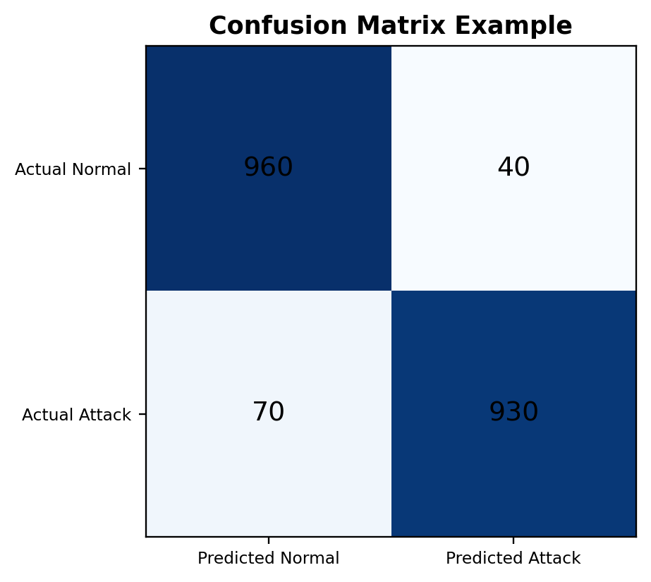
Figure 9. Confusion Matrix Example.
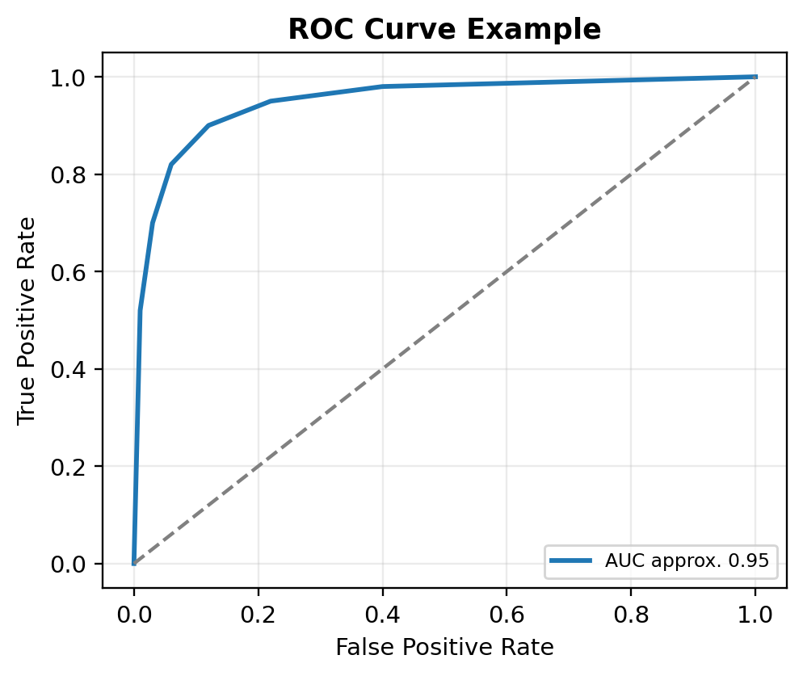
Figure 10. ROC Curve Example.

5.6 Expected Performance Comparison
Metric | RF | XGBoost | IF | Autoencoder | LSTM | Hybrid AI
Accuracy | 97.8% | 98.6% | 95.2% | 96.4% | 98.1% | 99.2%
Precision | 97.4% | 98.5% | 94.8% | 95.9% | 98.0% | 99.0%
Recall | 98.0% | 98.8% | 95.1% | 96.0% | 98.2% | 99.3%
F1 Score | 97.7% | 98.6% | 95.0% | 95.9% | 98.1% | 99.1%
ROC-AUC | 0.98 | 0.99 | 0.95 | 0.96 | 0.98 | 0.995
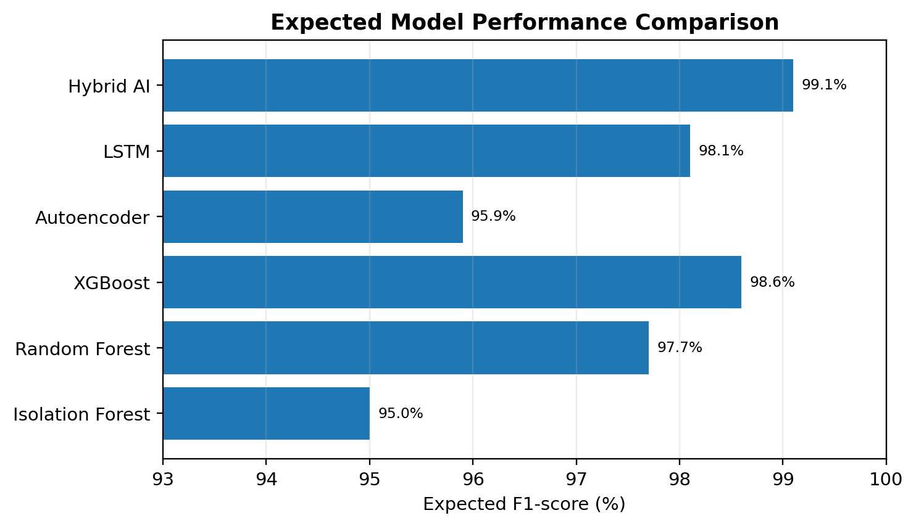
Figure 11. Expected Model Performance Comparison.
Important note: the values above are expected performance targets based on the system design and should be replaced with actual experimental results after running the final implementation. This note is included for academic honesty and to avoid presenting placeholders as confirmed results.

5.7 Success Criteria
- The system detects known attacks with high accuracy.
- The system detects unknown anomalies using unsupervised models.
- The dashboard updates without noticeable delay.
- The response engine sends alerts and records incidents.
- The system provides understandable explanations for predictions.
- The final report includes realistic metrics and avoids unsupported claims.

5.8 Detailed Test Cases
The following test cases help prove that the proposed system works as a complete platform. They can be used during the final demonstration and during the defense.
Test Case | Action | Expected Result
TC1 | Upload benign traffic dataset | System accepts file and stores extracted flows.
TC2 | Upload attack traffic dataset | System detects suspicious flows and creates alerts.
TC3 | Run live capture | System shows new traffic records on dashboard.
TC4 | Run Random Forest model | System returns class label and confidence score.
TC5 | Run Isolation Forest model | System identifies outlier traffic.
TC6 | Run Threat Intelligence lookup | System returns IP reputation and country information.
TC7 | Generate email alert | Administrator receives alert message.
TC8 | Generate Telegram alert | Telegram bot sends short incident notification.
TC9 | Block IP action | IP is inserted into blocked list or simulated firewall command.
TC10 | Export report | System generates incident report with alert details.

5.9 Data Validation Checklist
- Remove duplicate rows that may bias model training.
- Check class distribution before training.
- Do not use label columns as input features.
- Use the same preprocessing steps during training and prediction.
- Separate training and testing data to avoid data leakage.
- Evaluate more than accuracy because intrusion datasets may be imbalanced.
- Report whether metrics are real experimental results or expected placeholder values.
- Keep screenshots of the dashboard and confusion matrix for the final defense.

5.10 Error Handling and Reliability
The system should handle missing fields, invalid CSV files, unavailable Threat Intelligence APIs, database connection failures, and incorrect user input. In each case, the system should return a clear error message instead of crashing. Reliability is important because cybersecurity dashboards are expected to operate continuously during monitoring sessions.

5.11 Academic Honesty in Results
If final implementation results are not yet available, performance numbers must be clearly labeled as expected targets or example values. Before submission, the student should run the implementation, capture actual metrics, and replace all placeholder values with real outputs. This protects the report from unrealistic claims and improves academic credibility.

Chapter 6 - Deployment, Limitations and Future Work

6.1 Deployment Architecture
The proposed system can be deployed on a local laboratory machine or on a small server. The network capture service collects traffic, the backend processes requests, the AI engine performs predictions, the database stores events, and the dashboard provides visual monitoring. For a Bachelor project, local deployment is sufficient to demonstrate the full workflow.

6.2 Security Considerations
Risk | Mitigation
Unauthorized dashboard access | Use authentication, strong passwords, and role-based access.
Database tampering | Use access control, backups, and audit logs.
False positive IP blocking | Use thresholds and allow manual confirmation for high-impact actions.
Sensitive traffic leakage | Store only required metadata and protect the database.
Model drift | Retrain models using new traffic and review performance.
API misuse | Validate inputs, rate-limit requests, and log API access.

6.3 Limitations
- Benchmark datasets may not fully represent every real network environment.
- Deep Learning models require more computing resources and careful tuning.
- LSTM prediction is useful only when data is prepared as time sequences.
- Automatic IP blocking must be used carefully to avoid blocking legitimate users.
- The current version is an academic prototype and requires more testing before production deployment.

6.4 Future Work
- Add real-time packet capture from multiple network interfaces.
- Integrate Zeek or Suricata logs for richer metadata.
- Use SHAP values for stronger Explainable AI.
- Add multi-class attack classification with more detailed attack categories.
- Improve dashboard interactivity and add mobile monitoring.
- Deploy the system using Docker containers.
- Integrate SIEM/SOAR connectors for enterprise environments.
- Add continuous learning and model drift monitoring.

6.5 Ethical and Legal Considerations
Network monitoring must respect privacy, organizational policies, and legal boundaries. The system should be tested only on authorized networks or public datasets. Captured data should be minimized, protected, and used only for security purposes. Attack simulation must be performed in a controlled lab environment.

Chapter 7 - Practical Implementation Notes

7.1 Dataset Preparation Notes
Dataset preparation is one of the most important stages in this project. Intrusion detection datasets may contain missing values, infinite values, duplicated records, imbalanced classes, and features that do not exist in real live traffic. Therefore, the preprocessing pipeline must be written carefully and reused during real-time prediction. A common mistake is to train the model with one set of features and then send a different set of features during live detection. To avoid this issue, the final feature list should be saved and used consistently.

7.2 Handling Class Imbalance
Network intrusion datasets are often imbalanced. Normal traffic may dominate the dataset, or one attack type may appear more frequently than the others. If the model is evaluated only using accuracy, it may appear successful while ignoring rare attacks. Therefore, this project uses precision, recall, F1-score, confusion matrix, and ROC-AUC. For stronger implementation, class weights, stratified splitting, undersampling, or oversampling can be tested.

7.3 Threshold Tuning
The anomaly detection threshold directly affects false positives and false negatives. A low threshold may generate too many alerts, while a high threshold may miss attacks. The project should test several thresholds and select the one that gives an acceptable balance between detection and alert fatigue. In real cybersecurity environments, thresholds may also differ based on asset importance and business risk.

7.4 Explainability Strategy
Explainable AI is included because security administrators need to understand why an alert was created. For tree-based models, feature importance can explain which features had the strongest influence during training. For individual predictions, SHAP-style explanation can show which values increased the risk score. In the Bachelor prototype, feature importance and a simple reason message are enough to demonstrate the concept.

7.5 Report Generation
The report generation module should summarize alert ID, timestamp, source IP, destination IP, protocol, predicted class, confidence, threat score, Threat Intelligence result, recommended action, and response status. The report can be exported as PDF or CSV. This feature is important because it proves that the system can support documentation and incident review, not only display alerts.

7.6 Final Demonstration Scenario
- Start backend server and database.
- Open dashboard and verify initial statistics.
- Upload a small dataset or start live capture.
- Run AI detection and display predictions.
- Select one high-risk alert and view explanation.
- Check Threat Intelligence and geo-location fields.
- Trigger email or Telegram notification.
- Block or simulate blocking the malicious IP.
- Export the incident report.
- Explain the model comparison results.

Chapter 8 - User Manual and Operation Guide

8.1 Starting the System
The administrator starts the database service, then starts the FastAPI backend, then opens the dashboard in the browser. In a simple local setup, the backend can run on localhost and the dashboard can connect to it using REST endpoints. Before starting detection, the administrator should check that the model files, scaler file, and database connection are available.

8.2 Uploading Data or Capturing Live Traffic
The system supports two operating modes. In dataset mode, the administrator uploads a CSV file extracted from a dataset such as CICIDS2017. In live mode, the capture module collects packets from a selected network interface and converts them into flow features. Dataset mode is easier for training and evaluation, while live mode is better for demonstration.

8.3 Reading the Dashboard
The dashboard should be interpreted carefully. A high threat score does not always mean a confirmed attack; it means the traffic is suspicious and needs attention. The administrator should check the predicted class, confidence score, source IP, destination IP, protocol, model explanation, and Threat Intelligence result before taking final action.

8.4 Responding to Alerts
When an alert appears, the administrator can review details, mark the alert as investigated, export a report, or block the source IP. In the academic prototype, IP blocking may be simulated by storing the IP in the blocked_ips table. In a real deployment, this action can be connected to firewall rules only after careful testing and approval.

8.5 Maintenance Procedures
Frequency | Procedure
Daily | Check dashboard, alerts, and service status.
Weekly | Review false positives and update thresholds.
Monthly | Retrain models with new traffic samples if available.
Before defense | Run the demo scenario and export screenshots.
After major edits | Re-run tests and update report metrics.

8.6 Minimal Functional Requirements
Requirement | Description
FR1 | The system shall accept traffic input from dataset or capture module.
FR2 | The system shall extract numerical features from traffic flows.
FR3 | The system shall classify traffic using at least one supervised model.
FR4 | The system shall detect anomalies using at least one anomaly model.
FR5 | The system shall display alerts on a dashboard.
FR6 | The system shall store predictions and alerts in a database.
FR7 | The system shall generate reports for detected incidents.
FR8 | The system shall provide a simple explanation for each high-risk alert.

8.7 Non-Functional Requirements
Requirement Type | Description
Usability | The dashboard must be clear enough for a student and supervisor to understand during the demonstration.
Performance | The prototype should process small and medium datasets without excessive delay.
Maintainability | The project files should be organized into backend, AI engine, capture, dashboard, database, and tests.
Security | The dashboard and API should use authentication in the final version.
Scalability | The modular architecture should allow future deployment on a server or cloud environment.
Explainability | The system should avoid black-box alerts by giving a reason or important features for each prediction.

Conclusion
This Senior Project proposed an AI-Powered Network Traffic Analyzer & Anomaly Detector designed for Bachelor-level implementation in Computer Science. The project addresses the limitations of traditional signature-based IDS by integrating Machine Learning, Deep Learning, anomaly detection, Threat Intelligence, Explainable AI, automated alerts, and dashboard monitoring.
The literature review and the comparison of twenty cybersecurity applications show that many commercial systems are powerful but expensive, proprietary, and difficult to use for academic experimentation. The proposed system solves these gaps by using an open-source modular architecture that allows students and researchers to understand, modify, and evaluate every component.
The expected contribution of the project is not only a single ML classifier, but a complete academic NDR-style prototype. It demonstrates the full process from traffic capture to feature extraction, AI detection, risk scoring, explanation, storage, visualization, and response. With real experimental metrics added after implementation, this project can provide a strong and realistic graduation project suitable for AUCE Computer Science requirements.

Appendix A - Defense Preparation Notes
Question | Model Answer
Why did you choose this topic? | It combines two important Computer Science areas: cybersecurity and AI. It also solves a real problem because network traffic is too large to inspect manually.
Why not use only signatures? | Signatures are useful for known attacks, but unknown attacks and modified attacks require behavioral and anomaly detection.
Why use multiple models? | Each model has a different strength. Supervised models classify known attacks, anomaly models detect unusual behavior, and LSTM captures time-based patterns.
Is it production-ready? | No. It is an academic prototype. Production deployment requires more testing, hardening, privacy controls, and integration with enterprise infrastructure.
What is the main contribution? | The main contribution is an open, modular, explainable AI-based NDR prototype that compares models and provides detection, dashboard, and response workflow.

Appendix B - Presentation Outline
Slide | Content
1 | Title, name, AUCE, supervisor
2 | Problem statement
3 | Objectives and research questions
4 | Traditional IDS vs AI-based IDS
5 | State-of-the-art comparison
6 | System architecture
7 | AI detection pipeline
8 | Implementation technologies
9 | Dashboard and response
10 | Evaluation metrics and results
11 | Limitations and future work
12 | Conclusion and questions

Appendix C - Additional Defense Questions
Question | Answer
What is the difference between IDS and NDR? | IDS mainly detects intrusions and raises alerts, while NDR focuses on broader network detection, visibility, investigation, and response.
Why did you select CICIDS2017? | It provides modern benign and attack traffic with PCAP and flow-based CSV files, making it suitable for machine learning experiments.
What is the risk of false positives? | False positives waste analyst time and may block legitimate users if automatic response is not controlled.
How can your system detect unknown attacks? | Unknown attacks can be detected by anomaly models such as Isolation Forest and Autoencoder because they look for deviations from learned normal behavior.
Why is LSTM included? | LSTM is useful when traffic is treated as sequences over time. It can learn temporal behavior that normal tabular models may ignore.
What would you improve first after graduation? | I would add real live traffic testing, stronger SHAP explanations, Docker deployment, and integration with Zeek or Suricata.

Appendix D - Implementation Timeline
Week | Task
Week 1 | Finalize scope, datasets, and architecture.
Week 2 | Prepare dataset, clean data, and select features.
Week 3 | Train baseline Random Forest and XGBoost models.
Week 4 | Add Isolation Forest and Autoencoder anomaly detection.
Week 5 | Develop FastAPI backend and database schema.
Week 6 | Connect AI engine with backend API.
Week 7 | Build dashboard pages and alert views.
Week 8 | Add notifications, report export, and IP blocking simulation.
Week 9 | Run tests, collect metrics, and update results.
Week 10 | Prepare final presentation and defense answers.

Appendix E - Practical Code Skeleton
Step | Implementation Stage | Conceptual Code / Logic
1 | Initialize the API | from fastapi import FastAPI  app = FastAPI()
2 | Load trained resources | Load the trained AI model and the preprocessing scaler.
3 | Receive traffic features | Receive traffic features from the dashboard or the network capture module.
4 | Validate and structure input | Validate input fields and convert the received values into a pandas DataFrame.
5 | Apply preprocessing | Apply exactly the same cleaning, encoding, normalization, and scaling used during model training.
6 | Generate prediction | prediction = model.predict(features)
7 | Calculate risk score | score = model.predict_proba(features)  —or—  anomaly_score = model.decision_function(features)
8 | Store results | Store the prediction, confidence or anomaly score, timestamp, and traffic details in PostgreSQL.
9 | Trigger response | If the risk score exceeds the defined threshold, create an alert and send the configured notification.
10 | Return API response | Return a structured JSON response to the dashboard containing the prediction, score, severity, explanation, and recommended action.

Appendix F - Final Submission Checklist
Item | Verification
Cover page | Student name, ID, supervisor, department, academic year are correct.
Abstract | Summarizes problem, solution, models, and expected outcome.
TOC | Headings are formatted and ready for automatic update.
Figures | All diagrams are clear and have captions.
Tables | All tables are readable and relevant.
20 applications | Comparison includes strength, gap, and how the project solves it.
References | APA 7 format is used and sources are relevant.
Results | Expected values are clearly marked until real results are inserted.
Defense | Student can explain architecture, models, dataset, and limitations.
Final review | File is checked in Word and exported to PDF before submission.

Appendix G - Glossary of Important Terms
Term | Meaning
Anomaly | A behavior that differs from expected normal traffic.
Attack traffic | Traffic generated by malicious or suspicious activity.
Benign traffic | Normal traffic that is not considered malicious.
Flow | A summarized communication session between two endpoints.
Packet | A unit of data transmitted through a network.
Feature | A measurable value used as input to a machine learning model.
Label | The known class of a record, such as Normal or DDoS.
False positive | Normal traffic incorrectly detected as an attack.
False negative | Attack traffic incorrectly classified as normal.
Threat score | A numerical value representing the severity of a detected event.
Dashboard | The visual interface that displays alerts and model results.
Threat Intelligence | External information about IP reputation, blacklists, and attacker context.

References
Ahmad, Z., Khan, A. S., Wai Shiang, C., Abdullah, J., & Ahmad, F. (2021). Network intrusion detection system: A systematic study of machine learning and deep learning approaches. Transactions on Emerging Telecommunications Technologies, 32(1), e4150. https://doi.org/10.1002/ett.4150
Breiman, L. (2001). Random forests. Machine Learning, 45, 5-32. https://doi.org/10.1023/A:1010933404324
Canadian Institute for Cybersecurity. (n.d.). Intrusion detection evaluation dataset (CICIDS2017). University of New Brunswick. https://www.unb.ca/cic/datasets/ids-2017.html
Canadian Institute for Cybersecurity. (n.d.). NSL-KDD dataset. University of New Brunswick. https://www.unb.ca/cic/datasets/nsl.html
Chen, T., & Guestrin, C. (2016). XGBoost: A scalable tree boosting system. In Proceedings of the 22nd ACM SIGKDD International Conference on Knowledge Discovery and Data Mining (pp. 785-794). https://doi.org/10.1145/2939672.2939785
Cisco. (n.d.). Cisco Secure Network Analytics. https://www.cisco.com/site/us/en/products/security/secure-network-analytics/index.html
Cisco. (n.d.). Cisco XDR. https://www.cisco.com/site/us/en/products/security/xdr/index.html
Corelight. (n.d.). Open NDR platform. https://corelight.com/
Darktrace. (n.d.). Darktrace ActiveAI Security Platform. https://darktrace.com/
Elastic. (n.d.). Elastic Security. https://www.elastic.co/security
ExtraHop. (n.d.). RevealX network detection and response. https://www.extrahop.com/products/revealx/
Google Cloud. (n.d.). Google Security Operations. https://cloud.google.com/security/products/security-operations
IBM. (n.d.). IBM QRadar SIEM. https://www.ibm.com/products/qradar-siem
Khraisat, A., Gondal, I., Vamplew, P., & Kamruzzaman, J. (2019). Survey of intrusion detection systems: Techniques, datasets and challenges. Cybersecurity, 2, Article 20. https://doi.org/10.1186/s42400-019-0038-7
Liu, F. T., Ting, K. M., & Zhou, Z. H. (2008). Isolation forest. In 2008 Eighth IEEE International Conference on Data Mining (pp. 413-422). https://doi.org/10.1109/ICDM.2008.17
Microsoft. (n.d.). Microsoft Sentinel documentation. https://learn.microsoft.com/azure/sentinel/
Moustafa, N., & Slay, J. (2015). UNSW-NB15: A comprehensive data set for network intrusion detection systems. In 2015 Military Communications and Information Systems Conference (MilCIS) (pp. 1-6). IEEE. https://doi.org/10.1109/MilCIS.2015.7348942
National Institute of Standards and Technology. (2024). The NIST Cybersecurity Framework (CSF) 2.0 (NIST CSWP 29). https://doi.org/10.6028/NIST.CSWP.29
Palo Alto Networks. (n.d.). Cortex XSIAM. https://www.paloaltonetworks.com/cortex/cortex-xsiam
Pedregosa, F., Varoquaux, G., Gramfort, A., Michel, V., Thirion, B., Grisel, O., Blondel, M., Prettenhofer, P., Weiss, R., Dubourg, V., Vanderplas, J., Passos, A., Cournapeau, D., Brucher, M., Perrot, M., & Duchesnay, E. (2011). Scikit-learn: Machine learning in Python. Journal of Machine Learning Research, 12, 2825-2830.
Rapid7. (n.d.). InsightIDR. https://www.rapid7.com/products/insightidr/
Scikit-learn developers. (n.d.). IsolationForest. Scikit-learn documentation. https://scikit-learn.org/stable/modules/generated/sklearn.ensemble.IsolationForest.html
Security Onion Solutions. (n.d.). Security Onion documentation. https://docs.securityonion.net/
Sharafaldin, I., Habibi Lashkari, A., & Ghorbani, A. A. (2018). Toward generating a new intrusion detection dataset and intrusion traffic characterization. In Proceedings of the 4th International Conference on Information Systems Security and Privacy (pp. 108-116). https://doi.org/10.5220/0006639801080116
Snort. (n.d.). Snort 3. https://www.snort.org/snort3
Sommer, R., & Paxson, V. (2010). Outside the closed world: On using machine learning for network intrusion detection. In 2010 IEEE Symposium on Security and Privacy (pp. 305-316). https://doi.org/10.1109/SP.2010.25
Splunk. (n.d.). Splunk Enterprise Security. https://www.splunk.com/en_us/products/enterprise-security.html
Suricata. (n.d.). Suricata user guide. https://docs.suricata.io/
Trend Micro. (n.d.). Trend Vision One. https://www.trendmicro.com/en_us/business/products/one-platform.html
Vectra AI. (n.d.). Vectra AI platform. https://www.vectra.ai/
Wazuh. (n.d.). Wazuh documentation. https://documentation.wazuh.com/
Zeek. (n.d.). Zeek documentation. https://docs.zeek.org/

