1. Team Overview (Group 4)
- Mahmoud Mayaleh – RL & Algorithm Lead
Designs observation and reward functions, implements PPO agent, tunes hyperparameters, and manages training experiments.
- Luigi Lizzini – ROS 2 & Simulation Lead
Integrates PPO agent with ROS 2, manages lrturtlebotsim and Gazebo worlds, implements ROS nodes/topics, and maintains launch/config files.
- Youssef Elamin – Evaluation & Engineering Lead
Designs evaluation metrics and test scenarios, automates logging/plots, manages version control, and coordinates documentation, report, and presentation.

2. Objectives
Main objective
Develop a robust PPO-based navigation policy for ROSI that reaches goals in three mazes using only LiDAR and odometry, within the ROS 2 simulation environment.​
Sub-objectives
- Implement a clean ROS 2 interface between simulation and PPO agent (lrppo package).
- Engineer an observation vector and reward function that lead to stable learning.
- Train and validate policies across Maze 1–3, with curriculum and early stopping.
- Quantitatively evaluate policies and analyze failure modes with logs and visualizations.
- Deliver reproducible code, a detailed report, final presentation, and Gantt chart documenting estimated vs. actual effort.​

3. System Architecture
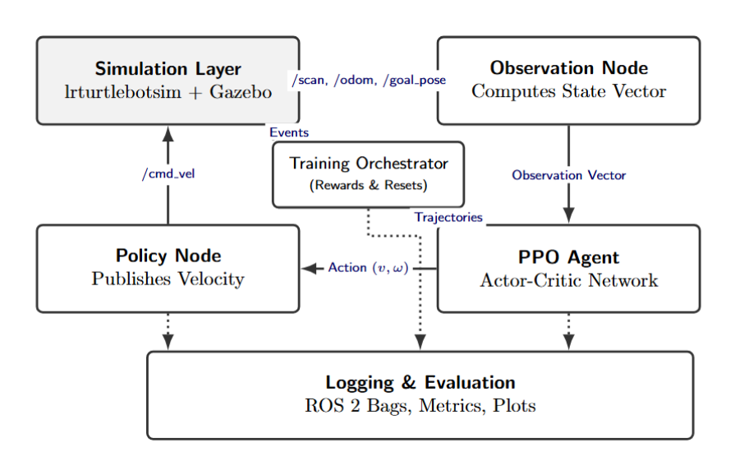
4. Algorithmic Workflow
- Episode Initialization
  - Spawn ROSI in chosen maze with random start and goal positions.
  - Reset PPO’s internal state.
- Interaction Loop (per time step)
  - Observation node collects LiDAR, odometry, and goal; constructs observation vector.
  - Policy node uses PPO actor network to produce continuous velocity commands.
  - Command is sent to /cmd_vel; Gazebo advances the physics simulation.
  - Environment checks termination:
    - Goal reached (within distance threshold).
    - Collision with walls/obstacles.
    - Maximum time steps exceeded.​
  - Reward is computed from progress, collisions, and goal events; added to buffer.
- Policy Update (after K steps or N episodes)
  - Use PPO with clipped objective, generalized advantage estimation, and minibatch SGD to update actor and critic networks.​
  - Periodically save model checkpoints.
- Evaluation
  - Freeze the best model.
  - Run multiple evaluation episodes per maze with fixed seeds and logging only.
  - Compute success rate, collisions, path length, and time-to-goal.

5. Technical Requirements
- Software
  - Ubuntu + ROS 2 (course default), Gazebo Sim, TurtleBot3 packages.​
  - Python 3, PyTorch or similar DL framework for PPO.
  - Additional Python libraries: NumPy, Matplotlib/Seaborn, Pandas for analysis.
- Packages
  - Provided lrturtlebotsim ROS 2 package for ROSI and maze environments.​
  - New lrppo package with training and inference nodes.
- Hardware
  - A machine or cluster node with:
    - Multi-core CPU.
    - Recommended: one mid-range GPU (optional but helpful).
  - Sufficient disk space for logs and checkpoints.

6. Milestone Schedule
- Week 3 (03.12–09.12): Setting up lrturtlebotsim and Gazebo, defining the observation vector, and creating a baseline navigation demo.
- Week 4 (10.12–16.12): Implementing the PPO agent, connecting ROS 2 topics, designing the reward function, and starting training in Maze 1.
- Week 5 (17.12–23.12): Evaluating the policy, tuning hyperparameters/rewards, extending to Maze 2, and automating logs.
- Week 6 (07.01–13.01): Final system integration, robustness testing on Maze 3, and collecting final metrics.
- Week 7 (14.01–21.01): Writing the final report, preparing the presentation.

7. Risk Management
- RL does not converge or policy is poor
  - Plan: maintain a simple fallback (e.g., Maze-1-only policy) as a minimum viable result.
  - Allocate time in Week 5 specifically for reward and hyperparameter tuning.
- ROS 2/Gazebo issues slow down progress
  - Plan: lock environment versions early; document working installation; keep a minimal “sandbox” launch file for rapid testing.
- Team availability or schedule conflicts
  - Plan: define clear weekly mini-milestones and hand-over notes; use shared Kanban board so any teammate can pick up blocked tasks.
- Data loss or corrupted models
  - Plan: push code and configs to remote repository frequently; store important checkpoints and logs under version control or cloud storage.

8. Expected Deliverables and Effort Estimation
Deliverables
- lrppo ROS 2 package:
  - PPO training and inference code.
  - Launch files for each maze and evaluation.
- Trained PPO models and example logs (training curves, success metrics).
- Architecture diagram, algorithm description, and evaluation plots.
- Project proposal, project plan, final report, final presentation, and Gantt charts (estimated vs. actual hours with differences).​
- Cleaned and documented repository (README and usage instructions).
Effort estimation (team of 3)
- Weeks 3: ~6–8 hours per person per week (setup and baseline).
- Weeks 4–5: ~8–10 hours per person per week (implementation and tuning).
- Weeks 6–7: ~6–8 hours per person per week (integration, testing, reporting).
These estimates will be updated with recorded hours and differences, as required.

