Name: Mahmoud Mohamed abd elrahman

B.N: 864

Date: 22-5-2020

Topic: programming languages

GitHub-link : <https://github.com/mahmoudmohamed1452001/ece001>

GitHub pages publish de website: <https://mahmoudmohamed1452001.github.io/ece001/programming_curves.html>

# Application Brief:

Modern human life is greatly influenced by computers. And the computer is run by a computer program. Computer programs are arranged by programming languages; therefore, they are the basis of all the conveniences that we feel. Programming languages are responsible for all programs that have been made; [rostering systems](https://esolveroster.co.uk/), virtual reality, scheduling software, online games, Uber app, anti-virus and so on. Thus mastering programming languages brings one closer to understanding how all digital technology originates. This article will highlight the importance of programming languages.

Programming languages ​​refer to different types of expressions and logical structuring rules that serve to generate recurring and systematic tasks. They are of great importance because they allow generating different systems that serve tasks that meet the needs of users. There is a great variety of these languages ​​and in any case they are oriented to different types of requirements; however, this plurality can be divided into two large groups, structured programming languages ​​and object-oriented languages. Almost everything we can use in computer science is largely due to programming languages.

Programming Languages are important for software technologies. It is a basic one, without it programming could not do a thing about software. It is a key factor to every software.

There are different types of programming languages that are currently trendy. This article explains the importance of programming languages.

Programming language is the heart of software. Without programming we cannot make many applications and software. Programming Language is key factor of software as well as embedded systems. Without programming language, we cannot communicate with machines or systems. Systems only know machine code. Machine codes mean some set of series of numbers. Machine code we can call bits,

Humans only know high level languages but machines do not know high level languages.Humans and machine could not communicate directly. We need one intermediate because humans could not understand machine languages like machines could not understand high level languages.

# Screenshots

This is the main page.

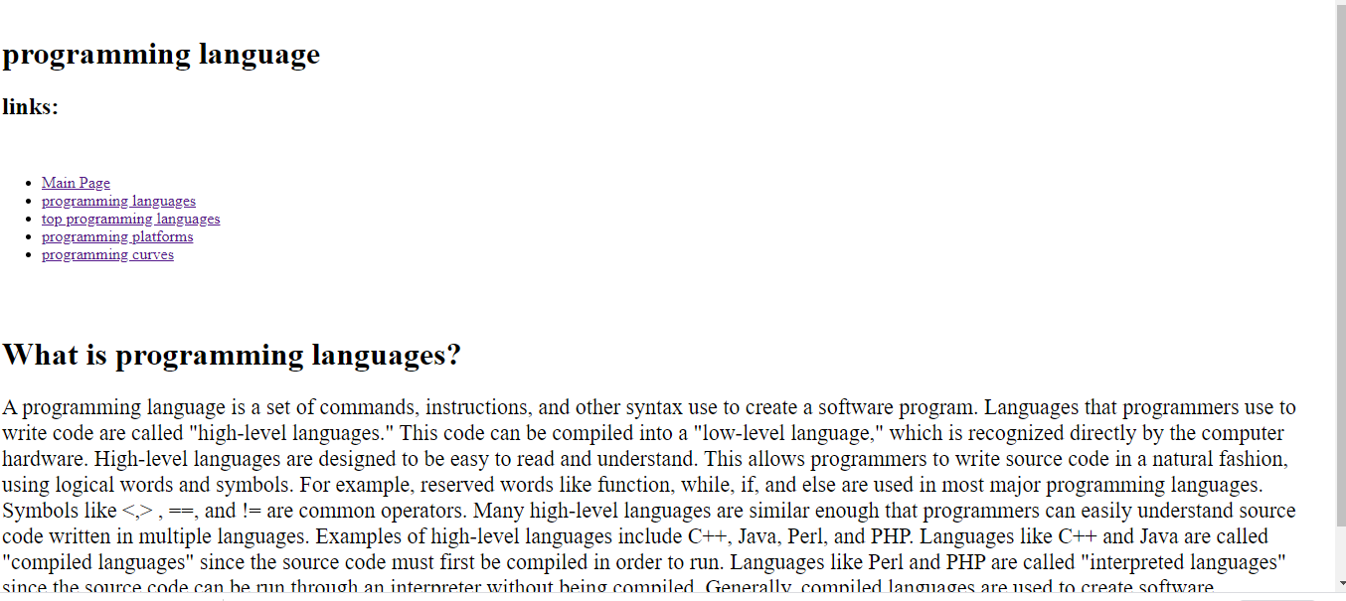

This Is the [programming languages](http://localhost:64679/programming_languages.html) page.

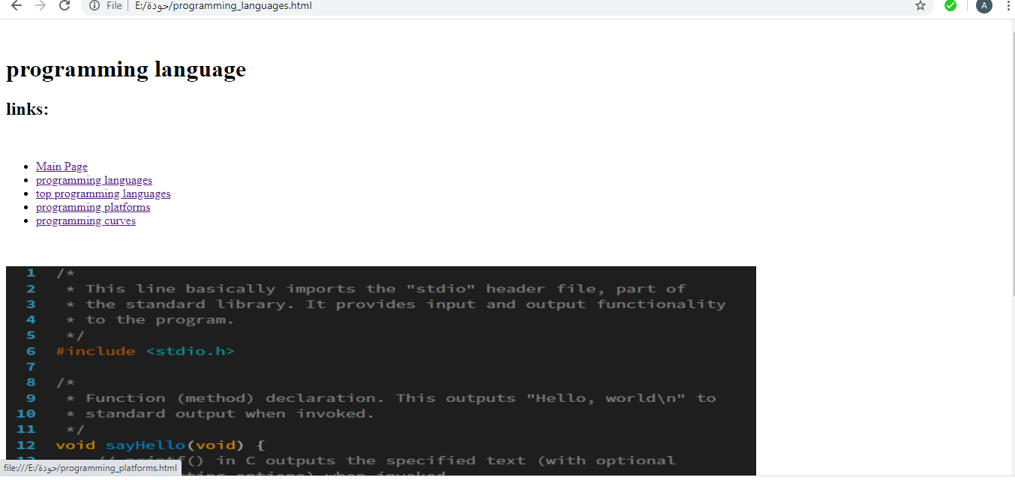

This is the programming curve page.

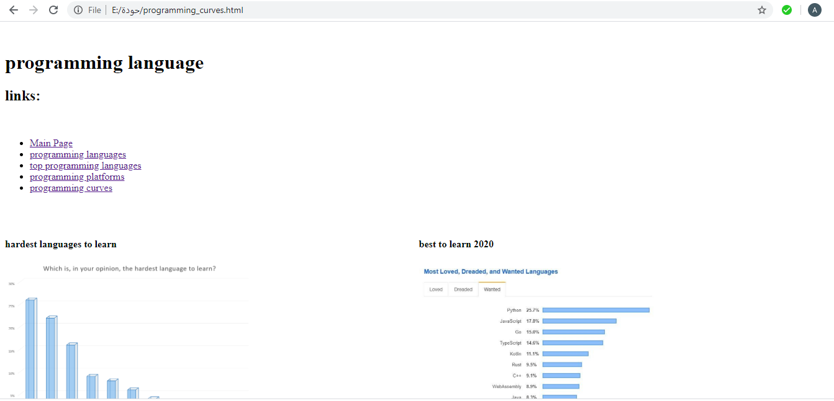

# Source code : of main page

