

**Faculty of engineering - Shoubra**

**Benha University**

|  |  |
| --- | --- |
| **Department** | **Electrical** |
| **Division** | **Computer Engineering** |
| **Academic Year** | **Third year (2021)** |
| **Course name** | **Database Design** |
| **Course code** | **ECE323C** |

**Title: -**

**Online Cinema Reservation System**

**D: Sabah Abdul-Aziz**

By:

|  |  |
| --- | --- |
|  | Name |
| 1 | يوسف محمد عبد المحسن |
| 2 | مروة عادل مصطفى |
| 3 | محمود محمد عبد الوهاب |
| 4 | ياسر مجدى عبد العزيز |
| 5 | محمد هانى ابوالعلا محمود |

Movie Ticketing System Database Design is basically aimed to provide complete information of the movie and schedule to the customer, according to which he/she can easily get a ticket instantly and can book a ticket on his/her favorite movies.

Our database made customer book tickets in our cinema in all our different branches in Egypt, so customer can reserve ticket in any branch through our online web site.

Admin can insert and delete data such as movie descriptions, movie schedules which will update the related webpage and will be accessible by the customers.

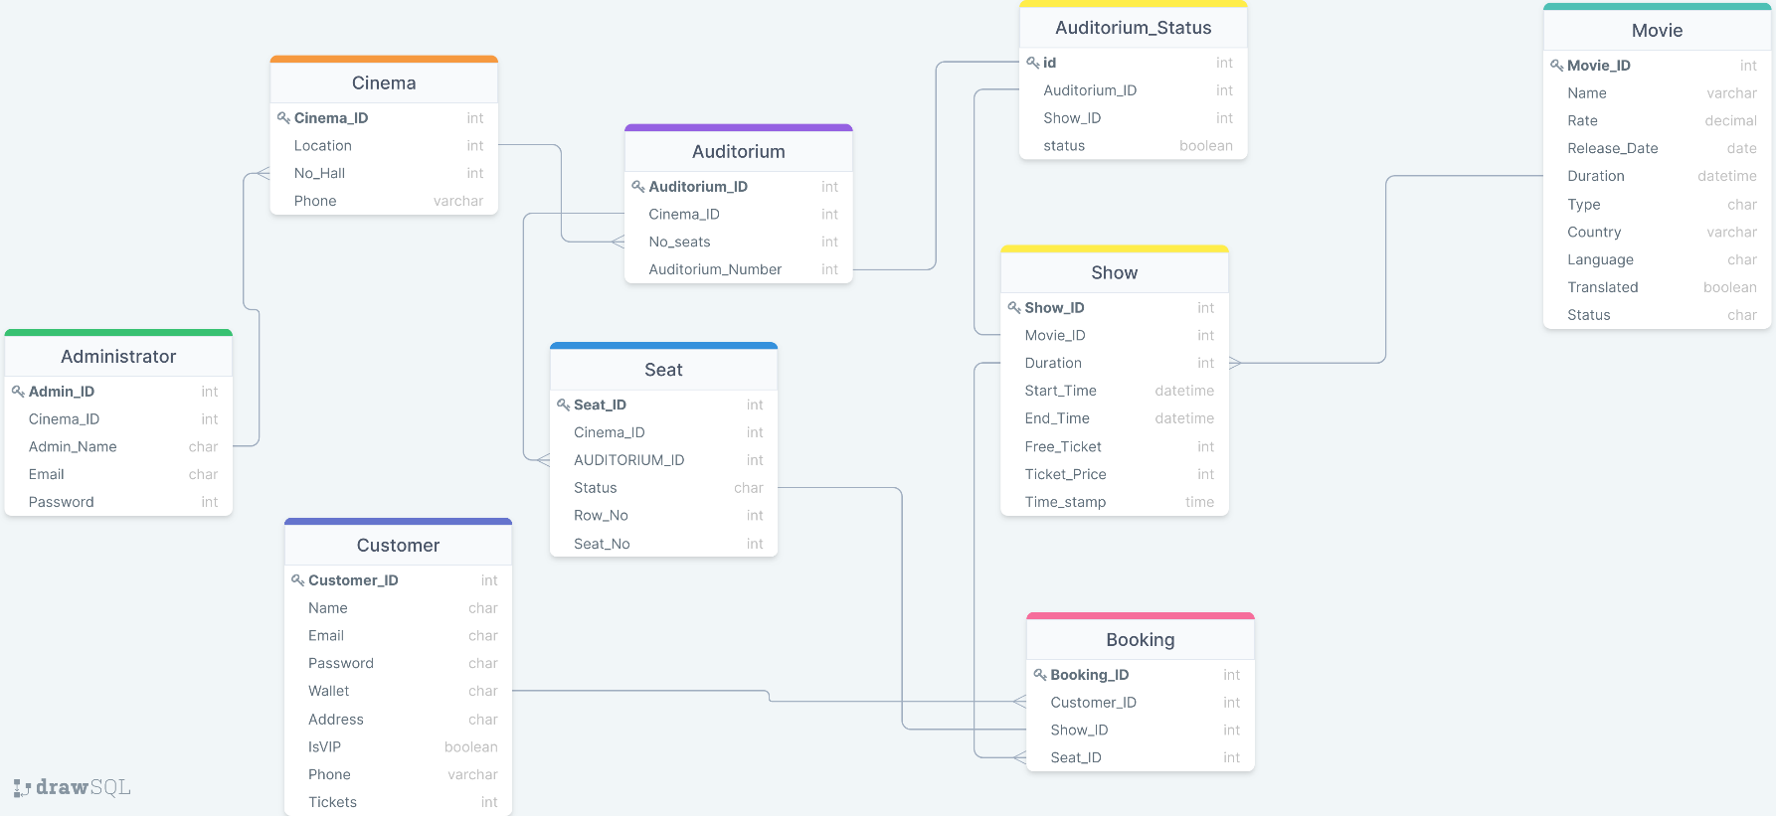

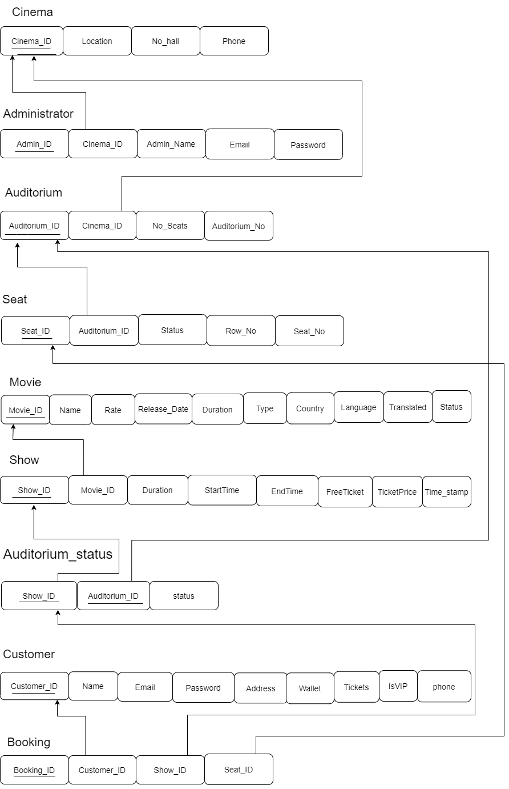

Our database design consists of:

* Cinema table

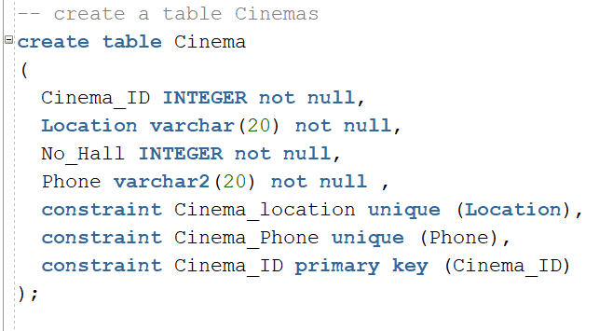Describes all branches of our cinema in Egypt, and their location, how many halls in each branch.

* Auditorium table

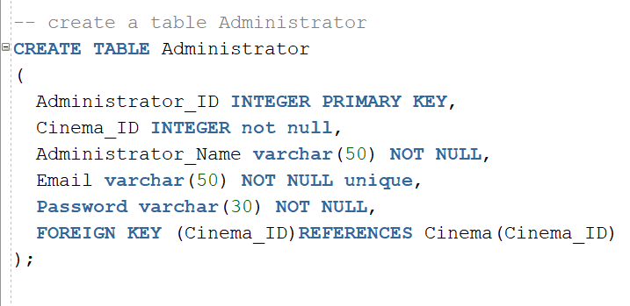Describes all admins can working on database, their names and mails.

* Auditorium table

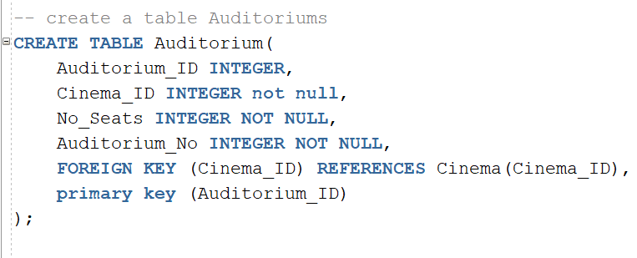Describes all halls that is existing in all branches, how many seats in each hall.

* Seat table

Describes information of all seats which cinema and auditorium and row is in and its status free or reversed, each seat must take number.

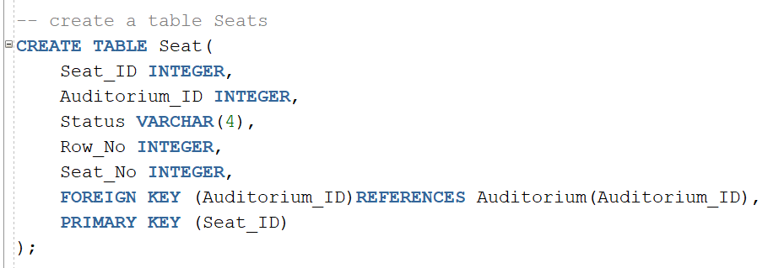

* Movie table

Describes all information of each movie, name, rate, language, type...

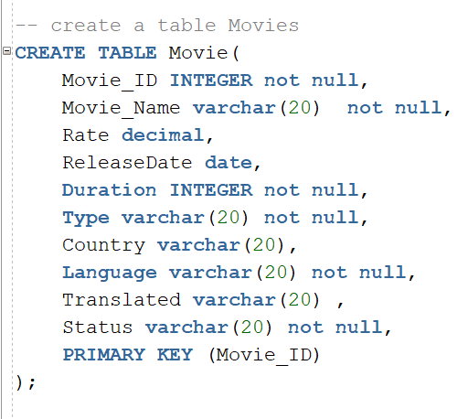

* Show table

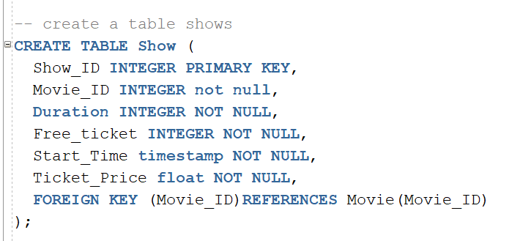Describes schedule of each auditorium which movie is being shown and in which time.

* Customer table

Describes all information of each customer, their names, mails, address, no of tickets which each customer reversed.

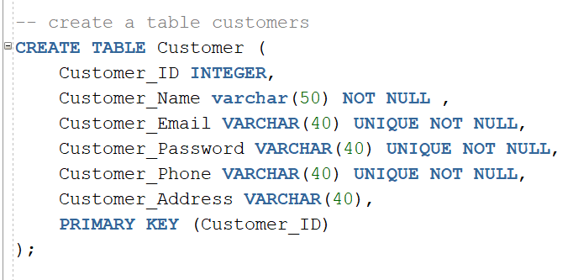

* booking table

Describes all information of each booking which customer book.

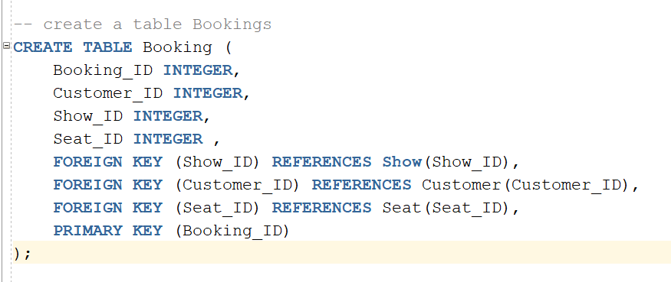

Source code

-- create a table Cinemas

create table Cinema

(

Cinema_ID INTEGER not null,

Location varchar(20) not null,

No_Hall INTEGER not null,

Phone varchar2(20) not null ,

constraint Cinema_location unique (Location),

constraint Cinema_Phone unique (Phone),

constraint Cinema_ID primary key (Cinema_ID)

);

-- create a table Auditoriums

CREATE TABLE Auditorium(

Auditorium_ID INTEGER,

Cinema_ID INTEGER not null,

No_Seats INTEGER NOT NULL,

Auditorium_No INTEGER NOT NULL,

FOREIGN KEY (Cinema_ID) REFERENCES Cinema(Cinema_ID),

primary key (Auditorium_ID)

);

-- create a table Administrator

CREATE TABLE Administrator

(

Administrator_ID INTEGER PRIMARY KEY,

Cinema_ID INTEGER not null,

Administrator_Name varchar(50) NOT NULL,

Email varchar(50) NOT NULL unique,

Password varchar(30) NOT NULL,

FOREIGN KEY (Cinema_ID)REFERENCES Cinema(Cinema_ID)

);

-- create a table Seats

CREATE TABLE Seat(

Seat_ID INTEGER,

Auditorium_ID INTEGER,

Status VARCHAR(4),

Row_No INTEGER,

Seat_No INTEGER,

FOREIGN KEY (Auditorium_ID)REFERENCES Auditorium(Auditorium_ID),

PRIMARY KEY (Seat_ID)

);

-- create a table Movies

CREATE TABLE Movie(

Movie_ID INTEGER not null,

Movie_Name varchar(20) not null,

Rate decimal,

ReleaseDate date,

Duration INTEGER not null,

Type varchar(20) not null,

Country varchar(20),

Language varchar(20) not null,

Translated varchar(20) ,

Status varchar(20) not null,

PRIMARY KEY (Movie_ID)

);

-- create a table shows

CREATE TABLE Show (

Show_ID INTEGER PRIMARY KEY,

Movie_ID INTEGER not null,

Duration INTEGER NOT NULL,

Free_ticket INTEGER NOT NULL,

Start_Time timestamp NOT NULL,

Ticket_Price float NOT NULL,

FOREIGN KEY (Movie_ID)REFERENCES Movie(Movie_ID)

);

-- create a table AuditoriumStatus

create table Auditorium_Status(

Auditorium_busy varchar(20),

Show_ID INTEGER,

Auditorium_ID INTEGER ,

FOREIGN KEY (Auditorium_ID) REFERENCES Auditorium(Auditorium_ID),

FOREIGN KEY (Show_ID) REFERENCES Show(Show_ID),

PRIMARY KEY (Show_ID,Auditorium_ID)

);

-- create a table customers

CREATE TABLE Customer (

Customer_ID INTEGER,

Customer_Name varchar(50) NOT NULL ,

Customer_Email VARCHAR(40) UNIQUE NOT NULL,

Customer_Password VARCHAR(40) UNIQUE NOT NULL,

Customer_Phone VARCHAR(40) UNIQUE NOT NULL,

Customer_Address VARCHAR(40),

PRIMARY KEY (Customer_ID)

);

-- create a table Bookings

CREATE TABLE Booking (

Booking_ID INTEGER,

Customer_ID INTEGER,

Show_ID INTEGER,

Seat_ID INTEGER ,

FOREIGN KEY (Show_ID) REFERENCES Show(Show_ID),

FOREIGN KEY (Customer_ID) REFERENCES Customer(Customer_ID),

FOREIGN KEY (Seat_ID) REFERENCES Seat(Seat_ID),

PRIMARY KEY (Booking_ID)

);

-- insert into Cinemas table

INSERT INTO Cinema VALUES (1111, 'Cairo', 3, +201284030016);

INSERT INTO Cinema VALUES (2222, 'Alexandria', 4, +201099315074);

SELECT * FROM Cinema;

-- insert into Auditoriums table

INSERT INTO Auditorium Values (1, 1111, 200, 1);

INSERT INTO Auditorium Values (2, 1111, 300, 2);

INSERT INTO Auditorium Values (3, 1111, 200, 3);

INSERT INTO Auditorium Values (4, 2222, 150, 1);

INSERT INTO Auditorium Values (5, 2222, 200, 2);

INSERT INTO Auditorium Values (6, 2222, 150, 3);

INSERT INTO Auditorium Values (7, 2222, 200, 4);

SELECT * FROM Auditorium;

-- insert into Administrators table

INSERT INTO Administrator Values (111, 1111, 'Mourad Fawzi', 'mourad@gmail.com', '123456');

INSERT INTO Administrator Values (222, 2222, 'Hamed Mahmoud', 'hamed@gmail.com', '123456789');

SELECT * FROM Administrator;

-- insert into Seats table

INSERT INTO Seat Values (1, 1, 'free', 25, 1);

INSERT INTO Seat Values (2, 1, 'free', 25, 2);

INSERT INTO Seat Values (3, 1, 'free', 25, 3);

INSERT INTO Seat Values (4, 1, 'free', 25, 4);

INSERT INTO Seat Values (5, 1, 'free', 25, 5);

INSERT INTO Seat Values (151, 2, 'free', 25, 1);

INSERT INTO Seat Values (152, 2, 'free', 25, 2);

INSERT INTO Seat Values (153, 2, 'free', 25, 3);

INSERT INTO Seat Values (154, 2, 'free', 25, 4);

INSERT INTO Seat Values (155, 2, 'free', 25, 5);

INSERT INTO Seat Values (61, 3, 'free', 25, 1);

INSERT INTO Seat Values (62, 3, 'free', 25, 2);

INSERT INTO Seat Values (63, 3, 'free', 25, 3);

INSERT INTO Seat Values (64, 3, 'free', 25, 4);

INSERT INTO Seat Values (65, 3, 'free', 25, 5);

INSERT INTO Seat Values (176, 4, 'free', 25, 1);

INSERT INTO Seat Values (177, 4, 'free', 25, 2);

INSERT INTO Seat Values (178, 4, 'free', 25, 3);

INSERT INTO Seat Values (179, 4, 'free', 25, 4);

INSERT INTO Seat Values (180, 4, 'free', 25, 5);

INSERT INTO Seat Values (281, 5, 'free', 25, 1);

INSERT INTO Seat Values (282, 5, 'free', 25, 2);

INSERT INTO Seat Values (283, 5, 'free', 25, 3);

INSERT INTO Seat Values (284, 5, 'free', 25, 4);

INSERT INTO Seat Values (285, 5, 'free', 25, 5);

INSERT INTO Seat Values (311, 6, 'free', 25, 1);

INSERT INTO Seat Values (312, 6, 'free', 25, 2);

INSERT INTO Seat Values (313, 6, 'free', 25, 3);

INSERT INTO Seat Values (314, 6, 'free', 25, 4);

INSERT INTO Seat Values (315, 6, 'free', 25, 5);

INSERT INTO Seat Values (501, 7, 'free', 25, 1);

INSERT INTO Seat Values (502, 7, 'free', 25, 2);

INSERT INTO Seat Values (503, 7, 'free', 25, 3);

INSERT INTO Seat Values (504, 7, 'free', 25, 4);

INSERT INTO Seat Values (505, 7, 'free', 25, 5);

SELECT * FROM Seat;

-- insert into Movies table

INSERT INTO Movie Values (11, 'Army of the Dead', 5.8, '14-MAY-2021', 148, 'Action', 'Spain', 'Spanish', 'English', 'Available');

INSERT INTO Movie Values (22, 'Cruella', 7.4, '27-MAY-2021', 134, 'Comedy', 'US', 'English', 'Arabic', 'Available');

INSERT INTO Movie Values (33, 'Wrath of Man', 7.2, '13-MAY-2021', 119, 'Action', 'US', 'English', 'Arabic', 'Available');

INSERT INTO Movie Values (44, 'F9: The Fast Saga', 7.2, '13-MAY-2021', 145, 'Action', 'US', 'English', 'Arabic', 'Available');

INSERT INTO Movie Values (55, 'Spiral', 5.4, '26-MAY-2021', 93, 'Horror', 'US', 'English', 'Arabic', 'Available');

SELECT * FROM Movie;

-- insert into Shows table

INSERT INTO Show VALUES (1, 11, 3, 200, '01-JUN-2021 3.00.00 AM', 125);

INSERT INTO Show VALUES (2, 22, 3, 200, '01-JUN-2021 3.00.00 PM', 125);

INSERT INTO Show VALUES (3, 33, 3, 200, '01-JUN-2021 7.00.00 PM', 125);

INSERT INTO Show VALUES (4, 44, 3, 200, '01-JUN-2021 11.00.00 PM', 125);

INSERT INTO Show VALUES (5, 55, 3, 200, '02-JUN-2021 3.00.00 AM', 125);

SELECT * FROM Show;

--insert into Auditoriumstatus table

INSERT INTO Auditorium_Status VALUES ('Available', 1, 1);

INSERT INTO Auditorium_Status VALUES ('Available', 1, 2);

INSERT INTO Auditorium_Status VALUES ('Available', 1, 3);

INSERT INTO Auditorium_Status VALUES ('Available', 2, 4);

INSERT INTO Auditorium_Status VALUES ('Available', 2, 5);

INSERT INTO Auditorium_Status VALUES ('Available', 2, 6);

INSERT INTO Auditorium_Status VALUES ('Available', 3, 7);

SELECT * FROM Auditorium_Status;

--insert into Customers table

INSERT INTO Customer VALUES (1, 'Mark', 'mark@gmail.com', 'mark1234', '+2001099315074','cairo' );

INSERT INTO Customer VALUES (2, 'jo', 'jo@gmail.com', 'jo1234', '+2001099315071','alex' );

INSERT INTO Customer VALUES (3, 'ahmed', 'ahmed@gmail.com', '123456789', '+2001099315072','ainshams');

INSERT INTO Customer VALUES (4, 'mohamed', 'mohamed@gmail.com', '123485', '+2001099315079','madaai' );

INSERT INTO Customer VALUES (5, 'Mahmoud', 'mahmoud@gmail.com', '12345679', '+2001099315076','giza' );

INSERT INTO Customer VALUES (6, 'ghada ', 'ghada@gmail.com', '1346798', '+2001099315077','aswan' );

INSERT INTO Customer VALUES (7, 'marowa', 'marowa@gmail.com', 'mark234', '+2001099315073','cairo' );

INSERT INTO Customer VALUES (8, 'yasser', 'yasser@gmail.com', 'jo234', '+2001099315087','alex' );

INSERT INTO Customer VALUES (9, 'youssef', 'youssef@gmail.com', '12356789', '+2001099315082','ainshams');

INSERT INTO Customer VALUES (10, 'alien', 'alien@gmail.com', '12345', '+2001099315081','madaai');

SELECT * FROM Customer;

-- insert into Bookings booking

insert into Booking values(100, 1, 2, 1);

insert into Booking values(101,2,2,151);

insert into Booking values(102,3,1,5);

insert into Booking values(103,4,1,151);

insert into Booking values(104,5,3,3);

insert into Booking values(105,6,4,4);

insert into Booking values(106,7,5,155);

insert into Booking values(107,8,5,4);

insert into Booking values(108,9,3,153);

insert into Booking values(109,10,2,2);

SELECT * FROM Booking;

SELECT Customer_Name, Movie_Name, Start_Time, Location

FROM Customer, Movie,Show, Cinema

WHERE Customer_ID=5 AND Booking.Show_ID=Show.Show_ID AND

Show.Movie_ID=Movie.Movie_ID AND Booking.Seat_ID=Seat.Seat_ID AND

Seat.Auditorium_ID=Auditorium.Auditorium_ID AND Auditorium.Cinema_ID=Cinema.Cinema_ID;

-- Queries

-- For Tickets

SELECT Customer.Customer_Name, Cinema.Location, Auditorium.Auditorium_No, Movie.Movie_Name, Show.Start_Time, Show.Ticket_Price

FROM (((Booking

INNER JOIN Customer ON Booking.Customer_ID = Customer.Customer_ID)

INNER JOIN Show ON Booking.Show_ID = Show.Show_ID INNER JOIN MOVIE ON Show.Movie_ID = Movie.Movie_ID)

INNER JOIN Seat ON Booking.Seat_ID = Seat.Seat_ID INNER JOIN Auditorium ON Seat.Auditorium_ID = Auditorium.Auditorium_ID

INNER JOIN Cinema ON Auditorium.Cinema_ID = Cinema.Cinema_ID)

WHERE Booking.Customer_ID = 5;

-- For Show List..

SELECT Booking.Booking_ID, Customer.Customer_ID, Customer.Customer_Name, Auditorium.Auditorium_No

FROM (((Booking

INNER JOIN Customer ON Booking.Customer_ID = Customer.Customer_ID)

INNER JOIN Show ON Booking.Show_ID = Show.Show_ID INNER JOIN Movie ON Show.Movie_ID = Movie.Movie_ID)

INNER JOIN Seat ON Booking.Seat_ID = Seat.Seat_ID INNER JOIN Auditorium ON Seat.Auditorium_ID = Auditorium.Auditorium_ID)

WHERE Booking.Show_ID = 1;