egypt_real_estate_listings
Context:
This dataset contains ~20,000 real estate property listings collected from PropertyFinder Egypt.
It includes detailed information about properties for sale such as price, size, location, type, number of bedrooms/bathrooms, availability, and payment methods.
Attribute Information:
1-url: Direct link to the property listing on PropertyFinder Egypt.
2-Price:Property price in Egyptian Pounds (string, contains comma separators).
3-Description:Detailed property description (English/Arabic mixed text).
4-Location:Full location including compound, city, and governorate.
5-type:Property type (Apartment, Villa, Townhouse, etc.).
6-Size:Property size in both square feet and square meters.
7-Bedrooms:Number of bedrooms (can be numeric or string like 3+ Maid).
8-Bathrooms:Number of bathrooms.
9-available_from:Availability date for the property (nullable).
10-payment_method:Payment method (e.g., Cash, Installments).
11-down_payment:Down payment amount (only available for ~5k listings).
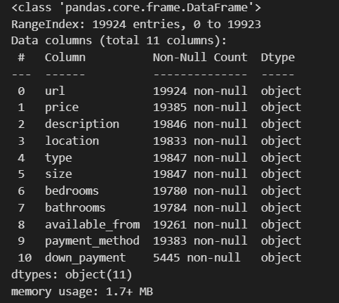
Data Information:

Data Information (Cont.):
- data with (19923) record & (11) features (columns).
- Data with (11) strings.
-Columns such as price, size, bedrooms, bathrooms, and down_payment should be numeric, not string.

-size column contains both square feet and square meters (e.g., “732 sqft / 68 sqm”) → needs extraction and standardization to a single unit (preferably sqm).

-location column contains hierarchical geographic data (e.g., “Swan Lake Gouna, Al Gouna, Hurghada, Red Sea”) → can be split into multiple levels (project, city, governorate, region).

-Missing values and inconsistent entries should be checked, especially in available_from and payment_method.

-Data cleaning (handling missing & inconsistent entries)

-Feature engineering (extract numeric size, split location)

