Installation of Apache Spark on Windows 10
- Install Java
  - First, we need to install Java to execute Spark applications
  - To do that, go to this page and download the latest version of the JDK.
  - After installing it, add the JAVA_HOME variable to your system variables and make sure its path is pointing to the JDK parent folder.
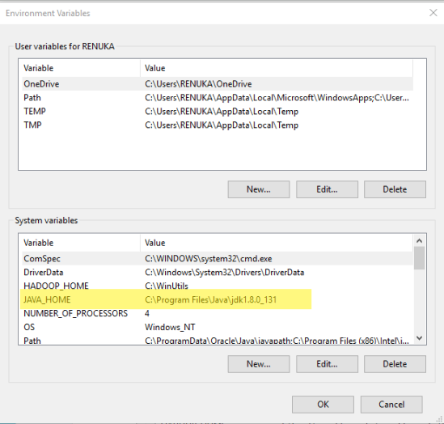
  - After adding this variable, modify the Path system variable and add a new entry like this: %JAVA_HOME%\bin. This will let Windows command line recognize Java commands
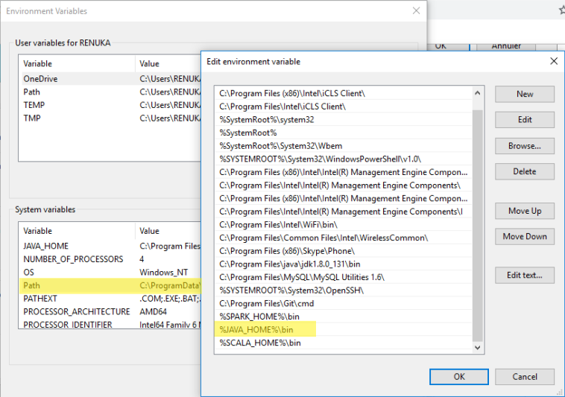
  - Now, start the command line and type
Java -version
to check if java was installed correctly
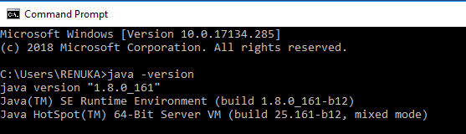
- Spark Binaries
  - Go to this page and choose the latest stable version pre-built for Hadoop 2.7 and later (see figure below)
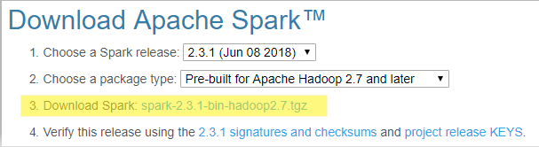
  - Extract the contents of spark-2.3.1-bin-hadoop2.7.tgz at C:\Spark\
  - Add a new variable to your system variables and name it: SPARK_HOME. This variable holds the Spark parent directory path (C:\spark-2.3.1-bin-hadoop2.7 for example).
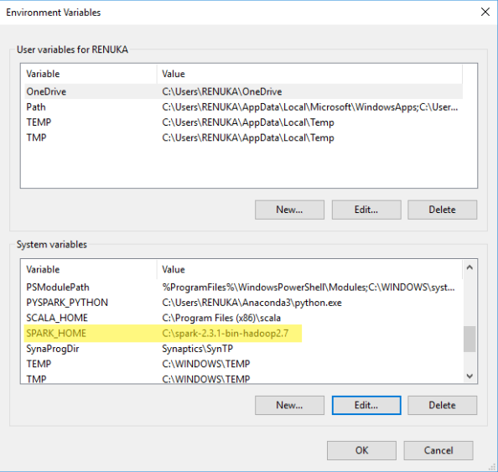
  - Add %SPARK_HOME%\bin to Path system variable.
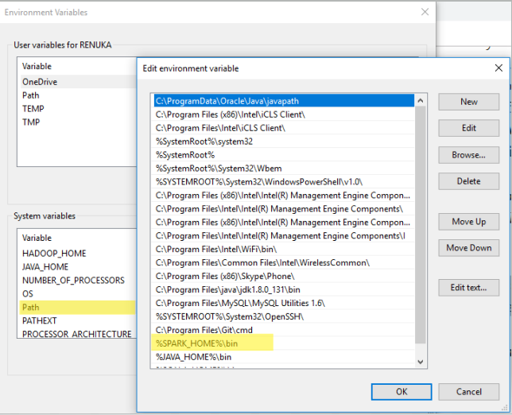
- Hadoop WinUtils
  - Create a new folder and name it “WinUtils” and place it in a parent directory of any partition (C:\WinUtils for example)
  - Go to this page and download this repository by clicking in the right green button and choosing Download ZIP option.
  - After downloading the zip file, extract it and copy files from this folder “hadoop-2.7.1” to WinUtils folder (don’t copy the whole directory, just its content, the bin folder).
  - Add HADOOP_HOME variable to your system variables and point it to the WinUtils folder (C:\WinUtils in this case).
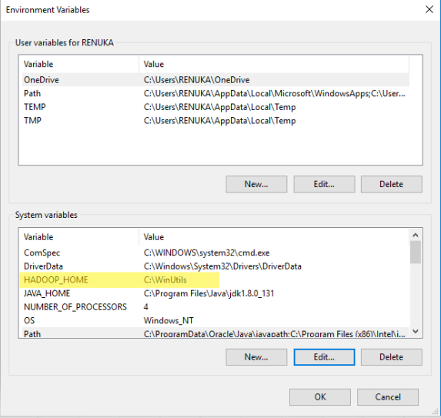
- Install Anaconda and Jupyter
  - Latest version available at https://www.anaconda.com/download/
  - Add a new variable to your system variables and name it: PYSPARK_PYTHON. This variable holds the path for python.exe (C:\Users\<user_name>\Anaconda3\python.exe) for example).
- Run pyspark
  - Open command line and type: pyspark
