**Exercise 1: SELECT and PROJECT operations.**

Let us consider the following tables which will be used to demonstrate the SELECT and PROJECT operations.

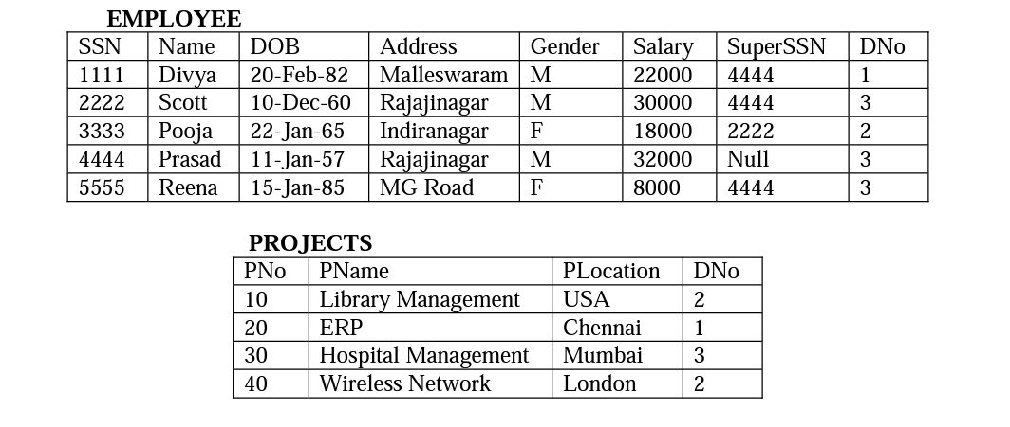

The general form of selection operation is shown below.

σ <selection-condition> (Relation)

1. Find the employees whose salary is greater than 10000.
2. Find the employees who work for department 3 and whose salary is greater than 30000.
3. Find all the employees who either work in department 1 and earn over 20000 or work in department 3 and earn over. 29000.
4. List all the projects controlled by department 2.

In relational algebra, the mathematical symbol, π (pi) is used for projection. The general syntax for projection is shown below:

π <attribute> (Relation)

1. List the name and salary of all the employees.
2. Retrieve the Name and Salary of all employees who are working for department 1.
3. List the name and location of the projects which are not controlled by department 2.