Datawarehouse Project

TA:- ENG. Ahmed Mohamed Galal

|  |  |
| --- | --- |
| Name | ID |
| Mahmoud Sayed Abdel’aty | 20210370 |
| Mario Malak Alabd | 20210313 |
| Shimaa Amer | 20211056 |
| Mohamed Hany | 20210358 |
| Hagar Ragaee | 20211108 |

* 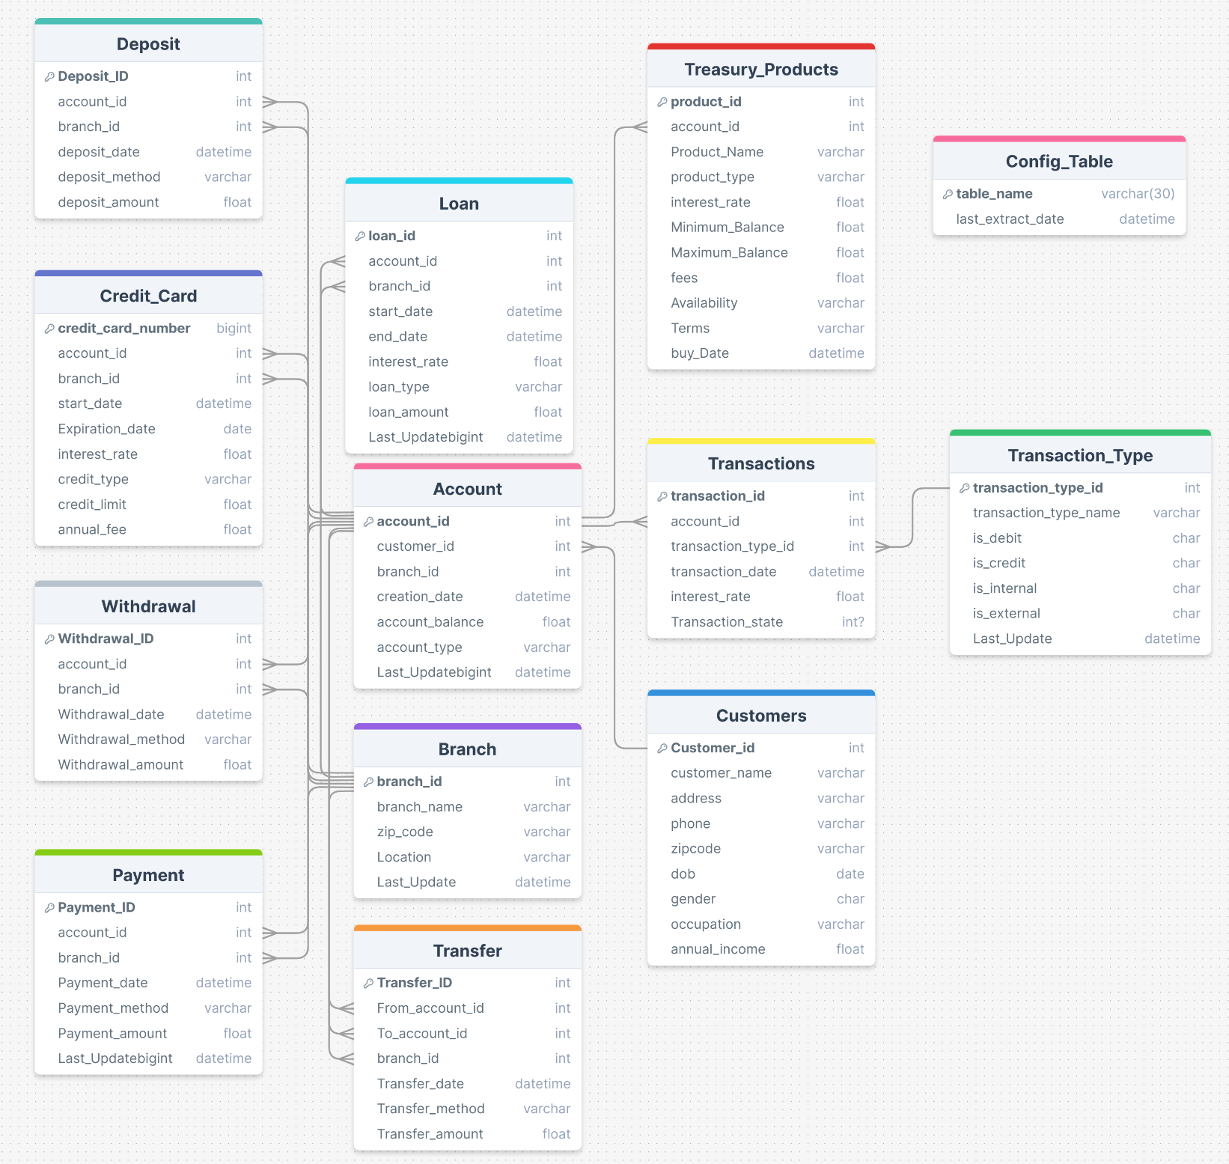Physical model of the source system
* Fact Tables:-

|  |  |  |
| --- | --- | --- |
| **Fact table** | **Representation** | **Measures** |
| **Loan_Fact** | This fact table represents information about loans granted by the bank. It contains data about loan amounts, type, interest rates, terms, and other loan-specific attributes with each Branch. | Total loans per branch  Total loan amount per loan type |
| **Product fact** | This fact table represents information about the different products and services offered by the bank, such as mortgages, investments, insurance policies, etc. It includes data about the product type, pricing, terms, and other product-specific attributes. | Total fees per product |
| **Payment fact** | This fact table represents information about payments made by customers to the bank or received by customers from the bank. It includes data about the payment amount, date, time, location, and other payment-specific attributes. It also includes data about the accounts and customers involved in each payment transaction. | Total payment amount per year  Total payment amount per branch |

* Dimensions:-

|  |  |
| --- | --- |
| **Dimension Table** | **Representation** |
| **Time_Dim** | This dimension is used to track various time-related information, such as date, day, month, quarter, year, etc. It can be used to filter and analyze data based on different time periods. |
| **Treasury_Products_Dim** | This dimension is used to track information related to different treasury products offered by the bank, such as savings accounts, money market accounts, certificates of deposit, etc. It can be used to analyze and compare different products based on their interest rates, fees, minimum balance requirements, etc. |
| **Branch_Dim** | This dimension is used to track information related to the various branches of the bank, such as branch location, address, phone number, etc. It can be used to filter and analyze data based on different branches. |
| **Loan_Dim** | This dimension is used to track information related to loans offered by the branch that made by a specific customer, such as loan type, interest rate, loan amount, start date, end date, etc. It can be used to analyze and compare different loans based on their terms and performance |
| **Account_DIm** | This dimension is used to track information related to bank accounts, such as account type, account balance, creation date, etc. It can be used to analyze and compare different accounts based on their performance and contains informations about the customer who have this account such as customer name,phone,address. |
| **Payment_Dim** | This dimension is used to track information related to payments made by customers in a specific branch , such as payment amount, payment date, payment method, etc. It can be used to analyze and compare different payments based on their amounts and sources. |

* Physical Model

**Conformed Dimension**

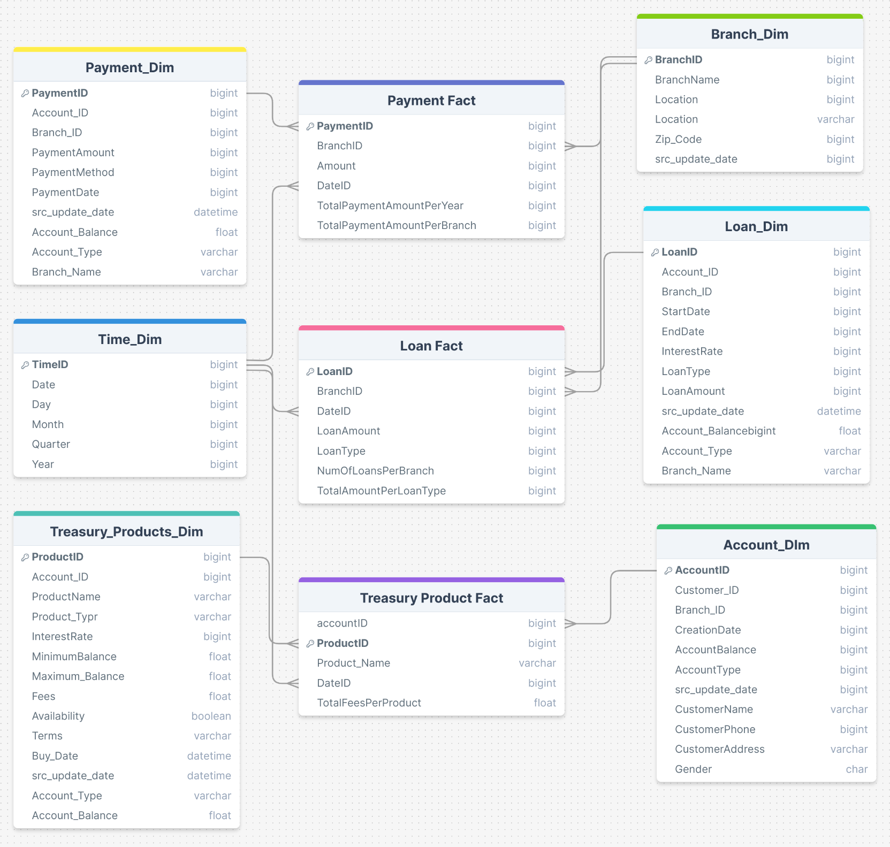

**Transaction Table**

**Transaction Table**

**Periodic Snapshot Table**

**Slowly Changing Dimension**

**Slowly Changing Dimension**

**Static Dimension**

**Role Playing Dimension**

**Degenerate Dimension**

* A screenshot of a computer

  Description automatically generatedControl Flow:-
* Data Flow Tasks:-

1. Last Extract Date 2. Update Config Table

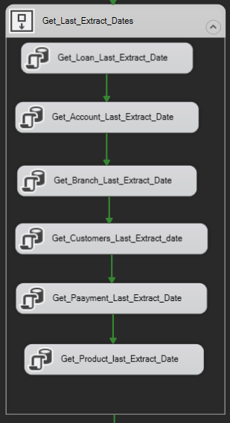 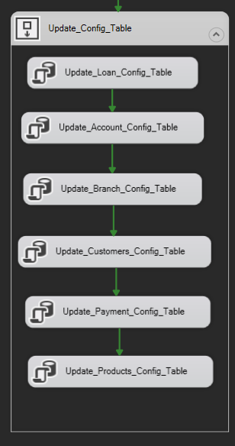

1. From Source to Stage

* 1. From Source to Stage 1

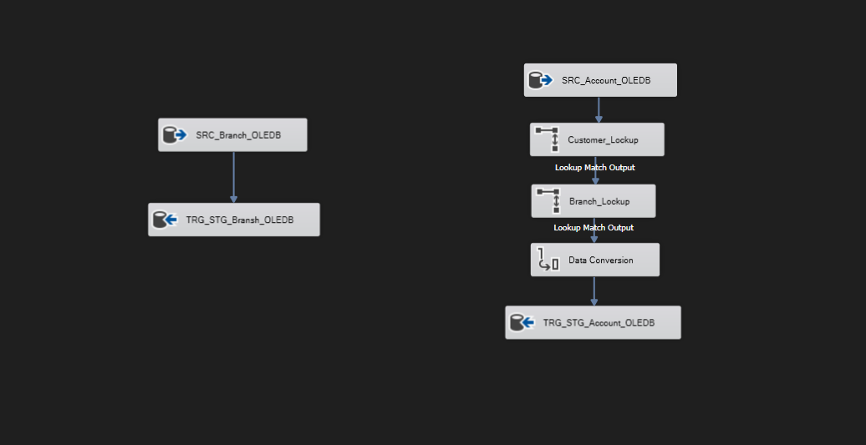

* 1. From Source to Stage 2

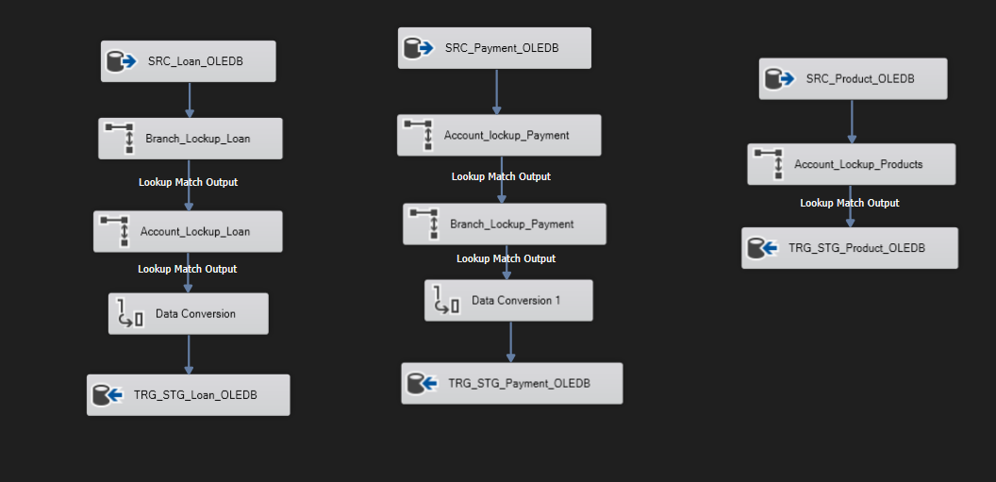

1. From Stage to Dim

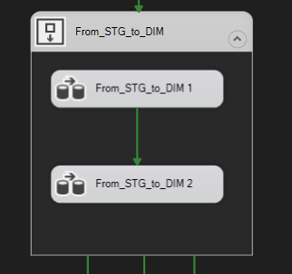

* 1. From Stage to Dim 1

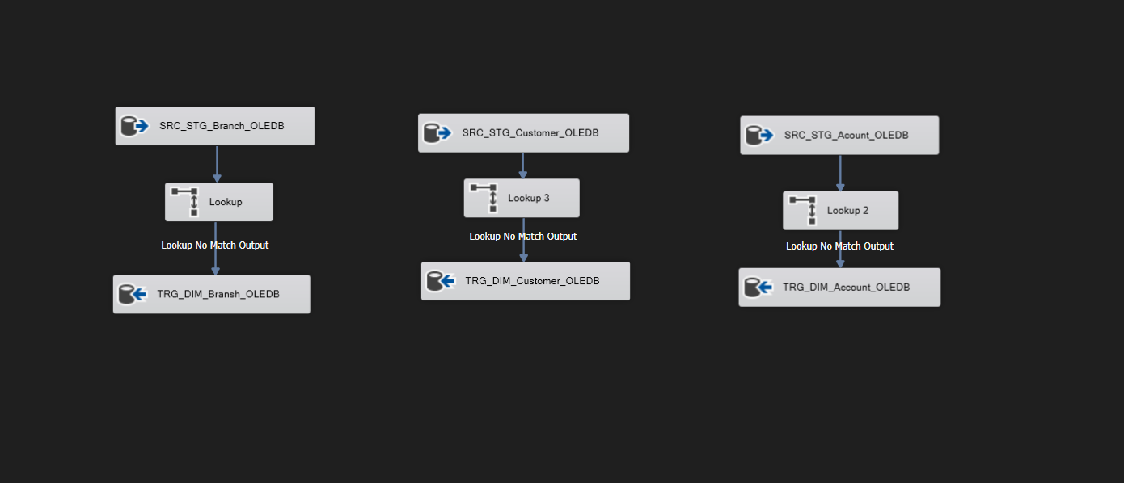

* 1. From Stage to Dim 2

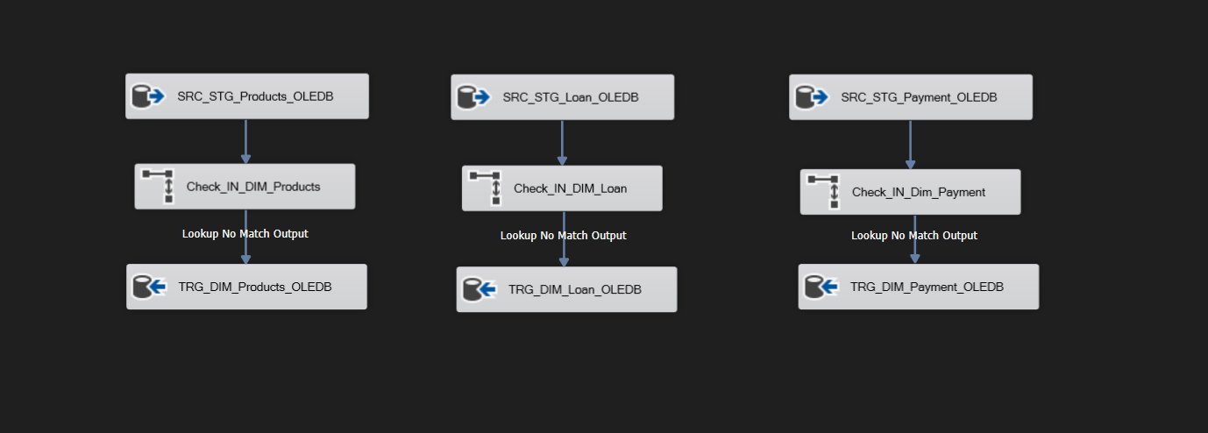

1. Dimension to Fact Loan

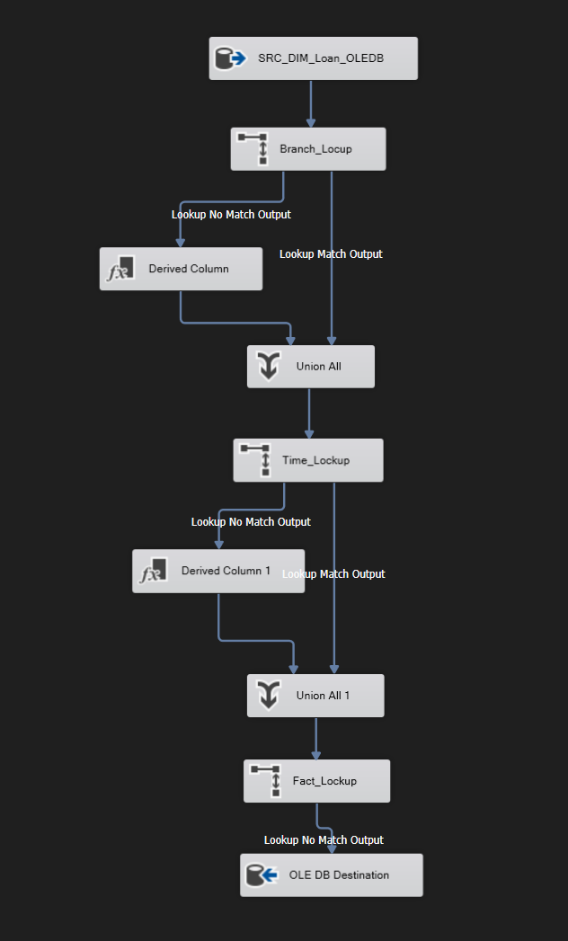

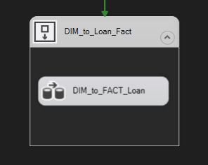

1. Dimension to Fact Payment

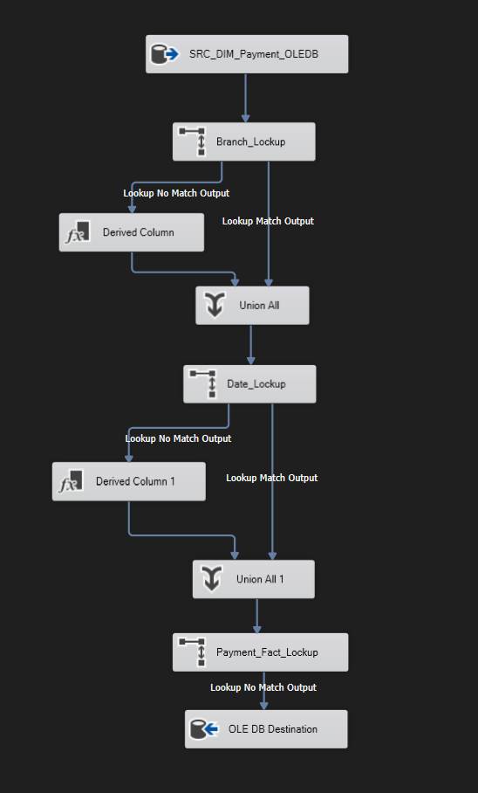

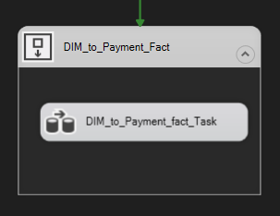

1. Dimension to Fact Products

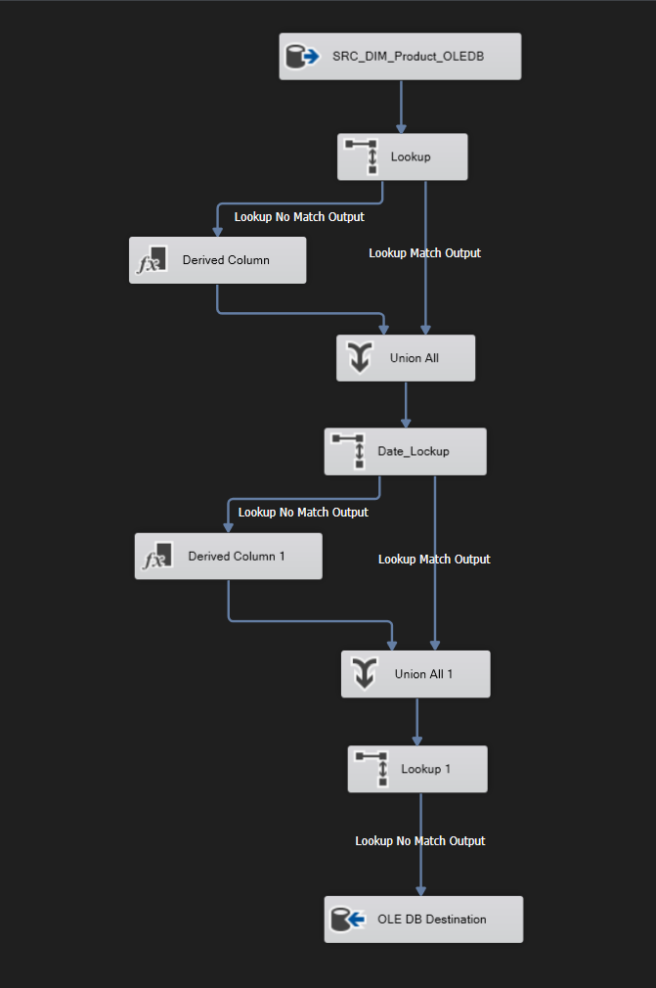

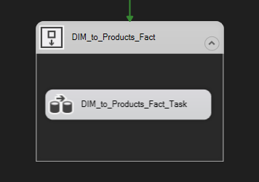

* 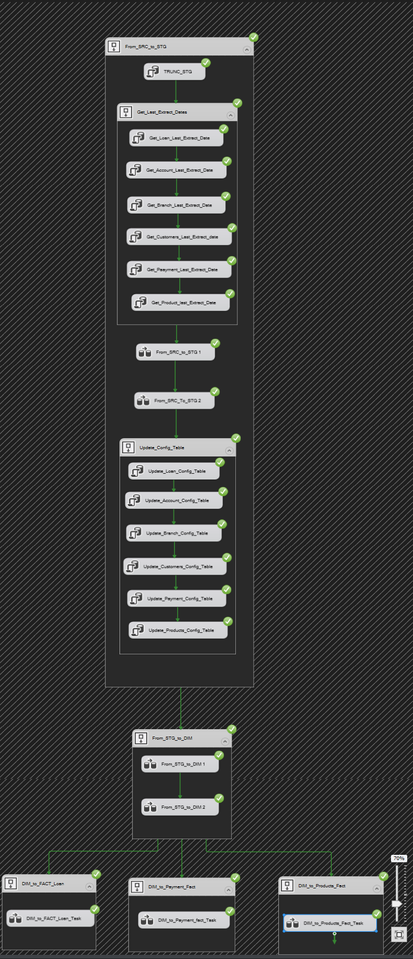Running SSIS
* Job Step

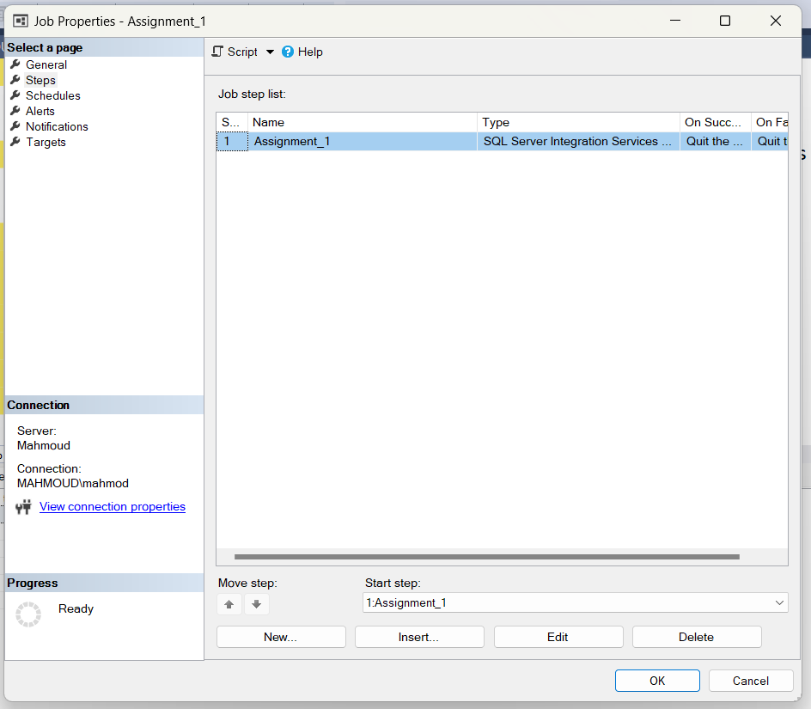

* Scheduling

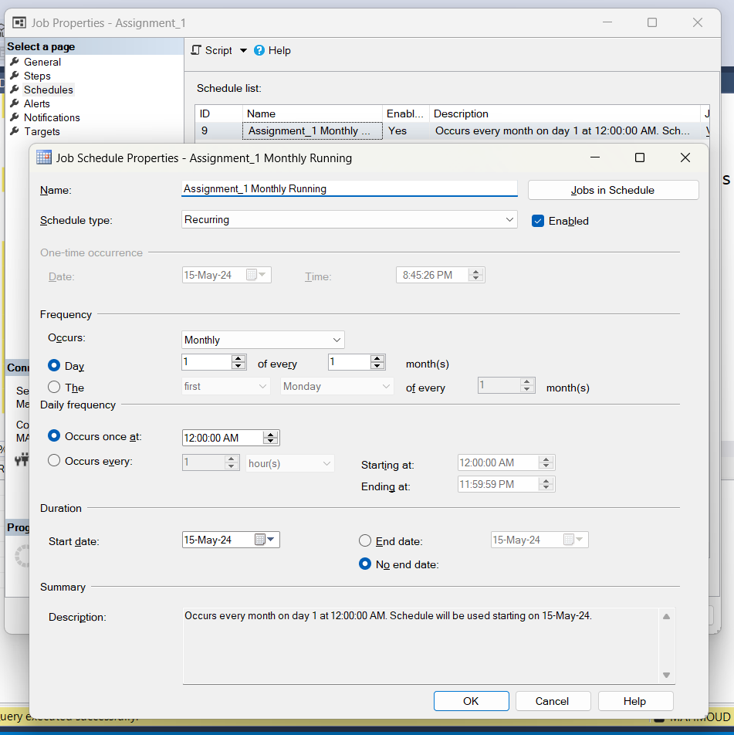

* Deployment Scheduling

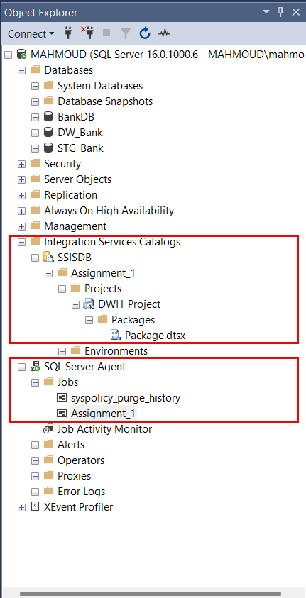

* Queries
  + Number of loans per branch

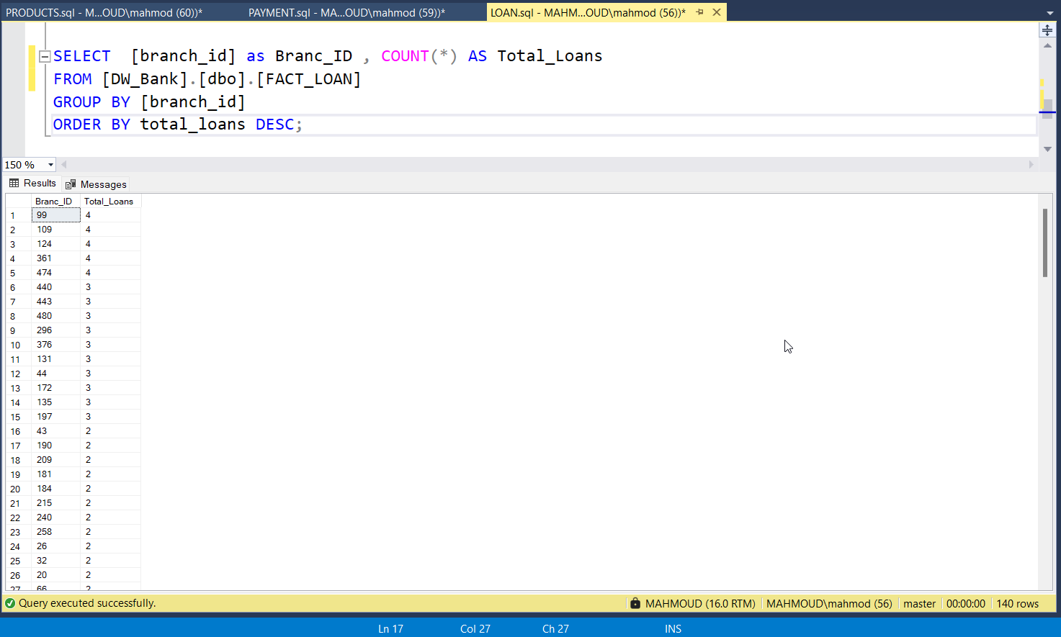

* + Total Fees per product

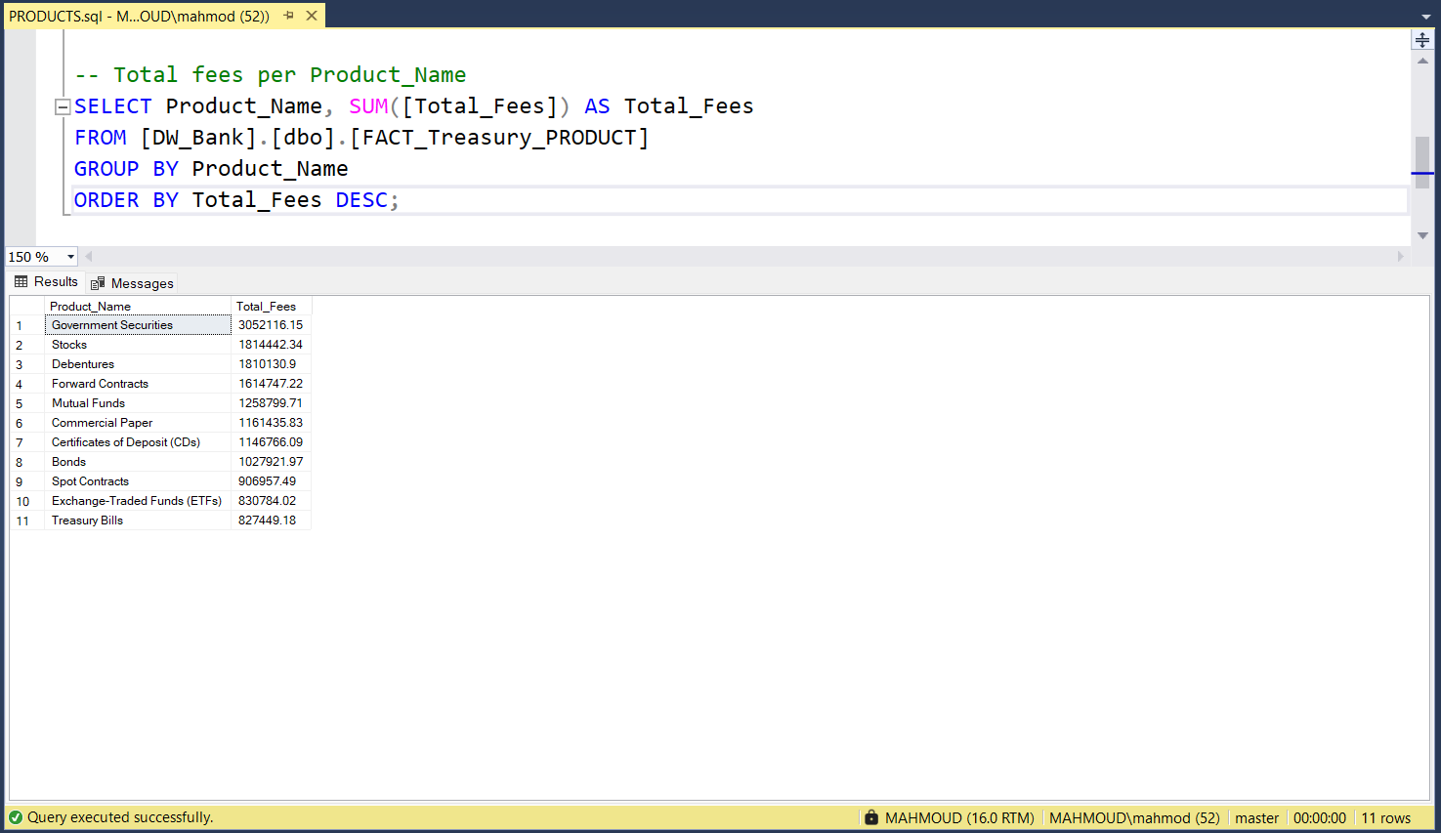

* + Total Loan Amount per Loan Type

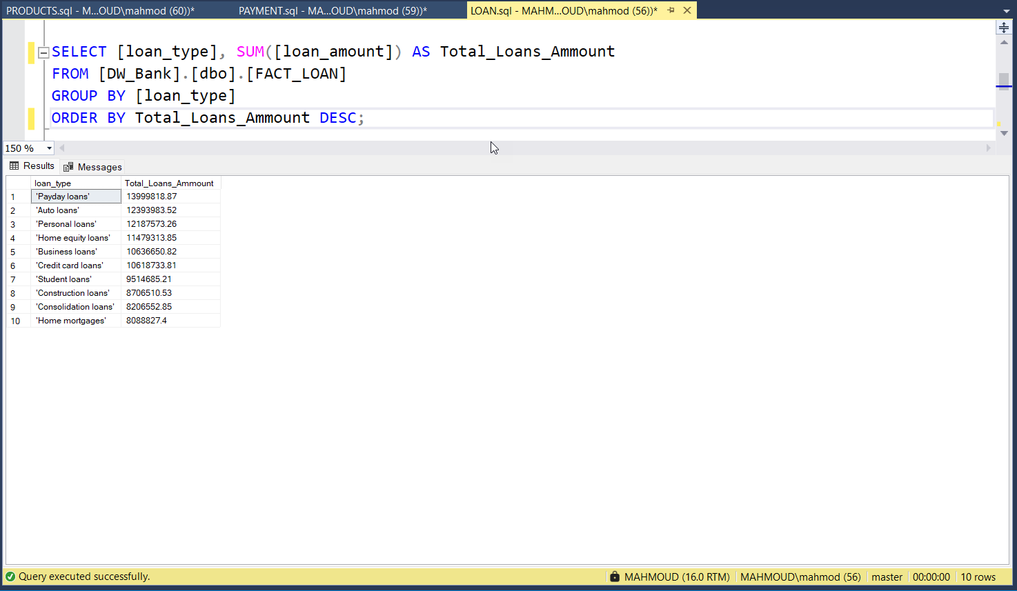

* + Total Payment Amount per branch In Time

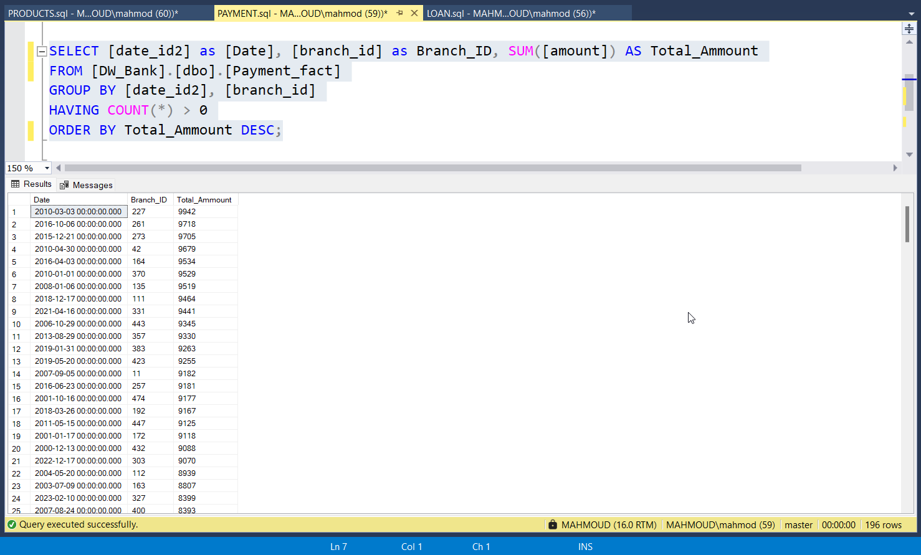

* Dashboard

