 

**Cairo University**

**Faculty of Computers and Artificial Intelligence**

**Information Systems Department**

**Graduation Project Report**

|  |  |
| --- | --- |
| Name | ID |
| Aya Mohamed Abdelrahman | 20211020 |
| Karin Kheir Abdallah Mataa | 20210292 |
| Shimaa Amer Mohamed | 20211056 |
| Mahmoud Sayed Abdel'aty | 20210370 |
| Mahmoud Ali Abdelmnam | 20210371 |
| Mario Malak Alabd | 20210313 |

**AlzCare**

By

**Under the Supervisors of:**

**Dr. Shimaa Galal**

**TA. Aliaa Magdy**

*Department of Information Systems, Faculty of Computers and Artificial Intelligence, Cairo University, Egypt  
  
2025*

**Acknowledgements**

We are immensely thankful to **Dr. Shimaa M. Galal** for her guidance, mentorship, and unwavering support. Her expertise and dedication have been instrumental in shaping the direction of our graduation project.

We extend our heartfelt thanks to **TA. Lamiaa Atef** for her insightful feedback and encouragement. Her wisdom and counsel have been invaluable in enhancing the quality of the work.

**Abstract**

Alzheimer's disease is a progressive neurodegenerative disorder that significantly impairs memory and cognitive function, making it difficult for patients to manage daily activities and recognize familiar faces. As the disease advances, caregivers face immense challenges in ensuring patient safety, monitoring medication adherence, and providing real-time support. The purpose of the AlzCare project is to develop a comprehensive, patient-centered application that bridges the gap between Alzheimer’s patients and their caregivers, offering digital tools to enhance safety, independence, and communication.

The AlzCare app focuses on intermediate-level Alzheimer's patients, utilizing a combination of geolocation-based features, real-time notifications, and cognitive support systems to address the key challenges in caregiving. The app includes features such as medication reminders, geofencing for safe zone alerts, and face recognition to help patients identify loved ones. Caregivers can track patient locations in real time, receive alerts when patients leave designated safe areas, and get notified if patients miss medications or trigger emergency actions. Additionally, the app syncs with smartwatches for health monitoring and offers cognitive training activities to slow memory decline.

The development of AlzCare follows the Waterfall methodology, ensuring structured, sequential phases from requirement gathering to deployment. Through iterative testing and user feedback, the application has been refined to meet both the functional needs of patients and the administrative needs of caregivers and medical professionals. The significance of this research lies in its ability to empower Alzheimer’s patients by promoting independence while providing caregivers with tools for real-time support. This digital solution not only enhances patient care but also reduces the burden on caregivers, allowing for a more effective, connected caregiving experience.

By integrating features such as emergency alerts, face recognition, and safe zone monitoring, the AlzCare project presents a novel approach to addressing the daily complexities faced by Alzheimer's patients and their families. This technology offers a valuable contribution to the field of healthcare by improving patient safety, communication, and overall quality of life.

**Table of Contents**

Chapter 1 Introduction 1

1.1 Background and Motivation 1

1.2 Problem Statement 1

1.3 Objectives 2

1.4 Project Scope and Limitations 2

1.5 Project Methodology 4

1.6 Project Report Outline 6

Chapter 2 Market and Literature Survey 7

2.1 Section 2.1 7

2.2 Section 2.2 7

2.2.1 Sub-section 2.2.1 7

Chapter 3 <Project title> Analysis 8

3.1 Section 3.1 8

3.2 Section 3.2 8

Chapter 4 <Project title> Design and Implementation 9

4.1 Section 4.1 9

4.2 Section 4.2 9

Chapter 5 <Project title> Testing and Evaluation 10

5.1 Section 5.1 10

5.2 Section 5.2 10

Chapter 6 Conclusions and Future Work 11

6.1 Section 6.1 11

6.2 Section 6.2 11

**List of Figures**

Figure number Page Number

Figure 1 - Waterfall methodology 5

Figure 2. Example figure 7

Figure 3. Use Case Example 8

**List of Tables**

Table number Page Number

Table 1. Example Table 7

**List of Abbreviations**

|  |  |
| --- | --- |
| Abbreviation | Meaning |
| PPM | Project Process management |
|  |  |
|  |  |
|  |  |
|  |  |
|  |  |
|  |  |
|  |  |
|  |  |
|  |  |
|  |  |
|  |  |
|  |  |
|  |  |
|  |  |
|  |  |
|  |  |
|  |  |
|  |  |
|  |  |
|  |  |
|  |  |
|  |  |
|  |  |
|  |  |
|  |  |
|  |  |

# Introduction

## Background and Motivation

Alzheimer's disease profoundly affects memory, cognitive functions, and daily life, creating immense challenges for both patients and caregivers. Traditional caregiving methods, which often depend on manual tracking and personal oversight, are insufficient to address the complexities patients face, such as medication management, personal safety, and daily routines.

The motivation for developing **AlzCare** arises from the need to create innovative, technology-driven solutions that empower patients to maintain independence. Through features like reminders, face recognition for familiar people, and emergency alerts, the app provides essential support to patients. For caregivers, **AlzCare** offers real-time tools for monitoring, communication, and intervention, enabling them to ensure the well-being of their loved ones more efficiently and effectively.

## Problem Statement

Caring for Alzheimer's patients presents numerous challenges, including managing daily activities, ensuring patient safety, and maintaining effective communication between patients and caregivers. Traditional caregiving methods often fall short, lacking the real-time support needed for medication adherence, accurate patient location tracking, and timely detection of emergencies. Additionally, patients with Alzheimer’s frequently experience memory loss and disorientation, making it difficult to recognize loved ones or navigate familiar surroundings.

To overcome these challenges and improve the quality of care, there is an urgent need for a comprehensive, integrated application. Such a solution should provide essential features like medication reminders, face recognition to aid memory retention, geofencing for safety alerts, and AI-powered tools for real-time assistance and caregiver education.

## Objectives

The **AlzCare** app aims to assist intermediate-level Alzheimer's patients by offering critical support features such as medication reminders and geolocation-based safe zone monitoring. The app will notify caregivers in real time if a patient leaves a designated safe area or misses a scheduled medication dose, ensuring patient safety and more effective caregiving. By empowering patients to maintain greater independence and reducing their reliance on constant supervision, the app will help alleviate the sense of being a burden on loved ones.

## Project Scope and Limitations

**Scope:**

Admin:

* Manage user accounts (patients and caregivers), including creating, updating, and suspending accounts.
* Assign caregivers to specific patients for personalized care.
* Monitor overall system usage, user activity, and generate analytics reports.
* Send announcements and updates to users, ensuring timely communication of important information.
* Manage and oversee emergency protocols and escalations for critical situations.

Patient:

* Receive automated medication reminders to ensure timely adherence to prescribed treatments.
* View and manage saved places using geolocation, providing orientation and familiarity.
* Access memory training exercises designed to strengthen cognitive functions.
* Utilize face recognition to identify and recall familiar people, improving daily interactions.
* Sync with smartwatches to monitor health metrics and enhance overall well-being.
* Trigger emergency actions to alert caregivers in case of distress or emergencies.
* Participate in interactive cognitive tests to track and improve mental health.

Caregiver:

* Monitor the patient’s real-time location using geofencing, with alerts for leaving designated safe zones.
* Receive notifications for missed medications, emergencies, or significant changes in patient behavior.
* Control and set up green areas where the patient can move freely, ensuring safety.
* Receive waste management alerts for improved caregiving efficiency.
* Participate in a community forum to exchange advice and experiences with other caregivers.
* Interact with a chatbot to receive caregiving tips, support, and assistance for daily care tasks.

**Project limitation:**

* **Face Recognition Accuracy**: The reliability of the face recognition feature may be influenced by the quality of images used and the lighting conditions. Additionally, the system may struggle to accurately identify individuals if the patient’s face database is outdated or incomplete.
* **Real-Time Location Tracking**: The accuracy of patient tracking via GPS is dependent on the availability of a strong internet connection and good GPS signal, particularly in rural or low-signal areas. Signal interruptions can delay or provide inaccurate location updates.
* **Emergency Response**: While the app can send emergency alerts to caregivers, it cannot guarantee immediate physical response or assistance. The app relies on caregivers receiving and acting on notifications promptly.
* **AI Chatbot Effectiveness**: The AI chatbot’s performance is dependent on the quality and breadth of the training data. The chatbot may not always provide accurate or contextually relevant advice, especially in complex caregiving situations.
* **Privacy and Data Security**: Although security measures will be in place, the app involves sensitive personal data such as health information, location, and facial recognition. Any security breach could expose users to privacy risks.
* **User Adoption and Learning Curve**: Some users, particularly elderly patients, may find it challenging to adopt new technologies, potentially limiting the effectiveness of certain features, such as memory training or emergency actions.

## Project Methodology

**Used methodology**: Waterfall methodology.

For this project, we have chosen the Waterfall model, a linear and sequential approach to software development. Each phase in the Waterfall model must be completed before moving on to the next, ensuring clear structure and well-defined goals. It suits the AlzCare app due to its focus on thorough planning, patient care, and safety-critical requirements.

**Sequential Phases:**

The project will be developed in a series of distinct, sequential phases, where progress flows in one direction – from requirements gathering to deployment. Each phase must be fully completed before moving to the next, minimizing risk and ensuring all specifications are met.

1. **Requirements Gathering:**

* **Objective:** To collect detailed functional and non-functional requirements for the system.
* **Activities:**
  + Interview caregivers, patients, and healthcare professionals.
  + Document all essential system features (e.g., medication reminders, geolocation tracking, face recognition) and system constraints (e.g., data security, device compatibility).

1. **System Design:**

* **Objective:** To create a blueprint of the system architecture and UI/UX.
* **Activities:**
  + Design the system architecture, database structure, and user interfaces.
  + Plan integrations with external systems like smartwatches and geolocation services.
  + Design the flow of emergency actions and caregiver notifications.

1. **Implementation:**

* **Objective:** To build the system based on the detailed design specifications.
* **Activities:** 
  + Develop the backend logic for user management, location tracking, emergency alerts, etc.
  + Implement the front-end user interface for patients and caregivers.
  + Integrate APIs for smartwatch syncing and GPS tracking.

1. **Testing:**

* **Objective:** To ensure the system meets all requirements and works as intended.
* **Activities**:
  + Perform unit testing for individual components
  + Conduct system testing to verify the functionality of all features.
  + Execute user acceptance testing with actual caregivers and patients to gather feedback and fix any issues.

1. **Deployment:**

* **Objective:** To launch the application for use by patients, caregivers, and administrators.
* **Activities:**
  + Deploy the application to the appropriate app stores and web servers.
  + Set up the backend infrastructure for monitoring and managing patient and caregiver data.
  + Configure real-time monitoring for system alerts and location tracking.

1. **Maintenance and Support:**

* **Objectives:** To provide ongoing support and make updates to the system.
* **Activities:**
  + Monitor the system for performance issues, user activity, and potential bugs.
  + Implement periodic updates for improved functionality and security.
  + A group of people on a staircase

    Description automatically generatedProvide support to users through documentation and help desks.

Figure - Waterfall methodology

## Project Report Outline

The following chapters of this report provide a comprehensive view of the design and analysis aspects of our Alzheimer patient support system.:

**Chapter 2: Market and Literature Survey**

This chapter explores the current solutions available for Alzheimer's patients, especially those in the early stages of the disease. It includes a detailed literature review of existing technologies and methodologies, identifying their strengths and limitations. This analysis helps to position our project within the context of current practices and highlights areas where our solution can bring innovation

**Chapter 3: System Analysis**

This chapter defines the core problem and outlines the functional and non-functional requirements of the system. It identifies the key stakeholders, their roles, and responsibilities in the project. Detailed system scenarios and essential UML diagrams, such as use case, class, and sequence diagrams, are presented to visualize and clarify the system's design

**Chapter 4: System Design and Implementation**

This section provides a thorough description of the design and implementation process for the Alzheimer's support system. It includes the system's architecture, user interface prototypes, data

models, and the rationale behind the choice of programming languages and development tools. The chapter also showcases prototype screens that illustrate the user interaction with the system.

**Chapter 5: System Testing and Evaluation**

Here, we detail the test cases used to validate the system's performance and effectiveness. The chapter includes testing tools, results for each system requirement, and an evaluation of the project in terms of cost, time, environmental impact, ethics, and social and political implications.

**Chapter 6: Conclusions and Future Work**

This chapter summarizes the project's findings, emphasizing how the system addresses the needs of Alzheimer's patients in the early stages. It also outlines potential future enhancements to expand the system's capabilities and improve its support for patients and caregivers.

# Market and Literature Survey

A survey of the state of the art concerning the subject under consideration. Also a sample of the literature that relates to the subject should be reviewed. **This chapter should be ended with a section where the project description is given in theory.**

## Section 2.1

## Section 2.2

### Sub-section 2.2.1



Figure . Example figure

Table . Example Table

|  |  |  |
| --- | --- | --- |
|  |  |  |
|  |  |  |

# <Project title> Analysis

This chapter describes the main problem functional, and non-functional requirements, stakeholders and their responsibilities, and system scenarios. Students are free to elicit the suitable set of UML diagrams to fully describe the system in details. Example of essential UML diagrams are use case, class, and sequence diagrams.

## Section 3.1

XX

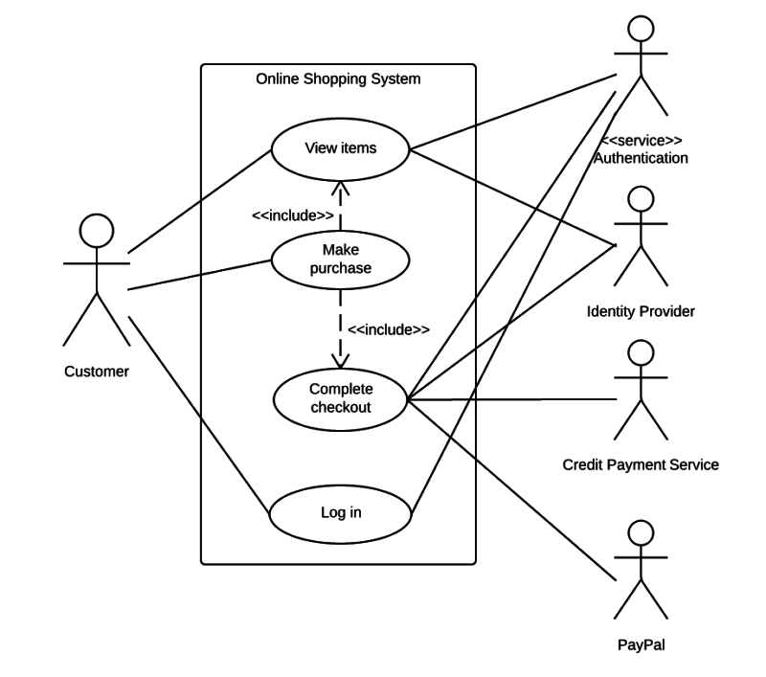

Figure . Use Case Example

## Section 3.2

XX

# <Project title> Design and Implementation

This chapter describes in depth how every aspect of the project was designed, implemented, or created. It should contain the system prototype screens and the used tools and programming languages along with selection reasons.

## Section 4.1

## Section 4.2

# <Project title> Testing and Evaluation

This chapter contains some of the detailed system test cases, used testing tools, and the test results of each system requirement. It also includes a project evaluation in terms of

* ***Cost (if possible)***
* ***Time compared to contemporary systems (if possible)***
* ***Environmental impact (if any)***
* ***Ethics (if any)***
* ***Social and Political Impact (if any)***

## Section 5.1

## Section 5.2

# Conclusions and Future Work

This chapter includes conclusions to validate both the system need and how the presented system solved the problem stated. Finally, describe future suggestions to improve the system.

## Section 6.1

## Section 6.2