 

**Cairo University**

**Faculty of Computers and Artificial Intelligence**

**Information Systems Department**

**Graduation Project Report**

**<Project Title>**

By

**<Student 1 Id and name>**

**<Student 2 Id and name>**

**<Student 3 Id and name>**

**<Student 4 Id and name>**

**Under the Supervisors of:**

**Prof. Dr. -------------**

**Dr. -----------------**

**TA. -------------------**

*Department of Information Systems, Faculty of Computers and Artificial Intelligence, Cairo University, Egypt*

2023

**Acknowledgements**

Use this section to acknowledge the contribution of different people to your work; these may include your supervisor(s), industry partners, sponsors, financial support, specific faculty members in your department, and even your family.

**Abstract**

An abstract is a one-paragraph summary of a research project (350 word max). The abstract allows readers to quickly grasp the purpose and major ideas of a the project.

Think of your abstract as a condensed version of your whole project. By reading it, the reader should understand the nature of your research question.

It should include the following information:

The purpose of the project identifying the area of study to which it belongs.

The problem that motivates the project.

The methods used to address this problem.

The implemented software features and conclusions reached.

The significance of the research project. Why are the results useful?

Whatever kind of work you are doing, your abstract should provide the reader with answers to the following questions: What are you asking? Why is it important? How will you solve it? What are those conclusions? What do they mean?

**Table of Contents**

Chapter 1 Introduction 1

1.1 Background and Motivation 1

1.2 Problem Statement 1

1.3 Objectives 1

1.4 Project Scope and Limitations 1

1.5 Project Methodology 2

1.6 Project Report Outline 3

Chapter 2 Market and Literature Survey 4

2.1 Section 2.1 4

2.2 Section 2.2 4

2.2.1 Sub-section 2.2.1 4

Chapter 3 <Project title> Analysis 5

3.1 Section 3.1 5

3.2 Section 3.2 5

Chapter 4 <Project title> Design and Implementation 6

4.1 Section 4.1 6

4.2 Section 4.2 6

Chapter 5 <Project title> Testing and Evaluation 7

5.1 Section 5.1 7

5.2 Section 5.2 7

Chapter 6 Conclusions and Future Work 8

6.1 Section 6.1 8

6.2 Section 6.2 8

**List of Figures**

Figure number Page Number

Figure 1. Project Plan Example. 2

Figure 2. Example figure 4

Figure 3. Use Case Example 5

**List of Tables**

Table number Page Number

Table 1. Example Table 4

**List of Abbreviations**

|  |  |
| --- | --- |
| Abbreviation | Meaning |
| PPM | Project Process management |
|  |  |
|  |  |
|  |  |
|  |  |
|  |  |
|  |  |
|  |  |
|  |  |
|  |  |
|  |  |
|  |  |
|  |  |
|  |  |
|  |  |
|  |  |
|  |  |
|  |  |
|  |  |
|  |  |
|  |  |
|  |  |
|  |  |
|  |  |
|  |  |
|  |  |
|  |  |

# Introduction

This chapter gives a general introduction providing an overview of the topic, problem statement and the project description. This chapter should be ended with a section that states verbally without numbering or bullet points the contents of the following chapters. (The rest of this report is organized as follows … chapter 1 consists of …)

## Background and Motivation

The introduction only contains preliminary information about the problem and does not state the purpose of the study. It clarifies the importance of the study in detail and the motivation to develop the project system.

## Problem Statement

A problem statement is a statement of a current issue or problem that requires timely action to improve the situation. This statement concisely explains the barrier the current problem places between a functional process and/or product and the current (problematic) state of affairs.

## Objectives

Project objectives are what you plan to achieve by the end of your project. This might include deliverables and assets, or more intangible objectives like increasing productivity or motivation. Your project objectives should be attainable, time-bound, specific goals you can measure at the end of your project.

* Example of a project objective: Add five new ways for customers to find the feedback form in-product within the next two months.

## Project Scope and Limitations

The purpose of a scope and limitations statement is to provide an outline of what your project will address and what it won’t address. What you turn in will include the following:

* a description of the project (what technology you are addressing and the rationale for choosing that technology),
* an explanation of what kind of data you will collect, the methods you will use (interviews, library research, observation, etc.).
* a proposal about how you will test your initial design suggestions.
* a timeline with major tasks to be accomplished for the project and which team member will take a leadership role and responsibility for the task.

**By the end of this section, you should include the initial project plan, team member, and their main responsibilities in the project.**

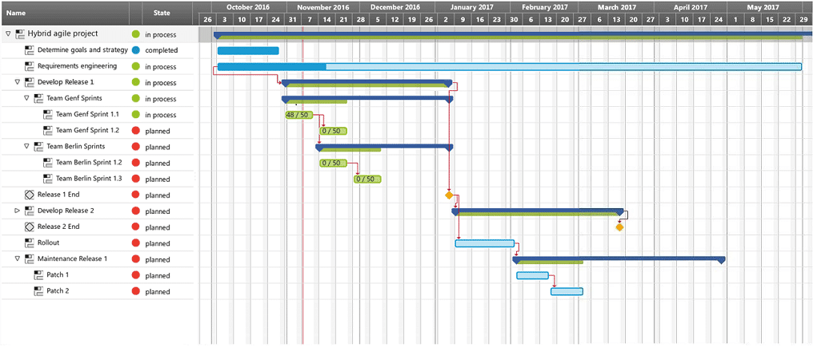

Figure . Project Plan Example.

## Project Methodology

A project management methodology is a set of principles and practices that guide you in organizing your projects to ensure their optimum performance. Basically, it’s a framework that helps you to manage your project in the best way possible. This section demonstrates which methodology will be used during the project implementation? and why?.

A list of *some* project methodologies includes:

1. Waterfall
2. Agile
3. Scrum
4. Extreme Programming
5. Adaptive Project Framework

Check more details in https://www.teamwork.com/project-management-guide/project-management-methodologies/

## Project Report Outline

This section demonstrates the documentation outline as follows:

- Chapter 2 presents the literature review of ……

- Chapter 3 presents the analysis of ………..

- Chapter 4 presents ……….. ………..

- Chapter 5 presents ……….. ………..

- Chapter 6 concludes the work and lessons learned, then sheds the light to future work.

# Market and Literature Survey

A survey of the state of the art concerning the subject under consideration. Also a sample of the literature that relates to the subject should be reviewed. **This chapter should be ended with a section where the project description is given in theory.**

## Section 2.1

## Section 2.2

### Sub-section 2.2.1



Figure . Example figure

Table . Example Table

|  |  |  |
| --- | --- | --- |
|  |  |  |
|  |  |  |

# <Project title> Analysis

This chapter describes the main problem functional, and non-functional requirements, stakeholders and their responsibilities, and system scenarios. Students are free to elicit the suitable set of UML diagrams to fully describe the system in details. Example of essential UML diagrams are use case, class, and sequence diagrams.

## Section 3.1

XX

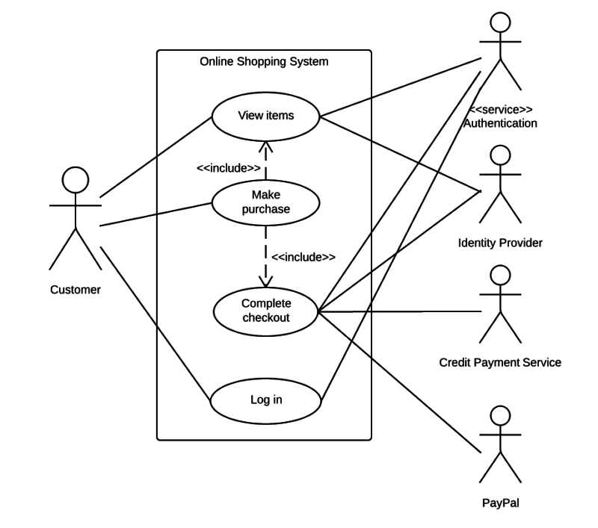

Figure . Use Case Example

## Section 3.2

XX

# <Project title> Design and Implementation

This chapter describes in depth how every aspect of the project was designed, implemented, or created. It should contain the system prototype screens and the used tools and programming languages along with selection reasons.

## Section 4.1

## Section 4.2

# <Project title> Testing and Evaluation

This chapter contains some of the detailed system test cases, used testing tools, and the test results of each system requirement. It also includes a project evaluation in terms of

* ***Cost (if possible)***
* ***Time compared to contemporary systems (if possible)***
* ***Environmental impact (if any)***
* ***Ethics (if any)***
* ***Social and Political Impact (if any)***

## Section 5.1

## Section 5.2

# Conclusions and Future Work

This chapter includes conclusions to validate both the system need and how the presented system solved the problem stated. Finally, describe future suggestions to improve the system.

## Section 6.1

## Section 6.2