Member1
Name:Mahmoud Said
ID:2305514

Member2
Name:Hossam Al-Nasser
ID:2305108

Member3
Name:Hassan Saeed
ID:2305143

Phase A - Dynamic Testing (DAST)

A1.Automated Scan:
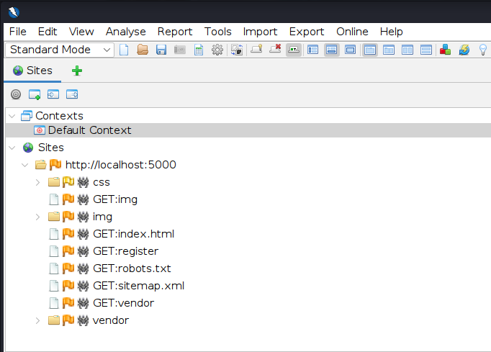

Discovered Endpoints:
- GET /index.html (Main application page)
- GET /register (User registration – accepts user input)
- GET /robots.txt (May expose hidden paths)
- GET /sitemap.xml (Lists application URLs)
- GET /vendor (Third-party libraries)
- GET /css/* (Static resources)
- GET /img/* (Static resources)

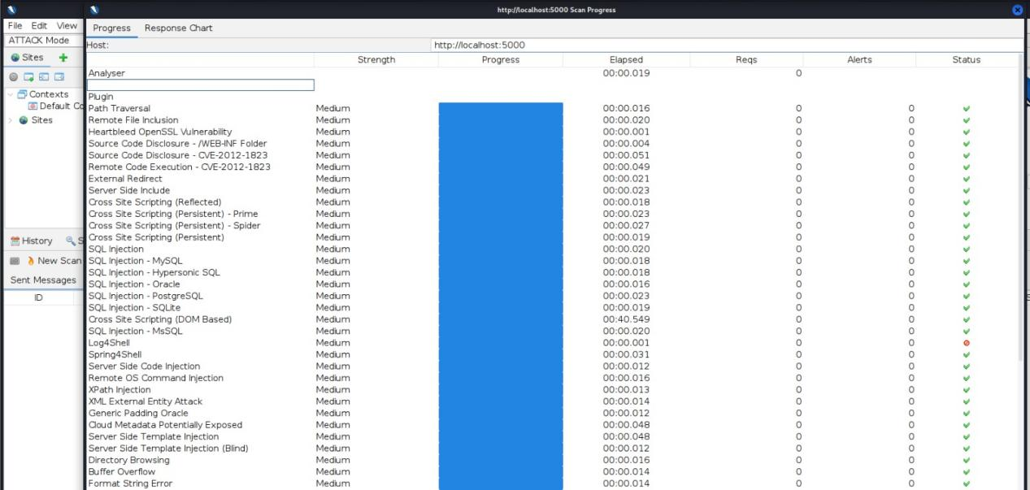
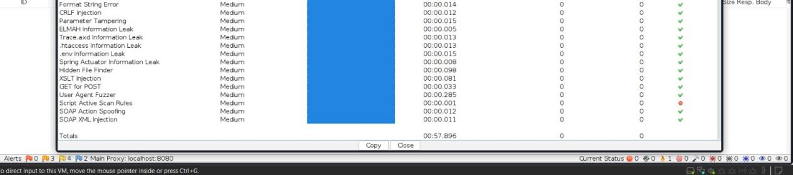

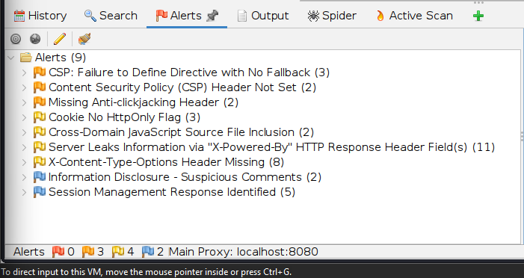

The OWASP ZAP scan indicates potential vulnerabilities mainly related to security misconfigurations (These include missing or weak HTTP security headers such as Content Security Policy (CSP), anti-clickjacking headers, and X-Content-Type-Options, which may expose the application to attacks like reflected XSS, clickjacking, insecure cookie access, and information disclosure)

A2. Manual Testing & PoCs:

SQLInjectoin
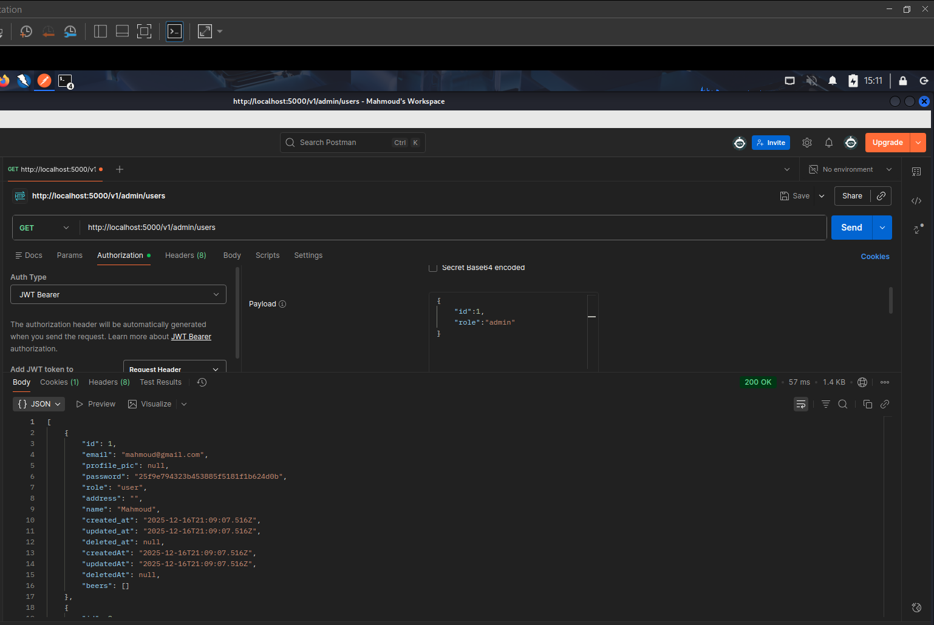
SQL Injection occurs when an application improperly handles user input in SQL queries, allowing attackers to manipulate the database. Exploitation can lead to unauthorized data access, data modification or deletion, and in some cases full system compromise.

XSS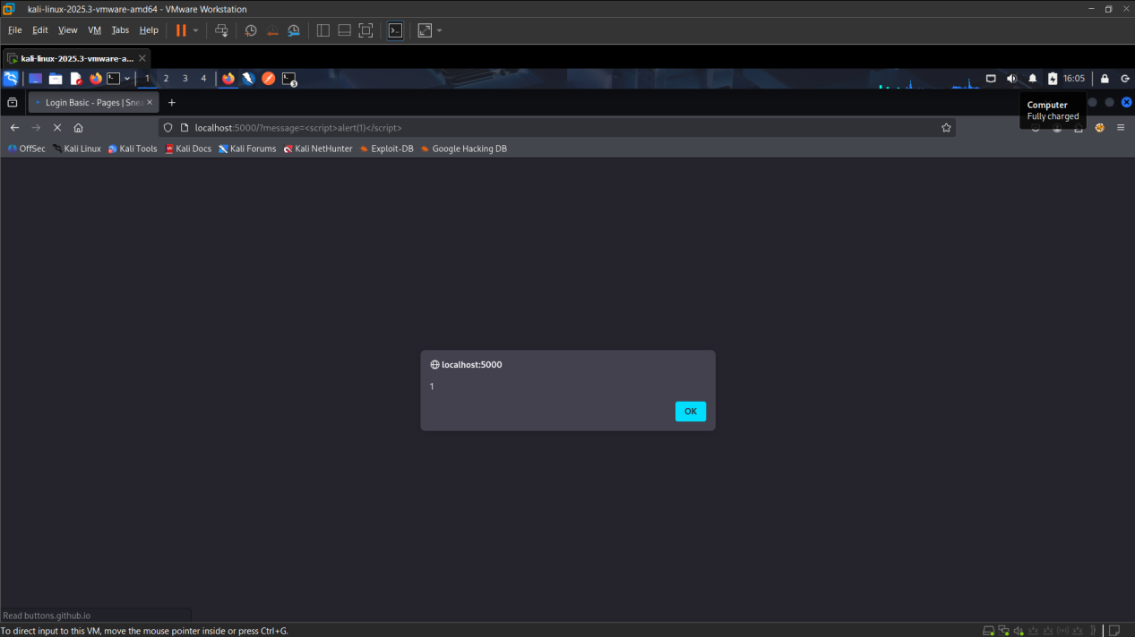

XSS occurs when an application improperly handles user-supplied input, allowing attackers to inject malicious scripts into web pages viewed by other users. This can lead to session hijacking, defacement, phishing attacks, or delivery of malware.

Broken auth / access control
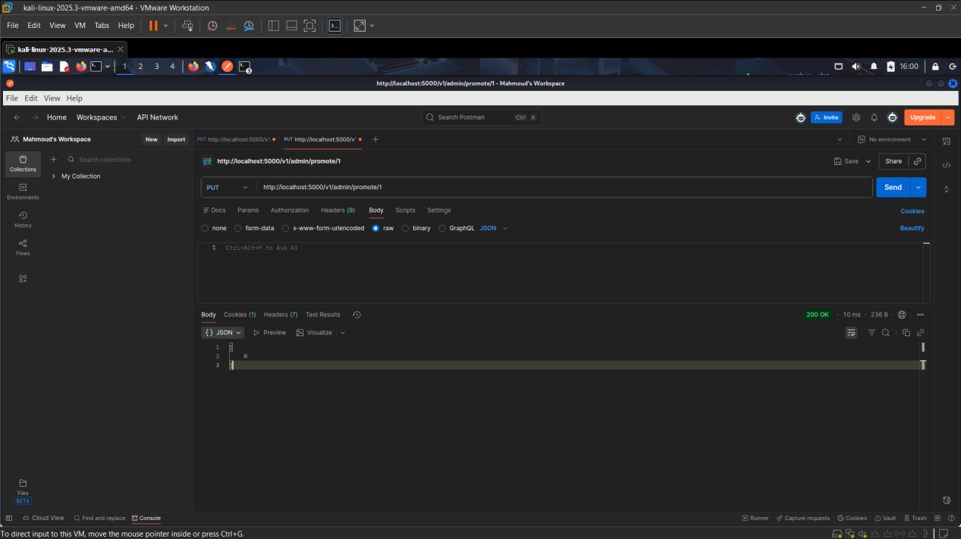

This vulnerability occurs when an application fails to properly enforce user authentication or authorization. Attackers can exploit it to bypass login mechanisms, access restricted resources, or perform actions beyond their privileges. Common issues include weak password policies, session management flaws, predictable tokens, and misconfigured access controls. Exploitation can lead to unauthorized data access, privilege escalation, and complete account takeover.

Insecure direct object references (idor)
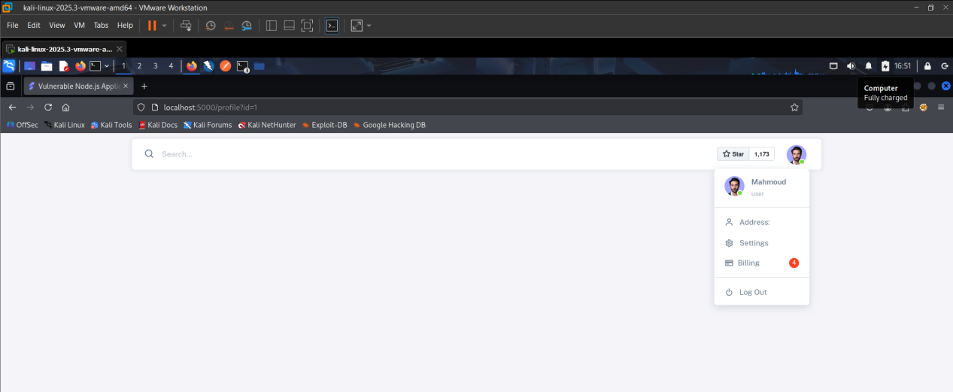

IDOR occurs when an application exposes internal objects (like files, database records, or user IDs) without proper access checks. Attackers can manipulate parameters to access data or perform actions they shouldn’t be allowed to, such as viewing other users’ accounts or modifying records. This can lead to data leakage, unauthorized modifications, or account compromise.

Insecure JWT handling (jwt)

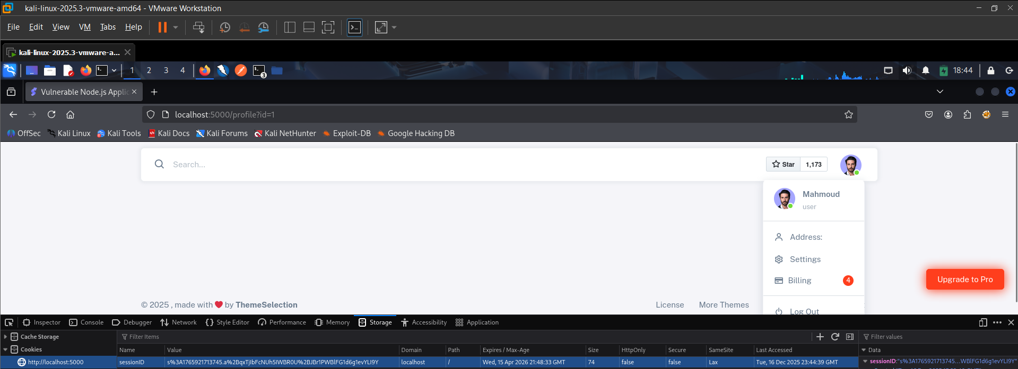
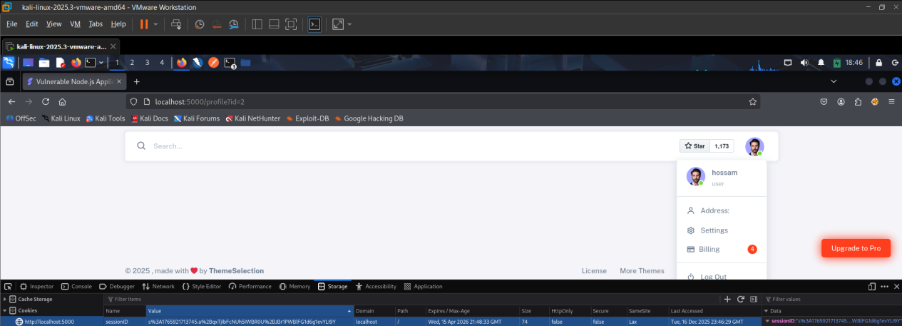

This vulnerability arises when JSON Web Tokens (JWTs) are poorly implemented or validated. Attackers can exploit weak signing algorithms, expired tokens, or improper verification to bypass authentication, escalate privileges, or impersonate users, potentially leading to unauthorized access.

Injection (SSTI)

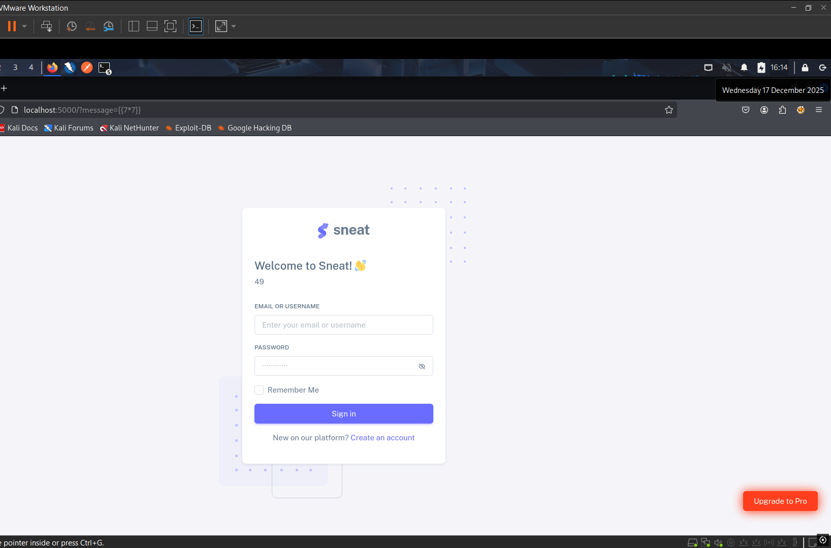
SSTI occurs when user input is improperly handled in server-side templates, allowing attackers to inject and execute arbitrary code on the server. Exploitation can lead to data exposure, remote code execution, or full server compromise.

Insecure Design
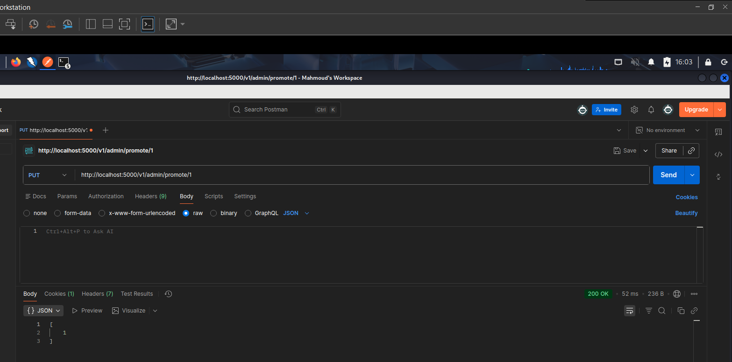
Insecure Design refers to flaws in the application’s architecture or logic that introduce security risks, even if the code is implemented correctly. These flaws can enable unauthorized access, data leaks, or bypass of security controls, making the system inherently vulnerable.

SERVER SIDE REQUES (SSRF)

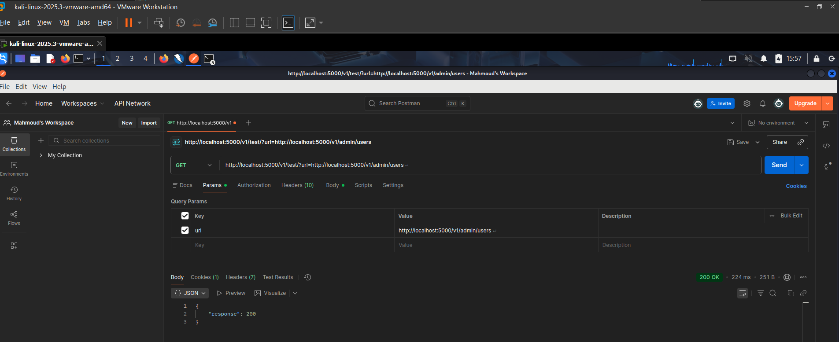
SSRF occurs when an application allows attackers to make arbitrary requests from the server. Exploitation can let attackers access internal systems, sensitive data, or internal APIs that are not publicly accessible, potentially leading to data theft or server compromise.

Security Misconfiguration

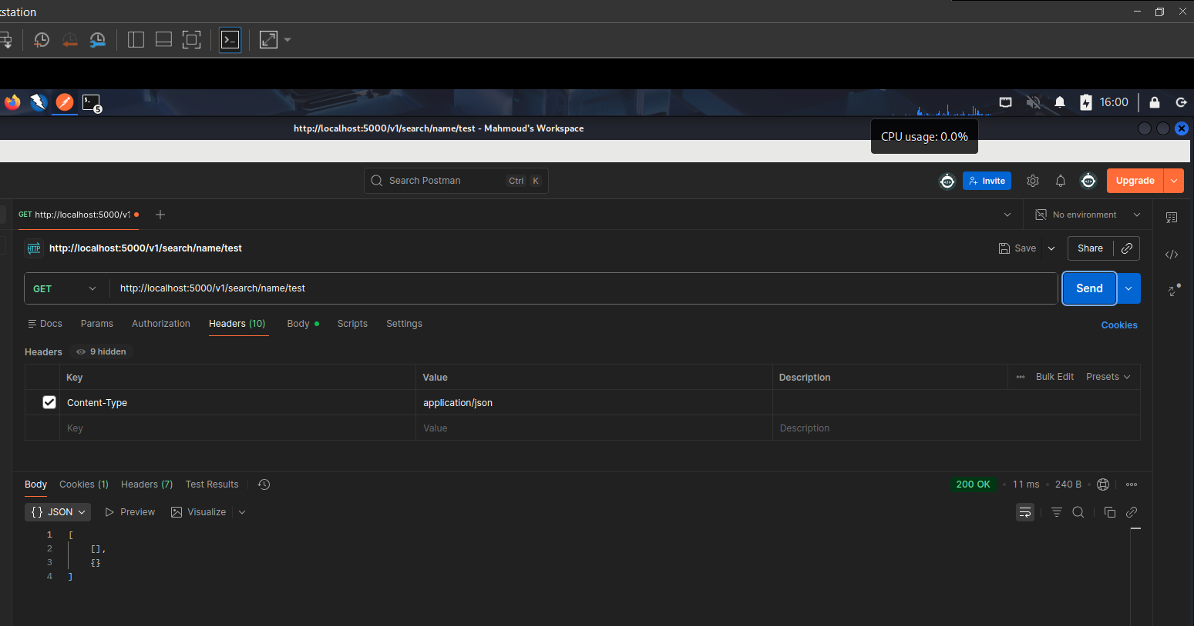

This vulnerability occurs when an application, server, or database is improperly configured, leaving it exposed to attacks. Examples include default credentials, unnecessary services, verbose error messages, or missing security headers. Exploitation can lead to information leakage, unauthorized access, or full system compromise.

A3
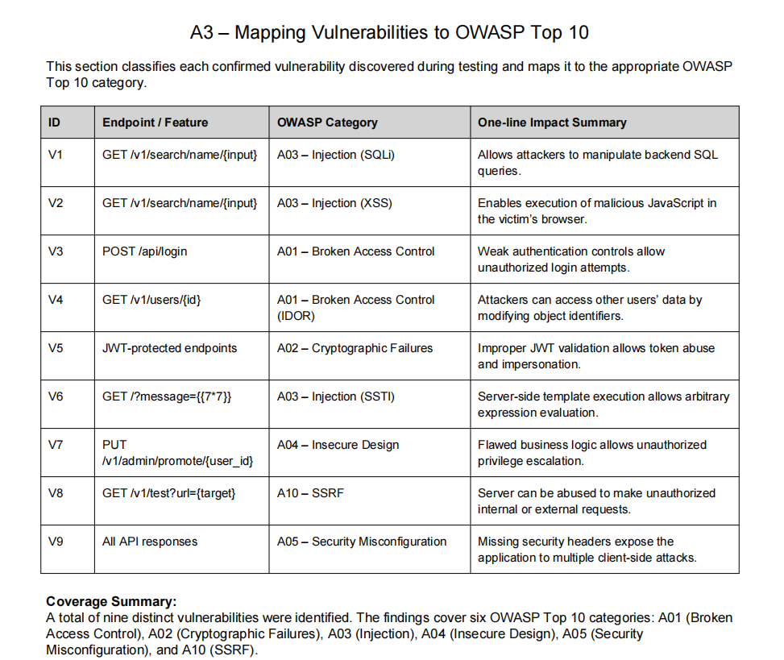

Phase B – Static Analysis with Semgrep (SAST)

B1 – Semgrep Static Analysis Summary

Semgrep was executed on the Node.js/Express application using the official JavaScript and Node.js rulesets.
The scan analyzed 23 JavaScript files and reported 16 security findings.
High-impact issues included:
- SQL Injection in Sequelize queries
- Server-Side Template Injection (SSTI) using Nunjucks
- Cross-Site Scripting (XSS) via direct response writing
- Open Redirect vulnerabilities
- Hardcoded secrets (JWT and session secrets)
Several of these findings directly correspond to vulnerabilities previously identified during DAST testing.
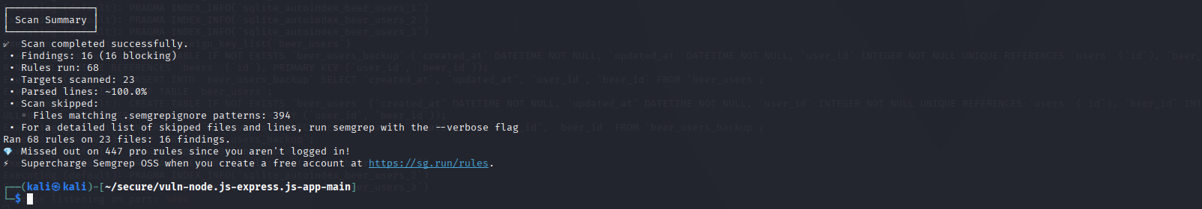

B2
Vuln ID | Endpoint / Feature | OWASP | File:Lines | Semgrep Rule
V1 | Frontend message rendering | A03: Injection | src/router/routes/frontend.js:17–40 | express-insecure-template-usage
V2 | Order file read | A01: Path Traversal | src/router/routes/order.js:33 | express-path-join-resolve-traversal
V2b | Order file read (Path Traversal) | A01: Path Traversal | src/router/routes/order.js:33 | semgrep-rules.js-path-traversal
V3 | Order SQL query | A03: Injection | src/router/routes/order.js:67 | sequelize-injection-express
V4 | System test response | A07: XSS | src/router/routes/system.js:18 | direct-response-write
V5 | Redirect endpoint | A10: Redirect | src/router/routes/system.js:37 | express-open-redirect
V6 | Object deserialization | A08: Software & Data Integrity | src/router/routes/system.js:64 | third-party-object-deserialization
V7 | JWT verification | A02: Cryptographic Failures | src/router/routes/user.js:18 | hardcoded-jwt-secret
V8 | Session configuration | A02: Cryptographic Failures | src/server.js:43–57 | express-session-hardcoded-secret

B3 –
1st rule Output
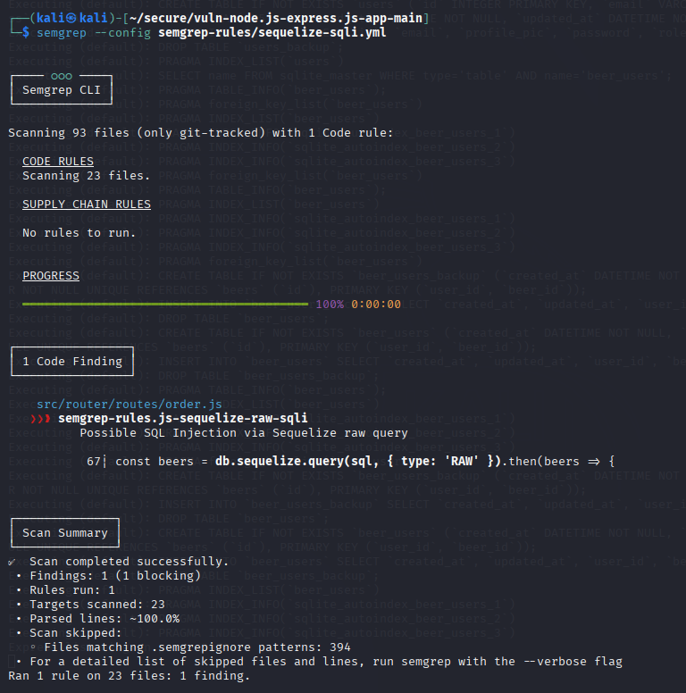

Rule 2 Output
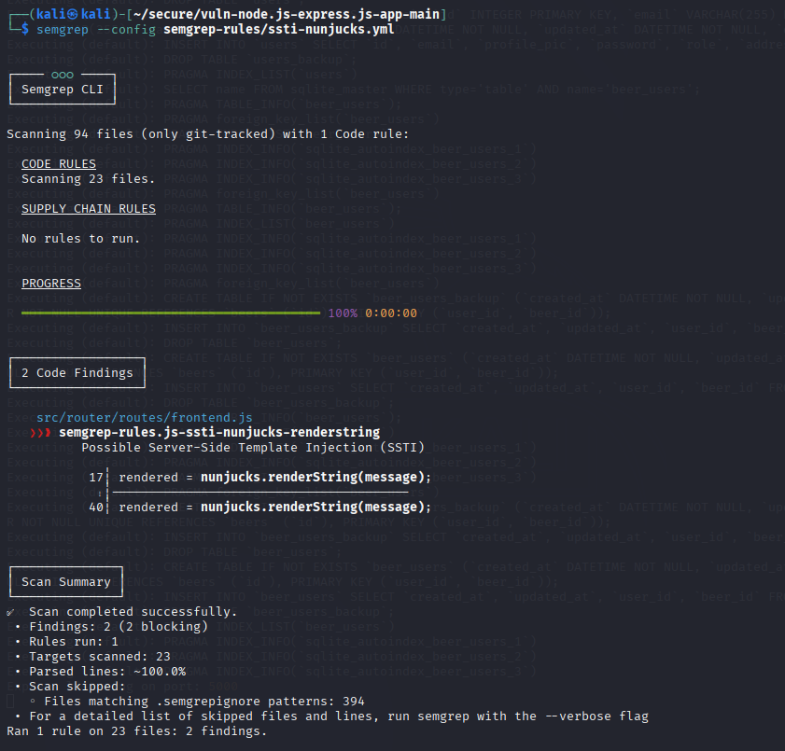

Rule 3 Output 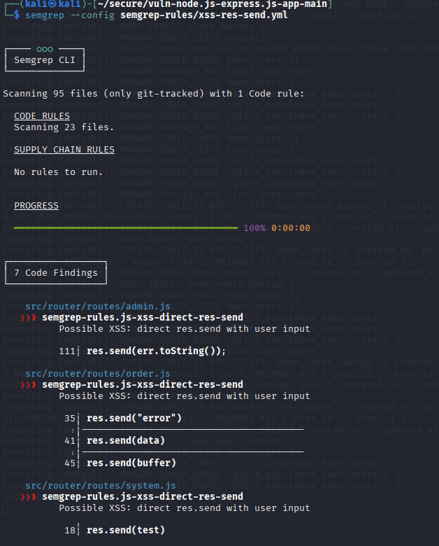

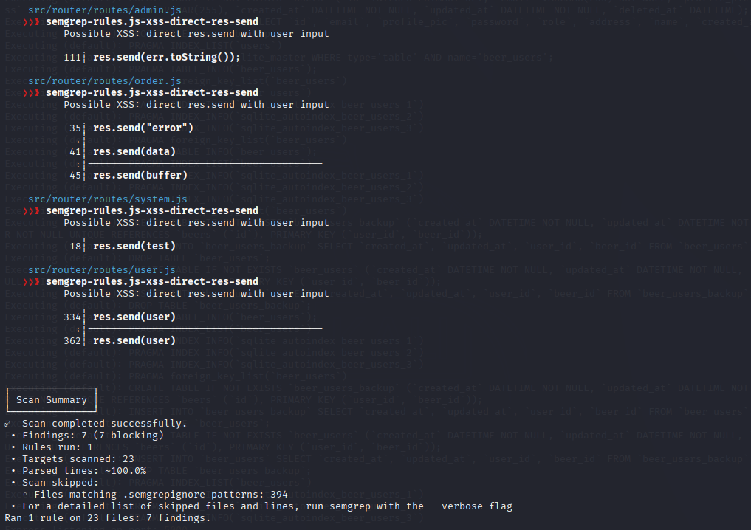

Rule 4 Output

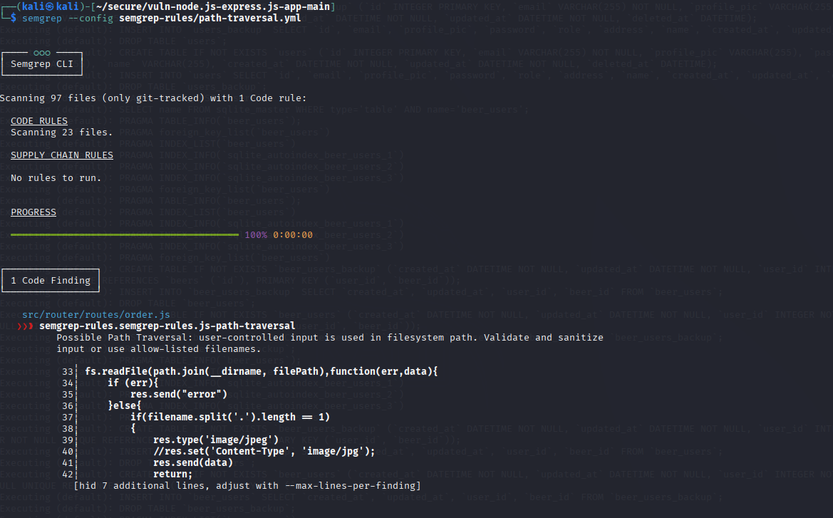
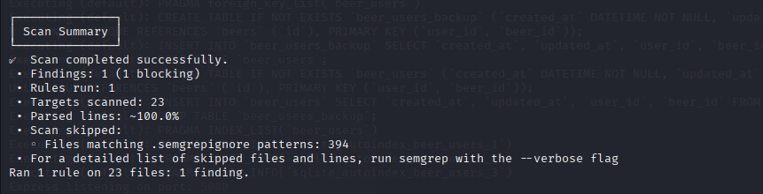

Rule 5 Output
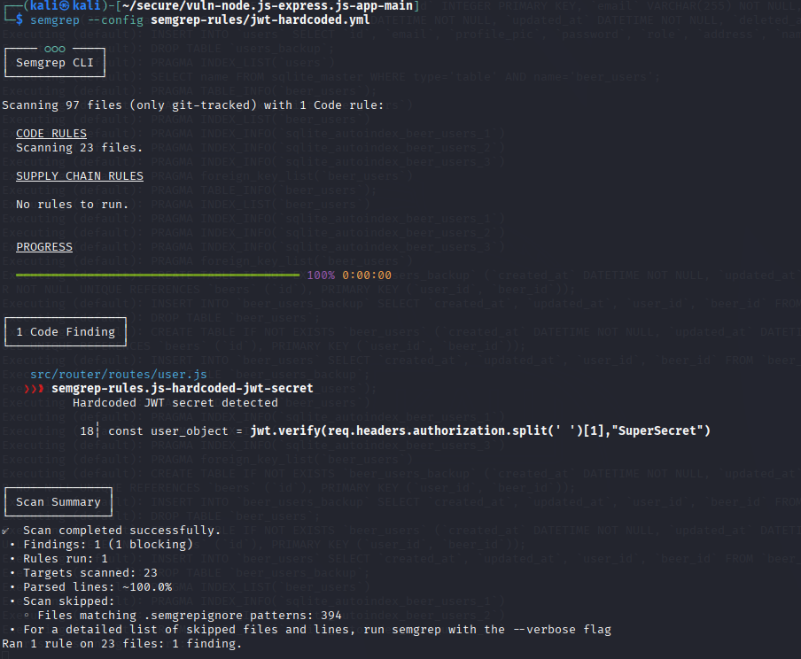

All the rules together
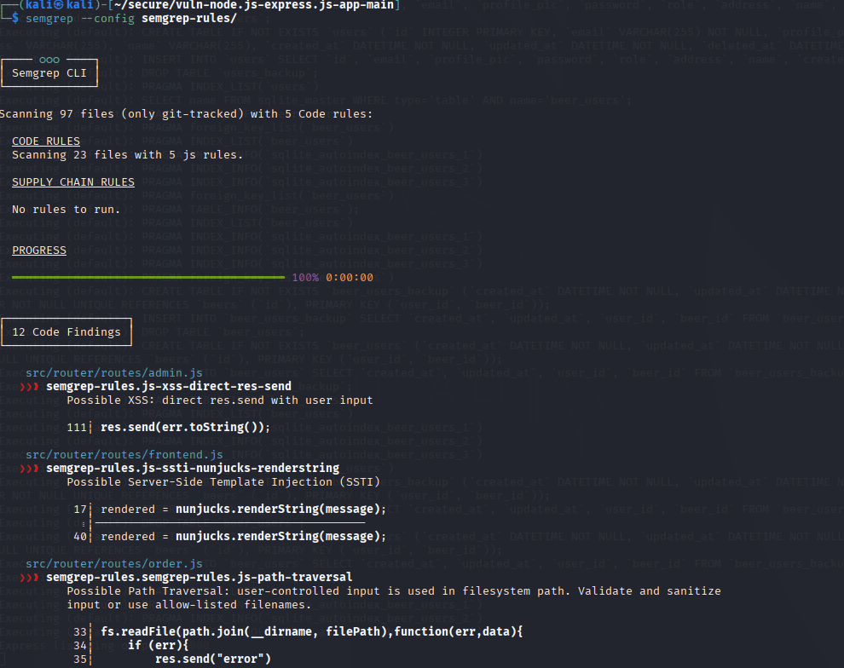
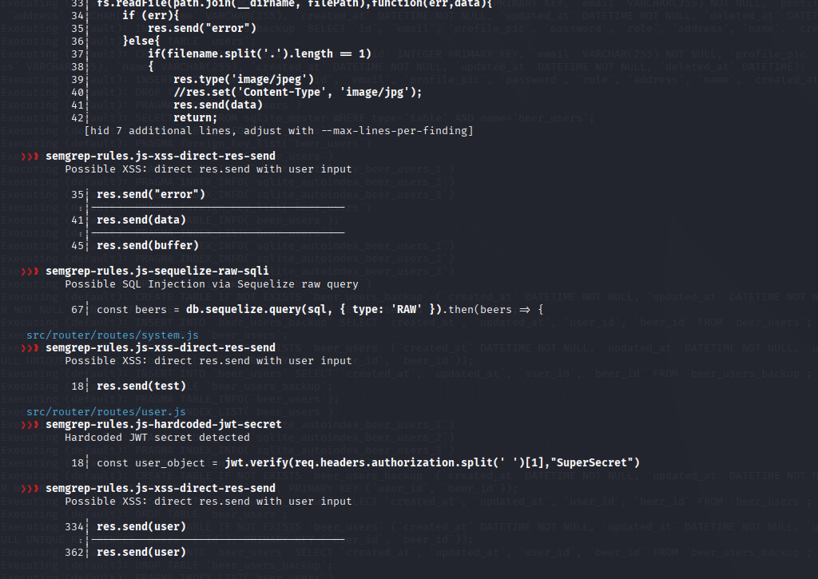
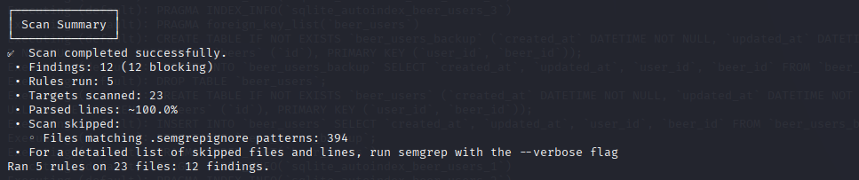

Phase c

