1. Project Overview
KubeQuest is a production-grade DevOps initiative focused on deploying a secure, scalable, and observable 3-tier application. The project implements a "Shift-Left" security approach, ensuring code is scanned for quality and vulnerabilities before ever reaching the cluster.

2. Technical Stack & Tools
Layer | Technology | Tool Icon/Role
Frontend | HTML5 , CSS3 | Web Interface & Client Logic
Backend | Python (Flask) | RESTful API & Business Logic
Database | PostgreSQL | Persistent Data Storage
CI/CD Engine | GitHub Actions | Automated Workflow Orchestration
Static Analysis | SonarQube | Code Quality & Syntax Security Gates
Security | Trivy | Filesystem & Container Image Scanning
Containerization | Docker | Multi-stage, non-root builds
Orchestration | Amazon EKS | Managed Kubernetes Cluster
Deployment | Helm & Argo CD | GitOps-based CD and Package Management
Monitoring | Grafana & Prometheus | Real-time Metrics & Dashboards

🏗️ Amazon EKS System Architecture
The application is deployed across three distinct logical layers within a dedicated Namespace to ensure isolation and resource management.

1. Presentation Tier (Frontend)
- Technology: HTML5 / CSS .
- Deployment: Managed as a Kubernetes Deployment.
- Connectivity: Exposed via a LoadBalancer or Ingress Controller to handle external user traffic.
- Scaling: Integrated with Horizontal Pod Autoscaler (HPA) to scale based on CPU/Memory usage.

2. Application Tier (Backend)
- Technology: Python (Flask).
- Deployment: Managed as a Kubernetes Deployment.
- Service: Exposed internally via a ClusterIP Service. The Frontend communicates with the Backend using the internal DNS name
- Security: Runs as a non-root user to minimize the blast radius of potential exploits.

3. Data Tier (Database)
- Technology: PostgreSQL.
- Deployment: Managed as a StatefulSet to ensure stable network identifiers and ordered deployment.
- Storage: Uses Persistent Volume Claims (PVC) linked to AWS EBS (Elastic Block Store) to ensure data persists even if pods are restarted.
- Connectivity: Strictly internal; only the Backend tier can initiate a connection to the DB.

3.1 digrama for Architecture

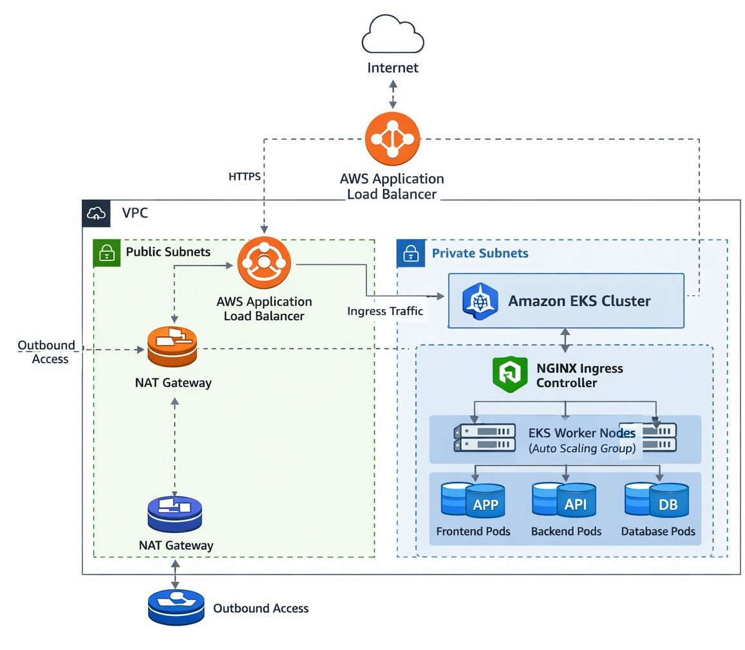

🛡️ Governance & Security Policies

To meet the "Hardening" requirements of Week 4, we implement strict Kubernetes-native security:

Network Policies (L3/L4 Security)
We implement a "Default Deny" posture and specifically allow:
- Ingress → Frontend: Allow traffic on port 80/443.
- Frontend → Backend: Allow traffic on the Flask API port.
- Backend → Database: Allow traffic on port 5432.
- Isolation: The Database has no direct access to or from the internet.

RBAC (Identity & Access)
- ServiceAccounts: Each tier (Frontend/Backend) has its own ServiceAccount with the minimum permissions required to function.
- Roles & Bindings: Restricted access for developers; only the CD (ArgoCD) has the authority to modify production resources.

Resource Governance
- ResourceQuotas: Limits the total CPU and Memory the KubeQuest namespace can consume on EKS.
- LimitRanges: Ensures every container has a minimum and maximum request/limit defined to prevent "noisy neighbor" issues.

4. The DevOps Pipeline (CI/CD)

Phase A: Continuous Integration (CI)
- Syntax & Quality: GitHub Actions triggers SonarQube to analyze the html and Python code for bugs and security "hotspots."

- Security Scan (Pre-Build): Trivy scans the source code repository for leaked secrets.

- Containerization: Docker builds the image.

- Security Scan (Post-Build): Trivy scans the final Docker image. If CRITICAL vulnerabilities are found, the build fails.
- Registry: Clean images are pushed to Docker Hub.

Phase B: Continuous Deployment (CD)
- Helm Chart Update: The pipeline updates the Helm chart with the new image version.
- GitOps Sync: ArgoCD detects the change in the GitHub repo and synchronizes the Amazon EKS cluster state.
- Promotion: Automated deployment to dev, followed by manual approval for prod.

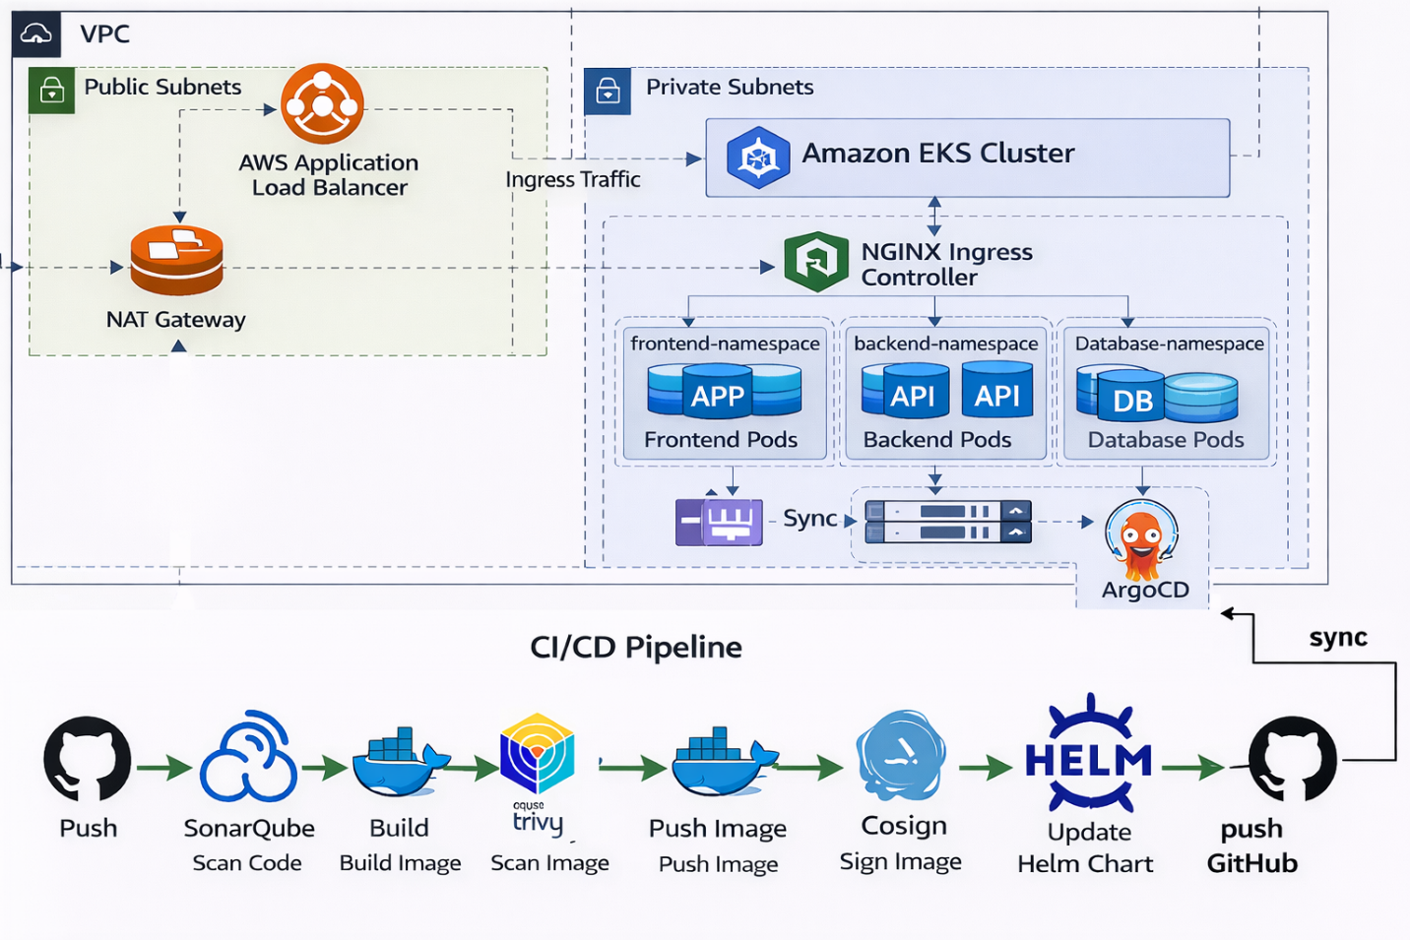

5. Repository Structure

med-project/
├── Project/ # Application source code and configurations
│ ├── backend/ # Python Flask REST API service
│ │ ├── app.py # Main Flask application
│ │ ├── Dockerfile # Container image for backend service
│ │ ├── requirements.txt # Python dependencies
│ │ ├── test_app.py # Unit tests
│ │ ├── QUALITY_REPORT.md # Code quality metrics
│ │ └── SECURITY_REPORT.md # Security assessment report
│ ├── frontend/ # Python web frontend application
│ │ ├── index.html # Web interface
│ │ ├── default.conf # Nginx configuration
│ │ ├── Dockerfile # Container image for frontend service
│ │ ├── QUALITY_REPORT.md # Code quality metrics
│ │ └── SECURITY_REPORT.md # Security assessment report
│ ├── k8s/ # Native Kubernetes manifests
│ │ ├── backend/ # Backend service and configs
│ │ ├── frontend/ # Frontend service and ingress
│ │ ├── db/ # Database (PostgreSQL & Redis)
│ │ └── network-policies/ # Network security policies
│ ├── helm/ # Helm umbrella chart for single release
│ │ └── devops-app/ # DevOps application chart
│ │ ├── Chart.yaml # Chart metadata
│ │ ├── values.yaml # Default configuration values
│ │ └── templates/ # Kubernetes resource templates
│ └── Deployment_Instructions.md # Detailed deployment guide
├── eks-terraform/ # AWS EKS infrastructure-as-code
│ ├── main.tf # Root Terraform configuration
│ ├── variables.tf # Input variable definitions
│ ├── outputs.tf # Output value definitions
│ ├── provider.tf # AWS provider configuration
│ ├── data.tf # Data source definitions
│ ├── terraform.tfvars # Terraform variable values
│ ├── eks/ # EKS cluster configuration
│ ├── vpc/ # VPC and networking resources
│ ├── ingress/ # Ingress controller setup
│ └── README.md # EKS deployment documentation
├── ARGOCD_SETUP.md # ArgoCD continuous deployment guide
└── README.md

6. Acceptance Criteria & Gates
- Code Gate: SonarQube Quality Gate must be "Passed."
- Security Gate: Zero "Critical" vulnerabilities in Trivy scan.
- Infrastructure Gate: HPA must successfully scale pods under load.
- Observability Gate: Grafana must show active metrics for all 3 tiers.

7. Monitoring & Reliability
We utilize the Prometheus-Stack:
- Prometheus: Scrapes metrics from Flask and PostgreSQL.
- Loki: Centralized logging for the 3-tier application.
- Grafana: Visualizes the health of the EKS cluster and application performance

