Cairo University  
Faculty of Computers and Information



**CS251**

**Software Engineering I**

# Phase – 3

# Team

|  |  |
| --- | --- |
| **ID** | **Name** |
| 20130166 | Amr ashraf abd el motelb |
| 20140248 | Mahmoud samir |

# 

# Document Purpose and Audience

* **This document shows the class diagram and sequence diagram , to know more about classes and how it work**
* **Audience ( dr , TA’s , project manager , customer )**

# 

**https://github.com/mahmoudsam45**

# System Models

## I. Class diagrams

## II. Sequence diagrams

### 

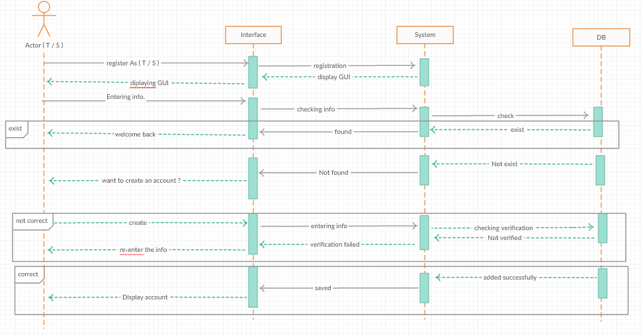

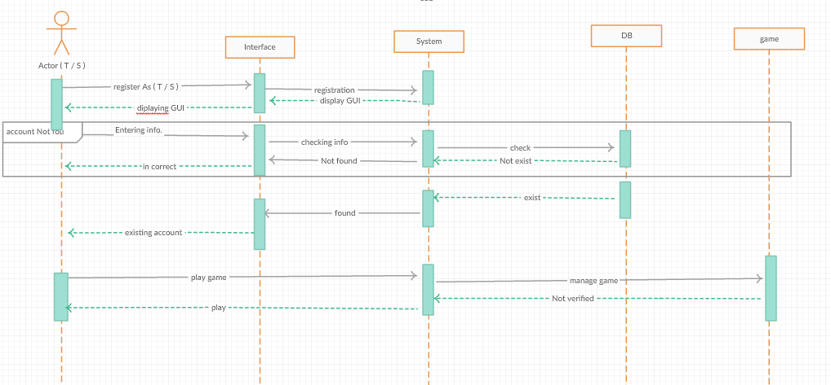

### Class - Sequence Usage Table

| **Class Name** | **Sequence Diagrams** | **Overall used methods** |
| --- | --- | --- |
|  |  |  |
|  |  |  |
|  |  |  |

* Ownership Report

|  |  |
| --- | --- |
| **Item** | **Owners** |
| Sequence diagram | *Amr Ashraf* |
| Class diagram | *Mohamed samir* |