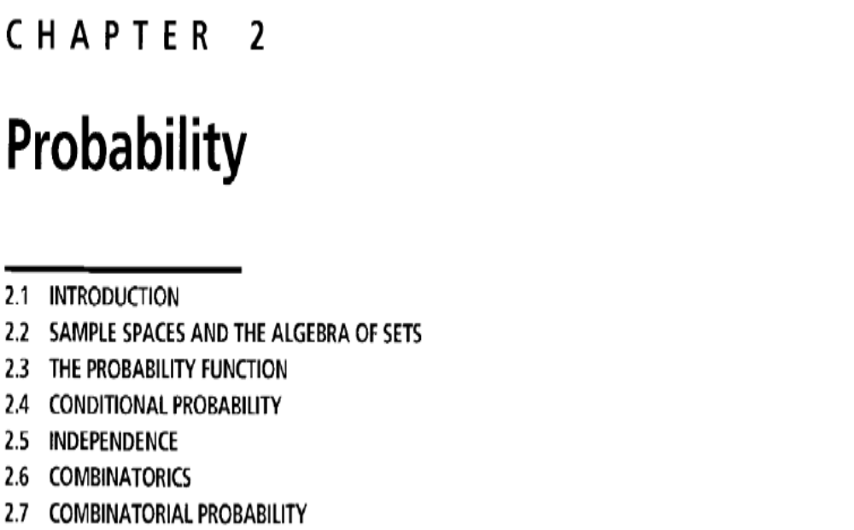

Definition 1 (A random experiment)
A random experiment is aprocedure that can be repeated theoretically an infinite number of times and has a well defined set of possible outcomes.

Definition 2 (Sample space)
The set of all possible outcomes of a random experiment is called a sample space and it is denoted by 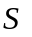.

Definition 3 (Sample point)
An outcome of a random experiment is a point in the sample space and it is called a sample point. It is denoted by , (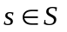).

Definition 4 (Event)
An event is any subset of a sample space and it is denoted by capital letters such as 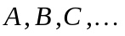

Note:
- The null set and the entire sample space are events.
- An event occurs if the outcome of the random experiment is one of the members of the event.

