Cairo University  
Faculty of Computers and Information



**CS251**

**Software Engineering 2**

BeHealthy

Software Requirements Specifications

Donia Khaled

Safwa Salman

Mahmoud Samy

Hager Sobeah

Fall-2016

Contents

Team 3

Document Purpose and Audience 3

Introduction 3

Software Purpose 3

Software Scope 3

Definitions, acronyms, and abbreviations 3

Requirements 4

Functional Requirements 4

Non Functional Requirements 4

System Models 4

Use Case Model 4

Use Case Tables 5

Ownership Report 6

# 

# Team

|  |  |  |  |
| --- | --- | --- | --- |
| **ID** | **Name** | **Email** | **Mobile** |
| 20146011 | Mahmoud Samy | mahmoudsamy995@gmail.com | 01097690138 |
| 20146013 | Hager Sobeah | hagersobeah@gmail.com | 01202590820 |
| 20146018 | Donia Khaled | doniaakhaled@gmail.com | 01001366636 |
| 20146009 | Safwa Mohammed |  |  |

# Document Purpose and Audience

* **Software Requirements Specification is a Formal document that describes the functionality of the software using the use cases model and table.**
* **Expected Audience : Product Owner - Customer**

# Introduction

# Software Purpose

**Being healthier doesn’t have to mean overhauling your entire lifestyle. Sometimes all it takes is a few simple changes. “BE Healthy” will show you how these changes can be done.**

# Software Scope

* **Keeps a log of your health information**
* **Reminds you of your next checkup, to drink water and to take your pills**
* **Calculates total day calories**
* **Provides everyday health tip**

# Definitions, acronyms, and abbreviations

* **None**

# Requirements

# Functional Requirements

* **The user first creates an account to login.**
* **Adds information to their health card.**
* **Adds pills, if any.**
* **Adds/searches for food items throughout the day.**
* **Adds cups of water drunk.**
* **Views and calculates number of calories consumed per day.**
* **System notifies user to drink water.**
* **System notifies user to take pill and go to the doctor.**

# Non Functional Requirements

1. **Documentation: to be as a guide for users.**
2. **Compatibility: Compatible with android and web platforms.**
3. **Response Time: at most 5 seconds for each request.**
4. **Security: proves security to personal information.**
5. **Reliability: software's ability to function, given environmental conditions, for a particular amount of time**
6. **Usability: startup a use guide will load to go through the whole system and how it could be used**
7. **Performance**

* **Adding an item to the database is done in at most 3 seconds.**
* **Searching an item in the database takes at most 5 seconds.**
* **Notifications are sent constantly, and at exact given times.**

# System Models

## Use Case Model

## 

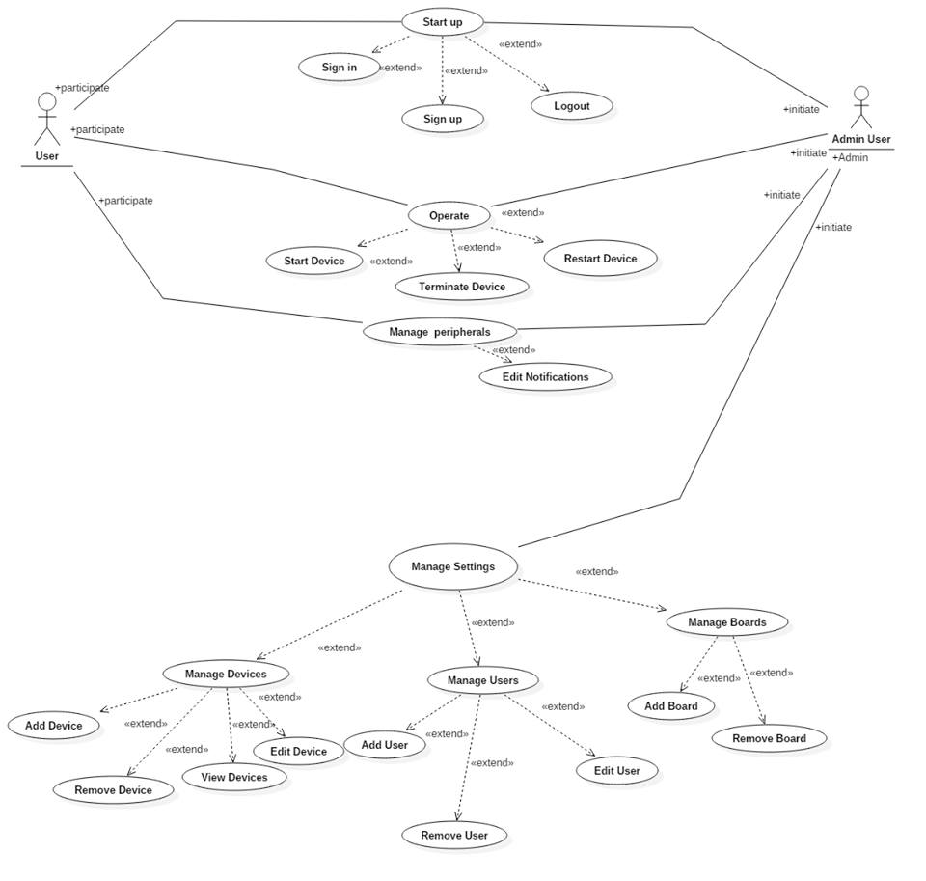

## Use Case Tables

|  |  |  |
| --- | --- | --- |
| Use Case ID: | 1 | |
| Use Case Name: | Sign in | |
| Actors: | User | |
| Pre-conditions: | User starts App | |
| Post-conditions: | User Sign in the app successfully | |
| Flow of events: | **User Action** | **System Action** |
| 1- User Enter Username and Password. |  |
|  | 2- System checks database |
| 3- User sign in successfully |  |
| Exceptions: | **User Action** | **System Action** |
| 1- User Enter Username and Password. |  |
|  | 2- e-mail or password is incorrect.  3- System rejects entry.  4-Asks user to enter data again. |
| Includes: |  | |
| Notes and Issues: |  | |

|  |  |  |
| --- | --- | --- |
| Use Case ID: | 2 | |
| Use Case Name: | Sign up | |
| Actors: | User | |
| Pre-conditions: | User starts App | |
| Post-conditions: | User Sign up to the app successfully | |
| Flow of events: | **User Action** | **System Action** |
| 1- User Enter e-mail and Password and other details. |  |
|  | 2- System verifies data. |
| 3- User sign up successfully |  |
| Exceptions: | **User Action** | **System Action** |
| 1- User Enter e-mail and Password and other details. |  |
|  | 2- System checks database.  3- System rejects entry.  4-Asks User to enter data again. |
| Includes: |  | |
| Notes and Issues: |  | |

|  |  |  |
| --- | --- | --- |
| Use Case ID: | 3 | |
| Use Case Name: | Sign Out | |
| Actors: | User | |
| Pre-conditions: | User is signed in | |
| Post-conditions: | User logout from the app successfully | |
| Flow of events: | **User Action** | **System Action** |
| 1- User presses logout button. |  |
|  | 2- System allow the user to logout and save a backup for his data. |
| Exceptions: | **User Action** | **System Action** |
| 1- User presses logout button. |  |
|  | 2- System fails to save a backup. |
| Includes: | NULL | |
| Notes and Issues: | NULL | |

|  |  |  |
| --- | --- | --- |
| Use Case ID: | 4 | |
| Use Case Name: | Add Device | |
| Actors: | Admin User | |
| Pre-conditions: | Admin User press manage devices button. | |
| Post-conditions: | Admin User add a device successfully. | |
| Flow of events: | **User Action** | **System Action** |
| 1- User Press Add button. |  |
|  | 2- System starts searching for the device. |
| 3- Admin User confirm that the addition of the device. |  |
|  |  | 4- SHCS connect the device onto the board |
| Exceptions: | **User Action** | **System Action** |
| 1- User chooses a device. |  |
|  | 2- System fails to connect the device. |
|  | 1- User search for an unsuitable device. |  |
|  |  | 2- System tries to connect the device but every time it fails. |
| Includes: | NULL | |
| Notes and Issues: | NULL | |

|  |  |  |
| --- | --- | --- |
| Use Case ID: | 5 | |
| Use Case Name: | Checkup Reminder | |
| Actors: | User | |
| Pre-conditions: | A checkup time is already assigned. | |
| Post-conditions: | A checkup notification is sent to the user. | |
| Flow of events: | **User Action** | **System Action** |
|  | System sends the checkup notification at the exact time that was already assigned |
| Exceptions: | **User Action** | **System Action** |
|  | 1-System sends a checkup notification |
| 2-no response from the user |  |
|  |  |
| Includes: | NULL | |
| Notes and Issues: | NULL | |

|  |  |  |
| --- | --- | --- |
| Use Case ID: | 6 | |
| Use Case Name: | Edit Device | |
| Actors: | Admin User | |
| Pre-conditions: | Admin User press manage devices button. | |
| Post-conditions: | Admin User edit a device successfully. | |
| Flow of events: | **User Action** | **System Action** |
| 1- Admin User Press Edit button. |  |
| 2- Admin User chooses a device to edit. |  |
| 3- Admin User edits the device. |  |
|  |  | 4- SHCS update the device details. |
| Exceptions: | **User Action** | **System Action** |
| 1- Admin User chooses a device. |  |
| 2- Admin User make an unsuitable change in details. |  |
|  |  | 3- System fails to update device details |
| Includes: | NULL | |
| Notes and Issues: | NULL | |

|  |  |  |
| --- | --- | --- |
| Use Case ID: | 7 | |
| Use Case Name: | View devices | |
| Actors: | Admin User / User | |
| Pre-conditions: | Admin User / User press view devices button. | |
| Post-conditions: | Admin User / Userviews all devices connected to SHCS on current board. | |
| Flow of events: | **User Action** | **System Action** |
| 1- User Press View devices button. |  |
|  | 2- System shows up all devices connected at the current time |
| Exceptions: | **User Action** | **System Action** |
| NULL |  |
| Includes: | NULL | |
| Notes and Issues: | NULL | |
| Use Case ID: | 8 | |
| Use Case Name: | Run device | |
| Actors: | Admin User / User | |
| Pre-conditions: | Admin User / User press Run device button. | |
| Post-conditions: | Admin User / User run a device successfully. | |
| Flow of events: | **User Action** | **System Action** |
| 1- User Press Run button. |  |
|  | 2- System starts to make the device run. |
| Exceptions: | **User Action** | **System Action** |
| 1- User Press Run. |  |
|  | 2- System fails to start up the device. |
| Includes: | NULL | |
| Notes and Issues: | NULL | |

|  |  |  |
| --- | --- | --- |
| Use Case ID: | 9 | |
| Use Case Name: | Terminate Device | |
| Actors: | Admin User / User | |
| Pre-conditions: | Admin User / User press terminate device button. | |
| Post-conditions: | Admin User terminates a device successfully. | |
| Flow of events: | **User Action** | **System Action** |
|  | NULL |  |
| Includes: | NULL | |
| Notes and Issues: | NULL | |

|  |  |  |
| --- | --- | --- |
| Use Case ID: | 10 | |
| Use Case Name: | Redo Device | |
| Actors: | Admin User / User | |
| Pre-conditions: | Admin User press Redo device button. | |
| Post-conditions: | Admin User restart a device successfully. | |
| Flow of events: | **User Action** | **System Action** |
| 1- User Press Redo button. |  |
|  | 2- System restart the device. |
| Exceptions: | **User Action** | **System Action** |
|  | NULL |  |
| Includes: | NULL | |
| Notes and Issues: | NULL | |

|  |  |  |
| --- | --- | --- |
| Use Case ID: | 11 | |
| Use Case Name: | Create Board | |
| Actors: | Admin | |
| Pre-conditions: | Admin User press create board button. | |
| Post-conditions: | The board is created. | |
| Flow of events: | **User Action** | **System Action** |
| 1- User Press create board button. |  |
|  | 2- Application creates a new board. |
| Exceptions: | **User Action** | **System Action** |
|  | NULL |  |
| Includes: | NULL | |
| Notes and Issues: | NULL | |

|  |  |  |
| --- | --- | --- |
| Use Case ID: | 12 | |
| Use Case Name: | Remove board | |
| Actors: | Admin | |
| Pre-conditions: | Admin presses on remove board button. | |
| Post-conditions: | The Board Is removed. | |
| Flow of events: | **User Action** | **System Action** |
| 1- Admin presses on remove board button. |  |
|  | 2 –System removes the desired board . |
| Exceptions: | **User Action** | **System Action** |
|  | NULL |  |
| Includes: | NULL | |
| Notes and Issues: | NULL | |

|  |  |  |
| --- | --- | --- |
| Use Case ID: | 13 | |
| Use Case Name: | Edit User | |
| Actors: | Administrator | |
| Pre-conditions: | Administrator chooses a user to be edited. | |
| Post-conditions: | User Info is updated. | |
| Flow of events: | **User Action** | **System Action** |
| 1-Admin Press chooses a user account | 3 – System displays User info |
| 2 – Admin clicks on edit user button  4 – Admin edits the user info | 5 – System displays successful editing notification |
| Exceptions: | **User Action** | **System Action** |
|  | NULL |  |
| Includes: | NULL | |
| Notes and Issues: | NULL | |

|  |  |  |
| --- | --- | --- |
| Use Case ID | 14 | |
| Use Case Name: | Enable Notification | |
| Actors: | Admin-User/Home-User | |
| Pre-conditions: | User clicks on Edit Notifications | |
| Post-conditions: | User successfully enabled the desire notification.  User returns to home page. | |
| Flow of events: | **User Action** | **System Action** |
| 1-User launches application |  |
|  | 2- System displays home page to user |
| 3- User clicks on Settings |  |
| 4- User clicks on Edit Notifications |  |
|  | 5-System displays the connected devices. |
| 6-User chooses the desired device and enables the notification button. |  |
|  |  | 7-System notifies the user that notifications have been enabled to the selected device. |
| Exceptions: | **User Action** | **System Action** |
|  |  |
|  | NULL |  |
| Includes: | NULL | |
| Notes and Issues: | NULL | |

|  |  |  |
| --- | --- | --- |
| Use Case ID | 15 | |
| Use Case Name: | Disable Notification | |
| Actors: | Admin-User/Home-User | |
| Pre-conditions: | User clicks on View Settings | |
| Post-conditions: | User clicked on Edit Notifications  User returns to home page. | |
| Flow of events: | **User Action** | **System Action** |
| 1-User launches application |  |
|  | 2- System displays home page to user |
| 3-User clicks on settings. |  |
| 4- User clicks on Edit Notifications |  |
|  | 5-System displays the connected devices. |
| 6-User chooses the desired device and disables the notification button. |  |
|  |  | 7- System notifies the user that notifications have been disabled to the selected device. |
| Exceptions: | **User Action** | **System Action** |
| NULL |  |
|  | NULL |  |
| Includes: | NULL | |
| Notes and Issues: | NULL | |

|  |  |  |
| --- | --- | --- |
| Use Case ID: | 16 | |
| Use Case Name: | Add User | |
| Actors: | Admin User | |
| Pre-conditions: | Admin user clicks Edit Users | |
| Post-conditions: | Admin user successfully added a new user.  Admin user returns to home page. | |
| Flow of events: | **User Action** | **System Action** |
| 1- User launches the application. |  |
|  | 2- System displays the home page to the user. |
| 3- User clicks on settings and then Edit Users option and chooses to add a user. |  |
|  | System displays the search box and waits for user to enter the email connected with the other user he wants to add. |
| 5- User enters the desired email address. |  |
|  | 6- System searches for the entered email address and displays the user if found. |
|  | 7-User chooses to add the user to his home board. |  |
|  |  | 8- System notifies the admin user that a new user was successfully added. |
| Exceptions: | **User Action** | **System Action** |
| 1-User enters an email address that is not found or invalid. |  |
|  | 2- System displays an error message. |
|  |  | 3- System asks the user to enter a valid username. |
| Includes: | NULL | |
| Notes and Issues: | NULL | |

|  |  |  |
| --- | --- | --- |
| Use Case ID: | 17 | |
| Use Case Name: | Remove User | |
| Actors: | Admin User | |
| Pre-conditions: | User clicks on Edit Users | |
| Post-conditions: | Admin user successfully removed a user.  Admin user returns to the home page. | |
| Flow of events: | **User Action** | **System Action** |
| 1- User launches the application. |  |
|  | 2- System displays the home page to the user. |
| 3- User clicks on settings then on Edit Users option and chooses to remove a user. |  |
|  | 4- System displays connected users. |
| 5- User chooses the desired user to be removed. |  |
|  |  | 6-System removes the chosen user and notifies the admin user that a user was successfully removed. |
| Exceptions: | **User Action** | **System Action** |
| 1- User chooses to remove a user and there are no users connected to this board. |  |
|  | 2- System displays that there are no users connected. |
| Includes: | NULL | |
| Notes and Issues: | NULL | |

# Ownership Report

* **Remove the following notes and any red notes**
* **For every item in this document, write the owners. If someone is owner of something, s/he understands it 100%**
* **Team leader must verify the table with the team members.**

|  |  |
| --- | --- |
| **Item** | **Owners** |
|  |  |
|  |  |