Cairo University  
Faculty of Computers and Information



**CS251**

**Software Engineering II**

BeHealthy

Software Requirements Specifications

Donia Khaled

Safwa Salman

Mahmoud Samy

Hager Sobeah

Fall-2016

Contents

Team 3

Document Purpose and Audience 3

Introduction 3

Software Purpose 3

Software Scope 3

Definitions, acronyms, and abbreviations 3

Requirements 4

Functional Requirements 4

Non Functional Requirements 4

System Models 4

Use Case Model 4

Use Case Tables 5

Ownership Report 6

# 

# Team

|  |  |  |  |
| --- | --- | --- | --- |
| **ID** | **Name** | **Email** | **Mobile** |
| 20146011 | Mahmoud Samy | mahmoudsamy995@gmail.com | 01097690138 |
| 20146013 | Hager Sobeah | hagersobeah@gmail.com | 01202590820 |
| 20146018 | Donia Khaled | doniaakhaled@gmail.com | 01001366636 |
| 20146009 | Safwa Mohammed |  |  |

# Document Purpose and Audience

* **Software Requirements Specification is a Formal document that describes the functionality of the software using the use cases model and table.**
* **Expected Audience : Product Owner – Customer hi**

# Introduction

# Software Purpose

**The Software Purpose is to provide the User with remote control on all home appliances through an application that allow to turn on / off any device on the board and view the status of each appliance to decide whether it works probably or it needs to be modified.**

# Software Scope

* **Control home appliances through sensors embedded in it**
* **Add Member or Device to the board**
* **Switch on/off appliances on the board**
* **Remove Member or Device from the board**
* **View Current Status of home appliances**
* **Cut the electic current from home circuits**
* **Automatically Switch on Fire extinguisher in case of fire**
* **SHCS Software will be available on Android Devices and as Web App**

# Definitions, acronyms, and abbreviations

* **None**

# Requirements

# Functional Requirements

* **The Admin user first create an account to login and add users and devices.**
* **Open / close a device through the board.**
* **Add / remove a new device to the board.**
* **Add / remove a new member to the board.**
* **Enable & Disable the electric current flowing in home appliances.**
* **Give Alarms or warning notifications in emergency cases such as fire or failure in some devices.**
* **View the board status and the status of each device.**
* **The user searches for compatible devices in the house and adds them to the Smart Board.**
* **The home page will show the status of each machine at the current time. By clicking on the name of each device another page opens up with all options that could be done at the current state.**
* **The device connection could be suspended without having to remove the device.**

# Non Functional Requirements

**1 – Scalibilty :**

* **response to many requests at a time.**
* **System handles smoothly up to 20 devices per board.**

**2 – Documentation : to be as a guide for users.**

**3 - Compatibility : Compatible with android and web platforms.**

**5 - Response Time : at most 5 seconds for each request.**

**6- Disaster Recovery : response to emergency cases without having the permission of the Adminstrator.**

**7 - Configuration Management : managed by administrator**

**8 - Security : providing Security for the board to not to be penetrated.**

**9 - Reliability : software's ability to function, given environmental conditions, for a particular amount of time**

**10 -Usibility :startup a use guide will load to go through the whole system and how it could be used**

**11 - Performance**

* **Turning On / Off device operation is done in atmost 5 seconds.**
* **Update the Status of the board is done in atmost 3 seconds.**
* **Response to emergency cases in atmost 1 second.**
* **Adding or removing Member / device Operation is done in atmost 3 seconds.**
* **Cutting electric current operation is done in atmost 1 second.**

# System Models

## Use Case Model

## 

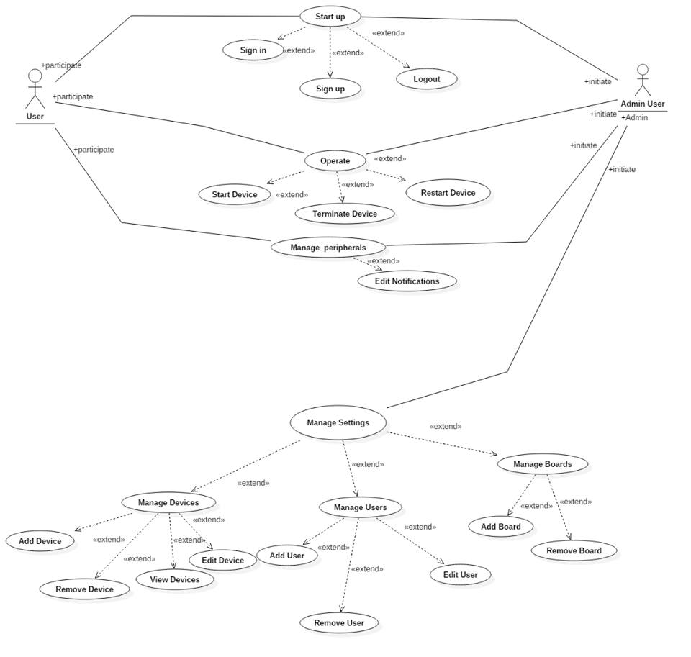

## Use Case Tables

|  |  |  |
| --- | --- | --- |
| Use Case ID: | 1 | |
| Use Case Name: | Sign in | |
| Actors: | Admin User/User | |
| Pre-conditions: | User starts App | |
| Post-conditions: | User Sign in the app successfully | |
| Flow of events: | **User Action** | **System Action** |
| 1- User Enter Card and Password. |  |
|  | 2- System check user data |
| 3- User sign in successfully |  |
| Exceptions: | **User Action** | **System Action** |
| 1- User Enter e-mail and Password. |  |
|  | 2- e-mail or password is incorrect.  3- System rejects entry. |
| Includes: |  | |
| Notes and Issues: |  | |

|  |  |  |
| --- | --- | --- |
| Use Case ID: | 2 | |
| Use Case Name: | Sign up | |
| Actors: | Admin User/User | |
| Pre-conditions: | User starts App | |
| Post-conditions: | User Sign up for the app successfully | |
| Flow of events: | **User Action** | **System Action** |
| 1- User Enter e-mail and Password and other details. |  |
|  | 2- System verify data. |
| 3- User sign up successfully |  |
| Exceptions: | **User Action** | **System Action** |
| 1- User Enter e-mail and Password and other details. |  |
|  | 2- System verify data.  3- System rejects entry. |
| Includes: |  | |
| Notes and Issues: |  | |

|  |  |  |
| --- | --- | --- |
| Use Case ID: | 3 | |
| Use Case Name: | Logout | |
| Actors: | Admin User/User | |
| Pre-conditions: | User starts App | |
| Post-conditions: | User logout from the app successfully | |
| Flow of events: | **User Action** | **System Action** |
| 1- User presses logout button. |  |
|  | 2- System allow the user to logout and save a backup for his data. |
| Exceptions: | **User Action** | **System Action** |
| 1- User presses logout button. |  |
|  | 2- System fails to save a backup. |
| Includes: | NULL | |
| Notes and Issues: | NULL | |

|  |  |  |
| --- | --- | --- |
| Use Case ID: | 4 | |
| Use Case Name: | Add Device | |
| Actors: | Admin User | |
| Pre-conditions: | Admin User press manage devices button. | |
| Post-conditions: | Admin User add a device successfully. | |
| Flow of events: | **User Action** | **System Action** |
| 1- User Press Add button. |  |
|  | 2- System starts searching for the device. |
| 3- Admin User confirm that the addition of the device. |  |
|  |  | 4- SHCS connect the device onto the board |
| Exceptions: | **User Action** | **System Action** |
| 1- User chooses a device. |  |
|  | 2- System fails to connect the device. |
|  | 1- User search for an unsuitable device. |  |
|  |  | 2- System tries to connect the device but every time it fails. |
| Includes: | NULL | |
| Notes and Issues: | NULL | |

|  |  |  |
| --- | --- | --- |
| Use Case ID: | 5 | |
| Use Case Name: | Remove Device | |
| Actors: | Admin User | |
| Pre-conditions: | Admin User press manage devices button. | |
| Post-conditions: | Admin User removes a device successfully. | |
| Flow of events: | **User Action** | **System Action** |
| 1- User Presses Remove Device button. |  |
| 2- User select needed device to be removed |  |
|  | 3- SHCS removes the device and saves data for this device for future usage. |
| Exceptions: | **User Action** | **System Action** |
| 1- User chooses a unavailable device. |  |
|  | 2- System fails to remove the device. |
| Includes: | NULL | |
| Notes and Issues: | NULL | |

|  |  |  |
| --- | --- | --- |
| Use Case ID: | 6 | |
| Use Case Name: | Edit Device | |
| Actors: | Admin User | |
| Pre-conditions: | Admin User press manage devices button. | |
| Post-conditions: | Admin User edit a device successfully. | |
| Flow of events: | **User Action** | **System Action** |
| 1- Admin User Press Edit button. |  |
| 2- Admin User chooses a device to edit. |  |
| 3- Admin User edits the device. |  |
|  |  | 4- SHCS update the device details. |
| Exceptions: | **User Action** | **System Action** |
| 1- Admin User chooses a device. |  |
| 2- Admin User make an unsuitable change in details. |  |
|  |  | 3- System fails to update device details |
| Includes: | NULL | |
| Notes and Issues: | NULL | |

|  |  |  |
| --- | --- | --- |
| Use Case ID: | 7 | |
| Use Case Name: | View devices | |
| Actors: | Admin User / User | |
| Pre-conditions: | Admin User / User press view devices button. | |
| Post-conditions: | Admin User / Userviews all devices connected to SHCS on current board. | |
| Flow of events: | **User Action** | **System Action** |
| 1- User Press View devices button. |  |
|  | 2- System shows up all devices connected at the current time |
| Exceptions: | **User Action** | **System Action** |
| NULL |  |
| Includes: | NULL | |
| Notes and Issues: | NULL | |
| Use Case ID: | 8 | |
| Use Case Name: | Run device | |
| Actors: | Admin User / User | |
| Pre-conditions: | Admin User / User press Run device button. | |
| Post-conditions: | Admin User / User run a device successfully. | |
| Flow of events: | **User Action** | **System Action** |
| 1- User Press Run button. |  |
|  | 2- System starts to make the device run. |
| Exceptions: | **User Action** | **System Action** |
| 1- User Press Run. |  |
|  | 2- System fails to start up the device. |
| Includes: | NULL | |
| Notes and Issues: | NULL | |

|  |  |  |
| --- | --- | --- |
| Use Case ID: | 9 | |
| Use Case Name: | Terminate Device | |
| Actors: | Admin User / User | |
| Pre-conditions: | Admin User / User press terminate device button. | |
| Post-conditions: | Admin User terminates a device successfully. | |
| Flow of events: | **User Action** | **System Action** |
|  | NULL |  |
| Includes: | NULL | |
| Notes and Issues: | NULL | |

|  |  |  |
| --- | --- | --- |
| Use Case ID: | 10 | |
| Use Case Name: | Redo Device | |
| Actors: | Admin User / User | |
| Pre-conditions: | Admin User press Redo device button. | |
| Post-conditions: | Admin User restart a device successfully. | |
| Flow of events: | **User Action** | **System Action** |
| 1- User Press Redo button. |  |
|  | 2- System restart the device. |
| Exceptions: | **User Action** | **System Action** |
|  | NULL |  |
| Includes: | NULL | |
| Notes and Issues: | NULL | |

|  |  |  |
| --- | --- | --- |
| Use Case ID: | 11 | |
| Use Case Name: | Create Board | |
| Actors: | Admin | |
| Pre-conditions: | Admin User press create board button. | |
| Post-conditions: | The board is created. | |
| Flow of events: | **User Action** | **System Action** |
| 1- User Press create board button. |  |
|  | 2- Application creates a new board. |
| Exceptions: | **User Action** | **System Action** |
|  | NULL |  |
| Includes: | NULL | |
| Notes and Issues: | NULL | |

|  |  |  |
| --- | --- | --- |
| Use Case ID: | 12 | |
| Use Case Name: | Remove board | |
| Actors: | Admin | |
| Pre-conditions: | Admin presses on remove board button. | |
| Post-conditions: | The Board Is removed. | |
| Flow of events: | **User Action** | **System Action** |
| 1- Admin presses on remove board button. |  |
|  | 2 –System removes the desired board . |
| Exceptions: | **User Action** | **System Action** |
|  | NULL |  |
| Includes: | NULL | |
| Notes and Issues: | NULL | |

|  |  |  |
| --- | --- | --- |
| Use Case ID: | 13 | |
| Use Case Name: | Edit User | |
| Actors: | Administrator | |
| Pre-conditions: | Administrator chooses a user to be edited. | |
| Post-conditions: | User Info is updated. | |
| Flow of events: | **User Action** | **System Action** |
| 1-Admin Press chooses a user account | 3 – System displays User info |
| 2 – Admin clicks on edit user button  4 – Admin edits the user info | 5 – System displays successful editing notification |
| Exceptions: | **User Action** | **System Action** |
|  | NULL |  |
| Includes: | NULL | |
| Notes and Issues: | NULL | |

|  |  |  |
| --- | --- | --- |
| Use Case ID | 14 | |
| Use Case Name: | Enable Notification | |
| Actors: | Admin-User/Home-User | |
| Pre-conditions: | User clicks on Edit Notifications | |
| Post-conditions: | User successfully enabled the desire notification.  User returns to home page. | |
| Flow of events: | **User Action** | **System Action** |
| 1-User launches application |  |
|  | 2- System displays home page to user |
| 3- User clicks on Settings |  |
| 4- User clicks on Edit Notifications |  |
|  | 5-System displays the connected devices. |
| 6-User chooses the desired device and enables the notification button. |  |
|  |  | 7-System notifies the user that notifications have been enabled to the selected device. |
| Exceptions: | **User Action** | **System Action** |
|  |  |
|  | NULL |  |
| Includes: | NULL | |
| Notes and Issues: | NULL | |

|  |  |  |
| --- | --- | --- |
| Use Case ID | 15 | |
| Use Case Name: | Disable Notification | |
| Actors: | Admin-User/Home-User | |
| Pre-conditions: | User clicks on View Settings | |
| Post-conditions: | User clicked on Edit Notifications  User returns to home page. | |
| Flow of events: | **User Action** | **System Action** |
| 1-User launches application |  |
|  | 2- System displays home page to user |
| 3-User clicks on settings. |  |
| 4- User clicks on Edit Notifications |  |
|  | 5-System displays the connected devices. |
| 6-User chooses the desired device and disables the notification button. |  |
|  |  | 7- System notifies the user that notifications have been disabled to the selected device. |
| Exceptions: | **User Action** | **System Action** |
| NULL |  |
|  | NULL |  |
| Includes: | NULL | |
| Notes and Issues: | NULL | |

|  |  |  |
| --- | --- | --- |
| Use Case ID: | 16 | |
| Use Case Name: | Add User | |
| Actors: | Admin User | |
| Pre-conditions: | Admin user clicks Edit Users | |
| Post-conditions: | Admin user successfully added a new user.  Admin user returns to home page. | |
| Flow of events: | **User Action** | **System Action** |
| 1- User launches the application. |  |
|  | 2- System displays the home page to the user. |
| 3- User clicks on settings and then Edit Users option and chooses to add a user. |  |
|  | System displays the search box and waits for user to enter the email connected with the other user he wants to add. |
| 5- User enters the desired email address. |  |
|  | 6- System searches for the entered email address and displays the user if found. |
|  | 7-User chooses to add the user to his home board. |  |
|  |  | 8- System notifies the admin user that a new user was successfully added. |
| Exceptions: | **User Action** | **System Action** |
| 1-User enters an email address that is not found or invalid. |  |
|  | 2- System displays an error message. |
|  |  | 3- System asks the user to enter a valid username. |
| Includes: | NULL | |
| Notes and Issues: | NULL | |

|  |  |  |
| --- | --- | --- |
| Use Case ID: | 17 | |
| Use Case Name: | Remove User | |
| Actors: | Admin User | |
| Pre-conditions: | User clicks on Edit Users | |
| Post-conditions: | Admin user successfully removed a user.  Admin user returns to the home page. | |
| Flow of events: | **User Action** | **System Action** |
| 1- User launches the application. |  |
|  | 2- System displays the home page to the user. |
| 3- User clicks on settings then on Edit Users option and chooses to remove a user. |  |
|  | 4- System displays connected users. |
| 5- User chooses the desired user to be removed. |  |
|  |  | 6-System removes the chosen user and notifies the admin user that a user was successfully removed. |
| Exceptions: | **User Action** | **System Action** |
| 1- User chooses to remove a user and there are no users connected to this board. |  |
|  | 2- System displays that there are no users connected. |
| Includes: | NULL | |
| Notes and Issues: | NULL | |

# Ownership Report

* **Remove the following notes and any red notes**
* **For every item in this document, write the owners. If someone is owner of something, s/he understands it 100%**
* **Team leader must verify the table with the team members.**

|  |  |
| --- | --- |
| **Item** | **Owners** |
|  |  |
|  |  |