**Name:** Mahmoud Yahia Ramadan Hassan Salem

**B.N: 875**

**Date:**

**Topic:** Mobile Computing

**GitHub link:**

**GitHub page:**

**Application brief:**

Mobile Computing describes the application of small, portable, wireless

computing and communication devices, which is used when mobile is changing its

location. It requires wireless network to support outdoor mobility and handover

from one network to another network. Challenges of the mobile computing are

mobility context aware applications, naming and locating, routing data and

messages, reliability in the presence of disconnection, data management, transaction

models, security, and seamless mobility.

The traditional mobile computing research focuses on user, mobile device,

interface design, authentication, innovative applications, security, improve the

performance, software defined radio, mobile infrastructure, integration and wired

with wireless systems internetworking. It supports seamless mobility, Quality of

Service (QoS), modeling analysis, mobile agents, ad-hoc networks and wireless test

beds for technology evaluation

**Screenshots:**

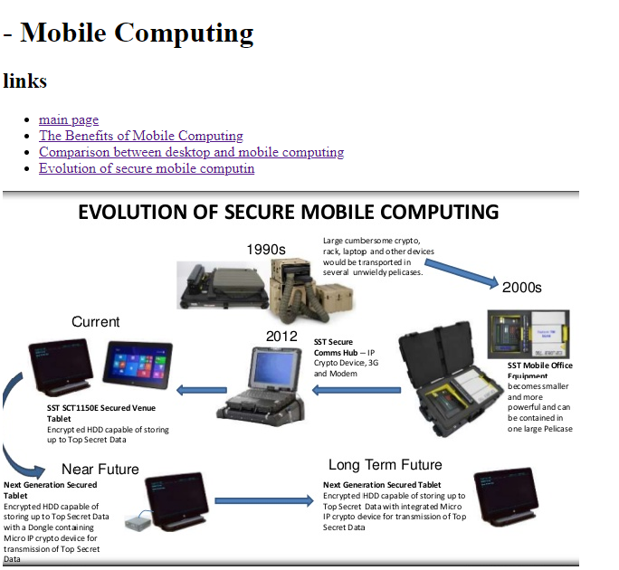

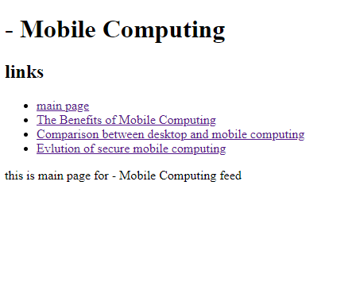

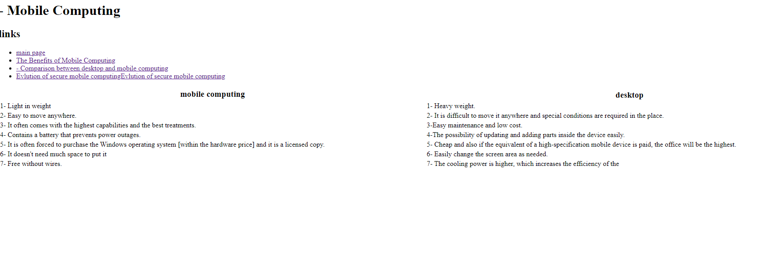

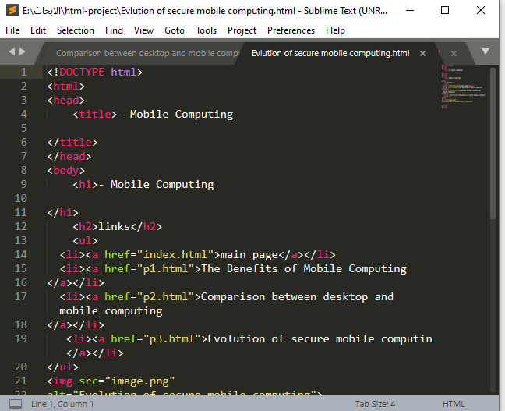

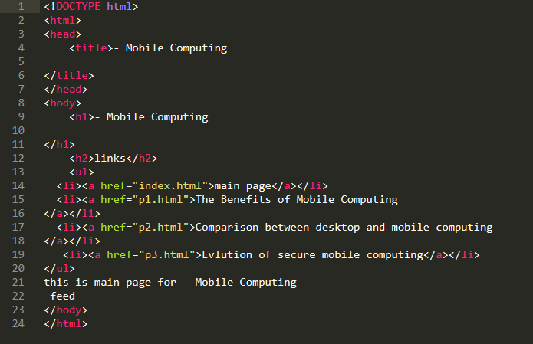

**Screen code**

