My study notes
This is a Word document shown inside a lesson. inPace shows the headings, lists, tables and pictures. To edit it, download it and open it in Word, LibreOffice or Google Docs.

What I want to learn this month
- Finish the Python Basics course
- Read one chapter of a book every week
- Save a milestone every Friday

My week
Day | What | Minutes
Monday | Lesson 1 | 20
Wednesday | Lesson 2 | 25
Friday | Review and milestone | 15

How it fits together
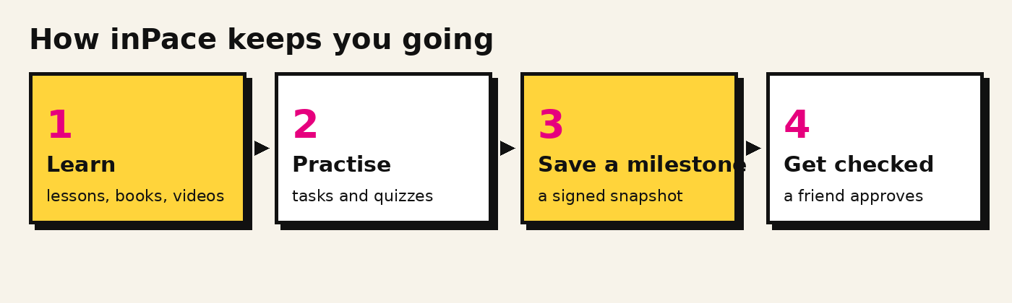
Tip: keep notes short. One idea per line is easier to review later.

