**Course End Project** - **Automating Infrastructure using Terraform**

**Problem Statement:**

**Use Terraform to build a virtual machine and install other required automation tools in it.**

* Launch an EC2 instance using Terraform
* Connect to the instance
* Install Jenkins, Java and Python in the instance

**Tools required:** Terraform, AWS account with security credentials, Keypair

**Solution:**

**Step 1: Terraform Core is installed on the Lab VM:**

**# terraform --version**

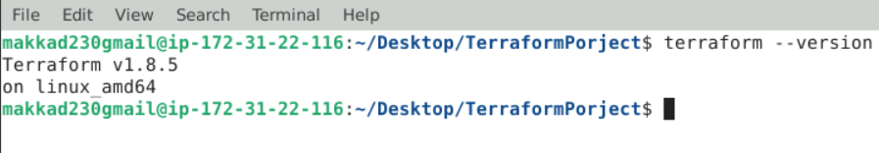

**Step 2: Create AWS user and security credentials:**

**Creating User:**

1. **In the AWS dashboard, search for IAM and then select it.**
2. **One the left navigation panel select Users**
3. **Click on Create user.**
4. **Provide a Username**
5. **Click Next**
6. **Choose Attach policies directly Permission option**
7. **Choose AdministratorAccess in the Permission Policies**
8. **Click Next then Click Create user**

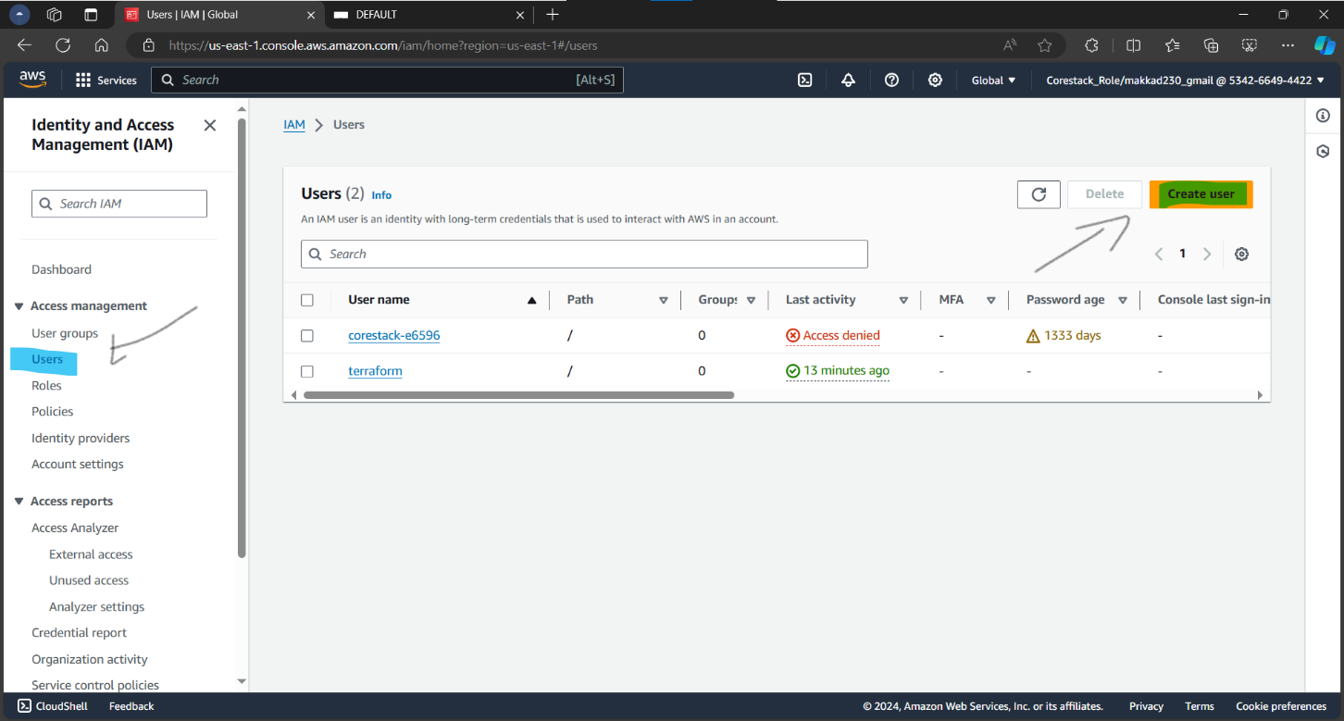

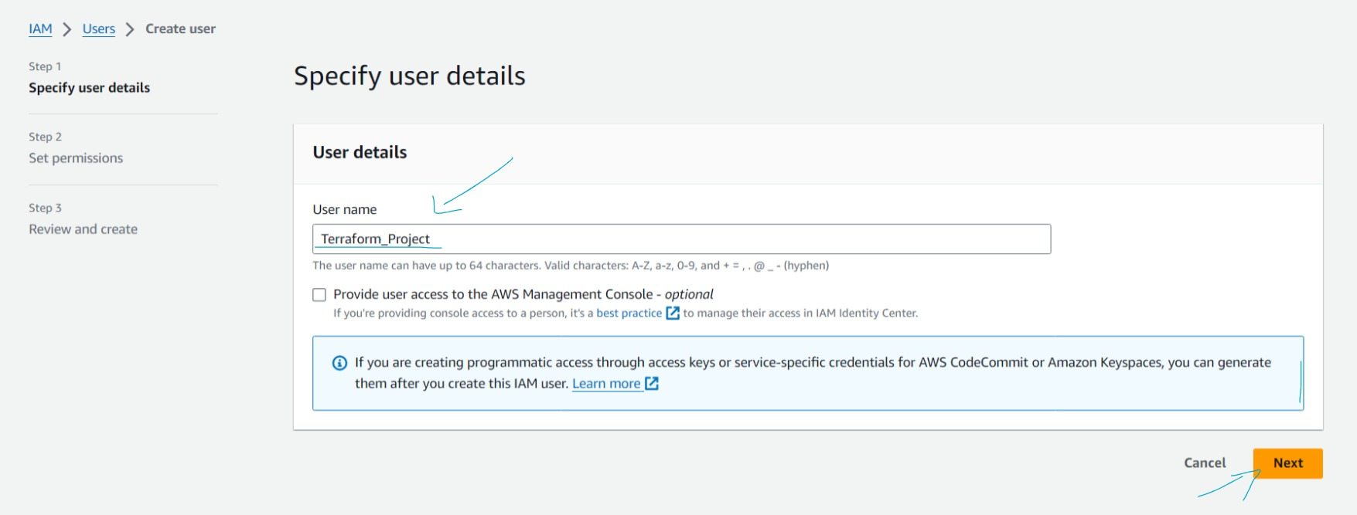

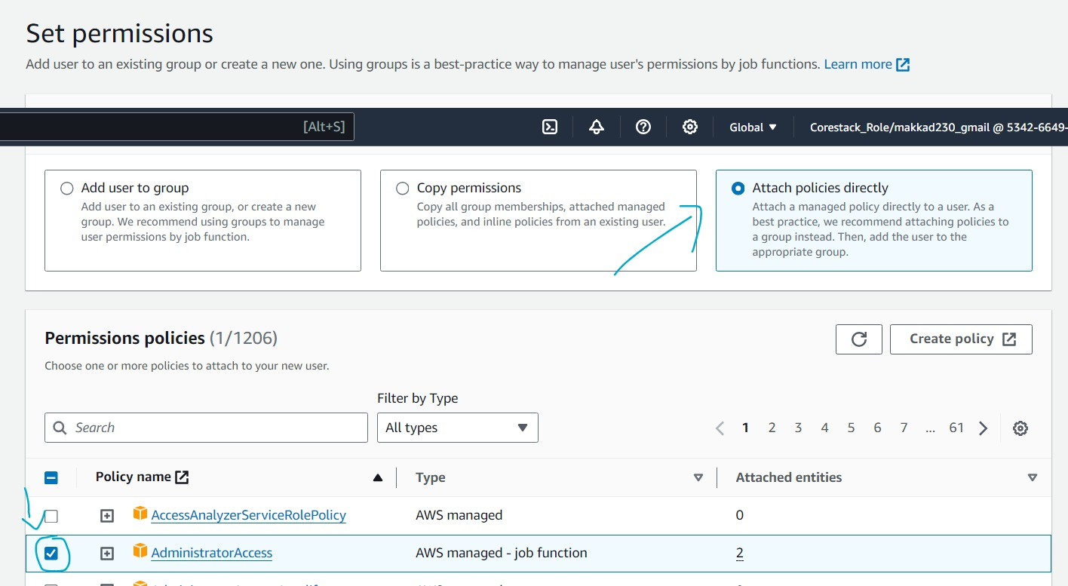

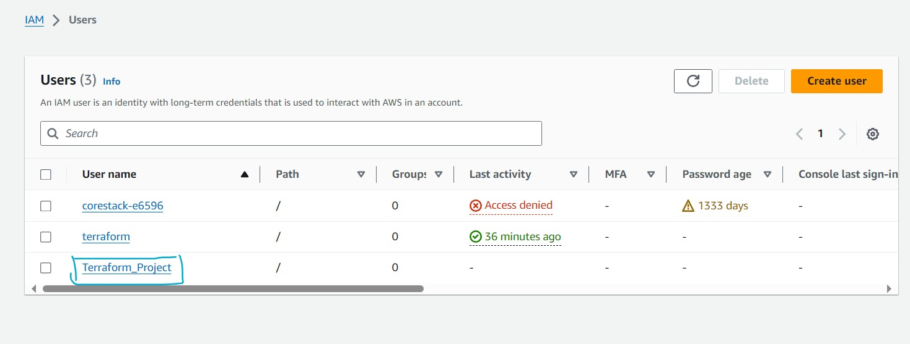

**Create Security Credentials**

1. **Click on username Terraform_Project**
2. **Click on Security credentials tab**
3. **Scroll and create Access Keys**
4. **Choose command line (CLI)**
5. **Check the box “I understand the above”**
6. **Create access Key**

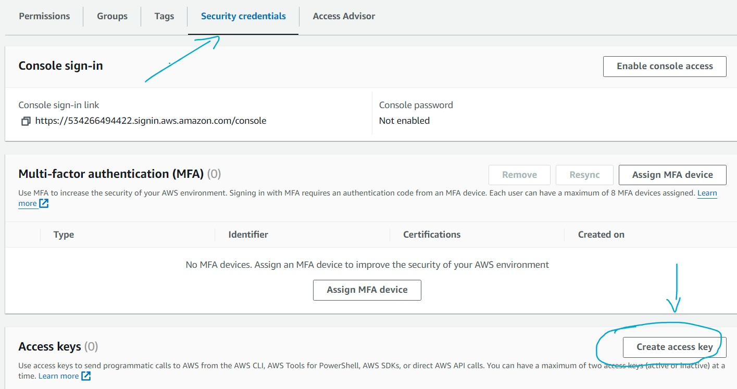

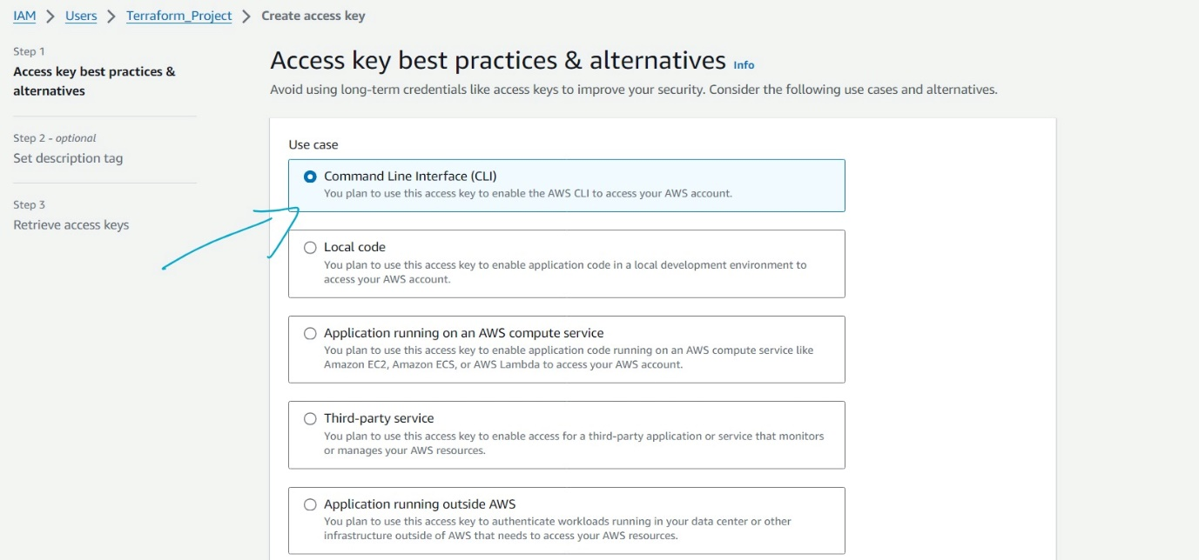

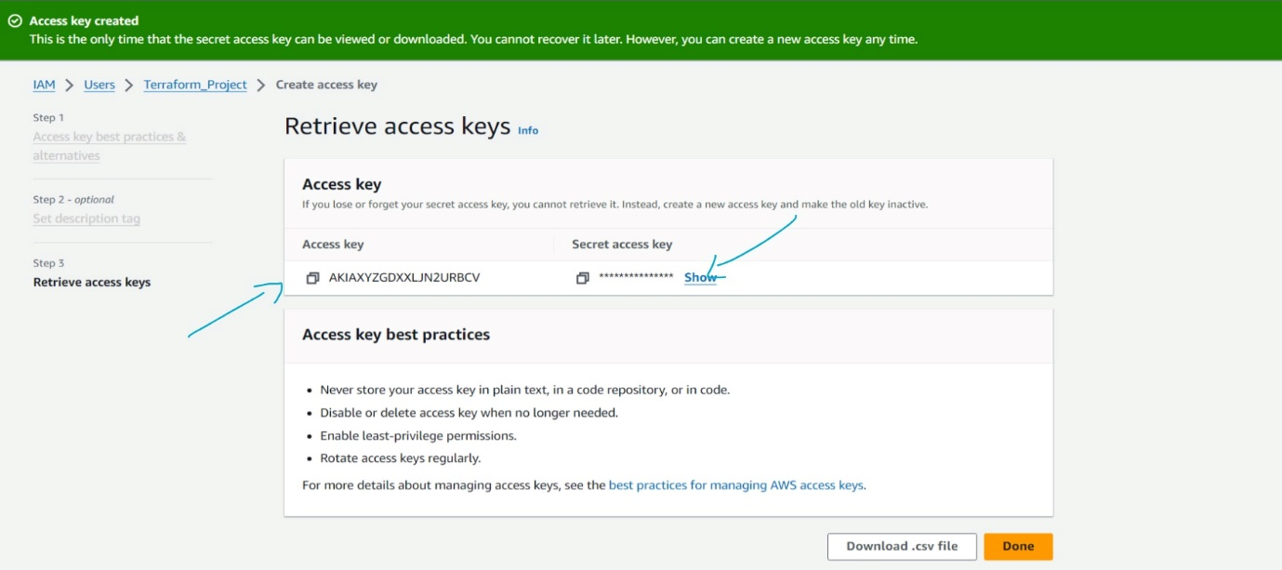

**Step 4: Create a key pair in AWS, we will use this keypair to connect to the ec2 instance**

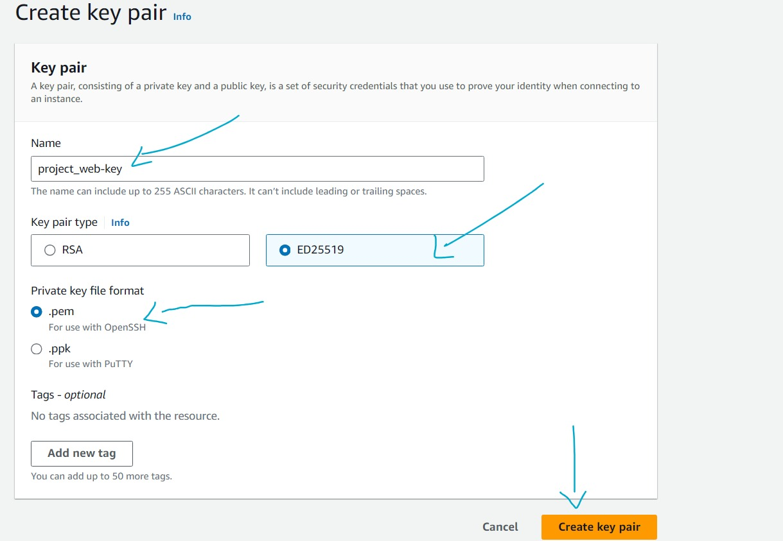

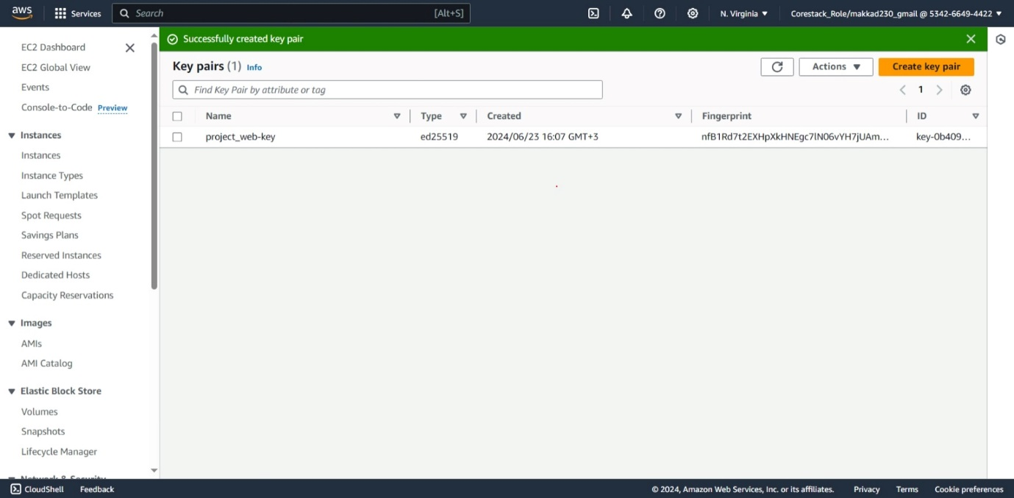

**Step 5: Prepare the terraform configuration file with provider and resource blocks**

**In the configuration file , we will use:**

* **Provider : aws**
* **Resource: security_group**
* **Resource: aws_instance**
* **Resource: aws_network_interface_sg_attachment**

**Final code:**

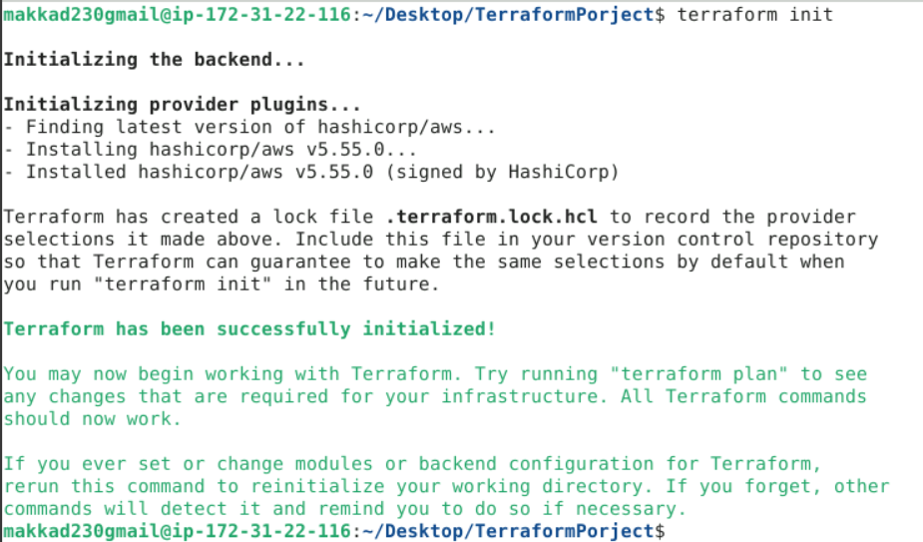

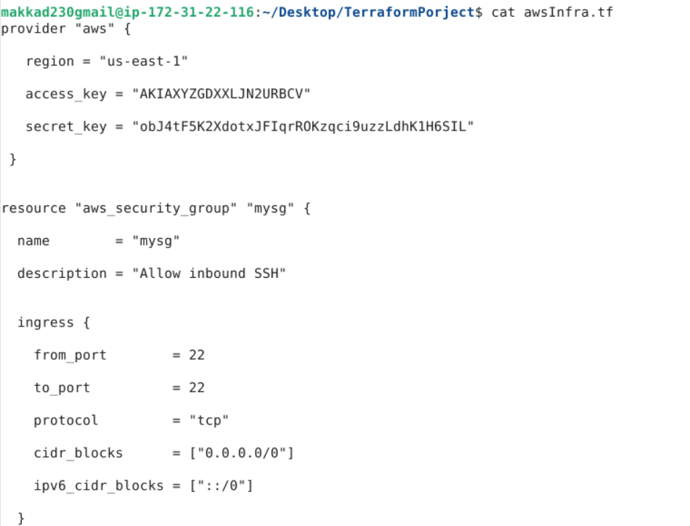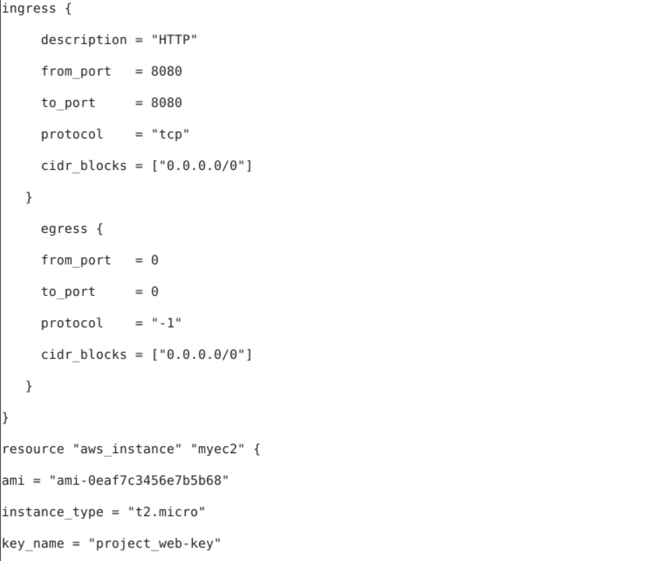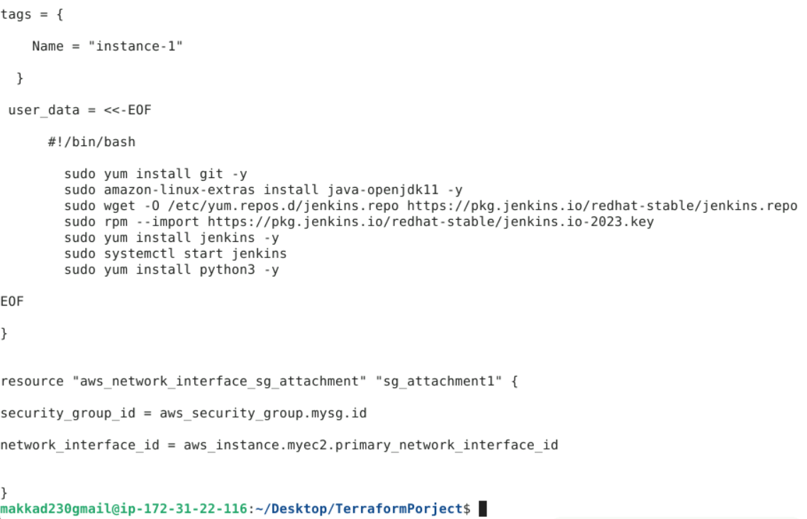

**Step 7: Execute the terraform configuration**

**# terraform apply**

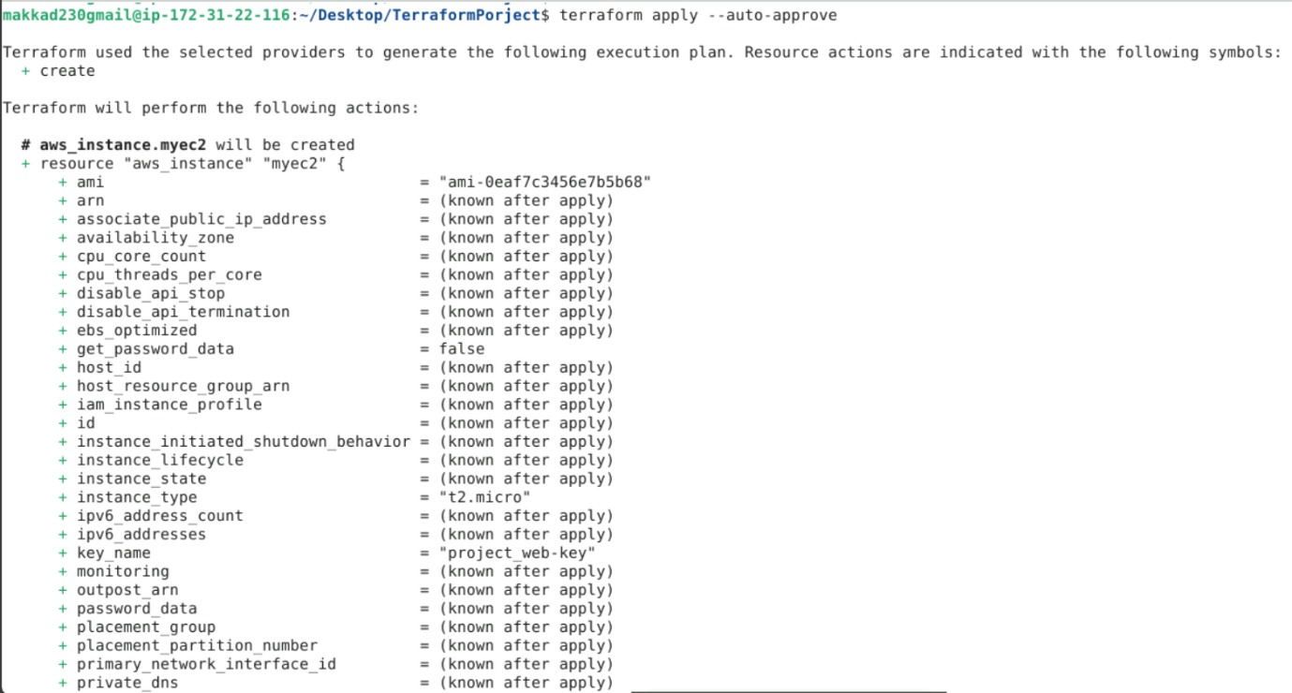

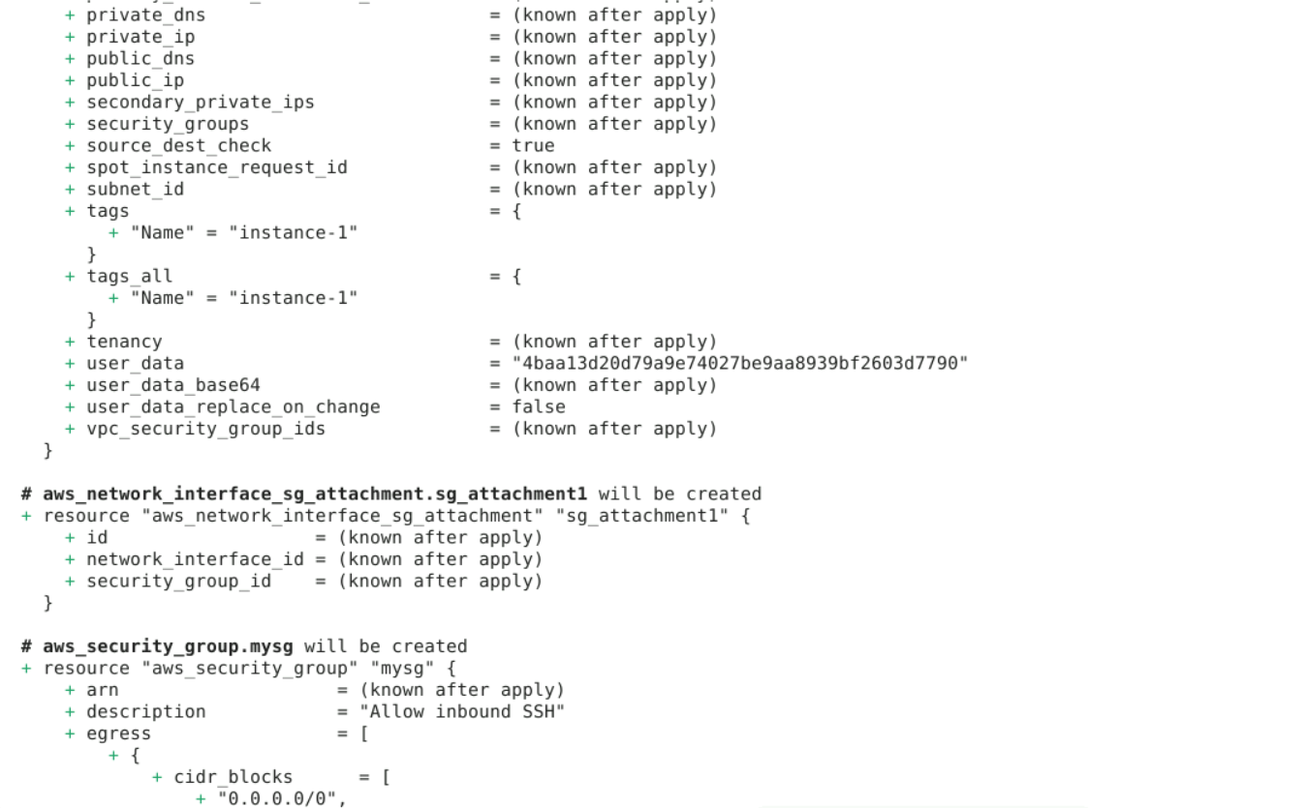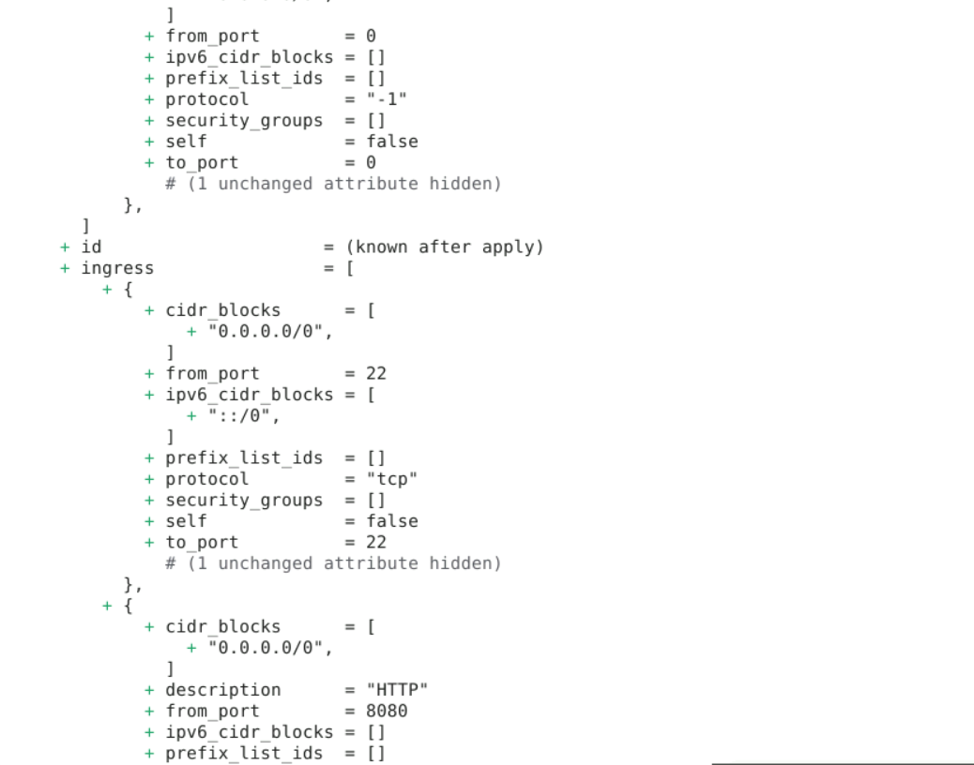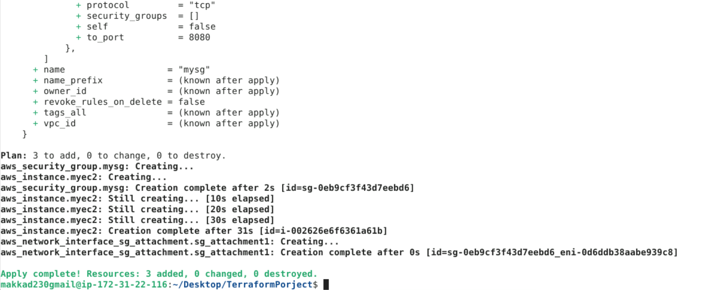

**Step 8: Validate and check if the tools have been installed on the VM or not.**

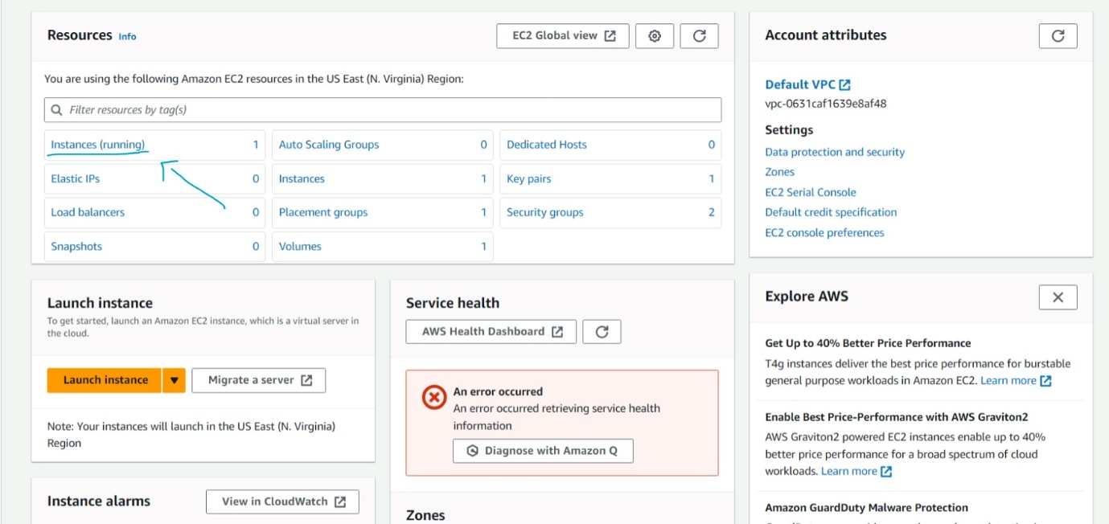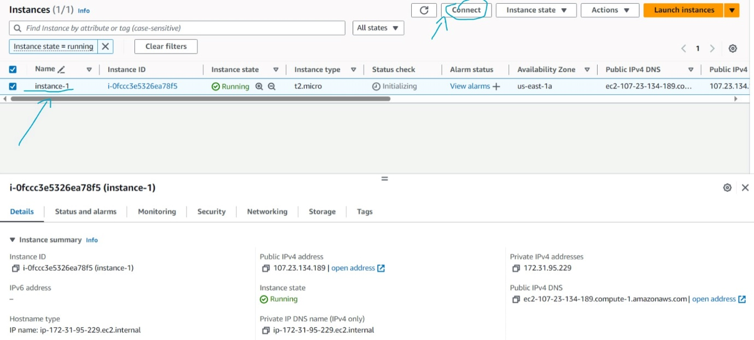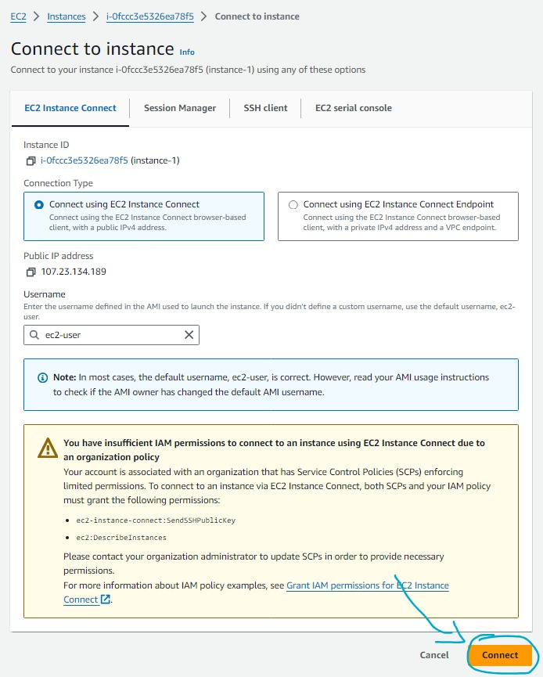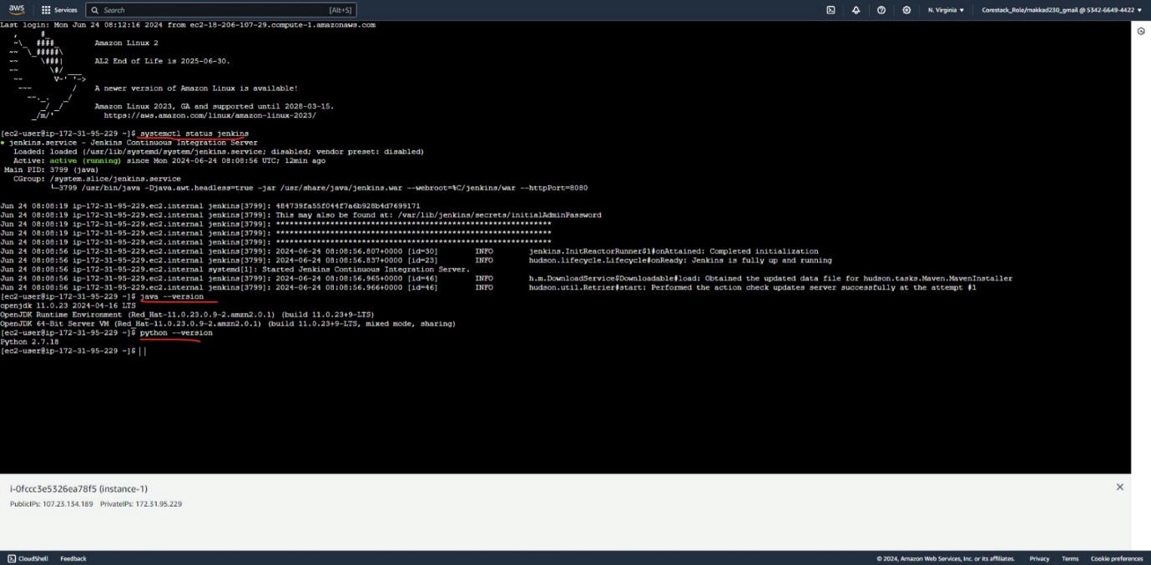

**Completed the project**