**Female Employees and their challenges**

Ankon Sarker Linkon

CSE, American International Univeristy-Bangladesh (AIUB)

ankonsarker17@gmail.com

**Abstract _The number of working women is increasing day by day in Bangladesh but simultaneously different challenges are faced by women in working place. The issue of working environment is more significant when women are concerned. The main objective of the study is to understand the challenges faced by female employee. The study found some cases of discrimination, incidences of sexual harassment and identified a few challenging facts for female employees. Most of cases, they are facing personal, power and psychological harassment and they are suffering from mental and physical stress, depression, lack of confidence and lack of proper balance between employment and family care.**

**Keywords—Female, sexual harassment, employee, discrimination.**

**INTRODUCTION**

The number of female employees is increasing day by day. While a majority of the women still face discrimination and gender bias. There is no profession today where women are not employee. However, it is true that working women have to face problems by virtue of their sex. For centuries women have been subjected to exploitation and torture, physically, sexually and mentally. There are innumerable challenge and problems faced by them both at home and workplace. This is because the workplace is not yet female friendly. Without recognition of better performance of female, their physical beauty is greatly appreciated. It does not care about its eligibility. In the private sector, female is not given adequate leave during pregnancy. Even after having a child, female does not get the minimum leave. As a result, the child does not get proper affection and milk right time. There is not even a working environment with the child. Pay inequity is one of the most major issues that women employees have to face at their workplace. Most of the time despite of being more proficient and qualified than fellow male employees, women workers are paid less than males for the same amount of work. Women are almost half of the workforce still they earn less than men workers in almost every single occupation.

Policies and laws can’t change the scenario or diminish the issues that are suffered by female employees at the workplace, the mindset and the level of acceptance of people require to be altered. To face these challenges tactfully and overcome them successfully, women need to be self-confident and aware of women rights. We can stop abusing female by reporting or raising public awareness. We can create apps so that female can report their problems and the police can take action.

**METHODOLOGY**

This survey was performed by preparing some question based on “Female employees and their challenges”. The survey made on a google from and 30 people respond to the survey. At first a survey link was shared through email and people were requested to give their opinion. The survey link also shared in different social media group. No personal information was collected. Only people opinion and advice were collected in this survey. We can prevent female employees’ problem by reporting, spreading awareness and speaking openly about problems. Also, we create a software name “Female Voice “to prevent the female harassment.

**FINDINGS AND ANALYSIS**

From the survey the research gets a positive response about the initiative. 60% female and 40% male

participated in the survey.

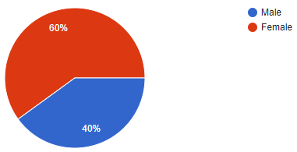

54.5% Female harassed but they did not report it to anyone. And 36.4% female harassed and they report it. Also 9.1% female prefer not to say.

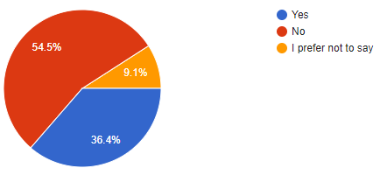

According to our survey Sexual harassment rate was 80%, Gender pay gap rate was 30%, Pregnancy discrimination rate was 10% and time of the Month rate was 25%.

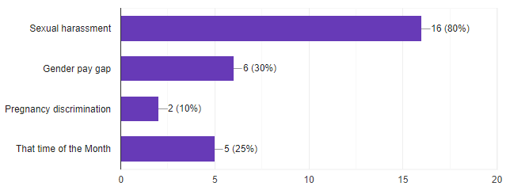

30% people agree with by reporting to prevent female employees’ problem,60% people agree with by spreading awareness to prevent female employees’ problem and 75% people agree with speaking openly about problems to prevent female employees’ problem.

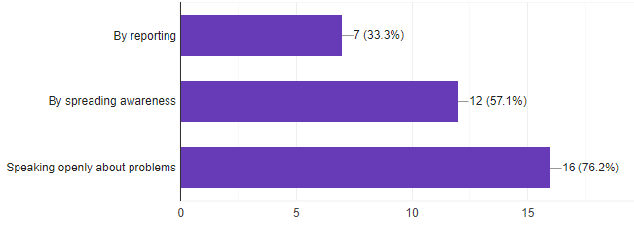

**CONCLUSION**

On conclusion it can be said, working women are contributing a lot in the economic growth of Bangladesh and a large part of economic activities are undertaken by women and overwhelmingly this working woman faced a lot of challenges at their working place. This research is conducted to explore the challenges faced by working women. In this study, we found that 81% women have faced harassment. Approximately 28.6% women have to face gender pay gap and 9.5% have to face Pregnancy discrimination also 23.8% women face to face That time of the Month problem. According to our respondents,28.6 % women are facing challenges because they are women. They are affected by mental stress mainly. They have pointed out many facilities and securities to improve their workplace.

Further study is required and recommended to explore the other findings regarding this topic. The data from the questionnaire of the respondents and our practical observation reflect that challenges that faced by working women in have become a severe phenomenon. The questionnaire, our observation has contributed to outline the following findings.

**REFERENCES**

[1] [Mohammad Didar Hossain](https://www.researchgate.net/profile/Mohammad-Hossain-241)” [Rajshahi University of Engineering & Technology](https://www.researchgate.net/institution/Rajshahi-University-of-Engineering-Technology)”[Online]..<https://www.researchgate.net/publication/328282292_Challenges_Faced_By_Urban_Working_Women_in_Bangladesh_A_Case_Study_in_Rajshahi_City?fbclid=IwAR0Oo2xzPTjb9SqNNkq7JIn9TGdXEYRNTNvv35P7taMfJ5Zj3AP_C49p00s> [Accessed: Aug. 04. 2021]

[2] Krishna Reddy <https://content.wisestep.com/women-workplace-issues-solve-challenge/?fbclid=IwAR1K__x_WYQKPtr2dDoFe8ujoI7SN6qScXZ5-Ym4WtPpIafs6w5usMMbmXQ> [Online] [Accessed: Aug. 04. 2021]

[3] Vongai S. Ruzungunde , Sindiso Zhou ”[Online]. <https://www.ajol.info/index.php/gab/article/view/203347?fbclid=IwAR2p04EMUAIMrv5tuQphdnPXXDoP-AH6MqUKW3RCtfvsFHPUYzTHj1Z13PI> [Accessed: Aug. 04. 2021]