

**AMERICAN INTERNATIONAL UNIVERSITY – BANGLADESH (AIUB)**

**Faculty of Engineering**

**Bachelor of Science in Electrical and Electronic Engineering**

**BAE2101: COMPUTER AIDED DESIGN AND ELECTRICAL DRAFTING**

|  |
| --- |
| **Final Examination Fall 2019-2020 Total Marks: 50 Time: 1 hrs.** |
| **Course Instructors**: Mr. Nafish Sarwar Islam |

1. Draw the floor plan given below using AUTOCAD software and put necessary dimensions. [20]

2. Put necessary equipment in the floor plan to maintain proper airflow and light at the house. [15]

3. Show necessary wiring arrangement in the floor plan to supply electricity to the equipment. [15]

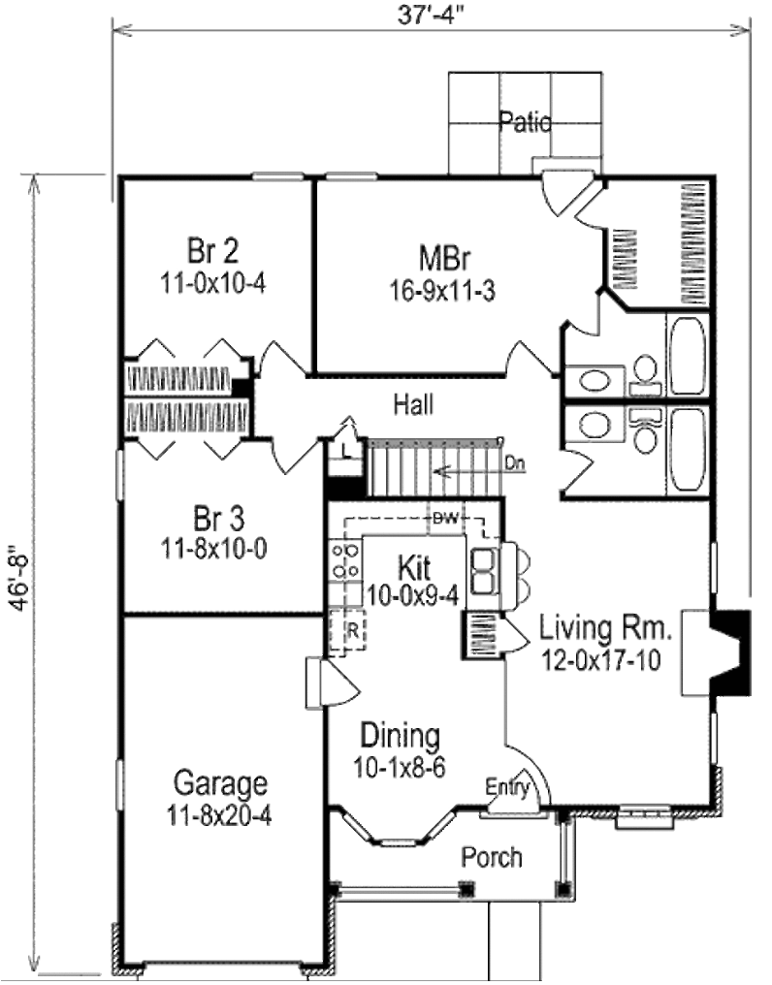

Save these files as a three pages pdf file.

File name: “Your Student ID Number”.

Send the pdf file to aiubautocad@555.gmail.com

Email Body: Your Name, ID Number and Section

Email Subject: CAD_FINAL