**Group-3**

Group Members:

|  |  |  |  |
| --- | --- | --- | --- |
| **SL** | **Name** | **ID** | **Section** |
| 01 | Ankon Sarker linkon | 19-40895-2 | D |
| 02 | Himel Datta | 19-41576-3 | D |

**Title:** Observation of Superposition Theorem in DC circuit.

# Objectives: -

The main objectives of this experiment are to

* Analyze the superposition theorem's use to multiple DC source circuits in terms of voltage and current measurements.
* Can Calculate the power direction.

# Equipment:

* Trainer board
* Digital multimeter
* DC source: 15v, 20v
* Resistors: 6k, 8k, 7k, 25k, 35k
* Connecting wire

**Procedure: -**

**Data: -**

|  |  |  |  |
| --- | --- | --- | --- |
| **Source** | **IR2 Theory** | **IR4 Experimental** | **Deviation** |
| **E1 only** | 3.343725uA | 3.343725uA | 0.0 |
| **E2 only** | 332uA | -333.067uA | -1.067 |
| **E1 & E2** | 10uA | 8.882uA | 2.228 |

Table:1

|  |  |
| --- | --- |
| **Source** | **PR2** |
| **E1 only** |  |
| **E2 only** |  |
| **E1+E2** |  |
| **E1 and E2** |  |

Table:1.2

**Simulation and Measurement: -**

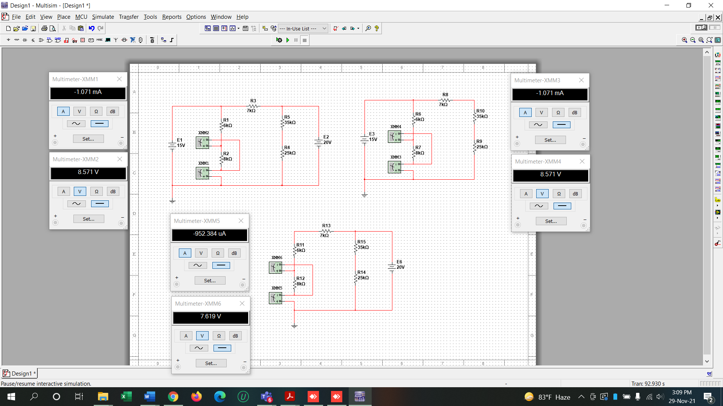

Figure:1

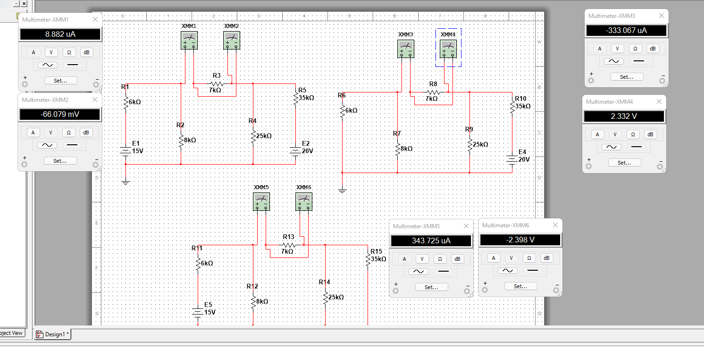

Figure 2

**Calculation and Result Analysis: -**

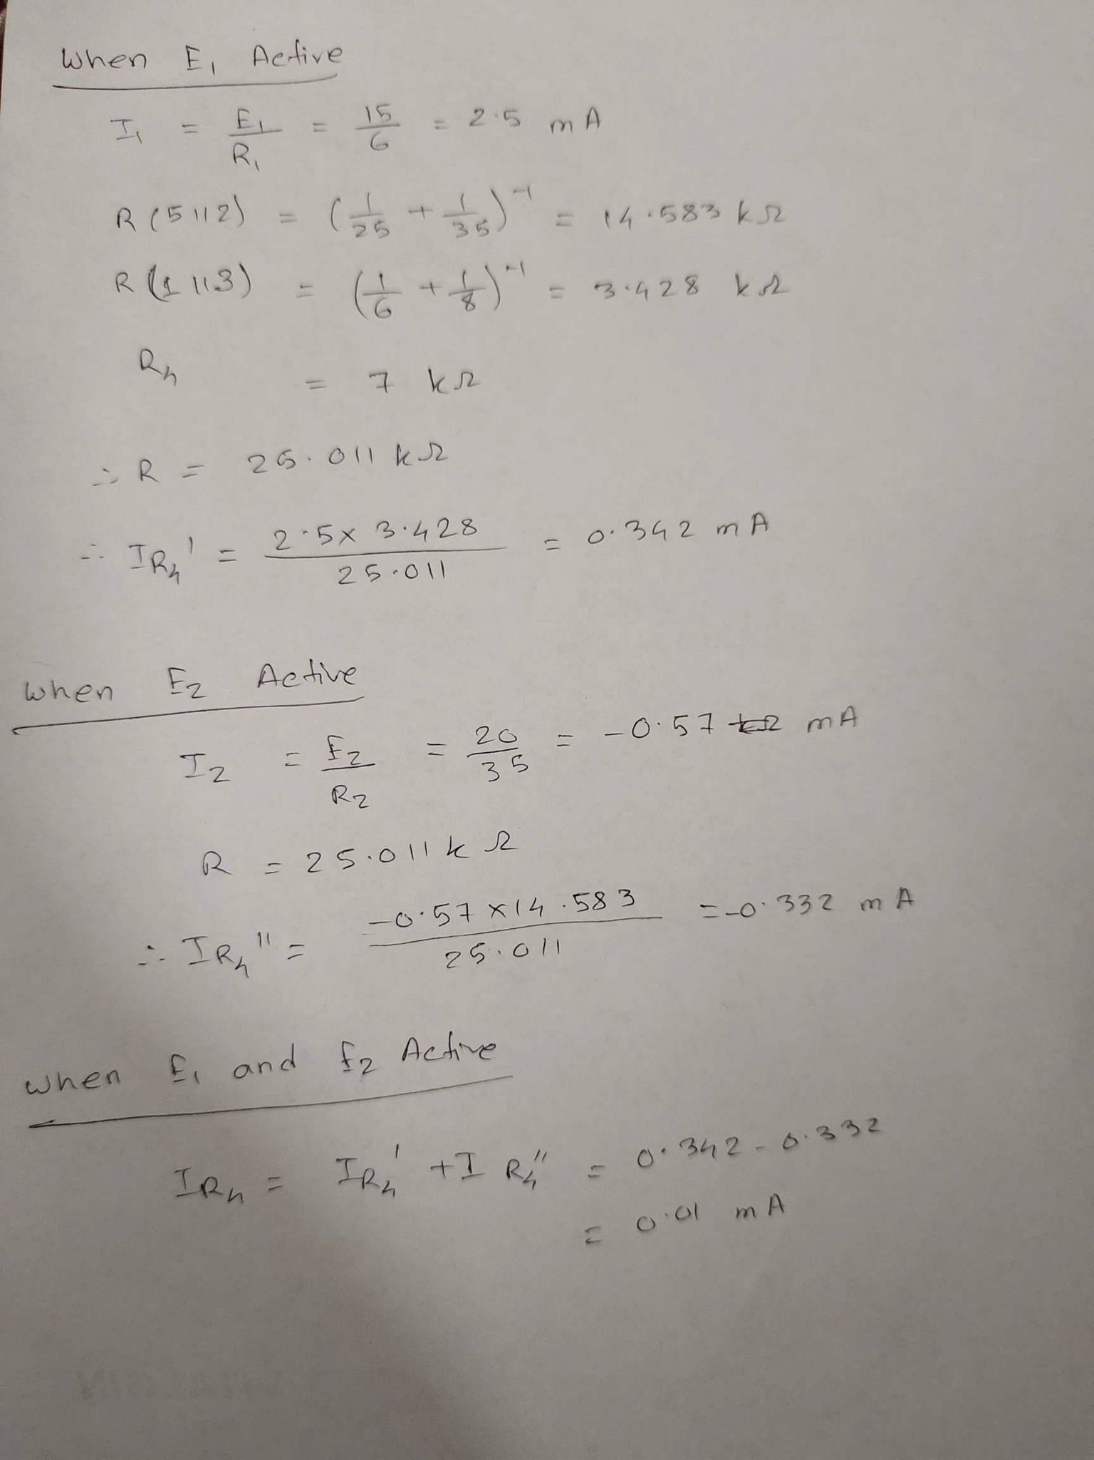

**Discussion: -**

The data/findings of the experiment were verified and observed that the experiment was successful. The strategy of the study was improved, investigated, and described by calculating the circuit of super position theorem.