Title: Study of Superposition Theorem.

Introduction:

The purpose of this experiment is to find the voltages and currents in a DC source circuit with two or more sources of supply using superposition theorem. The power measurement is also examined.

Theory and Methodology:

The superposition theorem is a derived result of the superposition principle suited to the network analysis of electrical circuits. The principle of superposition is applicable only for linear systems. The concept of superposition can be explained mathematically by the following response and excitation principle:

i1→ v1

i2→ v2

i1+ i2→v1 + v2

From this mathematical expression we can understand that a device, if excited by a current i1 will produce a response v1. Similarly, excitation of i2 will cause a response in v2. Again, if we use an excitation i 1 + i1, we will find a response v1 + v2.

**Superposition theorem states that,**

“In any linear circuit containing multiple independent sources, the current or voltage at any point in the network may be calculated as algebraic sum of the individual contributions of each source acting alone.”

Superposition theorem can make complicated problem much easier by breaking it into several problems each containing only a single independent source. All the remaining independent sources were disabled when determining the contribution due to a particular independent source. Then, all the remaining voltage sources were made zero by replacing them with short circuits, and all remaining current sources were made zero by replacing them with open circuits. There was no dependent source but if there was any that should active during the process of superposition.

Circuit Diagram:

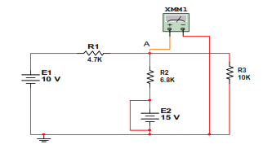

Figure:6.1 (E1 active)

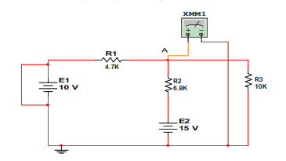

Figure:6.1 (E2 active)

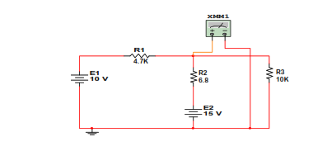

Figure:6.1 (E1 and E2 active)

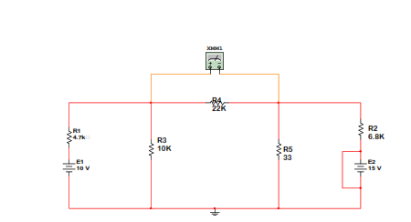

Figure:6.2 (E1 active)

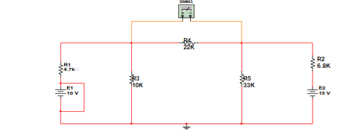

Figure:6.2 (E2 active)

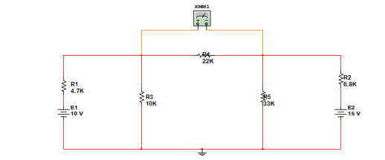

Figure:6.2 (E1 and E2 active)

**Simulation:**

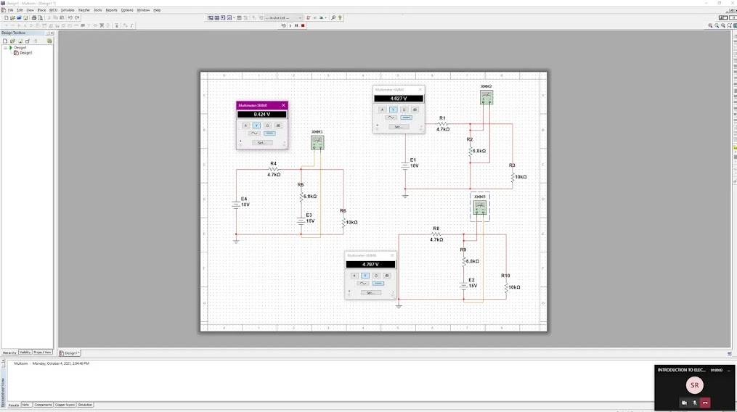

Figure:6.1

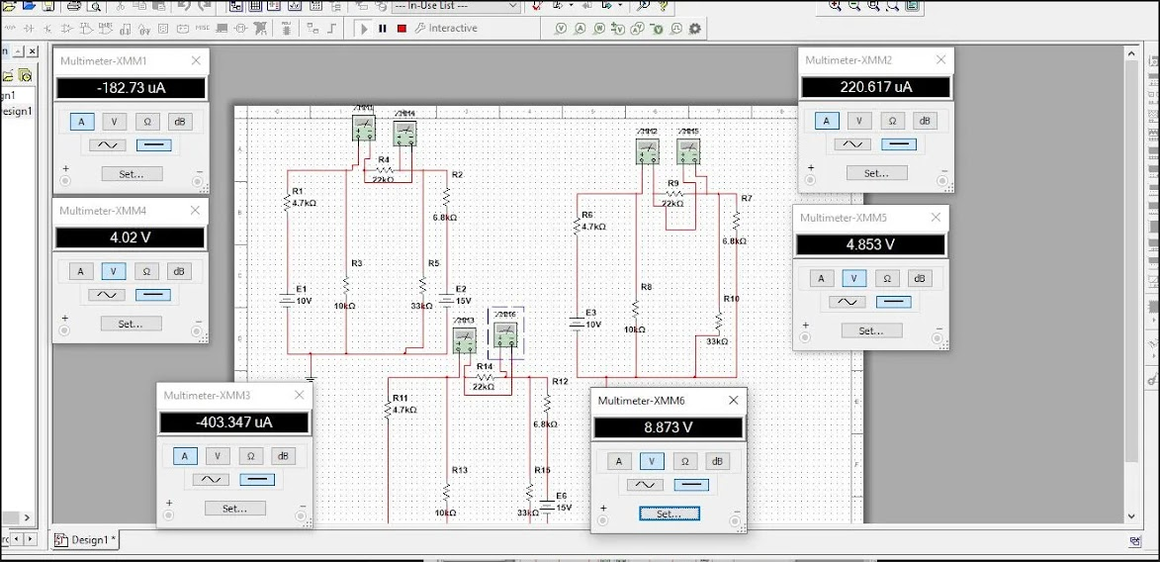

Figure:6.2

Measurement:

Data Tables:

|  |  |  |  |
| --- | --- | --- | --- |
| Source | VA Theory | VA Experimental | Deviation |
| E1 only | 4.6567V | 4.627 V | 0.027 |
| E2 only | 4.7975 V | 4.797 V | 0.0005 |
| E1 & E2 | 9.5115 V | 9.429 V | 0.0825 |

Table 6.1

|  |  |  |  |
| --- | --- | --- | --- |
| Source | IR4 Theory | IR4 Experimental | Deviation |
| E1 only | 0.0221 mA | 0.220617 mA | 0.198 |
| E2 only | -0.4035 mA | -0.403347 mA | 0.00015 |
| E1 & E2 | -0.3814 mA | -0.18273 mA | 0.1986 |

Table 6.2

|  |  |
| --- | --- |
| Source | total |
| E1 only | 1.0171*10^-3 |
| E2 only | 3.579*10^-3 |
| E1+E2 | 4.65*10^-3 |
| E1 and E2 | 1.664*10^-5 |

Table 6.3

Calculation:

For figure 6.1:

When E1 Active,

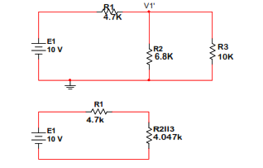

R = 4.7+4.047 = 8.747K and E1 = 10V

∴VA'= $\frac{10×R(2||3)}{R(2|\left|3\right)+R1}$ =4.6567V

When E2 Active,

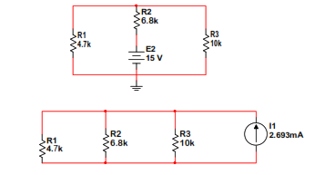

I1 = E2/R2=15/6.8 = 2.206mA



VA'' = I1 × 2.175= 2.206 × 2 = 4.7975 V

When E1 and E2 active:

VA = VA' + VA'' = 4.37 + 5.386 = 9.756 V

For figure 6.2:

When active E1,

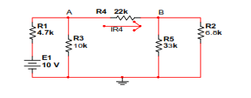

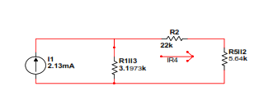

I1 = E1/R1 = 10/4.7 = 2.13mA

R(5ll2) = 5.64k and R(1ll3) =3.1973k

R=R(5ll2) + R(1ll3) +R4 = 4.76+3.18+22.51= 30.45k

IR4’= $\frac{2.13×R(1||3)}{R}$ =0.0221

When active E2,

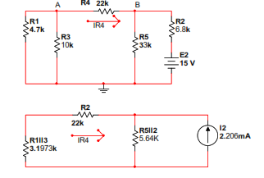

I2 = E2/R2 = 15/6.8 = -2.206mA

R(5ll2) =5.64k and R(1ll3) =3.1973k

R=R(5ll2) +R(1ll3) +R4 = 4.76+3.18+22.51= 30.83k

IR4'' = $\frac{-2.206×R(2||5)}{R}$ =-0.4035

When E1 and E2 active,

IR4 = IR4' + IR4'' = (0.0221-0.4035) mA = -0.3814mA

Results:

For figure 6.1: E1 only 4.374 V

E2 only 5.395 V

E1 & E2 9.769 V

For figure 6.2: E1 only 0.22243 mA

E2 only -0.42 mA

E1 & E2 -0.19 mA

**Conclusions:**

The data/findings of the experiment were verified and observed that the experiment was successful. The strategy of the study was improved, investigated, and described by calculating the circuit of super position theorem.