 | American International University- Bangladesh (AIUB)  Faculty of Engineering
Course Name: | Engineering Ethics | Course Code: | EEE 3107
Semester: | Spring 2020-21 | Section: | H
Title: | A report on ethical guidelines (CO5)
Student Name: | Abrar Jahin Khan | Student ID: | 19-41128-2
Student’s Department: | EEE | Submission Date: | 24.04.2021

Rubric:
Category | Proficient  [4] | Good  [3] | Acceptable  [2] | Unacceptable  [1] | Secured Marks
Resources  CA1 | Issue/problem to be considered critically and analysis has effectively involved using diverse resources. | Issue/problem to be considered and analysis has involved using diverse resources but not effectively. | Issue/problem to be considered has analyzed using some resources without any diversification. | Issue/problem to be considered has involved no or limited usage of resources.
Influence of context and assumptions  CA1 | Thoroughly (systematically and methodically) analyzes own and others’ assumptions and carefully evaluates the relevance of contexts when presenting a position. | Identifies own and others’ assumptions and several relevant contexts when presenting a position. | Questions some assumptions. Identifies several relevant contexts when presenting a position. May be more aware of others’ assumptions than one’s own (or vice versa). | Shows an emerging  awareness of present assumptions (sometimes labels assertions as assumptions). Begins to identify some contexts when presenting a position.
Student’s position  (perspective, thesis/  hypothesis)  CA3 | Specific position (perspective, hypothesis) is imaginative, considering the complexities of an issue. Limits of position (perspective, hypothesis) are acknowledged. Others’ points of view and assumptions are synthesized within position (perspective, hypothesis). | Specific position (perspective, thesis/hypothesis) considers the complexities of an issue. Others’ points of view and assumptions are acknowledged within position (perspective, hypothesis). | Specific position (perspective, hypothesis) acknowledges different sides of an issue. | Specific position (perspective, hypothesis) is stated, but is simplistic and obvious.
Innovative Thinking  or uniqueness (of idea, claim, question etc.)  CA3 | Extends a novel or unique idea, question, format, or product to create new knowledge or knowledge that crosses boundaries. | Creates a novel or unique idea, question, format, or product. | Experiments with creating a novel or unique idea, question, format, or product. | Reformulates a collection of available ideas.
Proper Documentation | Documentation and related outcomes are logical and reflect student’s informed evaluation and ability to place evidence. | Documentation and related outcomes are logically tied to a some of the information. | Documentation is logically tied to information (because information is chosen to fit the desired conclusion) but some related outcomes are not clear. | Documentation is inconsistently tied to some of the information discussed; related outcomes (consequences and implications) are oversimplified.
Comments: |  |  | Total Marks  (Out of 20):

A Presentation and Report on ethical guidelines:

Suppose, you are going to set up a startup company in Bangladesh. You need to mention the type of the company and to give a brief idea about it's organizational structure. Write the code of ethics for your startup. This code should provide guidelines for ethical and professional conduct and should comply with the code of ethics of IEB.

Hints: You may include but not be limited to the following issues to write code of ethics:
- Ethical Work Environment.
- Health and Safety standards.
- Professional Engineering.
- Economic, Social and Environment Factors.

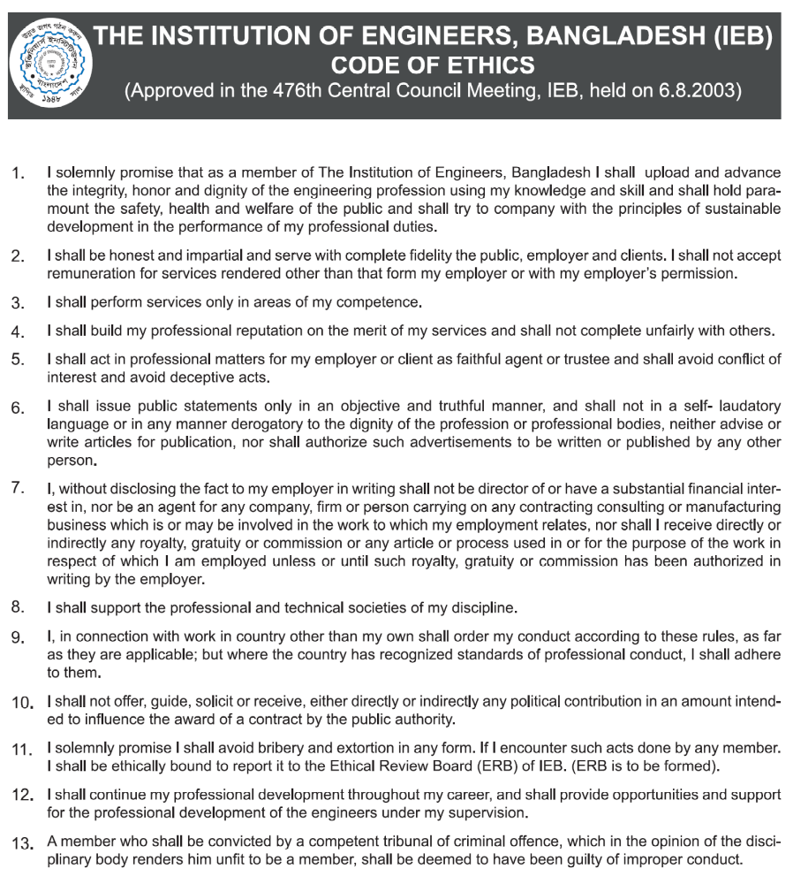
Report:
The most important thing for any start up is to begin its work from ground up with great foundation and for that we need polished organizational structure. So that the chain of command is maintained and flow of info is not disrupted. I wish to make a production-based company. As such there will be CEO (myself). Under the CEO, there will be managers who will be given the responsibility of managing production and marketing of the products. There will of course be two different divisions for this. One of each will handle one of the two core aspects which are production and production. Under the managing of the marketing manager, there will be sales officers who will move the salespersons towards the marketing endeavors and campaigns. Under the managing of the production manager, there will be foremen who will oversee fabrication and assembly of products. They will do these by managing the workers employed under their supervision.To run a company the Engineers who worked for the organization have to follow some code of ethics.
Ethics is a set of moral principles or values to govern the conduct of an individual belonging to a group or profession on the basis of honesty, fairness, and justice. An Engineer should observe a System of moral principles and values, not in passive recognition, but as a set of dynamic standards to guide his conduct and way of life.It is his duty to practice his profession according to this Code of Ethics. The keystone of professional conduct is integrity.So the code of ethics are defined:

1.An Engineer should discharge his duties with absolute fidelity to his clients and employers, and to act at all times, with fairness and impartiality to all, having due regard to public interest and welfare.

2.An Engineer should uphold the honor and dignity of his profession and, therefore,should avoid association with any person or enterprises of known questionable character.

3.An Engineer should strive to upgrade his skill and knowledge in electrical engineering in order to give the best possible service to the public which could be attained by interchanging information and experiences with other engineers, and by unselfishly contributing to the mission of engineering societies, institutes, schools and engineering and scientific media, and other public institutions.

4. An Engineer should only advertise his work or merit in a simple manner and avoid any practice that will discredit or do injury to the dignity and honor of his profession.

5. An Engineer should endeavor to extend public knowledge of engineering and shall discourage spreading the untrue, unfair, and exaggerated statements regarding engineering.

6. An Engineer, should have due regard at all times for the safety of the life and health of his employees, other workers, as well as of the general public and for the protection of property that may be affected by the work this responsibility.

7. An Engineer should express an opinion on engineering subject, whether publicly or privately, only when such opinion is called for, his opinion must be founded on adequate knowledge andinformation of the relevant issues and facts based upon his honest convictions.

8. An Engineer should not issue statements, criticisms, opinions, arguments or other views on matters except where public interest is affected.

9. An Engineer should be fair, impartial and reasonable in rendering professional service to his clients, employers and contractors regarding contracts or other agreements.

10. An Engineer should, before undertaking any engagement or entering into any contracts which calls for his professional service that will require or need the use of apparatus, other equipment or things in which he has financial interest, have such situation clarified in the contract or agreement to avoid conflict of interests.

11. An Engineer should be vigilant in guarding against conditions that may be dangerous or threatening to life, health, or property on work for which he is responsible, or otherwise bring such conditions to the attention of those responsible.

12. An Engineer should present clearly the known possible consequences or imitations of the work for which he will be responsible.

13. An Engineer should honestly advise his clients or employer to engage the services of other experts and specialists, and should cooperate with them in the interests of his client or employer.

