**Distant Health Care System**

**Fayeaz Ahmed (19-39360-1)**

**Hafizul Islam (19-40316-1)**

**Akram Hossain Lemon (19-39395-1)**

**Md Kamruzzaman Khan Nabil (19-39384-1)**

Online healthcare services are anything and everything that can be delivered without actually meeting a doctor and get examined. This service also helps patients find doctors near their location, and connect with them instantly. This is a one-stop destination for appointments, consultations, health records, insurance, and ordering medicines online. Users can call for emergency medical response and assistance with just one tap on the mobile app. It is a healthcare mobile app that connects people who need emergency responses with qualified medical, safety, rescue, and assistance professionals. Not everyone has the time or inclination to visit a doctor to discuss their healthcare needsespecially when it comes to potentiality embarrassing problems.

Developing countries like Bangladesh, where most of population living in rural areas have no or minimum access to proper healthcare system. Whereas people living in urban areas like Dhaka, has to tackle traffic situation everyday & it can be a serious problem when there is an emergency situation. A healthcare emergency can strike anyone, anytime, anywhere & it can be a life threatening if proper consulting can’t be taken from the expert in minimum time. Distance and travel time between patients and care providers can limit access to care. These are the common problem for middle income country like Bangladesh. With limited resources and much of the population living in remote and rural areas, Distant/online healthcare service has the potential to revolutionize the delivery of healthcare.

Bangladesh is a small developing country of South Asia with a huge number of populations. About 75% people live in rural areas where the healthcare facilities are very inadequate in contrast to the urban areas of Bangladesh. The healthcare facilities can effectively be given to this huge number of rural people through distant healthcare system.

**UML DIAGRAM**

# Use Case Diagram

A patient or a doctor can login to the system by verification. If the user does not have any account then he can login to the system after creating account by adding information and setting password. A patient can find doctor after selecting preference and setting up the desired location. In the case of selecting preference patient will be provided with two options: video conference and consultation. A patient can also order medicine using the system by selecting payment method. There are two options, cash on delivery and mobile banking. After logging, a doctor can set his/her availability by confirming appointments and setting consulting hours. During checkup, a doctor must check records of the patient. A patient can also check his/her records and both the doctor and the patient have the option to print the documents

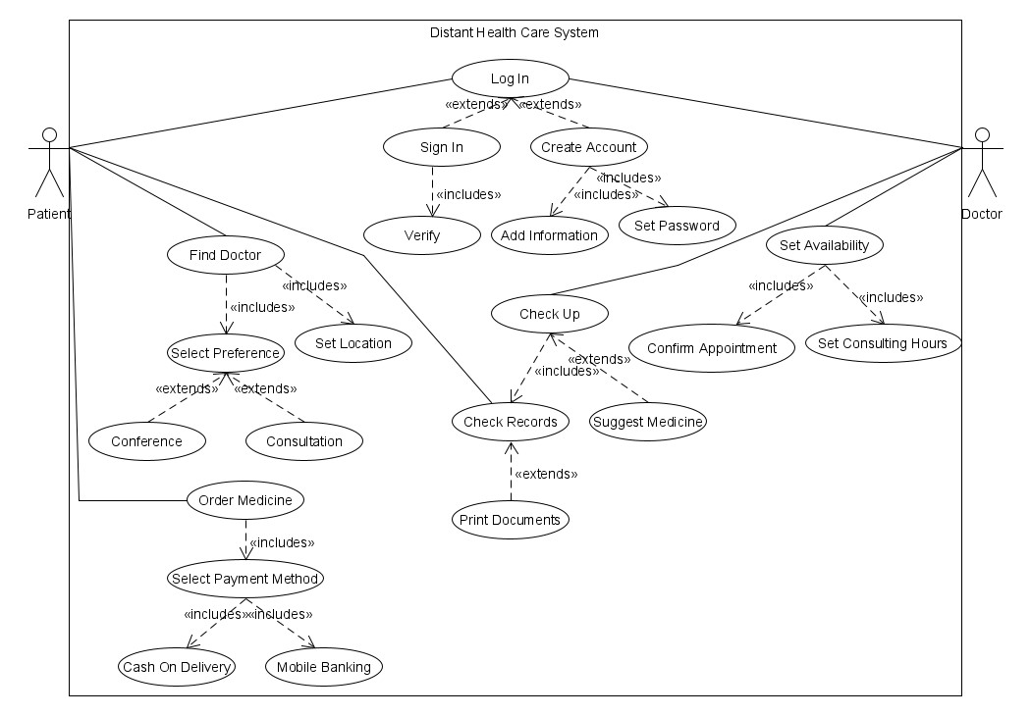

# Class Diagram

The Distant Health Care System consists of 5 classes with some attributes and methods. Every class has set methods and get methods. A system can have one or many doctors but a doctor can be part of only one system. Again, a patient can be a part of only one system but the system can have many patients. A patient must have one preference. But a preference can be selected by many patients. A patient can consult with many doctors and vice versa. A medicine can be bought by many patients or none. Also, a patient can buy many medicines or none. A system can have many medicines stored but a medicine can only be a part of one system.

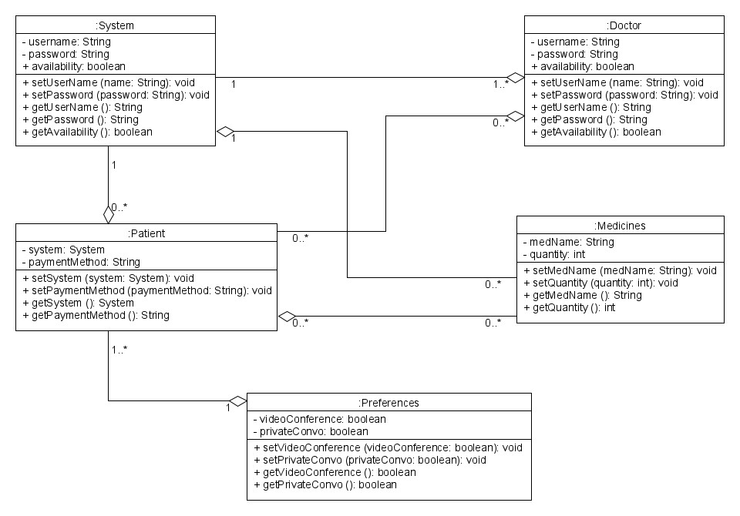

# Activity Diagram

A user attempt to login into the system. If the login is successful (system checks) then the system decides if the account is for patient or doctor. If the login is failed the system wants the user to create an account and add information. If the user is patient, he/she gets to select preference and request for a doctor on required field. If the doctor or selected preference are unavailable, then the system notifies the patient and wants him/her to request for doctor and select a preference again. If successful, the system provides the preferred time and preference of the doctor. Then the patient gets to confirm the appointment and after that he/she does the check-up. After finishing the check-up, patients upload the medical record into the server and then buys medicine by selecting and confirming the payment method. If the payment process is unsuccessful, system wants the patient to do those steps again. If the user is a doctor, then he/she gets the appointment from the system. By following scheduled appointment, the doctor check-ups all the patients one by one and prescribe them.

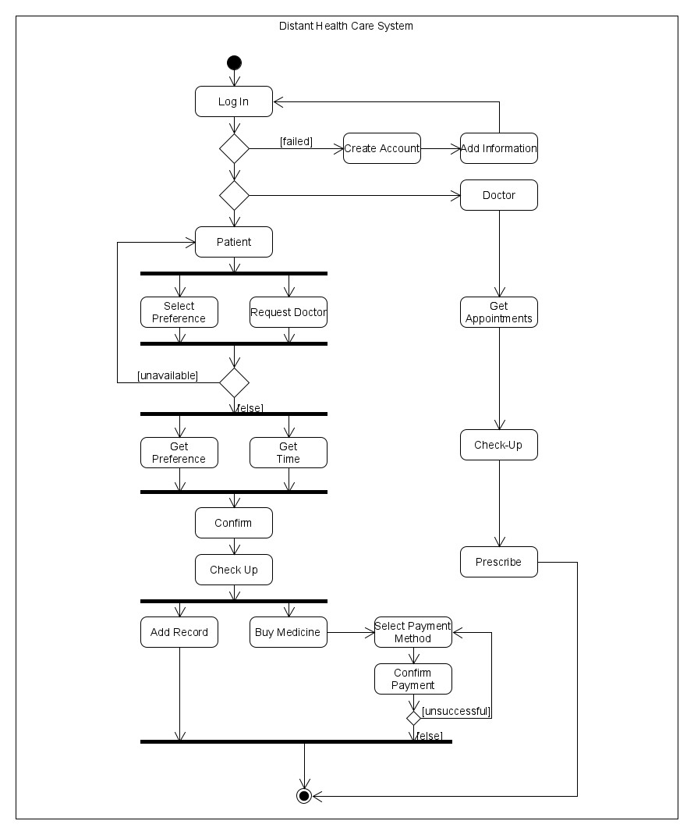

**Sequence Diagram**

A patient request to log in into the system after verifying his/her identity. System confirms if the account exists or not. If the account is available system notifies the patient and after that the patient request for doctor by providing desired preference. The system checks in database if the doctor is available at that time. If the doctor is available, system return the available time and the patient confirm the appointment. And at the same time the system sends notification to the doctor. If the verification is unsuccessful, the system tells the user to create an account and then try to login. A doctor also does the same thing. By verifying identity, doctor log in to the system. Then he/she attend the patient by video conferencing or consultation. Then the doctor prescribes medicines. A patient can also buy medicines using the system. First, he requests for the medicines. System checks if the medicine is available or not. If the medicine is available, system wants the user to confirm payment method and payment. Then the system generate payment. If the medicine is not available system notifies the user about the availability time.

