

American International University-Bangladesh (AIUB)  
**Department of Computer Science and Engineering   
Faculty of Science &Technology (FST)  
Fall 20-21  
CSC 00191- Object Oriented Analysis And Design (OOAD)**

**Section: I**

**Project Title: Vehicle Toll Plaza Management System**

**Submitted by:**

|  |  |
| --- | --- |
| **Name** | **ID** |
| 1. **Md. Tamim Hossen Sefat** | **19-39349-1** |
| 1. **Nahid Hasan Sajib** | **19-40866-2** |
| 1. **Jannatul Nusrat** | **19-40885-2** |
| 1. **Ankon Sarker Linkon** | **19-40895-2** |

**Submitted to:**

**MD. ANWARUL KABIR**

**Sr. Assistant Professor**

**Department of Computer Science**

# OOAD Project (Group Project)

## Project Proposal

# You have to propose any project of your own for which you want to implement a design. For this proposal you have to follow the following template.

# 1. Project Name: Vehicle Toll Plaza Management System

# 2. Project overview

# 3. Justification:

# 4. Overall Use Case of the Proposed Project

5. Class diagram of the project

6. Activity Diagram of the project:

7. Sequence Diagram of the project

8. State chart Diagram

9. Conclusion:

**Vehicle Toll Plaza Management System**

**02. Project overview:**

Vehicle toll plaza management is a system where drivers come to cross the bridge with tax if he/she has enough legal information and obey all the rules. One or more drivers are checked by one or many toll collectors where collectors check the vehicle category, driver details and license number. Then toll collector collects vehicle’s license to verify it by at least one police officer. After that police declares the confirmation to the collector to take payment. Driver can pay bill via cash, card. For over weight of vehicle, driver needs to pay extra charge.

User Group:

Driver, Toll Collector & Police.

**03. Justification:**

The main objective of this project is to computerize the manual system & reduce the time consumption.

In other words we can say that our project has the following objectives as well as benefits:

* Make all the system computerize
* Reduce time consumption
* Reduce error scope
* All system managements are automated
* Easy operations for operator of the system
* No paper work requirement
* Provides toll tax rates for different vehicles

**04. Use Case Diagram for the System:**

Actors:Driver, Toll Collector & Police.

Diagram:

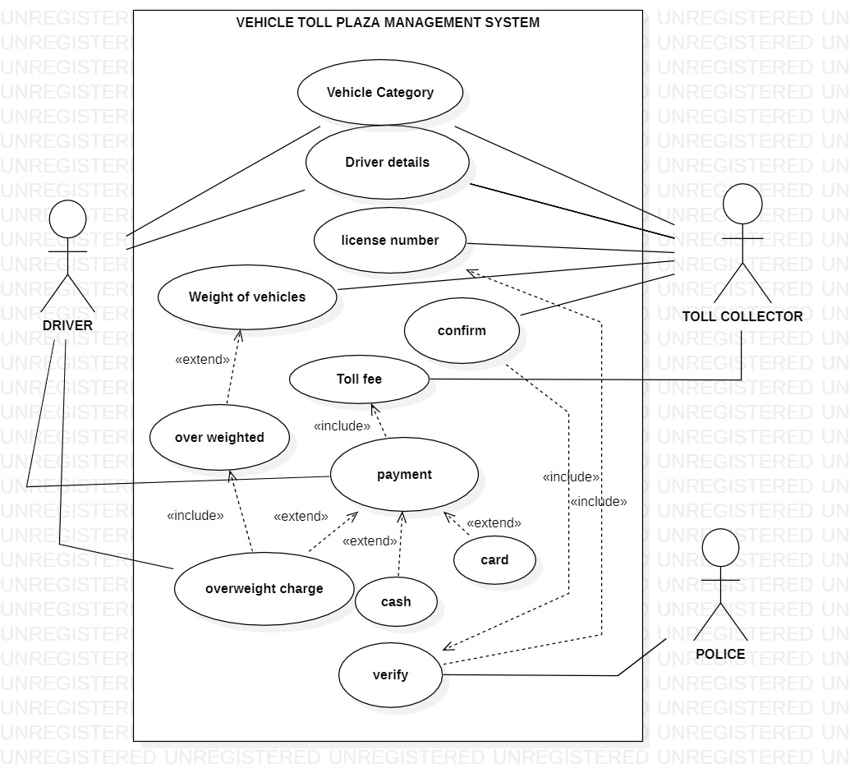

**05. Class Diagram for the System:**

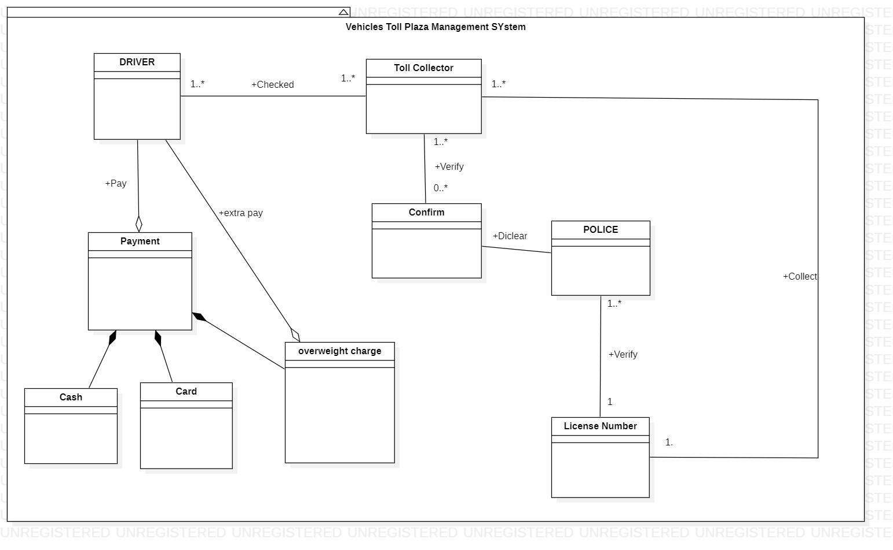

**06. Activity Diagram for the System:**

**Activity diagram: Vehicle’s Part**

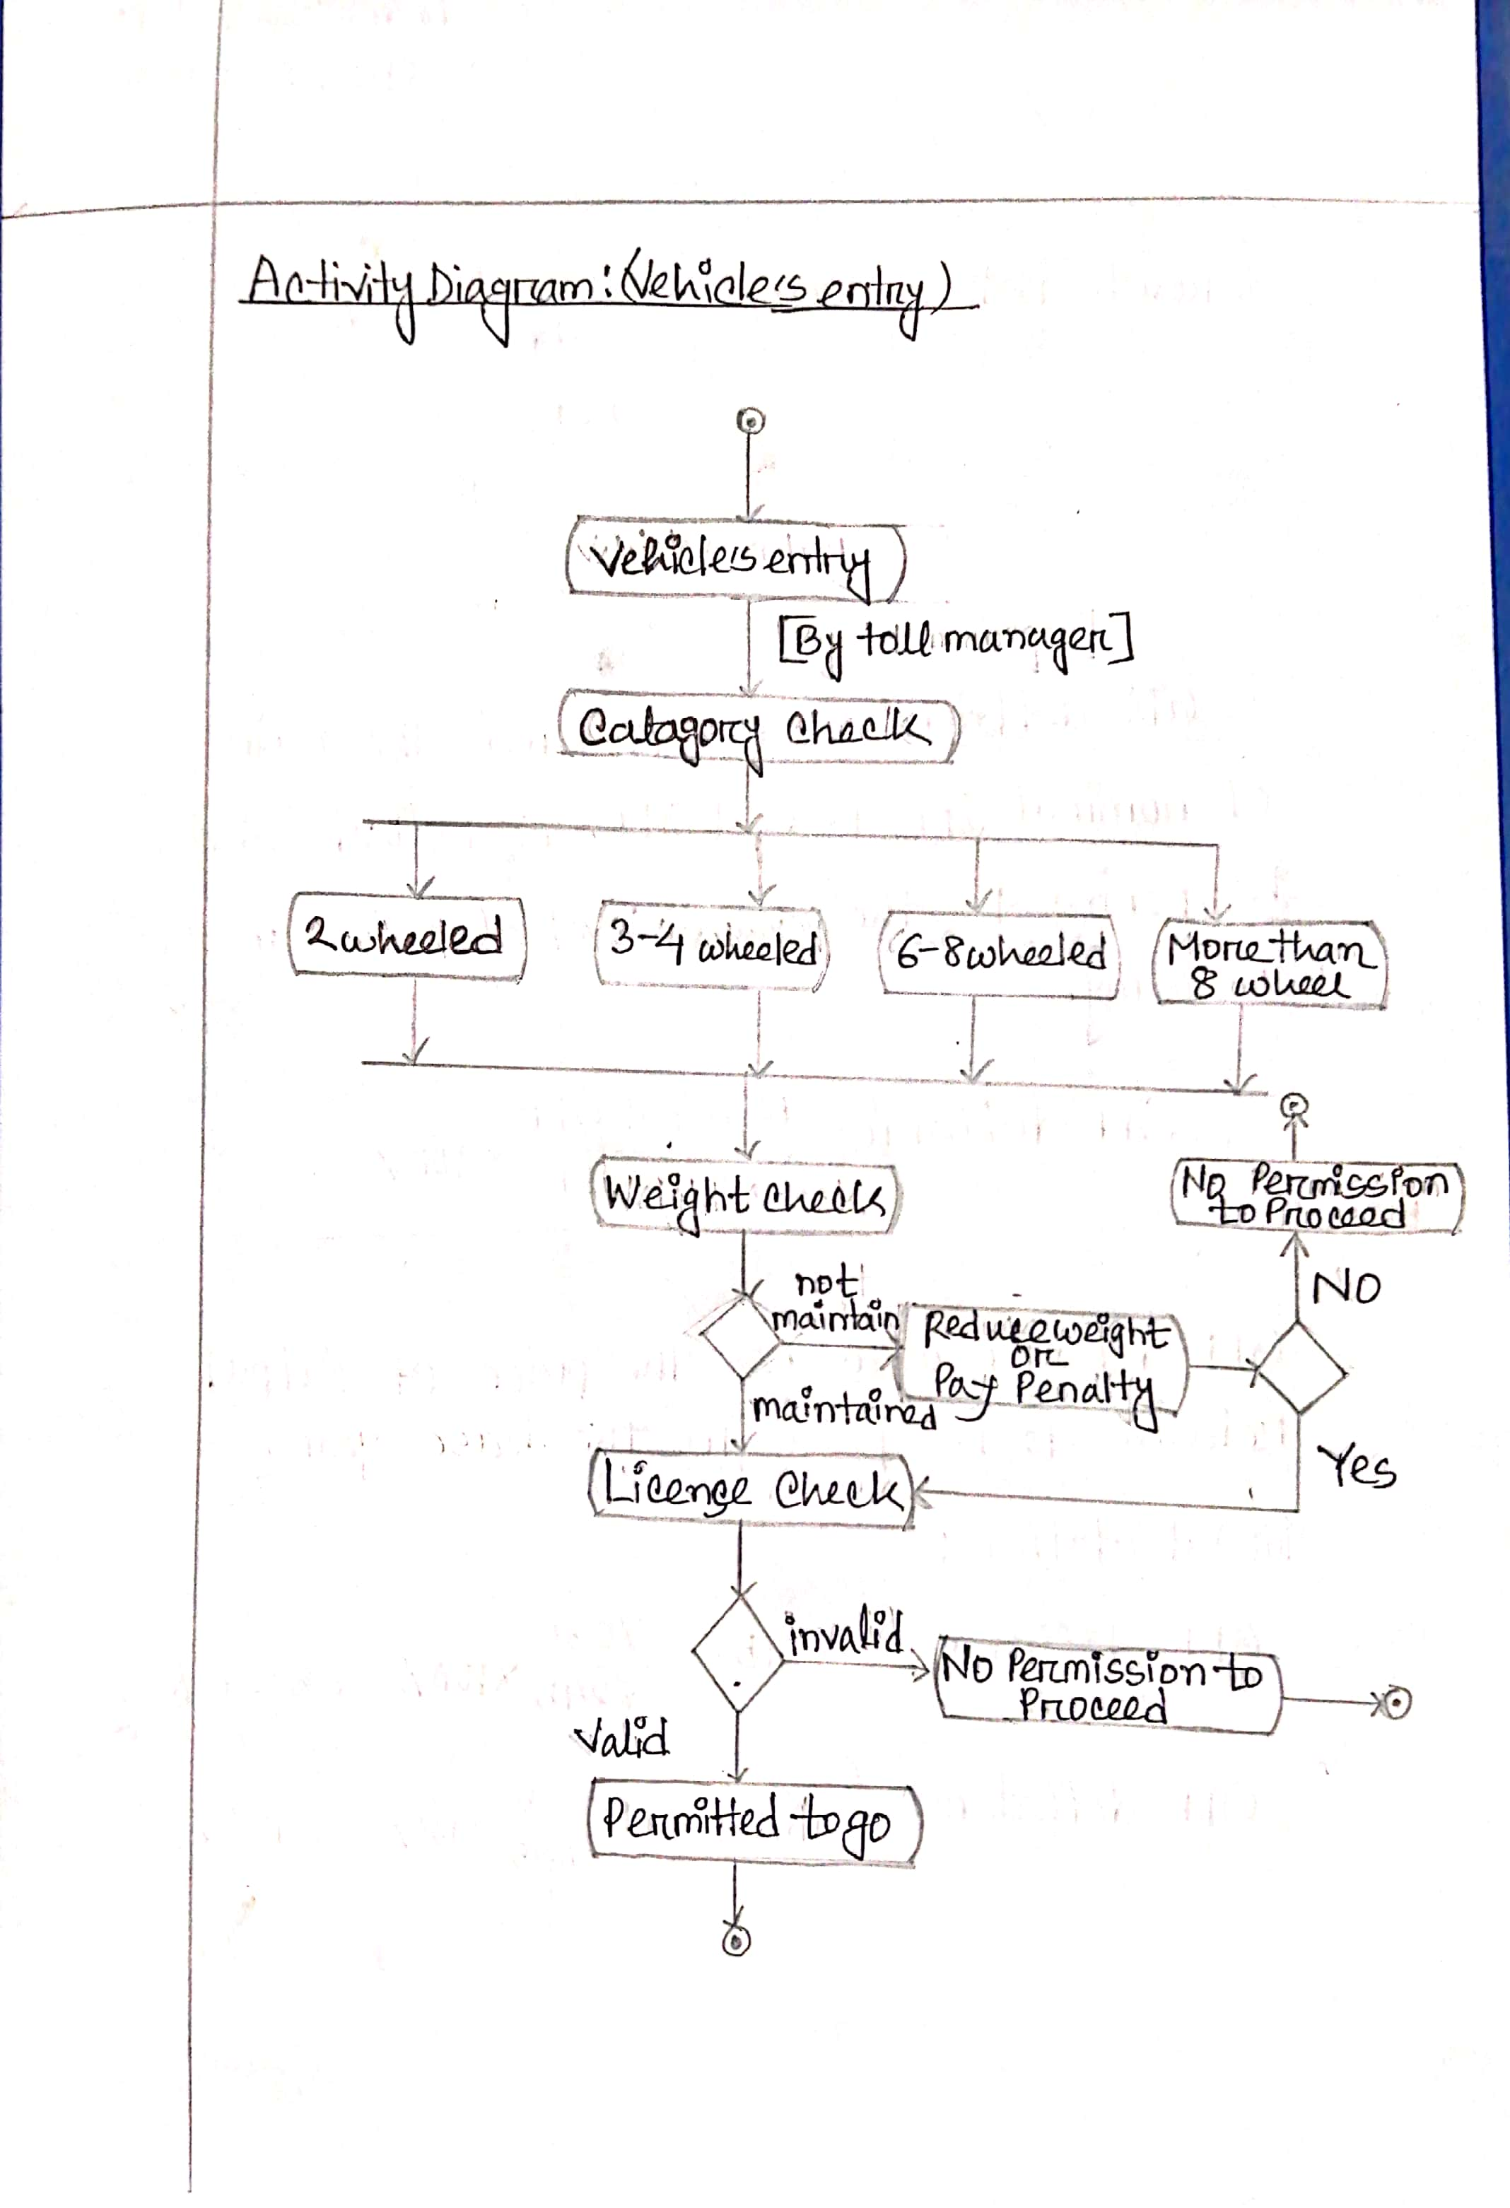

**Activity diagram: Pay Bill’s Part**

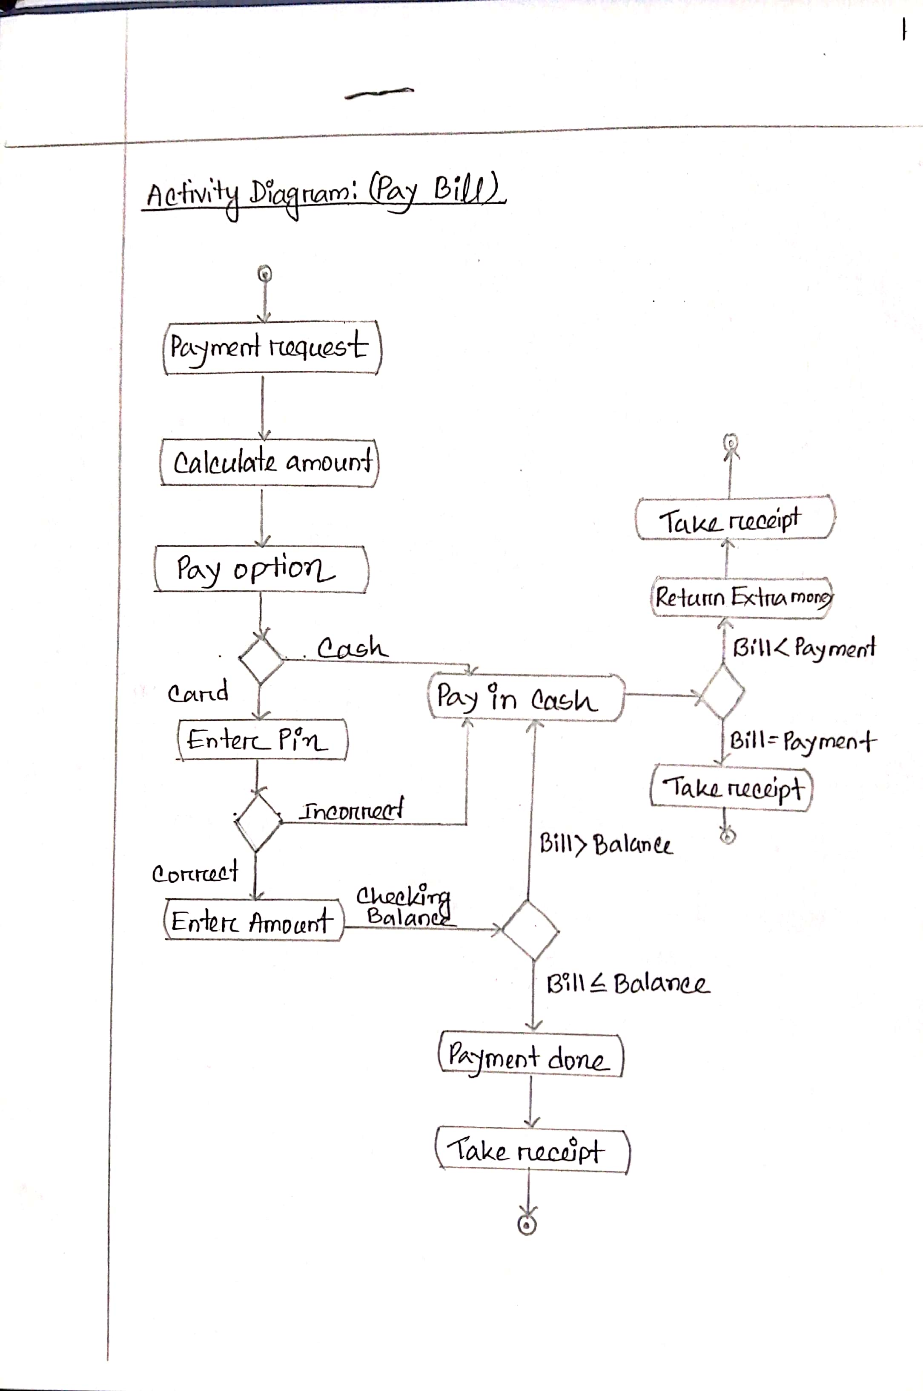

**07. Sequence Diagram for the System:**

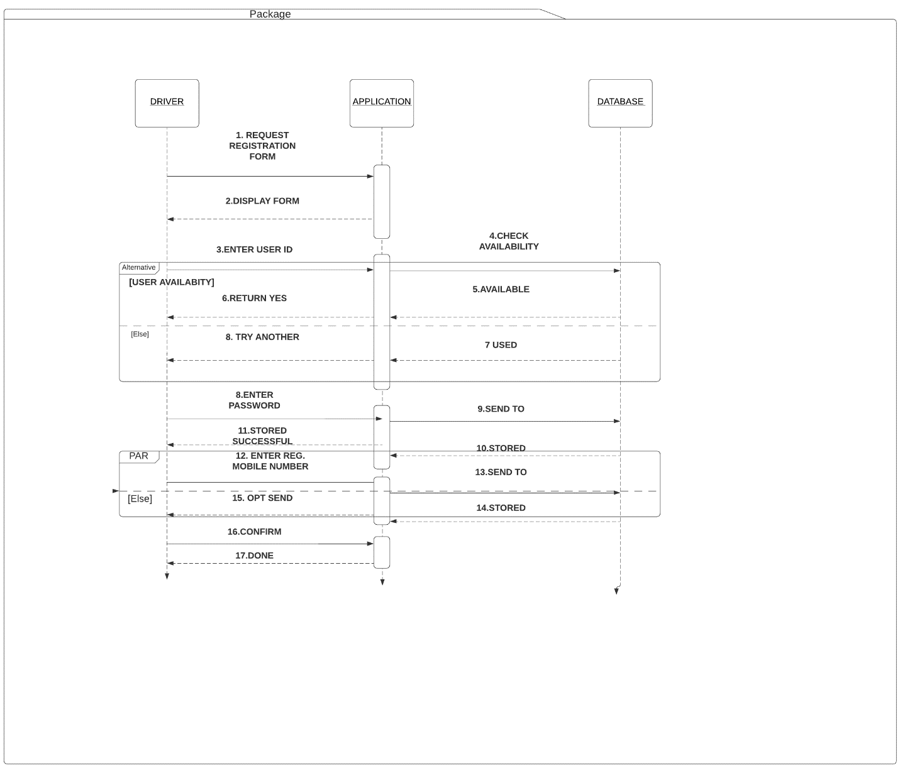

**08. State chart Diagram for the System:**

**Vehicle’s clarification**

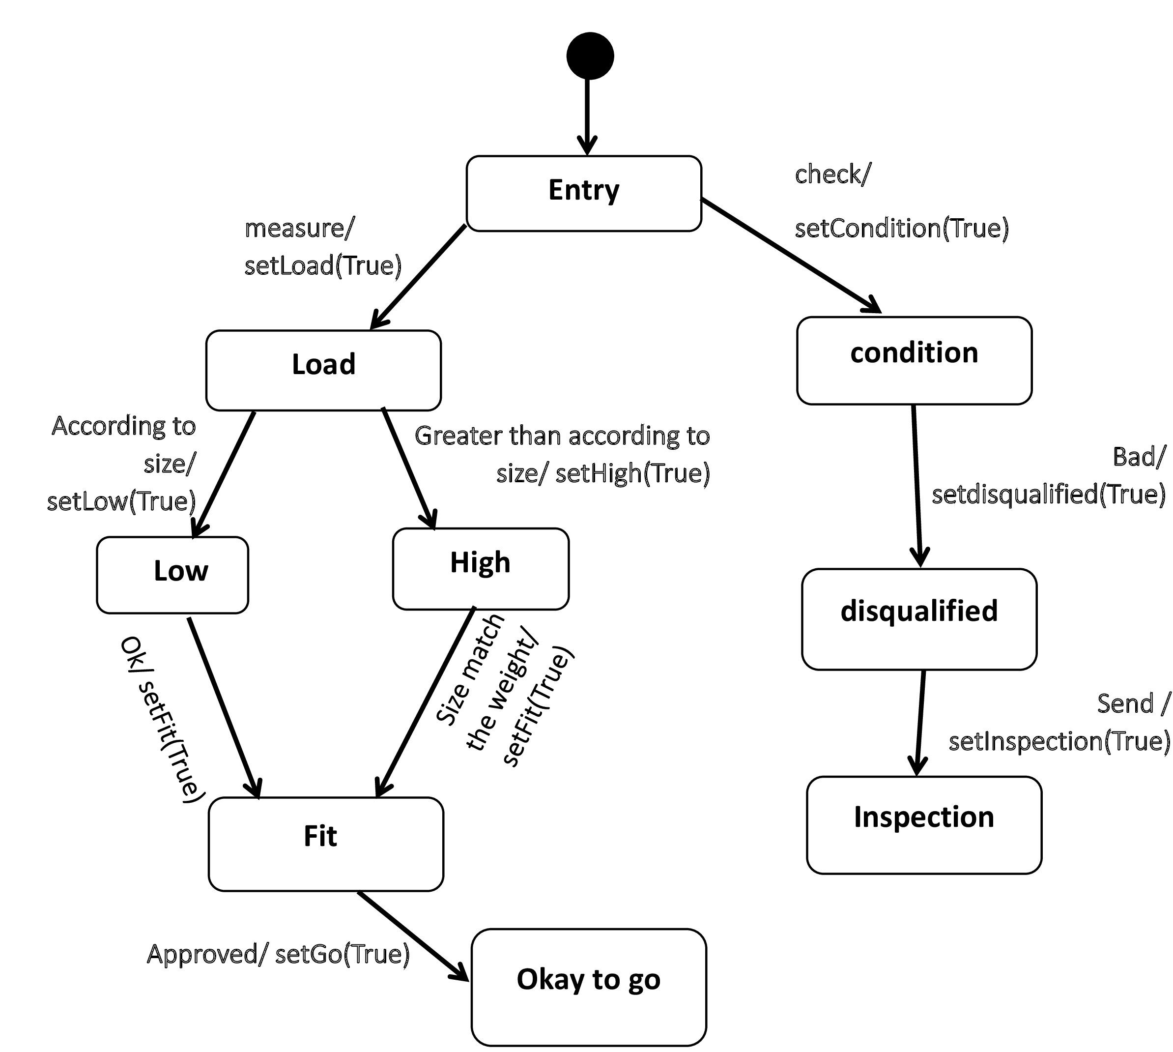

**Toll collection**

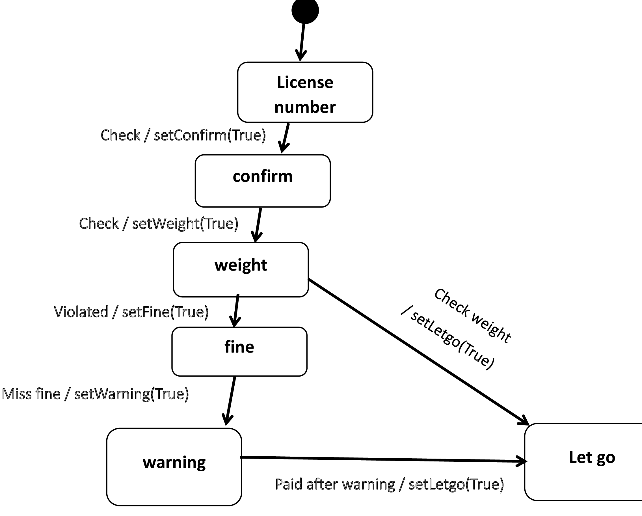

**09. Conclusion:**

Toll management systems play an important role in the growth of infrastructure all over the world. Tolling is a highly effective strategy for dealing with some of today’s most pressing transportation issues. Toll facilities help reduce congestion and improve mobility, and provide an additional source of funding for local construction and maintenance projects.

This system can provide all the information related to Toll booth and the passenger checks in and pays the amount, with the help of the system, then verify the identity of the user and then the vehicle. After the verification the system will collect toll amount and give a receipt to the driver/owner.

Project overview part shows how the proposed system will collect tolls, check license, vehicle type and so on.

Justification part showed why this system is justified and this system is justified

because of its different benefits. And all of the benefits proved in its justification part.

Use case diagram explains the overall use case of the project and Class diagram also showed the classes and there attributes with the operations.

Sequence Diagram showed the sequence work of the individuals. This diagram showed the runtime execution of the system. This diagram showed how

the system will accomplish task.

State chart diagram was an optional task. This diagram was divided into 2 parts.

One showed the different states of the **vehicle’s clarification**. Another one shows **toll- collection.**

So this is how this system will work. All of the diagram together showed the total working system of the “Vehicle toll plaza management system”.