

**American International University Bangladesh**

**(AIUB)**

**MID-TERM Assignment**

**OBJECT ORIENTED ANALYSIS AND DESIGN**

# Submitted To:

**Manzur H. Khan**

**Submitted by:**

**GROUP-25**

**SECTION- A**

**NAME ID**

**Barman,Sajib 19-40881-2**

**Alam, Api 19-40880-2**

**Badhan,Walid Bin 19-40845-2**

**ASSIGNMENT TOPIC:**

**VEHICLE TOLL PLAZA MANAGEMENT SYSTEM**

**FOLLOWING TOPICS:**

1. Scenario.
2. Use Case Diagram.
3. Class Diagram.
4. Detail design (name, attributes, operations) of 3 classes.
5. Design 3 CRC Card for 3 classes.

.

Working scenario of the System:

Vehicle toll plaza management is a system where drivers are come to cross the bridge with tax if he/she has enough legal information and obey all the rules .one or more drivers checked by one or many toll collector where collector check the vehicle category, driver details and license number. Then one license is collected from toll collector to verified by at least one police officer .After that police declare the confirmation to the collector to take payment .Driver can pay bill via cash, card. For over Weight of vehicle ,need to pay extra charge .

**Use Case Diagram for the System:**

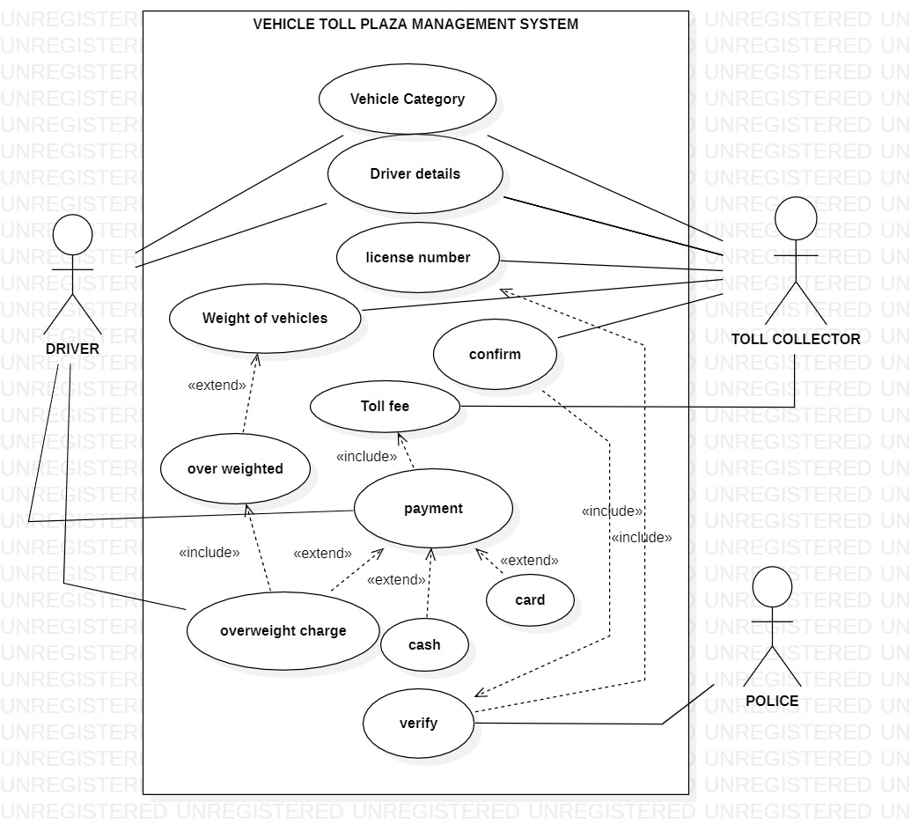

**Class Diagram:**

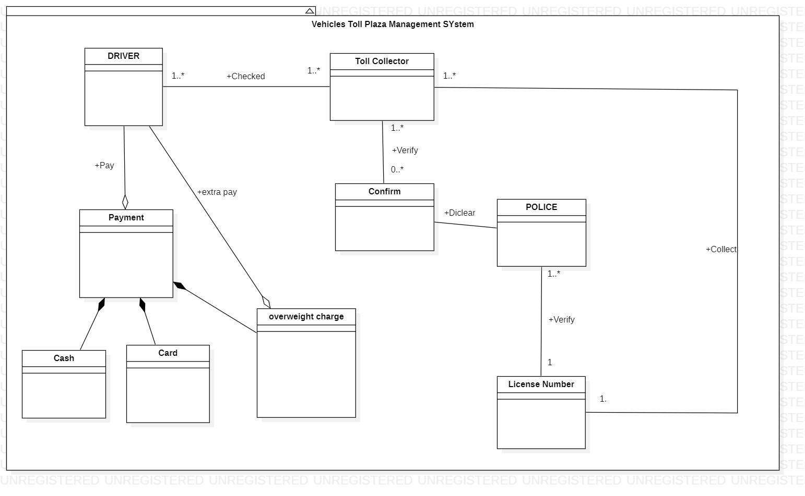

**Detailed design of classes:**

|  |
| --- |
| DRIVER |
| + name: String=blank  + category: string= blank  + Driver id: integer = none {assigned by system} |
| + setname(name:string)  + getname(): String  + setcategory(C:string)  + getcategory(): String |

|  |
| --- |
| PAYMENT |
| +tollfee: double = blank  +overweightcharge: double = none |
| +settollfee(tf:double)  + gettollfee() : double  + setoverweightcharge: (ow:double)  + getoverweightcharge: () : double  +addpayment():void |

|  |
| --- |
| POLICE |
| + licenceNumber: double=blank  + verify: string= blank |
| + set licenceNumber: (licenceNumber:double)  + get licenceNumber (): double  + verify ():void |

|  |  |  |  |
| --- | --- | --- | --- |
| **Class Name** | Driver | **Associated with classs:** Toll collector, Payment | |
| **Description** | Pay overweight charge, keep record of the payment | | |
| **Subclass** | None | **Superclass** | None |
| **Responsibilities** | | **Collaborators** | |
| Keep record of the payment | | Toll Collector | |
| Pay extra | | Overweight Charge | |
| Pay Bill | | Payment | |

|  |  |  |  |
| --- | --- | --- | --- |
| **Class Name** | Toll Collector | **Associated with class:** Driver, Check License Number, Confirm | |
| **Description** | Check license, hold record of driver, connfirm | | |
| **Subclass** | None | **Superclass** | None |
| **Responsibilities** | | **Collaborators** | |
| Check driver license | | Driver | |
| Keep record of driver | | Driver | |
| Verify clearance | | Confirm | |

**CRC Cards of classes:**

|  |  |  |  |
| --- | --- | --- | --- |
| **Class Name** | Police | **Associated with class:** Confirm, Toll Collector, License Number | |
| **Description** | To provide security, check license Number | | |
| **Subclass** | None | **Superclass** | None |
| **Responsibilities** | | **Collaborators** | |
| Check License | | Driver | |
| Provide Security | | Driver, Toll collector | |