

* American International University-Bangladesh (AIUB)  
  **Department of Computer Science  
  Faculty of Science &Technology (FST)  
  Project Title**

**Online service management system.**

**Submitted by**

**Sanjana Fariha Anny**

**ID:19-41184-2**

**Project Title:** **Online service management system.**

**Justification:**

**Project Background Analysis:**

**Description :** This management system makes easier to search any online service effectively. Users can choose their options easily as it gives multiple choice of services. So that they do not need go through the hassle of searching for their desired product on other websites. It brings different products under one roof when multiple websites are merged together. This gives the user a chance to come across products or services that are provided in the system that the user might not have been aware of otherwise and also compare them. For example, users can get multiple products or services in one system and if someone is searching for product ‘X’ and clicks on a website, whilst in our system we also show the same product but at a better price range with comparison of same type of product on other websites. So, the user gets the flexibility over his desired products/services and also in terms of prices.

**UML DIAGRAM**

**CASE: 01(Use Case):**

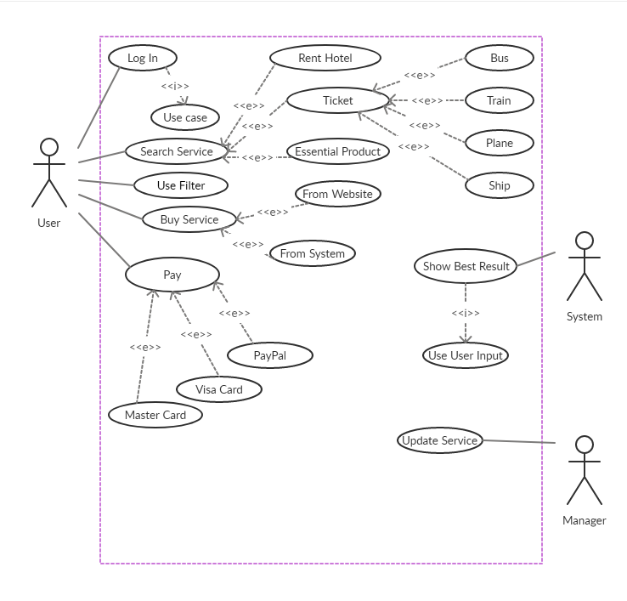

**Case 02: (Class Diagram):**

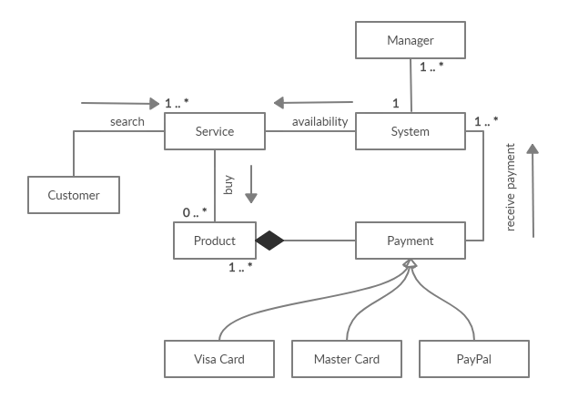

**Class Design:**

**Name of the class:** Payment

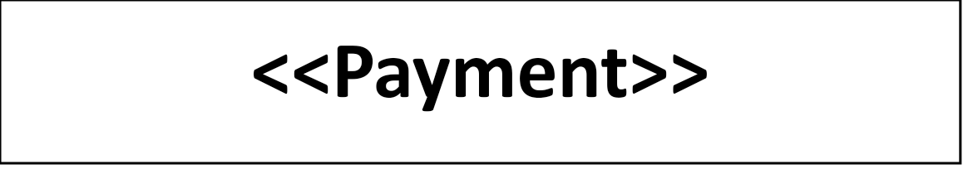

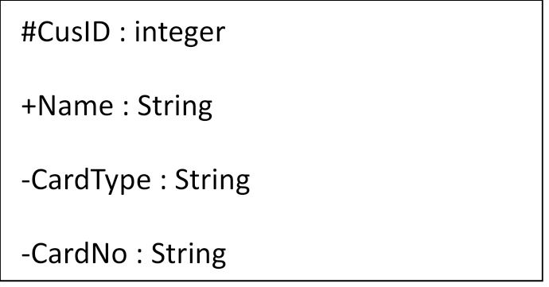



|  |
| --- |
| +PayOption() |

**Attributes :**

|  |  |  |  |
| --- | --- | --- | --- |
| Name | Data Type | Visibility | Remarks |
| CusID | Integer | Protected | Assigned by system |
| Name | String | Public |  |
| CardType | String | Private | From options |
| CardNo | String | Private | From user |

**Operations :**

|  |  |  |  |  |
| --- | --- | --- | --- | --- |
| Name | Arguments | Visibility | Return Datatype | Remarks |
| PayOption |  | Protected |  | Visa/Paypal |

**Name of the class:** Manager

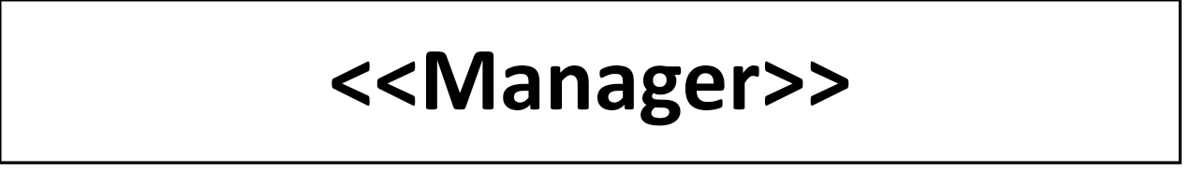

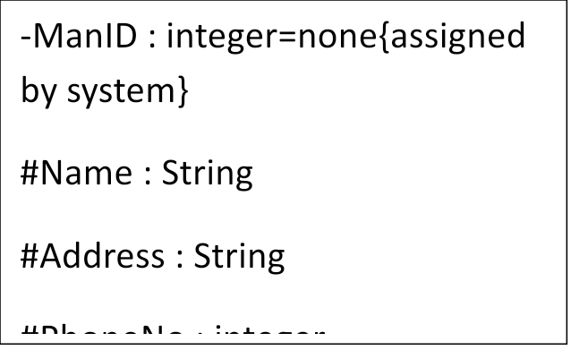

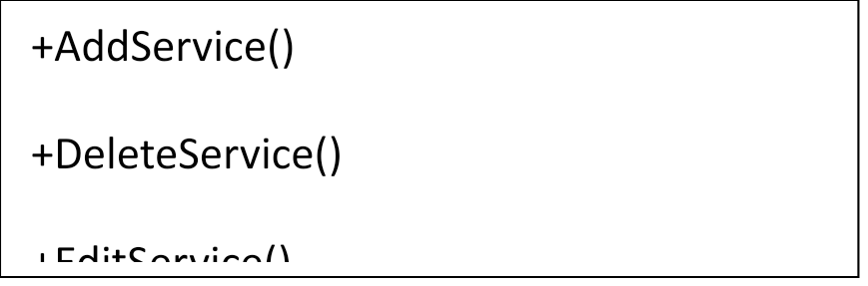

**Attributes :**

|  |  |  |  |
| --- | --- | --- | --- |
| Name | Data Type | Visibility | Remarks |
| ManID | String | Private | Assigned by system |
| Name | String | Protected |  |
| Address | String | Protected |  |
| PhoneNo | Integer | Protected |  |

**Operations:**

|  |  |  |  |  |
| --- | --- | --- | --- | --- |
| Name | Arguments | Visibility | Return Datatype | Remarks |
| AddService |  | Public |  |  |
| DeleteService |  | Public |  |  |
| EditService |  | Public |  |  |

**Name of the class:** User



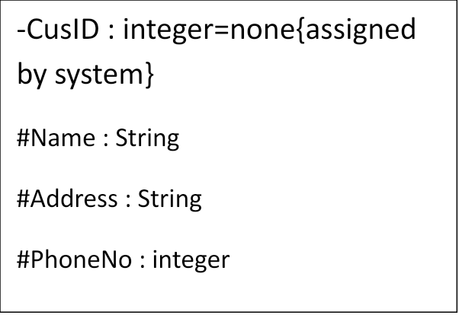

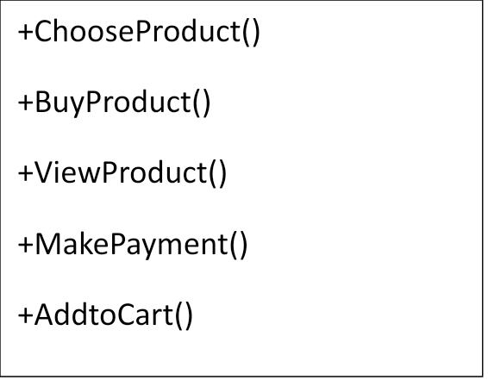

**Attributes :**

|  |  |  |  |
| --- | --- | --- | --- |
| Name | Data Type | Visibility | Remarks |
| CusID | Integer | Private | Assigned by system |
| Name | String | Protected | From user |
| Address | String | Protected | From user |
| PhoneNo | String | Protected | From user |

**Operations:**

|  |  |  |  |  |
| --- | --- | --- | --- | --- |
| Name | Arguments | Visibility | Return Datatype | Remarks |
| ChooseProduct |  | Public |  |  |
| BuyProduct |  | Public |  |  |
| ViewProduct |  | Public |  |  |
| MakePayment |  | Public |  |  |
| AddtoCart |  | Public | Integer |  |
| DeleteFromCart |  | Public | Integer |  |

**Case: 03 (Activity Diagram)**

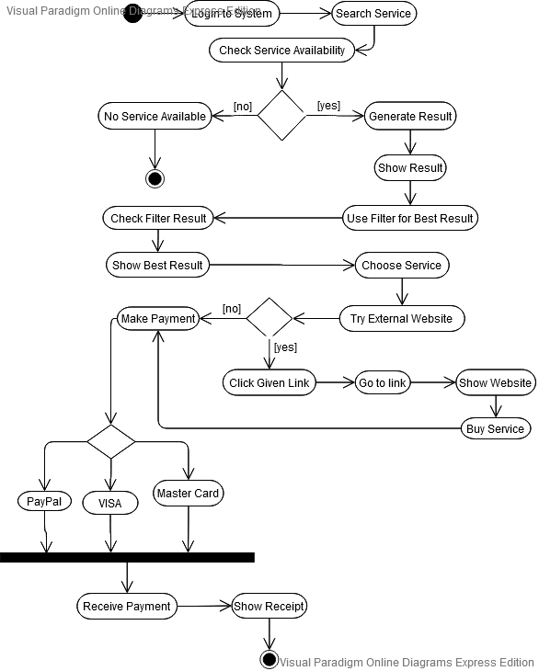

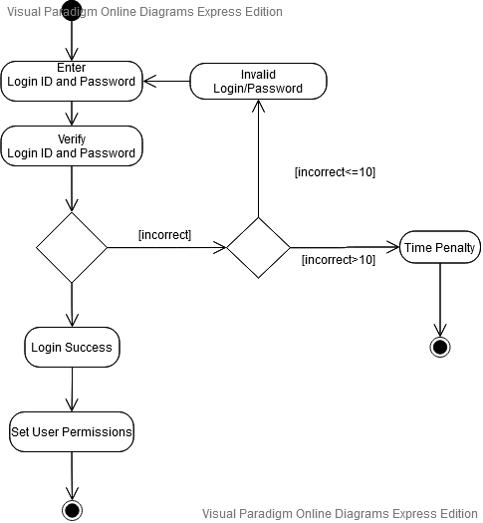

**Case 04 (Sequence Diagram):**

