

**2024**

Threads to Success: Vision of Green Fusion

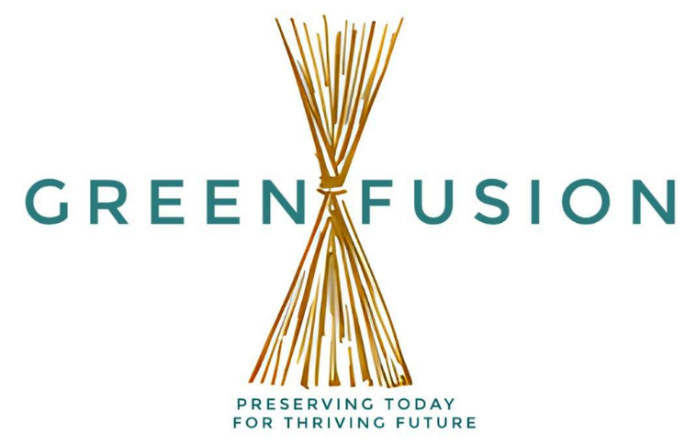

*Submitted to, Submitted by,*

*Ms. Soneya Akter TMS(Group03)*

*Lecturer Section 20*

*Southeast University Batch 65*

Presenting the group members

|  |  |  |  |
| --- | --- | --- | --- |
| NUM | ID | NAME | REMARKS |
| 1 | 2023000000765 | Md. Sahib Talukder |  |
| 2 | 2023200000781 | Md. Mahinol Islam |  |
| 3 | 2023200000795 | Shakil Ahamed |  |
| 4 | 2023200000799 | Md. Mahmud Hossain |  |
| 5 | 2023200000800 | Asaduzzaman Tuhin |  |
| 6 | 2023200000780 | Rifatul Bari Ratul |  |

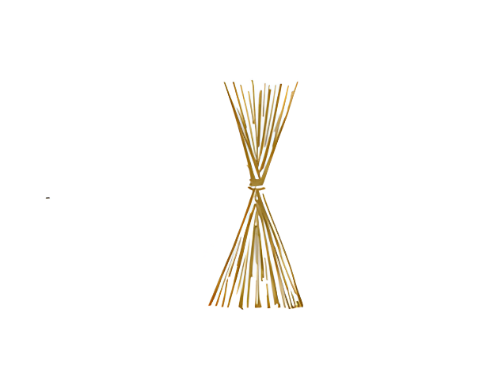

***Table of contents***

*1. Executive Summary*

*2. Introduction*

*3. Discussion*

*i. Business description*

*ii. Product name(s) and description*

*iii. Expanding towards global market*

*iv. Approaches & strategies for expedition of global market*

*v. Barriers to international business*

*vi. Adapting to foreign market*

*4. Conclusion*

*5. Reference(s)*

***1. Executive Summary:***

“Green Fusion” is a forward-thinking company dedicated to fostering a sustainable and eco-friendly future. Specializing in the development and promotion of jute products, Green Fusion focuses on harnessing the potential of this versatile and environmentally friendly material.

The company is committed to reducing the ecological footprint by offering a range of innovative and high-quality jute-based products. With a mission centered around sustainability, Green Fusion not only aims to provide eco-conscious alternatives but also strives to raise awareness about the benefits of utilizing jute. The company's dedication to environmental responsibility is evident in its comprehensive approach to product design, manufacturing, and distribution.

Green Fusion's product line includes a diverse array of jute-based items, catering to various needs and preferences. From durable packaging solutions to stylish and functional everyday products, the company combines sustainability with practicality, appealing to environmentally conscious consumers.

Through its initiatives, Green Fusion contributes to the global shift towards greener practices and reinforces the importance of sustainable choices in today's market. The company stands as a beacon for those seeking environmentally friendly alternatives, embodying a commitment to a greener future through its innovative use of jute materials.

***Climate change is moving faster than we are, but we don't give up because we know that climate action is the only path.***

***Antonio Guterres.***

***2. Introduction:***

Greetings! We have come together to build/for a live able present and a hopeful future. As world is steadily heading towards an inevitable apocalyptic future. But it’s not dark clouds all over the horizon. We can and should do something about this. So, We 5 has come with up “Green Fusion”.

As our moto is “Preserving today for thriving future” Our work is orientated towards sustainable and recyclable goods and products and also promoting and environmentally conscious populous and society. We plan to achieve that by educating masses by various means (demonstration, assembly, out-reach programs etc.). We must also enlighten them about horrors that can or will come because of climate change. Though profit and success always a good motivator for everyone but fighting the climate change is our main objective and goal of our project and company.

Although We plan to incorporate various eco-friendly product, technology and services in our project but our main proponent currently is around jute production and utilizing said jute with proper attention and responsibilities and deliver out products to our costumer.

Now let’s dive into our operation and plan as we discuss potential market, future prospects and hardships. Additionally, we get to analyze production, growth and venturing foreign markets as we plan expand beyond geo-graphical and national boundaries.

***3. Discussion:***

***i. Business name & description:***

We five have come forward with our ideas and co-operation to creation of the **“Green Fusion”**. Our goal is to work toward a green, safe and sustainable present and future. To have a bright future we need put in the work today. As world is record high temperatures with more and more catastrophic and deadly natural disasters and pandemics. We must have to do something about this or end of all we know is inevitable and not so distant. So, our group has come forward with our humble and little plan to do something for sake of the earth. We plan to push the production and use of recycle able, biodegradable and eco-friendly products and goods. Though Green Fusion plans to venture into various sectors and fields but currently we are mainly working towards **“free of plastic”** policy with our **biodegradable and reuseable jute** made products.

**Why Jute?**

It is normal and given that one might ask why jute and we have a logical and convincible argument to support our notion. We gladly will provide numbers and graphs and reasons to convince you of this project.

Jute is now recognized as an environmentally sustainable natural fiber for a wide range of applications, from low-cost geotextiles to high-end carpet, clothing, composites, decorative, upholstery furnishings, and fancy non-woven for new materials. Jute, with its unrivalled versatility, is rightfully dubbed "the fabric of the future." In the coming decades, a number of jute mills and mini-jute plants are expected to become heavily involved in the production of jute and jute blended yarns, especially of finer accounts, through various yarn manufacturing routes. Jute has a wide range of applications, but its common uses include sacking, hessian, and carpet backing. These low weight yarns are used in high-end textile applications such as upholstery, furniture, clothing, and handbags. Jute has been grown in India for centuries and is mostly a grain grown in eastern India. West Bengal, Assam, Bihar, Orissa, Tripura, and Uttar Pradesh are the main jute-growing states. Synthetic fibers, which have certain benefits over jute, have recently posed a threat to the jute industry. As a result, it is important to evaluate the feasibility of jute and the jute market, as well as establish a long-term growth plan.

**Geographical and Production Advantage:**

In the globally or Asian region as of 2024 Bangladesh is world’s largest jute producing country in the world. The country was formerly the world’s top jute producer, but then a lack of technological advancements in Bangladesh’s jute cultivation means that production was stagnant, as was later surpassed by **India** as the global leader in jute production. While India's jute production has decreased by **37%** in the last four fiscal years, Bangladesh's production has remained stable. Bangladesh now accounts for **58%** of global jute production and **53%** of jute, kenaf and fiber products. Our major jute producing regions **Tangail, Dhaka, Jessore, Jamalpur, Bogra**, and **Faridpur**. The country produced an annually **1.349** million tons jute product. (Source: Asia export & FAO, UN)

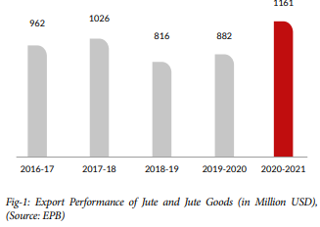

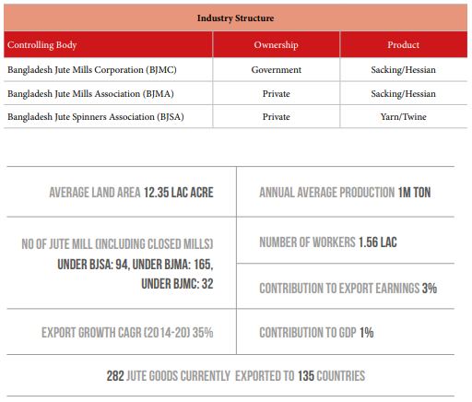

As above graphs show that our jute production and exportation is increasing and it has way more potential with modern technology and farming methods. Its market is as **golden** as golden fiber itself. So, we are confident and hopeful for our present and future endeavors.

***\*Domestic operations:***

“Green Fusion” consists of five highly motivated, work-hungry and committed individuals. Before going international we plan to be strong and formidable force in our countries domestic market. Though our project is more online service oriented but we plan to establish an outlet in our countries capital Dhaka and have plans to expand in future nationally and internationally to a somewhat smaller scale as we base our project around internet service with help of various web platforms. We have already made some progress in this sector as we have managed to create an online website for our products. In not distant future website will also be used for giving a glimpse to investors and foreign exporting companies.

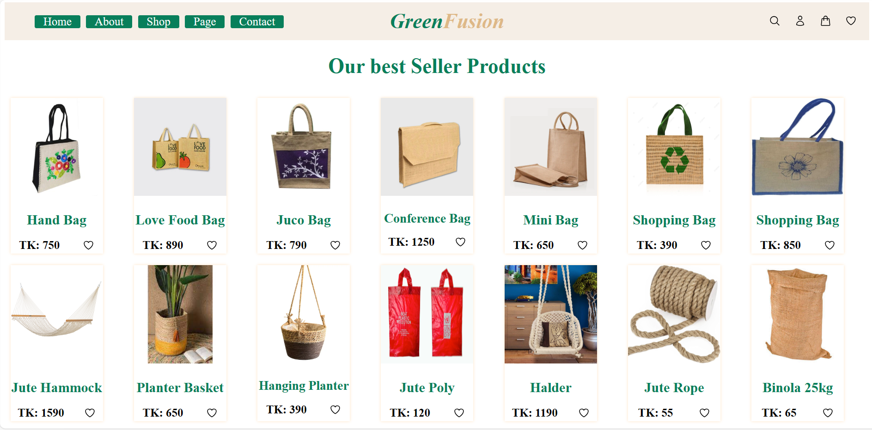

***ii. Product name & description:***

“Green Fusion” will be your trusted jute manufacturer and is dedicated to crafting eco-friendly essentials. From durable bags to stylish decor and smart packaging, we blend quality with environmental responsibility. Embrace a stylish and sustainable lifestyle with Green Fusion, where each choice reflects our commitment to both elegance and the planet.

Dive into our exquisite line of jute bags, meticulously crafted from high-quality, biodegradable jute fibers and we are also offering standard ordinary bag for heavy and daily use. These bags not only exude a timeless charm but also contribute to the **reduction of plastic waste**, aligning with Green Fusion's mission to promote a greener planet. From chic tote bags to durable shopping bags, each product reflects our dedication to combining fashion with ecological mindfulness.

Moreover, Green Fusion's commitment extends to practical and sustainable solutions for agriculture. Our jute-based agricultural products, including soil erosion control blankets **(Geo-textile)** and biodegradable mulch mats, cater to environmentally conscious farmers looking for effective yet sustainable farming practices. These products leverage the inherent properties of jute to provide eco-friendly alternatives that foster responsible agriculture. Geo-textile is also really beneficial for our country of rivers because it deters erosion, which is a major headache for our govt. and people.

We also have products home décor. Beautify your world and beyond with our décor items. From colorful carpets to high-end chandeliers, we can provide everything one needs to transform a gloomy and unimaginative concrete box to your so-called Home. Our jute made decors will make your home lively while protecting the planet from harmful products while also supporting our jute industry, that is a corner stone of our countries economy and livelihood of many.

Embrace sustainability with our products for a green and lively future. Join us for a journey to make a change and be part of climate conscious individuals of our green and exquisitely beautiful country.

***iii. Expanding beyond horizon:***

We want go beyond national and geo-graphic boundaries and spread our shade of green worldwide. We plan to develop our brand and establish outlets in every major city (NYC, London, Tokyo etc.) of the world. But we don’t want to stretch ourselves to thin and too fast. We want to take measured and calculated decisions regarding our expansion. For now, we have **Japan** and **Denmark** in our sights. As Demark ranks **1st** in terms of **most environmentally conscious** countries. And as for Japan, our reasoning is quite simple, it’s a major **Asian power** that has been a forefront warrior of climate war so expanding to Japan is a no brainer.

1. ***Market analysis: Denmark***

The minimum price of EUR **0.54** for a carrier bag, regardless of its size or type of plastic, sends a clear signal to the consumers that it pays off to reuse plastic carrier bags rather than throw them away after only one use. The ban on lightweight plastic carrier bags as well as the minimum price on plastic carrier bags came into force on **1 January 2021**. So, market for biodegradable and reuseable carrier is wide open and their populus is also open to adaptation as it will save them money in long run.

**\*We have estimated that a family of 4 will save around 54.37 £ (approximately) if they completely switch from plastic to reuseable bags**

***b) Market analysis: Japan***

Although Japan may lead in many sectors and various different fields (stem, tech) but they do have a massive problem regarding plastic usage. Japan has really high plastic usage in comparison of other developed countries. Per capita consumption is also high. **Japan has the second-highest plastic waste emissions per person in the world**. The most common method for disposing plastic waste in Japan is through incineration. Only **22%** of the collected plastic waste becomes mechanically or materially recycled. (source: IGES)

This opens up a market for us as there has been rise of interest in reuseable and biodegradable in younger and more climate conscious population. So far, we can we are hopeful for future endeavors and market trend supports our notion.

***iv. Approaches to international business:***

Every firm has different approaches and principals in international business. Our principals is quite simple and straight forward. We say ***“Co-operation for benefits and providing benefits for co-operation”*** in more simple terms it means mutual benefit is must and most important for us and we are ready to concede higher profit margin for a long and mutually beneficial contracts.

As of now our main approach is **Exporting** and **Trading Companies** but we have plan for joint ventures and even direct ownership. But they are future prospect. Now, lets talk about current approach.

1. ***Exporting:***

Exporting is our main approach at the most because it requires least amount off resources and money. Moreover, we plan to contact with various countries that sells BD made goods worldwide and come with deal that makes exporting cheaper for both companies. Bangladesh also has recent surge in exporting in jute and jute related products because of govt. policies and usages of modern machineries in farming also govt. subsidies this sector as well. So, exporting is now relatively hassle free, friendly and less bumpy compared to others for our journey.

1. ***Trading companies:***

Trading companies give us even a greater advantage. Our connection and name will grow if can produce quality products time and time again and our demand will increase so will our sells and stability. As our brand name and value increases, we will be able to conduct more and larger operations worldwide.

***v. Barriers to international business:***

1. ***Cultural and Social Barriers:***

In certain areas of the world, a simple gift may be interpreted as a bribe, while in others presents are commonly solicited to further negotiations. **Playing a game when you don't know the rules puts your business venture at risk**. So, being aware of cultural barriers makes them easier to navigate. Before we try breaking into a foreign market, we need to invest a lot time to prepare. We have to attend seminars and read about the culture in the countries where we wish to do business. This will help us avoid making incorrect assumptions or inadvertently committing gaffes that could hinder our project.

1. ***Tariffs and trade restrictions:***

Tariffs or import tax adds more cost to product to the production as production cost increases so does selling price. As this increase in cost makes product less desirable to locals which in turn reduces demands and instills chance of huge loss of products, materials and money.

***vi. Adapting to international business:***

1. ***Product***:

First foremost important thing is the quality of product but sometimes a quality product can fail because of various reasons. So, it is advisable and important is take note of culture and history of said country and alternate the product to cater that specific demographic.

**EX:P&G Diapers**completely remodeled its product for local markets. Their research many features weren’t considered necessary in poorer countries, and the price seemed to be the critical factor. So, by amending packaging and product materials, they managed to match the price point (to the same as a single egg) without damaging the brand. (source: ux)

We plan to do something similar to does as we are mainly exporting to Denmark and Japan. Both off these countries are very different from one other so plan to cater to their needs respectively. As Japan’s culture is very **colorful** and **vibrant**. (Colors in Japan are **heavily influenced by Shintoism)**. We plan to export more unique and colorful product to Japan. Whereas in Denmark we are keeping it more **standard** dark **colors** and using **less flashy** designs.

1. ***Promotion:***

Promotion strategy also differs from country to country. We must be aware of what type and what is considered acceptable promotion. Mistake can be costly and plumet companies’ reputation down. **Promotion with Cultural adaptation** Is crucial for success. To promote we must understand their lives and their culture. Regarding Japan, it is closely connected and traditional society. So, we need be extra careful to not come as arrogant or too out of touch.

Hard sell tactics, which focus on directly telling consumers why they should buy a particular product, are not popular in Japan. Instead, **Japanese ads aim to create a positive emotional experience for viewers,** which can be completely divorced from any particular product or service feature. **This is known as soft selling**, and it's a core concept that many ad campaigns in Japan are built around. Japanese advertising often relies on a soft sell approach, using elements such as **music, colors, symbols, aesthetics, and narratives** to create a specific mood and atmosphere. (source: Digital marketing of Asia)

1. ***Creating a connection:***

Connection is really important in today’s world. Building connection with our customers is our weapon to conqueror the global market. Being a big, famous brand and being one with customers isn’t same. We might not have budgets of other corporation giants but we plan to build **cordial** and **heartfelt** connection and build a **community** and be a part of them through and through.

Emotional appeal advertising is a marketing strategy that aims to create an emotional connection between the consumer and the product or service being advertised that will then influence the consumer's purchasing decision, often without their conscious, rational brain even realizing it. (source: Neurons, 2023)

***4. Conclusion:***

To draw a conclusion of our plan and vision we want to do something for that will not only benefit us, our country but whole world. It might seem insignificant and miniscule in grand scheme of things but we want to contribute to as much as possible.

***Even if one less extra pollutant is in market and even one person becomes climate conscious and reduces their carbon footprint, we will consider our project a successful endeavor.***

***Thanks for being with us.***

*The clearest way into the Universe is through*

*a forest wilderness.*

*John Muir*

***References***

1. ***Jute and hard fibers | FAO, United Nations***
2. ***Bangladesh jute production | BJRI***
3. ***Jute exports | ESB***
4. ***Jute exports rise record 31% | The business Standard***
5. ***Danish govt. ban lightweight plastic carrier bag | Ministry of Food, Agriculture and Fisheries of Denmark***
6. ***Japan’s plastic waste management | Institute for Global Environmental Strategies***
7. ***Production adaptation in foreign markets | UX24/7***
8. ***Marketing to Japan Consumers | World Bank***
9. ***Marketing in Japan | Digital Marketing for Asia***
10. ***Why Brands Use Emotional Advertising & How to Effectively Measure Emotions | Neurons HQ.***