Cosmic Microwave Background temperature and polarization
anisotropies from the large-N limit of global defects
†
†
†
§
†,‡
Elisa Fenu
,
Daniel
G.
Figueroa
,
Ruth Durrer
,
Juan Garc´ıa-Bellido
and Martin Kunz
†
D´epartement
de Physique Th´eorique and Center for Astroparticle Physics,
Universit´e de Gen`eve,
24 quai
Ernest
Ansermet,
CH–1211 Gen`eve 4,
Switzerland
§
Instituto de F´ısica Te´
orica IFT-UAM-CSIC,
Universidad Aut´
onoma de Madrid,
C/ Nicol´as Cabrera 13-15,
Cantoblanco,
28049 Madrid,
Spain and
‡
African Institute for Mathematical
Sciences,
6 Melrose Road,
Muizenberg,
7945,
South Africa
(Dated:
June 22, 2021)
We determine the full
C
spectra and correlation functions of the temperature and polarization
`
anisotropies in the CMB,
generated by a source modeled by the large N limit of
spontaneously
broken global
O(N )-theories.
We point out a problem in the standard approach of
treating the
radiation-matter transition by interpolating the eigenvectors of the unequal-time correlators of the
source energy-momentum tensor.
This affects the CMB predictions from all type of cosmic defects.
We propose a method to overcome this difficulty.
We find that in the large-N global model that we
study, differences in the final CMB power spectra amplitudes reach ∼ 10%−20% in all channels (TT,
EE, BB and TE) when compared to implementations of the eigenvector interpolation technique.
We
discuss as well
how to optimally search for the contribution in the CMB from active sources such
as cosmic defects, in experiments like Planck, COrE and PRISM.
PACS numbers:
98.80.-k,98.80.Es
metry.
They only scale like the energy density of
radi-
I.
INTRODUCTION
ation if they are line-like,
i.e.
cosmic strings.
Point-like
local defects, e.g. monopoles, which scale like matter and
The cosmic microwave background (CMB) is the most
soon come to dominate the Universe,
are therefore ex-
precious cosmological tool.
It has not only led to two No-
cluded.
Event-like local defects, i.e.
local textures, leave
bel prizes in physics, but it has truly revolutionized cos-
no significant trace.
Global defects are those from a phase
mology, promoting it from an order of magnitude science
transition which breaks a global
symmetry.
Except for
to ’precision cosmology’.
The reason for this is twofold:
the case of domain walls,
which also over-close the Uni-
on the one hand,
CMB temperature and polarization
verse,
global
defects in general
scale and are therefore
anisotropies are small, so that they can be calculated to
viable, independently of their dimension.
For reviews on
good accuracy by linear perturbation theory and, on the
cosmic defects see [9–11].
other hand,
very precise measurements have been per-
Cosmic defects
lead to a variety of
phenomenologi-
formed by a range of satellite, balloon and ground based
cal
effects,
including the creation of
CMB temperature
experiments [1–4],
most recently by the Planck collabo-
and polarization anisotropies [12–16], the imprint of non-
ration [5, 6].
The Planck temperature data demonstrates
Gaussian signatures in cosmological
perturbations [17–
an impressive agreement with the standard flat ΛCDM
20],
the generation of
cosmic rays [21,
22],
or the cre-
model for angular scales covering three orders of magni-
ation of cosmic magnetic fields [23].
Several backgrounds
tude, with error bars that are cosmic variance limited to
of
gravitational
waves are also expected from the cre-
above ` ∼ 1000, well into the damping tail of the CMB.
ation [24],
evolution [25–28]
and decay [29–32]
of
cos-
Planck has measured the baryon acoustic scale of
the
mic defects.
The amplitude of
the CMB fluctuations
CMB to a precision of 0.06%, and within the flat ΛCDM
from cosmic defects is of
the order ∆T/T ∼ 4πGµ =
model
it has constrained all
basic parameters,
with the
2
4π(M/M
)
,
where M denotes the energy scale of
the
exception of
the reionization optical
depth,
to an accu-
p
2
phase transition, and G = 1/M
is the gravitational cou-
racy of better than 3%.
p
19
pling, with M
= 1.22 × 10
GeV the Planck mass.
The ‘cleanliness’ of the data and the high accuracy of
p
the measurements render the CMB an optimal probe of
If
the phase transition creating the defects is driven
physics of the very early Universe,
i.e.
at very high en-
by thermal
effects,
the scale M is roughly given by the
arXiv:1311.3225v2 [astro-ph.CO] 10 Mar 2014
ergy.
One suggestion, which goes back to Kibble [7, 8], is
critical
temperature T
[9]
(as long as the gauge cou-
c
that a symmetry breaking phase transition in the early
pling is not larger than the self-coupling of the symmetry
Universe might have led to the formation of cosmic de-
breaking scalar field).
Hence a GUT scale transition with
15
16
fects.
Such defects are inherently inhomogeneous and
T
∼ 10
− 10
GeV should leave observable traces in
c
−8
−6
anisotropic field configurations,
thus leading necessarily
the CMB, with Gµ ∼ 10
−10
.
For cosmic strings, de-
to fluctuations in the CMB. Local defects are those gener-
tailed simulations have led to pre-Planck constraints as of
−7
ated from a phase transition which breaks a gauge sym-
Gµ ≤ 4.2 × 10
[33].
Assuming that cosmic string loops
2
decay into gravitational
waves,
constraints from limits
radiation-matter transition by interpolating the eigenvec-
on a gravitational wave background can be derived, with
tors of the unequal-time correlators of the source energy-
−7
limits from Pulsar Timing Arrays as of Gµ ≤ 5.3 × 10
.
momentum tensor.
We propose a method to overcome
Note however that these constraints depend on uncertain
this
difficulty,
and characterize the differences
arising
assumptions, see [34, 35] for recent discussions.
Also sim-
in all
CMB power spectra amplitudes from the large-N
ulations for global
defects [36]
and for semilocal
strings
model, as compared to previous estimations.
[37] have been performed and have led to similar, if some-
The paper is structured as follows.
In section II we
what weaker,
constraints.
The current best limits from
discuss the large-N modeling of
the defects arising af-
the CMB are those from the Planck collaboration [38],
ter the spontaneous symmetry breaking of a global O(N)
which contend that the contribution from cosmic defects
theory.
We place particular emphasis on the calculation
to the temperature anisotropy at multipole l
= 10 can-
of
the unequal
time correlators of
the various energy-
not be more than 1% − 5%, depending on the type of de-
momentum tensor
components,
which are
crucial
for
fect.
This translates into an improvement of the bounds
the correct computation of
the the CMB signals later.
−7
to Gµ ≤ 3.0 × 10
for Abelian-Higgs cosmic strings,
In section III
we describe how to compute the CMB
−7
to Gµ ≤ 1.3 × 10
for Nambu-Goto strings,
and to
anisotropies and polarization amplitudes, quantifying the
−6
Gµ . 10
for both semilocal
strings and global
O(4)
uncertainties in the calculation, which might also be rel-
textures.
evant for cosmic strings and other defects.
We calculate
both the power spectra and the correlation functions.
In
It has been shown in the past [39] that the energy den-
Section IV we determine the signal to noise ratio from dif-
sity from global
defects is dominated by the gradient of
ferent observations in order to specify the optimal strat-
the fields.
It has also been shown that O(N ) models with
egy to constrain the model.
In Section V we conclude.
N > 4, which do not lead to topological defects in 3 + 1
Notation:
Throughout
we consider
a flat
Friedman
space-time dimensions, actually lead to similar results as
background with metric
global monopoles (N = 3) and global textures (N = 4).

They exhibit the same scaling and the same shape of the
2
µ
ν
2
2
i
j
ds
= g
dx
dx
= a
(t)
−dt
+ δ
dx
dx
,
µν
ij
power spectrum; when normalised to the same power at
low `, their amplitudes differ by less than 30%.
The main
where a(t) is the scale factor.
A dot denotes a derivative
difference is the fact that decoherence [11], which leads to
w.r.t.
conformal
time t so that H = ˙
a/a is the comov-
a smearing out of the acoustic peaks in the CMB power
ing Hubble parameter,
related to the physical
Hubble
spectrum,
is stronger for N = 3, 4 defects than for the
parameter H by H = aH.
large-N limit which we discuss in this paper.
In the large-N limit, N 1, the equation of motion for
the global O(N ) symmetric scalar field can be linearized
II.
THE LARGE N SIGMA-MODEL
and solved exactly up to corrections of
order 1/N [40].
This allows for an analytical
understanding of
the re-
A.
The model
sulting non-topological field configurations.
In addition,
the calculation of
the energy-momentum tensor and its
We consider
an N -component
scalar
field with La-
unequal
time correlators in this case only requires some
grangian
convolution integrals and no expensive numerical
simu-

2
lations.
We will use the unequal time correlators (UTC)
†
µ
†
2
L = −∂
Φ
∂
Φ − λ Φ
Φ − v
/2
+ L
,
(1)
µ
int
of the global large-N limit to compute the CMB temper-
√
ature and polarization anisotropies.
We then compare
†
where Φ
= (φ
, φ
, ..., φ
)/
2, and λ and v are the di-
1
2
N
the resulting C
spectra and correlation functions with
mensionless self-coupling and vacuum expectation value
`
experimental
capabilities and identify the best strategy
(VEV) of
Φ in the true vacuum.
Here L
represents
int
to constrain defect models.
Besides being a ’cheap’
but
interactions of
Φ with other
degrees of
freedom.
For
quite accurate toy model for global
defects,
the large-N
a phase transition within a thermal
bath,
L
repre-
int
limit has an interest in itself:
it may very well
be the
sents the interactions of Φ with the thermal environment
case that inflation is not governed by one single scalar
at temperature T .
In this case,
and to leading order,
field but that there are multiple scalar fields which are
2
2
†
L
∼ g
T
Φ
Φ, with g
an effective thermal coupling.
int
T
T
exited e.g.
during preheating.
Such a situation might be
In the context of
hybrid preheating [42]
L
represents
int
modeled by the large-N limit discussed in this work.
interactions between Φ and a scalar singlet χ,
the infla-
In a previous
paper
[41]
we have looked at
the B-
ton.
A typical
interaction Langrangian in this scenario
2
2
†
2
polarization alone for both the large-N and other de-
is L
= g
χ
Φ
Φ, where g
is a dimensionless coupling.
int
fect models.
In this work we discuss all the spectra and
At low temperature T v in one case, or small inflaton
√
correlation functions,
T T ,
T E,
EE and BB,
but
we
amplitude χ (
λ/g)v in the other,
the global
O(N)
consider only the large-N model,
which represents the
symmetry of the Lagrangian is spontaneously broken to
entire class of
models with several
(3 or more) O(N )-
O(N −1).
Soon after the symmetry is broken, thermal or
symmetric global
scalar
fields.
We also point
out
an
tachyonic effects can be neglected,
and Φ is closely con-
inconsistency in the standard approach of
treating the
fined (in most of space) to the vacuum manifold, given by
3
P
1
1
†
2
2
Φ
Φ =
φ
(x, t) =
v
.
Nevertheless,
in positions
diverges for small
argument.
We keep only the regular
a
a
2
2
with co-moving distance larger than the inverse of
the
mode of the solution J
, which can be written as
ν
0
−1
co-moving Hubble parameter, |x − x
| > H
, the direc-

1
−γ
0
√
tion of Φ(x, t) and Φ(x
, t) within the vacuum manifold
t
J
(y)
2
ν
a
a
β
(k, t)
=
A
β
(k, t
) ,
(8)
are uncorrelated due to causality.
This leads to a gra-
∗
ν
t
(y
)
∗
∗
dient energy density associated to the N − 1 Goldstone
2
modes,
ρ ∼ (∇Φ)
.
For N > 2,
the dynamics of
the
i
where β
(k, t
) is the i-th component of the field at the
∗
Goldstone modes is approximately described by a non-
initial time t
and y = kt, y
= kt
.
In the large-N limit,
P
∗
∗
∗
2
2
linear sigma model [39, 40] where we enforce
φ
= v
β is initially distributed with a white noise spectrum on
a
a
by a Lagrange multiplier.
This corresponds to the limit
large scales and vanishing power on small scales
λ → ∞ in the above Lagrangian.
This approximation is
(
very good for physical scales which are much larger than
δ
3
0
(2π)
δ(k + k
)
,
kt
≤ 1
√
ij
∗
N
i
j
0
−1
hβ
(k, t
)β
(k
, t
)i =
m
≡ 1/(
λv).
∗
∗
0
,
kt
> 1 .
Normalizing the symmetry breaking field components
∗
(9)
to the VEV, β
≡ φ
/v, each component obeys the sigma
a
a
This means that the field is aligned on scales smaller than
model evolution equation [43]
the comoving horizon t
and has arbitrary orientation
∗
a
µ
a
β
− (∂
β · ∂
β)β
= 0
(2)
on scales larger than t
.
Consistency of
this solution
µ
∗
requires [26, 44]
P
µ
µν
a
a
where (∂
β ·
∂
β)
=
g
∂
β
(x, t)∂
β
(x, t)
and
P
µ
µ
ν
a
a
a
β
(x, t)β
(x, t) = 1.
In the large-N limit,
the sum
2
ω
= 3(γ + 1/4) ,
ν = γ + 1
and
(10)
a
0
over components can be replaced by an ensemble average
4Γ(2ν − 1/2)Γ(ν − 1/2)
A =
.
(11)
over one of the field components (say the first one),
3Γ(ν − 1)
X
µν
a
a
µν
1
1
2
g
∂
β
∂
β
= Nhg
∂
β
∂
β
i = ω
(t) ,
(3)
µ
ν
µ
ν
a
B.
Unequal time correlators
where in the last equality we applied the ergodic princi-
ple,
substituting ensemble averages by spatial
averages.
From Eqs. (8) and (9) we obtain the following expres-
2
By dimensional considerations, ω
(t) can be proportional
sion for the unequal time correlators (UTCs) of the field:
2
0
1
to H
and H
or, equivalently
,

a
∗b
0
0
β
(k, t)β
(k
, t
)
2
2
−2
ω
(t) = ω
t
.
(4)

o
3/2

0
0
tt
J
(y)J
(y
)
ν
ν
a
∗b
0
= A
β
(k, t
)β
(k
, t
)
2
with a real
and positive constant ω
> 0.
Replacing
∗
∗
2
ν
0ν
t
y
y
o
∗
the non-linearity in the sigma-model by this expectation
3
0
ab
0
≡ (2π)
δ(k−k
)P
(k, t, t
).
(12)
value we now obtain a linear equation which can be solved
β
exactly.
In Fourier space it reads
where

¨
˙
2
a
a
2
2
2
a
t
β
+ 2γt
β
+ k
t
− ω
β
= 0 ,
(5)
0
δ
3A
J
(kt)J
(kt
)
k
k
o
k
ab
ν
ν
ab
0
0
3/2
P
(k, t, t
)
=
(tt
)
β
ν
0
ν
N
4π
(kt)
(kt
)
where dots indicate derivatives w.r.t.
conformal
time t,
d log a
and γ =
.
In a radiation dominated universe γ = 1,
δ
ab
0
d log t
≡
f (k, t)f (k, t
)
with
(13)
while in a matter dominated universe γ = 2.
The solution
N
r
to Eq. (5) for constant γ is given by
3A
J
(kt)
ν
−3/2
f (k, t)
=
k
.
(14)
h
i
4π
ν−3/2
(kt)
1
a
−γ
β
(k, t) = (kt)
C
J
(kt) + C
Y
(kt)
,
(6)
2
1
ν
2
ν
It can be shown [45] that in the large-N limit the field β is
where
Gaussian distributed initially (up to corrections ∼ 1/N ).

Since its evolution is linear it will
remain a Gaussian
2
1
2
2
ν
=
− γ
+ ω
.
(7)
field,
and we can determine higher order correlators via
o
2
Wick’s theorem.
This will be important in the next sec-
tion when we determine the UTCs of its energy momen-
2
Thus,
ν
> 1/4 for a radiation dominated Universe and
tum tensor, in order to calculate the perturbations in the
2
or ν
> 9/4 for matter domination.
Choosing ν > 0, Y
ν
CMB.
Notice that this source is totally coherent [11]
in
the sense that its UTC is a product of a function of t and
0
−3/2
t
.
Note also the k
scaling law at horizon crossing
(kt ∼ 1),
analogous to the one from de Sitter quantum
1
Numerical
lattice simulations of the full
sigma model
evolution
fluctuations.
This suggests a scale-invariant spectrum of
Eq. (2) suggest that the ansatz (3) is approached on a very short
fluctuations at large scales in the CMB,
just like those
timescale compared with the expansion of the Universe.
4
2
produced by inflation.
However,
since fluctuations from
Setting 4πGv
/N = , Einstein’s equations give to first
defects are causal they generate isocurvature, as opposed
order in the metric perturbations,
to adiabatic spectra as in inflation [11].
2
− k
Φ
= (f
+ 3Hf
)
(20)
In order to compute the multipolar decomposition of
s
ρ
v
the CMB anisotropies
and polarization variances,
we
Ψ
− Φ
= 2f
(21)
s
s
π
need to compute the UTCs of the energy-momentum ten-
(v)
2
−k
Σ
= 4w
(22)
i
sor of the scalar field,
i
¨
˙
(π)
2
h
+ 2H
h
+ k
h
= 2τ
.
(23)

ij
ij
ij
ij
1
2
a
a
a
λ
a
T
(β) = v
∂
β
∂
β
−
g
∂
β
∂
β
.
(15)
µν
µ
ν
µν
λ
ˆ
2
(1)
(2)
In a positive orthonormal
frame (e
, e
,
k),
we can
write Σ
and h
as
i
i
As proposed originally in Ref.
[12]
and used in [11],
we
+
−
Σ
= Σ
e
+ Σ
e
,
parameterize T
(β) in terms of
four scalar functions,
i
+
−
µν
i
i
f
,
f
,
f
and f
,
describing its scalar contribution to
+
+
−
−
h
= h
e
e
+ h
e
e
,
ρ
v
p
π
ij
+
−
i
j
i
j
the energy density (ρ), energy flux (v), pressure (p) and
anisotropic stress (π) respectively;
two transverse vec-
1
±
(1)
(2)
where e
=
(e
± ie
),
and Σ
and h
are the
√
±
±
(v)
(π)
2
tors, w
and w
, describing its vector contribution to
positive and negative helicity components of
the vector
the energy flux and anisotropic stress and one transverse
and tensor contributions.
For dimensional
reasons and
(π)
traceless tensor,
τ
,
describing the tensor anisotropic
symmetry, the UTCs of these variables can be written as
√
stress.
In Fourier space these quantities are given by
0
0
0
0
functions of (y ≡ kt, y
= kt
), or of (z = k
tt
, r = t
/t),
as follows [46]
2
v
0
T
(β)
= −
f
(16)
ρ
0
2
a
2

h
i
∗
0
0
0
hϕ
(k, t)ϕ
(k
, t
)i = δ(k − k
)
R
(z, r) ,
(24)
2
v
i
ij
j
3
k
z
(v)
0
T
(β)
= −
ik
f
+ w
,
(17)
j
v
j
j
2
a
2

δ

ab
∗
0
0
0
hΣ
(k, t)Σ
(k
, t
)i = δ(k − k
)
W (z, r) ,
(25)
2
k
a
b
3
k
z
2
T
(β)
= v
δ
f
−
k
k
−
δ
f
+
ij
ij
p
i
j
ij
π
3
δ
ab
(π)∗
(π)
0
0
0

hτ
(k, t)τ
(k
, t
)i = δ(k − k
)
T (z, r) ,
(26)

a
b
i
3
k
z
(π)
(π)
(π)
w
k
+ w
k
+ τ
,
(18)
j
i
i
j
ij
2
where a, b = ±,
and ~
ϕ = (ϕ
, ϕ
) ≡ (Φ
, Ψ
).
All
other
1
2
s
s
correlators vanish if
we assume statistical
homogeneity
with
and isotropy as well as invariance under parity.
The ex-
pressions of R
,
W and H in terms of the scalar field β
(v)
(π)
(π)
(π) j
j
j
j
ij
k
w
= k
w
= k
τ
= τ
= 0 .
j
j
ij
j
are calculated in Appendix A.
The pre-factors in Eqs. (24) to (26) have been chosen
Since products in real space, in Eq. (15), turn into convo-
such that the remaining functions depend only on the
√
lutions in Fourier space,
the functions in Eqs.
(16)-(18)
0
0
dimensionless variables z ≡ k
tt
and r = t
/t,
or on
will be convolutions of powers of β(k, t).
Their UTCs in
0
0
y = kt and y
= kt
.
This ’scale invariance’ follows from
Fourier space can be obtained as products of the UTC of
a purely dimensional argument which is strictly true only
β, Eq. (13), and of its time derivative, using Wick’s theo-
for a ’scale free’
universe,
e.g.
during pure radiation or
rem.
Due to the convolutions, the resulting UTCs will no
matter domination.
As soon as a physical scale is present,
longer be totally coherent.
For completeness, we discuss
as it is the case due to the transition from RD to MD at
the derivation of the energy-momentum tensor UTCs in
the equality time t
,
the scale invariance is broken and
eq
Appendix A.
0
the correlator functions depend on k, t and t
separately.
Using Einstein’s equations, we can now determine the
In principle,
the unequal time correlators for the true
UTCs of the metric perturbations induced by this source.
expansion history of the Universe contain all the informa-
Working in longitudinal gauge, the perturbed FRW line
tion about the large-N source that we need for comput-
element is given by
ing the CMB power spectra.
Hence we need to compute

them very carefully.
2
2
2
ds
= a
− (1 + 2(Ψ
+ Ψ
)) dt
+
s
f
i
j
i
(1 − 2(Φ
+ Φ
)) δ
dx
dx
− 2Σ
dtdx
s
f
ij
i

C.
Modeling the unequal-time correlators
i
j
+2h
dx
dx
.
(19)
ij
Here Ψ
and Φ
are the Bardeen potentials coming from
Let us first consider any of our unequal time correlators
s
s
the large-N source while Ψ
and Φ
come from the cos-
from Eqs. (24)-(26),
which we will denote generically as
f
f
0
mic fluid (matter and radiation); Σ
and h
are the vec-
C(y, y
).
Since this is a symmetric positive operator in
i
ij
0
tor and tensor perturbations from the the large-N source,
y and y
we can diagonalize it,
finding an orthonormal
i
i
i
so that ∂
Σ
= 0 and h
= ∂
h
= 0.
base of eigenvectors with real positive eigenvalues λ
> 0,
i
ij
i
i
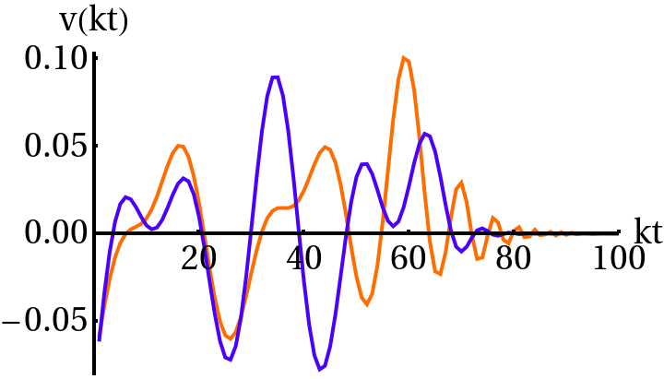
5
which therefore can be ordered as λ
> λ
> λ
> ...0.
1
2
3
0
Denotingv
(y) as an eigenvector of
C(y, y
),
and λ
its
n
n
positive eigenvalue, then
Z
0
0
0
0
dy
g(y
)C(y, y
)v
(y
) = λ
v
(y) ,
(27)
n
n
n
0
where g(y
) is a positive weight function which can be
chosen appropriately.
Since the eigenvectors v
are or-
n
thonormal, we have
Z
∗
dyg(y)v
(y)v
(y) = δ
.
n
nm
m
The unequal
time correlator can then be written conse-
FIG. 1:
14th eigenvector from of the R
correlator for pure
11
quently as
RD (red) and MD (blue).
X
0
∗
0
C(y, y
) =
λ
v
(y)v
(y
) .
(28)
n
n
n
but not a fixed orientation.
This means that adding up
n
linearly the eigenvector components from RD and MD
0
In our numerical
work we discretize C(y, y
) and order
sources,
as in Eq.
(29),
is not a well
defined operation
the eigenvalues such that 0 < λ
< λ
.
n+1
n
(r)
(m)
since the relative sign between v
and v
is undeter-
0
0
The scaling behavior, i.e. C(k, t, t
) = C(kt, kt
), is an
n
n
mined.
Large differences can arise in the interpolated
extraordinarily useful property.
First or all, it reduces the
component v
by arbitrarily flipping the sign of
either
problem from 3 to 2 dimensions.
Secondly, for y 1 and
n
(r)
(m)
0
0
v
or v
.
y
1, C(y, y
) is constant.
On the other hand for y 1
n
n
0
or y
1 it decays like a power law.
This power law can
One possible way to deal
with this problem is to de-
be determined analytically,
see Appendix A.
With this
mand a positive scalar product as
0
we only have to determine C(y, y
) numerically in the
Z
0
regions, say 0.1 < y,
y
< 100.
(r)
(m)
(r)
(m)
hv
v
i ≡
g(y)v
(y)v
(y)dy > 0 .
(31)
n
n
n
n
In the real universe, however, we have a transition from
radiation to matter domination happening shortly before
After diagonalizing the RD and MD sources with arbi-
decoupling.
This spoils scaling.
This problem arises ac-
trary sign, one flips the sign, say, of the MD eigenvectors,
tually for any type of cosmic defects sourcing the CMB.
in order to verify the positivity condition Eq. (31).
In the large-N global
scenario the index of
the Bessel
(r)
(m)
However,
the eigenvectors v
and v
describe the
function in the solution for β,
given by ν = 1 + γ,
goes
scalar fields when these are deep in the RD and MD
from ν = 2 during radiation to ν = 3 in the matter
era, respectively.
This means that some of the eigenvec-
era.
However
there is
no analytical
solution describ-
tors from RD and from MD will
typically oscillate out
ing this
transition.
In the case of
other
defects,
one
of phase.
In Fig. 1 we show one eigenvector (the 14th in
often obtains
the UTC’s
at
pure RD or
MD epochs
this example) of
the unequal-time-correlator R
,
both
alone (i.e.
when there is scaling),
but not in between,
11
for exact MD and RD.
One can see that the two vec-
during the radiation-matter
transition.
In the litera-
tors are out of
phase with each other for kt & 30.
In
ture [15,
36,
39,
47]
this problem is usually dealt with
this case the scale product between them becomes small,
by interpolating the eigenvectors from the radiation and
(r)
(m)
matter dominated correlators,
|hv
v
i| < 1, and its sign is not very significant.
n
n
Therefore the positive cross-product condition does not
q
p
seem very meaningful,
particularly because the RD and
(r)
(r)
λ
v
(y, t)
= f (t/t
)
λ
v
(y) +
n
n
n
eq
n
q
MD eigenvectors describe the sources respectively in very
(m)
different epochs of the history of the Universe.
(m)
(1 − f (t/t
))
λ
v
(y)
(29)
n
eq
n
For
this
reason we have considered a different
ap-
proach.
In particular we have introduced a procedure
(r)
(r)
(m)
(m)
where λ
,
v
(t) and λ
,
v
(t) denote the eigen-
n
n
n
n
that does not rely on the linear superposition of the eigen-
values and eigenvectors in the radiation and matter dom-
vectors as in Eq.
(29).
As we will
show later,
we find
inated era respectively.
Here f (x) is an interpolating
indeed important differences in the CMB anisotropies,
function verifying
of
the order of
few×10% for scalar perturbations,
de-
x→0
x→∞
pending on the procedure used to determine the UTCs
f (x)
−−−→ 1 ,
f (x)
−−−−→ 0 .
(30)
of
the source.
The issue of
how to introduce correctly
Let us note, however, the following problem:
although
scaling sources in a Boltzmann code around the time of
the eigenvectors can be chosen real,
their sign is unde-
matter-radiation equality in order to obtain an accurate
termined, they are simply rays which define a direction,
prediction of the CMB anisotropies, is a relevant aspect
6
not only for the large-N model, but for all scaling cosmic
adjacent intervals will be similar to each other.
From the
defects.
computation of the UTCs with Eqs.
(24)-(26),
in terms
a
The origin of the problem is simple:
the transition from
of convolutions of the β
’s from Eq.
(34),
we then ob-
(i)
radiation- to matter-domination breaks scaling,
i.e.
the
tain the corresponding eigenvectors of every UTC in each
scale free behavior of
the source in the pure radiation
interval ∆t
.
The scalar product of adjacent eigenvectors
i
or matter era.
So the problem translates into how to
will thus be large, such that the positivity condition (31)
source the Boltzmann equation with a scalar field evolv-
becomes meaningful again.
The choice of q can be made,
ing around the radiation-matter equality time t
.
A lin-
for instance, by demanding that the total angular power
eq
ear combination of RD and MD eigenvectors is not well
spectrum C
’s change by less than a certain tolerance,
`
defined,
so we should source our code around t
with
say 1%, with increasing q.
eq
the physical solution for the self-ordering fields in an ex-
The ‘adiabatic’ method just described should capture
panding background dictated by a mixture of radiation
the evolution of the self-ordering fields with sufficient pre-
and matter.
However,
in the large-N global
scenario,
cision around t
, ensuring an accuracy in the final C
’s
eq
`
a
β
(k, t) cannot be solved analytically in those circum-
below a given tolerance requirement,
while preserving
stances, and secondly, it cannot be written as a function
at the same time the description of
the UTCs as scal-
of y = kt.
Breaking scaling implies that the correlators
0
ing functions depending on scale only through (kt, kt
).
0
depend again on the three variables, (k, t, t
), and not just
However theoretically correct, in practice this method is
0
on two (kt, kt
).
One way to solve the problem would be
difficult to use directly.
First of all, because a priori we
to source the Boltzmann code with the UTCs calculated
do not know the number of
time subintervals q (for a
0
for each relevant k, as a function of t and t
.
In practice
given tolerance).
This means that we must proceed by
this is unfeasible.
trial and error, calculating all UTCs repeatedly for every
Thus,
we want to preserve the very useful
property
0
interval
t
< t, t
< t
(and from there the C
’s),
and
i
i+1
`
0
of the correlator depending only on (kt, kt
), while at the
repeating this procedure for every new set of subintervals
same time, describing correctly the evolution of the fields
as we increase progressively q.
Computing all the UTCs
around t
.
Theoretically we know this is inconsistent.
with a good accuracy is however computationally very
eq
In practice, there is a way to circumvent the problem, as
costly, rendering this procedure unfeasible.
Secondly, the
follows.
Let us divide the time evolution into q intervals
problem previously explained about the undefined sign
as t
< t
< t
< ...
< t
< t
,
of
length ∆t
=
in the method interpolating RD and MD eigenvectors as
1
2
3
q
q+1
i
t
− t
, i = 1, 2, ..., q, with t
lying somewhere between
in Eq.
(29),
is a general
problem for sourcing the CMB
i+1
i
eq
t
and t
.
If the ∆t
intervals are sufficiently short, the
with any type of
cosmic defects.
The discussed adia-
1
q+1
i
behavior of the scale factor will
not change appreciably
batic method relies on the fact that analytical solutions
between t
and t
.
One can then think of an adiabatic
exist for the self-ordering non-topological
textures,
but
i
i+1
solution for the self-ordering fields within each interval
this is not the case for other defects, particularly for the
∆t
,
given by Eq.
(8),
but with a fixed value ν
for the
most interesting case of cosmic strings.
For general
de-
i
i
index ν between 2 and 3.
Since at every time t there is
fects one would need to run a large number of simulations
a well defined value of ν given by
for ‘intermediate’ expansion rates, which again would be

computationally very costly.
Therefore, it would be more

d log a

satisfactory to find a procedure potentially valid for any
ν(t) = 1 +
,
(32)

d log t
type of cosmic defects.
t
Although inapplicable in practice,
the previous adi-
we can set the value of ν within the interval (t
, t
), as
i
i+1
abatic method still
gives us the clue how to proceed.
the arithmetic mean of the value at the boundaries,
Maintaining the idea of
subdividing the time evolution
1
into q intervals of
length ∆t
= t
− t
,
if
the latter
i
i+1
i
ν
≡
[ν(t
) + ν(t
)] .
(33)
i
i
i+1
are sufficiently short, we can expect that the equal time
2
correlators (ETCs) C
(k, t) can be written for a time t
i
Thus, ν
is an effective index weighting the relative devi-
i
within the period (t
, t
), as
i
i+1
ation from pure RD (ν = 2) and MD (ν = 3) during the
time interval
t
< t < t
,
during which the adiabatic
i
i+1
RD
MD
C
(k, t) = f (t)C
(kt) + [1 − f (t)]C
(kt) ,
(35)
i
solution is written as

RD
MD
1
where C
, C
are the ETCs in pure RD or MD peri-
−γ
p
t
J
(kt)
i
2
ν
a
a
β
(kt) ≡
A
β
(kt
) ,
(34)
i
ods, and f (t) is an interpolating function like in Eq. (29),
i
∗
(i)
ν
t
(kt
)
i
∗
∗
verifying the conditions in Eqs. (30).
Since in the large-N
RD
MD
limit of global
defects we can obtain C
and C
ex-
with γ
≡ ν
− 1 and A
given by the normalization con-
i
i
i
0
actly from Eqs. (24)-(26), just evaluating them at t = t
,
stant Eq. (11) evaluated at ν = ν
.
By taking q arbitrar-
i
we can then invert the problem to find f (t) as
ily large, the set of solutions with effective indices ν
given
i
in Eq. (34), tend to the real physical solution.
In practice
MD
C
(k, t) − C
(kt)
we cannot take q to infinity.
However,
if
we take suffi-
i
f (t) ≡
.
(36)
ciently small
time intervals,
the subsequent solutions in
RD
MD
C
(kt) − C
(kt)
7
−3
3
10,
for a large time interval
t = 10
t
− 10
t
.
From
3.0
eq
eq
there we have computed the ETCs evaluating Eqs.
(24)
k
0.1 k
"
eq
to (26) with the numerical
solutions,
and obtained the
k
1.0 k
"
2.5
eq
function f (t) for each scale k considered,
via Eq.
(36).
k
10. k
"
eq
The result is shown in Fig.
2.
Clearly the interpolating
2.0
function,
f (t),
is the same for every scale k.
We fitted
1
#
t
"
the curves with a function f given by
f
2
1
t
4 t
1.5
"
!
! "
##
eq
−2
f (t) = [1 + (t/4t
)]
,
(40)
eq
Interpol.
1.0
which does an excellent job.
1
If the subintervals are short enough (say ∆t
t
, t
i
i
i+1
0.5
2
1
t
t
0
"
!
!
#
and therefore t, t
∼ t
, t
), then we should also be able
eq
i
i+1
0
to approximate each UTC at the times t
< t, t
< t
,
i
i+1
0.0
2
0.001
0.01
0.1
1
10
100
1000
by
t
t
!
eq
¯
0
RD
0
C
(k, t, t
)
= f(
t
)C
(kt, kt
)
i
i
¯
MD
0
+ [1 − f (
t
)] C
(kt, kt
) ,
(41)
i
−2
FIG.
2:
The interpolation function f (t)
= (1 + t/4t
)
,
eq
¯
X
with
t
≡ (t
+t
)/2, and C
the UTCs calculated with
in blue,
is a universal
function for all
k.
We show here the
i
i
i+1
solution Eq. (8) for ν = 2 (X = RD) or ν = 3 (X = MD).
comparison for three very different wavenumbers,
k/k
=
eq
The larger is q the shorter are the time intervals,
and
0.1, 1, 10,
around the radiation-matter transition.
The al-
−2
ternative parametrization f (t) = (1 + t/t
)
,
in green,
is
therefore the more accurate this ansatz approaches the
eq
clearly not a good description.
real physical answer.
To test the approximation, we sim-
ply require the same criteria stated before for the adia-
batic approximation:
the total C
’s obtained from a given
`
Of course, this is all under the assumption that Eq. (35)
q should change by less than a given percent tolerance
is a good approximation to the ETC around t
,
which
eq
when we increase the number of subintervals.
We hope
is equivalent to assuming that there exists a scale-free
that our approximation reproduces the physical solution
but time-dependent interpolating function f (t).
In such
in that moment, with an accuracy better than the chosen
a case,
the apparent
scale dependence on the rhs.
of
tolerance.
Eq.
(36)
should drop out,
so that
the
lhs
is
scale-
After trial and error, we have found that we satisfy the
independent.
We should then be able to find f (t) by
above criterion for a 1% tolerance, by taking q = 11 and
simply computing the rhs of Eq. (36) for different scales
choosing the boundary times t
in the intervals as fol-
i
k,
and the result should always be the same at a given
lows:
Evaluating Eq. (32) with the scale factor Eq. (38),
time t, independently of the scale k.
we have considered regularly spaced values (except for
In order to find f (t),
proving at the same time its
the extreme values t
and t
) of
the effective index ν
1
q
scale-invariance, we need to know the exact ETC C
(k, t)
i
of
the adiabatic approximation,
ν(t
)
= 2.05, ν(t
)
=
2
3
around t
,
just when the fields are not in the scaling
eq
2.15, ν(t
) = 2.25, ..., ν(t
) = 2.85, ν(t
) = 2.95,
and
4
10
11
regime and Eq. (8) is not a valid solution.
To overcome
ν(t
) = 2.01 and ν(t
) = 2.99.
From here we find the
1
12
this difficulty, all we have to do is to solve numerically the
times at the boundaries of the intervals by inverting the
equation of motion of the self-ordering fields for scales k
relation (32), yielding
close to k
, at times around t
.
In order to do this we
eq
eq
need to consider the large-N limit ansatz Eq. (3),
ν(t
) = 2.01 ,
t
/t
= 0.049
1
1
eq
ν(t
) = 2.05 ,
t
/t
= 0.254
2
2
eq
µ
2
2
0
∂
β
∂
β
= ω
(t) = c
H
− c
H
,
(37)
a
µ
a
1
2
ν(t
) = 2.15 ,
t
/t
= 0.852
3
3
eq
ν(t
) = 2.25 ,
t
/t
= 1.609
but this time with the scale factor a(t) given by
4
4
eq
ν(t
) = 2.35 ,
t
/t
= 2.600

h
i
5
5
eq
√
2
ν(t
) = 2.45 ,
t
/t
= 3.950
a(t) = a
(
2 − 1)(t/t
) + 1
− 1
,
(38)
6
6
eq
eq
eq
ν(t
) = 2.55 ,
t
/t
= 5.901
7
7
eq
ν(t
) = 2.65 ,
t
/t
= 8.967
8
8
eq
which corresponds to a mixed radiation-matter fluid.
We
ν(t
) = 2.75 ,
t
/t
= 14.49
9
9
eq
can easily fix the coefficients c
and c
by matching the
1
2
ν(t
) = 2.85 ,
t
/t
= 27.36
10
10
eq
expression in Eq.
(37) with its asymptotic behavior in
ν(t
) = 2.95 ,
t
/t
= 91.74
11
11
eq
the MD and RD regimes.
This yields c
= −3/8 and
1
ν(t
) = 2.99 ,
t
/t
= 478.0
12
12
eq
c
= 33/8.
Having fixed these coefficients,
the mode
2
equation can be written as

¨
˙
a
a
2
2
a
β
+ 2H
β
+ k
− ω
(t)
β
= 0 ,
(39)
k
k
k
¯
2
An alternative approach would have been to replace f (
t
) by
i
p
2
with ω
(t) and a(t) given by Eq. (37) and Eq. 38, respec-
f (t
)f (t
),
but in principle there is no more reason for one
i
i+1
tively.
We have solved Eq.
(39) for k/k
= 0.1, 1 and
choice or another.
eq
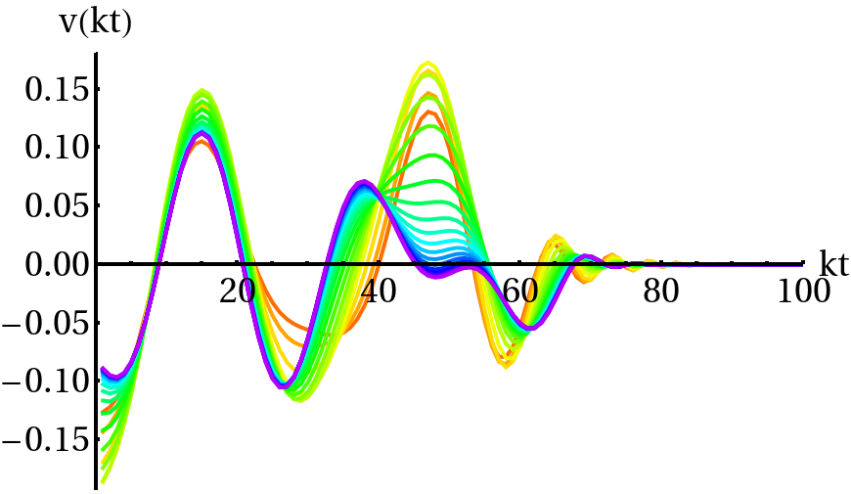
8
For t < t
,
we provide just the UTCs from the pure
1
RD universe, ν = 2, whereas for t > t
, we use the MD
12
solution,
ν = 3.
Note however that the present age of
the Universe t
is actually smaller than t
,
so in prac-
0
12
tice, we never source the Boltzman code with the solution
from a pure MD universe.
Note also that we do not dis-
cuss the fact that the Universe becomes Λ–dominated
at late times,
since there is no need:
in that case the
a
linearized field equation for β
is not of
the form (2).
2
The term γt
has to be replaced by Ht
,
which spoils
scaling and the possibility of
obtaining an analytic so-
lution.
However it is expected that the main effect will
appear at the quadrupole and octopole moments of the
power spectrum, whose uncertainty is dominated by cos-
FIG.
3:
The 11th eigenvector from the C
tensor correlators
i
mic variance.
within the succesive periods (t
, t
).
The color coding shows
i
i+1
As mentioned before, we have found that q = 11 is the
the transition from red (ν = 2.03) to orange (ν = 2.10), yellow
minimum number of
subintervals required for the total
and green(s) (ν = 2.15 − 2.50), blue(s) (ν = 2.55 − 2.95) and
C
’s to change by less than 1% when subdividing the time
finally purple (ν = 2.97).
`
evolution with one more subinterval, q → q + 1.
There is
the possibility, however, that when increasing further the
are the most precise calculations we have done.
We how-
number of
subintervals,
the accumulated change could
ever insist on the fact that these spectra differ by less
become larger than 1% with respect to the case q = 11.
than 1% from the ones obtained with q = 11,
and that
In order to avoid this,
we have yet imposed a stronger
showing the latter would had sufficed as well.
We have
criteria:
that the C
’s should not change more than 1%
`
RD
0
MD
0
computed the matrices C
(y, y
) and C
(y, y
) for all
when increasing the number of
subintervals as q → 2q.
sources (scalar, vector and tensor) with a high resolution
We have considered the following times
integrator (4 months computation in a standard CPU
serial processor).
Then we have built the corresponding
ν(t
) = 2.01 ,
t
/t
= 0.049
1
1
eq
0
correlators C
(y, y
) for every interval
t
< t < t
,
by
ν(t
) = 2.03 ,
t
/t
= 0.150
i
i
i+1
2
2
eq
−2
means of Eq.
(41) with f (t) = (1 + t/4t
)
evaluated
ν(t
) = 2.06 ,
t
/t
= 0.308
eq
3
3
eq
¯
at the intermediate times
t
≡ (t
+ t
)/2.
ν(t
) = 2.10 ,
t
/t
= 0.536
i
i
i+1
4
4
eq
We have diagonalized the scalar, vector and tensor cor-
ν(t
) = 2.15 ,
t
/t
= 0.852
5
5
eq
relators C
’s (defining C
as C
) and sourced the Boltz-
ν(t
) = 2.20 ,
t
/t
= 1.207
i
0
RD
6
6
eq
man code at the times t
< t < t
with the correspond-
ν(t
) = 2.25 ,
t
/t
= 1.609
i
i+1
7
7
eq
(i)
ν(t
) = 2.30 ,
t
/t
= 2.069
ing eigenvectors v
.
In order to match smoothly the
8
8
eq
n
ν(t
) = 2.35 ,
t
/t
= 2.600
eigenvectors from a correlator C
with those from C
9
9
eq
i−1
i
ν(t
) = 2.40 ,
t
/t
= 3.219
at the transition times t = t
, we have imposed the posi-
10
10
eq
i
ν(t
) = 2.45 ,
t
/t
= 3.950
tivity criterion,
11
11
eq
ν(t
) = 2.50 ,
t
/t
= 4.828
Z
12
12
eq
ν(t
) = 2.55 ,
t
/t
= 5.901
(i−1)
(i)
δ
≡
g(y)v
(y)v
(y)dy > 0 .
13
13
eq
n,i
n
n
ν(t
) = 2.60 ,
t
/t
= 7.243
14
14
eq
ν(t
) = 2.65 ,
t
/t
= 8.967
15
15
eq
This criterion becomes now always meaningful, since the
ν(t
) = 2.70 ,
t
/t
= 11.27
16
16
eq
time subintervals are sufficiently short so that the nth
ν(t
) = 2.75 ,
t
/t
= 14.49
17
17
eq
eigenvector of C
is only ’slightly’
out of phase with re-
i
ν(t
) = 2.80 ,
t
/t
= 19.31
18
18
eq
spect to the corresponding one of C
.
This is opposite
i−1
ν(t
) = 2.85 ,
t
/t
= 27.36
19
19
eq
to matching eigenvectors from deep in RD with those
ν(t
) = 2.90 ,
t
/t
= 43.46
20
20
eq
deep in MD,
which are significantly out of
phase,
see
ν(t
) = 2.95 ,
t
/t
= 91.74
21
21
eq
(i)
Fig. 1.
In Fig. 3 we see how an eigenvector v
changes
n
ν(t
) = 2.97 ,
t
/t
= 156.1
22
22
eq
(i+1)
smoothly to v
.
In particular,
we are plotting the
ν(t
) = 2.99 ,
t
/t
= 478.0 ,
n
23
23
eq
(i)
11th eigenvector from the tensor UTCs H
obtained
as the boundaries of q = 22 subinterval around t
, again
at each period (t
, t
).
The color coding shows the
eq
i
i+1
regularly spaced in ν (except for close to the extremes).
transition from red,
corresponding to the closest
one
We have found that indeed when increasing the number
to pure RD with an effective index ν
= 2.01,
to or-
of subdivisions to q = 22, the total C
’s do not change by
ange (ν = 2.10),
then yellow and different greens for
`
more than 1% with respect the corresponding amplitudes
ν = 2.15 − 2.50,
different blues for ν = 2.55 − 2.95,
and
obtained for q = 11.
finally purple,
corresponding to the one closest to MD,
In what follows we show the results from q = 22 subin-
ν = 2.97.
tervals with the time boundaries listed above, since these
Note also that for cosmic string simulations one usually
9
computes their UTC’s in the scaling regimes in pure RD
and the two point correlators are
and MD,
and then interpolate the corresponding eigen-
∗
0
hX
(k, t)X
(k
, t)i =
(46)
vectors as in Eq. (29) [36].
Our exercise shows that one
i
j
Z
gets significantly different results in the CMB power spec-
t
0
00
0
0
00
0
0
00
dt
dt
G
(k, t, t
)G
(k
, t, t
)hS
(k, t
)S
(k
, t
)i
tra, see next section, when one compares the method we
im
jn
m
n
t
have proposed versus the standard interpolation method
∗
at the level
of
the eigenvectors.
It would be therefore
If we diagonalize the UTCs of the source as
very interesting to repeat this exercise with cosmic string
UTCs.
It is possible that the interpolation function that
0
0
00
hS
(k, t
)S
(k
, t
)i
(47)
m
n
X
we have found,
Eq.
(40),
is universal,
in the sense that
3
0
(p)
0
(p)
00
= (2π)
δ(k − k
)
λ
v
(k, t
)v
(k, t
) ,
it can be used for any type of defect.
However, we have
p
m
n
p
found its time dependence from the large-N model,
by
solving numerically the scalar field evolution around t
.
eq
we obtain
Thus,
although considering it as a plausible speculation
X
that f (t) given by Eq. (40) might be the one to be used
∗
0
3
0
hX
(k, t)X
(k
, t)i = (2π)
δ(k − k
)
λ
×
i
p
j
for every type of defects – why should it depend on the
p
large-N model? – this can only be demonstrated with de-
Z
t
fect simulations around t
, which is beyond the scope of
0
00
0
00
(p)
0
(p)
00
dt
dt
G
(k, t, t
)G
(k, t, t
)v
(k, t
)v
(k, t
) .(48)
eq
im
jn
m
n
this paper.
Despite the absence of this exercise, we sug-
t
∗
gest the use of our f (t) for other defects as well.
Besides,
The power spectra evaluated today, which are defined by
the new method described by Eq.
(41) should of course
replace the old eigenvector interpolation prescription for
∗
0
3
0
hX
(k, t
)X
(k
, t
)i = (2π)
δ(k − k
)P
(k)
i
0
0
ij
introducing active sources in CMB codes.
j
are then given as by a sum of products of deterministic
(not stochastic) solutions,
III.
CMB POWER SPECTRA AND
X
X
(m)
(m)
∗ (m)
CORRELATION FUNCTIONS
P
(k) =
P
(k) =
X
X
(k) with
(49)
ij
ij
i
j
m
m
Z
p
t
A.
The formalism
0
(m)
(m)
X
(k) =
λ
dtG
(k, t
, t)v
(k, t) . (50)
m
ij
0
i
j
t
∗
Formally, the CMB spectra are of the form
(m)
Hence P
(k) is the product of the solutions of Eq. (44)
Z
ij
√
√
dk
(m)
(m)
XY
XY
with source
λ
v
and
λ
v
respectively.
This
C
=
∆
(k) ,
(42)
m
m
i
j
`
`
k
explains, why the unequal time correlators are all we need
to calculate the power spectra within linear perturbation
where X and Y are T , E or B, and
theory.
For more details, see Ref. [11].
3
0
XY
hX
(k, t
)Y
(k, t
)i = (2π)
δ(k − k
)∆
.
(43)
`
0
`
0
`
B.
The power spectra
The only non-vanishing cross correlation is T E, both T B
and EB vanish in a universe which is invariant under
We have used a modified version of CMBEASY [48] to
parity.
Collecting all
the perturbation variables X
as
`
include sources [36].
We have then computed the CMB
well
as the dark matter,
the baryon and the neutrino
power spectra from large-N global defects using various
perturbations into one long vector which we call X(k, t),
procedures.
First of all, we have obtained the CMB spec-
the first order perturbation equation is of the form
tra using Eq. (29) in two different ways, which we refer to
as procedures 1 and 2:
In procedure 1, we use the eigen-
D
X
(k, t) = S
(k, t) .
(44)
vectors with arbitrary sign as given by default by the di-
ij
j
i
agonalization algorithm of the correlators.
In procedure
Here D
is a first order differential
operator depending
2,
we use the same eigenvectors but only after having
ij
on time and S
is the source which can be parameterized
flipped the signs appropriately,
such that the positivity
i
0
in terms of Φ
, Ψ
, Σ
and h
.
Be G
(k, t, t
) the Green
criterion (31) is imposed between MD and RD eigenvec-
s
s
i
ij
ij
function for D
which depends only on the background
tors.
On the other hand, we have also obtained the CMB
ij
universe.
Then the solution with vanishing initial condi-
power spectra by using the procedure explained in detail
tion at t
is given by
in section II C, which we will refer to as procedure 3 from
∗
now on.
By this we mean that we have divided the time
Z
t
evolution into q sub-intervals (t
, t
), i = 1, 2, ...
q, and
0
0
0
i
i+1
X
(k, t) =
dt
G
(k, t, t
)S
(k, t
) ,
(45)
i
ij
j
then we have introduced as a source at each interval the
t
∗
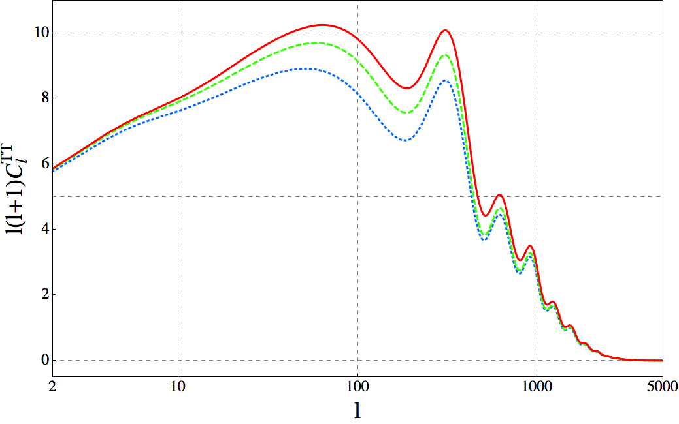
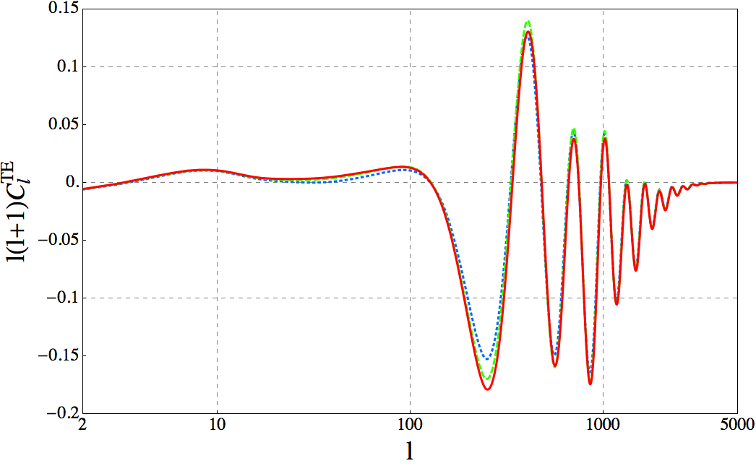
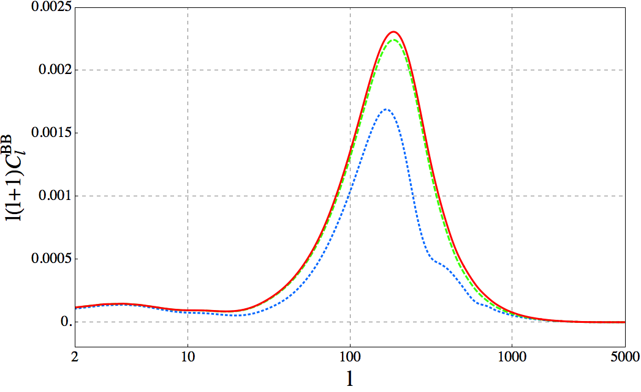
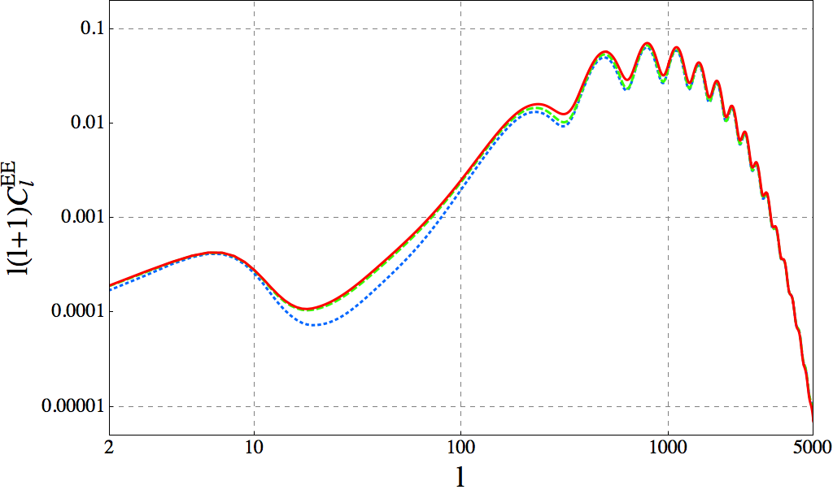
10
T T
TE
FIG.
4:
The total
C
spectrum (sum of
scalar,
vector
FIG.
6:
The total
C
spectrum (sum of
scalar,
vector
`
`
and tensor contributions) from procedure 1 (dotted, blue), 2
and tensor contributions) from procedure 1 (dotted,
blue),
(dashed, green) and 3 (solid, red).
Note the different position
2 (dashed, green) and 3 (solid, red).
of the acoustic peaks as compared to the standard inflation-
ary spectrum, e.g. the first peak is at ` ∼ 50 versus the usual
` ∼ 200.
EE
FIG.
7:
The total
C
spectrum (sum of
scalar,
vector
`
and tensor contributions) from procedure 1 (dotted,
blue),
2 (dashed, green) and 3 (solid, red).
BB
FIG.
5:
The total
C
spectrum (sum of
scalar,
vector
`
and tensor contributions) from procedure 1 (dotted,
blue),
2 (dashed, green) and 3 (solid, red).
corresponding contribution from the first 200 eigenvec-
tors of all
perturbations (scalar,
vector and tensor).
In
the TT anisotropies,
see Fig.
4,
the difference in ampli-
eigenvectors of the UTCs given by Eq. (41).
We consider
tude between the three methods reaches up to about 25%
this latter procedure as the closest one to the physical
in the height of
the first peak when comparing proce-
answer.
We have varied the number of intervals until
a
dure 1 with procedure 3.
The amplitude of the spectrum
further increase changes the resulting CMB spectra by
obtained with procedure 1 is of course random to some
less than a given tolerance factor, which we fixed as 1%.
extent, since the relative sign between MD and RD eigen-
In the
first
series
of
plots,
Figs.
4-7,
we
compare
vectors used is random.
But even when comparing the
the shape and amplitude of
the different CMB power
output from procedure 2 with that from procedure 3, the
spectra
obtained
by
the
three
different
procedures.
difference in amplitude is still of the order of 10% − 15%.
The color-coding/line-style among them is shared,
with
For the BB channel,
the differences between procedures
blue/dotted for procedure 1, green/dashed for procedure
1 and 3 reach ∼ 100% (i.e. a factor ∼ 2 of discrepancy),
2, and red/solid for procedure 3.
In these figures we show
but on the other hand,
the difference when comparing
the total
amplitude for the TT,
BB,
EE and TE chan-
procedures 2 and 3 only amounts to a 2-3 % at low `
nels, respectively, having summed up in each channel the
(although it goes up to 10% − 15% for ` > 300, a feature
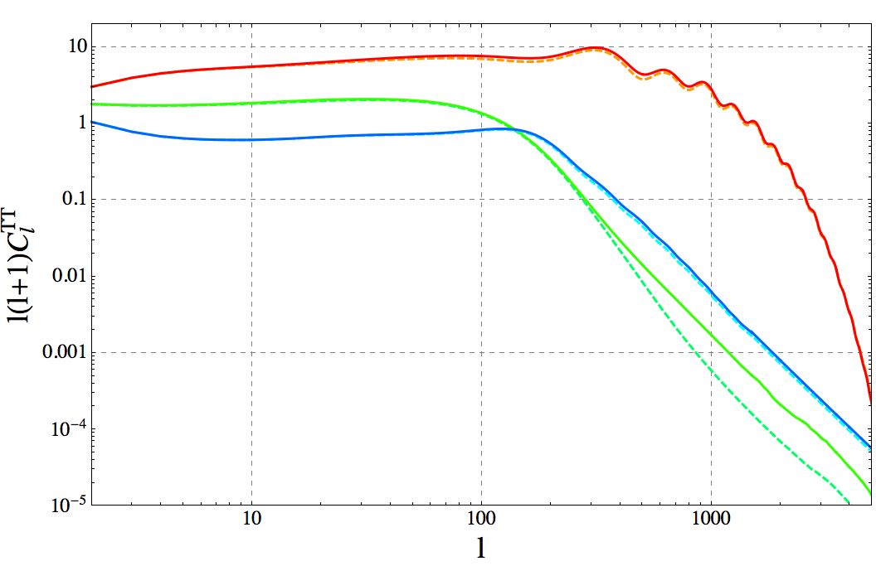
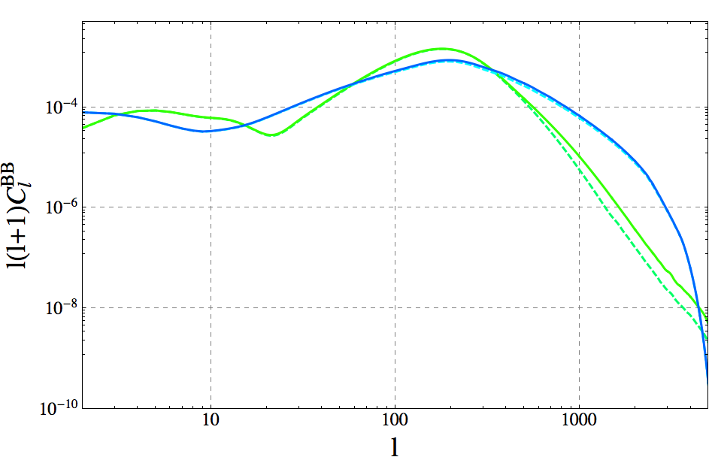
11
T T
BB
FIG.
8:
The
C
spectrum decomposed into its
scalar
FIG. 9:
The C
spectrum decomposed into its vector (green
`
`
(red/orange top curves at low `), vector (green middle curves
(upper) curves at ` = 100) and tensor (blue (lower) curves at
at low `) and tensor (blue bottom curves at low `) parts.
Here,
` = 100) parts.
In this channel there are no scalar perturba-
and in the analogous figures for BB,
T E and EE,
we only
tions,
and the differences between procedures 2 and 3 are of
show the differences between procedures 2 (dashed lines) and
the same order for the tensor and vector contributions.
3 (solid lines).
In this case the differences are most significant
for the dominant scalar perturbations,
whilst they are small
for vector perturbations (except at very small scales ` > 400,
where however vectors are completely subdominant).
fects in the CMB, the differences found are relevant, since
they depend on the multipole ` and therefore they also
change the resulting shapes of the spectra.
For instance,
in Fig.
7 one can observe how the relative amplitude of
not appreciated by eye in the linear plot in Fig.
5).
In
the first valley at ` ≈ 300 with respect to the amplitude
the TE channel the difference in amplitude between pro-
of the valley at ` ≈ 20, is higher than in the procedures 1
cedure 3 with respect both procedures 1 and 2,
reaches
and 2.
In other words, using procedures 1 or 2 we would
about 10% − 15% (when comparing the curves far from
be looking for a signal with the second trough (` ≈ 300)
TE
the zeros of C
).
In the case of EE, the relative ampli-
`
at a given relative amplitude with respect to the first one
tude between procedures 1 and 3 is of the order of a few
(` ≈ 20), but we find with procedure 3 that the effect of
times 10% (reaching even ∼ 70% at ` ≃ 20 − 30),
while
considering the field evolution around t
in a more pre-
it becomes smaller when comparing the amplitudes from
eq
cise manner,
lifts up the second trough with respect to
procedures 2 and 3,
differing 2% − 6% for ` < 100,
but
the first one.
reaching up to ∼ 20% in the dips of
the oscillations at
multipoles ` ≥ 200.
Let us also discuss the contributions of
each type of
Clearly there are noticeable differences in amplitude
perturbation,
scalar,
vector and tensor,
to each CMB
depending on the procedure used to treat
the defect
power spectrum.
In Figs.
8-11,
we show separately the
sources.
Using a linear combination of RD and MD eigen-
power spectra sourced only by the eigenvectors from ten-
vectors is not well
defined (procedures 1 and 2) due to
sor, vector and scalar UTCs.
The color coding/line style
the sign choice,
which also in procedure 2 is still
some-
is again common to all Figs. 8-11 (though different than
what arbitrary.
Our procedure 3 is more realistic.
With
in Figs.
4-7),
dashed and continuous lines correspond-
the choice of time subintervals discussed in the previous
ing to procedures 2 and 3 respectively,
and red/orange
section,
an accuracy of order ∼ 1% is reached in the fi-
to scalar perturbations,
green to vector perturbations,
nal
answer.
As shown in Figs.
4-7,
differences of
order
and blue to tensor perturbations.
For each case we plot
O(10)% arise in the channels TT,
TE and EE,
and of
the amplitudes obtained from procedures 2 and 3.
This
order O(1)% in the channel
BB,
when comparing the
allows us to identify the contribution which is most af-
amplitudes obtained with (the more physically correct)
fected by the more realistic treatment of
the evolution
procedure 3 versus the procedure 2.
This difference is not
around t
.
In Fig. 8 we see that the TT power spectrum
eq
relevant from the point of view of constraining the sym-
is dominated by the scalar contribution over the entire `
metry scale.
The UTCs, and therefore the C
’s, scale as
range.
Tensor contributions have a discrepancy of ∼ 10%
`
4
(VEV)
and therefore the differences found in the tem-
between procedure 3 versus procedure 2 (from ` > 250),
perature and polarization power spectra will
translate
but we conclude that the ∼ 25% difference in the total
at most into a few % difference in the upper bound for
temperature power spectrum is mainly due to the dis-
the VEV, which does not represent a significant improve-
crepancy (of the same order) in the scalar contribution,
ment.
However,
from the point of view of detecting de-
which dominates completely over the vector and tensor
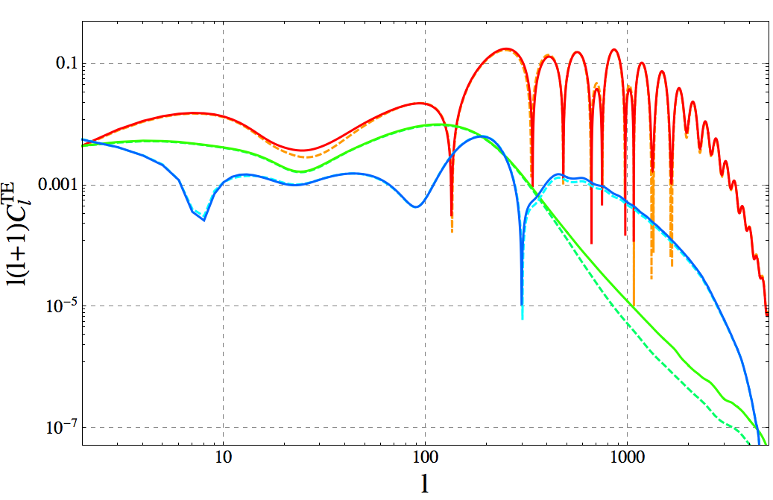
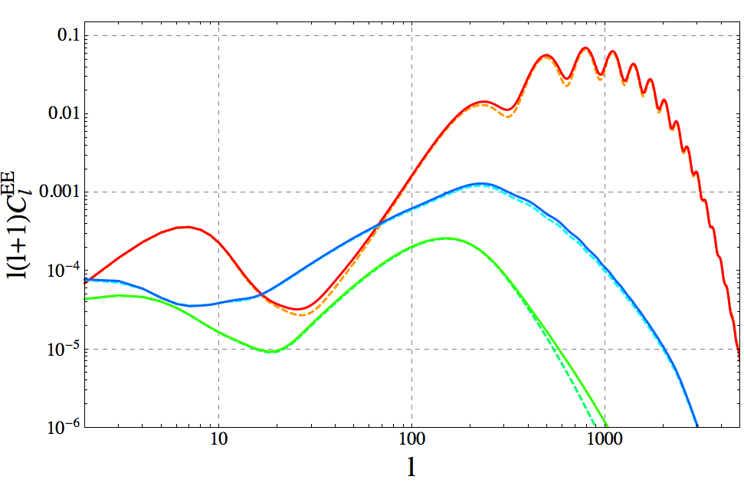
12
EE
TE
FIG. 11:
The C
spectrum decomposed into its scalar (top
FIG. 10:
The C
spectrum decomposed into its scalar (top
`
`
red/orange curves at ` = 100),
vector (bottom green curves
red/orange curves at ` = 10), vector (middle green curves at
` = 10) and tensor (bottom blue curves at ` = 10) parts.
at ` = 100) and tensor (middle blue curves at ` = 100) parts.
Again,
the differences between procedures 2 and 3 are small
Also here,
procedures 2 and 3 differ much more significantly
for vector perturbations.
for the scalar and tensor modes than for the vector mode.
Finally, in Fig. 11, we report the analogous decompo-
3
contributions
.
In Fig. 9 we show the analogous decom-
sition for the EE channel.
The difference in amplitude
position but for the BB power spectrum.
First of all, both
between procedure 3 and procedure 2,
is mostly due to
tensor and vector contributions are relevant,
essentially
the scalar contribution for almost the entire ` range, ex-
of the same order,
though vectors are slightly dominat-
cept for the small
interval
` ≈ 15 − 50 for which the
ing, except for the interval around ` ≈ 15 − 60, as well as
tensors dominate.
Like for the temperature, the discrep-
for small scales, ` & 350.
Procedures 2 and 3 do not differ
ancies among the procedures are of the same order in the
significantly for either tensor or vector perturbations in
scalar and tensor contributions, and smaller for the vec-
this channel.
The deviation between the amplitudes ob-
tor mode.
The differences in the final
spectrum of
this
tained with procedure 3 and with procedure 2 are indeed
channel
are due essentially to only the scalar contribu-
of
similar order for vectors and tensors.
The total
dis-
tion,
since the latter dominates over the entire `-range.
crepancy among the different procedures in the final BB
Note that the first bump is like in the inflationary case
spectrum over the full
` range (see previous comments
due to reionization, whereas for the rest of the spectrum
about Fig. 5, is due to a combination of both the tensor
the peaks are out of phase with respect to the inflationary
and vector contributions.
We can say that this channel
signal, since defects produce isocurvature perturbations.
is the least affected by the choice of the procedure.
The result that the vector mode is not very sensitive to
In Fig. 10 we show the same decomposition for the TE
the chosen procedure might be related to fact that vector
channel.
In this case both tensor and vector contribu-
perturbations of the CMB do not oscillate.
This can lead
tions have some few percent discrepancy when comparing
to a more stable scalar product for vector modes.
Note
the results of procedure 3 and procedure 2.
But as in the
however,
that the decay rate for vector perturbations is
case of of the TT channel,
the final
curve is completely
different for the two procedures.
However, this shows up
dominated by the scalar contribution, which therefore is
only in the highly suppressed tail at small scales, ` > 400,
responsible for the final differences in amplitude of the to-
and has no observational relevance.
tal spectrum (which we reported before when discussing
Note that all
the power spectra shown have been ob-
Fig. 6).
tained summing up the contributions from the first 200
eigenvectors of each type of perturbation (scalar,
vector
P
(n)
(n)
200
or tensor), i.e. C
≡
C
, with C
the contribu-
`
n=1
`
`
tion from the nth eigenvector.
The convergence of
the
3
Note that the vector contribution shows a signifcant discrepancy
successive adition of
contributions is indeed quite fast,
of O(100)% for ` > 400, but this is irrelevant since at small scales

P

the vectors are really subdominant (even more than at low `)
(n)
m
verifying
C
− C
0.01C
already for the first

`
`
as compared to the scalar contribution.
An analogous feature,
n=1
`
m = 40 eigenvectors,
in almost every perturbation and
i.e.
a significant deviation of
the vectors between methods 2
and 3 at very small
scales,
actually shows up in the rest of the
channel (the exception being the BB polarization at small
channels,
BB,
TE and EE.
However,
again this is an irrelevant
scales ` > 1000, where the convegence is slower).
issue, since at those scales the vector contribution is always very
In all the results that we will present in the following
subdominant versus either the tensor or the scalar contributions.
13
we only use procedure 3,
which for the large-N model
6000
is more than 1% accurate.
Interestingly, the spectra ob-
5000
Large N
tained for the large-N using procedure 3 are typically
somewhat larger than those obtained from the standard
4000
%
2
procedure 2, typically of O(10)%, depending on the chan-
K
$Μ
3000
nel
and the multipolar scale `.
For the convenience of
!Θ"
Inflation
TT
C
2
the reader and of
workers in the field,
all
the spectra
#
2000
1
Θ
XY
C
are available on the homepage of the Geneva cos-
`
mology group:
http://cosmology.unige.ch/research
under ’data products’.
1000
0.1
1
10
Let us finally remark that,
of course,
when using the
°
Θ !
"
10 000
large-N case as a template for monopoles or O(4) tex-
tures, intrinsic differences of the order of 10% have to be
added to the error budget.
Moreover,
the case of
cos-
mic strings is simply not well
described by the large-N
$
2
K
#Μ
scenario.
Therefore,
we cannot quantify how presently
published CMB spectra from topological defects, partic-
ularly from the most relevant case of cosmic strings, will
be affected by recalculating them using a similar treat-
ment as the procedure 3 outlined here.
Our present work,
8000
6000
Large N
4000
!Θ"
TT
C
2000
Inflation
0
0.0
1.0
2.0
3.0
0.5
1.5
2.5
although based only on the large-N case, suggests that it
°
Θ !
"
60
is possible that differences of O(10)% might arise.
There-
fore,
the accuracy of
previously calculated CMB power
40
spectra from topological
defects should be taken with
caution, at least until an equivalent methodology to pro-
cedure 3 is employed.
We consider this observation as a
first important result of our present work.
20
C.
The correlation functions
Inflation
$
2
K
#Μ
0
!Θ"
Large N
TE
C
20
!
40
!
0.01
0.1
1
10
100
°
Θ !
"
The correlation functions
of
the CMB temperature
60
anisotropies and polarization are given by
40
X
1
XY
XY
ξ
(θ) =
(2` + 1)C
P
(cos θ) ,
(51)
`
`
20
4π
`
where X and Y denote as before T ,
E and B and P
`
is the Legendre polynomial
of order `.
In principle,
the
power spectrum and the correlation function contain ex-
actly the same information.
However, the form of certain
Inflation
$
2
K
#Μ
0
!Θ"
Large N
TE
C
20
!
40
!
0.0
1.0
2.0
3.0
correlation functions from defect sources have very char-
0.5
1.5
2.5
°
Θ !
"
acteristic shapes, which can make it easier to distinguish
them from inflation, than by looking at the power spec-
trum.
A similar situation is known from the acoustic
FIG.
12:
The correlation functions from large-N and from
peaks in the matter power spectrum which are easier to
inflation.
Clearly,
the main difference is at angular scales
o
θ < 3
.
Note the characteristic sign difference of
the TE
see in the correlation function.
In Fig.
12 we show the
correlation functions.
The large-N contribution is normalized
T T and T E correlation functions.
The acoustic peak at
T T largeN
T T inf
such that C
= 0.1C
at ` = 10,
and then it is
o
θ ≃ 1
is a pronounced minimum and kink in the infla-
`
`
multiplied by a factor 50 for visibility.
tionary TT correlation function.
For the large-N model
there is only a slight kink.
Also,
in the TE correlation
function the acoustic peaks show up as a pronounced
see [51]) are especially useful.
Let us repeat their defi-
double-maximum well separated by a minimum, while in
nition here.
The usual polarization correlation functions
the large-N TE correlation function the first maximum
and of course all
the CMB power spectra are non-local,
and the minimum are entirely missing.
This is a conse-
i.e.
they require in principle information from the en-
quence of causality as has been pointed out already in [49]
tire sky.
Local
polarization correlation functions can be
and tested with a toy model in [50].
defined as follows.
As we have pointed out in [41],
the so called ’local’
polarization correlation functions
(for
an introduction
Polarization of the CMB is described as a rank-2 ten-
14
sor field P
on the sphere.
It is usually decomposed
0.010
ab
(0)
(1)
(2)
into Stokes parameters, P
= (Iσ
+ Uσ
+ V σ
+
ab
ab
ab
ab
(3)
(j)
Qσ
)/2 = Iδ
/2 + P
,
where σ
are the Pauli
ma-
ab
ab
ab
(0)
trices and σ
= δ
/2 [51].
The variable I corresponds
$
2
ab
ab
mK
to the intensity of
the radiation and contains the tem-
perature anisotropies.
As the relevant scattering process
at late times – Thomson scattering – does not induce
circular polarization we expect V = 0 for the CMB po-
larization,
and hence P
to be real.
For a given di-
ab
0.008
0.006
0.004
Large N
#
0.002
!Θ"
EE
0.000
C
Inflation
0.002
!
0.004
!
1.0
10.0
100.0
0.5
5.0
50.0
rection n we define the orthonormal
frame (e
, e
, n)
°
Θ !
"
1
2
0.010
1
and the circular polarization vectors e
=
(e
± ie
)
√
±
1
2
2
as before.
This allows us to introduce the components
a
b
P
= 2e
e
P
= Q ± iU and P
∝ V = 0.
The
±±
ab
+−
±
±
second derivatives of this polarization tensor are related
˜
˜
to the local
E- and
B-polarizations,
˜
∇
∇
P
+ ∇
∇
P
= 2∇
∇
P
≡
E ,
−
−
++
+
+
−−
a
b
ab
˜
∇
∇
P
− ∇
∇
P
= 2

∇
∇
P
≡
B .
−
−
++
+
+
−−
cd
ab
c
a
bd
0.008
$
2
mK
0.006
0.004
Large N
#
0.002
!Θ"
EE
0.000
C
Inflation
0.002
!
0.004
!
0.0
1.0
2.0
3.0
0.5
1.5
2.5
°
Θ !
"
Here ∇
are the derivatives in the directions e
and
±
±

is the 2-dimensional
totally anti-symmetric tensor.
cd
These functions are defined locally.
The usual
E-
and
B-modes can be obtained by applying the inverse of the
˜
2
Laplacian,
∇
= ∇
∇
+ ∇
∇
to the local
E-
and
+
−
−
+
˜
B-polarizations.
Such inversions of
differential
opera-
tors
depend on boundary conditions
which can affect
˜
˜
the result for local
observations.
The
B (and
E) cor-
˜
˜
˜
B
0
relation functions,
ξ
(θ)
≡ h
B(n)
B(n
)i
,
and
0
n·n
=cos θ
10
5
Inflation
0
$
2
K
#Μ
5
!
!Θ"
BB
Large N
C
10
!
15
!
1.0
10.0
100.0
0.5
5.0
50.0
˜
˜
˜
E
0
ξ
(θ)
≡ h
E(n)
E(n
)i
are measurable locally.
°
Θ !
"
0
n·n
=cos θ
They are related to the power spectrum by [51]
10
5
Inflation
∞
X
1
(` + 2)!
˜
˜
B, E
B,
E
$
0
(θ) =
ξ
(2` + 1)P
(cos θ)C
.
(52)
2
`
K
`
4π
(` − 2)!
#Μ
`=2
5
!
!Θ"
BB
Large N
C
10
!
4
The additional factor n
= (` + 2)!/(` − 2)! ∼ `
enhances
`
the power on small
scales where the defect polarization
is enhanced with respect to the inflationary one.
15
!
0.0
1.0
2.0
3.0
0.5
1.5
2.5
°
Θ !
"
In Fig.
13 we show the local
correlation functions
of
E and B polarization for the large-N model
and we
FIG.
13:
The
local
correlation functions
for
E-
and B-
compare them with the corresponding ones from infla-
polarization from large-N and from inflation.
The
B-
o
tion.
Clearly, at small angles, θ . 3
their shape is very
o
correlations on angular scales θ < 1.5
are very different from
o
different.
Around θ = 1.2
,
inflationary E-polarisation
the inflationary ones.
Also the E-polarizations have opposite
has a maximum while E-polarization from large-N has
o
signs at about 1
degree.
Again, the large-N contribution has
a minimum.
Also the most significant structure of
B-
been multiplied by 50 in order to compare with inflation.
The
o
polarisation from the large-N model
is around θ ∼ 0.3
BB contribution due to gravitational waves from inflation is
o
to 1
,
where the inflationary signal
is already small.
In
BB inf
T T inf
normalized such that C
= 0.1C
at ` = 10.
`
`
a previous paper [41]
we have exploited this fact,
which
is even more pronounced for topological defects like cos-
mic strings or global
monopoles and texture,
to predict
IV.
COMPARISON TO PRESENT AND
limits on a defect contribution from future B-polarisation
FUTURE EXPERIMENTS
measurements.
In the next section we shall use the shape of the power
spectrum to identify a possible small large-N component
In this section we want to estimate the signal-to-noise
in the CMB sky.
ratio of the different channels for three different types of
15
experiments:
1) Planck,
2) a COrE-like experiment,
3)
δβ
Planck
COrE
PRISM
CVL
PRISM and 4) an optimal polarization experiment which
−2
−3
−4
−4
TT 1.4 · 10
3.5 · 10
8 · 10
3 · 10
is cosmic variance limited out to ` = 10000.
We assume
−3
−3
−3
−3
EE 6 · 10
4.1 · 10
4 · 10
3.7 · 10
that the true signal is of the form
−4
−5
−5
−5
TE 4 · 10
3 · 10
2.5 · 10
2.4 · 10
largeN
2
inf
2
C
= (1 −
)C
+
C
,
(53)
`
`
`
TABLE II:
The TT,
EE and TE errors on β,
for Planck,
a
COrE-like experiment,
PRISM and a CVL experiment.
We
and we want to study how well
a given experiment can
set f
= 0.7 in all cases.
sky
constrain the amplitude .
In (53) we normalize C
to
20
the observed value,
However, when both, large-N and inflation contribute
2π
largeN
inf
2
C
= C
= 915.92 (µK)
.
to the signal,
S/N > 1 is not sufficient to detect the
20
20
20 × 21
signal,
but we must also be able to distinguish it from
the inflationary signal.
To quantify this we use the Fisher
We assume that the covariance matrix is diagonal
in
matrix technique.
We consider a signal to which not only
`-space, i.e.
that not only the signal but also the noise is
the large-N (or defects) contribute but there is also an
statistically isotropic.
For Gaussian C
’s we then have
`
inflationary contribution.
We split the signal as

XV
Y W
XW
Y V
C
C
+ C
C
`
`
`
`
XY
V W
Cov[C
, C
] =
δ
, (54)
i
d
C
= αC
+ βC
+ N
,
(57)
0
``
0
`
`
`
`
f
(2` + 1)
`
`
sky
i,d
XV
XV
XV
2
where C
denotes the inflationary (i) and large-N defect
C
= (C
+ N
) exp[`(` + 1)/`
] .
(55)
`
`
`
`
s
(d) signal, normalized such that they are equal at ` = 20,
Here f
is the fraction of
the observed sky,
N
is the
sky
`
2π
noise spectrum of the experiment and `
is a smoothing
i
d
2
C
= C
= 915.92 (µK)
.
s
20
20
20 × 21
scale which must be larger than the resolution of
the
experiment,
T T
Here
C
can mean the
temperature,
C
,
the
E-
`
`
p
EE
polarization, C
or the temperature-polarization cross-
`
8 ln(2)
T E
.
correlation, C
`
< `
=
,
(θ
= beam width) .
`
s
r
FWHM
θ
Studying how well we can measure different parameters
FWHM
in a signal depending on several parameters, is best done
The noise spectrum is assumed to be white noise char-
with the Fisher matrix technique.
The resulting limits
acterized by an amplitude ∆
for polarization and ∆
P,eff
T
assume that the errors on the parameters are Gaussian,
for temperature noise,
which is often not true,
but nevertheless,
if
the errors

are small enough it is usually a good approximation.
For
`(` + 1)
`(` + 1)
X
2
N
=
exp
∆
.
C
’s depending on a series of
parameters λ
the Fisher
`
X
2
2π
`
`
i
r
matrix is determined by
X
∂C
∂C
`
`
−1
F
=
Cov
,
(58)
Planck
COrE PRISM
CVL
ij
`
∂λ
∂λ
i
j
`
θ
7.2
4.7
2.3
1.0
FWHM
where we have already used that the covariance matrix
∆
23.4
2.05
1.43
0
P,eff
is diagonal,
Cov
= δ
Cov
.
We are only interested
∆
14.5
1.19
1.01
0
0
0
``
``
`
T
in the two parameters λ
≡ α and λ
≡ β.
We will
Ref.
PLA [52]
[53]
[54]
noiseless
1
2
fix all other cosmological parameters to the values mea-
sured by the Planck collaboration.
In the light of
the
TABLE I: The FWHM beam width, in arcmin, and the noise
level
of
the different CMB experiments considered here,
in
Planck results,
the presence of defects (parametrized by
units of µK·arcmin.
their fractional
contribution f
at multipole ` = 10) is
10
actually very weakly correlated with the standard cos-
We shall
consider the experiments listed in Table I.
mological parameter values [38], the latter being affected
When we consider a signal to which only the defects con-
only in their third decimal
digit by the inclusion of f
10
tribute, we can simply calculate the signal to noise from
in the Monte Carlo Markov Chain analysis.
Therefore,
the large-N contribution either with the correlation func-
there is no danger of
a degeneracy and we can fix the
tion or the C
’s via
standard cosmological parameters to the values measured
`
by Planck in the absence of cosmic defects.
The Fisher
`
X
max
S
C
matrix is obtained as
`
=
.
(56)
P
N
N
`
f
2`+1
i
2
F
=
(C
)
= F
,
(59)
sky
`=2
αα
11
`
`
2
(C
)
2
`
P
As we have seen in Ref. [41], for the B-mode, most of
f
2`+1
d
2
F
=
(C
)
= F
,
(60)
sky
ββ
22
`
`
2
(C
)
2
the large-N or defect signal
comes from the correlation
`
P
f
2`+1
i
d
F
=
C
C
= F
= F
.
(61)
o
sky
function at small angles, θ < 1
.
αβ
12
21
`
`
`
2
(C
)
2
`
16
2
global
textures and for more than four coupled global
Gv
/N
Planck
COrE
PRISM
CVL
scalar fields, which in 3+1 dimension do not give raise to
−7
−7
−7
−8
TT
5.2 · 10
2.7 · 10
1.3 · 10
7.8 · 10
topological defects (but yet produce non-topological gra-
−7
−7
−7
−7
EE
3.5 · 10
2.9 · 10
2.9 · 10
2.7 · 10
dient field configurations,
so called non-topological
de-
−8
−8
−8
−8
TE
9.0 · 10
2.5 · 10
2.3 · 10
2.2 · 10
fects).
We have found that the breaking of scale invari-
ance which happens at the transition from radiation to
2
TABLE III:
The upper
bounds
on Gv
/N from the TT,
matter is important and leads to an imprint on the CMB
EE and TE errors on β,
for Planck,
COrE-like experiment,
power spectra.
Taking it into account by a simple in-
PRISM,
and a CVL experiments.
We set f
= 0.7 in all
sky
terpolation from the radiation dominated to the matter
cases.
dominated source, at the level of the eigenvectors, leads
to errors of the order of up to 25%.
Only after using of
and its inverse is given by
the order of 10 interpolation steps can we trust our result
to be accurate at the 1% level.

!

1
We have found the time-dependence of
a universal
F
−F
ββ
αβ
−1
F
=
(62)
(scale independent) interpolation function that one can
ij
det F
−F
F
αβ
αα
use to weight correctly the MD and RD correlators at ev-
ery moment (within one of the chosen subintervals).
Be-
The marginalized error on the parameter β = β
± δβ is
0
sides, we have proposed a prescription, using the previous
now simply given by (see [51], p231ff)
interpolation function,
for introducing active sources in
F
CMB codes accounting accurately for the contribution of
αα
2
−1
(δβ)
= (F
)
=
.
(63)
22
such sources around t
.
It would be very interesting to
2
F
F
− (F
)
eq
αα
ββ
αβ
test this procedure also on topological defects like cosmic
strings.
We have to compute δβ for some fiducial values (α
, β
).
0
0
Finally,
we have investigated how well
such a compo-
We found that the result is nearly independent of β
for
0
nent can be detected in the CMB.
This can be cast in
β
< 0.1,
hence we can set β
= 0.
The value of δβ to-
0
0
2
d
terms of
upper limits for Gv
/N .
We have found that
gether with the normalization of C
then determines the
`
for experiments with considerable noise,
like Planck the
VEV of the large-N field, or equivalently the combination
2
TE correlation is the most sensitive channel, while for a
Gv
/N .
See table III.
cosmic variance limited or very low noise experiment like
Interestingly,
the TE-correlation gives the best con-
PRISM the B-polarisation channel
is a more than two
straints,
even better than those from B-polarization for
orders of magnitude more sensitive probe.
Planck [41].
Furthermore,
there is
virtually no addi-
We
have
made
available
our
final
CMB spectra
tional gain when going from an experiment like COrE or
at http://cosmology.unige.ch/research (under ’data
PRISM to a cosmic variance limited experiment.
This
products’) for the convenience of the reader.
means
that
already for
PRISM (or
COrE)
the domi-
nant
contribution to the uncertainly comes
from cos-
mic variance and cannot be improved by better exper-
Acknowledgments
iment technology.
In this case,
B-polarisation limits are
much better than those from T and E-polarization.
In
Ref. [41] we have shown that a cosmic variance limited B-
We
are
very grateful
to Mark Hindmarsh,
Joanes
polarisation experiment can detect a large-N signal down
Lizarraga and Jon Urrestilla, for critical discussions and
2
−10
to Gv
/N = 1.4×10
which is more than two orders of
comments on the draft.
We also acknowledge helpful
magnitude better than the best limit we can achieve from
discussions
with Jos´e
Juan Blanco Pillado and Mar-
T and E signals.
This confirms our claim of
Ref.
[41],
tin Bucher.
This work is supported by the Swiss Na-
that B-polarisation is a very sensitive probe for cosmic
tional
Science Foundation.
Some numerical
calculations
defects, here in the case of large-N .
were run on the Andromeda cluster of
the University
of Geneva.
The authors also acknowledge financial
sup-
port from the Madrid Regional Government (CAM) un-
V.
DISCUSSION AND CONCLUSIONS
der the program HEPHACOS S2009/ESP-1473-02, from
the Spanish MICINN under grant AYA2009-13936-C06-
In this paper we have fully calculated the imprint on
06 and Consolider-Ingenio 2010 PAU (CSD2007-00060),
the CMB temperature anisotropy and polarization from
and from the MINECO,
Centro de Excelencia Severo
large-N scaling seeds.
This model has the advantage that
Ochoa Programme,
under grant SEV-2012-0249,
as well
the source term can be computed analytically.
In addi-
as from the European Union Marie Curie Initial Training
tion,
it is a good approximation for global
monopoles,
Network UNILHC PITN-GA-2009-237920.
17
Appendix A: The unequal time correlators
Equal time correlators and asymptotic behaviour of scalar sources
As discussed in section III A we need to calculate the unequal-time two point functions of the metric perturbations
in order to be able to compute the CMB power spectra.
Here we present analytic expressions for the unequal
time
correlators of
the scalar field energy momentum tensor and we discuss their asymptotic behavior,
from [44].
The
˙
2
2
energy density,
f
= [(
β)
+ ∇β)
]/2 can be expressed in terms of the exact solution given in (8).
To simplify the
ρ
notation, we set

J
(x)
3
J
(x)
ν
ν+1
χ(x) ≡
,
ϕ(x) ≡
χ(x) −
.
(A1)
ν
ν−1
x
2
x
˙
where the form of ϕ arises from
β in the energy momentum tensor, with the derivative of J
(x) re-expressed with the
ν
ν
ν
help of the usual relation for Bessel functions, d/dx[J
(x)/x
] = −J
(x)/x
.
ν
ν+1
We also introduce the dimensionless variables x ≡ qt
and y ≡ kt.
Furthermore,
the products in real
space
become convolutions in Fourier space,
and it is useful
to introduce for expressions like g(x)h(|y − x|) the compact
a
notation g(x)h(|y − x|)
≡ (gh).
We also use that the random variables β
are Gaussian so that products like
a
b
c
0
d
0
hβ
(k)β
(p)β
(k
)β
(p
)i can be reduced via Wick’s theorem to sums over products of two-point expectations, which
in turn are given by Eq. (9).
With this we obtain
Z

3
(2π)
2
3
2
2
2
|f
|
(y, t)
=
d
x
(ϕϕ)
+ [x(y − x)]
(χχ)
− 2[x(y − x)](ϕϕ)(χχ)
(A2)
ρ
2
2NN
t
Z

4
(2π)
2
2
2
2
2
2
=
dx dµ x
(ϕϕ)
+ [xyµ − x
]
(χχ)
− 2[xyµ − x
](ϕϕ)(χχ)
.
(A3)
2
2NN
t
where N = 16/15 for RD (ν = 2) or N = 128/2835 for MD (ν = 3).
In the last equation we have performed the
integration over one angular variable and introduced µ = cos φ.
The pressure f
contains the same terms,
only the
p
2
pre-factors differ.
The pre-factor of the (χχ)
term is 1/9 and the one of (ϕϕ)(χχ) is 2/3.
From the above expressions it is clear that f
and f
behave like white noise on super horizon scales.
Numerically
ρ
p
we have found
(

4
−2
(2π)
1.72 · 10
for ν = 2
2
|f
|
(y = 0, t)
=
,
(A4)
ρ
2
−5
NtN
3.34 · 10
for ν = 3
(

4
−3
(2π)
1.96 · 10
for ν = 2
2
|f
|
(y = 0, t)
=
.
(A5)
p
2
−6
NtN
2.61 · 10
for ν = 3
In the limit y 1 they decay like

2
1−2ν
−1
|f
|
(y 1, t)
∼ y
t
,
(A6)
ρ

2
1−2ν
−1
|f
|
(y 1, t)
∼ y
t
.
(A7)
p
f
is calculated analogously to f
and f
:
v
ρ
p

k
˙
j
ββ
(k, t)
(A8)
f
(k, t)
= −i
v
,j
2
k
Z
k(k − q)
2
3
= −At
d
q
ϕ(qt)χ(|k − q|t)β
(q)β
(k − q).
(A9)
in
in
2
k
Using the same dimensionless variables and the same notation as above, we find for the equal-time correlator of f
,
v
Z
n
o

3
(2π)
t
2
2
3
2
|f
|
(y, t)
=
d
x
[y(y − x)]
(χϕ)
+ [y(y − x)] [yx] (χϕ)(ϕχ)
(A10)
v
2
4
NN
y
Z
n
o

4
(2π)
t
2
2
2
2
2
=
dxdµx
y
− xyµ
(χϕ)
+
y
− xyµ
[xyµ] (χϕ)(ϕχ)
.
(A11)
2
4
NN
y
18
3
A lengthy expansion around y = 0 shows that the integrand vanishes up to y
,
and that this term vanishes upon
integration over µ.
Therefore, f
does not diverge for y → 0.
We obtain the finite result
v
(

4
−3
(2π)
t
1.96 · 10
for ν = 2
2
|f
|
(y = 0, t) =
(A12)
v
2
−6
NN
2.61 · 10
for ν = 3.

2
In the limit y 1,
|f
|
decays like
v

2
−1−2ν
|f
|
(y 1, t) ∼ y
t .
(A13)
v
For f
we find
π

3
k
k
1
i
j
2
f
(k, t)
= −
β
β
−
δ
(∇β)
(A14)
π
,i
,j
ij
4
2
k
3

Z
3
3At
1
3
2
2
2
=
d
q
(kq)(k
− kq) −
k
(kq − q
)
χ(qt)χ(|k − q|t)β
(q)β
(k − q) .
(A15)
in
in
2
3
The resulting equal time correlator is given by

Z
2
1
2
2
2
4
3
xyµ − x
µ
+
x
− xyµ
9(2π)
t
∗
0
2
2
3
hf
(k, t)f
(k
, t)i =
dxdµx
(χχ)
.
(A16)
π
π
2
4
2NN
y
Clearly f
diverges for y → 0 and we find easily that
π

Z
Z
2
1
∞

4
3
9(2π)
t
1
2
2
6
4
|f
|
(y → 0, t)
=
dµ
− µ
dxx
χ(x)
π
2
4
2NN
y
3
−1
0
(
4
3
−3
9(2π)
t
2.08 · 10
for ν = 2
=
(A17)
2
4
−5
2NN
y
5.24 · 10
for ν = 3.
In the limit x 1 it decays like

2
−3−2ν
3
|f
|
(y 1, t) ∼ y
t
.
(A18)
π
The unequal-time source functions
We are not going to list all scalar unequal time correlators (UTC), since there are no special problems involved in
their calculation, and they are not very illuminating anyway.
As an example, we present the UTC for f
:
v
Z
n
o

4
2
(2π)
tr
2
∗
0
2
2
2
hf
(k, t)f
(k, t
)i =
dxdµx
y
− xyµ
(χϕ)( ˜
χ ˜
ϕ) +
y
− xyµ
[xyµ] (χϕ)( ˜
ϕ ˜
χ)
,
(A19)
v
v
2
4
NN
y
˜
0
where we have additionally introduced (˜
g
h) ≡ g(xr)h(|y − x|r) with r ≡ t
/t,
while retaining the notation from the
previous section, i.e. x ≡ qt and y ≡ kt, and g(x)h(|y − x|) ≡ (gh).
∗
−γ
The correlators decay as power laws for large r.
If we parameterise them like hf
f
i(y, r) ∝ r
, we find for r 1
i
i
i
γ
= 3/2,
γ
= 3/2,
γ
= 3/2,
γ
= 5/2.
(A20)
ρ
p
v
π
The UTCs for the scalar seed variables Φ
and Ψ
can then be pieced together using the above scalar variables
s
s
as well
as the equations (20) and (21).
For the vector sources,
we need to calculate the function W (z, r).
We can
use the fact that W depends only on the magnitude of k,
but not on its direction:
we choose the special
direction
(v)
k = (0, 0, k).
In that case we can for example use w
in the expression
1
D
E
(v)
(v)∗
0
w
(k, t)w
(k, t
)
1
1
0
√
W (kt, kt
) =
,
(A21)
2
0
k
tt
(v)
based on Eqs. (22) and (25).
From Eq. (17) we can see that w
is given by
i
i
j
k
k
(v)
(V )
w
= T
= T
−
T
.
(A22)
i0
j0
i
i0
2
k
19
(v)
Since for our choice of coordinates where k
= 0 we have that w
= T
, the required correlator is then obtained as
1
10
1
Z
√

2
∗
2
2
2
3
3
4
k
tsW (kt, ks)
= hT
T
i (k, t, s) = A
t
s
d
qd
p q
(−p
)ϕ(qt)χ(|k − q|t)ϕ(ps)χ(| − k − p|s)
β
01
1
1
01
in
Z
3
(2π)
2
2
3
2
=
t
s
d
q q
(χ(qs)ϕ(|k − q|s) − ϕ(qs)χ(|k − q|s)) ϕ(qt)χ(|k − q|t)
1
2
NN
Z
3
2
(2π)
r
4
2
=
π
dx dµ x
(1 − µ
) (( ˜
χ ˜
ϕ) − ( ˜
ϕ ˜
χ)) (ϕχ).
(A23)
2
NN
t
To perform the integration numerically, it can be advantageous to change to an integration variable which is symmetric
√
in t and s, e.g.
, x ≡ qt → q
ts.
(π)
The tensor type two-point functions are determined by τ
.
We can use the same simplification as above, and for
ij
k = (0, 0, k) ≡ k
we find
z
√
(π)
(π)∗
hτ
(k
, t)τ
(k
, s)i
≡ T/
ts
and
(A24)
z
z
12
12
(π)
τ
(k
, t)
= T
(k
, t).
(A25)
z
12
z
12
With the same variables as above, T is then given by
Z
3
(2π)
π
7/2
6
2
2
T (z, r) =
r
dx dµ x
(1 − µ
)
(χχ)( ˜
χ ˜
χ).
(A26)
2
NN
2
As explained in the main text, the UTC for the sources have to be diagonalized and their eigenvectors are then to
be used as source terms in the linear perturbation equations of a Boltzmann solver.
[1]
D.
Larson et
al.,
Astrophys.
J.
Suppl.
192,
16 (2011),
D59, 123005 (1999), [astro-ph/9811174],
10.1103/Phys-
[arXiv:1001.4635],
10.1088/0067-0049/192/2/16.
RevD.59.123005.
[2]
WMAP Collaboration, E. Komatsu et al.,
Astrophys. J.
[15]
U.-L.
Pen,
U.
Seljak and N.
Turok,
Phys.Rev.Lett.
Suppl. 192, 18 (2011), [arXiv:1001.4538],
10.1088/0067-
79,
1611 (1997),
[astro-ph/9704165],
10.1103/Phys-
0049/192/2/18.
RevLett.79.1611.
[3]
J.
Dunkley
et
al.,
Astrophys.J.
739,
52
(2011),
[16]
U.-L. Pen, D. N. Spergel and N. Turok,
Phys.Rev. D49,
[1009.0866],
10.1088/0004-637X/739/1/52.
692 (1994),
10.1103/PhysRevD.49.692.
[4]
C.
Reichardt
et
al.,
Astrophys.J.
755,
70
(2012),
[17]
M.
Hindmarsh,
C.
Ringeval
and T.
Suyama,
Phys.Rev.
[1111.0932],
10.1088/0004-637X/755/1/70.
D80,
083501
(2009),
[0908.0432],
10.1103/Phys-
[5]
Planck Collaboration, P. Ade et al.,
1303.5072.
RevD.80.083501.
[6]
Planck collaboration, P. Ade et al.,
1303.5075.
[18]
M.
Hindmarsh,
C.
Ringeval
and T.
Suyama,
Phys.Rev.
[7]
T.
Kibble,
J.Phys.A A9,
1387 (1976),
10.1088/0305-
D81,
063505
(2010),
[0911.1241],
10.1103/Phys-
4470/9/8/029.
RevD.81.063505.
[8]
T.
Kibble,
Phys.Rept.
67,
183 (1980),
10.1016/0370-
[19]
D.
Regan and E.
Shellard,
Phys.Rev.
D82,
063527
1573(80)90091-5.
(2010), [0911.2491],
10.1103/PhysRevD.82.063527.
[9]
A.
Vilenkin and E.
P.
S.
Shellard,
Cosmic Strings and
[20]
D.
G.
Figueroa,
R.
R.
Caldwell
and M.
Kamionkowski,
Other Topological
Defects (Cambridge Monographs
on
Phys.Rev.
D81,
123504
(2010),
[1003.0672],
Mathematical Physics, Cambridge, UK, 1994).
10.1103/PhysRevD.81.123504.
[10]
M.
Hindmarsh and T.
Kibble,
Rept.Prog.Phys.
58,
477
[21]
C. T. Hill, D. N. Schramm and T. P. Walker,
Phys.Rev.
(1995), [hep-ph/9411342],
10.1088/0034-4885/58/5/001.
D36, 1007 (1987),
10.1103/PhysRevD.36.1007.
[11]
R.
Durrer,
M.
Kunz and A.
Melchiorri,
Phys.Rept.
[22]
A.
Gill
and T.
Kibble,
Phys.Rev.
D50,
3660 (1994),
364,
1
(2002),
[astro-ph/0110348],
10.1016/S0370-
[hep-ph/9403395],
10.1103/PhysRevD.50.3660.
1573(02)00014-5.
[23]
K.
Dimopoulos,
Phys.Rev.
D57,
4629 (1998),
[hep-
[12]
R.
Durrer,
Fund.Cosmic Phys.
15,
209 (1994),
[astro-
ph/9706513],
10.1103/PhysRevD.57.4629.
ph/9311041].
[24]
J.-F.
Dufaux,
D.
G.
Figueroa
and
J.
Garcia-
[13]
R.
Durrer,
A.
Gangui
and
M.
Sakellariadou,
Bellido,
Phys.Rev.
D82,
083518 (2010),
[1006.0217],
Phys.Rev.Lett.
76,
579
(1996),
[astro-ph/9507035],
10.1103/PhysRevD.82.083518.
10.1103/PhysRevLett.76.579.
[25]
K.
Jones-Smith,
L.
M.
Krauss
and
H.
Mathur,
[14]
R.
Durrer,
M.
Kunz
and A.
Melchiorri,
Phys.Rev.
Phys.Rev.Lett.
100,
131302
(2008),
[0712.0778],
20
10.1103/PhysRevLett.100.131302.
RevD.63.081301.
[26]
E. Fenu, D. G. Figueroa, R. Durrer and J. Garcia-Bellido,
[40]
N.
Turok and D.
N.
Spergel,
Phys.Rev.Lett.
66,
3093
JCAP 0910,
005 (2009),
[0908.0425],
10.1088/1475-
(1991),
10.1103/PhysRevLett.66.3093.
7516/2009/10/005.
[41]
J.
Garcia-Bellido,
R.
Durrer,
E.
Fenu,
D.
G.
Figueroa
[27]
J.
Giblin,
John T.,
L.
R.
Price,
X.
Siemens and B.
Vl-
and M. Kunz,
Phys.Lett. B695,
26 (2011),
[1003.0299],
cek,
JCAP 1211, 006 (2012), [1111.4014],
10.1088/1475-
10.1016/j.physletb.2010.11.031.
7516/2012/11/006.
[42]
G.
N.
Felder et
al.,
Phys.Rev.Lett.
87,
011601 (2001),
[28]
D.
G.
Figueroa,
M.
Hindmarsh
and
J.
Urrestilla,
[hep-ph/0012142],
10.1103/PhysRevLett.87.011601.
Phys.Rev.Lett.
110,
101302
(2013),
[1212.5458],
[43]
M.
Kunz and R.
Durrer,
Phys.Rev.
D55,
4516 (1997),
10.1103/PhysRevLett.110.101302.
[astro-ph/9612202],
10.1103/PhysRevD.55.R4516.
[29]
A. Vilenkin,
Phys.Lett. B107, 47 (1981),
10.1016/0370-
[44]
M. Kunz,
Th`ese de doctorat:
Univ. Gen`eve (1999).
2693(81)91144-8.
[45]
A.
H.
Jaffe,
Phys.Rev.
D49,
3893
(1994),
[astro-
[30]
T.
Vachaspati
and A.
Vilenkin,
Phys.Rev.
D31,
3052
ph/9311023],
10.1103/PhysRevD.49.3893.
(1985),
10.1103/PhysRevD.31.3052.
[46]
R. Durrer and M. Kunz,
Phys.Rev. D57, R3199 (1998),
[31]
S. Olmez, V. Mandic and X. Siemens,
Phys. Rev. D81,
[astro-ph/9711133],
10.1103/PhysRevD.57.3199.
104028 (2010).
[47]
R.
Durrer,
M.
Kunz
and A.
Melchiorri,
Phys.Rev.
[32]
J.
J.
Blanco-Pillado,
K.
D.
Olum and
B.
Shlaer,
D59, 123005 (1999), [astro-ph/9811174],
10.1103/Phys-
1309.6637.
RevD.59.123005.
[33]
J.
Urrestilla,
N.
Bevis,
M.
Hindmarsh and M.
Kunz,
[48]
M. Doran,
JCAP 0510, 011 (2005), [astro-ph/0302138],
JCAP 1112,
021 (2011),
[1108.2730],
10.1088/1475-
10.1088/1475-7516/2005/10/011.
7516/2011/12/021.
[49]
D.
N.
Spergel
and M.
Zaldarriaga,
Phys.Rev.Lett.
[34]
P.
Binetruy,
A.
Bohe,
C.
Caprini
and J.-F.
Dufaux,
79,
2180 (1997),
[astro-ph/9705182],
10.1103/Phys-
JCAP 1206,
027 (2012),
[1201.0983],
10.1088/1475-
RevLett.79.2180.
7516/2012/06/027.
[50]
S.
Scodeller,
M.
Kunz
and R.
Durrer,
Phys.Rev.
[35]
S.
Sanidas,
R.
Battye
and B.
Stappers,
Phys.Rev.
D79,
083515
(2009),
[0901.1845],
10.1103/Phys-
D85,
122003
(2012),
[1201.2419],
10.1103/Phys-
RevD.79.083515.
RevD.85.122003.
[51]
R.
Durrer,
The Cosmic Microwave Background (Cam-
[36]
N.
Bevis,
M.
Hindmarsh and M.
Kunz,
Phys.Rev.
bridge University Press, Cambridge, UK, 2008).
D70, 043508 (2004), [astro-ph/0403029],
10.1103/Phys-
[52]
Planck legacy archive, http://www.sciops.esa.int/index.php...
RevD.70.043508.
...?project=planck&page=Planck Legacy Archive.
[37]
J.
Urrestilla,
N.
Bevis,
M.
Hindmarsh,
M.
Kunz and
[53]
Core
proposal,
White
paper
arXiv:1102.2181,
A.
R.
Liddle,
JCAP 0807,
010 (2008),
[0711.1842],
http:www.core-mission.org.
10.1088/1475-7516/2008/07/010.
[54]
Prism proposal,
White
papers
arXiv:1306.2259,
[38]
Planck Collaboration, P. Ade et al.,
[1303.5085].
arXiv:1310.1554, http:www.prism-mission.org.
[39]
R.
Durrer,
M.
Kunz
and A.
Melchiorri,
Phys.Rev.
D63, 081301 (2001), [astro-ph/0010633],
10.1103/Phys-

