CosmicMicrowaveBackgroundtemperatureandpolarization anisotropiesfromthelarge-Nlimitofglobaldefects
ElisaFenu†,DanielG.Figueroa†,RuthDurrer†,JuanGarc´ıa-Bellido§andMartinKunz†,‡†D´epartementdePhysiqueTh´eoriqueandCenterforAstroparticlePhysics,
Universit´edeGen`eve,24quaiErnestAnsermet,CH–1211Gen`eve4,Switzerland
§InstitutodeF´ısicaTe´oricaIFT-UAM-CSIC,UniversidadAut´onomadeMadrid, C/Nicol´asCabrera13-15,Cantoblanco,28049Madrid,Spainand
‡AfricanInstituteforMathematicalSciences,6MelroseRoad,Muizenberg,7945,SouthAfrica (Dated:June22,2021)
WedeterminethefullCℓspectraandcorrelationfunctionsofthetemperatureandpolarization anisotropiesintheCMB,generatedbyasourcemodeledbythelargeNlimitofspontaneously brokenglobalO(N)-theories.Wepointoutaprobleminthestandardapproachoftreatingthe radiation-mattertransitionbyinterpolatingtheeigenvectorsoftheunequal-timecorrelatorsofthe
arXiv:1311.3225v2 [astro-ph.CO] 10 Mar 2014 | sourceenergy-momentumtensor.ThisaffectstheCMBpredictionsfromalltypeofcosmicdefects. Weproposeamethodtoovercomethisdifficulty.Wefindthatinthelarge-Nglobalmodelthatwe study, differences in the final CMB power spectra amplitudes reach ∼10%−20% in all channels (TT, EE, BB and TE) when compared to implementations of the eigenvector interpolation technique.We discussaswellhowtooptimallysearchforthecontributionintheCMBfromactivesourcessuch ascosmicdefects,inexperimentslikePlanck,COrEandPRISM.  PACSnumbers:98.80.-k,98.80.Es
 | I. | INTRODUCTION | metry.Theyonlyscaleliketheenergydensityofradi-
 | ationiftheyareline-like,i.e.cosmicstrings.Point-like
 | The cosmic microwave background (CMB) is the most precious cosmological tool.It has not only led to two No-belprizesinphysics,butithastrulyrevolutionizedcos-mology, promoting it from an order of magnitude science to’precisioncosmology’.Thereasonforthisistwofold: ontheonehand,CMBtemperatureandpolarization anisotropiesaresmall,sothattheycanbecalculatedto goodaccuracybylinearperturbationtheoryand,onthe otherhand,veryprecisemeasurementshavebeenper- |  | local defects, e.g. monopoles, which scale like matter and sooncometodominatetheUniverse,arethereforeex-cluded.Event-likelocaldefects,i.e.localtextures,leave no significant trace.Global defects are those from a phase transitionwhichbreaksaglobalsymmetry.Exceptfor thecaseofdomainwalls,whichalsoover-closetheUni-verse,globaldefectsingeneralscaleandaretherefore viable,independentlyoftheirdimension.Forreviewson cosmicdefectssee[9–11].
 | formedbyarangeofsatellite,balloonandgroundbased |  | Cosmicdefectsleadtoavarietyofphenomenologi-
 | experiments[1–4],mostrecentlybythePlanckcollabo- |  | caleffects,includingthecreationofCMBtemperature
 | ration [5, 6].The Planck temperature data demonstrates |  | and polarization anisotropies [12–16], the imprint of non-
 | animpressiveagreementwiththestandardflatΛCDM |  | Gaussiansignaturesincosmologicalperturbations[17–
 | modelforangularscalescoveringthreeordersofmagni- |  | 20],thegenerationofcosmicrays[21,22],orthecre-
 | tude,witherrorbarsthatarecosmicvariancelimitedto |  | ation of cosmic magnetic fields [23].Several backgrounds
 | aboveℓ∼1000,wellintothedampingtailoftheCMB. |  | ofgravitationalwavesarealsoexpectedfromthecre-
 | Planckhasmeasuredthebaryonacousticscaleofthe |  | ation[24],evolution[25–28]anddecay[29–32]ofcos-
 | CMB to aprecisionof0.06%,andwithintheflat ΛCDM |  | micdefects. | TheamplitudeoftheCMBfluctuations
 | modelithasconstrainedallbasicparameters,withthe exceptionofthereionizationopticaldepth,toanaccu-racyofbetterthan3%. |  | fromcosmicdefectsisoftheorder∆T/T∼4πGµ= 4π(M/Mp)2,whereMdenotestheenergyscaleofthe phase transition, and G = 1/M2 pis the gravitational cou-
 | The‘cleanliness’ofthedataandthehighaccuracyof |  | pling,withMp= 1.22 × 1019GeVthePlanckmass.
 | themeasurementsrendertheCMBanoptimalprobeof |  | Ifthephasetransitioncreatingthedefectsisdriven

physicsoftheveryearlyUniverse,i.e.atveryhighen-ergy.One suggestion, which goes back to Kibble [7, 8], is thatasymmetrybreakingphasetransitionintheearly Universemighthaveledtotheformationofcosmicde-fects. Suchdefectsareinherentlyinhomogeneousand anisotropicfieldconfigurations,thusleadingnecessarily to fluctuations in the CMB. Local defects are those gener-atedfromaphasetransitionwhichbreaksagaugesym-

bythermaleffects,thescaleMisroughlygivenbythe criticaltemperatureTc[9](aslongasthegaugecou-pling is not larger than the self-coupling of the symmetry breaking scalar field).Hence a GUT scale transition with Tc∼1015−1016GeVshouldleaveobservabletracesin the CMB, with Gµ ∼10−8−10−6.For cosmic strings, de-tailed simulations have led to pre-Planck constraints as of Gµ ≤4.2×10−7[33].Assuming that cosmic string loops

2

decayintogravitationalwaves,constraintsfromlimits on a gravitational wave background can be derived,with limits from Pulsar Timing Arrays as of Gµ ≤5.3 × 10−7. Note however that these constraints depend on uncertain assumptions, see [34, 35] for recent discussions.Also sim-ulationsforglobaldefects[36]andforsemilocalstrings [37] have been performed and have led to similar, if some-whatweaker,constraints.Thecurrentbestlimitsfrom theCMBarethosefromthePlanckcollaboration[38], whichcontendthatthecontributionfromcosmicdefects tothetemperatureanisotropyatmultipolel=10can-not be more than 1%−5%,depending on the type of de-fect.Thistranslatesintoanimprovementofthebounds toGµ≤3.0×10−7forAbelian-Higgscosmicstrings, toGµ≤1.3×10−7forNambu-Gotostrings,andto Gµ≲10−6forbothsemilocalstringsandglobalO(4)

radiation-matter transition by interpolating the eigenvec-tors of the unequal-time correlators of the source energy-momentumtensor.Weproposeamethodtoovercome thisdifficulty,andcharacterizethedifferencesarising inallCMBpowerspectraamplitudesfromthelarge-N model,ascomparedtopreviousestimations.
Thepaperisstructuredasfollows.InsectionIIwe discussthelarge-Nmodelingofthedefectsarisingaf-ter the spontaneous symmetry breaking of a global O(N) theory.Weplaceparticularemphasisonthecalculation oftheunequaltimecorrelatorsofthevariousenergy-momentumtensorcomponents,whicharecrucialfor thecorrectcomputationofthetheCMBsignalslater. InsectionIIIwedescribehowtocomputetheCMB anisotropies and polarization amplitudes, quantifying the uncertaintiesinthecalculation,whichmightalsoberel-

textures. evantforcosmicstringsandotherdefects.Wecalculate

It has been shown in the past [39] that the energy den-sityfromglobaldefectsisdominatedbythegradientof the fields.It has also been shown that O(N) models with N> 4,whichdonotleadtotopologicaldefectsin3 + 1 space-time dimensions,actually lead to similar results as globalmonopoles(N=3)andglobaltextures(N=4).

boththepowerspectraandthecorrelationfunctions.In Section IV we determine the signal to noise ratio from dif-ferentobservationsinordertospecifytheoptimalstrat-egytoconstrainthemodel.InSectionVweconclude.
Notation: ThroughoutweconsideraflatFriedman backgroundwithmetric

They exhibit the same scaling and the same shape of the | ds2= gµνdxµdxν= a2(t) | −dt2+ δijdxidxj | ,
powerspectrum;whennormalisedtothesamepowerat

low ℓ, their amplitudes differ by less than 30%.The main difference is the fact that decoherence [11], which leads to asmearingoutoftheacousticpeaksintheCMBpower spectrum,isstrongerforN=3, 4defectsthanforthe large-Nlimitwhichwediscussinthispaper.
In the large-Nlimit, N≫1, the equation of motion for

wherea(t)isthescalefactor.Adotdenotesaderivative w.r.t.conformaltimetsothatH=˙a/aisthecomov-ingHubbleparameter,relatedtothephysicalHubble parameterHbyH = aH.

theglobalO(N)symmetricscalarfieldcanbelinearized | II. | THELARGENSIGMA-MODEL
andsolvedexactlyuptocorrectionsoforder1/N[40].
Thisallowsforananalyticalunderstandingofthere- | A. | Themodel
sultingnon-topologicalfieldconfigurations.Inaddition,

thecalculationoftheenergy-momentumtensorandits unequaltimecorrelatorsinthiscaseonlyrequiressome convolutionintegralsandnoexpensivenumericalsimu-lations.Wewillusetheunequaltimecorrelators(UTC) of the global large-Nlimit to compute the CMB temper-atureandpolarizationanisotropies.Wethencompare theresultingCℓspectraandcorrelationfunctionswith experimentalcapabilitiesandidentifythebeststrategy toconstraindefectmodels.Besidesbeinga’cheap’but quiteaccuratetoymodelforglobaldefects,thelarge-N limithasaninterestinitself:itmayverywellbethe casethatinflationisnotgovernedbyonesinglescalar fieldbutthattherearemultiplescalarfieldswhichare exitede.g.duringpreheating.Suchasituationmightbe modeledbythelarge-Nlimitdiscussedinthiswork.
Inapreviouspaper[41]wehavelookedattheB-polarizationaloneforboththelarge-Nandotherde-fectmodels.Inthisworkwediscussallthespectraand correlationfunctions,TT,TE,EEandBB,butwe consideronlythelarge-Nmodel,whichrepresentsthe entireclassofmodelswithseveral(3ormore)O(N)-

WeconsideranN-componentscalarfieldwithLa-grangian
L = −∂µΦ†∂µΦ −λ | Φ†Φ −v2/2 | 2 + Lint, | (1)
√
whereΦ†=(φ1, φ2, ..., φN)/ 2,andλandvarethedi-
mensionlessself-couplingandvacuumexpectationvalue (VEV)ofΦinthetruevacuum.HereLintrepresents interactionsofΦwithotherdegreesoffreedom. For aphasetransitionwithinathermalbath,Lintrepre-sents the interactions of Φ with the thermal environment attemperatureT. Inthiscase,andtoleadingorder, Lint∼g2 TT 2Φ†Φ,withgTaneffectivethermalcoupling. Inthecontextofhybridpreheating[42]Lintrepresents interactionsbetweenΦandascalarsingletχ,theinfla-ton.AtypicalinteractionLangrangianinthisscenario isLint= g2χ2Φ†Φ,whereg2isadimensionlesscoupling.
AtlowtemperatureT≪vinonecase,orsmallinflaton√
amplitudeχ≪(λ/g)vintheother,theglobalO(N)
symmetryoftheLagrangianisspontaneouslybrokento O(N −1).Soon after the symmetry is broken, thermal or

symmetricglobalscalarfields. | Wealsopointoutan | tachyoniceffectscanbeneglected,andΦiscloselycon-

inconsistencyinthestandardapproachoftreatingthe

fined (in most of space) to the vacuum manifold, given by

3

Φ†Φ=1 2 P aφ2 a(x, t)=1 2v2.Nevertheless,inpositions withco-movingdistancelargerthantheinverseofthe co-movingHubbleparameter,|x −x′| > H−1,thedirec-tionofΦ(x, t)andΦ(x′, t)withinthevacuummanifold
areuncorrelatedduetocausality.Thisleadstoagra-
dientenergydensityassociatedtotheN−1Goldstone modes,ρ∼(∇Φ)2. ForN>2,thedynamicsofthe
Goldstonemodesisapproximatelydescribedbyanon-linear sigma model [39, 40] where we enforceP aφ2 a= v2 byaLagrangemultiplier.Thiscorrespondstothelimit
λ →∞intheaboveLagrangian.Thisapproximationis
verygoodforphysicalscaleswhicharemuchlargerthan√
m−1≡1/( λv).
Normalizingthesymmetrybreakingfieldcomponents
to the VEV, βa≡φa/v, each component obeys the sigma modelevolutionequation[43]
□βa−(∂µβ · ∂µβ)βa=0 (2)

divergesforsmallargument.Wekeeponlytheregular modeofthesolutionJν,whichcanbewrittenas
βa(k, t)= | √ | t | 1 2−γJν(y) βa(k, t) , | (8)
 | A
 |  | t∗ | (y∗)ν ∗
whereβi(k, t∗)isthei-thcomponentofthefieldatthe initial time t∗and y= kt, y∗= kt∗.In the large-Nlimit,βisinitiallydistributedwithawhitenoisespectrumon largescalesandvanishingpoweronsmallscales
⟨βi(k, t∗)βj(k′, t∗)⟩= | ( | (2π)3 δij Nδ(k + k′),kt∗≤1
 |  | 0 | ,kt∗> 1.
(9) This means that the field is aligned on scales smaller than thecomovinghorizont∗andhasarbitraryorientation onscaleslargerthant∗. Consistencyofthissolution

where(∂µβ·∂µβ)=P agµν∂µβa(x, t)∂νβa(x, t)and  P aβa(x, t)βa(x, t)=1.Inthelarge-Nlimit,thesum |  |  | requires[26,44] |  |  |  | and | (10)
 |  |  | ω2 0=3(γ + 1/4) , |  | ν= γ + 1
over components can be replaced by an ensemble average |  |  |  |  |  |  |  | (11)
 |  |  | A=4Γ(2ν −1/2)Γ(ν −1/2) 3Γ(ν −1) |  |  | .
overoneofthefieldcomponents(saythefirstone),
X | gµν∂µβa∂νβa= N⟨gµν∂µβ1∂νβ1⟩= ω2(t), | (3) | B. | Unequaltimecorrelators
a
whereinthelastequalityweappliedtheergodicprinci-

ple,substitutingensembleaveragesbyspatialaverages. By dimensional considerations, ω2(t) can be proportional toH2andH′or,equivalently1,

FromEqs.(8)and(9)weobtainthefollowingexpres-sion for the unequal time correlators (UTCs) of the field:

ω2(t) = ω2 ot−2 . |  |  |  |  |  |  | (4) |  |  | βa(k, t)β∗b(k′, t′)
 |  |  |  |  |  |  |  |  |  | = A | tt′ | 3/2 Jν(y)Jν(y′) |  |  |  | βa(k, t∗)β∗b(k′, t∗)
witharealandpositiveconstantω2 o>0. |  |  |  |  |  |  | Replacing
 |  |  |  |  |  |  |  |  |  |  | t2∗ | yνy′ν
thenon-linearityinthesigma-modelbythisexpectation value we now obtain a linear equation which can be solved exactly.InFourierspaceitreads
 |  |  |  |  |  |  |  |  |  | ≡(2π)3δ(k−k′)Pabβ(k, t, t′). |  |  |  |  |  |  |  |  | (12)
 |  |  |  |  |  |  |  |  |  | where
t2 ¨βa k+ 2γt ˙βa k+ |  |  | k2t2−ω2 o |  |  | βa k= 0 , | (5)
 |  |  |  |  |  |  |  |  |  | Pabβ(k, t, t′)=δab  N |  |  |  |  | 4π(tt′)3/2 Jν(kt)Jν(kt′)
wheredotsindicatederivativesw.r.t.conformaltimet, and γ=d log a d log t.In a radiation dominated universe γ= 1, while in a matter dominated universe γ= 2.The solution
toEq.(5)forconstantγisgivenby
 |  |  |  |  |  |  |  |  |  | ≡δab Nf(k, t)f(k, t′) |  |  |  |  |  |  |  | with |  | (13)
 |  |  |  |  |  |  |  |  |  | f(k, t)= |  |  | r | 3A  4πk−3/2 |  |  | Jν(kt)  (kt)ν−3/2. |  | (14)
βa(k, t) = (kt) | 2−γh C1 Jν(kt) + C2 Yν(kt) i |  |  |  |  |  |  | , | (6)
where |  |  |  |  |  |  |  |  |  | It can be shown [45] that in the large-Nlimit the field β is Gaussian distributed initially (up to corrections ∼1/N). SinceitsevolutionislinearitwillremainaGaussian field,andwecandeterminehigherordercorrelatorsvia Wick’stheorem.Thiswillbeimportantinthenextsec-
ν2= |  | 1  2−γ |  | 2 | + ω2 o. |  | (7)

Thus,ν2>1/4foraradiationdominatedUniverseand orν2>9/4formatterdomination.Choosingν>0,Yν

tionwhenwedeterminetheUTCsofitsenergymomen-tum tensor, in order to calculate the perturbations in the CMB.Noticethatthissourceistotallycoherent[11]in

the sense that its UTC is a product of a function of t and
t′.Notealsothek−3/2scalinglawathorizoncrossing

1Numericallatticesimulationsofthefullsigmamodelevolution Eq.(2)suggestthattheansatz(3)isapproachedonaveryshort timescalecomparedwiththeexpansionoftheUniverse.

(kt∼1),analogoustotheonefromdeSitterquantum fluctuations.Thissuggestsascale-invariantspectrumof fluctuationsatlargescalesintheCMB,justlikethose

4

producedbyinflation.However,sincefluctuationsfrom defects are causal they generate isocurvature, as opposed

Setting 4πGv2/N= ϵ, Einstein’s equations give to first orderinthemetricperturbations,

toadiabaticspectraasininflation[11]. | −k2Φs=ϵ(fρ + 3Hfv) | (20)
Inordertocomputethemultipolardecompositionof

theCMBanisotropiesandpolarizationvariances,we need to compute the UTCs of the energy-momentum ten-sorofthescalarfield,
Tµν(β) = v2 | ∂µβa∂νβa−1 2gµν∂λβa∂λβa | . | (15)
AsproposedoriginallyinRef.[12]andusedin[11],we parameterizeTµν(β)intermsoffourscalarfunctions, fρ,fv,fpandfπ,describingitsscalarcontributionto theenergydensity(ρ),energyflux(v),pressure(p)and anisotropicstress(π)respectively;twotransversevec-tors,w(v)andw(π),describingitsvectorcontributionto the energy flux and anisotropic stress and one transverse tracelesstensor,τ(π),describingthetensoranisotropic stress.InFourierspacethesequantitiesaregivenby

Ψs −Φs=2ϵfπ | . | (21)
 |  | (22)
−k2Σi=4ϵw(v) i
¨hij+ 2H˙hij+ k2hij=2ϵτ(π) ij |  | (23)
Inapositiveorthonormalframe(e(1), e(2),ˆk),wecan writeΣiandhias
Σi= Σ+e+ i+ Σ−e−i,
hij= h+e+ ie+ j+ h−e−ie−j,
wheree±= | √1  2(e(1)±ie(2)),andΣ±andh±arethe
positiveandnegativehelicitycomponentsofthevector
andtensorcontributions.Fordimensionalreasonsand
symmetry,the UTCs of these variables can be written as√
functions of (y≡kt, y′= kt′), or of (z= k tt′, r= t′/t),

 | T0 0(β)=−v2 a2 fρ |  |  |  |  |  |  |  |  |  |  |  |  | (16) | asfollows[46]
 |  |  |  |  |  |  |  |  |  |  |  |  |  |  | ⟨ϕi(k, t)ϕ∗j(k′, t′)⟩= δ(k −k′)ϵ2 k3zRij(z, r) , |  |  | (24)
 | T0 j(β)=−v2 a2 |  |  | h ikjfv + w(v) |  |  |  | i |  | ,
 |  |  |  |  |  |  |  |  |  |  |  |  |  | (17)
 |  |  |  |  |  |  |  |  |  |  |  |  |  |  | ⟨Σa(k, t)Σ∗b(k′, t′)⟩= δ(k −k′) ϵ2δab k3zW(z, r) , |  |  | (25)
 | Tij(β)=v2 |  | δijfp − |  |  |  | kikj−k2 3δij |  |  |  |  | fπ+
 |  |  |  |  |  |  |  |  |  |  |  |  |  |  | ⟨τ(π) a | (k, t)τ(π)∗ | (k′, t′)⟩= δ(k −k′)δab k3zT(z, r) , | (26)
 | i |  |  |  | w(π) i |  | kj+ w(π) j |  |  |  | k | + τ(π) ij |  | ,(18) |  | b
with | 2 |  |  |  |  |  |  |  |  |  | i |  |  |  | wherea, b=±,and⃗ϕ=(ϕ1, ϕ2)≡(Φs, Ψs).Allother
 | kjw(v) j | =kjw(π) j |  |  |  | = kjτ(π) ij |  |  | = τ(π) j j |  |  |  | = 0 . |  | correlatorsvanishifweassumestatisticalhomogeneity
 |  |  |  |  |  |  |  |  |  |  |  |  |  |  | andisotropyaswellasinvarianceunderparity.Theex-
 |  |  |  |  |  |  |  |  |  |  |  |  |  |  | pressionsofRij,WandHintermsofthescalarfieldβ
 |  |  |  |  |  |  |  |  |  |  |  |  |  |  | arecalculatedinAppendixA.

Since products in real space, in Eq. (15), turn into convo-lutionsinFourierspace,thefunctionsinEqs.(16)-(18) willbeconvolutionsofpowersofβ(k, t).TheirUTCsin Fourier space can be obtained as products of the UTC ofβ, Eq. (13), and of its time derivative, using Wick’s theo-rem.Due to the convolutions, the resulting UTCs will no longerbetotallycoherent.Forcompleteness,wediscuss thederivationoftheenergy-momentumtensorUTCsin AppendixA.
UsingEinstein’sequations,wecannowdeterminethe UTCs of the metric perturbations induced by this source. Workinginlongitudinalgauge,theperturbedFRWline elementisgivenby

Thepre-factorsinEqs.(24)to(26)havebeenchosen
suchthattheremainingfunctionsdependonlyonthe√
dimensionlessvariablesz≡k tt′andr=t′/t,oron
y=ktandy′=kt′.This’scaleinvariance’followsfrom a purely dimensional argument which is strictly true only fora’scalefree’universe,e.g.duringpureradiationor matter domination.As soon as a physical scale is present, asitisthecaseduetothetransitionfromRDtoMDat theequalitytimeteq,thescaleinvarianceisbrokenand thecorrelatorfunctionsdependonk, tandt′separately.
Inprinciple,theunequaltimecorrelatorsforthetrue expansion history of the Universe contain all the informa-tionaboutthelarge-Nsourcethatweneedforcomput-ingtheCMBpowerspectra.Henceweneedtocompute

ds2=a2 | −(1 + 2(Ψs + Ψf)) dt2+ | themverycarefully.
(1 −2(Φs + Φf)) δijdxidxj−2Σidtdxi
+2hijdxidxj | . | (19) | C. | Modelingtheunequal-timecorrelators

HereΨsandΦsaretheBardeenpotentialscomingfrom thelarge-NsourcewhileΨfandΦfcomefromthecos-micfluid(matterandradiation);Σiandhijarethevec-tor and tensor perturbations from the the large-Nsource, sothat∂iΣi= 0andhi i= ∂ihij= 0.

Let us first consider any of our unequal time correlators fromEqs.(24)-(26),whichwewilldenotegenericallyas C(y, y′).Sincethisisasymmetricpositiveoperatorin yandy′wecandiagonalizeit,findinganorthonormal base of eigenvectors with real positive eigenvalues λi> 0,

5

whichthereforecanbeorderedasλ1>λ2>λ3>...0. Denotingvn(y)asaneigenvectorofC(y, y′),andλnits positiveeigenvalue,then
Z | dy′g(y′)C(y, y′)vn(y′) = λnvn(y) , | (27)
whereg(y′)isapositiveweightfunctionwhichcanbe chosenappropriately.Sincetheeigenvectorsvnareor-thonormal,wehave
Z | dyg(y)vn(y)v∗m(y) = δnm.
Theunequaltimecorrelatorcanthenbewrittenconse-quentlyas
C(y, y′) = | X | λnvn(y)v∗n(y′) . | (28)

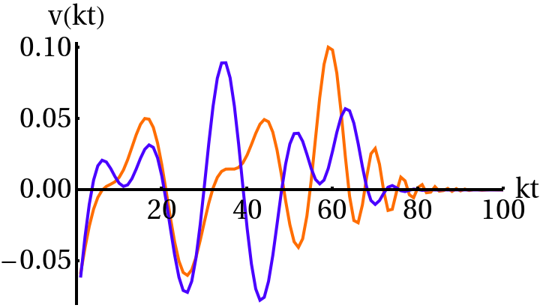
FIG.1:14theigenvectorfromoftheR11correlatorforpure
RD(red)andMD(blue).

n butnotafixedorientation.Thismeansthataddingup

InournumericalworkwediscretizeC(y, y′)andorder theeigenvaluessuchthat0 < λn+1< λn.
Thescalingbehavior,i.e.C(k, t, t′)=C(kt, kt′),isan extraordinarily useful property.First or all, it reduces the problem from 3 to 2 dimensions.Secondly, for y≪1 and y′≪1, C(y, y′) is constant.On the other hand for y≫1 ory′≫1itdecayslikeapowerlaw.Thispowerlawcan

linearlytheeigenvectorcomponentsfromRDandMD sources,asinEq.(29),isnotawelldefinedoperation sincetherelativesignbetweenv(r) andv(m) isundeter-mined. Largedifferencescanariseintheinterpolated componentvnbyarbitrarilyflippingthesignofeither v(r) orv(m) .
Onepossiblewaytodealwiththisproblemistode-

bedeterminedanalytically,seeAppendixA.Withthis | mandapositivescalarproductas |  |  |  | (y)dy> 0 . | (31)
weonlyhavetodetermineC(y, y′)numericallyinthe
 | ⟨v(r) nv(m) | ⟩≡ | Z | g(y)v(r) n(y)v(m)
regions,say0.1 < y,y′< 100.
In the real universe, however, we have a transition from

radiation to matter domination happening shortly before decoupling.Thisspoilsscaling.Thisproblemarisesac-tuallyforanytypeofcosmicdefectssourcingtheCMB. Inthelarge-NglobalscenariotheindexoftheBessel functioninthesolutionforβ,givenbyν=1 + γ,goes fromν=2duringradiationtoν=3inthematter era. Howeverthereisnoanalyticalsolutiondescrib-ingthistransition. Inthecaseofotherdefects,one oftenobtainstheUTC’satpureRDorMDepochs alone(i.e.whenthereisscaling),butnotinbetween, duringtheradiation-mattertransition. Inthelitera-ture[15,36,39,47]thisproblemisusuallydealtwith byinterpolatingtheeigenvectorsfromtheradiationand matterdominatedcorrelators,

AfterdiagonalizingtheRDandMDsourceswitharbi-trary sign, one flips the sign, say, of the MD eigenvectors, inordertoverifythepositivityconditionEq.(31).
However,theeigenvectorsv(r)andv(m)describethe scalarfieldswhenthesearedeepintheRDandMD era,respectively.Thismeansthatsomeoftheeigenvec-torsfromRDandfromMDwilltypicallyoscillateout ofphase.InFig.1weshowoneeigenvector(the14thin thisexample)oftheunequal-time-correlatorR11,both forexactMDandRD.Onecanseethatthetwovec-torsareoutofphasewitheachotherforkt≳30.In this case the scale product between them becomes small, |⟨v(r) nv(m)⟩| < 1,anditssignisnotverysignificant.

pλnvn(y, t)=f(t/teq) q  λ(r) nv(r) n(y) + |  |  |  | Therefore the positive cross-product condition does not
 |  |  |  | seemverymeaningful,particularlybecausetheRDand
 |  |  |  | MD eigenvectors describe the sources respectively in very
(1 −f(t/teq)) | q  λ(m) | v(m) n | (y)(29)
 |  |  |  | differentepochsofthehistoryoftheUniverse.
 |  |  |  | Forthisreasonwehaveconsideredadifferentap-

whereλ(r) n,v(r) n(t)andλ(m) | ,v(m) | (t)denotetheeigen-
values and eigenvectors in the radiation and matter dom-inatederarespectively. Heref(x)isaninterpolating functionverifying

proach. Inparticularwehaveintroducedaprocedure that does not rely on the linear superposition of the eigen-vectorsasinEq.(29).Aswewillshowlater,wefind indeedimportantdifferencesintheCMBanisotropies, oftheorderoffew×10%forscalarperturbations,de-

f(x) | x→0  −−−→1, | f(x) | x→∞  −−−−→0 . | (30) | pendingontheprocedureusedtodeterminetheUTCs
 |  |  |  |  | ofthesource.Theissueofhowtointroducecorrectly

Letusnote,however,thefollowingproblem:although theeigenvectorscanbechosenreal,theirsignisunde-termined,theyaresimplyrayswhichdefineadirection,

scalingsourcesinaBoltzmanncodearoundthetimeof matter-radiationequalityinordertoobtainanaccurate predictionoftheCMBanisotropies,isarelevantaspect

6
not only for the large-Nmodel, but for all scaling cosmic adjacent intervals will be similar to each other.From the
defects. computationoftheUTCswithEqs.(24)-(26),interms

The origin of the problem is simple:the transition from radiation-tomatter-dominationbreaksscaling,i.e.the scalefreebehaviorofthesourceinthepureradiation ormatterera. Sotheproblemtranslatesintohowto sourcetheBoltzmannequationwithascalarfieldevolv-ing around the radiation-matter equality time teq.A lin-earcombinationofRDandMDeigenvectorsisnotwell defined,soweshouldsourceourcodearoundteqwith thephysicalsolutionfortheself-orderingfieldsinanex-pandingbackgrounddictatedbyamixtureofradiation andmatter. However,inthelarge-Nglobalscenario,βa(k, t)cannotbesolvedanalyticallyinthosecircum-stances,andsecondly,itcannotbewrittenasafunction ofy=kt.Breakingscalingimpliesthatthecorrelators depend again on the three variables, (k, t, t′), and not just ontwo(kt, kt′).Onewaytosolvetheproblemwouldbe tosourcetheBoltzmanncodewiththeUTCscalculated foreachrelevantk,asafunctionoftandt′.Inpractice thisisunfeasible.
Thus,wewanttopreservetheveryusefulproperty of the correlator depending only on (kt, kt′), while at the same time, describing correctly the evolution of the fields aroundteq.Theoreticallyweknowthisisinconsistent. Inpractice,thereisawaytocircumventtheproblem,as follows.Letusdividethetimeevolutionintoqintervals ast1<t2<t3<... <tq<tq+1,oflength∆ti= ti+1 −ti, i = 1, 2, ..., q, with teqlying somewhere between t1and tq+1.If the ∆tiintervals are sufficiently short, the behaviorofthescalefactorwillnotchangeappreciably betweentiandti+1.Onecanthenthinkofanadiabatic solutionfortheself-orderingfieldswithineachinterval∆ti,givenbyEq.(8),butwithafixedvalueνiforthe indexνbetween2and3.Sinceateverytimetthereis awelldefinedvalueofνgivenby

ofconvolutionsoftheβa (i)’sfromEq.(34),wethenob-tain the corresponding eigenvectors of every UTC in each interval ∆ti.The scalar product of adjacent eigenvectors will thus be large,such that the positivity condition (31) becomes meaningful again.The choice of qcan be made, forinstance,bydemandingthatthetotalangularpower spectrumCℓ’schangebylessthanacertaintolerance, say1%,withincreasingq.
The‘adiabatic’methodjustdescribedshouldcapture the evolution of the self-ordering fields with sufficient pre-cisionaroundteq,ensuringanaccuracyinthefinalCℓ’s belowagiventolerancerequirement,whilepreserving atthesametimethedescriptionoftheUTCsasscal-ingfunctionsdependingonscaleonlythrough(kt, kt′). Howevertheoreticallycorrect,inpracticethismethodis difficulttousedirectly.Firstofall,becauseaprioriwe donotknowthenumberoftimesubintervalsq(fora giventolerance).Thismeansthatwemustproceedby trial and error, calculating all UTCs repeatedly for every intervalti<t, t′<ti+1(andfromtheretheCℓ’s),and repeating this procedure for every new set of subintervals asweincreaseprogressivelyq.ComputingalltheUTCs withagoodaccuracyishowevercomputationallyvery costly, rendering this procedure unfeasible.Secondly, the problempreviouslyexplainedabouttheundefinedsign inthemethodinterpolatingRDandMDeigenvectorsas inEq.(29),isageneralproblemforsourcingtheCMB withanytypeofcosmicdefects. Thediscussedadia-baticmethodreliesonthefactthatanalyticalsolutions existfortheself-orderingnon-topologicaltextures,but thisisnotthecaseforotherdefects,particularlyforthe mostinterestingcaseofcosmicstrings.Forgeneralde-fects one would need to run a large number of simulations for‘intermediate’expansionrates,whichagainwouldbe

ν(t) = 1 +d log a d log t | t | , | (32) | computationally very costly.Therefore, it would be more
 |  |  |  | satisfactorytofindaprocedurepotentiallyvalidforany
 |  |  |  | typeofcosmicdefects.

wecansetthevalueofνwithintheinterval(ti, ti+1),as thearithmeticmeanofthevalueattheboundaries,

Althoughinapplicableinpractice,thepreviousadi-abaticmethodstillgivesusthecluehowtoproceed. Maintainingtheideaofsubdividingthetimeevolution

νi≡1 2 [ν(ti) + ν(ti+1)] . | (33) | intoqintervalsoflength∆ti=ti+1−ti,ifthelatter
 |  | aresufficientlyshort,wecanexpectthattheequaltime

Thus,νiisaneffectiveindexweightingtherelativedevi-ationfrompureRD(ν= 2)andMD(ν= 3)duringthe

correlators(ETCs)Ci(k, t)canbewrittenforatimet withintheperiod(ti, ti+1),as

timeintervalti<t<ti+1,duringwhichtheadiabatic solutioniswrittenas |  |  |  |  | Ci(k, t) = f(t)CRD(kt) + [1 −f(t)]CMD(kt) , | (35)
βa (kt) ≡ | p A | t | 1 2−γiJνi(kt) βa(kt) , | (34) | whereCRD, CMDaretheETCsinpureRDorMDperi-ods, and f(t) is an interpolating function like in Eq. (29), verifying the conditions in Eqs. (30).Since in the large-N
(i) | i | t∗ | (kt∗)νi ∗

withγi≡νi −1andAigivenbythenormalizationcon-stantEq.(11)evaluatedatν= νi.Bytakingqarbitrar-ily large, the set of solutions with effective indices νi given in Eq. (34), tend to the real physical solution.In practice wecannottakeqtoinfinity.However,ifwetakesuffi-cientlysmalltimeintervals,thesubsequentsolutionsin

limitofglobaldefectswecanobtainCRDandCMDex-actlyfromEqs.(24)-(26),justevaluatingthematt = t′,
wecantheninverttheproblemtofindf(t)as
f(t) ≡Ci(k, t) −CMD(kt) CRD(kt) −CMD(kt). | (36)

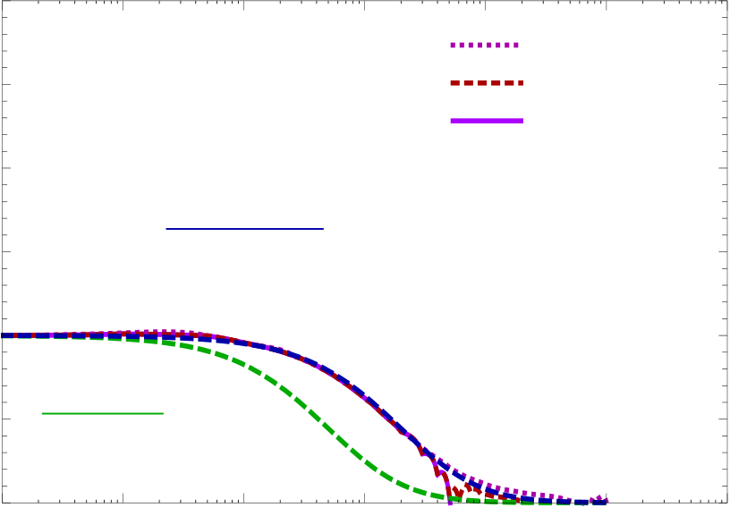
7
Interpol.f"t# | 3.0 | 1 | 1 | 1 | 10 | k"0.1keq | 1000 | 10,foralargetimeintervalt=10−3teq −103teq.From
 |  |  |  |  |  |  |  | therewehavecomputedtheETCsevaluatingEqs.(24)
 | 2.5 |  |  |  |  | k"1.0keq |  | to(26)withthenumericalsolutions,andobtainedthe
 | 2.0 |  |  |  |  | k"10.keq |  | functionf(t)foreachscalekconsidered,viaEq.(36).
 |  |  |  |  |  |  |  | TheresultisshowninFig.2.Clearlytheinterpolating
 |  |  |  |  |  |  |  | function,f(t),isthesameforeveryscalek.Wefitted
 | 1.5
 |  |  |  |  |  |  |  | thecurveswithafunctionfgivenby
 |  |  | "1 ! t ! "4 teq##2
 |  |  |  |  |  |  |  | f(t) = [1 + (t/4teq)]−2, | (40)
 | 1.0
 |  |  |  |  |  |  |  | whichdoesanexcellentjob.
 | 0.5 |  |  |  |  |  |  | If the subintervals are short enough (say ∆ti≪ti, ti+1
 |  | "1 ! t ! teq#2
 |  |  |  |  |  |  |  | andthereforet, t′∼ti, ti+1),thenweshouldalsobeable
 | 0.0  0.001 | 0.01 | 0.1 |  |  | 100 |  | toapproximateeachUTCatthetimesti<t, t′<ti+1,
 |  |  |  |  |  |  |  | by2
 |  |  |  | t!teq |  |  |  | Ci(k, t, t′)=f(¯ti)CRD(kt, kt′)

FIG.2:Theinterpolationfunctionf(t)=(1+t/4teq)−2, inblue,isauniversalfunctionforallk.Weshowherethe comparisonforthreeverydifferentwavenumbers,k/keq= 0.1,1,10,aroundtheradiation-mattertransition. Theal-ternativeparametrizationf(t)=(1 + t/teq)−2,ingreen,is clearlynotagooddescription.
Ofcourse,thisisallundertheassumptionthatEq.(35) isagoodapproximationtotheETCaroundteq,which isequivalenttoassumingthatthereexistsascale-free buttime-dependentinterpolatingfunctionf(t).Insuch acase,theapparentscaledependenceontherhs.of Eq.(36)shoulddropout,sothatthelhsisscale-independent. Weshouldthenbeabletofindf(t)by simplycomputingtherhsofEq.(36)fordifferentscales k,andtheresultshouldalwaysbethesameatagiven timet,independentlyofthescalek.
Inordertofindf(t),provingatthesametimeits scale-invariance, we need to know the exact ETC Ci(k, t) aroundteq,justwhenthefieldsarenotinthescaling regimeandEq.(8)isnotavalidsolution.Toovercome this difficulty, all we have to do is to solve numerically the equationofmotionoftheself-orderingfieldsforscalesk closetokeq,attimesaroundteq.Inordertodothiswe

+ [1 −f(¯ti)] CMD(kt, kt′) , (41)
with ¯ti≡(ti+ti+1)/2, and CXthe UTCs calculated with solution Eq. (8) for ν= 2 (X = RD) or ν= 3 (X = MD). Thelargerisqtheshorterarethetimeintervals,and thereforethemoreaccuratethisansatzapproachesthe real physical answer.To test the approximation,we sim-plyrequirethesamecriteriastatedbeforefortheadia-batic approximation:the total Cℓ’s obtained from a given qshouldchangebylessthanagivenpercenttolerance whenweincreasethenumberofsubintervals.Wehope thatourapproximationreproducesthephysicalsolution in that moment, with an accuracy better than the chosen tolerance.
After trial and error, we have found that we satisfy the abovecriterionfora1%tolerance,bytakingq= 11and choosingtheboundarytimestiintheintervalsasfol-lows:EvaluatingEq.(32)withthescalefactorEq.(38), wehaveconsideredregularlyspacedvalues(exceptfor theextremevaluest1andtq)oftheeffectiveindexνoftheadiabaticapproximation,ν(t2)=2.05, ν(t3)= 2.15, ν(t4)=2.25, ..., ν(t10)=2.85, ν(t11)=2.95,andν(t1)=2.01andν(t12)=2.99.Fromherewefindthe timesattheboundariesoftheintervalsbyinvertingthe relation(32),yielding

needtoconsiderthelarge-NlimitansatzEq.(3), |  |  |  | (37) | ν(t 1) = 2.01 , | t 1/teq= 0.049
∂µβa∂µβa= ω2(t) = c1H2−c2H′, |  |  |  |  | ν(t 2) = 2.05 , | t 2/teq= 0.254
 |  |  |  |  | ν(t 3) = 2.15 , | t 3/teq= 0.852
butthistimewiththescalefactora(t)givenby |  |  |  |  | ν(t 4) = 2.25 , | t 4/teq= 1.609
 | h (√  2 −1)(t/teq) + 1 i2 |  |  |  | ν(t 5) = 2.35 , | t 5/teq= 2.600
a(t) = aeq |  | −1 | , | (38) | ν(t 6) = 2.45 , | t 6/teq= 3.950
 |  |  |  |  | ν(t 7) = 2.55 , | t 7/teq= 5.901

which corresponds to a mixed radiation-matter fluid.We caneasilyfixthecoefficientsc1andc2bymatchingthe expressioninEq.(37)withitsasymptoticbehaviorin theMDandRDregimes.Thisyieldsc1=−3/8and c2=33/8. Havingfixedthesecoefficients,themode equationcanbewrittenas
¨βa k+ 2H ˙βa k+ | k2−ω2(t) | βa k= 0 , | (39)
with ω2(t) and a(t) given by Eq. (37) and Eq. 38, respec-tively.WehavesolvedEq.(39)fork/keq=0.1, 1and

ν(t 8) = 2.65 , t 8/teq= 8.967ν(t 9) = 2.75 , t 9/teq= 14.49ν(t10) = 2.85 ,t10/teq= 27.36ν(t11) = 2.95 ,t11/teq= 91.74ν(t12) = 2.99 ,t12/teq= 478.0
2Analternativeapproachwouldhavebeentoreplacef(¯ti)by p f(ti)f(ti+1),butinprinciplethereisnomorereasonforone choiceoranother.

8

Fort<t1,weprovidejusttheUTCsfromthepure RDuniverse,ν= 2,whereasfort > t12,weusetheMD solution,ν=3.Notehoweverthatthepresentageof theUniverset0isactuallysmallerthant12,soinprac-tice, we never source the Boltzman code with the solution fromapureMDuniverse.Notealsothatwedonotdis-cussthefactthattheUniversebecomesΛ–dominated atlatetimes,sincethereisnoneed:inthatcasethe linearizedfieldequationforβaisnotoftheform(2). ThetermγthastobereplacedbyHt2,whichspoils scalingandthepossibilityofobtainingananalyticso-lution.Howeveritisexpectedthatthemaineffectwill appearatthequadrupoleandoctopolemomentsofthe power spectrum,whose uncertainty is dominated by cos-micvariance.
As mentioned before,we have found that q= 11 is the minimumnumberofsubintervalsrequiredforthetotal Cℓ’s to change by less than 1% when subdividing the time evolutionwithonemoresubinterval,q→q + 1.Thereis the possibility, however, that when increasing further the numberofsubintervals,theaccumulatedchangecould becomelargerthan1%withrespecttothecaseq=11. Inordertoavoidthis,wehaveyetimposedastronger criteria:thattheCℓ’sshouldnotchangemorethan1% whenincreasingthenumberofsubintervalsasq→2q.
Wehaveconsideredthefollowingtimes

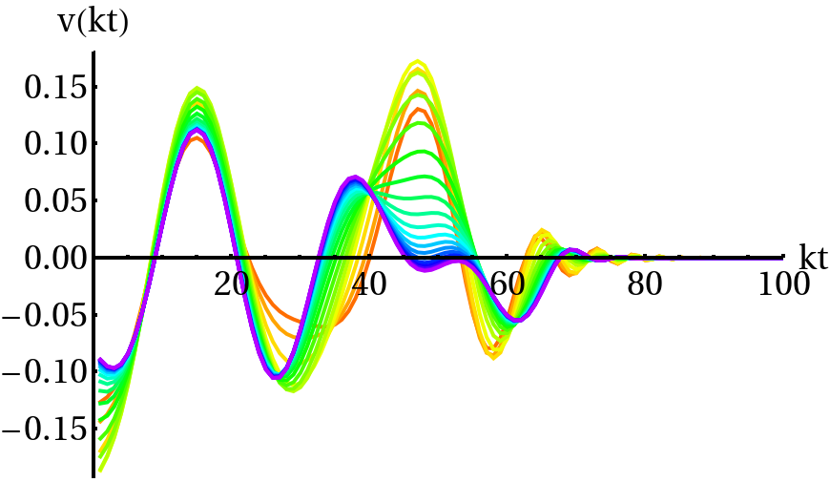
FIG.3:The11theigenvectorfromtheCitensorcorrelators within the succesive periods (ti, ti+1).The color coding shows the transition from red (ν= 2.03) to orange (ν= 2.10), yellow andgreen(s)(ν= 2.15 −2.50),blue(s)(ν= 2.55 −2.95)and finallypurple(ν= 2.97).
are the most precise calculations we have done.We how-everinsistonthefactthatthesespectradifferbyless than1%fromtheonesobtainedwithq=11,andthat showingthelatterwouldhadsufficedaswell.Wehave computedthematricesCRD(y, y′)andCMD(y, y′)forall sources (scalar, vector and tensor) with a high resolution integrator(4monthscomputationinastandardCPU

ν(t 1) = 2.01 , | t 1/teq= 0.049 | serialprocessor).Thenwehavebuiltthecorresponding correlatorsCi(y, y′)foreveryintervalti<t<ti+1,by meansofEq.(41)withf(t)=(1 + t/4teq)−2evaluated attheintermediatetimes¯ti≡(ti + ti+1)/2.  We have diagonalized the scalar, vector and tensor cor-  relators Ci’s (defining C0as CRD) and sourced the Boltz-man code at the times ti< t < ti+1with the correspond-
ν(t 2) = 2.03 , | t 2/teq= 0.150
ν(t 3) = 2.06 , | t 3/teq= 0.308
ν(t 4) = 2.10 , | t 4/teq= 0.536
ν(t 5) = 2.15 , | t 5/teq= 0.852
ν(t 6) = 2.20 , | t 6/teq= 1.207
ν(t 7) = 2.25 , | t 7/teq= 1.609
ν(t 8) = 2.30 , | t 8/teq= 2.069 | ingeigenvectorsv(i) n. |  |  | Inordertomatchsmoothlythe
ν(t 9) = 2.35 , | t 9/teq= 2.600 | eigenvectorsfromacorrelatorCi−1withthosefromCi atthetransitiontimest = ti,wehaveimposedtheposi-tivitycriterion,
ν(t10) = 2.40 , | t10/teq= 3.219
ν(t11) = 2.45 , | t11/teq= 3.950
ν(t12) = 2.50 , | t12/teq= 4.828 | δn,i≡ | Z | g(y)v(i−1) n |  |  | (y)v(i) n(y)dy> 0 .
ν(t13) = 2.55 , | t13/teq= 5.901
ν(t14) = 2.60 , | t14/teq= 7.243
ν(t15) = 2.65 , | t15/teq= 8.967 | Thiscriterionbecomesnowalwaysmeaningful,sincethe timesubintervalsaresufficientlyshortsothatthenth eigenvectorofCiisonly’slightly’outofphasewithre-specttothecorrespondingoneofCi−1.Thisisopposite tomatchingeigenvectorsfromdeepinRDwiththose deepinMD,whicharesignificantlyoutofphase,see
ν(t16) = 2.70 , | t16/teq= 11.27
ν(t17) = 2.75 , | t17/teq= 14.49
ν(t18) = 2.80 , | t18/teq= 19.31
ν(t19) = 2.85 , | t19/teq= 27.36
ν(t20) = 2.90 , | t20/teq= 43.46
ν(t21) = 2.95 , | t21/teq= 91.74
 |  | Fig.1.InFig.3weseehowaneigenvectorv(i) |  |  |  |  |  | changes
ν(t22) = 2.97 , | t22/teq= 156.1
 |  | smoothlytov(i+1) |  | . | Inparticular,weareplottingthe
ν(t23) = 2.99 , | t23/teq= 478.0 ,
 |  | 11theigenvectorfromthetensorUTCsH(i)obtained
as the boundaries of q= 22 subinterval around teq, again |  | ateachperiod(ti, ti+1). |  |  |  | Thecolorcodingshowsthe

regularlyspacedinν(exceptforclosetotheextremes). Wehavefoundthatindeedwhenincreasingthenumber of subdivisions to q= 22, the total Cℓ’s do not change by more than 1% with respect the corresponding amplitudes obtainedforq= 11.

transitionfromred,correspondingtotheclosestone topureRDwithaneffectiveindexν=2.01,toor-ange(ν=2.10),thenyellowanddifferentgreensforν=2.15 −2.50,differentbluesforν=2.55 −2.95,and finallypurple,correspondingtotheoneclosesttoMD,

In what follows we show the results from q= 22 subin- ν= 2.97.

tervals with the time boundaries listed above, since these

Note also that for cosmic string simulations one usually

9
computestheirUTC’sinthescalingregimesinpureRD andMD,andtheninterpolatethecorrespondingeigen-vectorsasinEq.(29)[36].Ourexerciseshowsthatone gets significantly different results in the CMB power spec-tra,seenextsection,whenonecomparesthemethodwe haveproposedversusthestandardinterpolationmethod | andthetwopointcorrelatorsare
 | ⟨Xi(k, t)X∗j(k′, t)⟩= |  | (46)
 | Zt | dt′dt′′Gim(k, t, t′)Gjn(k′, t, t′′)⟨Sm(k, t′)Sn(k′, t′′)⟩
 | t∗

attheleveloftheeigenvectors. Itwouldbetherefore
very interesting to repeat this exercise with cosmic string

IfwediagonalizetheUTCsofthesourceas

UTCs.Itispossiblethattheinterpolationfunctionthat wehavefound,Eq.(40),isuniversal,inthesensethat itcanbeusedforanytypeofdefect.However,wehave founditstimedependencefromthelarge-Nmodel,by solvingnumericallythescalarfieldevolutionaroundteq. Thus,althoughconsideringitasaplausiblespeculation thatf(t)givenbyEq.(40)mightbetheonetobeused foreverytypeofdefects–whyshoulditdependonthe large-Nmodel?– this can only be demonstrated with de-fect simulations around teq,which is beyond the scope of thispaper.Despitetheabsenceofthisexercise,wesug- | ⟨Sm(k, t′)Sn(k′, t′′)⟩ |  |  | (47)
 | = (2π)3δ(k −k′) |  | X | λpv(p) m(k, t′)v(p) n(k, t′′) ,
p
weobtain
 | ⟨Xi(k, t)X∗j(k′, t)⟩= (2π)3δ(k −k′) |  |  |  | X | λp ×
 | p
 | Zt | dt′dt′′Gim(k, t, t′)Gjn(k, t, t′′)v(p) m(k, t′)v(p) n(k, t′′) .(48)
 | t∗

gest the use of our f(t) for other defects as well.Besides, thenewmethoddescribedbyEq.(41)shouldofcourse replacetheoldeigenvectorinterpolationprescriptionfor introducingactivesourcesinCMBcodes.

The power spectra evaluated today, which are defined by ⟨Xi(k, t0)X∗j(k′, t0)⟩= (2π)3δ(k −k′)Pij(k)
arethengivenasbyasumofproductsofdeterministic (notstochastic)solutions,

III. | CMBPOWERSPECTRAAND |  |  |  | (42) | Pij(k) = | X | P(m) ij |  | (k) = |  | X |  | X(m) i | X∗(m) j | (k)with |  | (49)
CORRELATIONFUNCTIONS
A. |  | Theformalism |  |  |  | m |  | m
 |  |  |  |  |  | X(m) i | (k) = |  | pλm |  | Zt0 |  | dtGij(k, t0, t)v(m) j |  |  |  | (k, t) .(50)
Formally,theCMBspectraareoftheform
 |  |  |  |  |  |  |  |  |  |  | t∗
CXYℓ |  | = | Zdk  k∆XY | (k) , |  | Hence P(m) ij (k) is the product of the solutions of Eq. (44)  withsource√λmv(m) i and√λmv(m) j respectively.This
 |  |  |  |  |  | explains, why the unequal time correlators are all we need

whereXandYareT,EorB,and

to calculate the power spectra within linear perturbation theory.Formoredetails,seeRef.[11].

⟨Xℓ(k, t0)Yℓ(k, t0)⟩= (2π)3δ(k −k′)∆XYℓ | . | (43) | B. | Thepowerspectra
The only non-vanishing cross correlation is TE, both TB

andEBvanishinauniversewhichisinvariantunder parity.CollectingalltheperturbationvariablesXℓas wellasthedarkmatter,thebaryonandtheneutrino perturbationsintoonelongvectorwhichwecallX(k, t), thefirstorderperturbationequationisoftheform

We have used a modified version of CMBEASY [48] to includesources[36].WehavethencomputedtheCMB powerspectrafromlarge-Nglobaldefectsusingvarious procedures.First of all, we have obtained the CMB spec-tra using Eq. (29) in two different ways, which we refer to

DijXj(k, t) = Si(k, t) . | (44) | asprocedures1and2:Inprocedure1,weusetheeigen-
 |  | vectorswitharbitrarysignasgivenbydefaultbythedi-

HereDijisafirstorderdifferentialoperatordepending ontimeandSiisthesourcewhichcanbeparameterized intermsofΦs,Ψs,Σiandhij.BeGij(k, t, t′)theGreen functionforDijwhichdependsonlyonthebackground universe.Thenthesolutionwithvanishinginitialcondi-tionatt∗isgivenby

agonalizationalgorithmofthecorrelators.Inprocedure 2,weusethesameeigenvectorsbutonlyafterhaving flippedthesignsappropriately,suchthatthepositivity criterion(31)isimposedbetweenMDandRDeigenvec-tors.On the other hand, we have also obtained the CMB powerspectrabyusingtheprocedureexplainedindetail in section II C, which we will refer to as procedure 3 from

Xi(k, t) = | Zt | dt′Gij(k, t, t′)Sj(k, t′) , | (45) | nowon.Bythiswemeanthatwehavedividedthetime
 |  |  |  | evolution into qsub-intervals (ti, ti+1), i = 1, 2, ...q, and
 | t∗ |  |  | thenwehaveintroducedasasourceateachintervalthe

10

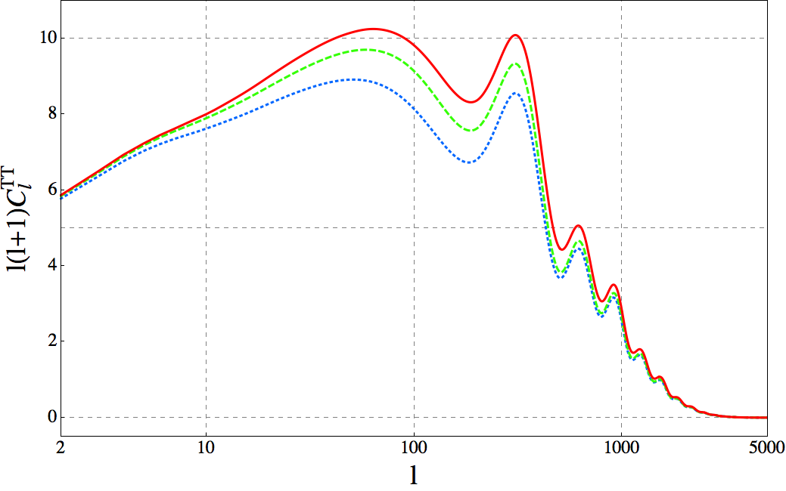

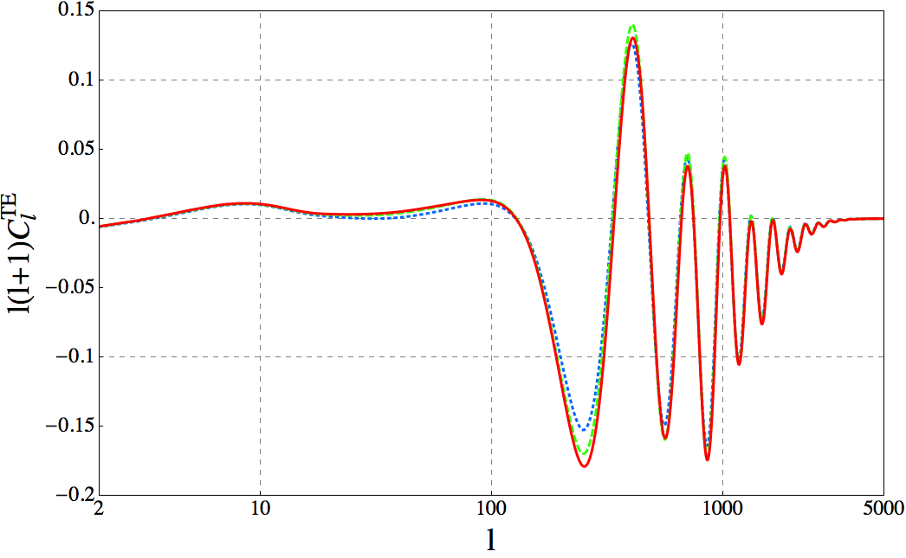

FIG.4: | ThetotalCT Tℓ | spectrum(sumofscalar,vector | FIG.6: | ThetotalCT Eℓ | spectrum(sumofscalar,vector

andtensorcontributions)fromprocedure1(dotted,blue),2 (dashed,green)and3(solid,red).Notethedifferentposition oftheacousticpeaksascomparedtothestandardinflation-aryspectrum,e.g.thefirstpeakisatℓ∼50versustheusualℓ∼200.
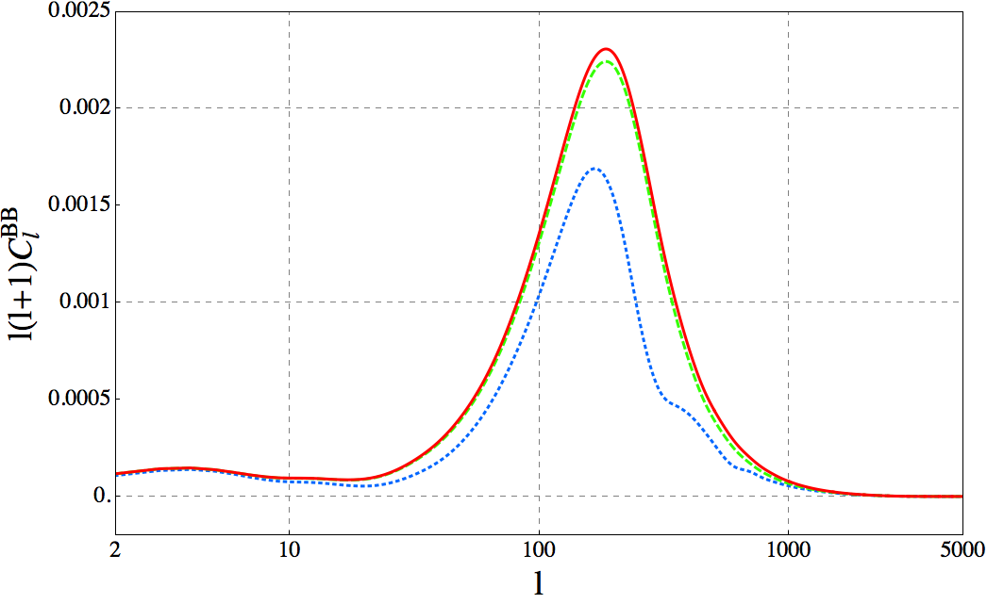

andtensorcontributions)fromprocedure1(dotted,blue), 2(dashed,green)and3(solid,red).
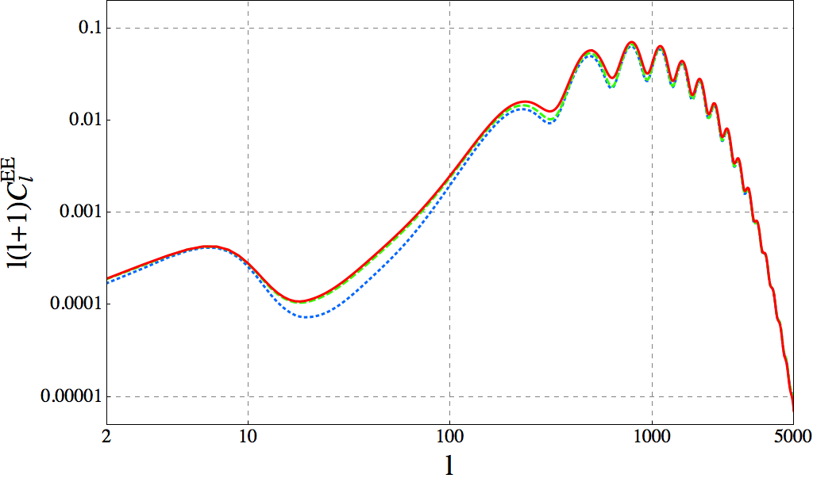
FIG.7: | ThetotalCEEℓ | spectrum(sumofscalar,vector
andtensorcontributions)fromprocedure1(dotted,blue),

FIG.5: | ThetotalCBBℓ | spectrum(sumofscalar,vector | 2(dashed,green)and3(solid,red).
andtensorcontributions)fromprocedure1(dotted,blue),

2(dashed,green)and3(solid,red).
eigenvectors of the UTCs given by Eq. (41).We consider thislatterprocedureastheclosestonetothephysical answer.Wehavevariedthenumberofintervalsuntila furtherincreasechangestheresultingCMBspectraby lessthanagiventolerancefactor,whichwefixedas1%.
Inthefirstseriesofplots,Figs.4-7,wecompare theshapeandamplitudeofthedifferentCMBpower spectraobtainedbythethreedifferentprocedures. Thecolor-coding/line-styleamongthemisshared,with blue/dotted for procedure 1,green/dashed for procedure 2, and red/solid for procedure 3.In these figures we show thetotalamplitudefortheTT,BB,EEandTEchan-nels, respectively, having summed up in each channel the

correspondingcontributionfromthefirst200eigenvec-torsofallperturbations(scalar,vectorandtensor).In theTTanisotropies,seeFig.4,thedifferenceinampli-tude between the three methods reaches up to about 25% intheheightofthefirstpeakwhencomparingproce-dure 1 with procedure 3.The amplitude of the spectrum obtainedwithprocedure1isofcourserandomtosome extent, since the relative sign between MD and RD eigen-vectorsusedisrandom.Butevenwhencomparingthe output from procedure 2 with that from procedure 3, the difference in amplitude is still of the order of 10%−15%. FortheBBchannel,thedifferencesbetweenprocedures 1and3reach∼100%(i.e.afactor∼2ofdiscrepancy), butontheotherhand,thedifferencewhencomparing procedures2and3onlyamountstoa2-3%atlowℓ(althoughitgoesupto10% −15%forℓ> 300,afeature

11

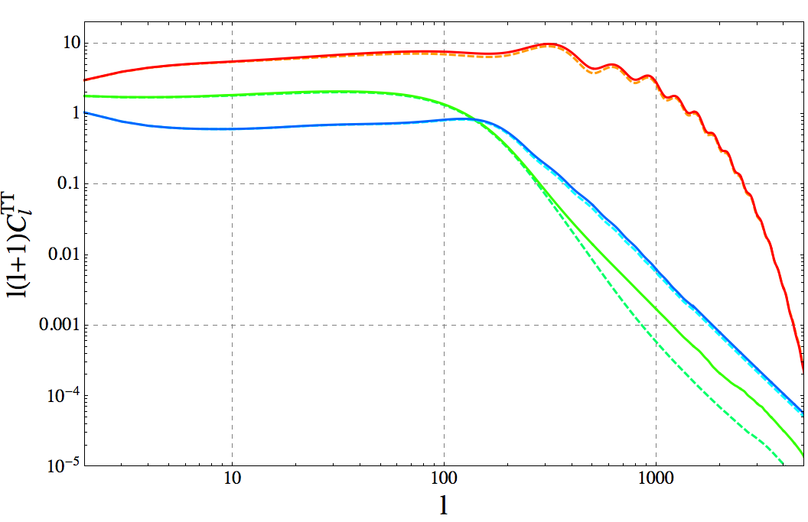

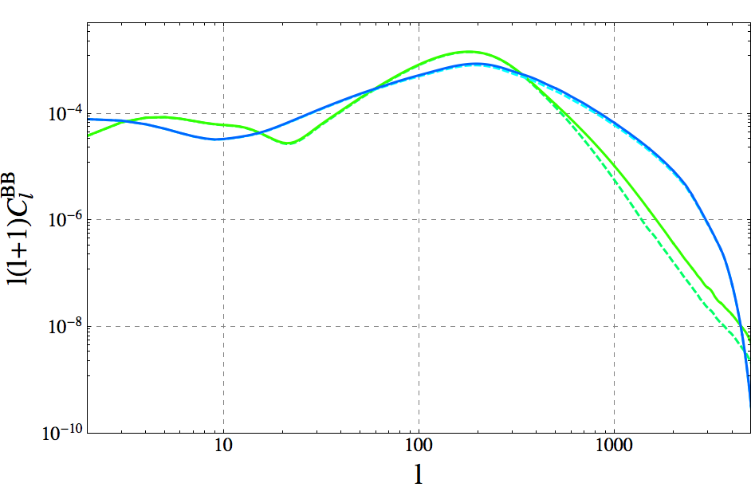

FIG.8: | TheCT Tℓ | spectrumdecomposedintoitsscalar | FIG. 9:The CBBℓ | spectrum decomposed into its vector (green

(red/orangetopcurvesatlowℓ),vector(greenmiddlecurves at low ℓ) and tensor (blue bottom curves at low ℓ) parts.Here, andintheanalogousfiguresforBB,TEandEE,weonly showthedifferencesbetweenprocedures2(dashedlines)and 3 (solid lines).In this case the differences are most significant forthedominantscalarperturbations,whilsttheyaresmall forvectorperturbations(exceptatverysmallscalesℓ> 400, wherehowevervectorsarecompletelysubdominant).
notappreciatedbyeyeinthelinearplotinFig.5).In theTEchannelthedifferenceinamplitudebetweenpro-cedure3withrespectbothprocedures1and2,reaches about10% −15%(whencomparingthecurvesfarfrom thezerosofCTEℓ ).InthecaseofEE,therelativeampli-tudebetweenprocedures1and3isoftheorderofafew times10%(reachingeven∼70%atℓ≃20 −30),while itbecomessmallerwhencomparingtheamplitudesfrom procedures2and3,differing2% −6%forℓ<100,but reachingupto∼20%inthedipsoftheoscillationsat multipolesℓ≥200.
Clearlytherearenoticeabledifferencesinamplitude dependingontheprocedureusedtotreatthedefect sources.Using a linear combination of RD and MD eigen-vectorsisnotwelldefined(procedures1and2)dueto thesignchoice,whichalsoinprocedure2isstillsome-whatarbitrary.Ourprocedure3ismorerealistic.With thechoiceoftimesubintervalsdiscussedintheprevious section,anaccuracyoforder∼1%isreachedinthefi-nalanswer.AsshowninFigs.4-7,differencesoforder O(10)%ariseinthechannelsTT,TEandEE,andof orderO(1)%inthechannelBB,whencomparingthe amplitudesobtainedwith(themorephysicallycorrect) procedure 3 versus the procedure 2.This difference is not relevantfromthepointofviewofconstrainingthesym-metryscale.TheUTCs,andthereforetheCℓ’s,scaleas (VEV)4andthereforethedifferencesfoundinthetem-peratureandpolarizationpowerspectrawilltranslate atmostintoafew%differenceintheupperboundfor the VEV, which does not represent a significant improve-ment.However,fromthepointofviewofdetectingde-

(upper)curvesatℓ= 100)andtensor(blue(lower)curvesatℓ=100)parts.Inthischanneltherearenoscalarperturba-tions,andthedifferencesbetweenprocedures2and3areof thesameorderforthetensorandvectorcontributions.
fects in the CMB, the differences found are relevant, since theydependonthemultipoleℓandthereforetheyalso changetheresultingshapesofthespectra.Forinstance, inFig.7onecanobservehowtherelativeamplitudeof thefirstvalleyatℓ≈300withrespecttotheamplitude of the valley at ℓ≈20, is higher than in the procedures 1 and2.Inotherwords,usingprocedures1or2wewould belookingforasignalwiththesecondtrough(ℓ≈300) at a given relative amplitude with respect to the first one (ℓ≈20),butwefindwithprocedure3thattheeffectof consideringthefieldevolutionaroundteqinamorepre-cisemanner,liftsupthesecondtroughwithrespectto thefirstone.
Letusalsodiscussthecontributionsofeachtypeof perturbation,scalar,vectorandtensor,toeachCMB powerspectrum.InFigs.8-11,weshowseparatelythe power spectra sourced only by the eigenvectors from ten-sor,vectorandscalarUTCs.Thecolorcoding/linestyle isagaincommontoallFigs.8-11(thoughdifferentthan inFigs.4-7),dashedandcontinuouslinescorrespond-ingtoprocedures2and3respectively,andred/orange toscalarperturbations,greentovectorperturbations, andbluetotensorperturbations.Foreachcaseweplot theamplitudesobtainedfromprocedures2and3.This allowsustoidentifythecontributionwhichismostaf-fectedbythemorerealistictreatmentoftheevolution around teq.In Fig. 8 we see that the TT power spectrum isdominatedbythescalarcontributionovertheentireℓrange.Tensor contributions have a discrepancy of ∼10% betweenprocedure3versusprocedure2(fromℓ> 250), butweconcludethatthe∼25%differenceinthetotal temperaturepowerspectrumismainlyduetothedis-crepancy(ofthesameorder)inthescalarcontribution, whichdominatescompletelyoverthevectorandtensor

12

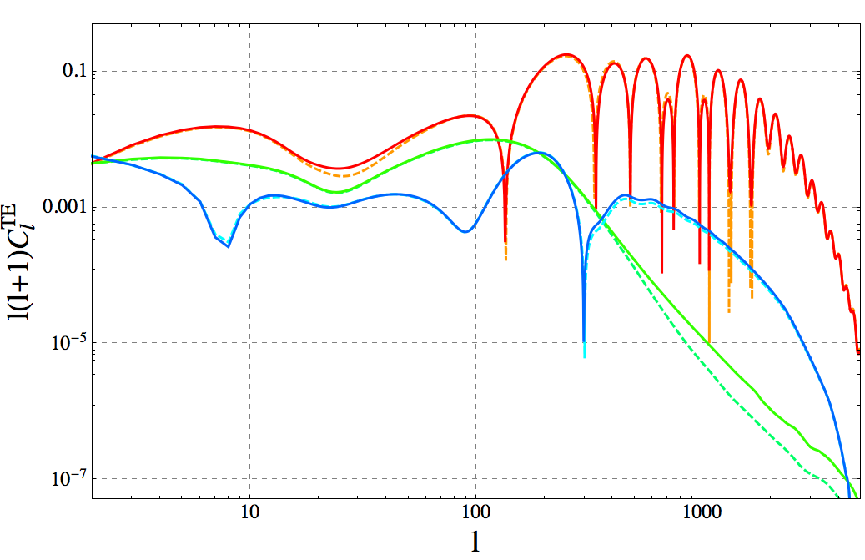

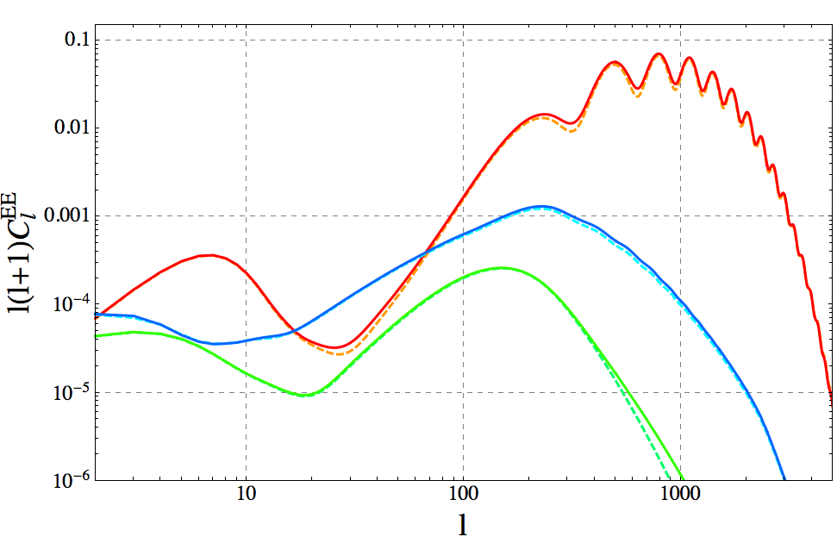

FIG.10:TheCT Eℓ | spectrumdecomposedintoitsscalar(top | FIG.11:TheCEEℓ | spectrumdecomposedintoitsscalar(top

red/orangecurvesatℓ=10),vector(middlegreencurvesatℓ=10)andtensor(bottombluecurvesatℓ=10)parts. Again,thedifferencesbetweenprocedures2and3aresmall forvectorperturbations.
contributions3.InFig.9weshowtheanalogousdecom-position but for the BB power spectrum.First of all, both tensorandvectorcontributionsarerelevant,essentially ofthesameorder,thoughvectorsareslightlydominat-ing,except for the interval around ℓ≈15−60,as well as for small scales, ℓ≳350.Procedures 2 and 3 do not differ significantlyforeithertensororvectorperturbationsin thischannel.Thedeviationbetweentheamplitudesob-tained with procedure 3 and with procedure 2 are indeed ofsimilarorderforvectorsandtensors.Thetotaldis-crepancyamongthedifferentproceduresinthefinalBB spectrumoverthefullℓrange(seepreviouscomments aboutFig.5,isduetoacombinationofboththetensor andvectorcontributions.Wecansaythatthischannel istheleastaffectedbythechoiceoftheprocedure.
In Fig. 10 we show the same decomposition for the TE channel.Inthiscasebothtensorandvectorcontribu-tions have some few percent discrepancy when comparing the results of procedure 3 and procedure 2.But as in the caseofoftheTTchannel,thefinalcurveiscompletely dominatedbythescalarcontribution,whichthereforeis responsible for the final differences in amplitude of the to-talspectrum(whichwereportedbeforewhendiscussing Fig.6).

red/orangecurvesatℓ=100),vector(bottomgreencurves atℓ= 100)andtensor(middlebluecurvesatℓ= 100)parts. Alsohere,procedures2and3differmuchmoresignificantly forthescalarandtensormodesthanforthevectormode.
Finally,inFig.11,wereporttheanalogousdecompo-sitionfortheEEchannel.Thedifferenceinamplitude betweenprocedure3andprocedure2,ismostlydueto thescalarcontributionforalmosttheentireℓrange,ex-ceptforthesmallintervalℓ≈15−50forwhichthe tensorsdominate.Likeforthetemperature,thediscrep-ancies among the procedures are of the same order in the scalarandtensorcontributions,andsmallerforthevec-tormode.Thedifferencesinthefinalspectrumofthis channelaredueessentiallytoonlythescalarcontribu-tion,sincethelatterdominatesovertheentireℓ-range. Notethatthefirstbumpislikeintheinflationarycase duetoreionization,whereasfortherestofthespectrum the peaks are out of phase with respect to the inflationary signal,sincedefectsproduceisocurvatureperturbations.
The result that the vector mode is not very sensitive to the chosen procedure might be related to fact that vector perturbations of the CMB do not oscillate.This can lead toamorestablescalarproductforvectormodes.Note however,thatthedecayrateforvectorperturbationsis differentforthetwoprocedures.However,thisshowsup only in the highly suppressed tail at small scales, ℓ> 400, andhasnoobservationalrelevance.
Notethatallthepowerspectrashownhavebeenob-tainedsummingupthecontributionsfromthefirst200

eigenvectorsofeachtypeofperturbation(scalar,vector

3Notethatthevectorcontributionshowsasignifcantdiscrepancy of O(100)% for ℓ> 400, but this is irrelevant since at small scales thevectorsarereallysubdominant(evenmorethanatlowℓ) ascomparedtothescalarcontribution.Ananalogousfeature, i.e. asignificantdeviationofthevectorsbetweenmethods2 and3atverysmallscales,actuallyshowsupintherestofthe channels,BB,TEandEE.However,againthisisanirrelevant issue,sinceatthosescalesthevectorcontributionisalwaysvery subdominant versus either the tensor or the scalar contributions.

ortensor),i.e.Cℓ≡P200 n=1C(n) ,withC(n)ℓ thecontribu-tionfromthentheigenvector.Theconvergenceofthe successiveaditionofcontributionsisindeedquitefast,
verifying | Pm n=1C(n) | −Cℓ | ≪0.01Cℓalready for the first
m=40eigenvectors,inalmosteveryperturbationand channel (the exception being the BB polarization at small scalesℓ> 1000,wheretheconvegenceisslower).
Inalltheresultsthatwewillpresentinthefollowing

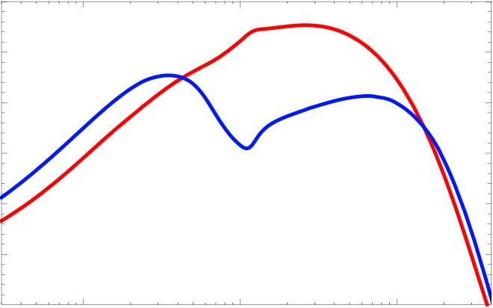
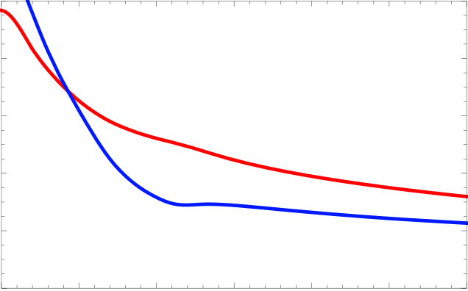
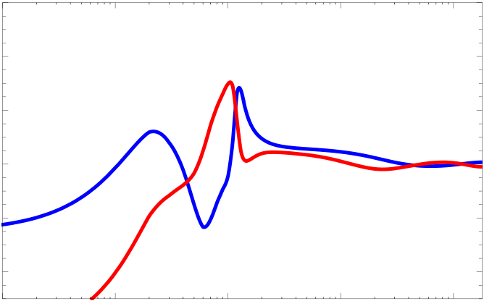
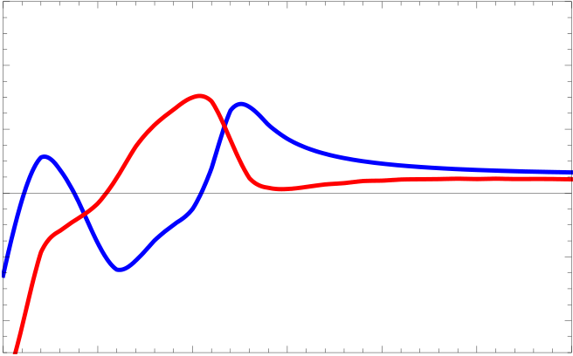
13
weonlyuseprocedure3,whichforthelarge-Nmodel | Θ1#2CTT!Θ"$ΜK2% | 6000 | 0.1 | 1 | Large N | 10
ismorethan1%accurate.Interestingly,thespectraob- |  | 5000
tainedforthelarge-Nusingprocedure3aretypically
somewhatlargerthanthoseobtainedfromthestandard |  | 4000 |  |  | Inflation
procedure 2, typically of O(10)%, depending on the chan- |  | 3000
nelandthemultipolarscaleℓ.Fortheconvenienceof
thereaderandofworkersinthefield,allthespectra |  | 2000
CXYℓareavailableonthehomepageoftheGenevacos-  mologygroup: |  | 1000
under’dataproducts’.
 |  | 10000 |  | Θ!°"
Letusfinallyremarkthat,ofcourse,whenusingthe
large-NcaseasatemplateformonopolesorO(4)tex-
tures,intrinsicdifferencesoftheorderof10%havetobe | #ΜK2$ | 8000 | 0.5 | Inflation | 1.5 | Large N | 2.5 | 3.0
addedtotheerrorbudget.Moreover,thecaseofcos- |  | 6000
micstringsissimplynotwelldescribedbythelarge-N
 | CTT!Θ" | 4000
scenario.Therefore,wecannotquantifyhowpresently
publishedCMBspectrafromtopologicaldefects,partic-
 |  | 2000
ularlyfromthemostrelevantcaseofcosmicstrings,will
beaffectedbyrecalculatingthemusingasimilartreat-
ment as the procedure 3 outlined here.Our present work, | CTE!Θ"#ΜK2$ | 0  0.0 |  | 1.0 |  | 2.0
although based only on the large-Ncase, suggests that it |  |  |  |  | Θ!°"
 |  | 60
is possible that differences of O(10)% might arise.There-
fore,theaccuracyofpreviouslycalculatedCMBpower |  | 40 |  |  |  | Inflation
spectrafromtopologicaldefectsshouldbetakenwith
 |  | 20
caution,atleastuntilanequivalentmethodologytopro-
cedure3isemployed.Weconsiderthisobservationasa |  | 0 |  |  |  | Large N
firstimportantresultofourpresentwork.
!20
C. | Thecorrelationfunctions | !40 | 0.1 | 1 | 10 | 100
 |  | 0.01
ThecorrelationfunctionsoftheCMBtemperature |  | 60 |  | Θ!°"
anisotropiesandpolarizationaregivenby
40
ξXY(θ) =1 4π | X (2ℓ+ 1)CXYℓ | Pℓ(cos θ) , | (51) | CTE!Θ"#ΜK2$ | 20 | 0.5 | 1.0 | 1.5 | Inflation | 2.5 | 3.0
 | ℓ |  |  |  | 0 |  |  |  | Large N
whereXandYdenoteasbeforeT,EandBandPℓ
istheLegendrepolynomialoforderℓ.Inprinciple,the |  |  |  |  | !20 |  |  |  | 2.0
powerspectrumandthecorrelationfunctioncontainex-
 |  |  |  |  | !40
actly the same information.However, the form of certain
 |  |  |  |  | 0.0
correlationfunctionsfromdefectsourceshaveverychar-
 |  |  |  |  |  |  |  | Θ!°"
acteristicshapes,whichcanmakeiteasiertodistinguish
themfrominflation,thanbylookingatthepowerspec-
trum. | Asimilarsituationisknownfromtheacoustic | FIG.12:Thecorrelationfunctionsfromlarge-Nandfrom

peaksinthematterpowerspectrumwhichareeasierto seeinthecorrelationfunction.InFig.12weshowthe TTandTEcorrelationfunctions.Theacousticpeakatθ≃1oisapronouncedminimumandkinkintheinfla-tionaryTTcorrelationfunction.Forthelarge-Nmodel thereisonlyaslightkink.Also,intheTEcorrelation functiontheacousticpeaksshowupasapronounced double-maximum well separated by a minimum,while in thelarge-NTEcorrelationfunctionthefirstmaximum andtheminimumareentirelymissing.Thisisaconse-quence of causality as has been pointed out already in [49] andtestedwithatoymodelin[50].
Aswehavepointedoutin[41],thesocalled’local’polarizationcorrelationfunctions(foranintroduction

inflation. Clearly,themaindifferenceisatangularscalesθ<3o. NotethecharacteristicsigndifferenceoftheTE correlation functions.The large-Ncontribution is normalized suchthatCT TlargeNℓ=0.1CT Tinfℓatℓ=10,andthenitis multipliedbyafactor50forvisibility.
see[51])areespeciallyuseful.Letusrepeattheirdefi-nitionhere.Theusualpolarizationcorrelationfunctions andofcoursealltheCMBpowerspectraarenon-local, i.e.theyrequireinprincipleinformationfromtheen-tiresky.Localpolarizationcorrelationfunctionscanbe definedasfollows.
PolarizationoftheCMBisdescribedasarank-2ten-

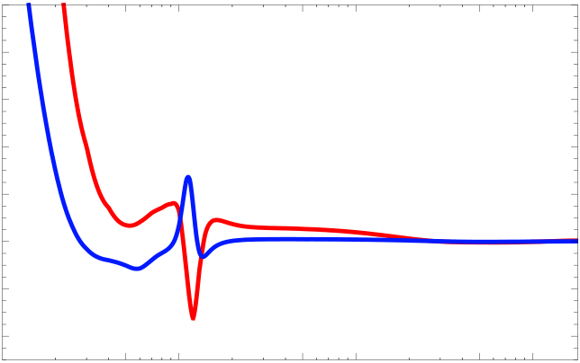
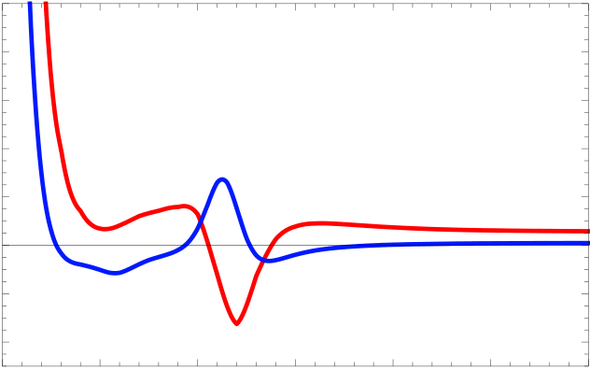
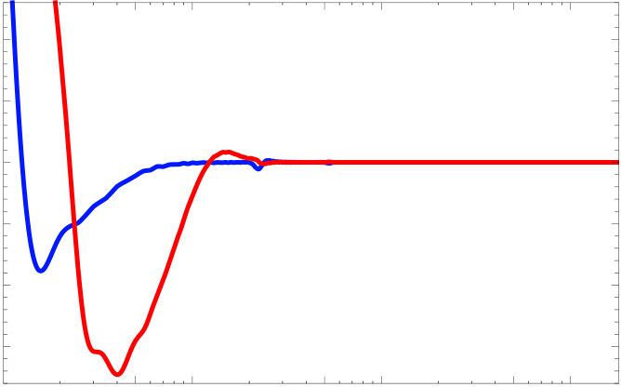
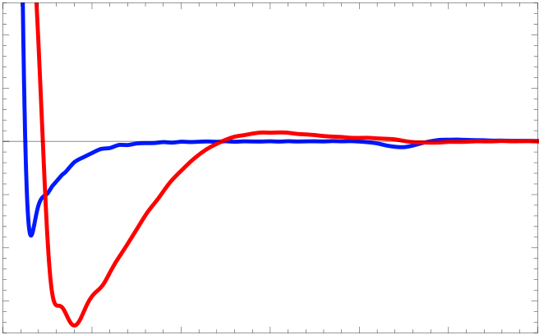
14
sorfieldPabonthesphere. | Itisusuallydecomposed |  | CEE!Θ"#mK2$ | 0.010 | 0.5 | 1.0 | Large N |  | 50.0 | 100.0
intoStokesparameters,Pab=(Iσ(0) ab+ Uσ(1) ab+ V σ(2) ab+ |  |  |  | 0.008
Qσ(3) ab)/2=Iδab/2 + Pab,whereσ(j)arethePaulima- |  |  |  | 0.006
tricesandσ(0) ab=δab/2[51].ThevariableIcorresponds |  |  |  | 0.004
totheintensityoftheradiationandcontainsthetem- |  |  |  | 0.002
peratureanisotropies.Astherelevantscatteringprocess |  |  |  | 0.000 |  |  | Inflation
atlatetimes–Thomsonscattering–doesnotinduce |  |  |  | !0.002
circularpolarizationweexpectV=0fortheCMBpo- |  |  |  | !0.004 |  |  | 5.0 | 10.0
larization,andhencePabtobereal. |  | Foragivendi-
rectionnwedefinetheorthonormalframe(e1, e2, n) andthecircularpolarizationvectorse±=√1 2(e1 ± ie2) |  |  |  | 0.010 |  |  | Θ!°"
 |  |  | CEE!Θ"#mK2$ | 0.008 |  |  | Large N
asbefore.Thisallowsustointroducethecomponents |  |  |  | 0.006
P±±=2ea±eb±Pab=Q ± iUandP+−∝V=0.The
secondderivativesofthispolarizationtensorarerelated tothelocal˜E-and˜B-polarizations, |  |  |  | 0.004
 |  |  |  | 0.002
0.000
∇−∇−P++ + ∇+∇+P−−=2∇a∇bPab≡˜E , | !0.002 | 0.5 | 1.0 | 1.5 | Inflation | 2.5 | 3.0
∇−∇−P++ −∇+∇+P−−=2ϵcdϵab∇c∇aPbd≡˜B . | !0.004 |  |  |  | 2.0
 | 0.0
Θ!°"
Here∇±arethederivativesinthedirectionse±and |  | CBB!Θ"#ΜK 2$ | 10 | Inflation |  | 5.0 | 10.0 | 50.0 | 100.0
 |  |  | 5
ϵcdisthe2-dimensionaltotallyanti-symmetrictensor.
Thesefunctionsaredefinedlocally.TheusualE-and
B-modescanbeobtainedbyapplyingtheinverseofthe Laplacian,∇2=∇+∇−+ ∇−∇+tothelocal˜E-and |  |  | 0 | Large N
 |  |  | !5
˜B-polarizations. | Suchinversionsofdifferentialopera-
torsdependonboundaryconditionswhichcanaffect theresultforlocalobservations. The˜B(and˜E)cor- |  |  | !10
 |  |  | !15
 |  |  |  | 0.5 | 1.0
relationfunctions,ξ˜B(θ)≡⟨˜B(n) ˜B(n′)⟩n·n′=cos θ,and
ξ˜E(θ)≡⟨˜E(n) ˜E(n′)⟩n·n′=cos θaremeasurablelocally. |  |  | 10 |  |  | Θ!°"
Theyarerelatedtothepowerspectrumby[51]
5
ξ | B,˜E(θ) =1 | ∞ | (ℓ+ 2)! (2ℓ+ 1)P(cos θ)CB, E | .(52) | ΜK 2$ | 0 | Inflation
 |  | X
 | 4π |  | (ℓ−2)!ℓ |  | CBB!Θ"# | !5
 |  | ℓ=2
Large N
!10
The additional factor nℓ= (ℓ+2)!/(ℓ−2)! ∼ℓ4enhances |  | !15 | 0.5 | 1.0 | 1.5 | 2.0 | 2.5 | 3.0
thepoweronsmallscaleswherethedefectpolarization
isenhancedwithrespecttotheinflationaryone. |  | 0.0
 |  |  |  |  | Θ!°"
InFig. | 13weshowthelocalcorrelationfunctions
ofEandBpolarizationforthelarge-Nmodelandwe

comparethemwiththecorrespondingonesfrominfla-tion.Clearly,atsmallangles,θ≲3otheirshapeisvery different.Aroundθ=1.2o,inflationaryE-polarisation hasamaximumwhileE-polarizationfromlarge-Nhas aminimum. AlsothemostsignificantstructureofB-polarisationfromthelarge-Nmodelisaroundθ∼0.3o to1o,wheretheinflationarysignalisalreadysmall.In apreviouspaper[41]wehaveexploitedthisfact,which isevenmorepronouncedfortopologicaldefectslikecos-micstringsorglobalmonopolesandtexture,topredict

FIG.13: ThelocalcorrelationfunctionsforE-andB-polarizationfromlarge-N andfrominflation. TheB-correlations on angular scales θ< 1.5oare very differentfrom theinflationaryones.AlsotheE-polarizationshaveopposite signs at about 1odegree.Again, the large-Ncontribution has been multiplied by 50 in order to compare with inflation.The BBcontributionduetogravitationalwavesfrominflationis normalizedsuchthatCBBinfℓ = 0.1CT Tinfℓatℓ= 10.

limits on a defect contribution from future B-polarisation | IV. | COMPARISONTOPRESENTAND
measurements. |  | FUTUREEXPERIMENTS
In the next section we shall use the shape of the power
spectrum to identify a possible small large-Ncomponent Inthissectionwewanttoestimatethesignal-to-noise intheCMBsky. ratioofthedifferentchannelsforthreedifferenttypesof

15

experiments:1)Planck,2)aCOrE-likeexperiment,3) PRISM and 4) an optimal polarization experiment which iscosmicvariancelimitedouttoℓ=10000.Weassume thatthetruesignalisoftheform

δβ | Planck | COrE | PRISM | CVL
TT | 1.4 · 10−2 | 3.5 · 10−3 | 8 · 10−4 | 3 · 10−4
EE | 6 · 10−3 | 4.1 · 10−3 | 4 · 10−3 | 3.7 · 10−3
TE | 4 · 10−4 | 3 · 10−5 | 2.5 · 10−5 | 2.4 · 10−5

Cℓ= (1 −ϵ2)Cinfℓ | + ϵ2ClargeNℓ | , | (53) | TABLEII:TheTT,EEandTEerrorsonβ,forPlanck,a

andwewanttostudyhowwellagivenexperimentcan constraintheamplitudeϵ.In(53)wenormalizeC20to theobservedvalue,

COrE-likeexperiment,PRISMandaCVLexperiment.We setfsky= 0.7inallcases.

Cinf 20= ClargeN | = 915.92 (µK)2 | 2π  20 × 21. | However,whenboth,large-Nandinflationcontribute
 |  |  | tothesignal,S/N>1isnotsufficienttodetectthe
 |  |  | signal,butwemustalsobeabletodistinguishitfrom

Weassumethatthecovariancematrixisdiagonalinℓ-space,i.e.thatnotonlythesignalbutalsothenoiseis statisticallyisotropic.ForGaussianCℓ’swethenhave

the inflationary signal.To quantify this we use the Fisher matrix technique.We consider a signal to which not only thelarge-N(ordefects)contributebutthereisalsoan

Cov[CXY | , CV W | ] = | CXVℓ | CY Wℓ | + CXWℓ | CY Vℓ | δ , (54) | inflationarycontribution.Wesplitthesignalas
 |  |  |  |  |  |  |  | i d
ℓ | ℓ′ |  |  | fsky(2ℓ+ 1) |  |  | ℓℓ′ | Cℓ= αCℓ+ βCℓ+ Nℓ, | (57)

CXVℓ | = (CXVℓ | + NXVℓ | ) exp[ℓ(ℓ+ 1)/ℓ2 s] . | (55)
Herefskyisthefractionoftheobservedsky,Nℓisthe noisespectrumoftheexperimentandℓsisasmoothing scalewhichmustbelargerthantheresolutionofthe

where Ci,dℓ denotes the inflationary (i) and large-Ndefect
(d) signal, normalized such that they are equal at ℓ= 20,
Ci 20= Cd 20= 915.92 (µK)2 | 2π  20 × 21.

experiment, |  |  |  | HereCℓcanmeanthetemperature, CT Tℓ , theE-  polarization, CEE or the temperature-polarization cross-
ℓ< ℓ= | p 8 ln(2) | , | (θ= beamwidth) . | ℓcorrelation,CT E .
sr | θFWHM |  | FWHM | ℓ
 |  |  |  | Studying how well we can measure different parameters

The noise spectrum is assumed to be white noise char-acterized by an amplitude ∆P,efffor polarization and ∆T fortemperaturenoise,

in a signal depending on several parameters, is best done withtheFishermatrixtechnique.Theresultinglimits assumethattheerrorsontheparametersareGaussian, whichisoftennottrue,butnevertheless,iftheerrors

NX | =ℓ(ℓ+ 1) | exp | ℓ(ℓ+ 1) | ∆2 . | are small enough it is usually a good approximation.For
ℓ | 2π |  | ℓ2r | X | Cℓ’sdependingonaseriesofparametersλitheFisher
 |  |  |  |  | matrixisdeterminedby

 | Planck | COrE | PRISM | CVL
θFWHM∆P,eff∆T  Ref. | 7.2  23.4  14.5  PLA[52] | 4.7  2.05 1.19 [53] | 2.3  1.43 1.01 [54] | 1.0  0  0  noiseless
TABLEI:TheFWHMbeamwidth,inarcmin,andthenoise levelofthedifferentCMBexperimentsconsideredhere,in unitsofµK·arcmin.
WeshallconsidertheexperimentslistedinTableI. When we consider a signal to which only the defects con-tribute,wecansimplycalculatethesignaltonoisefrom the large-Ncontribution either with the correlation func-tionortheCℓ’svia

F= | X | ∂Cℓ | ∂Cℓ | Cov−1 | , | (58)
ij |  | ∂λi | ∂λj | ℓ
 | ℓ
wherewehavealreadyusedthatthecovariancematrix isdiagonal,Covℓℓ′=δℓℓ′Covℓ.Weareonlyinterested inthetwoparametersλ1≡αandλ2≡β. Wewill fixallothercosmologicalparameterstothevaluesmea-suredbythePlanckcollaboration.Inthelightofthe Planckresults,thepresenceofdefects(parametrizedby theirfractionalcontributionf10atmultipoleℓ=10)is actuallyveryweaklycorrelatedwiththestandardcos-mological parameter values [38],the latter being affected onlyintheirthirddecimaldigitbytheinclusionoff10 intheMonteCarloMarkovChainanalysis.Therefore, thereisnodangerofadegeneracyandwecanfixthe standard cosmological parameters to the values measured

S = | ℓmax | Cℓ | . | (56) | byPlanckintheabsenceofcosmicdefects.TheFisher matrixisobtainedas
 | X
N |  | Nℓ |  |  | Fαα=Pℓ(Ciℓ)22ℓ+1 (Cℓ)2 |  | fsky | = F11 , | (59)
 | ℓ=2
 |  |  |  |  |  |  | 2
AswehaveseeninRef.[41],fortheB-mode,mostof thelarge-Nordefectsignalcomesfromthecorrelation functionatsmallangles,θ< 1o. |  |  |  |  | Fββ=Pℓ(Cdℓ)22ℓ+1 (Cℓ)2 |  | fsky | = F22 , | (60)
 |  |  |  |  |  |  | 2
 |  |  |  |  | F=P Ci Cd | 2ℓ+1 | fsky | = F12= F21 . | (61)
 |  |  |  |  | αβ ℓ ℓ | (Cℓ)2 | 2

16

Gv2/N | Planck | COrE | PRISM | CVL
TT | 5.2 · 10−7 | 2.7 · 10−7 | 1.3 · 10−7 | 7.8 · 10−8
EE | 3.5 · 10−7 | 2.9 · 10−7 | 2.9 · 10−7 | 2.7 · 10−7
TE | 9.0 · 10−8 | 2.5 · 10−8 | 2.3 · 10−8 | 2.2 · 10−8
TABLEIII:TheupperboundsonGv2/NfromtheTT, EEandTEerrorsonβ,forPlanck,COrE-likeexperiment, PRISM,andaCVLexperiments.Wesetfsky=0.7inall cases.
anditsinverseisgivenby

globaltexturesandformorethanfourcoupledglobal scalar fields, which in 3+1 dimension do not give raise to topological defects (but yet produce non-topological gra-dientfieldconfigurations,socallednon-topologicalde-fects).Wehavefoundthatthebreakingofscaleinvari-ancewhichhappensatthetransitionfromradiationto matter is important and leads to an imprint on the CMB powerspectra.Takingitintoaccountbyasimplein-terpolationfromtheradiationdominatedtothematter dominatedsource,attheleveloftheeigenvectors,leads toerrorsoftheorderofupto25%.Onlyafterusingof the order of 10 interpolation steps can we trust our result

F−1 | = | 1 | Fββ | −Fαβ | ! | (62) | tobeaccurateatthe1%level.
 |  |  |  |  |  |  | Wehavefoundthetime-dependenceofauniversal
 | ij | det F | −Fαβ | Fαα |  |  | (scaleindependent)interpolationfunctionthatonecan
 |  |  |  |  |  |  | use to weight correctly the MD and RD correlators at ev-

Themarginalizederrorontheparameterβ= β0 ± δβis nowsimplygivenby(see[51],p231ff)

erymoment(withinoneofthechosensubintervals).Be-sides, we have proposed a prescription, using the previous interpolationfunction,forintroducingactivesourcesin

(δβ)2= (F−1)22= | Fαα  FααFββ−(Fαβ)2. | (63) | CMB codes accounting accurately for the contribution of suchsourcesaroundteq.Itwouldbeveryinterestingto test this procedure also on topological defects like cosmic strings.
Wehavetocomputeδβforsomefiducialvalues(α0, β0).

Wefoundthattheresultisnearlyindependentofβ0forβ0<0.1,hencewecansetβ0=0.Thevalueofδβto-getherwiththenormalizationofCdℓthendeterminesthe VEV of the large-Nfield, or equivalently the combination Gv2/N.SeetableIII.
Interestingly,theTE-correlationgivesthebestcon-straints,evenbetterthanthosefromB-polarizationfor

Finally,wehaveinvestigatedhowwellsuchacompo-nentcanbedetectedintheCMB.Thiscanbecastin termsofupperlimitsforGv2/N.Wehavefoundthat forexperimentswithconsiderablenoise,likePlanckthe TEcorrelationisthemostsensitivechannel,whilefora cosmic variance limited or very low noise experiment like PRISMtheB-polarisationchannelisamorethantwo

Planck[41]. | Furthermore,thereisvirtuallynoaddi- | ordersofmagnitudemoresensitiveprobe.

tionalgainwhengoingfromanexperimentlikeCOrEor PRISMtoacosmicvariancelimitedexperiment.This meansthatalreadyforPRISM(orCOrE)thedomi-nantcontributiontotheuncertainlycomesfromcos-micvarianceandcannotbeimprovedbybetterexper-imenttechnology.Inthiscase,B-polarisationlimitsare muchbetterthanthosefromTandE-polarization.In Ref. [41] we have shown that a cosmic variance limited B-polarisation experiment can detect a large-Nsignal down to Gv2/N= 1.4×10−10which is more than two orders of magnitude better than the best limit we can achieve from TandEsignals.ThisconfirmsourclaimofRef.[41], thatB-polarisationisaverysensitiveprobeforcosmic defects,hereinthecaseoflarge-N.

WehavemadeavailableourfinalCMBspectra at (under ’data products’)fortheconvenienceofthereader.
Acknowledgments
WeareverygratefultoMarkHindmarsh,Joanes LizarragaandJonUrrestilla,forcriticaldiscussionsand commentsonthedraft. Wealsoacknowledgehelpful discussionswithJos´eJuanBlancoPilladoandMar-tinBucher. ThisworkissupportedbytheSwissNa-tionalScienceFoundation.Somenumericalcalculations wererunontheAndromedaclusteroftheUniversity ofGeneva.Theauthorsalsoacknowledgefinancialsup-

V. | DISCUSSIONANDCONCLUSIONS | portfromtheMadridRegionalGovernment(CAM)un-
 |  | dertheprogramHEPHACOSS2009/ESP-1473-02,from
theSpanishMICINNundergrantAYA2009-13936-C06-

Inthispaperwehavefullycalculatedtheimprinton theCMBtemperatureanisotropyandpolarizationfrom large-Nscaling seeds.This model has the advantage that thesourcetermcanbecomputedanalytically.Inaddi-tion,itisagoodapproximationforglobalmonopoles,

06andConsolider-Ingenio2010PAU(CSD2007-00060), andfromtheMINECO,CentrodeExcelenciaSevero OchoaProgramme,undergrantSEV-2012-0249,aswell as from the European Union Marie Curie Initial Training NetworkUNILHCPITN-GA-2009-237920.

17
AppendixA:Theunequaltimecorrelators
Equaltimecorrelatorsandasymptoticbehaviourofscalarsources
AsdiscussedinsectionIII Aweneedtocalculatetheunequal-timetwopointfunctionsofthemetricperturbations inordertobeabletocomputetheCMBpowerspectra.Herewepresentanalyticexpressionsfortheunequaltime correlatorsofthescalarfieldenergymomentumtensorandwediscusstheirasymptoticbehavior,from[44].The energydensity,fρ=[( ˙β)2+ ∇β)2]/2canbeexpressedintermsoftheexactsolutiongivenin(8).Tosimplifythe notation,weset
χ(x) ≡Jν(x)  xν | , | ϕ(x) ≡ | 2χ(x) −Jν+1(x) | . | (A1)
wheretheformofϕarisesfrom˙βintheenergymomentumtensor,withthederivativeofJν(x)re-expressedwiththe helpoftheusualrelationforBesselfunctions,d/dx[Jν(x)/xν] = −Jν+1(x)/xν.
Wealsointroducethedimensionlessvariablesx≡qtandy≡kt. Furthermore,theproductsinrealspace becomeconvolutionsinFourierspace,anditisusefultointroduceforexpressionslikeg(x)h(|y −x|)thecompact notationg(x)h(|y−x|)≡(gh). WealsousethattherandomvariablesβaareGaussiansothatproductslike⟨βa(k)βb(p)βc(k′)βd(p′)⟩canbereducedviaWick’stheoremtosumsoverproductsoftwo-pointexpectations,which inturnaregivenbyEq.(9).Withthisweobtain
|f2 | | (y, t)= | (2π)3 | Z | d3x | (ϕϕ)2+ [x(y −x)]2(χχ)2−2[x(y −x)](ϕϕ)(χχ) |  |  | (A2)
ρ |  | 2NN2t | Z |  |  |  | .
 | = | (2π)4 |  | dx dµ x2 |  | (ϕϕ)2+ [xyµ −x2]2(χχ)2−2[xyµ −x2](ϕϕ)(χχ) |  | (A3)
 |  | 2NN2t
whereN=16/15forRD(ν=2)orN=128/2835forMD(ν=3).Inthelastequationwehaveperformedthe integrationoveroneangularvariableandintroducedµ=cos φ.Thepressurefpcontainsthesameterms,onlythe pre-factorsdiffer.Thepre-factorofthe(χχ)2termis1/9andtheoneof(ϕϕ)(χχ)is2/3.
Fromtheaboveexpressionsitisclearthatfρandfpbehavelikewhitenoiseonsuperhorizonscales.Numerically wehavefound
|f|2 | (y= 0, t)= | (2π)4 | ( | 1.72 · 10−2forν= 2 , | (A4)
ρ |  | NtN2 | ( | 3.34 · 10−5forν= 3
|f|2 | (y= 0, t)= | (2π)4 |  |  | (A5)
 |  |  |  | 1.96 · 10−3forν= 2 .
p |  | NtN2 |  | 2.61 · 10−6forν= 3
Inthelimity≫1theydecaylike
|fρ|2 | (y≫1, t)∼y1−2νt−1, | (A6)
 | (y≫1, t)∼y1−2νt−1. | (A7)
|fp|2
fviscalculatedanalogouslytofρandfp:
fv(k, t)=−ikj k2 | Z | ˙ββ,j | (k, t) | ϕ(qt)χ(|k −q|t)βin(q)βin(k −q). | (A8)
=−At2 |  | d3qk(k −q) k2 |  |  | (A9)
Usingthesamedimensionlessvariablesandthesamenotationasabove,wefindfortheequal-timecorrelatoroffv,
|f|2 | (y, t)= | (2π)3t | Z | d3x | n [y(y −x)]2(χϕ)2+ [y(y −x)] [yx] (χϕ)(ϕχ) o |  |  |  |  | (A10)
v |  | NN2y4 | Z |  |  |  |  |  | .
 | = | (2π)4t |  | dxdµx2 n y2−xyµ |  | 2 (χϕ)2 + | y2−xyµ | [xyµ] (χϕ)(ϕχ) o |  | (A11)
 |  | NN2y4

18
Alengthyexpansionaroundy=0showsthattheintegrandvanishesuptoy3,andthatthistermvanishesupon integrationoverµ.Therefore,fvdoesnotdivergefory→0.Weobtainthefiniteresult
Inthelimity≫1, | |fv|2 | |fv|2 | (y= 0, t) =(2π)4t NN2 |  | ( | 1.96 · 10−3forν= 2 | (A12)
 |  |  |  |  |  | 2.61 · 10−6forν= 3.
 |  | decayslike | |fv|2 | (y≫1, t) ∼y−1−2νt . |  |  | (A13)
Forfπwefind
f(k, t)=−3 | kikj |  | β,iβ,j−1 3δij (∇β)2 |  |  | (A14)
π 2 | k4 |  |  |  | χ(qt)χ(|k −q|t)βin(q)βin(k −q) .
=3At3  2 |  | Z | d3q | (kq)(k2−kq) −1 3k2(kq −q2) |  | (A15)
Theresultingequaltimecorrelatorisgivenby
⟨f(k, t)f∗(k′, t)⟩=9(2π)4t3 | Z | dxdµx2 | xyµ −x2µ2+1 3 | x2−xyµ | 2 | (χχ)2. | (A16)
π π 2NN2 |  |  | y4
Clearlyfπdivergesfory→0andwefindeasilythat
|f|2 | (y→0, t)= | 9(2π)4t3 | Z1 |  | dµ | 1 −µ2 | 2 Z∞ | dxx6χ(x)4
π |  | 2NN2y4 | −1 |  |  | 3 | 0 |  | (A17)
 | = | 9(2π)4t3
 |  |  | ( | 2.08 · 10−3forν= 2
 |  | 2NN2y4 | 5.24 · 10−5forν= 3.
Inthelimitx ≫1itdecayslike
|fπ|2 | (y≫1, t) ∼y−3−2νt3. | (A18)
Theunequal-timesourcefunctions
Wearenotgoingtolistallscalarunequaltimecorrelators(UTC),sincetherearenospecialproblemsinvolvedin theircalculation,andtheyarenotveryilluminatinganyway.Asanexample,wepresenttheUTCforfv:
⟨fv(k, t)f∗v(k, t′)⟩=(2π)4tr2 NN2y4 | Z | dxdµx2 n y2−xyµ | 2 (χϕ)(˜χ ˜ϕ) + | y2−xyµ | [xyµ] (χϕ)( ˜ϕ˜χ) o | , | (A19)
wherewehaveadditionallyintroduced(˜g˜h)≡g(xr)h(|y −x|r)withr≡t′/t,whileretainingthenotationfromthe previoussection,i.e.x ≡qtandy≡kt,andg(x)h(|y −x|) ≡(gh).
Thecorrelatorsdecayaspowerlawsforlarger.Ifweparameterisethemlike⟨fif∗i⟩(y, r) ∝r−γi,wefindforr≫1
γρ= 3/2,γp= 3/2,γv= 3/2,γπ= 5/2. (A20)
TheUTCsforthescalarseedvariablesΦsandΨscanthenbepiecedtogetherusingtheabovescalarvariables aswellastheequations(20)and(21).Forthevectorsources,weneedtocalculatethefunctionW(z, r).Wecan usethefactthatWdependsonlyonthemagnitudeofk,butnotonitsdirection:wechoosethespecialdirection
k = (0, 0, k).Inthatcasewecanforexampleusew(v) 1 |  |  | intheexpression |  |  |  | (A21)  (A22)
W(kt, kt′) = |  | D w(v) 1(k, t)w(v)∗  k2√tt′ |  |  | (k, t′) E | ,
basedonEqs.(22)and(25).FromEq.(17)wecanseethatw(v) i |  |  |  | isgivenby
w(v) i | = T(V ) i0 |  | = Ti0 −kikj k2Tj0 .

19
Sinceforourchoiceofcoordinateswherek1= 0wehavethatw(v) 1 |  |  |  |  |  | = T10,therequiredcorrelatoristhenobtainedas
k2√ | tsW(kt, ks)=⟨T01T∗01⟩(k, t, s) = A2t2s2 |  |  | Z | d3qd3p q1(−p1)ϕ(qt)χ(|k −q|t)ϕ(ps)χ(| −k −p|s) |  | β4 in
=(2π)3 NN2 t2s2 |  | Z | d3q q2 1(χ(qs)ϕ(|k −q|s) −ϕ(qs)χ(|k −q|s)) ϕ(qt)χ(|k −q|t)
=(2π)3 NN2 π r2 |  | Z | dx dµ x4(1 −µ2) ((˜χ ˜ϕ) −( ˜ϕ˜χ)) (ϕχ). |  |  |  | (A23)
To perform the integration numerically, it can be advantageous to change to an integration variable which is symmetric√
intands,e.g.,x ≡qt →q ts.
Thetensortypetwo-pointfunctionsaredeterminedbyτ(π) ij.Wecanusethesamesimplificationasabove,andfor
k = (0, 0, k) ≡kzwefind
⟨τ(π) 12(kz, t)τ (π)∗ | √  (kz, s)⟩≡T/ ts | and | (A24)  (A25)
τ(π) 12(kz, t)=T12(kz, t).
Withthesamevariablesasabove,Tisthengivenby
T(z, r) =(2π)3  NN2 | π  2r7/2 | Z | dx dµ x6(1 −µ2)2(χχ)(˜χ˜χ). | (A26)
Asexplainedinthemaintext,theUTCforthesourceshavetobediagonalizedandtheireigenvectorsarethento beusedassourcetermsinthelinearperturbationequationsofaBoltzmannsolver.

[1]D.Larsonetal.,Astrophys.J.Suppl.192,16(2011), | D59,123005(1999),[astro-ph/9811174],10.1103/Phys-

[arXiv:1001.4635],10.1088/0067-0049/192/2/16.  [2]WMAPCollaboration,E.Komatsuetal.,Astrophys.J.  Suppl.192,18(2011),[arXiv:1001.4538],10.1088/0067-0049/192/2/18. |  |  |  |  | RevD.59.123005.
 |  |  |  |  | [15]U.-L.Pen,U.SeljakandN.Turok, |  |  |  |  |  |  | Phys.Rev.Lett.
 |  |  |  |  | 79,1611(1997),[astro-ph/9704165], |  |  |  |  |  |  | 10.1103/Phys-
RevLett.79.1611.
[16]U.-L.Pen,D.N.SpergelandN.Turok,Phys.Rev.D49, 692(1994),10.1103/PhysRevD.49.692.
[17]M.Hindmarsh,C.RingevalandT.Suyama,Phys.Rev.
[3]J.Dunkleyetal., |  | Astrophys.J.739, |  | 52(2011),
[1009.0866],10.1088/0004-637X/739/1/52.
[4]C.Reichardtetal., |  | Astrophys.J.755,70(2012),
[1111.0932],10.1088/0004-637X/755/1/70.  [5]PlanckCollaboration,P.Adeetal.,1303.5072. [6]Planckcollaboration,P.Adeetal.,1303.5075. |  |  |  |  | D80, | 083501 |  | (2009), |  | [0908.0432], |  | 10.1103/Phys-
RevD.80.083501.
[18]M.Hindmarsh,C.RingevalandT.Suyama,Phys.Rev.
[7]T.Kibble, | J.Phys.AA9,1387(1976), |  | 10.1088/0305- |  | D81, | 063505 |  | (2010), |  | [0911.1241], |  | 10.1103/Phys-
4470/9/8/029. |  |  |  |  | RevD.81.063505.
[8]T.Kibble, | Phys.Rept.67,183(1980), |  | 10.1016/0370- |  | [19]D.ReganandE.Shellard, |  |  |  |  |  | Phys.Rev.D82,063527
1573(80)90091-5.  [9]A.VilenkinandE.P.S.Shellard,CosmicStringsand OtherTopologicalDefects(CambridgeMonographson |  |  |  |  | (2010),[0911.2491],10.1103/PhysRevD.82.063527.  [20]D.G.Figueroa,R.R.CaldwellandM.Kamionkowski,
 |  |  |  |  | Phys.Rev. |  | D81, |  | 123504 |  | (2010), | [1003.0672],

MathematicalPhysics,Cambridge,UK,1994).
[10]M.HindmarshandT.Kibble,Rept.Prog.Phys.58,477 (1995),[hep-ph/9411342],10.1088/0034-4885/58/5/001.

10.1103/PhysRevD.81.123504.
[21]C.T.Hill,D.N.SchrammandT.P.Walker,Phys.Rev. D36,1007(1987),10.1103/PhysRevD.36.1007.

[11]R.Durrer,M.KunzandA.Melchiorri, Phys.Rept. [22]A.GillandT.Kibble, Phys.Rev.D50,3660(1994),
364, 1(2002), [astro-ph/0110348], 10.1016/S0370- [hep-ph/9403395],10.1103/PhysRevD.50.3660.
1573(02)00014-5. [23]K.Dimopoulos, Phys.Rev.D57,4629(1998),[hep-
[12]R.Durrer, Fund.CosmicPhys.15,209(1994),[astro- ph/9706513],10.1103/PhysRevD.57.4629.
ph/9311041]. [24]J.-F. Dufaux, D. G. Figueroa and J. Garcia-
[13]R. Durrer, A. Gangui and M. Sakellariadou, Bellido, Phys.Rev.D82,083518(2010),[1006.0217],
Phys.Rev.Lett. 76, 579 (1996), [astro-ph/9507035], 10.1103/PhysRevD.82.083518.
10.1103/PhysRevLett.76.579. [25]K. Jones-Smith, L. M. Krauss and H. Mathur,
[14]R.Durrer,M.KunzandA.Melchiorri, Phys.Rev. Phys.Rev.Lett. 100, 131302 (2008), [0712.0778],

20
10.1103/PhysRevLett.100.131302. RevD.63.081301.
[26]E. Fenu, D. G. Figueroa, R. Durrer and J. Garcia-Bellido, [40]N.TurokandD.N.Spergel,Phys.Rev.Lett.66,3093
JCAP0910,005(2009),[0908.0425], 10.1088/1475- (1991),10.1103/PhysRevLett.66.3093.

7516/2009/10/005.
[27]J.Giblin,JohnT.,L.R.Price,X.SiemensandB.Vl-cek,JCAP 1211,006 (2012),[1111.4014],10.1088/1475-7516/2012/11/006.

[41]J.Garcia-Bellido,R.Durrer,E.Fenu,D.G.Figueroa andM.Kunz,Phys.Lett.B695,26(2011),[1003.0299], 10.1016/j.physletb.2010.11.031.
[42]G.N.Felderetal.,Phys.Rev.Lett.87,011601(2001),

[28]D. G. Figueroa, M. Hindmarsh and J. Urrestilla, [hep-ph/0012142],10.1103/PhysRevLett.87.011601.
Phys.Rev.Lett. 110, 101302 (2013), [1212.5458], [43]M.KunzandR.Durrer,Phys.Rev.D55,4516(1997),
10.1103/PhysRevLett.110.101302. [astro-ph/9612202],10.1103/PhysRevD.55.R4516.
[29]A.Vilenkin,Phys.Lett.B107,47(1981),10.1016/0370- [44]M.Kunz,Th`esededoctorat:Univ.Gen`eve(1999).
2693(81)91144-8. [45]A.H.Jaffe, Phys.Rev.D49,3893(1994),[astro-
[30]T.VachaspatiandA.Vilenkin, Phys.Rev.D31,3052 ph/9311023],10.1103/PhysRevD.49.3893.
(1985),10.1103/PhysRevD.31.3052. [46]R.DurrerandM.Kunz,Phys.Rev.D57,R3199(1998),
[31]S.Olmez,V.MandicandX.Siemens,Phys.Rev.D81, [astro-ph/9711133],10.1103/PhysRevD.57.3199.
104028(2010). [47]R.Durrer,M.KunzandA.Melchiorri, Phys.Rev.
[32]J.J.Blanco-Pillado, K.D.OlumandB.Shlaer, D59,123005(1999),[astro-ph/9811174],10.1103/Phys-
1309.6637. RevD.59.123005.
[33]J.Urrestilla,N.Bevis,M.HindmarshandM.Kunz, [48]M.Doran,JCAP0510,011(2005),[astro-ph/0302138],
JCAP1112,021(2011),[1108.2730], 10.1088/1475- 10.1088/1475-7516/2005/10/011.
7516/2011/12/021. [49]D.N.SpergelandM.Zaldarriaga, Phys.Rev.Lett.
[34]P.Binetruy,A.Bohe,C.CapriniandJ.-F.Dufaux, 79,2180(1997),[astro-ph/9705182], 10.1103/Phys-
JCAP1206,027(2012),[1201.0983], 10.1088/1475- RevLett.79.2180.
7516/2012/06/027. [50]S.Scodeller,M.KunzandR.Durrer, Phys.Rev.
[35]S.Sanidas,R.BattyeandB.Stappers, Phys.Rev. D79, 083515 (2009), [0901.1845], 10.1103/Phys-
D85, 122003 (2012), [1201.2419], 10.1103/Phys- RevD.79.083515.
RevD.85.122003. [51]R.Durrer,TheCosmicMicrowaveBackground(Cam-
[36]N.Bevis,M.HindmarshandM.Kunz, Phys.Rev. bridgeUniversityPress,Cambridge,UK,2008).
D70,043508(2004),[astro-ph/0403029],10.1103/Phys- [52]Planck legacy archive, http://www.sciops.esa.int/index.php...
RevD.70.043508. ...?project=planck&page=PlanckLegacyArchive.
[37]J.Urrestilla,N.Bevis,M.Hindmarsh,M.Kunzand [53]Core proposal, White paper arXiv:1102.2181,
A.R.Liddle, JCAP0807,010(2008),[0711.1842], http:www.core-mission.org.
10.1088/1475-7516/2008/07/010. [54]Prism proposal, White papers arXiv:1306.2259,
[38]PlanckCollaboration,P.Adeetal.,[1303.5085]. arXiv:1310.1554,http:www.prism-mission.org.
[39]R.Durrer,M.KunzandA.Melchiorri, Phys.Rev.
D63,081301(2001),[astro-ph/0010633],10.1103/Phys-

