Early CVD Prediction: A Leakage-Audited and Site-Aware Machine Learning Study on Public Heart Disease Data
Mahmud Rashik
Department of Computer Science and Engineering
Bangladesh University of Professionals
Dhaka, Bangladesh
ABSTRACT
Cardiovascular disease prediction is a common machine-learning laboratory problem, but many public-dataset studies rely on random train-test splits, duplicate-prone benchmark files, and limited calibration assessment. This project develops a reproducible early cardiovascular disease prediction system using public heart disease data while preserving and improving an existing neural-network notebook. The primary dataset was the UCI-style heart_disease_uci.csv file containing 920 records from four centers. The binary target was defined as absence of disease for num = 0 and presence of disease for num > 0. The supplementary heart.csv file was audited separately and found to contain 1,025 rows with 723 exact duplicates, leaving 302 unique rows. The selected model was penalized logistic regression, which achieved mean held-out-center AUROC of 0.799, AUPRC of 0.880, Brier score of 0.168, and balanced accuracy of 0.745. The system is intended as a reproducible research and educational prototype, not as a clinically deployable diagnostic device.
Keywords: cardiovascular disease prediction, heart disease, machine learning, calibration, explainable AI, site-aware validation
I. INTRODUCTION
Early identification of cardiovascular disease risk is an important healthcare problem and a useful applied machine-learning task. Public heart disease datasets contain interpretable clinical variables such as age, chest pain type, resting blood pressure, cholesterol, exercise-induced angina, ST depression, and thalassemia-related findings. However, simple demonstrations can overstate performance if duplication, preprocessing leakage, target definition, and validation design are not handled carefully.
The starting point was an existing Jupyter notebook that trained feedforward neural networks. The notebook was useful as exploratory work, but it depended on a local 303-row heart.csv file and used a single random train-test split. The final project therefore reframed the work as a reproducible prediction-model study rather than a neural-network-only exercise.
II. LITERATURE REVIEW
Clinical prediction models should be evaluated not only by accuracy but also by discrimination, calibration, stability, and applicability. Reporting guidance such as TRIPOD+AI emphasizes transparent reporting of data sources, preprocessing, validation, model development, and limitations [1]. PROBAST+AI highlights the need to assess risk of bias and applicability in artificial-intelligence prediction-model studies [2].
The UCI heart disease data originate from historical coronary artery disease prediction research and have become common in machine-learning education [3]. Scikit-learn was used because it provides consistent APIs for preprocessing pipelines, cross-validation, model development, and evaluation [4]. Explainability was supported through model coefficients, global importance, and SHAP-style summaries [5].
III. METHODOLOGY
A. Data Sources and Target
Three source materials were audited: the original neural-network notebook, heart_disease_uci.csv, and heart.csv. The primary research dataset was heart_disease_uci.csv, containing 920 records from Cleveland, Hungary, Switzerland, and VA Long Beach. The binary target was target_binary = 0 for num = 0 and target_binary = 1 for num > 0. The secondary heart.csv file was used only for supplementary sensitivity analysis because it contained 723 exact duplicate rows.
B. Preprocessing and Validation
The canonical features included age, sex, chest pain type, resting blood pressure, cholesterol, fasting blood sugar, resting ECG, maximum heart rate, exercise-induced angina, oldpeak, ST slope, number of major vessels, and thalassemia/stress-test defect category. The center variable was used only for validation grouping and was not used as a predictor. Numeric features were median-imputed and standardized. Categorical features were imputed using the most frequent value and one-hot encoded. All preprocessing was fitted inside training folds only.
The main validation used leave-one-center-out internal-external validation. In each outer fold, one center was held out for testing while the remaining centers were used for model development and hyperparameter selection.
C. Candidate Models
The compared models were penalized logistic regression, random forest, gradient boosting, calibrated gradient boosting, and a multilayer perceptron baseline preserving the original notebook idea. Final selection considered AUROC, AUPRC, Brier score, calibration slope, MCC, stability, and interpretability.
IV. EXPERIMENTATION
The experiment pipeline generated data audits, model comparison tables, center-wise metrics, threshold analysis, bootstrap confidence intervals, plots, model metadata, and a serialized model bundle. The primary dataset contained 411 records without heart disease and 509 with heart disease. Missingness was substantial for ca (66.4%), thal (52.8%), and slope (33.6%), supporting fold-contained imputation and cautious interpretation.
V. RESULTS AND DISCUSSION
TABLE I. Primary Model Comparison
Model | AUROC | AUPRC | Brier | Bal. Acc. | MCC
Logistic regression | 0.799 | 0.880 | 0.168 | 0.745 | 0.441
Calibrated boosting | 0.809 | 0.877 | 0.174 | 0.714 | 0.385
Random forest | 0.800 | 0.873 | 0.170 | 0.716 | 0.387
Gradient boosting | 0.793 | 0.861 | 0.180 | 0.732 | 0.410
MLP baseline | 0.779 | 0.858 | 0.187 | 0.678 | 0.342
Calibrated gradient boosting had the highest mean AUROC, but penalized logistic regression was selected because it had the best overall balance of calibration, Brier score, MCC, stability, and interpretability. At the pooled outer-fold level, the selected model achieved AUROC of 0.855 with 95% bootstrap confidence interval 0.828 to 0.878, AUPRC of 0.864, Brier score of 0.159, sensitivity of 0.729, and specificity of 0.842 at threshold 0.50.
Center-wise performance showed that the model performed better on Cleveland and Hungary than on VA Long Beach. Switzerland had very high disease prevalence, making negative predictive value unstable. These differences show that random-split-only evaluation would be misleading.
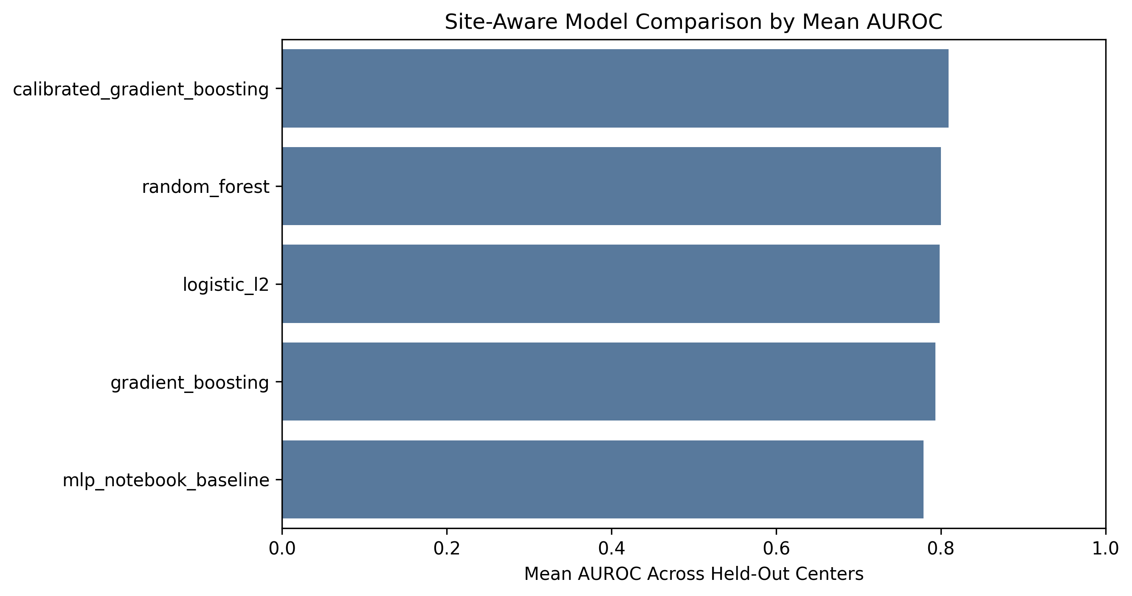
Fig. 1. Mean AUROC comparison across candidate models.
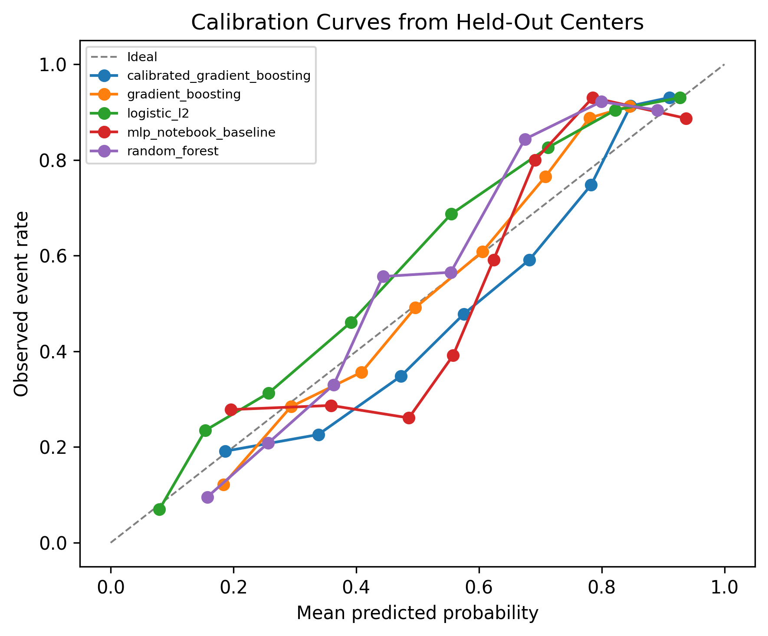
Fig. 2. Calibration curves from held-out center predictions.
VI. ABLATION AND COMPARATIVE STUDIES
A. Model Comparison
The model comparison is the main comparative study. The MLP notebook baseline was not the final model. It achieved mean AUROC of 0.779 and Brier score of 0.187, while logistic regression achieved mean AUROC of 0.799 and Brier score of 0.168. This supports the use of a simpler and more interpretable model for this dataset.
B. Duplicate Sensitivity
TABLE II. Duplicate Sensitivity on Supplementary heart.csv
Dataset version | AUROC | AUPRC | Bal. Acc. | Brier
Duplicate-expanded | 0.924 | 0.926 | 0.855 | 0.110
Deduplicated | 0.909 | 0.917 | 0.832 | 0.125
The duplicate-expanded benchmark produced higher apparent performance than the deduplicated version. This confirms that duplicate rows can inflate results and should not be used as the primary scientific evidence.
C. Threshold Sensitivity
Threshold analysis showed a clinically relevant sensitivity-specificity trade-off. At threshold 0.10, sensitivity was 0.988 and specificity was 0.214. At threshold 0.50, sensitivity was 0.729 and specificity was 0.842. Therefore, the app reports probability and risk category rather than claiming a universal clinical decision threshold.
VII. LOCALHOST PROTOTYPE
The final model is served through a FastAPI application. The interface provides one prediction workflow with a clinical-style input form. It returns predicted probability, risk category, important feature explanations, model metadata, and a disclaimer. The app does not use a language model in the prediction path; explanations are generated from the trained model artifact and feature dictionary.
VIII. CONCLUSION AND FUTURE WORK
This project converts a notebook-based heart disease experiment into a reproducible machine-learning research system. Penalized logistic regression was selected over more complex models because it provided the best balance of calibration, interpretability, and validation performance. Future work should include prospective validation, larger modern datasets, fairness analysis, external validation on independent cohorts, improved missingness modeling, and clinician-centered usability evaluation.
REFERENCES
[1] G. S. Collins et al., "TRIPOD+AI statement: updated guidance for reporting clinical prediction models that use regression or machine learning methods," BMJ, vol. 385, e078378, 2024.
[2] G. S. Collins et al., "PROBAST+AI: an updated quality, risk of bias, and applicability assessment tool for prediction models using regression or artificial intelligence methods," BMJ, vol. 388, e082505, 2025.
[3] R. Detrano et al., "International application of a new probability algorithm for the diagnosis of coronary artery disease," American Journal of Cardiology, 1989.
[4] F. Pedregosa et al., "Scikit-learn: Machine Learning in Python," Journal of Machine Learning Research, vol. 12, pp. 2825-2830, 2011.
[5] S. M. Lundberg and S.-I. Lee, "A Unified Approach to Interpreting Model Predictions," Advances in Neural Information Processing Systems, 2017.

