Standardized Precipitation Evapotranspiration Index (SPEI)

**Introduction**

The Standardized Precipitation Evapotranspiration Index (SPEI) is an extension of another widely used Standardized Precipitation Index (SPI). The SPEI is constructed to account for both precipitation and potential evapotranspiration (PET) in determining drought. As a result, unlike the SPI, the SPEI captures the main impact of increased temperatures on water demand. Like the SPI, the SPEI can be calculated on a range of timescales from 1-48 months. At longer timescales (>~18 months), the SPEI has been shown to correlate with the self-calibrating PDSI (sc-PDSI). If only limited data are available, say temperature and precipitation, PET can be estimated with the simple Thornthwaite method. In this simplified approach, variables that can affect PET such as wind speed, surface humidity and solar radiation are not accounted for. In cases where more data are available, a more sophisticated method to calculate PET is often preferred in order to make a more complete accounting of drought variability. However, these additional variables can have large uncertainties.

**Methodology**

The Standardized Precipitation Evapotranspiration Index (SPEI) was used to identify the drought characteristics. The SPEI’s main advantage lies in its ability to detect the onset and spatial and temporal changes of drought consistently; it is suggested for operational drought monitoring studies worldwide.

**Steps of estimation**

The following four steps and specific settings are used to calculate the SPEI. First, the monthly potential evapotranspiration (PET) is computed based on the data of monthly minimum and maximum temperature by using the Thornthwaite equation. Then, a simple monthly water balance is expressed as the difference between monthly precipitation (𝑃) and PET. Third, a three parameter log-logistic distribution is used to fit the data series of monthly water balance. Finally, the original values are normalized to obtain standardized units that are comparable in space and time as the SPEI. The updated version of the R SPEI package (<http://cran.r-project.org/web/packages/SPEI>) was used to estimate the monthly SPEI in the study.

The SPEI was computed at monthly time scale and the smaller negative SPEI means the most serious drought events tend to occur. The negative SPEIs are related to the dry condition; a drought event is defined when the SPEI is continuously negative and reaches a value of “−1.0” or less.

**Result and discussion**

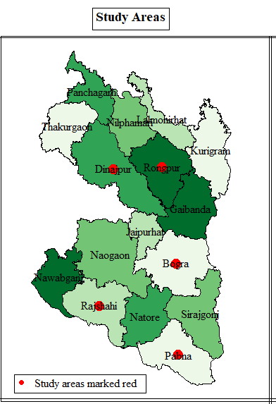

**Analysis with Bogura region**

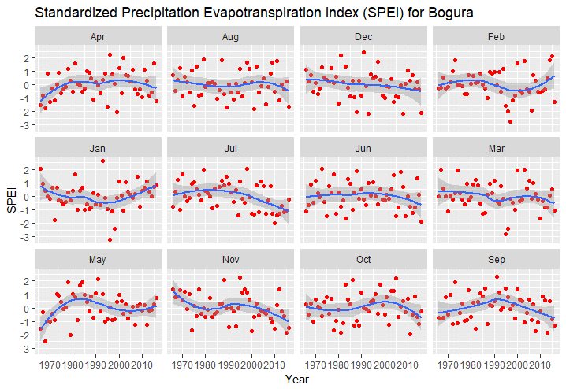

The plot shows twelve months SPEI for the district of Bogura. We have said earlier that the smaller negative SPEI means the most serious drought events tend to occur. The negative SPEIs are related to the dry condition; a drought event is defined when the SPEI is continuously negative and reaches a value of “−1.0” or less. Hence, it is evident from the plot that extreme droughts are prevalent in all months, and in most of the months, the indices have downward trend, indicating a trend toward more intense drought. Drought is most intense in January, February, and March. However, the rest months are also highly dry. The droughts have increasing trends only in January and February months.

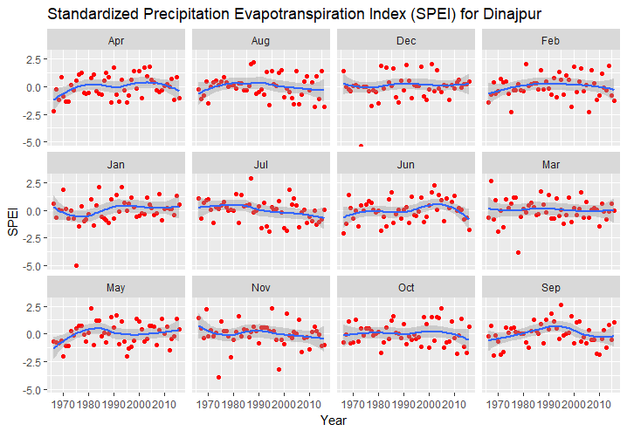

The indices for Dinajpur district show that the values are, for many years, well below 0 and consistently equal to below -1, indicating dry periods. None of the twelve months has an increasing trend in the value of the SPEI index. The severest downward trend is seen in the month of June, the closest being April, July, and October. The months of February, April, and July have the most consistent dry periods.

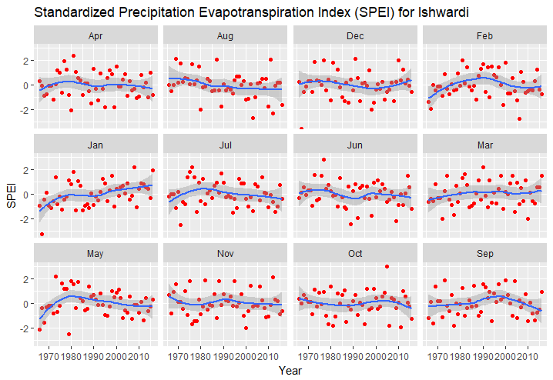

The SPEI indices for the region of Ishwardi show that most of the months have downward trend in the values of the index. The indices are with upward only for the months of December, February, and January. In most of the remaining months, there exist constant droughts. Of them, the month of March has the severest drought, followed by September and October. Moreover, the months with upward indices also have, for some years, constant dry periods.

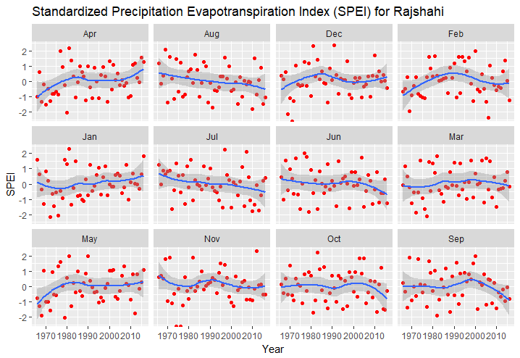

Only April and January months are showing upward trend in Standardized Precipitation Evapotranspiration Index (SPEI), while both months a significant portion of years experiencing severe drought since the values equal to or below -1 are very common. Downward trends are severest in September and October months, both also having a consistent period of drought. In most months, values below zero are more common, providing evidence in favor of intensity toward dryness.

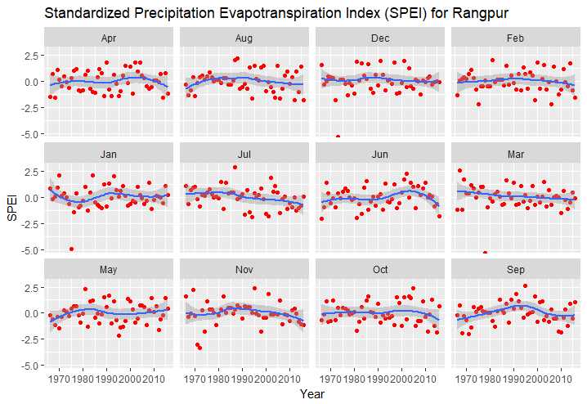

The Standardized Precipitation Evapotranspiration Index (SPEI) for Rangpur shows that in the month of May, there are several dry periods. The same is true in the case of April, June, July, October, December, while other months also experienced occasional dry periods.

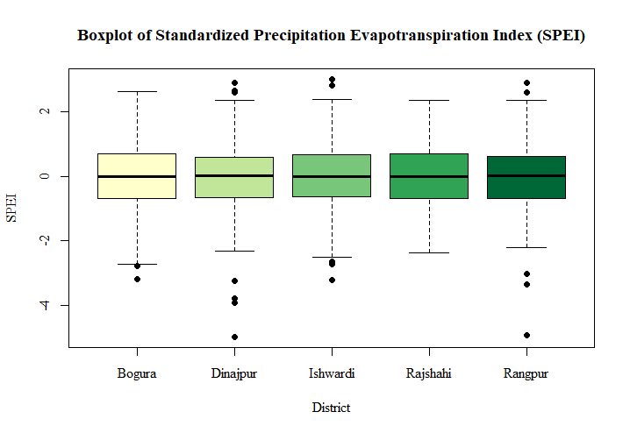

The box plot of SPEI’s suggest that drought is most severe in the regions of Dinajpur and Rangpur, where the index drops as low as almost -5, while only -1 is enough to be classified as a dry region. In both regions, there are a number of indices below interquartile range, which indicates they are atypical outcomes. Apart from this, the distributions of the index in the five regions are alike, the mean remaining close to zero, which implies, when considered with the fact that there are some extreme negative values, the regions are more tended to drought than wetness.