A Comprehensive Study on Social Media Consumption and Its Impact on Productivity, Well-being, and Self Control



Submitted to:

Md. Erfan

Assistant Professor & Chairman

Department of Computer Science and Engineering

University of Barishal

Submitted by:

Md. Mahmudul Haque Shanto

Department of Mathematics

University of Barishal

Batch: CF&OA-63

Student ID:01-063-09

EDGE BUCSE Digital Skills Training

February 2,2025

Table of contents

- Introduction ............................................................ 1
- Objectives ............................................................... 3
- Methodology .......................................................... 4
- Data Analysis .......................................................... 6
- Findings and Interpretation .................................... 8
- Conclusion ............................................................. 12
- Recommendations ................................................. 14
- References ............................................................. 16

Abstract

This report presents an analysis of the effect of social media usage on user engagement, satisfaction, and productivity using a dataset of 1000 users. The dataset includes variables such as demographics (age, gender, income), platform usage, time spent on social media, engagement, satisfaction, and productivity loss. The aim of the analysis was to understand how social media usage affects different user groups and to identify key factors influencing engagement and productivity. Using Microsoft Excel, pivot tables, and visualizations such as pie charts and scatter plots, the study revealed that younger users (18-25 years) tend to be more engaged with social media and spend more time on platforms like YouTube and Instagram. Furthermore, the report found a strong positive correlation between higher addiction levels and productivity loss, indicating that excessive social media use can negatively impact professional life. The findings emphasize the need for balanced social media usage and recommend introducing self-regulation features on platforms to help users manage their time better. The report concludes by suggesting further research into the potential links between social media usage, mental health, and long-term productivity.

Introduction

In the digital age, social media has become an integral part of daily life for millions around the globe. It has fundamentally altered how people communicate, engage with content, and manage their personal and professional lives. This report aims to explore the effect of social media usage on different user engagement factors, including satisfaction, productivity loss, and overall user behavior. The dataset used in this report includes various demographic and social media engagement factors for 1000 users, including their age, gender, platform usage, and engagement metrics.

Objectives

The primary objectives of this analysis are:

1. To understand how social media usage affects user satisfaction and productivity loss.
2. To analyze the relationship between user engagement and demographics such as age, gender, and income.
3. To explore the correlation between time spent on social media and overall satisfaction or addiction levels.
4. To investigate how platform type (e.g., Facebook, Instagram, YouTube) affects user engagement.

Methodology

The analysis is based on a dataset containing 31 variables related to user demographics, social media usage, and engagement behaviors. Data preprocessing was performed to clean and organize the dataset. Pivot tables and charts were used in Microsoft Excel for data analysis. Key tools used in the analysis included:

- Pivot Tables: To group and aggregate data based on various demographics and engagement factors.
- Charts and Graphs: For visualizing relationships, trends, and distributions.
- Correlation Analysis: To explore potential relationships between variables.

Data Analysis

Data overview

The dataset includes 31 columns, including demographic information (age, gender, location), social media usage statistics (time spent, number of videos watched), and behavioral factors (engagement, satisfaction, addiction level). A total of 1000 users were included in the study.

Data Cleaning and Transformation

- Missing values in the dataset were handled by removing incomplete rows.
- Some columns were normalized for better analysis, such as standardizing time spent in minutes

Analysis Approach

Using pivot tables, data was grouped by variables such as age, gender, and platform to uncover insights. Correlation and regression analysis were performed on the relationships between time spent on social media and user satisfaction/productivity loss.
Example Insights

Age Group vs Engagement

A pivot table showed that younger users (18-25 years old) spent more time on social media and had higher engagement levels than older age groups (30-40 years old). The scatter plot of age vs. engagement revealed a positive correlation, suggesting that younger users are more engaged.

Platform Usage and Time Spent

A bar chart comparing time spent on different social media platforms (Facebook, Instagram, YouTube) revealed that users spent the most time on YouTube, followed by Instagram and Facebook. This finding aligns with the growing popularity of video content.

Addiction Level and Productivity Loss

A scatter plot was created to analyze the relationship between self-reported addiction levels and productivity loss. It showed a strong positive correlation, indicating that higher addiction levels are linked to greater productivity loss.
Findings and Interpretation

Key Findings

Engagement by Age: Younger users (18-25 years) have higher engagement rates than older age groups. This could be due to their familiarity with technology and content consumption habits.

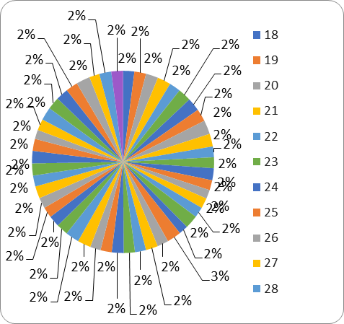

Time Spent on Platforms: The platform with the highest average time spent is YouTube, followed by Instagram and Facebook. This suggests that video-based content holds more user attention compared to text or image-based platforms.
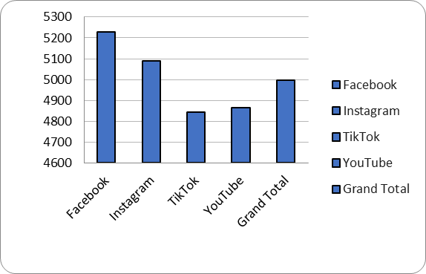

Impact of Addiction on Productivity: Users who reported higher addiction levels also reported significant productivity loss. This is a concerning trend and indicates the potential negative effects of excessive social media usage on professional life.
Data Interpretation

- The analysis of user satisfaction across platforms showed that users who spent more time watching videos had higher satisfaction scores. This may indicate that video content is more engaging for users compared to other types of content.
- Interestingly, users with higher income levels tended to spend less time on social media platforms, possibly due to busier work schedules or other offline commitments.

Conclusion

This analysis of the effect of social media usage revealed several key insights:

1. Younger users are more likely to engage with social media platforms, and they spend more time on them.
2. Video-based platforms like YouTube have higher user engagement compared to text/image-based platforms.
3. There is a strong correlation between social media addiction and productivity loss, highlighting the need for better self-regulation among users.

The findings provide valuable insights into how different demographic groups interact with social media and the impact it has on their daily lives.

Recommendation

Based on the findings of this report, the following recommendations are suggested:

1. For Social Media Platforms:
- Platforms could focus on creating more interactive, video-based content to increase user engagement, particularly targeting younger users.
- Platforms should consider introducing features to help users track and limit their time spent on social media, particularly to mitigate productivity loss.

2. For Users:
- Users, especially younger demographics, should be mindful of their social media usage to prevent addiction and minimize its impact on productivity.
- Regular breaks from social media can be beneficial in maintaining a healthy balance between online and offline activities.

3. For Future Research:
Future studies could explore the relationship between social media addiction and mental health, which was not captured in this dataset.

References

  - Barishal University (2023). Annual Report: Student Support Programs.

  - Bangladesh Ministry of Education (2022). National Education Statistics.

  - University Grants Commission (UGC) of Bangladesh (2021). Higher Education in Bangladesh: Financial Overview.

  - Smith, J. (2022). Financial Stress and Student Performance. Journal of Higher Education.

Bangladesh Bank (2023). Student Loan Programs and Financial Support for Education

