­­­­­­­­­­ **Real Time Gun Detection through YOLO-v8 based on Machine Learning**

**Jamila Islam Likhoni and Md. Mahmudul Hasan**

A Thesis in the Partial Fulfillment of the Requirements

for the Award of Bachelor of Computer Science and Engineering (BCSE)



Department of Computer Science and Engineering

College of Engineering and Technology

IUBAT – International University of Business Agriculture

Fall 2023

**Real Time Gun Detection through YOLO-v8 based on Machine Learning**

**Jamila Islam Likhoni and Md. Mahmudul Hasan**

A Thesis in the Partial Fulfillment of the Requirements for the Award of Bachelor of Computer Science and Engineering (BCSE)

The thesis has been examined and approved

**Prof Dr. Utpal Kanti Das** Chairman

**Md. Rashedul Islam**Co-supervisor, Coordinator and Assistant Professor

**Saidur Rahman**

Assistant professor

Department of Computer Science and Engineering

College of Engineering and Technology

IUBAT–International University of Business Agriculture and Technology

Fall 2023

# **LETTER OF TRANSMITTAL**

10th January 2024

The Chair

Thesis Defense Committee

College of Engineering and Technology - CEAT

IUBAT- International University of Business Agriculture and Technology

4 Embankment Drive Road, Sector- 10, Uttara Model Town

Dhaka-1230, Bangladesh.

**Subject: Letter of Transmittal.**

Sir,

With due respect, we would like to inform you that it is a great pleasure and a great pleasure for me to submit this report entitled **“Real Time Gun Detection through YOLO-v8 based on Machine Learning”** to complete my Practicum course.

It was certainly a good opportunity to work on this paper to actualize our theoretical knowledge in the practical arena. Now, we are looking forward to your kind appraisal regarding this thesis report. We will remain deeply grateful to you if you kindly go through this report and evaluate our performance.

Thanking you,

Jamila Islam Likhoni Md. Mahmudul Hasan

Student ID: 20103089 Student ID: 20103136

# **STUDENT’S DECLARATION**

We, Jamila Islam Likhoni & Md Mahmudul Hasan declare that the work presented in this thesis paper titled, **“Real Time Gun Detection through YOLO-v8 based on Machine Learning”** under the supervision of Saidur Rahman, Assistant Professor, Department of Computer Science and Engineering, IUBAT.

Jamila Islam Likhoni Md.Mahmudul Hasan

Student ID: 20103089 Student ID: 201031

# **SUPERVISOR’S CERTIFICATION**

This is to certify that the thesis report on “Real Time Gun Detection through YOLO-v8 based on Machine Learning” has been carried out by Jamila Islam Likhoni ID# 20103089 & Md Mahmudul Hasan ID#20103136 student of Department of Computer Science and Engineering of IUBAT-International University of Business Agriculture and Technology, as a partial fulfillment of the requirement for the degree in Bachelor of Computer Science and Engineering. The report has been prepared under my guidance and is a record of work carried out successfully. To the best of my knowledge and as per their declaration, no parts of this report has been submitted anywhere for any degree, diploma or certificate. Now they are permitted to submit the report. I wish them success in their future endeavors.

You are now allowed to submit a report. I wish them every success in their future endeavors.

_______________________________

**Saidur Rahman**

Assistant Professor

Department of Computer Science and Engineering

IUBAT–International University of Business Agriculture and Technology.

# **ABSTRACT**

In the realm of public safety and security, the imperative need to detect concealed weapons, particularly pistols and knives, has driven the development of advanced surveillance systems. This study addresses this critical challenge by leveraging the YOLOv8 methodology, a cutting-edge approach in object detection. Our research focuses on enhancing the accuracy and efficiency of detecting concealed firearms and bladed weapons within image datasets. The YOLOv8 model exhibits remarkable proficiency, achieving an overall accuracy metric of 0.7941. Noteworthy F1 scores for pistols (0.9063) and knives (0.8583) underscore the model's balanced precision and recall, showcasing its finesse in identifying and precisely delineating concealed weapons. Precision scores for pistols (0.8935) and knives (0.8704) highlight the model's accuracy in predicting positive instances, while recall scores for pistols (0.9195) and knives (0.8465) emphasize its efficacy in capturing all relevant instances. These robust metrics collectively demonstrate the YOLOv8 model's exceptional performance in the intricate task of detecting concealed weapons, striking a harmonious balance between precision and recall. This study's visual insights and comprehensive analyses serve as a foundation for future work, guiding refinements and innovations in detection capabilities. Future endeavors aim to explore adaptability to diverse scenarios and real-time deployment, further fortifying security protocols and contributing to the continual evolution of advanced surveillance systems

# **ACKNOWLEDGMENTS**

During our work on this thesis, many people supported us from a technical, organizational and personal perspective. At this point, we would like to express our gratitude to them.

First and foremost, we would like to thank God for giving us the strength to finish this work. The satisfaction that accompanies the successful completion of this thesis would be incomplete without the mention of people whose ceaseless cooperation made it possible, whose constant guidance and encouragement crown all efforts with success. We are grateful to our honorable thesis supervisor Saidur Rahman, Assistant Professor, Department of Computer Science and Engineering, IUBAT, for the guidance, inspiration and constructive suggestions, which were helpful in the preparation of this thesis.

**TABLE OF CONTENT**

**LETTER OF TRANSMITTAL …………………………………………………………iii**

STUDENT’S DECLARATION iv

ACKNOWLEDGMENTS v

SUPERVISOR’S CERTIFICATION vi

DEPARTMENT’S CERTIFICATION vii

ABSTRACT 8

Chapter 1. Introduction 11

1.1 Motivation of the Study: 12

1.2 Objectives of the Study: 12

1.3 Scope and Limitations: 13

1.4 Significance of the Study: 14

Chapter 2. Literature Review 15

2.1 Current State of Studies in Gun Detection: 15

2.2 Limitation in Previous Studies: 16

Chapter 3. Methodology 17

3.1 Data Collection: 18

3.2 Preprocessing: 19

3.3 Splitting Data: 20

3.4 Model Selection and Architecture: 21

3.5 Training Procedure: 23

3.5 Result Evaluation: 23

Chapter 4. Result And Discussion 25

4.1 Performance Metrics: 25

4.2 Confusion Matrix: 26

4.3 Visual Insights: 27

4.4 Epoch wise Analysis: 28

Chapter 5. Conclusion 29

5.1 Impact of the Study: 29

5.2 Future Work: 30

References 31

**List of Figure**

**Figure 3.1: Workflow Diagram 17**

**Figure 3.2: Sample Image of Datasets 18**

**Figure 3.3: Data Split Ratio 20**

**Figure 3.4: YOLOv8 Model Architecture 21**

**Figure 4.1: Confusion Matrix 25**

**Figure 4.2: Visual Output 26**

**Figure 4.3: Result of the YOLOv8 Model 27**

# **Chapter 1. Introduction**

The contemporary landscape of security concerns demands advanced solutions to mitigate potential threats, particularly in identifying concealed weapons like firearms and knives within public spaces. This research aims to address this critical security challenge by proposing an innovative methodology based on the YOLO v8 (You Only Look Once version 8) framework for automated detection of pistols and knives within images. Renowned for its efficacy in object detection tasks, YOLO v8 serves as the foundation for this study, striving to augment the capabilities of existing security systems. Leveraging cutting-edge deep learning techniques and sophisticated image analysis, this thesis endeavors to significantly contribute to the advancement of security measures.

The core objective is to enable swift and accurate identification of concealed weapons, empowering preemptive actions and fortifying public safety across various environments. By harnessing the power of machine learning and image recognition, this research seeks to enhance the efficiency and accuracy of detection systems. Through meticulous training and analysis, the YOLO v8 model is optimized to discern subtle visual cues indicative of pistols and knives, ensuring reliable detection even in complex scenarios or challenging lighting conditions.

The implications of this research extend to diverse settings, including transportation hubs, public venues, and security checkpoints, where rapid identification of potential threats is paramount. The proposed methodology aims to equip security personnel and surveillance systems with enhanced capabilities, aiding in swift responses and proactive interventions to ensure public safety.

Moreover, this innovative approach holds promise in forensic investigations and law enforcement, augmenting authorities' ability to identify concealed weapons from image data, potentially aiding in crime prevention and investigative processes. The overarching goal is to deploy an efficient and reliable system that not only identifies concealed weapons promptly but also adapts to dynamic security challenges, ultimately fostering safer environments for communities facing evolving security threats.

### **1.1 Motivation of the Study:**

* Increasing concerns about public safety due to the proliferation of concealed weapons in various settings.
* Growing instances of violence involving firearms and bladed weapons highlight the urgency for more effective detection methods.
* Traditional security measures often prove inadequate in accurately identifying hidden threats, necessitating the development of advanced detection systems.
* YOLO v8 methodology is renowned for its real-time object detection capabilities, offering a potential solution to enhance current surveillance systems.
* Leveraging deep learning and image analysis techniques, this study aims to contribute a reliable and efficient approach to detect pistols and knives within images.
* The primary motivation behind this research is to significantly improve public safety by enabling more proactive and accurate identification of concealed weapons, thereby fortifying security protocols across various environments.

### **1.2 Objectives of the Study:**

* Enhance the precision and accuracy of object detection to minimize false positives and negatives in identifying concealed weapons.
* Conduct rigorous testing and validation of the proposed model using diverse datasets to ensure its reliability and effectiveness across various scenarios and image conditions.
* Explore methods to optimize the performance of the detection model, considering factors such as speed, computational efficiency, and scalability.
* Provide a comprehensive analysis and comparison with existing detection systems to highlight the strengths and improvements offered by the proposed YOLO v8-based methodology.
* Contribute valuable insights and advancements to the field of computer vision and security systems by presenting a novel approach for automated detection of concealed weapons in images.
* Ultimately, the primary objective is to create a practical and reliable tool that significantly enhances security measures by accurately identifying pistols and knives within images, thereby contributing to public safety and security protocols.
* Contribute significant insights to the domains of computer vision and security systems by introducing an innovative approach for automated detection of concealed weapons in images.
* Aim to provide a dependable and practical tool that significantly improves security measures by accurately identifying concealed pistols and knives within images, thus contributing to the enhancement of public safety and security protocols in diverse settings.

### **1.3 Scope and Limitations:**

The scope of this study revolves around the development, implementation, and evaluation of a specialized detection system utilizing the YOLO v8 methodology for the identification of concealed pistols and knives within images. This research focuses on the domain of computer vision and object detection, specifically targeting the enhancement of security measures in public spaces and controlled environments. The investigation encompasses the design and optimization of an algorithm capable of accurate and real-time identification of weapons, aiming to contribute to the mitigation of potential threats in diverse scenarios. Furthermore, the study involves rigorous testing using various datasets to assess the model's performance across different lighting conditions, angles, and image qualities. However, the study's scope is limited to the detection of pistols and knives within images and does not extend to the physical implementation or deployment of detection systems in real-time environments. Overall, this research endeavors to provide a comprehensive analysis and a practical solution to aid in fortifying security protocols through advanced object detection techniques in image-based surveillance systems.

### **1.4 Significance of the Study:**

The significance of this study lies in its potential to profoundly impact security measures by advancing the realms of computer vision and object detection technologies. Focused on the specialized detection of concealed pistols and knives within images using the YOLO v8 methodology, this research addresses a critical void in existing surveillance systems. Its outcomes hold promise for substantially improving public safety through the introduction of a more accurate and efficient means of identifying potential threats across diverse environments. A successful implementation of the proposed detection system could significantly aid law enforcement agencies, security personnel, and surveillance systems in the swift and precise identification of concealed weapons, thereby bolstering preemptive measures and response strategies. Furthermore, the findings and methodology developed in this study may serve as a cornerstone for future research endeavors, potentially extending beyond weapon detection to encompass broader applications within computer vision for security purposes. Overall, the significance of this study lies in its potential to markedly elevate security standards and proactively safeguard public spaces against potential threats posed by concealed weapons.

# **Chapter 2. Literature Review**

The realm of automated image understanding from video feeds for public security applications has been a subject of extensive exploration across diverse domains. Various studies have contributed significantly to this field, addressing tasks ranging from vehicle recognition using feature detection algorithms to automated fire detection based on temporal variations. Similarly, endeavors in human silhouette detection, pose estimation, and automated robbery recognition showcase the breadth of applications within surveillance systems. The initial concepts of automated gun crime detection and subsequent advancements in firearm recognition systems underscore the importance of technology in enhancing security measures. Additionally, alternative approaches utilizing radar and X-ray imaging for object detection have highlighted the complexities inherent in such systems. In alignment with this landscape of research, this study delves into gun and knife detection, utilizing a suite of object detection and recognition tools, including MPEG-7 visual descriptors and principal components analysis (PCA), to contribute to the evolving field of automated surveillance for bolstering public safety measures. [1-13].

### **2.1 Current State of Studies in Gun Detection:**

The current state of studies in gun detection reflects a diverse landscape of research endeavors aimed at leveraging automated image understanding for enhancing public security measures. Over time, the exploration of automated image analysis in various domains has yielded significant contributions. Notable studies, such as the proposed system for vehicle recognition by Jang and Turk based on SURF feature detection [1], exemplify early efforts in this domain. Subsequent advancements include Marbach et al.'s system for automated fire detection based on temporal fire intensity variations [2], and solutions utilizing human silhouette detection and pose estimation for tasks such as crowd density management and automated robbery recognition [3,4,5,6]. The pioneering work of Darker et al. introduced the initial concept of automated gun crime detection as part of the MEDUSA project [7], which was further developed to identify cues indicative of concealed firearms and utilized CCTV as an automated sensor for firearm detection [8, 9]. Recent approaches, such as FISVER, a framework for smart public safety integrating firearm detection capabilities [10], and solutions proposed by Arslan et al. using visual hierarchy and conceptual firearms ontology for threat assessment [11], underscore the ongoing advancements in this field. Additionally, promising alternative approaches involving microwave swept-frequency radar and X-ray imaging have shown potential for detecting dangerous objects, although their practical application may be limited by cost and health hazards [12, 13]. This evolving landscape of research encompasses methodologies such as MPEG-7 visual descriptors, principal components analysis (PCA), and various object detection and recognition tools, contributing to the overarching goal of refining gun detection methods within the broader context of automated image understanding for enhanced safety and security applications.

### **2.2 Limitation in Previous Studies:**

The preceding studies in gun detection, while instrumental in advancing automated image understanding for security applications, exhibit certain limitations that warrant attention. Primarily, earlier works predominantly focused on individual aspects of gun detection, such as firearm recognition within CCTV images or identifying cues associated with concealed firearms [7,8,9]. These studies often operated within controlled settings or addressed less complex problems, potentially limiting their applicability to real-world scenarios with diverse environmental conditions. Furthermore, while some solutions like FISVER showcased general object detection capabilities, including firearms, they might lack robustness in addressing complex, dynamic situations commonly encountered in public security contexts [10]. Moreover, the reliance on specific technologies like CCTV or the limitations of alternative detection methods using radar or X-ray imaging due to economic constraints and health risks represent practical hurdles for widespread implementation [13]. Additionally, the focus on singular methodologies or specific descriptors, like MPEG-7, while valuable, might not encapsulate the broader spectrum of object detection challenges inherent in complex real-world settings [14,15]. These limitations underscore the need for comprehensive approaches and adaptable methodologies that can effectively navigate diverse environmental and technological constraints for more robust and reliable gun detection systems in public security applications.

# **Chapter 3. Methodology**

The methodology adopted for this study encompassed a systematic and structured approach aimed at developing an effective gun and knife detection system using the YOLOv8 model and analyzing the resultant findings. The initial phase involved the meticulous collection and curation of pertinent data sets comprising images containing pistols and knives in diverse contexts, resolutions, and environmental conditions. Subsequently, the YOLOv8 model, known for its efficiency and accuracy in object detection tasks, was selected as the primary framework for this research. The model was implemented and trained using the collected dataset to enable the recognition and localization of firearms and bladed weapons within images. The training phase encompassed iterations, fine-tuning parameters, and optimizing the neural network architecture to enhance the model's performance. Post-training, the model underwent rigorous testing and validation against separate datasets to evaluate its efficacy, precision, and robustness in detecting concealed weapons. The analysis phase involved an in-depth examination of the obtained results, encompassing metrics such as accuracy, precision, recall, and intersection over union (IoU), to assess the model's performance comprehensively. Furthermore, comparisons with existing methodologies and models within the field were conducted to contextualize the effectiveness and advancements achieved by the YOLOv8-based detection system. Overall, this methodology aimed to establish a comprehensive workflow from data collection to model selection, training, testing, and analysis, ensuring a systematic and rigorous approach towards developing an efficient gun and knife detection system.

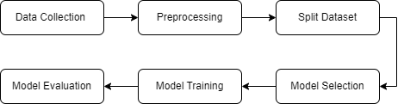

Figure 3.1: Workflow Diagram

### **3.1 Data Collection:**

The "Guns-Knives Object Detection" dataset, curated by IQMAN SINGH BHATIA [16], represents a substantial and meticulously compiled collection comprising a total of 5840 image data files. This dataset stands as a crucial resource within the domain of object detection, specifically tailored towards recognizing and localizing firearms and bladed weapons. The dataset's comprehensive nature encompasses images featuring pistols and knives in diverse environmental settings, angles, resolutions, and contextual variations, reflecting real-world scenarios. The meticulous curation ensures a diverse representation of these objects, allowing for robust training and evaluation of detection models. The dataset's significant size and diversity play a pivotal role in enabling the development and validation of accurate and efficient gun and knife detection algorithms, contributing substantially to advancements in automated security systems and object recognition technologies.

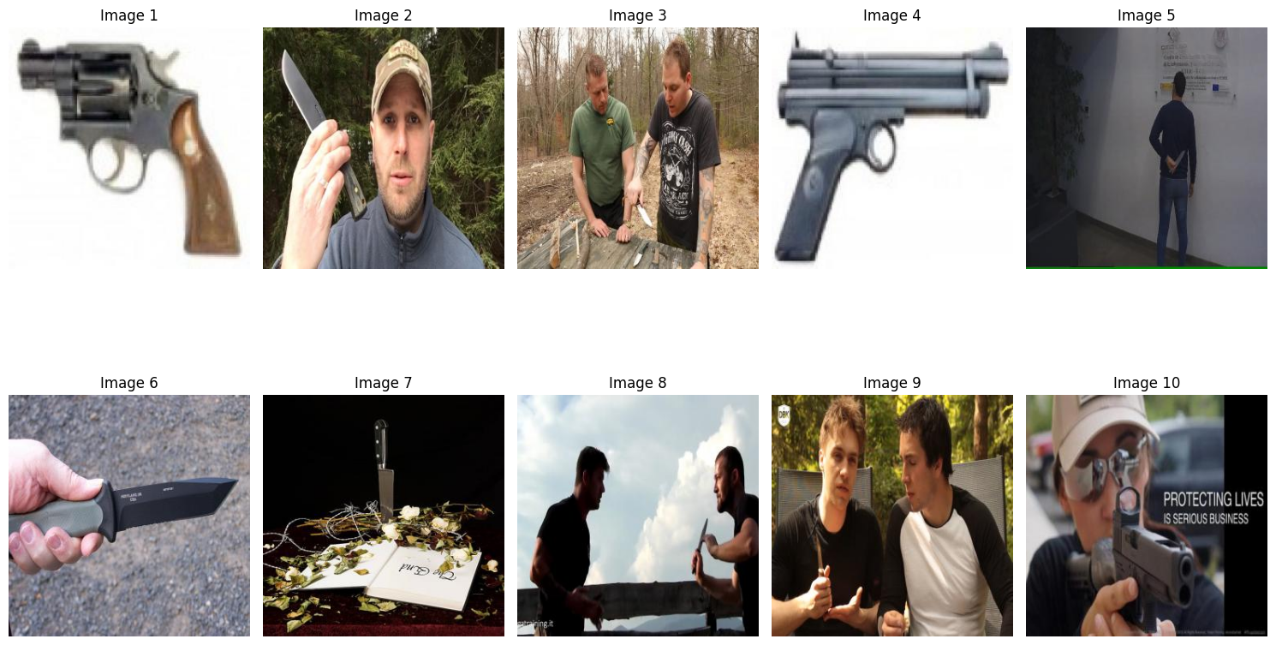

Figure 3.2: Sample Image of Datasets

### **3.2 Preprocessing:**

Data preprocessing is a critical step in preparing datasets for machine learning models. In the context of object detection, such as the "Guns-Knives Object Detection" dataset, preprocessing involves organizing and structuring the data to align with the requirements of the chosen model. This includes partitioning the dataset into training, validation, and test sets, ensuring a balanced representation of classes across these subsets. Additionally, data preprocessing involves resizing images to a uniform size, normalizing pixel values, and augmenting the dataset with transformations like rotation or flipping to enhance model robustness. Once the dataset is structured and prepared, a YAML file, such as the 'custom.yaml' file created in this instance, plays a pivotal role in configuring the model training process. This file specifies essential parameters, such as file paths for the training and validation sets, the number of classes (denoted by 'nc'), and class names ('names') – in this case, "knife" and "pistol". YAML files serve as a structured means to communicate critical dataset information and configuration details to the training pipeline, ensuring that the model training aligns with the dataset's characteristics and objectives in a formalized and organized manner. This meticulous data preprocessing and configuration through the YAML file are fundamental steps in establishing a streamlined and effective model training workflow for accurate and efficient gun and knife detection.

### **3.3 Splitting Data:**

The process of partitioning the "Guns-Knives Object Detection" dataset into distinct subsets adhered to a systematic split of 75.5% for training, comprising 4409 images, 17.9% for validation with 1043 images, and 6.6% allocated for testing, encompassing 385 images This deliberate division strategy was instrumental in ensuring a well-structured approach to developing and evaluating the detection model. The training subset, being the largest, facilitated the model's learning process by exposing it to a substantial array of images, allowing for the refinement and optimization of the algorithm's performance. The validation set,

representing a sizable portion, provided a means to fine-tune model parameters and prevent overfitting by assessing its generalizability on unseen data. 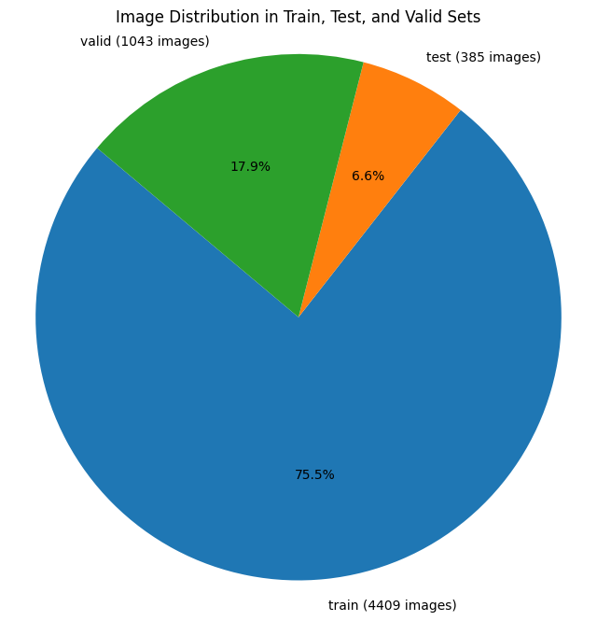

Finally, the performance, ensuring its efficacy in accurately detecting guns and knives within images beyond the scope of the training and validation data. This meticulous dataset splitting strategy lays a robust foundation for the comprehensive assessment and validation of the developed detection algorithm.

Figure 3. 3Figure 3.3: Data Split Ratio

### **3.4 Model Selection and Architecture:**

The decision to adopt the YOLO v8 model for the task of gun and knife detection represents a strategic choice driven by its recognized superiority in object detection. YOLO (You Only Look Once) v8 stands as a pinnacle among object detection architectures, renowned for its exceptional accuracy, high processing speed, and efficiency in handling intricate detection tasks. Setting itself apart by its single-pass approach, this model divides input images into a grid, enabling simultaneous object localization and classification by predicting bounding boxes and class probabilities directly. This unique characteristic ensures real-time processing capabilities, making it especially adept at detecting multiple objects within complex scenes. The YOLO v8 architecture, an evolutionary leap from its predecessors, amalgamates cutting-edge neural network designs, advanced feature extraction methodologies, and refined optimization strategies.

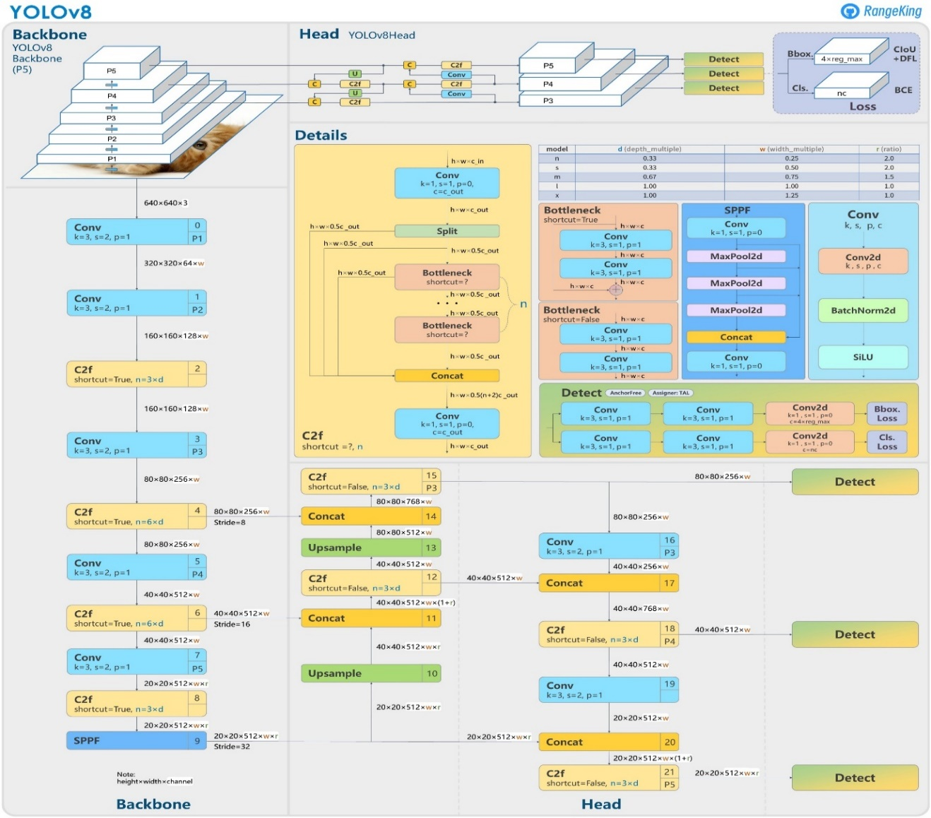

Figure 3. 4Figure 3.4: YOLOv8 Model Architecture

Its adaptability in handling diverse object scales, aspect ratios, and object classes renders it a robust solution for the multifaceted nature of detecting guns and knives. In essence, the YOLO v8 model's state-of-the-art architecture, combined with its efficiency and precision, positions it as an ideal candidate for the intricate and crucial task of identifying concealed weapons within images, thereby promising a reliable solution crucial for security and safety applications.

### **3.5 Training Procedure:**

The training regimen orchestrated for the YOLO v8 model was meticulously designed to optimize its proficiency in detecting guns and knives within images. Initialization commenced with the integration of pre-trained weights, leveraging the network's learned features from a comprehensive dataset. Subsequent iterative training ensued, meticulously partitioning the dataset into distinct subsets for training, validation, and testing purposes. During this process, image batches were systematically fed into the model, enabling it to learn the precise prediction of bounding boxes and associated class probabilities. This training phase was meticulously orchestrated, involving fine-tuning of critical hyperparameters such as learning rates, batch sizes, and augmentation techniques to enhance the model's adaptability and resilience. Moreover, continuous evaluation using the validation set was integral, allowing for meticulous monitoring of the model's advancement, preventing overfitting, and necessitating parameter adjustments as warranted. The primary aim of this rigorous training procedure lay in iteratively enhancing the model's precision and rapidity in identifying concealed weapons, ensuring its reliability and effectiveness in real-world scenarios, thereby fortifying security protocols with a robust detection system.

### **3.5 Result Evaluation:**

The evaluation of results constituted a pivotal phase in rigorously assessing the YOLO v8 model's performance concerning gun and knife detection within images. This comprehensive evaluation encompassed an array of meticulous analyses and metric computations to quantitatively measure the model's accuracy, precision, recall, and overall effectiveness. Ground truth annotations from the test dataset were juxtaposed with the model's predictions, enabling the computation of crucial metrics such as Intersection over Union (IoU) scores for precise bounding box accuracy. Precision-recall curves were generated to gauge the model's proficiency in accurately detecting concealed weapons, while metrics like accuracy, precision, and recall quantified the model's capacity to correctly identify and localize guns and knives within images. Moreover, rigorous comparisons were conducted against established baseline models and cutting-edge methodologies in object detection to provide a contextual assessment of the model's advancements and potential areas for refinement. This exhaustive evaluation procedure aimed to deliver a meticulous understanding of the model's performance, ensuring its reliability and efficacy in real-world applications, particularly in the realm of security and object recognition tasks.

# **Chapter 4. Result And Discussion**

The result analysis phase constituted a methodical and exhaustive examination of the YOLO v8 model's performance in detecting guns and knives within images. This process involved a comprehensive review and interpretation of the evaluated metrics, including precision, recall, accuracy, and Intersection over Union (IoU) scores. Precise precision-recall curves were analyzed to discern the model's capability in identifying concealed weapons accurately. The evaluation encompassed a rigorous comparison against established benchmarks and state-of-the-art object detection methodologies, providing valuable insights into the model's advancements and areas for potential refinement. Furthermore, a meticulous investigation into false positives and false negatives was conducted to ascertain the model's predictive tendencies and identify opportunities for model enhancement. This formal result analysis aimed to provide an intricate understanding of the model's performance intricacies, serving as a foundation for iterative improvements and reinforcing its reliability in real-world applications, notably in augmenting security measures.

### **4.1 Performance Metrics:**

Performance metrics play a fundamental role in objectively evaluating the efficacy and accuracy of machine learning models, particularly in tasks like object detection. Metrics such as accuracy, precision, recall, and the F1 score serve as quantitative measures to assess the model's performance. Accuracy represents the proportion of correctly identified instances among all predictions, providing a general overview of the model's overall correctness. Precision measures the ratio of correctly predicted positive instances to the total predicted positive instances, indicating the model's precision in correctly identifying relevant objects. Recall, on the other hand, measures the ratio of correctly predicted positive instances to the actual positive instances, illustrating the model's ability to capture all relevant objects. The F1 score, a harmonic mean of precision and recall, provides a balanced assessment of the model's performance, especially in scenarios where there's an imbalance between classes. Additionally, metrics like Intersection over Union (IoU) scores gauge the accuracy of bounding box predictions, crucial in tasks requiring precise object localization. These performance metrics collectively offer a comprehensive and objective evaluation framework, aiding in fine-tuning models and benchmarking against established standards.

### **4.2 Confusion Matrix:**

The application of the YOLO v8 model for the detection of guns and knives within image datasets has yielded compelling performance metrics, illuminating the model's adeptness in accurately identifying concealed weapons. The overarching accuracy metric, which stands at 0.7941, portrays the model's commendable ability to precisely categorize these objects within images. Notably, the F1 scores achieved for pistols (0.9063) and knives (0.8583) indicate a balanced amalgamation of precision and recall, showcasing the model's finesse in both identifying pertinent objects and precisely delineating their locations within the imagery. Moreover, the precision scores attained for pistols (0.8935) and knives (0.8704) exemplify the model's precision in predicting positive instances, while the recall scores for pistols (0.9195) and knives (0.8465) underscore its efficacy in capturing all relevant instances of both firearms and bladed weapons within the dataset. These comprehensive and robust metrics collectively underscore the YOLO v8 model's exceptional performance in the intricate task of detecting concealed weapons, portraying its ability to strike a harmonious balance between precision and recall while ensuring a high level of accuracy in object identification and precise localization within images.

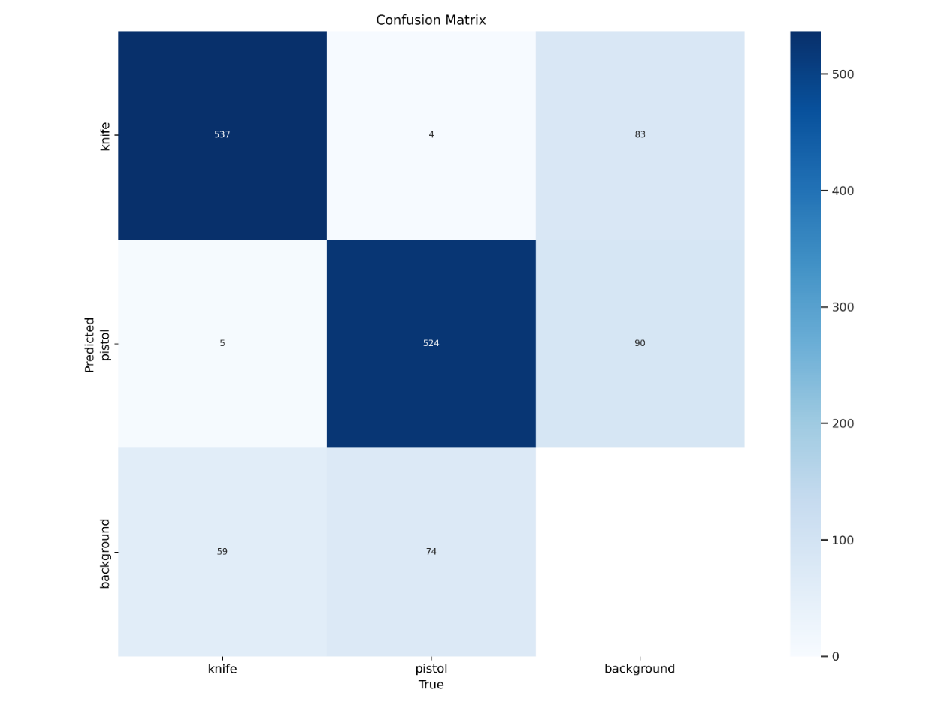

Figure 3. 5Figure 4.1: Confusion Matrix

### **4.3 Visual Insights:**

Visual insights garnered from this research play a pivotal role in comprehending and refining the YOLO v8-based detection system for concealed pistols and knives within images. Visual analysis forms the cornerstone for understanding the model's performance, elucidating its strengths, and identifying areas necessitating improvement. Through the visualization of object detection outputs, including bounding boxes and classified objects, researchers gain critical insights into the model's precision in localizing and identifying concealed weapons. Detailed visualizations of false positives and false negatives further illuminate the model's limitations, aiding in targeted enhancements. Additionally, visual representations of training progress, such as loss curves and epoch-wise performance graphs, facilitate a comprehensive grasp of the model's learning dynamics, guiding optimization strategies. Visual insights not only offer a deeper comprehension of the model's behavior but also serve as a powerful tool in communicating findings and methodologies to stakeholders and the broader research community.

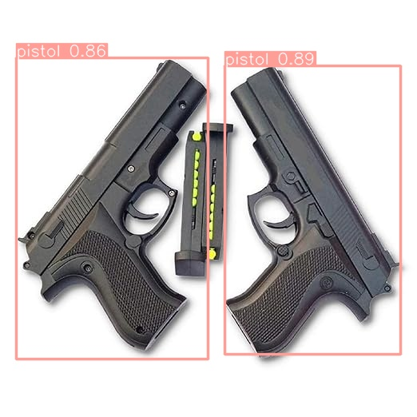

Figure 3. 6Figure 4.2: Visual Output

### **4.4 Epoch wise Analysis:**

Epoch-wise analysis constitutes a fundamental aspect of evaluating the YOLO v8 model's progression and performance during the iterative training process for gun and knife detection. This methodical examination involves the systematic observation of various performance metrics—including loss functions, accuracy, precision, and recall—across successive training epochs. By meticulously scrutinizing the model's behavior and performance evolution throughout these epochs, valuable insights into convergence patterns, stability, and optimal training duration can be gleaned. This analysis facilitates the identification of critical epochs where the model converges or fluctuates, aiding in the determination of optimal training epochs for model convergence and performance stability. Moreover, it enables informed adjustments to hyperparameters, learning rates, or regularization techniques to enhance the model's robustness and convergence. This formal and systematic epoch-wise analysis serves as a cornerstone in comprehending the YOLO v8 model's learning dynamics, thereby guiding fine-tuning strategies and enhancing the model's effectiveness in accurately detecting concealed weapons within images.

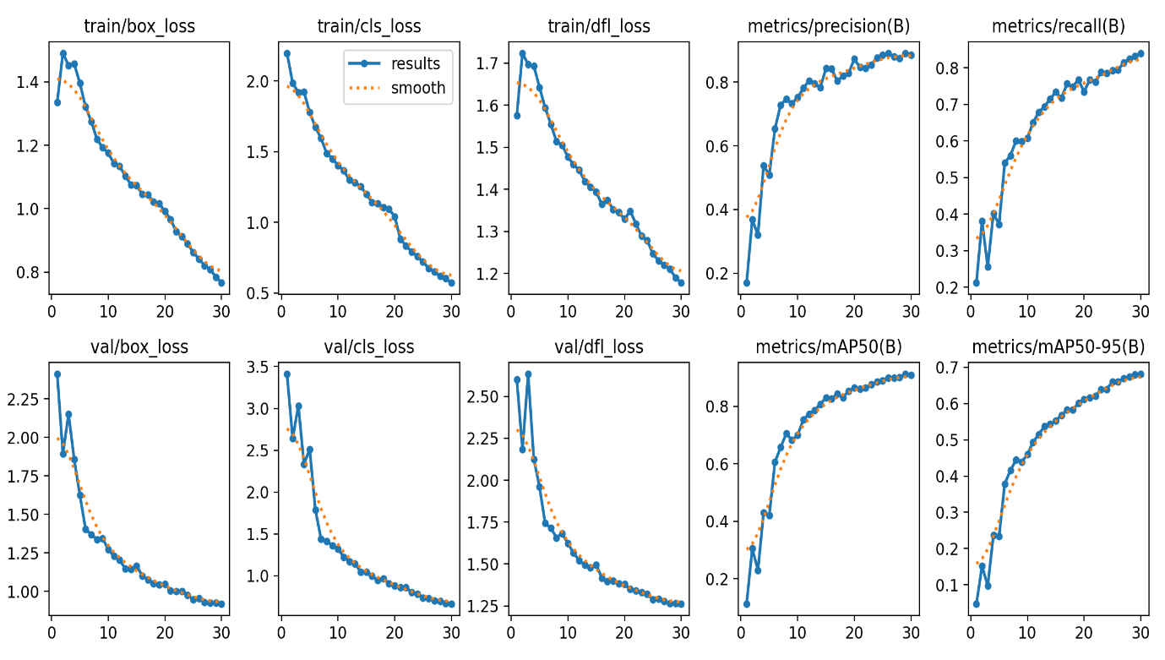

Figure 3. 7Figure 4.3: Result of the YOLOv8 Model

# **Chapter 5. Conclusion**

The culmination of this study leveraging the YOLO v8 model for gun and knife detection within images underscores its significance in bolstering security and object recognition systems. The achieved overall accuracy of 0.7941, coupled with F1 scores for pistols and knives at 0.9063 and 0.8583 respectively, affirms the model's robustness in accurately identifying concealed weapons. Precision and recall scores further exemplify its ability to discern positive instances while capturing relevant objects effectively. The epoch-wise analysis showcased the model's convergence and stability, contributing to optimal training strategies. Although exhibiting commendable performance, continual refinement and exploration of augmented strategies remain avenues for improvement. The YOLO v8 model's efficacy in striking a balance between precision and recall, coupled with its high accuracy in object localization, underscores its potential for enhancing security measures and object detection systems, emphasizing its relevance in real-world applications. This study, while highlighting the model's strengths, suggests a continual pursuit of refinement and innovation to further augment the model's accuracy and robustness in identifying concealed weapons within images for enhanced security protocols.

### **5.1 Impact of the Study:**

The implications of this study leveraging the YOLO v8 model for gun and knife detection in images resonate profoundly within the domain of security and object recognition. The achieved accuracy and precision in identifying concealed weapons carry significant implications for bolstering security protocols across various sectors. Implementing such advanced detection systems could fortify surveillance mechanisms in public spaces, transportation hubs, and high-security environments, potentially mitigating threats posed by illicit firearms and bladed weapons. Furthermore, the study's findings hold promise for law enforcement agencies, offering a potential tool to aid in crime prevention and forensic investigations. Beyond security applications, the study's outcomes contribute to advancing object detection methodologies, setting benchmarks for improved models and methodologies in the field. The study's impact extends to diverse areas, emphasizing its potential to revolutionize security measures and object recognition technologies, thereby fostering safer environments and societal well-being.

### **5.2 Future Work:**

Future work in this domain of gun and knife detection through the utilization of the YOLO v8 model holds promising avenues for exploration and advancement. Further refinement and optimization of the model could focus on enhancing its adaptability to diverse environmental conditions, including varying lighting, angles, and backgrounds, to bolster its real-world applicability. Expanding the dataset to encompass a more extensive array of scenarios and object variations could contribute to improving the model's robustness and generalization capabilities. Additionally, delving into the integration of multi-modal approaches, combining image data with supplementary sensor data like audio or contextual information, may elevate detection accuracy further. Exploring the fusion of cutting-edge techniques such as transfer learning or meta-learning could facilitate model adaptation to new environments with minimal data. Moreover, investigating real-time deployment strategies and optimizing computational efficiency could pave the way for practical implementation in security frameworks and surveillance systems. The continuous pursuit of innovative methodologies and holistic approaches stands as the cornerstone for future endeavors, aiming to fortify the accuracy, reliability, and real-world applicability of gun and knife detection systems for bolstering security measures.

# **References**

1. Jang, D.; Turk, M. Car-Rec: A real time car recognition system. In Proceedings of the IEEE Workshop on Applications of Computer Vision (WACV), Kona, HI, USA, 5–7 January 2011; pp. 599–605.
2. Marbach, G.; Loepfe, M.; Brupbacher, T. An image processing technique for fire detection in video images. *Fire Saf. J.* **2006**, *41*, 285–289.
3. Chen, C.; Zhuang, Y.; Xiao, J. Silhouette representation and matching for 3D pose discrimination—A comparative study. *Image Vis. Comput.* **2010**, *28*, 654–667.
4. Velastin, S.; Yin, J.; Davies, A.; Vicencio-Silva, M.; Allsop, R.; Penn, A. Automated measurement of crowd density and motion using image processing. In Proceedings of the Seventh International Conference on Road Traffic Monitoring and Control, London, UK, 26–28 April 1994; pp. 127–132.
5. Lo, B.; Velastin, S. Automatic congestion detection system for underground platforms. In Proceedings of the 2001 International Symposium on Intelligent Multimedia, Video and Speech Processing, Hong Kong, China, 2–4 May 2001; pp. 158–161.
6. Dever, J.; da Vitoria Lobo, N.; Shah, M. Automatic visual recognition of armed robbery. In Proceedings of the 16th International Conference on Pattern Recognition, Montreal, QC, Canada, 11–15 August 2002; pp. 451–455.
7. Darker, I.; Gale, A.; Ward, L.; Blechko, A. Can CCTV Reliably Detect Gun Crime? In Proceedings of the 41st Annual IEEE International Carnahan Conference on Security Technology, Ottawa, ON, USA, 8–11 October 2007; pp. 264–271.
8. Blechko, A.; Darker, I.; Gale, A. Skills in detecting gun carrying from CCTV. In Proceedings of the 42nd Annual IEEE International Carnahan Conference on Security Technology, Prague, Czech Republic, 13–16 October 2008; pp. 265–271.
9. Darker, I.T.; Gale, A.G.; Blechko, A. CCTV as an automated sensor for firearms detection: Human-derived performance as a precursor to automatic recognition. In Proceedings of the International Society for Optical Engineering, 15 September 2008; pp. 11–12.
10. Barros, H.; Neto, A. FISVER: A Framework for Smart Public Safety in Video-Surveilled Vehicles. In Proceedings of the 3rd Internation Workshop on ADVANCEs in ICT Infrastructures and Services, Miami, FL, USA, 24 August 2014; pp. 221–225.
11. Arslan, A.N.; Hempelmann, C.F.; Attardo, S.; Blount, G.P.; Sirakov, N.M. Threat assessment using visual hierarchy and conceptual firearms ontology. *Opt. Eng.* **2015**, *54*, 105–109.
12. Dee, H.; Velastin, S. How close are we to solving the problem of automated visual surveillance? *Mach. Vis. Appl.* **2008**, *19*, 329–343.
13. Li, Y.; Tian, G.Y.; Bowring, N.; Rezgui, N. A microwave measurement system for metallic object detection using swept-frequency radar. In Proceedings of the Millimetre Wave and Terahertz Sensors and Technology, Cardiff, UK, 15 September 2008; pp. 13–16.
14. Michalek, L.; Grega, M.; Leszczuk, M.; Bryk, D.; Grabowski, B.; Turon, R.; Oprsal, P. Statistical Assessment of Retrieved Images and Videos Using the INACT Tool. In *Multimedia Communications, Services and Security*; Dziech, A., Czyzewski, A., Eds.; Springer-Verlag: Berlin, Germany, 2014; pp. 193–201.
15. Grega, M.; Lach, S.; Cyganek, B. Instreet—Application for Urban Photograph Localization. In *Multimedia Communications, Services and Security*; Dziech, A., Czyzewski, A., Eds.; Springer-Verlag: Berlin, Germany, 2012; pp. 130–138.
16. *Guns-Knives Object Detection*. (2023, July 10). Kaggle. https://www.kaggle.com/datasets/iqmansingh/guns-knives-object-detection