Decoder

* Extract information from code
* Binary to octal conversion



n x 2n

Input output

If n=2, output = 4, if n=4, output=16, if n=3 output=8

2x4 Decoder

|  |  |  |  |  |  |
| --- | --- | --- | --- | --- | --- |
| A | B | D0 | D1 | D2 | D3 |
| 0 | 0 | 1 | 0 | 0 | 0 |
| 0 | 1 | 0 | 1 | 0 | 0 |
| 1 | 0 | 0 | 0 | 1 | 0 |
| 1 | 1 | 0 | 0 | 0 | 1 |

$D0 = A’B’ D1 = A’B, D2=AB’, D3=AB$

Decoder with enable input:

|  |  |  |  |  |  |  |
| --- | --- | --- | --- | --- | --- | --- |
| EN | A | B | D0 | D1 | D2 | D3 |
| 0 | 0 | 0 | 0 | 0 | 0 | 0 |
| 0 | 0 | 1 | 0 | 0 | 0 | 0 |
| 0 | 1 | 0 | 0 | 0 | 0 | 0 |
| 0 | 1 | 1 | 0 | 0 | 0 | 0 |
| 1 | 0 | 0 | 1 | 0 | 0 | 0 |
| 1 | 0 | 1 | 0 | 1 | 0 | 0 |
| 1 | 1 | 0 | 0 | 0 | 1 | 0 |
| 1 | 1 | 1 | 0 | 0 | 0 | 1 |

Active High decoder

|  |  |  |  |  |  |  |
| --- | --- | --- | --- | --- | --- | --- |
| EN | A | B | D0 | D1 | D2 | D3 |
| 0 | x | x | 0 | 0 | 0 | 0 |
| 1 | 0 | 0 | 1 | 0 | 0 | 0 |
| 1 | 0 | 1 | 0 | 1 | 0 | 0 |
| 1 | 1 | 0 | 0 | 0 | 1 | 0 |
| 1 | 1 | 1 | 0 | 0 | 0 | 1 |

3x8 Decoder:

|  |  |  |  |  |  |  |  |  |  |  |
| --- | --- | --- | --- | --- | --- | --- | --- | --- | --- | --- |
| A | B | C | D0 | D1 | D2 | D3 | D4 | D5 | D6 | D7 |
| 0 | 0 | 0 | 1 | 0 | 0 | 0 | 0 | 0 | 0 | 0 |
| 0 | 0 | 1 | 0 | 1 | 0 | 0 | 0 | 0 | 0 | 0 |
| 0 | 1 | 0 | 0 | 0 | 1 | 0 | 0 | 0 | 0 | 0 |
| 0 | 1 | 1 | 0 | 0 | 0 | 1 | 0 | 0 | 0 | 0 |
| 1 | 0 | 0 | 0 | 0 | 0 | 0 | 1 | 0 | 0 | 0 |
| 1 | 0 | 1 | 0 | 0 | 0 | 0 | 0 | 1 | 0 | 0 |
| 1 | 1 | 0 | 0 | 0 | 0 | 0 | 0 | 0 | 1 | 0 |
| 1 | 1 | 1 | 0 | 0 | 0 | 0 | 0 | 0 | 0 | 1 |

Design 3x8 Decoder using two 2x4 Decoder

For, 3x8 decoder, input line =3 and output line =8 and for 2x4 decoder, input line=2 output line 4

|  |  |  |  |  |  |  |  |  |  |  |  |
| --- | --- | --- | --- | --- | --- | --- | --- | --- | --- | --- | --- |
| A (EN) | B | C | D0 | D1 | D2 | D3 |  | D4 | D5 | D6 | D7 |
| 0 | 0 | 0 | 1 | 0 | 0 | 0 |  | 0 | 0 | 0 | 0 |
| 0 | 0 | 1 | 0 | 1 | 0 | 0 |  | 0 | 0 | 0 | 0 |
| 0 | 1 | 0 | 0 | 0 | 1 | 0 |  | 0 | 0 | 0 | 0 |
| 0 | 1 | 1 | 0 | 0 | 0 | 1 |  | 0 | 0 | 0 | 0 |
|  |  |  |  |  |  |  |  |  |  |  |  |
| 1 | 0 | 0 | 0 | 0 | 0 | 0 |  | 1 | 0 | 0 | 0 |
| 1 | 0 | 1 | 0 | 0 | 0 | 0 |  | 0 | 1 | 0 | 0 |
| 1 | 1 | 0 | 0 | 0 | 0 | 0 |  | 0 | 0 | 1 | 0 |
| 1 | 1 | 1 | 0 | 0 | 0 | 0 |  | 0 | 0 | 0 | 1 |

x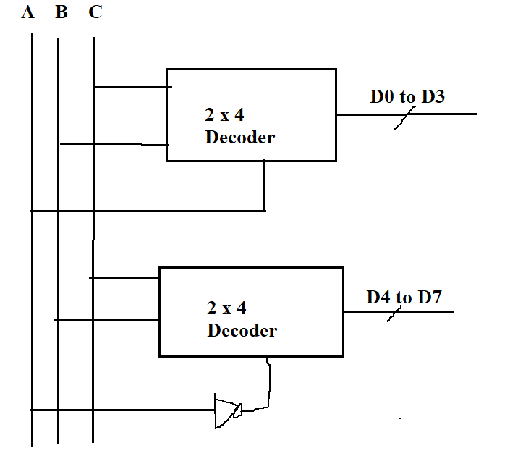

Design a 4 x16 Decoder by using 2 (3x8) decoder:

4 x16 = input 4 (A.B, C, D) output = D0-D15

3x8 = input (A, B, C) output = D0 - D7

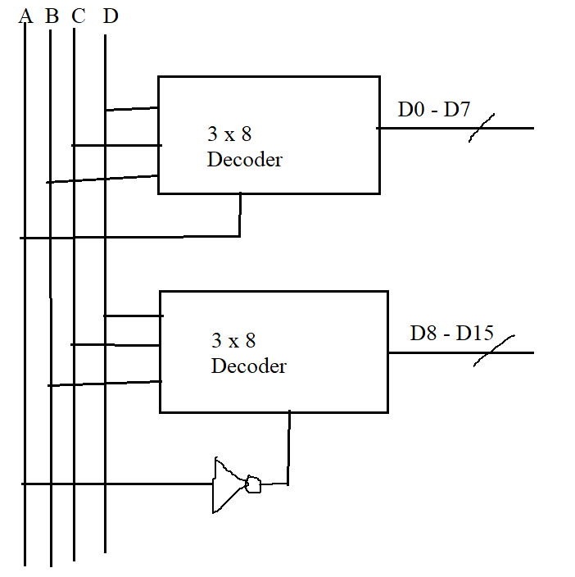

Design a 4x16 Decoder by using two 3x8 and one 1x2 Decoder